(2 Point) You are given an interface named Convertible (DO NOT CREATE THIS ONE). Design a class MyConvertible which will implement the interface Convertible.

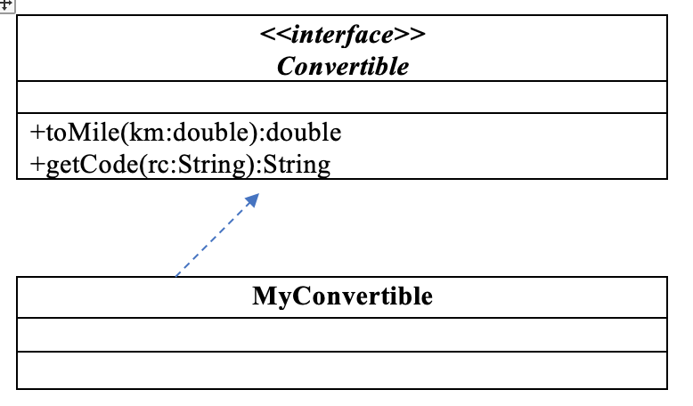
1. double toMile(km:double) – used to convert a km value to mile value. Given 1km = 0.621371 mile

2. String getCode(rc:String) – assuming that length of Reservation code is dividable by 3 ; this function return code of RC as the rule:
- Code of RC = separate a RC into groups, each group has exactly 3 characters with same order of orginal RC, groups are seperated by character “-“, eg A12-BE2-CM5
The program output might look something like:

No of test case | Correct output
1 | 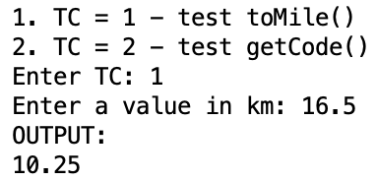
2 | 