(2 Point) Design and code a class named Person that holds information of a Person.

Person
-name:String
-age:int
+Person ()
+Person(name:String, age:int)
+getName():String
+getAge():int
+setAge(age:int):void
+toString():String

1. getName(): String – return a name of the person where every letters are in uppercase.
2. getAge(): int – return a age of the person
3. setAge(Age:int): void – set current age of the person is to a given age.
4. toString():String – return value of a Person as a string age name
Do not format the result

The program output might look something like:

No of test case | Correct output
1 | 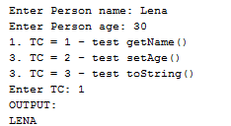
2 | 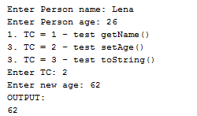
3 | 