(2 Point) Design and code a class named Teacher that holds information of a Teacher.

Teacher
-name:String
-salary:double
+Teacher ()
+Teacher (name:String,salary:double)
+getName():String
+getSalary():double
+setSalary(salary:double):void
+toString():String

1. getName(): String – return a name of the teacher where every letters are in uppercase.
2. getSalary(): double – return a salary of the teacher
3. setSalary(salary:double): void – set current salary of the teacher is to a given salary.
4. toString():String – return value of a Teacher as a string name salary
Do not format the result

The program output might look something like:

No of test case | Correct output
1 | 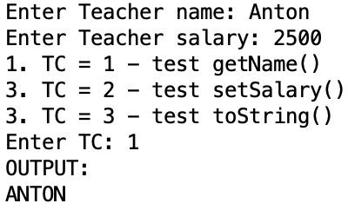
2 | 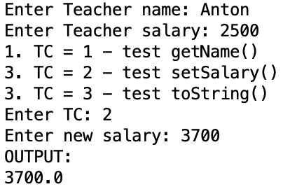
3 | 