(3 Point) Design and code a class named Computer that holds information about a Computer and class named SComputer which is derived from Computer.
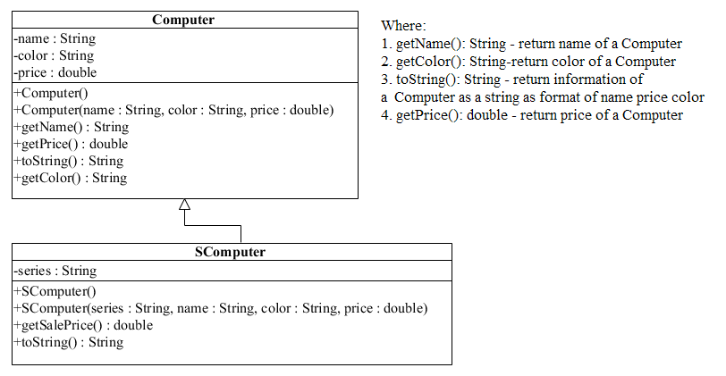
- toString():String - return information of a SComputer as a string as format of Name price color series
- getSalePrice():double – use to determine sale fare of a Computer, sale price = original price – discount, where:
    - discount = 5 percent out of original price if last of series is ‘A’.The comparison must ignores the case during comparison
    - otherwise discount = 10 percent out of original price.
Do not format the format the result.
The program output might look something like:

Correct output | Correct output
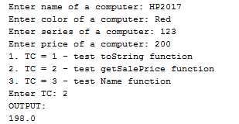 | 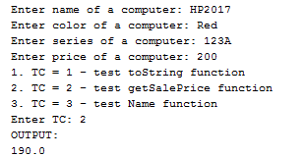
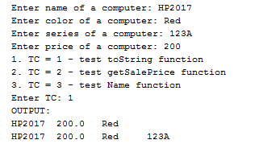 | 