(2 Point)
Design and code a class named Bicyle that holds information about a Bicyle.
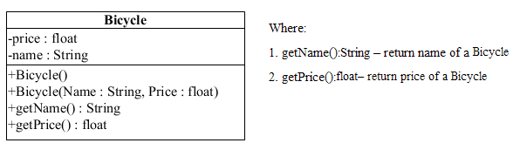
The interface IBicycle is given (DO NOT CREATE THIS ONE). Design and code a class named MyBycle which will implement interface IBicycle and complete 2 methods which were declared in IBicycle:
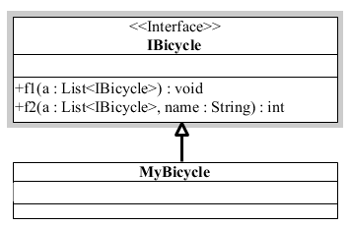
- void f1(List<Bicycle > a) – remove from the list of Bicycle "a" the first Bicycle has chepeast price
- int f2(List<Bicycle > a, String name) - count and return number of Bicycle which are in the list “a” and has given name in last of the name. The comparison must ignores the case during comparison.

Given some data which is added to list “a” in the Main already:

Bicyle name | Bicyle price
Yamaha 2017A | 110
Audi 2017B | 250
Porche 2017C | 120

By using given data, the program output might look something like:
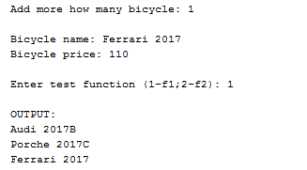 | 