(3 Point) You are given an interface named House (DO NOT CREATE THIS ONE). Design a class MyHouse which will implement the interface House.
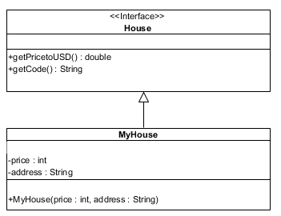
2. double getPricetoUSD()– used to convert price in VND into USD . Given 1USD = 23000 VND
3. String getCode() – assuming that length of address is greater than 3 ; this function return code of address as the rule:
- Code of address = first 3 characters of address if address constains digit only.
- Otherwise Code of address = last 3 characters of address.
No of test case | Correct output
1 | 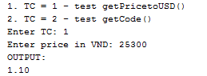
2 | 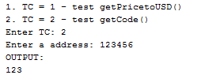
3 | 