(3 marks) You have main function which is saved on folder named Q1 already. Use these classes and functions to test all your operations in this question, DO NOT EDIT ANY CODE in main function. You can add more operations/classes/interfaces to be able to answer the below question.

Design and code a class named Employee that holds information about a Employee. Information of an Employee includes:
- A string describes the name of an Employee.
- A double value describes basic salary of an Employee.
Include the following member functions in your design:
- Constructors to set values for instance variables.
- Add needed operations to the class.
Design and code a deriving class named Seller from Employee class that holds information about a Seller. Information of a Seller includes:
- A double value describes revenue of a Seller of a year.
Include the following member functions in your design:
- Constructors to set values for instance variables.
- Add needed operations to the class so that the main function can be run and complete the below method which is declared in Seller class, the function will be used in second test case.
  - double getSalary() – use to determine sale price of a seller; salary = basic salary + bonus, where:
    - bonus = 5 percent out of revenue if revenue < 30000.
    - otherwise bonus = 10 percent out of revenue.

The program output might look something like:

No of test case | Correct output | Correct output
2 | 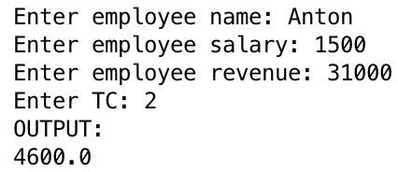 | 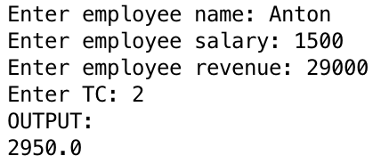
1 | 