Master of Science Thesis

Nonlinear Geometric Control of a Quadrotor with a Cable-Suspended Load

N.N. Vo

August 13, 2017

Delft Center for Systems and Control Delft University of Technology

Nonlinear Geometric Control of a Quadrotor with a Cable-Suspended Load

Master of Science Thesis

For obtaining the degree of Master of Science in Mechanical

Engineering at Delft University of Technology

- Vo

August 13, 2017

Faculty of Mechanical, Maritime and Materials Engineering Delft University of Technology



The work in this Master of Science Thesis was supported by Alten Nederland. Their cooperation is hereby gratefully acknowledged.


Delft University of Technology

Copyright © Delft Center for Systems and Control All rights reserved.

Delft University Of Technology

Delft Center for Systems and Control

The undersigned hereby certify that they have read and recommend to the Faculty of Me-chanical, Maritime and Materials Engineering for acceptance a thesis entitled \Nonlinear Geometric Control of a Quadrotor with a Cable-Suspended Load" by N.N. Vo in partial ful llment of the requirements for the degree of Master of Science.

Supervisor TU Delft:

Readers:

Supervisor Alten:

Dated: August 13, 2017

dr.ir. T. Keviczky

Dr. J. Alonso-Mora

A. Shari Kolarijani

ir. B. van Vliet

Abstract

A Quadrotor is a type of Unmanned Aerial Vehicle that has received an increasing amount of attention recently with many applications being actively investigated. Possible applications include search and rescue, surveillance, supply of food and medicines in emergency situations and object manipulation in construction and transportation. An important problem of load transportation is the control over the position of a cable suspended load. The challenge is in the fact that the Quadrotor-Load system is hard to model, it is highly nonlinear and under-actuated. The load cannot be controlled directly and has a natural swing at the end of each Quadrotor movement.

This thesis presents a Nonlinear Geometric Control approach and tests its’ possibilities and limitations to track the position of a cable suspended load. The focus lies on the Quadrotor-Load system where the cable tension is non-zero, this is analogous to modeling a rigid link between the Quadrotor and Load.

After introducing the basic concepts, an introduction is given on geometric mechanics, a differential geometric technique that helps building effective coordinate spaces, based on the geometric properties and dynamics of the system. It is shown how the con guration of the quadrotor-load sys-tem can be described on smooth nonlinear geometric spaces. This method allows for modeling in an un-ambiguous coordinate-free dynamic fashion, while avoiding the problem of singularities that would occur on local charts.

Next, the quadrotor-load system is modeled with the tools of di erential geometry in order to create coordinate spaces based on nonlinear manifolds suitable for Nonlinear Geometric Control. The geometric properties are utilized to de ne tracking error functions on these same spaces, making it possible to design nearly-globally de ned controllers. A backstepping approach is applied to generate a cascaded struc-ture with multiple nonlinear geometric controllers, allowing control of several ight modes that are responsible for the control of 1) quadrotor altitude, 2) load altitude and 3) Load position.

Finally, simulations demonstrate the stability and abilities of the Nonlinear Geometric Con-troller. A Linear Quadratic Regulator is derived to compare control performance. The tracking performances of both controllers are discussed for three typical trajectories and nal conclusions are presented.The thesis is concluded with a summary and recommendations for future work.

M.Sc. Thesis N.N. Vo

vi Abstract

N.N. Vo M.Sc. Thesis

Acknowledgements

I would like to thank my supervisors dr.ir. T. Keviczky from Delft Center of Systems and Control, and ir. B. van Vliet from Alten Nederland B.V. for their assistance during my research and the writing of this thesis. I would also like to thank all colleagues from Alten and TU Delft for their time and advice.

Delft, University of Technology

August 13, 2017

N.N. Vo

viii Acknowledgements

N.N. Vo M.Sc. Thesis

Table of Contents

 | Abstract |  |  | v
 | Acknowledgements |  |  | vii
1 | Introduction |  |  | 1
 | 1-1 Aim and Motivation . . . . . . . . . . . . . . . . . . . . . . . . . . . . . . . . . |  |  | 2
 | 1-2 | Organization of the Report . . . . . . . . . . . . . . . . . . . . . . . . . . . . . |  | 3
2 | Dynamic Model |  |  | 5
 | 2-1 | Geometric Mechanics . . . . . . . . . . . . . . . . . . . . . . . . . . . . . . . . |  | 6
 | 2-2 | Quadrotor Model . . . . . . . . . . . . . . . . . . . . . . . . . . . . . . . . . . |  | 10
 | 2-3 | Quadrotor-Load Model . . . . . . . . . . . . . . . . . . . . . . . . . . . . . . . |  | 12
3 | Control Design |  |  | 17
 | 3-1 | Nonlinear Geometric Control . . . . . . . . . . . . . . . . . . . . . . . . . . . . |  | 18
 |  | 3-1-1 | Error Functions . . . . . . . . . . . . . . . . . . . . . . . . . . . . . . . | 18
 | 3-2 | Backstepping Control . . . . . . . . . . . . . . . . . . . . . . . . . . . . . . . . |  | 22
 |  | 3-2-1 | Quadrotor Attitude Tracking . . . . . . . . . . . . . . . . . . . . . . . . | 23
 |  | 3-2-2 | Load Attitude Tracking . . . . . . . . . . . . . . . . . . . . . . . . . . . | 25
 |  | 3-2-3 | Load Position Tracking . . . . . . . . . . . . . . . . . . . . . . . . . . . | 26
4 | Experiment |  |  | 29
 | 4-1 | Procedure . . . . . . . . . . . . . . . . . . . . . . . . . . . . . . . . . . . . . . |  | 30
 | 4-2 | Trajectories . . . . . . . . . . . . . . . . . . . . . . . . . . . . . . . . . . . . . |  | 31
 | 4-3 Setup . . . . . . . . . . . . . . . . . . . . . . . . . . . . . . . . . . . . . . . . . |  |  | 35
 | 4-4 Results . . . . . . . . . . . . . . . . . . . . . . . . . . . . . . . . . . . . . . . . |  |  | 38
 | 4-5 | Conclusion . . . . . . . . . . . . . . . . . . . . . . . . . . . . . . . . . . . . . . |  | 48

M.Sc. Thesis N.N. Vo

x |  |  |  | Table of Contents
5 | Conclusions and Future Work |  |  |  | 49
 | 5-1 | Summary and Conclusions . . . . . . . . . . |  | . . . . . . . . . . . . . . . . . . . . | 49
 | 5-2 | Recommendations for Future Work . . . . . |  | . . . . . . . . . . . . . . . . . . . . | 50
 |  | 5-2-1 | Investigate Implementation . . . . . | . . . . . . . . . . . . . . . . . . . . | 50
 |  | 5-2-2 | Minimum Snap Trajectory Generation | . . . . . . . . . . . . . . . . . . . | 51
 |  | 5-2-3 | Hybrid System . . . . . . . . . . . . | . . . . . . . . . . . . . . . . . . . . | 51
A | Appendix |  |  |  | 53
 | A-1 | Derivation of Equations of motion . . . . . |  | . . . . . . . . . . . . . . . . . . . . | 53
 |  | A-1-1 | Load Dynamics . . . . . . . . . . . | . . . . . . . . . . . . . . . . . . . . | 53
 | A-2 | Derivation Error dynamics . . . . . . . . . . |  | . . . . . . . . . . . . . . . . . . . . | 53
 |  | A-2-1 | Quadrotor Attitude . . . . . . . . . | . . . . . . . . . . . . . . . . . . . . | 53
 |  | A-2-2 | Load Attitude . . . . . . . . . . . . | . . . . . . . . . . . . . . . . . . . . | 54
 | A-3 | LQR controller . . . . . . . . . . . . . . . . |  | . . . . . . . . . . . . . . . . . . . . | 55
 | A-4 | Classical Modeling . . . . . . . . . . . . . . |  | . . . . . . . . . . . . . . . . . . . . | 56
 | A-5 | Figures . . . . . . . . . . . . . . . . . . . . |  | . . . . . . . . . . . . . . . . . . . . | 57
 | Acronyms |  |  |  | 65

N.N. Vo M.Sc. Thesis

List of Figures

2-1 | Con guration Space of a 2-link arm . . . . . . . . . . . . . . . . . . . . . . . . | 6
2-2 | A manifold locally resembles a Euclidean space . . . . . . . . . . . . . . . . . . | 7
2-3 | Tangent Spaces on di erent manifolds . . . . . . . . . . . . . . . . . . . . . . . | 8
2-4 | Quadrotor model representation . . . . . . . . . . . . . . . . . . . . . . . . . . | 11
2-5 | Quadrotor with Load model representation . . . . . . . . . . . . . . . . . . . . . | 12
3-1 | Transport map T (q; r) . . . . . . . . . . . . . . . . . . . . . . . . . . . . . . . | 19
3-2 | Nonlinear Geometric Control Loop of the QR-Load system [1] . . . . . . . . . . | 22
3-3 | QR Attitude Controller . . . . . . . . . . . . . . . . . . . . . . . . . . . . . . . | 23
3-4 | Construction of b_{1c} to de ne R_{c} . . . . . . . . . . . . . . . . . . . . . . . . . . | 25
4-1 | Desired Load Position Case A . . . . . . . . . . . . . . . . . . . . . . . . . . . . | 31
4-2 | Desired Load Position Case B . . . . . . . . . . . . . . . . . . . . . . . . . . . . | 33
4-3 | Desired Load Position Case C . . . . . . . . . . . . . . . . . . . . . . . . . . . . | 33
4-4 | Command Filter . . . . . . . . . . . . . . . . . . . . . . . . . . . . . . . . . . . | 36
4-5 | LQR control design . . . . . . . . . . . . . . . . . . . . . . . . . . . . . . . . . | 37
4-6 | Load Position Tracking Nonlinear Geometric Control Case A . . . . . . . . . . . | 38
4-7 | Geometric Error functions Nonlinear Geometric Control Case A . . . . . . . . . | 39
4-8 | Controller Comparison Case A. Solid: NGC, Dash-dot: LQR . . . . . . . . . . . | 40
4-9 | Controller Comparison Case A. Solid: NGC, Dash-dot: LQR . . . . . . . . . . . | 41
4-10 | Load Position Tracking Nonlinear Geometric Control Case B . . . . . . . . . . . | 42
4-11 | Geometric Error functions Nonlinear Geometric Control Case B . . . . . . . . . | 43
4-12 | Controller Comparison Case B. Solid: NGC, Dash-dot: LQR . . . . . . . . . . . | 44
4-13 | Load Position Tracking Nonlinear Geometric Control Case C . . . . . . . . . . . | 45
4-14 | Geometric Error functions Nonlinear Geometric Control Case C . . . . . . . . . | 46
4-15 | Controller Comparison Case C. Solid: NGC, Dash-dot: LQR . . . . . . . . . . . | 47
A-1 | Model representation . . . . . . . . . . . . . . . . . . . . . . . . . . . . . . . . | 57
A-2 | Simulink Command Filter . . . . . . . . . . . . . . . . . . . . . . . . . . . . . . | 58

M.Sc. Thesis N.N. Vo

xii List of Figures

N.N. Vo M.Sc. Thesis

List of Tables

2-1 | Modeling assumptions Quadrotor model . . . . . . . . . . . . . . . . . . . . . . | 10
2-2 | Modeling assumptions Quadrotor-Load model . . . . . . . . . . . . . . . . . . . | 12
4-1 | Modeling Parameters . . . . . . . . . . . . . . . . . . . . . . . . . . . . . . . . | 35
4-2 | Hardware Parameters for Bebop Parrot Drone 1 . . . . . . . . . . . . . . . . . . | 35
4-3 | Command Filter Parameters . . . . . . . . . . . . . . . . . . . . . . . . . . . . | 36
4-4 | Controller Gains Nonlinear Geometric Controller . . . . . . . . . . . . . . . . . . | 37

M.Sc. Thesis N.N. Vo

xiv List of Tables

N.N. Vo M.Sc. Thesis

Chapter 1

Introduction

A Quadrotor (QR) is a type of Unmanned Aerial Vehicle (UAV) that has received an increas-ing amount of attention recently with many applications being actively investigated. Possible applications include search and rescue, surveillance, reliable supply of food and medicines as disaster relief and object manipulation in construction and transportation. It has already proven itself useful for many tasks like multi-agent missions, mapping, explorations, trans-portation and entertainment such as acrobatic performances.

The inspiration for this research is build upon the idea of creating a system of multiple autonomous QRs for a cooperative towing task such as .... The advantage of such systems for object manipulation is the increased reach and the possibility to reduce complexity of the individual robot, decrease cost over traditional robotic systems and high reliability. One can think of examples in nature, where individuals coordinate, cooperate and collaborate to perform tasks that they individually can not accomplish. Redundancy makes development of fail safe control methods possible and can extend the capabilities of a single robot.

Considering a multi-agent task, one can think of multiple QRs assisting in the transportation of a common load in many ways. One interesting method is the transportation of a load suspended via a cable. Prior to a multi-agent load transportation task, research must be done to this task involving a single QR. This research revolves around load position control of a single QR with a cable-suspended load in motion. The suspended object naturally continues to swing at the end of every movement. In case a residual motion can result in damage or in order to avoid obstacles and path following, an accurate positioning is required. Reducing the oscillation or controlling the position of the suspended load might be necessary, but is challenging in the fact that this cable-suspended system is under-actuated. Possible objectives are minimizing the oscillations of the load during or after motion, minimizing the time to position the load, trajectory tracking, trajectory generation and obstacle avoidance.

M.Sc. Thesis N.N. Vo

2 Introduction

1-1 Aim and Motivation

The aim is to control the position of a suspended load using a QR. Before considering multiple QRs, it is important to investigate the possibilities of a single QR with load system. Hence, in this research a single QR is considered for the transportation of a cable suspended load, which will exert additional forces and torques on the QR. This is a challenging control problem in the fact that the QR system is under-actuated. Adding a suspended load will add extra degrees of freedom (DOFs) and oscillations of the load occur at the end of every movement.

The system can be divided into two subsystems. The rst subsystem is where the cable tension is non-zero and the distance between the QR and the load is de ned by the cable length. Both QR and load are coupled as one system. The second subsystem is where the cable tension is zero, such that the QR and load in free fall are two separate decoupled systems. This research focuses on the rst subsystem, such that the cable tension is non-zero. In order to control both subsystems, hybrid control must be applied, which is considered out of the scope of this research.

Former work on attitude control of QR and/or load often relies on linear control methods such as PID, MPC and LQR control. The dynamics are linearized around an equilibrium point, describing the system dynamics by a set of linear di erential equations. The control of a QR-Load system is a very speci c case and scarcely investigated. Former work includes MPC [2] and LQR control approaches, where an optimal control strategy is used to minimize the swing of the load.

The reason that linear control near an equilibrium state is commonly applied, is partly to avoid di culties that come with modeling and controlling the non-linearities of the system. However, linear control limits the system to small angle movements, as the optimization will not allow large angles that deviate to far from the linearized point. This type of modeling and control will not be su cient for applications that require fast aggressive maneuvers. Nonlinear control systems are often governed by nonlinear di erential equations and are able to represent the dynamics in a more realistic manner. Nonlinear control approaches to minimize the load swing includes a Model Based Algorithm controller applied by [3].

***************************************

Bart: I think you might need some references here.

Nam: Duidelijk: is nog ToDo

***************************************

Nonlinear Geometric Control is a nonlinear model based control technique based on a model-ing approach involving the concepts of di erential geometry. This results in a globally de ned coordinate-free dynamical model, while preventing issues regarding singularities, and enabling the design of controllers that o er almost-global convergence properties. For a study on rigid body dynamics and optimal control problems, where geometric features are incorporated, one can refer to [4].

Former work includes a nonlinear geometric control of a QR [5, 6] and nonlinear geometric control of the load position, load attitude and QR attitude of a QR-Load system [7, 8, 9]. Nonlinear Geometric Control for QR systems is rarely found in literature, despite the advantageous properties of di erential geometry.

N.N. Vo M.Sc. Thesis

1-2 Organization of the Report | 3

This motivates to investigate the potential and limitations of a rarely used nonlinear Ge-ometric Control approach, and the performance of a load transportation maneuver, when compared to a commonly used linear control strategy.

Di erent aspects involving the modeling and control for the QR-Load system must be in-vestigated, for it can be expected that the non-linearity will have a great in uence in the representation of the dynamics and the stability, accuracy and type of the control design. It is possible to investigate which advantages or disadvantages this nonlinear approach has compared to a linear approach, in terms of stability and performance.

1-2 Organization of the Report

In this rst chapter, a brief introduction of the subject is given and the problem is described. This is followed by discussing the aim, motivation and contributions of this thesis for this research. The organization of the report is as follows.

Chapter 2 introduces Geometric Mechanics to understand and derive the system's equations of motion in order to allow nonlinear geometric controller design and analysis. The system con guration space is described on a di erentiable manifold using the tools of Di erential geometry instead of Euclidean geometry, where the system dynamics evolve in a three di-mensional space. The dynamics of the QR-Load system are then described by the laws of kinematics and the application of Newton's laws and Lagrangian mechanics. In contrast with classical modeling techniques, geometric modeling results in a compact, unambiguous and coordinate-free model.

Describing the system dynamics on nonlinear manifolds allows the design of nonlinear geo-metric controllers on these same manifolds. The control design is presented in Chapter 3. The controller has a cascaded structure, allowing the control of several ight modes that are accountable for the control of di erent degrees of freedom.

Chapter 4 describes the experiments that are done to investigate the abilities and performance of a nonlinear Geometric Control design. Di erent tracking objectives are de ned in order to compare the performance between an LQR control design and a nonlinear Geometric Control design. The results are presented and ndings are discussed.

In the nal chapter a summary of the thesis is given, followed by the conclusions that were made based on the results of the research. Finally, recommendations are given which could serve as an starting point for future work.

M.Sc. Thesis N.N. Vo

4 Introduction

N.N. Vo M.Sc. Thesis

Chapter 2

Dynamic Model

A mathematical model of the system needs to be derived in order to simulate and study the e ects of Nonlinear Geometric Control. In Section 2-1, an introduction is given on Geometric Mechanics., a modern description of classical mechanics from the per-spective of Di erential Geometry. Geometric mechanics is a discipline in mathematics that studies manifolds and their geometric properties, using the tools of calculus.

Section 2-2 starts by discussing assumptions that are applied to simplify the model. Next, a dynamical model of the QR is presented. In Section 2-3, the same is done to obtain a dynamical model of the QR-Load system with Geometric Mechanics, resulting in a com-pact, coordinate-free, unambiguous representation of the dynamics, described on nonlinear manifolds.

M.Sc. Thesis N.N. Vo

6 Dynamic Model

2-1 Geometric Mechanics

For the derivation of the equations of motions, traditional modeling methods often parame-terize the rotations in a local coordinate system. This can be done with Euler Angles, and despite this parametrization might result in singularities, this is a commonly used method to describe rotations. There are 24 possible sets of Euler angles and many di erent conventions are used, which introduces ambiguity. The de nition of Euler angles is not unique and a se-quence of rotations is not commutative. Therefore, Euler angles are never expressed in terms of the external frame, or in terms of the co-moving rotated body frame, but in a mixture.

An other disadvantage of Euler angles, is that the transformation from their time rates of change to the angular velocity vector is not globally de ned. Furthermore, when angular errors are large, the di erence in Euler angles is no longer a good metric to de ne the orientation error. Hence, the error is rather written as the required rotation to get from the current to a desired orientation, which can be achieved by considering geometric properties of the system.

In Geometric Mechanics the con guration space of systems is a group manifold instead of a Euclidean space. The kinetic and potential energies are expressed in terms of this con gu-ration space and their tangent spaces. It explores the geometric structure of a Lagrangian-or Hamiltonian system through the concepts of vector calculus, linear algebra, di erential geometry, and nonlinear control theory. Geometric mechanics provides fundamental insights into the nonlinear system mechanics and yields useful tools for dynamics and control theory.

An example is given of a simple 2-link arm, to illustrate di erent representations of a con g-uration space, see Figure 2-1. Let the con guration of the arm be de ned by two coordinates in a Cartesian coordinate system, which is a local representation. This can be seen in Figure 2-1b, where the colored edges illustrate singularities, because the de nition of one point has multiple solutions.

Next, the con guration space is represented as a geometric shape called a torus, as shown in Figure 2-1c. It is a smooth manifold where each con guration is mapped uniquely, which allows the con guration to be de ned globally.
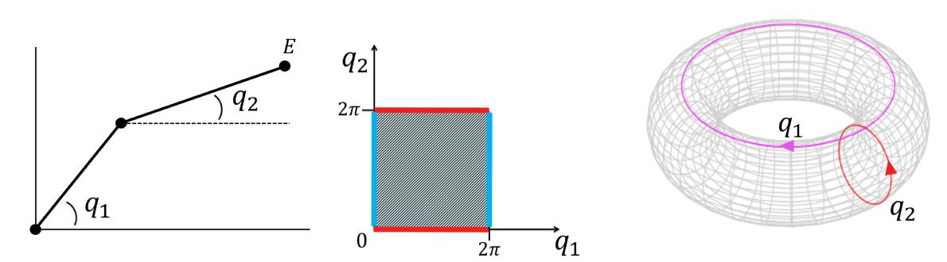

(a) (b) (c)

Figure 2-1: Con guration Space of a 2-link arm

Manifolds The fundamental object of di erential geometry a manifold. A manifold is a mathematical space, a collection of points, that locally resembles Euclidean space near each

N.N. Vo M.Sc. Thesis

2-1 Geometric Mechanics | 7

point. Examples are a plane, a ball, a torus and a sphere. Manifolds are important objects in mathematics and physics because they allow more complicated structures to be expressed and understood in terms of the relatively well-understood properties of simpler spaces. Each point of an n-dimensional manifold has a neighborhood that is homeomorphic to the n-dimensional Euclidean space, meaning that there is a continuous function describing the relation between these spaces, illustrated in Figure 2-2.

***************************************

Bart: Link coordinate free to singularity

Nam: ToDo

***************************************
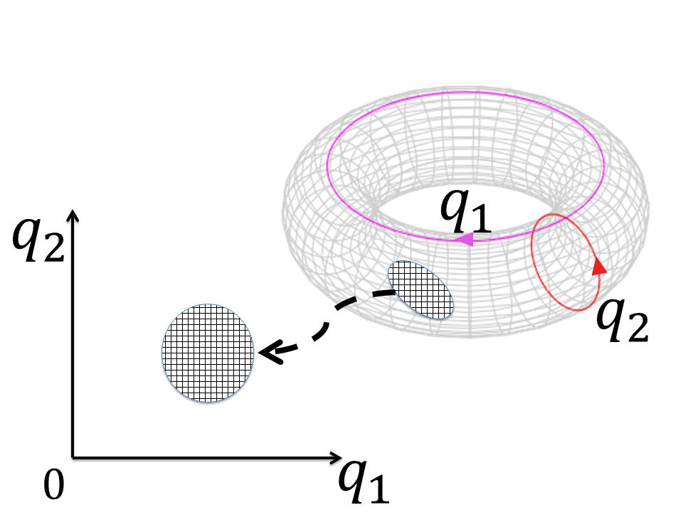

Figure 2-2: A manifold locally resembles a Euclidean space

A di erentiable manifold is a smooth and continuous manifold and is locally similar enough to a linear space to allow to do calculus. One can de ne directions, tangent spaces, and di erentiable functions on such a manifold.

Taking the derivative at a point on a manifold is equivalent to a tangent vector at that point. Meaning that derivatives are conceptually equivalent to an in nitesimally short tangent vector. Each point of an n-dimensional di erentiable manifold has a tangent space, which is an n-dimensional Euclidean space consisting of all the tangent vectors of all curves that pass through that point.

A tangent space describes a relationship between a position and a velocity at that position. This property is of importance for the determination of con guration error functions, which give a measure of the error between a desired state and an actual state. The con guration errors will be described in Section 3-1.

To illustrate a tangent space, a point x is chosen on a 2-sphere, which is a manifold denoted by S² and de ned by a sphere of dimension 2. The tangent space at point x is the collection of all tangent vectors at point x and is denoted by T_{x}S², see Figure 2-3a.

Geometric Con guration Spaces Several methods exist to describe rotations, such as Euler Angles, quaternions or rotation matrices. The main disadvantages of Euler angles are that some functions have singularities and they are a less accurate measure for the integration of incremental changes in attitude over time, compared to other methods. To avoid these

M.Sc. Thesis N.N. Vo

8 Dynamic Model
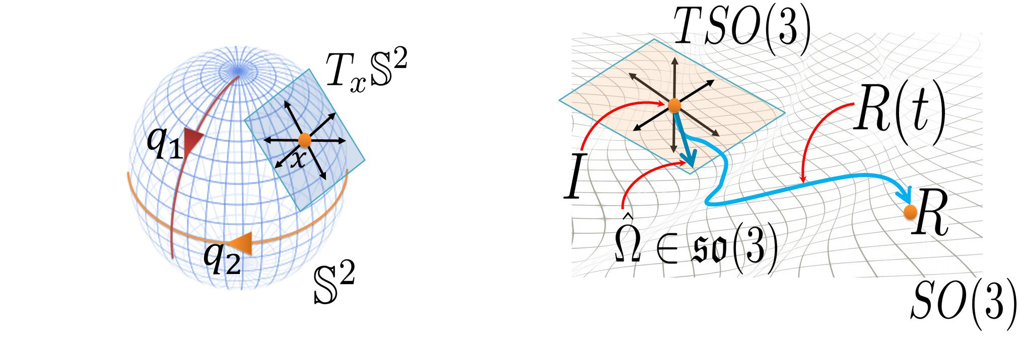

(a) Representation of a manifold with a tangent (b) Identity map of manifold SO(3) with Lie Al-

space gebra so(3)

Figure 2-3: Tangent Spaces on di erent manifolds

problems, in Geometric Mechanics rotations are expressed as rotation matrices to provide a global representation of the attitude of a rigid body.

The QR attitude is expressed as a rotation matrix R in the Special Orthogonal Group SO(3), which describes the rotation of a body frame relative to the spatial frame. The manifold SO(3) is de ned as

SO(3) , R 2 R³ ³jRR^{T} = I₃ ₃; det(R) = 1 | (2-1)
where SO(3) is the group of all rotations about the origin of a 3-D Euclidean space, which preserves the origin, Euclidean distance and orientation. [10, 11]

Every rotation has a unique inverse rotation and the identity map satis es the de nition of a rotation. The elements of Lie Algebra so(3), a property associated with SO(3), are the elements of the tangent space of SO(3) at the identity element, see Figure 2-3b. These elements de ne the relation between the rotation R and its derivative R_, such that
_ | ^ | (2-2)
R = R |  | (2-2)

For n 2 N, so(n) is is the vector space of skew-symmetric matrices in R^{n n} and de ned as

so(n) , S 2 R^{n n}jS^{T} = S | (2-3)
The hat map ^ : R³ ! so(3) is an isomorphism between R³ and the set of 3 3 skew

symmetric matrices, such that xy^ = x y for any x; y 2 R³. The vee map _ : so(3) ! R³, and is the inverse isomorphism of the hat map. Several properties of the hat map are

 |  | 1 |  | xy^ = x y = y x = yx;^ |  |  |  |  | (2-4)
tr[Ax^] = |  | 1 | tr[^x(A |  |  | A^{T} )] = x^{T} (A |  | A^{T} )_; | (2-5)
tr[Ax^] = | 2
 | xA^ |  |  | + A^{T} x^ = (ftr[A]I₃ ₃ Agx)^; |  |  |  |  | (2-6)
 |  |  |  |  |  | RxR^^{T} = (Rx)^; |  |  | (2-7)

N.N. Vo M.Sc. Thesis

2-1 Geometric Mechanics | 9

for any x; y 2 R³; A 2 R³ ³, and R 2 SO(3). The mapping between the body angular velocity
vector 2 R | 3 | ^
vector 2 R |  | and 2 so(3) is written as |  |  |  | 3 |  | 2 |  |  |  | 3
 |  |  | 0 | ₃ | ₂ | 3 |  | 2 | 0 | ₃ | ₂ | 3 | _
 |  | ^ = | ² ₃ | ₀ | ₁ | 3 | ; | 2 | ₃ | ₀ | ₁ | 3 | = | (2-8)
 |  |  | ⁴ ₂ | ₁ | 0 | 5 |  | 4 | ₂ | ₁ | 0 | 5
The load attitude is expressed as a unit vector q, which points from fBg to the load. The con guration space is a two-sphere S² de ned as

S² , q 2 R³jq q = 1 | (2-9)
The plane tangent to the sphere at q is the tangent space

T_{q}S² ' ! 2 R³jq ! = 0 (2-10)

where ! is the angular velocity of the suspended load.

M.Sc. Thesis N.N. Vo

10 Dynamic Model

2-2 Quadrotor Model

Assumptions can be made to simplify the complexity of the mathematical model. Table 2-1 shows the assumptions that are used for modeling the QR system.

Modeling assumptions Quadrotor model

  - The structure of the QR is rigid and symmetric.

Elastic deformations and shock (sudden accelerations) of the QR are ignored.
  - The mass distribution of the QR is symmetrical in the x-y plane.
  - The inertia matrix is time-invariant.

  - Aerodynamic e ects acting on the QR are neglected. Blade apping, Turbulence, Ground E ects.

  - The air density around the QR is constant.

- The propellers are rigid ) The thrust produced by rotor i is parallel to the axis of rotor i.

  - Drag factor d and thrust factor b are approximated by a constant.
Thrust force F_{i} and moment M_{i} of each propeller is proportional to the square of the propeller speed.

Table 2-1: Modeling assumptions Quadrotor model

The QR model representation is shown in Figure 2-4. Two Cartesian coordinate frames are de ned:

- The body- xed reference frame fBg (Body Frame) with unit vectors fb₁; b₂; b₃g along the axes
- The ground- xed reference frame fIg (Inertial Frame) with unit vectors fe₁; e₂; e₃g along the axes

such that fIg is xed to earth and the body-frame axes b₁ and b₂, coincide with the arms of the QR.

The QR is described as a rigid body with six degrees of freedom, driven by the system inputs:
the total upward force f and the moments M = M M | M ^{T} around the body axes.
The con guration of the QR can be described by 1) the | location of the QR's Center of
Mass (CM), x_{Q} 2 R³, described in the Euclidean space w.r.t. fIg , and 2) the attitude which is the orientation of fBg w.r.t. fIg evolving on a nonlinear space, described by a rotation matrix R 2 SO(3). Rotations w.r.t. fBg , about the axes b₁; b₂ and b₃ are parameterized by ; and , respectively, which is illustrated in Figure 2-4b.

The dynamics of a rigid body can be expressed on the manifold SE(3), which is the group of rigid displacements in R³. A rigid displacement describes both the rotation and the position of fBg relative to fIg .

Rotor dynamics The complex dynamics of the rotors and their interactions with drag and thrust forces are represented by a simpli ed model. The angular speed !_{i} of rotor i, for

N.N. Vo M.Sc. Thesis

2-2 Quadrotor Model | 11
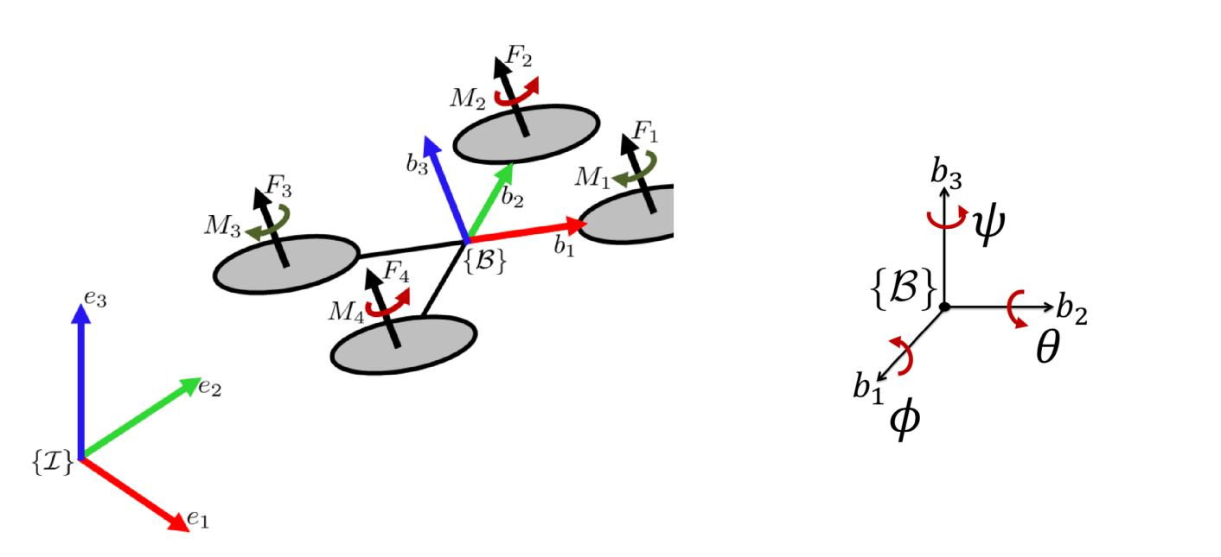

(a) QR model with forces and moments (b) Angle representation

Figure 2-4: Quadrotor model representation

i = 1; 2; 3; 4, generates a force F_{i} parallel to the direction of the rotor axis of rotor i, given by
F_{i} = | K_{v}K ^{p} |  | !_{i} | 2
F_{i} = | K_{v}K ^{p} | 2 A | !_{i} | 2
F_{i} = |  |  | !_{i} | ' b!_{i}² | (2-11)
F_{i} = | ^{K}t |  | !_{i} | ' b!_{i}² | (2-11)
where K_{v}; K_{t} are constants related to the motor properties, is the density of the surrounding air, A is the area swept out by the rotor, K is a constant determined by the blade con gu-ration and parameters, and b is the thrust factor.

The torque around the axis of rotor i, generated due to drag is given by

M_{i} = ¹₂R C_{D}A(!_{i}R)² ' d!_{i}² (2-12)

where R is the radius of the propeller, C_{D} is a dimensionless constant, and d is the drag constant.

The required rotor speeds !_{i} can be calculated for a given desired total thrust f and total
moment M= | M |  | M |  | M |  | T |  |  |  |  |  |  |  |  |  | equation
moment M= |  |  |  |  |  |  |  | , by solving the following |  |  |  |  |  |  |  |  | 3 2 | 2 | 3 | (2-13)
 |  |  |  |  | 2 |  |  |  | 3 | = | 2 |  |  |  |  |  | 3 2 | 2 | 3 | (2-13)
 |  |  |  |  | 6 |  | f |  | 7 |  | 6 | b | b |  | b | b | 7 6 | !₁
 |  |  |  |  | 6 | ^{M} |  |  | 7 |  | 6 | 0 |  | lb | 0 | lb | 7 6 | !2
 |  |  |  |  | 6 | M |  |  | 7 |  | 6 | lb | 0 |  | lb 0 |  | 7 6 | !₃⁷
 |  |  |  |  | 6 |  |  |  | 7 |  | 6 |  |  |  |  |  | 7 6 | 2 | 7
 |  |  |  |  | 4 | M |  |  | 5 |  | 4 | d | d |  | d | d | 5 4 | !₄² | 5

where l is the distance from the rotor to the QR's CM, d is the drag factor and b is the thrust factor.

M.Sc. Thesis N.N. Vo

12 Dynamic Model

2-3 Quadrotor-Load Model

Assumptions are also made to simplify the mathematical model for the QR-Load system.

Table 2-2 shows the assumptions that are used for modeling the QR-Load system.

Modeling assumptions Quadrotor-Load model

- The cable is modeled as a rigid and massless cable.
- The cable is connected to a friction-less joint at the origin of the body- xed.
- The tension in the cable is considered to be non-zero.

This implies that the QR-Load subsystem that consists of a QR and a Load in free fall, is disregarded.

- Aerodynamic e ects acting on the load are neglected.

Table 2-2: Modeling assumptions Quadrotor-Load model

The total Quadrotor-Load model consists of two subsystems, 1) where the cable tension is zero, and 2) where the cable tension is non-zero. In this research, the focus is only on the subsystem where the cable tension is non-zero.

The QR-Load model is shown in Figure 2-5. The unit vector q 2 S² gives the direction from the QR to the Load expressed in fBg . The position of the QR and Load are related by
x_{Q} = x_{L} Lq | (2-14)

where x_{Q} 2 R³ is the position of the QR's CM expressed in fIg , x_{L} 2 R³ is the position of the load expressed in fIg , and L is the length of the cable.
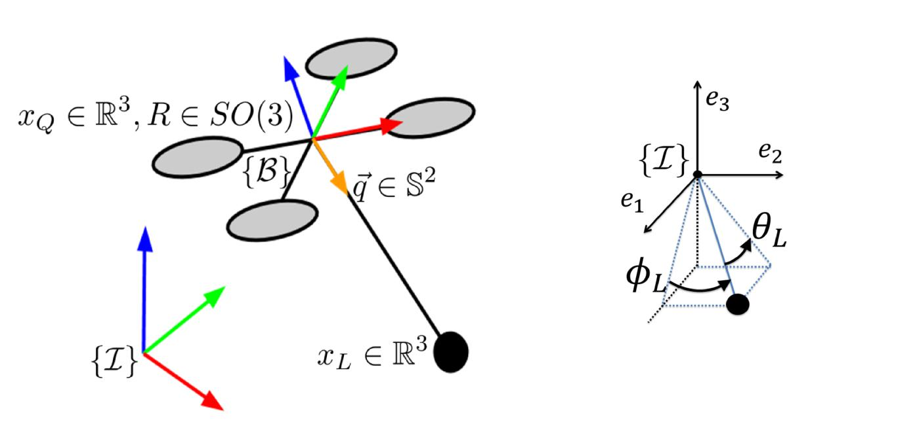

(a) QR model with Load (b) Angle representation

Figure 2-5: Quadrotor with Load model representation

N.N. Vo M.Sc. Thesis

2-3 Quadrotor-Load Model | 13

The con guration of the load can be described by its location x_{L} 2 R³ w.r.t. fIg , evolving in Euclidean space, and the load attitude evolving on a nonlinear space S², described by the unit vector q 2 S². Rotations of the load w.r.t. fIg , about the axes e₁ and e₂ are denoted by _{L} and _{L} , respectively, see Figure 2-5b.

Euler-Lagrange To develop the Euler-Lagrange equations for mechanical systems that evolve on manifolds, an approach developed by [4, 12, 13, 14] is applied. The basic idea is to express the variations of the curves evolving on S² and SO(3). This approach is based on Hamilton's principle, which states that the evolution of a physical system is a solution of the functional equation given by
S | = 0 | (2-15)
x(t) | = 0 | (2-15)

where x de nes the con guration space. S is the action integral, de ned as
- t₂
S = Ldt (2-16)
t₁

where L = T U is the Lagrangian of the system, and T ; U are the kinetic and potential energy, respectively.

Hamilton's principle of least action states that the path a conservative mechanical system takes between two states x₁ and x₂ at time t₁ and t₂, is the one for which Equation 2-16 is a stationary point, resulting in
^{Z} t₂
S =Ldt = 0 | (2-17)
t₁
where L is the variation of the Lagrangian. For systems with non-conservative forces and moments, Equation 2-17 is extended to
- t₂
S = ( W + L)dt = 0 (2-18)
t₁

where W is the virtual work. Equation 2-18 is applied to the QR-Load system, where the con guration manifold is R³ S² SO(3). With the following states

 |  |  | x = | x_{L} x_{L} |  | q ! R |  | T |  | (2-19)
where ! is the angular velocity of the load and denotes the angular velocity of the body- xed
frame.
The kinetic energy T and the potential energy U for the system are denoted as
 | 1 |  |  |  | 1 |  | 1
T | = |  | m_{Q}x_{Q} | x_{Q} + |  | m_{L}x_{L} x_{L} + |  |  | J
T | = | 2 | m_{Q}x_{Q} | x_{Q} + | 2 | m_{L}x_{L} x_{L} + |  | 2 | J | (2-20)

U = m_{Q}gx_{Q} e₃ + m_{L}gx_{L} e₃

where J 2 R³ ³ is the inertia tensor of the QR, and g is the gravity constant.
The energy can be rewritten in terms of q and x_{L}, by substituting Equation 2-14, giving

T = | 1 | (m_{Q} + m_{L})x_{L} x_{L} m_{Q}Lx_{L} q + | 1 | m_{Q}L²q q + | 1 |  | J | (2-21)
T = | 2 | (m_{Q} + m_{L})x_{L} x_{L} m_{Q}Lx_{L} q + | 2 | m_{Q}L²q q + | 2 |  | J | (2-21)
U = (m_{Q} + m_{L})gx_{L} e₃ m_{Q}gLq e₃ |  |  |  |  |  |  |  | (2-22)

M.Sc. Thesis N.N. Vo

14 |  |  |  |  |  |  |  |  |  |  |  |  |  |  |  |  | Dynamic Model
Variations |  |  |  | The variations of T and U are approximated by a rst-order Taylor approxima-
tion, which results in
 | T |  |  | @T |  | x | L |  | + |  | @T |  | q + |  | @T
 |  |  |  | @x_{L} |  |  |  |  |  |  | @q |  |  |  | @
 |  |  | = ((m_{Q} + m_{L})x_{L} m_{Q}Lq) x_{L} + ( m_{Q}Lx_{L} + m_{Q}L²q) q + (J ) |  |  |  |  |  |  |  |  |  |  |  |  |  |  |  | (2-23)
 |  | U |  | @U |  | x | L |  | + |  | @U |  | q
 |  |  |  |  | @x_{L} |  |  |  |  |  |  | @q

- ((m_{Q} + m_{L})ge₃) x_{L} (m_{Q}gLe₃) q

The rst term of virtual work is obtained from f acting on the QR and is given by the following term,
3 | @x_{Q}
^{X}j
^{X}j | _{@qj} ^{q}j |  | (2-24)
W₁ = fRe₃ |  |  | (2-24)
=1
- f Re₃ ( x_{L} L q)

where q_{j} = x_{L}; q; R and x_{Q} is substituted by Equation 2-14. The second term of virtual work is obtained from M acting on the QR. This gives the following term

3 |  | @
X_{j}
X_{j} | _{@qj} ^{q}j |  |  | (2-25)
W₂ = M |  |  |  | (2-25)
=1

- M (R^{T} R)

The variations in energy and the virtual work can be substituted into Equation 2-18, such that
- ^{t2}
S = ( W₁ + W₂ + T U)dt | (2-26)
t₁

While x_{L}; x_{L} vary on R³, Equation 2-26 is also a function of variations on manifolds, where

R is a variation on SO(3) and q is a variation on S². These so called in nitesimal variations de ne how the curves on the manifold "vary", and are obtained as shown in [1, 15, 12, 14, 16].

R = R^ 2 T_{R}SO(3), where 2 R³; ^ 2 so(3) |  | (2-27)
q = q 2 T_{q}S², where 2 R³; q = 0
The following variations follow from di erentiation,
q = _ q + q;
_ _ | ^
R = R^ + R ;
^ | T _
= (R | R)

- R^{T} R_ + R^{T} R_
= (R^) | ^{T} _ | T |  | _ | ^ | (2-28)
= (R^) | R + R |  | (R^ + R )
T ^ ^ |  | ^

= ^ + ^ +

^ ^ ^
= ( ) + ;

^
= ( ) +

N.N. Vo M.Sc. Thesis

2-3 Quadrotor-Load Model | 15

These variations are substituted into Equation 2-26, allowing it to be a function of variations in each generalized coordinate.
- t₂
S = ( W₁ + W₂ + T U)dt
^{t}1
  - t₂

- (((m_{Q} + m_{L})x_{L} m_{Q}Lq) x_{L} + (f Re₃ (m_{Q} + m_{L})ge₃) x_{L})dt

t₁ | (2-29)
+ ^{Z}_{t1}^{t2} | (2-29)
+ ^{Z}_{t1}^{t2} | ((m_{Q}L²q m_{Q}Lx_{L}) q + (m_{Q}gLe₃ f LRe₃) q)dt

  - t₂
- ( ^{T} J+ M (R^{T} R))dt
t₁

After rearranging and setting each variation to 0, the following equations of motion for the QR-Load system are found.

 | d
 |  | x_{L} = x_{L} |  | (2-30)
 | dt |  |  | (2-30)
(m_{Q} + m_{L})(•x_{L} + ge₃) = (q f Re₃ m_{Q}L(q q))q |  |  |  | (2-31)
 |  | q = ! q |  | (2-32)
m_{Q}L! = q f Re₃ |  |  |  | (2-33)
_ |  |  | ^ | (2-34)
 |  | R = R |  | (2-34)
_ |  |  |  | (2-35)
J +J = M |  |  |  | (2-35)

where Equations 2-31 and 2-33 are the load position and attitude dynamics, and Equation 2-35 represents the QR attitude dynamics.

The dynamics of the complete QR-Load system can be globally expressed on the Special Orthogonal Group SO(3), two-sphere S² and Special Euclidean Group SE(3), which are all smooth manifolds. This results in a compact notation of the equations of motion, making the large amount of trigonometric functions unnecessary, that normally are introduced by Euler angles.

Summary

In this chapter, the dynamical model of the Quadrotor-Load system was derived. The motiva-tion to use Geometric Mechanics and a basic understanding of its concepts are given in order to understand the di erence between a Nonlinear Geometric model and a model obtained with classical modeling approaches.

With the tools of di erential geometry, the system dynamics are expressed on nonlinear con g-uration manifolds, which results in a globally de ned, compact, unambiguous representation of the model. This dynamical model is used for a nonlinear geometric control approach, which is discussed in the next chapter.

M.Sc. Thesis N.N. Vo

16 Dynamic Model

N.N. Vo M.Sc. Thesis

Chapter 3

Control Design

Section 3-1 introduces Nonlinear Geometric Control and concepts of geometric properties that are used for analysis and control design. In the previous chapter, the con guration spaces of the system dynamics were expressed on nonlinear manifolds,. In Section 3-1-1, error functions and geometric mappings are de ned on these same nonlinear manifolds in order to measure the error between current and desired states.

In order to deal with the under-actuated nature of the system, a backstepping control ap-proach is applied to stabilize the system . This control design allows multiple controllers to operate in a cascaded structure, which results in the possibility to track a load position, while stabilizing the system. The control design with its di erent ight modes and the correspond-ing controllers are discussed in Section 3-2.

M.Sc. Thesis N.N. Vo

18 Control Design

3-1 Nonlinear Geometric Control

Many control systems are developed for the standard form of ordinary di erential equations

x = f(x; u) (3-1)

where x is the state and u the control input. It is assumed that the state and the control input lie in Euclidean spaces, and the system equations are de ned in terms of smooth functions between Euclidean spaces. However, for many mechanical systems, the con guration space can only be expressed locally as a Euclidean space. A nonlinear space is required to express the con guration space globally, which is discussed in the previous chapter.

Geometric Control Theory is the study on how geometry of the state space in uences control problems. In control systems engineering, the underlying geometric features of a dynamic system are often not considered carefully. Di erential Geometric control techniques utilize these geometric properties for control system design and analysis. The objective is to express both the system dynamics and control inputs on nonlinear manifolds instead of local charts. In contrast to locally de ned linear control, nonlinear geometric control can be de ned almost globally, avoiding singularities that would occur in the representation of large angles and complex maneuvering.

The design of the controllers for the QR attitude can be found in [5], and the controllers of load attitude- and position this can be found in [1]. Thorough stability analyses are presented in these references. For a deeper understanding of Lyapunov stability analysis in geometric control, the reader can refer to [16]. Other control systems that are able to switch between control modes, such as the hybrid control described in [17], require complicated reachability set analysis to guarantee safe switching between di erent ight modes. Nonlinear Geometric Control does not require such analysis, as the region of attraction for each ight mode covers the con guration space almost globally. A study on global nonlinear dynamics of various classes of closed loop attitude control systems can be found in [18].

3-1-1 Error Functions

The control of a trajectory tracking problem requires state feedback to de ne tracking errors, a measure of the di erence between the current states and the desired states. Since the closed-loop system dynamics evolve on nonlinear manifolds, which describe the con guration space of the QR attitude 2 SO(3) and the load attitude 2 S², error functions are de ned on these same manifolds [16]. These functions play a role in the de nition of the potential function for the closed-loop system and form the basis for both stabilizing and tracking controllers of the QR-Load system.

Quadrotor Attitude Error

Recall that R is the rotation matrix to describe the QR attitude, and R_{d} is the desired rotation matrix. To describe the relative rotation from the body frame to the desired frame, an attitude error is de ned as R_{d}^{T} R. Note that R_{d}^{T} R is again a rotation matrix itself. Based on this attitude error, the tracking error function _{R} on SO(3) is chosen to be

 | 1 | _{I Rd}T _{R}
_{R}(R; R_{d}) = | ₂tr | _{I Rd}T _{R} | (3-2)

N.N. Vo M.Sc. Thesis

3-1 Nonlinear Geometric Control | 19

such that _{R} is locally positive-de nite about R_{d}^{T} R = I within the region where the rotation angle between R and R_{d} is less than 180 . It can be shown that this region where _{R} < 2 almost covers SO(3) [19].

Using Equation 2-5 and 2-27, the derivative of the tracking error function _{R} with respect to R along the direction of R = R^ for 2 R³ is given by

D_{R} (R; R_{d}) R^ = |  |  | 1 | tr[R_{d}^{T} R^]
 |  |  | 2
 | 1 |  |  |  | (3-3)
= | 1 | (R_{d}^{T} R |  |  | R^{T} R_{d})_
= | 2 |  |  |  | R^{T} R_{d})_

where the vee map _ : so(3) ! R³ is the inverse of the hat map de ned in Section 2-1. From this equation, the QR attitude tracking error e_{R} 2 R³ is chosen as follows

e_{R} = | 1 | (R_{d}^{T} R R^{T} R_{d})_ | (3-4)
e_{R} = | 2 | (R_{d}^{T} R R^{T} R_{d})_ | (3-4)

It is important to note that the velocities R_ and R__{d} cannot be compared directly, since they do not lie in the same space. At time t = t₀, assume that R(t₀) = q and R_{d}(t₀) = r, then R_ and R__{d} lie in their own tangent spaces, denoted by T_{q}SO(3) and T_{r}SO(3), respectively. For this reason, R__{d} must be transformed into a vector on T_{q}SO(3) to allow a meaningful comparison with R_. De ning a velocity error can be achieved with a mathematical object called a transport map, which enables the comparison of tangent vectors living in di erent spaces.
In Figure 3-1, two curves R(t) and R_{d}(t) evolve on manifold SO(3). Transport map T (q; r) :
T_{r}SO(3) 7!T_{q}SO(3) allows comparison of the velocity curves R_ and R__{d}.
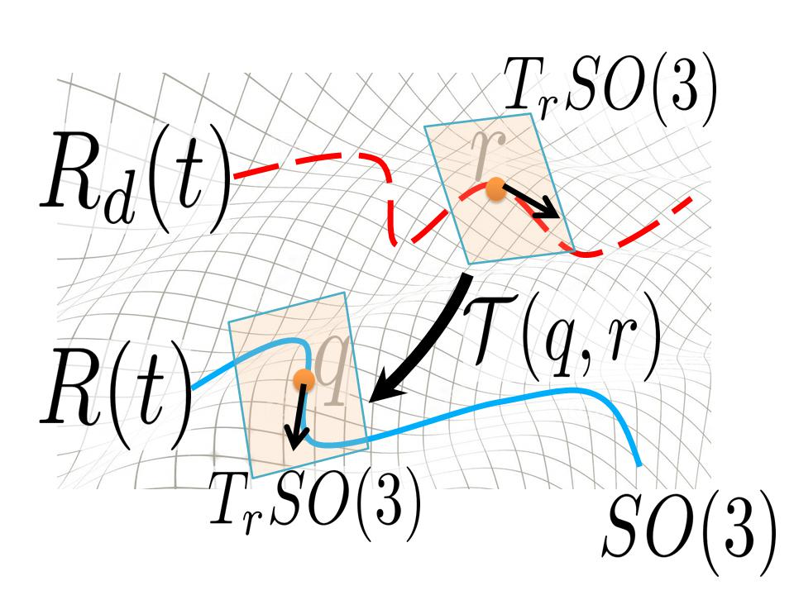

Figure 3-1: Transport map T (q; r)

The velocity error e is a vector eld along R corresponding to the transport map. It de nes the velocity error between the curves R and R_{d}, and is de ned as

_ _ | T | R) | (3-5)
e = R R_{d}(R_{d} |  | R) | (3-5)

M.Sc. Thesis N.N. Vo

20 Control Design

This equation is rewritten to obtain the angular velocity tracking error, as follows

_ _ | T | ^ | ^ | T | R)
R R_{d}(R_{d} |  | R) = R R_{d d}(R_{d} |  |  | R)
^ T ^ T
= R( ) (RR )R_{d d}R_{d} R

= R( )^ R(R^{T} R_{d d})^

= R( R^{T} R_{d d})^

The angular velocity tracking error e expressed in fBg is de ned as

e = R^{T} R_{d d}

(3-6)

(3-7)

Similar to the form of Equation 2-34, e represents the angular velocity vector of the relative rotation matrix R_{d}^{T} R, represented in fBg . Hence, it can be shown that the following equation holds

d |  |  | (R_{d}^{T} R) = (R_{d}^{T} R)^e |  | (3-8)
dt

The values of the QR attitude tracking error e_{R} and the QR angular velocity tracking error e are used later on to design control for the QR attitude.

Load Attitude Error

The load attitude dynamics evolve on S² and its tangent space T S², where the error of the load attitude is described in a similar approach. The error between the load attitude q and the desired load attitude q_{d} is de ned by the error function q_{d}^{T} q. Based on the error function, the tracking error function _{q} on S² is chosen to be

_{q} = 1 q_{d}^{T} q | (3-9)

The derivative of the tracking error function _{q} is given by

d₁ _{q}(q; q_{d}) = q^²q_{d} | (3-10)

From this equation, the load attitude error function e_{q} is de ned as follows

e_{q} = q^²q_{d} | (3-11)

Again, a transport map is used for a comparison between the tangent vectors on di erent tangent spaces. Using the tracking error _{q} and the transport map T_{S}2 , a closed-loop energy function evolving on S² is derived [16, 11.3.2]. From this energy function, the load angular velocity error function is de ned as

e_{q} = q (q_{d} q_{d}) q | (3-12)

The values of the load attitude tracking error e_{q} and the load angular velocity tracking error e_{q} are used later on to design control for the load attitude.

N.N. Vo M.Sc. Thesis

3-1 Nonlinear Geometric Control | 21
Load Position Error
The tracking errors for the load position and load velocity are de ned as
e_{x} = x x_{d} | (3-13)
e_{v} = v v_{d} | (3-14)

where v_{d} = x_{d}. Furthermore, x_{d}(t) 2 R³ must be a smooth twice-di erentiable load trajectory, such that functions are well de ned. The values of the position error e_{x} and the velocity error e_{v} are used later on to design control for the load position.

M.Sc. Thesis N.N. Vo

22 Control Design

3-2 Backstepping Control

A backstepping approach will be used in this research for the control of the load trajectory tracking problem, and is commonly used for QR control[20]. Backstepping control is a Lya-punov based control technique for the stabilization of nonlinear dynamical systems, developed by [21]. The method relies on a triangular structure of the system in a certain set of coordi-nates. The system is split into subsystems in a cascaded structure and recursive techniques allow a systematically design of feedback control laws and corresponding Lyapunov functions.
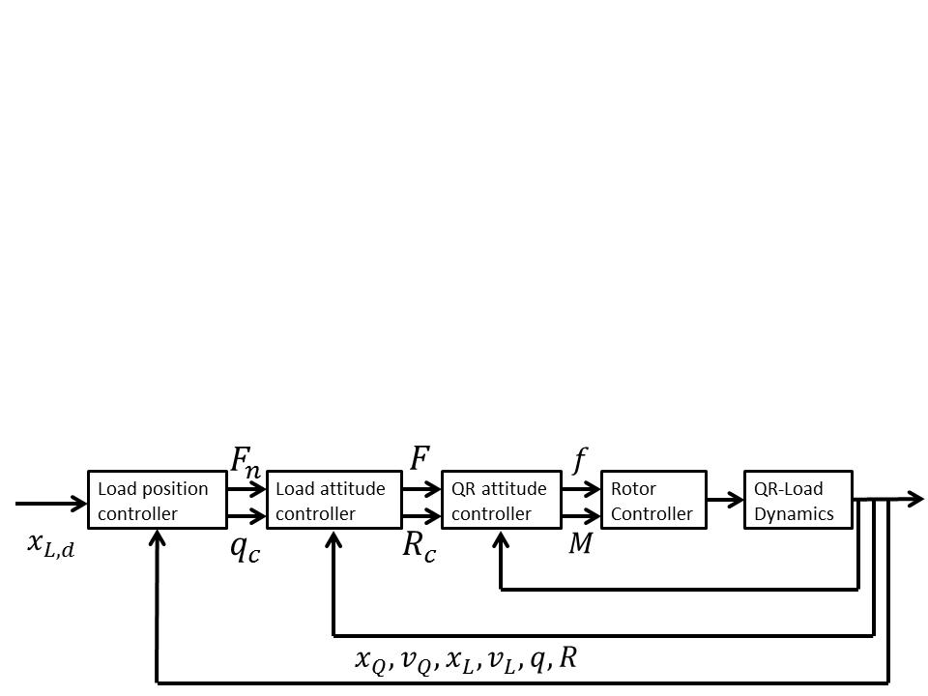

The control structure is created by starting with a stable system as the most inner subsystem. By "stepping back" from this subsystem, a control loop can be added around it containing a control law that de nes a change of coordinates. This creates a virtual control input, that must stabilize the inner structure. The control law is designed by using states as virtual control inputs, such that each loop computes a virtual command signal for the adjacent inner loop. This is repeated until the nal external control is reached.

The backstepping approach is able to calculate the control inputs f and M that are required to stabilize the QR, while several controllers are able to track di erent states, see Figure 3-2. The inner controller determines what the required control inputs are, driven by R_{c}. The next controller calculates how to drive the computed rotation matrix R_{c} based on q_{c}, such that the QR is stabilized. And the last controller determines which load attitude q_{c} is required, such that the desired load position x_{L;d} is tracked.

Figure 3-2: Nonlinear Geometric Control Loop of the QR-Load system [1]

Since the QR has only four actuators, it is not possible to control all DOFs of the QR-Load system simultaneously. The backstepping approach allows control of di erent ight modes in which a combination of DOFs is controlled. The ight modes and their functions are de ned below in order, from the most inner loop to the most outer loop.

- QR Attitude Controlled Mode

{ Track a desired QR attitude R_{d}(t) or commanded signal R_{c}(t)

{ Optional tracking of a desired heading direction b_{1d} (t), the rst column of R_{d}(t) { Calculate the control input M for the QR-Load system

- Load Attitude Controlled Mode

{ Track a desired load attitude q_{d}(t) or commanded signal q_{c}(t)

N.N. Vo M.Sc. Thesis

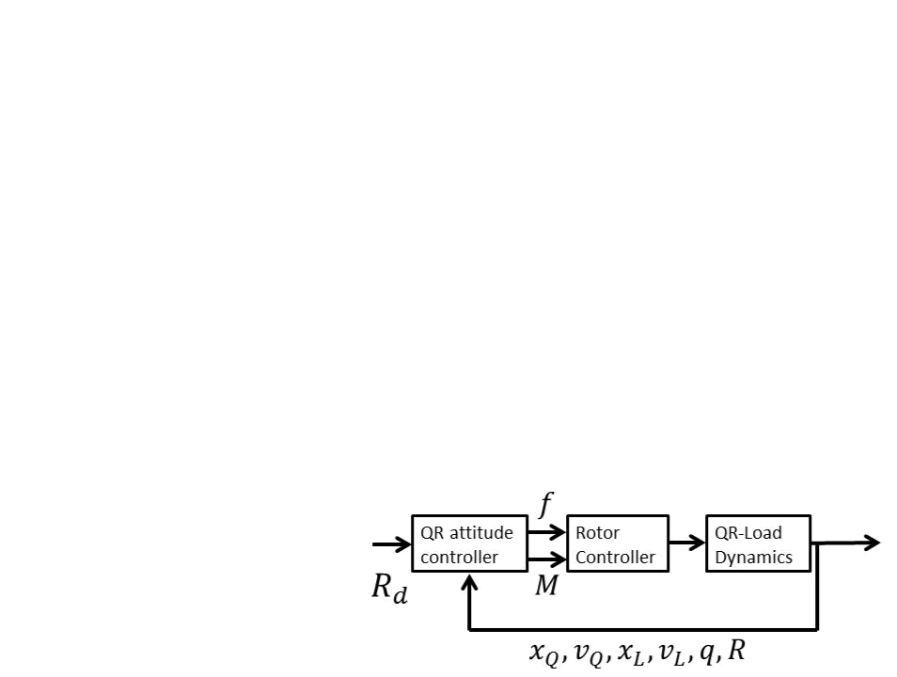
3-2 Backstepping Control | 23

{ Calculate a computed QR attitude R_{c} for the QR attitude controller { Calculate the control input f for the QR-Load system

- Load Position Controlled Mode

{ Track a desired load position x_{L;d}(t)

{ Calculate a computed load attitude q_{c} for the load attitude controller { Calculate the control input f for the QR-Load system

where the subscript d denotes a desired tracking reference, which must be given whenever it is not calculated by a controller. For example in Figure 3-3, where the QR attitude controller works as a standalone controller, without taking load attitude and position into account. The subscript c denotes a computed tracking reference, calculated by the controllers.

Figure 3-3: QR Attitude Controller

3-2-1 Quadrotor Attitude Tracking

The QR Attitude Controlled Mode is designed to control the QR attitude by tracking a smooth desired QR attitude R_{d}(t). Analysis of the error dynamics e_{R} and e requires the calculation of their time derivatives.

Using Equations 3-4 and 3-7, the derivative of the attitude tracking error e_{R} can be written as
e | = | 1 | (R^{T} Re^ | + e^ R^{T} R |  | ₎_ | (3-15)
R |  | 2 | d |  | d

The derivative of the angular velocity tracking error e , follows from Equations 2-34, 3-7 and
^
_{d d} = 0, such that
_ ^ | T | R_{d d} R | T | _ | (3-16)
e = + R |  | R_{d d} R |  | R_{d d} | (3-16)

Recall from Equation 2-34, that the kinematics equation for the desired attitude can be written as
_ | ^ | ^ | T _ | (3-17)
R_{d} = R_{d d} and _{d} = R_{d} R_{d} |  |  |  | (3-17)
The desired angular acceleration _ _{d} follows from the following equation
_ | _ | T | _ |  | T | •
^ | _ |  | _ |  |  | •
_{d} = (R_{d} |  |  | R_{d}) + (R_{d} R_{d})
 |  |  | ^ | T | ^ |  | T • | (3-18)
 | = (R_{d d}) |  |  |  | (R_{d d}) + (R_{d} R_{d}) |  |  | (3-18)
^ ^^{T} •
- _{d d} + R_{d} R_{d}

M.Sc. Thesis N.N. Vo

24 |  |  |  |  |  |  |  |  |  | Control Design
such that,
_ | d | = ( | ^ | d | ^ | d | ₊ _{R}^{T} _{R}• | d | ₎_ | (3-19)
 | d |  |  | d |  | d | d | d
By substituting Equation 2-35 into Equation 3-16, the following equation is obtained
e = J ¹(J + M) + ^R^{T} R_{d d} R^{T} R_{d} _ _{d} |  |  |  |  |  |  |  |  |  | (3-20)

From this, the control input M is de ned [19], and consists of a proportional term, a derivative term and a canceling term, as follows

^ | T | R_{d d} R | T | _ | (3-21)
M = k_{R}e_{R} k e +JJ( R |  | R_{d d} R |  | R_{d d}) | (3-21)

Rapid exponential convergence of the attitude error function and angular velocity error func-tion can be achieved by adding the parameter to Equation 3-21 as done in [1], where 0 < < 1,, given by

 | 1 |  |  | 1 | ^ | T |  | T | _
M = |  | ² | k_{R}e_{R} |  | k e +JJ( R |  | R_{d d} R |  | R_{d d}) | (3-22)

Substituting Equation 3-22 into Equation 3-20 results in the time derivative of the angular velocity tracking error, given by

e = J ¹( | 1 |  | k_{R}e_{R} | 1 | k e ) | (3-23)
e = J ¹( |  | 2 | k_{R}e_{R} |  | k e ) | (3-23)

for any positive constants k_{R}; k .
Equation 2-6 is used to rewrite the time derivative of e_{R} as follows

e |  | = |  | 1 | (R^{T} Re^ + e^ R^{T} R |  |  | ₎_
e | R | = |  |  |  |  |  | ₎_
 | R |  | 2 |  |  | d | d | (3-24)
 |  |  | 1 |  |  |  |  | (3-24)
 |  | = |  |  |  | (tr[R^{T} R_{d}]I R^{T} R_{d})e C(R_{d}^{T} R)e
 |  | = | 2

where k C(R_{d}^{T} R) k₂ 1, such that k e_{R} k k e k for all R_{d}^{T} R 2 SO(3), guaranteeing that e_{R} will be bounded, whenever e is bounded. In [5] it is proven that the Lyapunov functions, which are functions of the error dynamics e_{R}; e ; e_{R}; e described above, are non-increasing

and bounded. With this controller stability analysis, it is proven that the zero equilibrium of the closed loop tracking error (e_{R}; e ) = (0; 0) is exponentially stable, if the initial conditions satisfy
 | _{R}(R(0); R_{d}(0)) < 2 |  |  |  |  |  | (3-25)
k e (0) k²< |  | 2 k_{R} |  |  | (2 | _{R}(R(0); R_{d}(0))) | (3-26)
k e (0) k²< |  | _{M} (J) ² |  |  | (2 | _{R}(R(0); R_{d}(0))) | (3-26)
where _{M} ( ) denotes the maximum eigenvalue. Furthermore, there exist constants _{R}; _{R} > 0 such that

n o
_{R}(R(t); R_{d}(t)) min 2; _{R}e R^{t} (3-27)

Equations 3-25 and 3-26 determine the domain of attraction, which is the region in which the trajectory of the system is able to converge to an asymptotically stable equilibrium point.

N.N. Vo M.Sc. Thesis

3-2 Backstepping Control | 25

The domain of attraction almost covers SO(3), this is referred to as almost-global exponential attractiveness.

Note that the tracking of the QR attitude does not require any speci cation of the thrust magnitude f. During this ight mode, the translational motion can only be controlled par-tially, which makes this ight mode suitable for attitude maneuvers with short time periods. For a QR system without load, in [5] a tracking controller is described that calculates both a thrust magnitude f and total moment M in order to track a QR position trajectory.

3-2-2 Load Attitude Tracking

The Load Attitude Controlled Mode is designed to track a desired load attitude q_{d}. In order to in uence the load dynamics, see Equation 2-33, the load attitude controller calculates a computed QR attitude R_{c} for the QR attitude controller, which replaces R_{d}.
The commanded directions of the body frame axes are de ned by R_{c}, and is de ned as follows

R_{c} = b_{1c}; b_{3c} b_{1c}; b_{3c} |  | (3-28)
_{d} is replaced by _{c}, where _{c} is de ned by
^ | T _ | (3-29)
_{c} | ⁼ ^{R}c ^{R}c | (3-29)
which will in uence the QR attitude dynamics, see Equation 2-35.

The unit vector b_{1c} is the rst column of R_{c} and is constructed by normalizing the projection of a desired heading angle b_{1d} 2 S² onto the plane normal to b_{3c}, see Figure 3-4. De ning b_{1c} 2 S² orthogonal to b_{3c} guarantees that R_{c} 2 SO(3) [19].
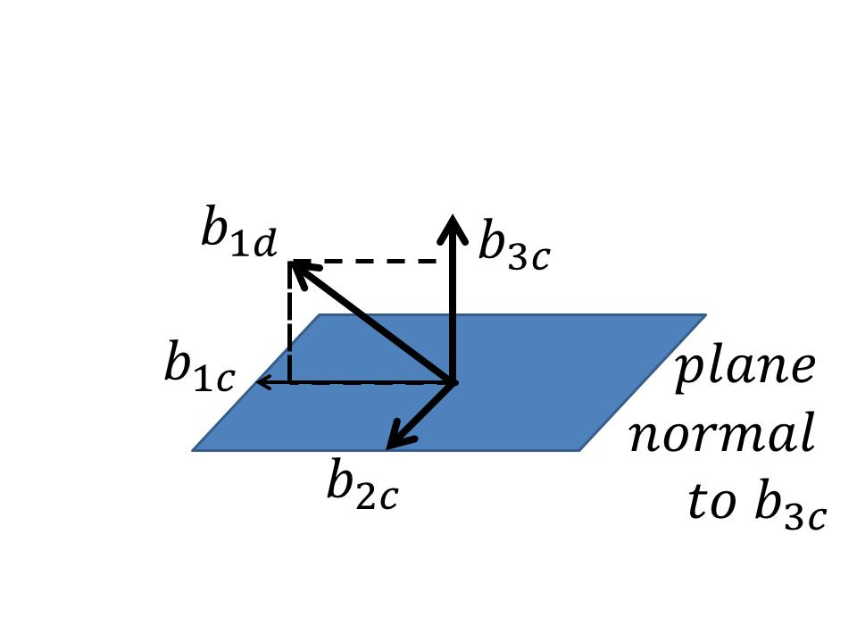

Figure 3-4: Construction of b_{1c} to de ne R_{c}

b_{1c} is de ned as follows

1
^{b1c} ⁼ jjb_{3c} b_{1d}jj | (b_{3c} (b_{3c} b_{1d})) | (3-30)

Such that b_{2c} = b_{3c} b_{1c}, and b_{1d} is chosen, not parallel to b_{3c} 2 S², the third column of R_{c}. b_{3c} is de ned by a normalization of F ,

b_{3c} = | F | (3-31)
b_{3c} = | jjF jj | (3-31)

where F is de ned by a normal component Fn, a proportional-derivative component Fpd and feedforward control force Fff
F = F_{n} F_{pd} F_{ff} | (3-32)

M.Sc. Thesis N.N. Vo

26 | Control Design
The inclusion of F_{n} ensures that b_{3c} is always well de ned. F_{n} is de ned as
F_{n} = (q_{d} q)q | (3-33)

The control forces F_{pd} and F_{ff} are de ned for trajectory tracking in [16, 11.2.5] as follows

F_{pd} = k_{P} q^²q_{d} k_{D}(q (q_{d} q_{d}) q) | (3-34)
= k_{q}e_{q} k!e_{q}
and
F_{ff} = m_{Q}Lhhq; q_{d} q_{d}ii_{R}3 (q q) + m_{Q}L(q_{d} q•_{d}) q | (3-35)

for positive constants k_{q}; k!.

This controller a ects the control input f, which is de ned as

 |  |  |  | f = F Re₃
and the control input M will be de ned as
 | 1 |  | 1 |  | ^ | T |  | T | _
M = | ² | k_{R}e_{R} |  | k e +JJ( R |  |  | R_{c c} R |  | R_{c c})

(3-36)

(3-37)

It is proven in [1] and [16, Lemma 11.23] that the zero equilibrium of the closed loop tracking error (e_{q}; e_{q}; e_{R}; e ) = (0; 0; 0; 0) is exponentially stable, if the initial conditions satisfy

 | _{q}(q(0); q_{d}(0)) < 2 |  |  |  | (3-38)
k e_{q}(0) k² | 2 |  |  | _{q}(q(0); q_{d}(0)))
k e_{q}(0) k² | < |  | k_{R}(2 | _{q}(q(0); q_{d}(0))) | (3-39)
k e_{q}(0) k² | < | m_{Q}L | k_{R}(2 | _{q}(q(0); q_{d}(0))) | (3-39)

The domain of attraction is de ned by Equations 3-25, 3-26, 3-38 and 3-39. Equation 3-38 states that the initial load attitude error should be less than 180 , which means that the controller achieves almost-global exponential convergence for load attitude q. Furthermore, there exist constants _{q}; _{q} > 0 such that

n o
_{q}(q(t); q_{d}(t)) min 2; _{q}e ^{qt} (3-40)

3-2-3 Load Position Tracking

The Load Position Controlled Mode is designed to track a desired load position x_{L;d}. Analysis of the error dynamics e_{x} and e_{v} requires the calculation of their time derivatives. The derivative of the load position error e_{x} is given by

e_{x} = e_{v} | (3-41)

and from Equation 2-31 and given that e_{v} = x•_{L} x•_{L;d} follows

(m_{Q} + m_{L})e_{v} = (m_{Q} + m_{L})(ge₃ + x•_{L;d}) m_{Q}L(q q)q + (q f Re₃)q | (3-42)

N.N. Vo M.Sc. Thesis

3-2 Backstepping Control | 27

Equations 3-41 and 3-41 are used in a stability analysis of the controller. The load position controller calculates a computed load attitude q_{c} for the load attitude controller. R_{d} and q_{d} are replaced by R_{c} and q_{c}, respectively. In order to stabilize the error dynamics, it is proven in [1] that the required computed load attitude is de ned as

q_{c} = | A |  | (3-43)
q_{c} = | jjAjj |  | (3-43)
where
A = k_{x}e_{x} k_{v}e_{v} + (m_{Q} + m_{L})(•x_{L;d} + ge₃) + m_{Q}L(q q)q |  |  | (3-44)
Furthermore, Equation 3-33 is rede ned as
F_{n} = (A q)q |  |  | (3-45)
which is substituted in Equation 3-32, resulting in a new control input f.
This controller ensures that the zero equilibrium of the closed loop |  |  | tracking error

(e_{x}; e_{v}; e_{q}; e_{q}; e_{R}; e ) = (0; 0; 0; 0; 0; 0) is exponentially attractive, if the initial conditions sat-isfy

_{q}(q(0); q_{c}(0)) < ₁ < 1 | (3-46)
k e_{x}(0) k²< e_{xmax} | (3-47)
where e_{xmax} and ₁ are xed design depended constants.

The domain of attraction is de ned by Equations 3-25, 3-26, 3-46 and the following equation

k e_{q}(0) k² | 2 | _{q}(q(0); q_{d}(0)))
k e_{q}(0) k² | < _{mQL}^{k}q⁽ 1 | _{q}(q(0); q_{d}(0))) | (3-48)

Summary

In this chapter, control design based on Nonlinear Geometric Control is discussed. What is particular in this control technique, is the fact that error functions are de ned on non-Euclidean manifolds, similar to the manifolds that describe the con guration space of the system. Since these manifolds are locally Euclidean, local stability properties of a closed-loop equilibrium solution can be determined by using standard Lyapunov methods. Based on these error functions, controllers are designed in a backstepping approach, enabling both load position tracking and stabilization of the system. Using the geometric properties of the system allows the design of globally de ned controllers that ensure almost-global convergence of the QR attitude and load attitude. In order to test the control performance of a load position tracking objective, experiments are de ned in the next chapter.

M.Sc. Thesis N.N. Vo

28 Control Design

N.N. Vo M.Sc. Thesis

Chapter 4

Experiment

The experimental procedure is explained in Section 4-1. It is discussed what experiments can be done in order to investigate closed-loop stability and the tracking performance of Nonlinear Geometric Control. In addition, a comparison is made between the performances of the Nonlinear Geometric Controller and a linear LQR controller.

The controllers are tested on their ability to track a desired load trajectory. Section 4-2 presents several desired load trajectories that create di erent challenges for load position tracking, and it is discussed what could be expected from these experiments.

***************************************

Bart: Challenge of what? control challenges?

Nam: challenges for load position tracking, beter?

***************************************

In Section 4-3 the experimental setup is discussed. The model parameters for the QR-Load system are presented, as well as the controller parameters for both Nonlinear Geometric controller and LQR controller. The notion of a backstepping command lter is made to explain a mathematical simpli cation in the experiments.

Finally, in Section 4-4 the results that are obtained from the load trajectory tracking exper-iments are presented and discussed. The stability of the closed-loop system is demonstrated for the Nonlinear Geometric Controller and the di erences in linear- and nonlinear controller performance are discussed.

M.Sc. Thesis N.N. Vo

30 Experiment

4-1 Procedure

Performance of both Nonlinear Geometric Control and LQR control can be evaluated by comparing their ability to track a load trajectory with minimal error. In linear control however, a linearized model is obtained by assuming small angles of both load and QR around an equilibrium point. The model is obtained by assuming the system in equilibrium when the QR is in hover position with the load hanging directly underneath it. As a result, the linearized model does not allow direct reference tracking of the load position.

The LQR cost function allows control of the inputs f and M, and the states which de ne the QR position, QR attitude and load attitude. Therefore, full load position control is not possible. It can be approached by QR position control or minimization of the load swing. This limitation illustrates an important di erence between the use of a linear and a nonlinear model.

The experiments describe a smooth desired load trajectory x_{L;d}(t) in order to get well-de ned control functions. In this work the desired load paths are generated by hand. The associated required velocity and acceleration are calculated by a command lter, which is explained in more detail in Section 4-3.

The experiments done with the LQR controller will apply reference tracking of the QR posi-tion, which is based on the desired load trajectories that are used for the nonlinear Geometric controller. When assuming small angles and minimal load swing, the QR position should be a cable length above the prede ned desired load position. Note that this will not allow a direct comparison of the load trajectory tracking performance, nevertheless this will illustrate important di erences between the controllers. For the purpose of load transportation, both controllers can be used. The di erence is in the approach of the problem.

N.N. Vo M.Sc. Thesis

4-2 Trajectories | 31

4-2 Trajectories

This section discusses a number of cases that describe di erent load trajectories for the QR-Load system. A description is given of desired trajectory and the challenges that are involved.

Case A

In the rst case, a smooth step-like trajectory is generated to investigate the step response of the system. The step response is a commonly used analysis tool to obtain information about the stability of a dynamical system. A step function is used to investigate the e ects of a sudden input to the desired load position. Typical response properties that can be investigated are: rise time, overshoot, settling time and steady-state error. The goal is to transport the load from a starting position along the direction of the x-axis to a nal position. Figure 4-1 shows the desired trajectory over time.

The geometric control design requires the desired load trajectory to be twice-di erentiable. For this reason a smooth step-like function is generated. The load position controller outputs a commanded load attitude signal q_{c}, see Equation 3-43, which is a function of x_{L;d}; x_{L;d} and x•_{L;d}. It can be expected that the step response is only able to track a trajectory up to a limited steepness. The commanded acceleration in Equation 3-44 is required to be bounded, such that

k (m_{Q} + m_{L})(•x_{L;d} + ge₃) + m_{Q}L(q q)q k< B | (4-1)

where B is a design parameter to guarantee Lyapunov stability [1]. This might result in large errors, and it must be investigated whether the system is able to maintain stable. Input constraints are not yet considered in the control design, this might be required to avoid input commands that are out of reach and
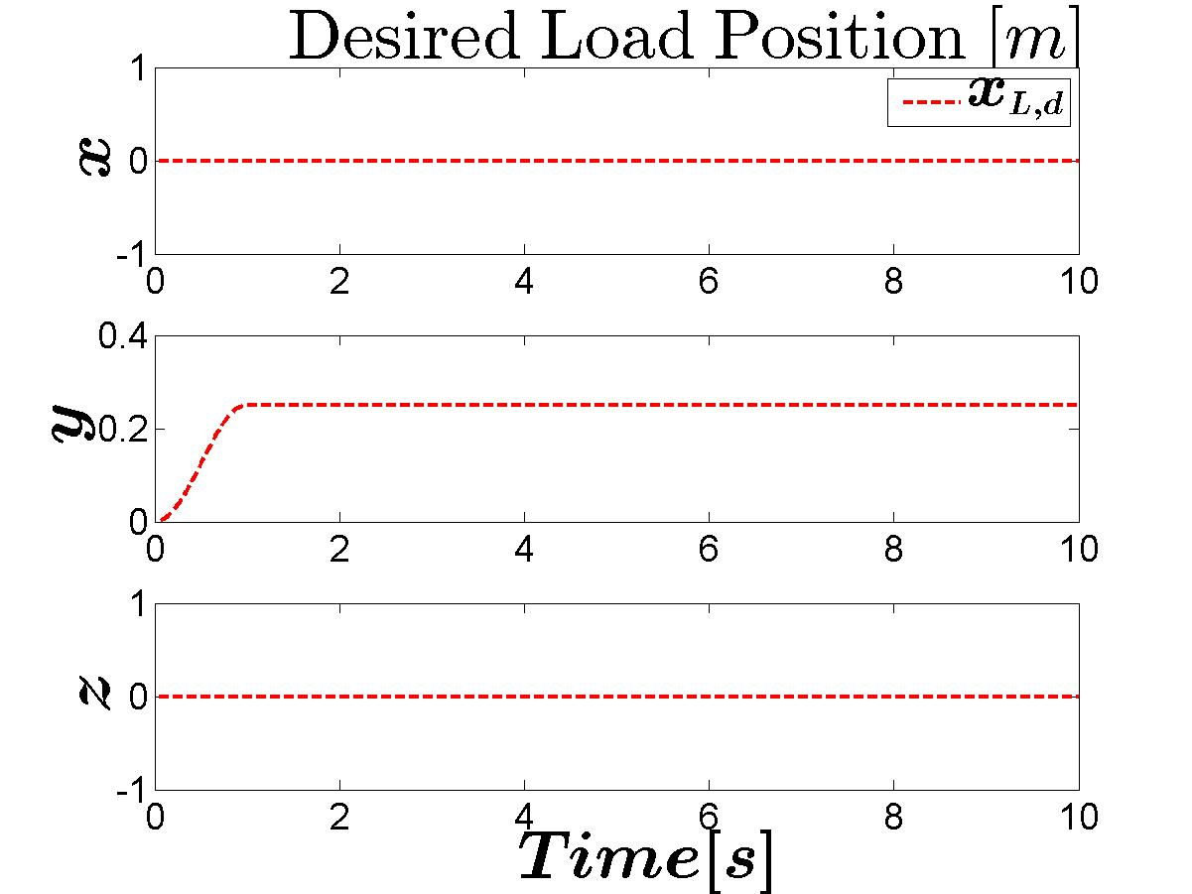

Figure 4-1: Desired Load Position Case A

***************************************

Bart: Did you found out with Daniel why a steep step works with simple pid controllers?
Nam: Waarschijnlijk.. e_{v} wordt instantaan oneindig.

PID: De gecalculeerde gewenste input wordt instantaan oneindig. De werkelijk response is gelimiteerd door het systeem. Een actuator zal zijn hoogst mogelijke output geven, maar 1

M.Sc. Thesis N.N. Vo

32 Experiment

sample periode erna is dat al niet meer nodig, omdat e_{v} dan weer gezakt is.
NGC: load position controller berekent een commanded load attitude q_{c} = _{k}^{A}_{Ak}, waar A = k_{x}e_{x} k_{v}e_{v} + (m_{Q} + m_{L})(•x_{L;d} + ge₃) + m_{Q}L(q q)q. Als e_{v} ! 1, dan krijg je rotzooi. Het

lijkt me dat de controller hierdoor niet meer goed gede nie•erd is.

Verderop in een paper staat nog: Assumed that commanded acceleration is uniformly bounded such that k (m_{Q} + m_{L})(•x_{L;d} + ge₃) + m_{Q}L(q q)q k< B. En dat is niet het geval wanneer er een keiharde step wordt toegepast.

Voorlopige conclusie:

PID: controller berekent een sampletijd een oneindig hoge desired input, actuatoren zullen pieken, maar het systeem klapt niet (per se).

NGC: load position controller kan geen commanded state meer berekenen voor desired input, waarschijnlijk gaan de control laws hierdoor overhoop.

Verder [16] geeft een voorbeeld voor trajectory tracking op S ²: "Let t 7!r(t) be a twice-di erentiable reference trajectory with bounded velocity ...". Wellicht dat met een steile smooth step en een limiet op inputs, dat q_{c} (en de rest van de controllers) wel goed gede nie•erd is?

***************************************

***************************************

Bart: Also speed of response/ rise time is important or not? With high rise time it is easy to have no overshoot but mostly this is not desired behavior. Nam: Edited, please check

***************************************

***************************************

Bart: You mentioned ""What could be expected from these experiments" {> I don't see the expectation for the step response om this paragraph Nam: Added. Compleet genoeg?

***************************************

Case B

The nonlinear geometric controllers are expected to be able to deal with large angles in the QR attitude, allowing aggressive maneuvering. This can be tested by describing the next trajectory as a sine wave, growing in amplitude over time, in the direction of one axis in fIg . This will result in a increasing distance between the load positions at each end of the movement, requiring increasing velocities on both the QR and the load. To achieve this, it can be expected that the QR requires large rotations. It is investigated whether the system is able to perform load position tracking while dealing with increasing QR rotations.

The trajectory is generated by the product of signals A and B, shown in Figure 4-2a, of which the rst signal is a sine and the second consists of a smooth step up and down. This product results in signal C, shown in the same gure, which is chosen to be the trajectory in the direction of the y-axis of fIg . Figure 4-2b shows the desired trajectory over time.

N.N. Vo M.Sc. Thesis

4-2 Trajectories | 33
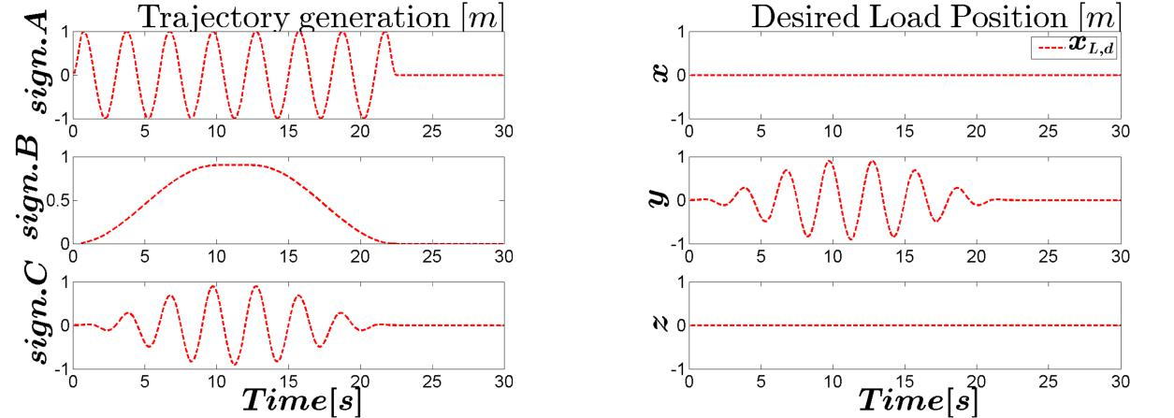

(a) Trajectory generation (b) Desired trajectory

Figure 4-2: Desired Load Position Case B

Case C

This case is generated in order to investigate the response on tracking multiple conditions at the same time. The trajectory along the y-axis in fIg is described as a sine wave with an increasing and decreasing amplitude over time, as in case B. While following this wave, the load is commanded to move forward along the x-axis, while tracking an increasing and decreasing height. The changing amplitude of the trajectory that moves from side to side, requires varying velocities to 'keep up' with the trajectory. In this case it can also be expected large QR rotations are required to track the changing amplitude of the sine wave and the varying velocities. While doing so, the QR is expected to lose height due to the rotations, It can be investigated how the close-loop system responds to the forward movement, while tracking a swinging motion and whether the controller can correct for the expected height loss, while tracking an up and down movement.

Figure 4-3 shows the desired trajectory over time, and a three dimensional representation.
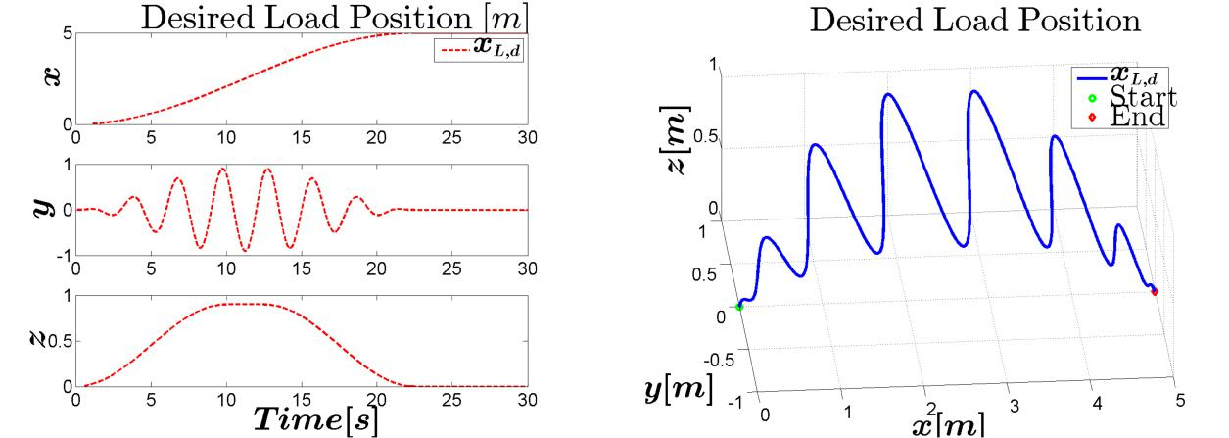

(a) (b)

Figure 4-3: Desired Load Position Case C

M.Sc. Thesis N.N. Vo

34 Experiment

***************************************

Bart: Which multiple disciplines? Do you mean Large QR rotations leads to less lifting force which might limit the tracking performance in z-direction

Nam: Ik bedoelde eigenlijk, meerdere objectives. Hoge zijwaartse snelheden, terwijl het hoogte moet tracken. Indirect daarmee ook, testen of het hoogte kan houden terwijl de QR kantelt. Beetje herschreven, beter?

***************************************

N.N. Vo M.Sc. Thesis

4-3 Setup | 35

4-3 Setup

Model parameters The simulations are developed using Matlab® and Simulink® R2013b. The model parameters to de ne the system are based on a Parrot® Bebop Drone 1, also used in a research by [22], see Table 4-1, where m_{L} and L are chosen arbitrarily.

Parameter | Value |  | Description
m_{Q} | 0.4 | kg | Quadrotor Mass
l | 0.126 | m | Arm length from QR CM to rotor
^{I}xx | 2.23 10 ³ | kgm² | Quadrotor Inertia about x-axis
^{I}yy | 2.99 10 ³ | kgm² | Quadrotor Inertia about y-axis
^{I}zz | 4.8 10 ³ | kgm² | Quadrotor Inertia about z-axis
m_{L} | 0.1 | kg | Load Mass
L | 0.7 | m | Cable Length

Table 4-1: Modeling Parameters

In order to get a feel for realistic physical limits, these can be based on hardware data, which could be found on the web ¹. These values are shown in Table 4-2, and can be compared with the simulation results, in order to check whether the outcome is in the same order of magnitude of a real physical system.

Value |  | Description
13 | m=s | Maximum top speed
2.5 | m=s | Maximum vertical speed
30 | deg | Maximum inclination

Table 4-2: Hardware Parameters for Bebop Parrot Drone 1

***************************************

Bart: Inclination of what? Is this the same as QR Attitude?

Nam: Yes. Just general de nition of inclination. Hellingshoek/inclinatie

***************************************

Command Filtering A consequence of a backstepping control approach, is that it increases the order of the commanded states. The controllers generate control laws that are a function of the commanded signals and their derivatives. As can be seen in Chapter 3, the control
_ •
laws require the values R_{c}; R_{c}; R_{c}; q_{c}; q_{c} and q•_{c}. Time derivatives of the virtual control vari-

ables may be quite complex and the calculation could result in high computational costs. Instead of analytic di erentiation of these terms, which can be tedious, these values can be obtained with the use of a Command Filter[23, 24]. The result of a command lter is that the command signal is being pre- ltered by low pass lters and generates an estimation of the derivatives of the commanded signal. Backstepping command lters are implemented to

- http://blog.parrot.com/2016/01/12/comparison-bebop-2-vs-bebop-drone/

M.Sc. Thesis N.N. Vo

36 | Experiment
_ | •
compute R_{c}; R_{c}; q_{c}; q•_{c}; x_{L;d} and x•_{L;d}. This approach is explained in more detail in [25]. The nonlinear state space representation of this lter is given by

 |  |  | _{xc} = _{q2}
 |  |  | x_{c} |  | q₁
 | q₂(t) |  | "2 !_{n} S_{R} | 2 !_{n} | [S_{M} (x_{c}) |  |  | q₁] | q₂ | #
 |  |  | n |  | q₂ |  |  | º
 | q₁(t) | = |  | !_{n}² |  | o

(4-2)

(4-3)

where S_{M} and S_{R} are functions that can limit the magnitude and rate. The implemented command lter is shown in Figure 4-4.
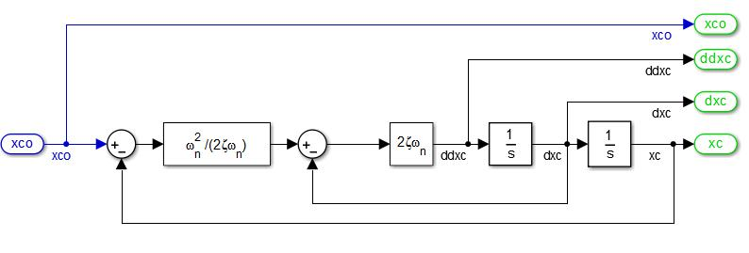

Figure 4-4: Command Filter

The chosen values for !_{n} and for the command lters are shown in Table 4-3. The parameters were determined by trial and error. The higher the value for !_{n}, the higher the frequencies that are passed through the lter. Whenever the frequency was chosen too high, noisy derivatives are calculated, resulting in a destabilization of the system. Choosing the values too low resulted in slow responses, and a bad estimation of the derivatives. The damping ratio was chosen high, in order to give a su cient damping. No limits for the magnitude and rates are implemented, meaning that S_{M} and S_{R} are omitted.

Table 4-3: Command Filter Parameters

 |  | Filter
 | R | q | ^{x}L;d
!_{n} | 30 | 25 | 25
 | 0.98 | 0.98 | 0.98

Geometric Control The chosen controller gains in Equations 3-21, 3-34 and 3-44 can be found in Table 4-4.

LQR Control Linear Quadratic Regulator (LQR) control uses an algorithm to obtain a state-feedback controller, minimizing a cost function depending on the states and weight factors. An LQR design is shown in Figure 4-5

N.N. Vo M.Sc. Thesis

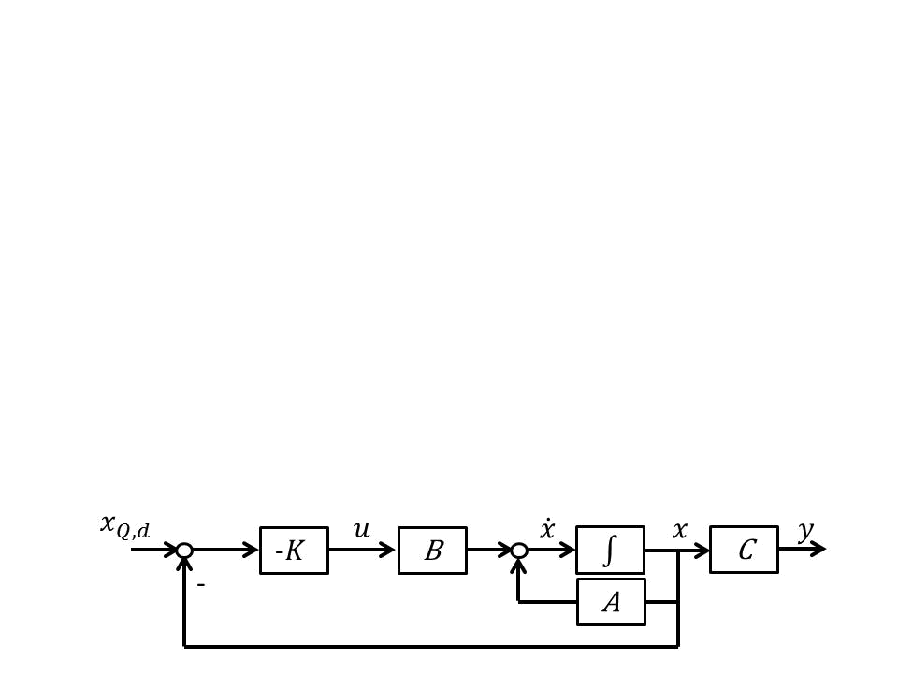
4-3 Setup |  |  |  | 37
 | Gain | Case A | Case B | Case C
 | k_{R} | 0.981 | 0.981 | 0.981
 | k | 0.1 | 0.45 | 0.45
 | k_{q} | 10 | 10 | 10
 | k! | 7.5 | 7.5 | 7.5
 | ^{k}x | 10 | 10 | 10
 | k_{v} | 3 | 3 | 3

Table 4-4: Controller Gains Nonlinear Geometric Controller

Figure 4-5: LQR control design

LQR control is based on a small angle assumption. Therefore, following a traditional modeling method, the rotation matrix is represented with a local coordinate system, for example with an Euler Angle parameterization. A continuous time linearized model of the system used in this controller is represented in the following form

 |  |  |  |  |  |  |  | x = Ax + Bu |  |  |  |  |  |  |  |  |  |  |  | (4-4)
 |  |  |  |  |  |  |  | y = Cx + Du |  |  |  |  |  |  |  |  |  |  |  | (4-5)
where x is the state vector and u is the input vector, de ned as follows
x = | x y z |  |  |  |  |  |  |  |  |  |  |  | _ _ | _ _ _ |  |  |  |  | T | (4-6)
x = |  |  |  |  |  |  |  |  |  |  |  | x y z |  |  |  |  |  |  |  | (4-6)
u = | f M |  | M |  | M |  | T |  | L |  | L |  |  |  | L |  | L |  |  | (4-7)

Using Matlab command lqr(A,B,Q,R), an optimal gain matrix K is calculated, such that the state-feedback law u = K(x x_{ref} ) [26] minimizes the quadratic cost function. Where the cost function is de ned as

Z 1
J(u) =(x^{T} Qx + u^{T} Ru)dt | (4-8)
0

The weight matrices Q and R de ne the e ects of the states and inputs in the cost func-tion, and the gain matrix K can be calculated. The derivation of the state space matrices A; B; C; D, the weight matrices Q; R and the calculated gain matrix K can be found in Section A-3.

M.Sc. Thesis N.N. Vo

38 Experiment

4-4 Results

In this section the results of the experiments are discussed, for each case separately. The load tracking performance for the Nonlinear Geometric Controller is discussed by analyzing the desired and actual load trajectories, together with the corresponding load position and velocity errors.

The stability of the closed-loop system is investigated by observing whether the controller is able to bring the system to a stationary nal state. The error dynamics are analyzed through the error functions, as described in Chapter 3. The con guration errors _{R}; _{q} and the corresponding tracking errors of the QR attitude e_{R}; e , load attitude e_{q}; e_{q} are presented.

Finally, the load position tracking results of the Nonlinear Geometric Controller and a LQR Controller are compared.

Case A

In this case, the desired trajectory was shaped like a smooth step-like function to investigate the response of the system to a sudden input. The desired and actual load trajectory are shown in Figure 4-6a. The corresponding load position and velocity error are shown in Figure 4-6b.

Since this function is di erent from a normal step function, it might be less meaningful to say something about the rise time. Normally one checks the time it takes to reach 90% of the step height. In this case, the step is a smooth function, meaning that the system is not forced to the step height instantly, but in a smooth manner. However, it can be seen in Figure 4-8c that the required time such that 90% of the desired value is reached for the rst time is 0:38s. It can be observed that the system responds with approximately 10% overshoot in the y-direction, and loses height during this maneuver. This was to be expected due to large QR rotations. The error remains within a 5% error bound after 2:83s, to eventually reach a steady-state at the step size of 0:25m.
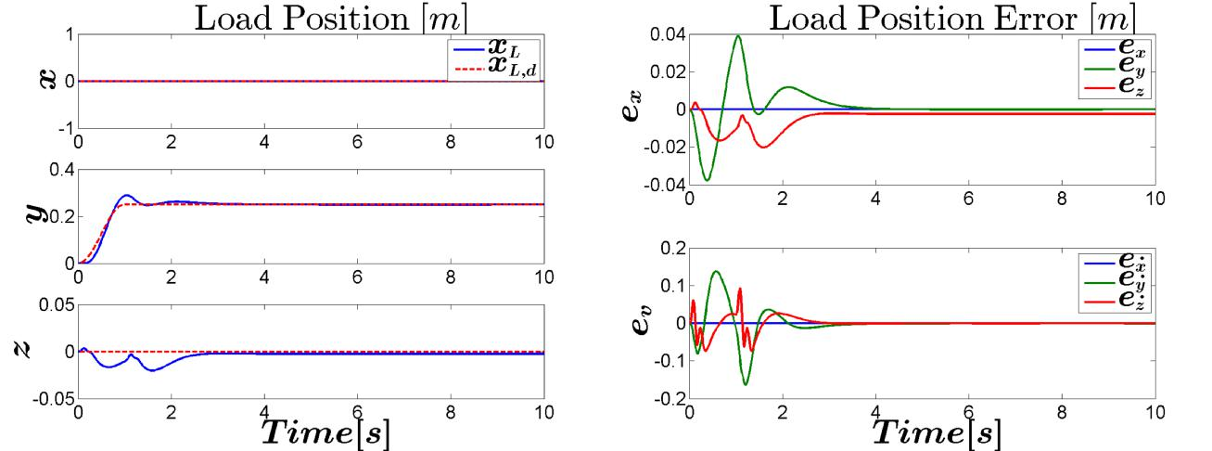

(a) (b)

Figure 4-6: Load Position Tracking Nonlinear Geometric Control Case A

N.N. Vo M.Sc. Thesis

4-4 Results | 39

Tuning of the controller is be done by checking the responses of the error functions. Too high gains for the QR attitude controller will create aggressive responses to errors. This will require large and fast rotations, which results in overshoot and destabilization of the closed-loop system. Too small gains however will result in slow responses, and small rotations, creating large errors in the load position.

Figure 4-7a and 4-7b show the tracking errors of the QR attitude and load attitude, respec-tively. The error in QR attitude and angular velocity are large at the moments the slope starts and ends, indicating that a large sudden QR rotation with high angular velocity is required to respond to the sudden input. Nevertheless, the gures indicate that the errors in both QR and load attitude are driven to zero. Furthermore, Figure 4-7c and 4-7d show that the tracking error functions of the QR and load, respectively, are also driven to zero. From this can be concluded that (e_{x}; e_{v}; e_{q}; e_{q}; e_{R}; e ) = (0; 0; 0; 0; 0; 0) is exponentially stable.
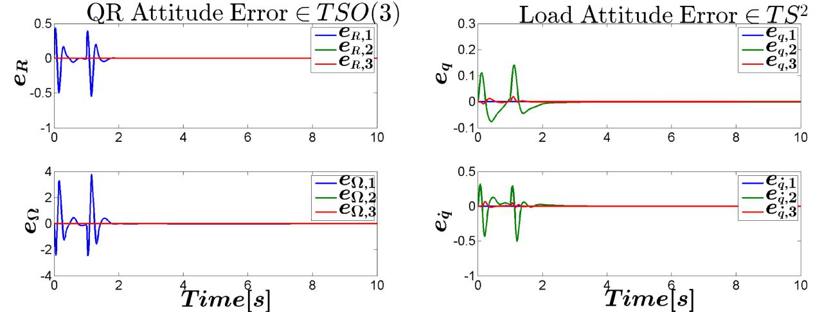

(a) (b)
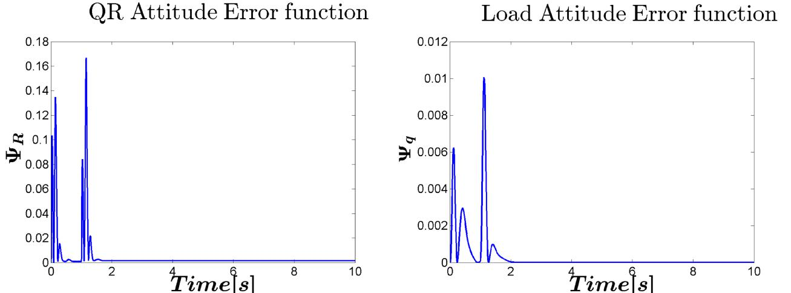

(c) (d)

Figure 4-7: Geometric Error functions Nonlinear Geometric Control Case A

For both control approaches, Figure 4-8a shows the load position along the desired load position x_{L;d} and Figure 4-8b shows the corresponding load position error. From this can be observed that the LQR controller has a slower response.

M.Sc. Thesis N.N. Vo

40 Experiment

Figure 4-9a shows the QR attitude with respect to fIg .

In Figure 4-9b the load angle with respect to fIg is shown.

whereas for the LQR, this is reached at
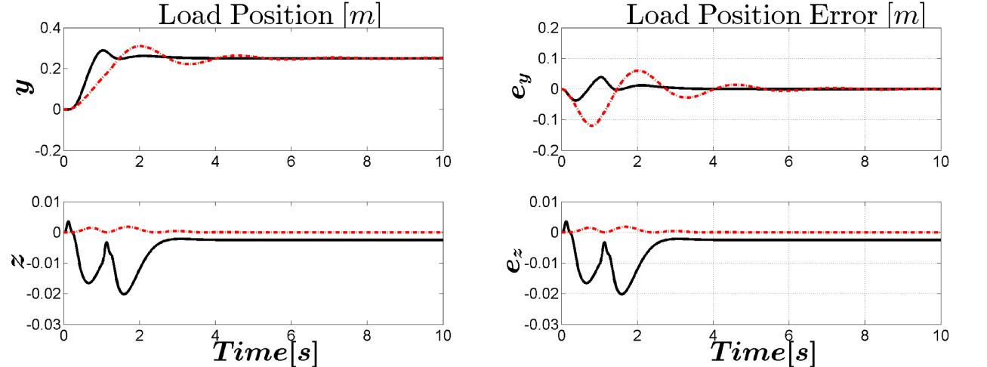

(a) Load position tracking (b) Load Position Error
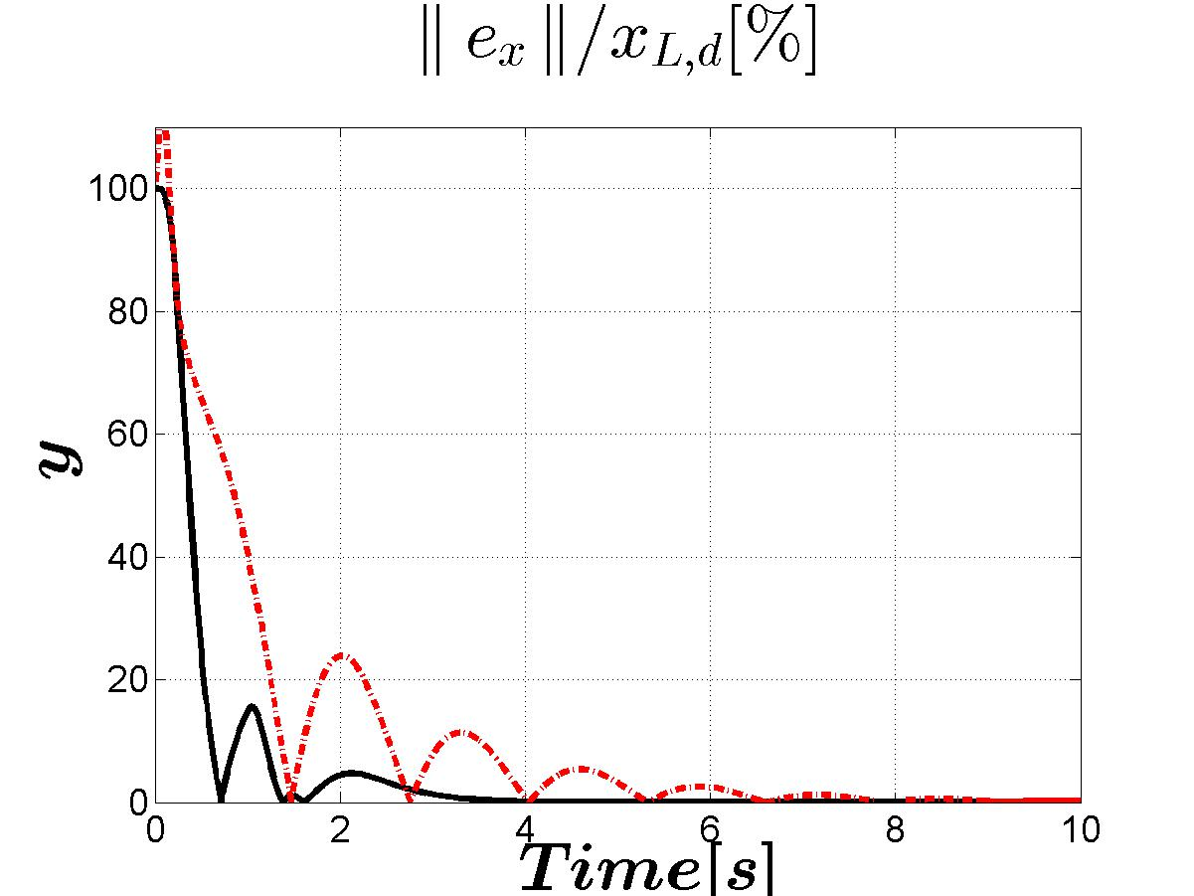

(c) Load Position Error Percentage

Figure 4-8: Controller Comparison Case A. Solid: NGC, Dash-dot: LQR

N.N. Vo M.Sc. Thesis

4-4 Results | 41
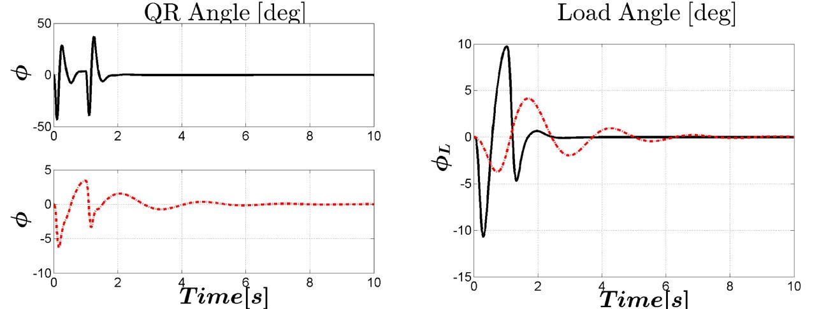

(a) QR Attitude (b) Load Attitude

Figure 4-9: Controller Comparison Case A. Solid: NGC, Dash-dot: LQR

M.Sc. Thesis N.N. Vo

42 Experiment

Case B

Figure 4-12a shows the load position along the desired load position x_{L;d} of both controllers.
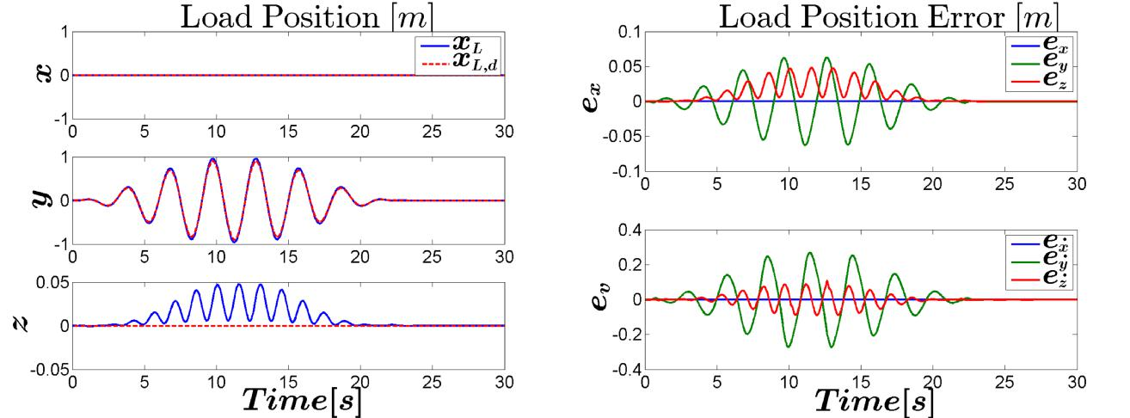

(a) (b)

Figure 4-10: Load Position Tracking Nonlinear Geometric Control Case B

Figure 4-12a shows the load position along the desired load position x_{L;d} for both control approaches.

Figure 4-12b shows the load position error for both control approaches.

N.N. Vo M.Sc. Thesis

4-4 Results | 43
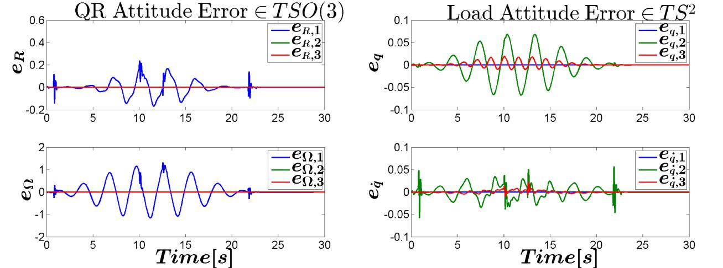

(a) (b)
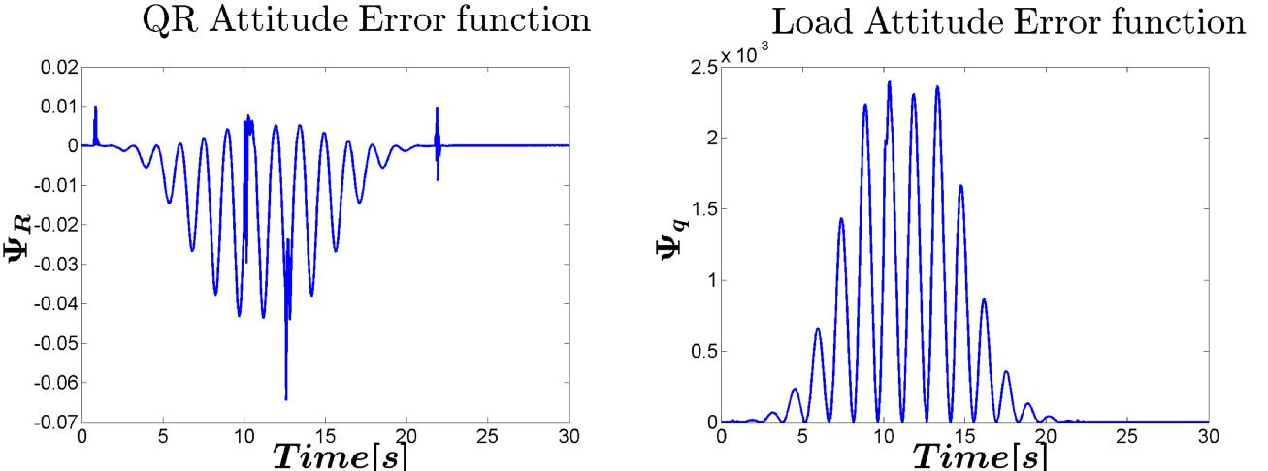

(c) (d)

Figure 4-11: Geometric Error functions Nonlinear Geometric Control Case B

M.Sc. Thesis N.N. Vo

44 Experiment
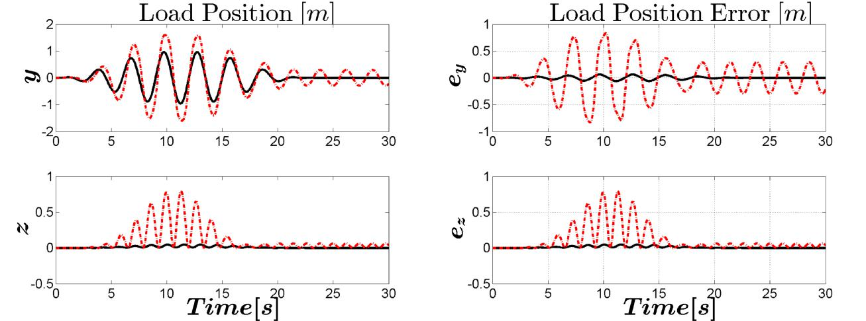

(a) Load position tracking (b) Load Position Error
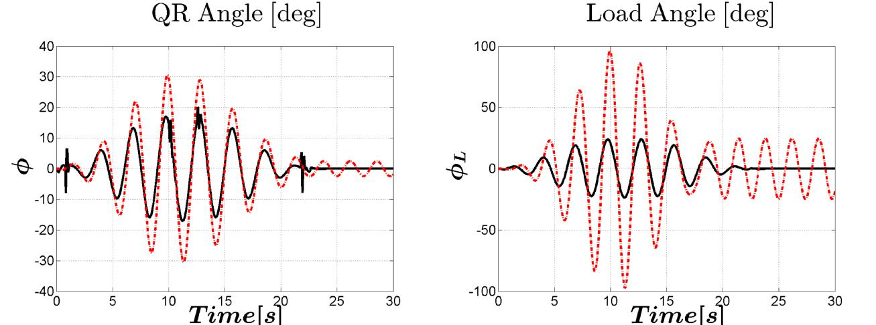

(c) QR Attitude (d) Load Attitude

Figure 4-12: Controller Comparison Case B. Solid: NGC, Dash-dot: LQR

N.N. Vo M.Sc. Thesis

4-4 Results | 45

Case C

Figure 4-13a shows the desired load position, and Figure 4-13b shows that the error is domi-nated by the overshoot in the x-direction, due to the fast desired swinging motion.

While tracking the required QR attitude, which tilts the QR to reach the desired velocities in the right direction, it can be seen that the system has di culties to also maintain the desired height, which can be explained by the fact that the total force will not point upwards if the QR is tilted. Despite the fact that the QR is moving from side to side, the upward force is still controlled to track the desired height.
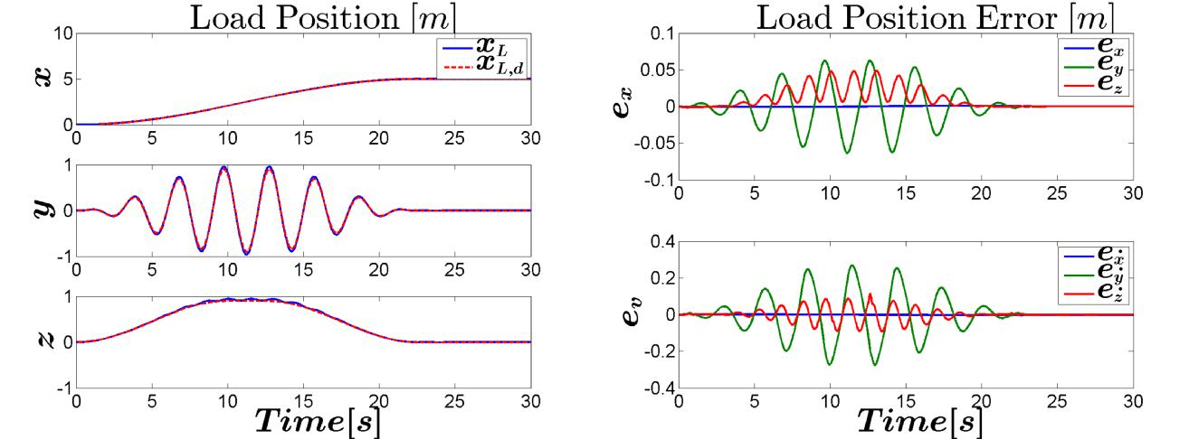

(a) (b)

Figure 4-13: Load Position Tracking Nonlinear Geometric Control Case C

Figure 4-14a and 4-14b show the tracking errors of the QR attitude and load attitude, re-spectively.
Observations: (e_{x}; e_{v}; e_{q}; e_{q}; e_{R}; e ) = (0; 0; 0; 0; 0; 0) is exponentially stable. Figure 4-14c and

4-14d show the tracking error functions of the QR and load, respectively.
Observations: there exist constants _{q}; _{q} > 0 such that

n o
_{q}(q(t); q_{d}(t)) min 2; _{q}e ^{qt}

Figure 4-15a shows the load position along the desired load position x_{L;d} approaches.

Figure 4-15b shows the load position error for both control approaches. FOR LQR!

(4-9)

for both control

OTHER GAINS

Very small penalty on load angle results in swinging load; decreasing load position error, but very bad anti-swing. Observations: fact that LQR can not control load position is obvious.

Figure 4-15c shows the QR attitude with respect to fIg .

In Figure 4-15d the load angle with respect to fBg is shown.
Observations: Load angles are huge, check results

M.Sc. Thesis N.N. Vo

46 Experiment
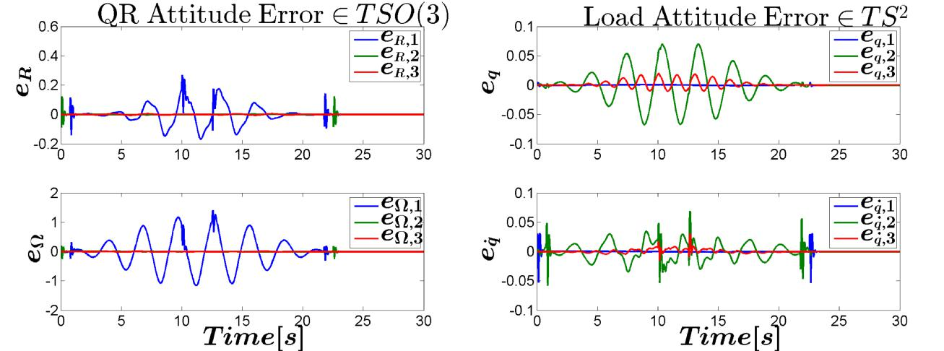

(a) (b)
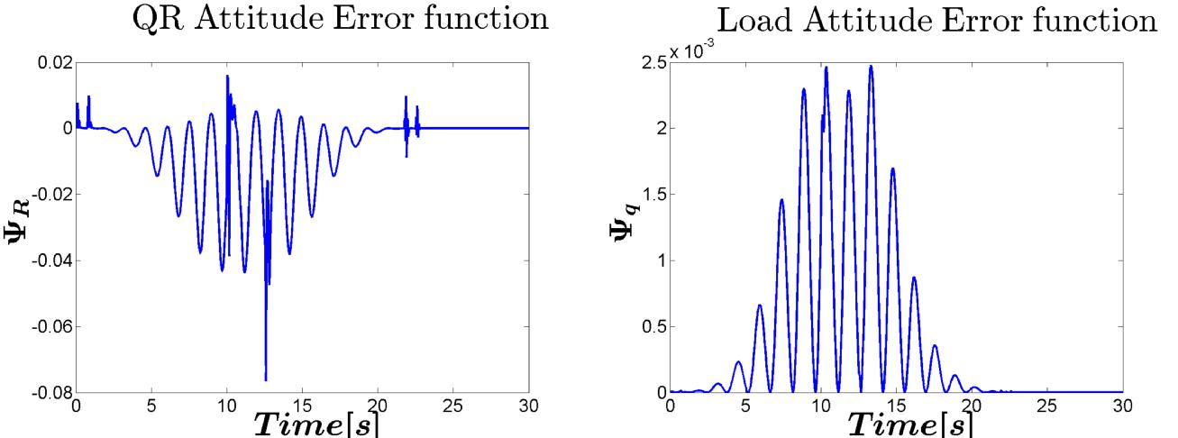

(c) (d)

Figure 4-14: Geometric Error functions Nonlinear Geometric Control Case C

N.N. Vo M.Sc. Thesis

4-4 Results | 47
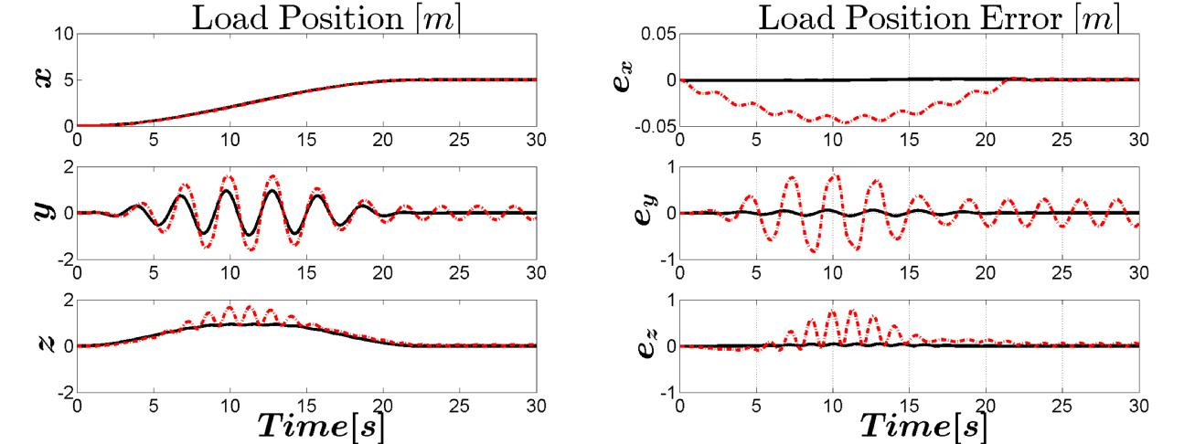

(a) Load position tracking (b) Load Position Error
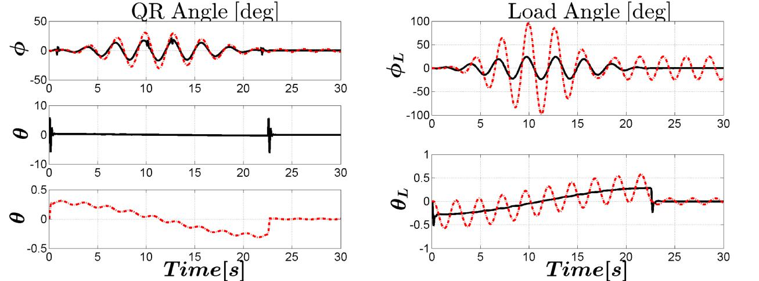

(c) QR Attitude (d) Load Attitude

Figure 4-15: Controller Comparison Case C. Solid: NGC, Dash-dot: LQR

M.Sc. Thesis N.N. Vo

48 Experiment

4-5 Conclusion

The Nonlinear Geometric Controller was tested for its ability to track various load trajectories.

The control design is capable of stabilizing the system and enables tracking of a load trajectory.

of tracking various load position tracking

High gains in the QR attitude controller forces the QR to large and fast rotations.

Near the equilibrium con guration, the LQR controller is able to reduce the swing fast and accurate, as can be seen in the results of case A. However, the shortcomings of the LQR controller become evident when it is commanded to track fast trajectories. Following these trajectories continuously requires fast changing movements, far away from the equilibrium con guration. The controller is not able to cope with the fast changing dynamics, resulting in overshoots and slow responses, lagging behind the desired trajectory.

The controllers are functions of the computed tracking references q_{c}; R_{c} and their derivatives. These terms are approximated by a command lter, which means that the accuracy decreases because high frequency terms are ltered.

N.N. Vo M.Sc. Thesis

Chapter 5

Conclusions and Future Work

Geometric Mechanics creates a new perspective

5-1 Summary and Conclusions

The report aims to create and test a new method to track and control a quadrotor with a cable suspended load. To do this, a nonlinear gemotric controller is designed and compared to the proven concept of a LQR.

To be able to provide a stable solution, a new geometric model needs to be created. To create this model, the concepts of Geometric Mechanics are introduced. Di erential Geometry is a mathematical discipline that is used to study geometric problems. Instead of employing Euclidean spaces that are de ned by Cartesian coordinates, the con guration space of the system is described on nonlinear manifolds. The nonlinear manifolds allow for configuration spaces without singularities. With the tools of di erential geometry, di erential calculus and integral calculus, a globally de ned model is obtained that can be used to implement a nonlinear geomtric controller.

Based on the geometric model, a nonlinear geometric control design is discussed. A back-stepping approach allows di erent DOFs of the under-actuated system to be controlled in a cascaded structure. The controllers are driven by error functions, which are de ned on the geometric spaces through matrix operations that arise from linear algebra.

The geometric control is based on are functions of error functions de ned on nonlinear man-ifolds. by Di erential Geometry.

Next, the experiment is de ned. The nonlinear controller is used to track desired load tra-jectories in di erent situations. The nonlinear performance is compared to an LQR control Testing the Nonlinear Geometric Controller To compare with a common linear controller, LQR control is used to compare

Results are,

This research The conclusions that can be extracted from the experiments is that

The nonlinear geometric controller depends on feed forward terms that are obtained from the desired trajectories. Trajectory generation approaches exist that are able to generate the

M.Sc. Thesis N.N. Vo

50 Conclusions and Future Work

required desired position, velocity and acceleration by however it is possible to compute these with trajectory generating algorithms too.

5-2 Recommendations for Future Work

5-2-1 Investigate Implementation

Digital Control The concept of Geometric Control is shown under the assumption of continuous-time control. However, an analysis must be done in the discrete-time domain for the implementation of a real-time application. This must verify whether it is feasible to run the controller on an on-board processor on a QR. The control performance could be lim-ited by the bandwidth of either the discretized control system or the wireless communication. It must be investigated whether the control system is still able to deal with the fast dynam-ics that are required for aggressive maneuvering. Continuous-time Euler-Lagrange equations could be found by minimizing the action integral, which is a function of the Lagrangian. In a similar procedure the discrete-time Euler-Lagrange can be obtained, by minimizing te summation of a discrete Lagrangian, which is demonstrated in [4].

Model identi cation and validation In this thesis the model parameters are either obtained from examples in literature or arbitrarily chosen. In practice, identi cation and validation of the QR model and rotor dynamics is required. The mathematical model requires inclusion of the masses, inertia matrix and lengths of the QR, as well as the drag and thrust constants of the rotors, that are very unlikely to be identical.

As a theoretical extension the in uence of model mismatches could be simulated.

Robustness The control in this thesis assumes perfect state feedback. In practice the con-troller depends on visual feedback or data obtained from an on-board inertial measurement unit. Unlike in simulations, this data will contain noise, uncertainties and possibly drift. Based on a nonlinear geometric approach for a QR without load, [6] includes uncertainties in the translational dynamics and rotational dynamics to prove the robustness against unstruc-tured uncertainties. This work could be extended to a QR-Load system to investigate the e ects of non-perfect state feedback.

Due to uncertainties In what way would parameter choice in the controllers a ect robustness? To test the controller for

How to estimate states?

Parameter Estimation can be done by

State Estimation can be done by

Drawback: assumes all states to be known

Model based. What if analytical model is not accurate?

What parameters must be

N.N. Vo M.Sc. Thesis

5-2 Recommendations for Future Work | 51

5-2-2 Minimum Snap Trajectory Generation

The trajectories described in Section ?? were arbitrarily generated by hand to test the per-formance of the controller in di erent situations. Whenever more complex trajectories are desired, or when an optimal trajectory is required, this approach is no longer e cient and too complex to solve by hand. A recommended extension to this thesis is the automatic genera-tion of a trajectory. This approach is presented by [27] and applied in [9, 28]. A QP problem is solved by minimizing the second derivative of the acceleration (snap), which guarantees a smooth optimal trajectory. The QP allows inclusion of constraints, such as maximum inputs and checkpoints in trajectories, by formulating these as constraints of the QP problem. Fur-thermore, it is proven that the system is di erential at, meaning that all states and inputs can be expressed in terms of only four states and their derivatives. This property is used to transform the high-dimensional optimization problem into a four-dimensional problem.

5-2-3 Hybrid System

This thesis is only focused on the subsystem where the tension in the cable is non-zero. A possible extension is to apply hybrid control, such that the controller is able to switch between two subsystem models whenever the cable tension switches between zero and non-zero. A trajectory generation method that accounts for the switching dynamics of the hybrid system is presented in [9]. In [1, 9, 28] both subsystems are expressed in the form of one hybrid model.

M.Sc. Thesis N.N. Vo

52 Conclusions and Future Work

N.N. Vo M.Sc. Thesis

Let x_{CM}

Appendix A

Appendix

A-1 Derivation of Equations of motion

A-1-1 Load Dynamics

denote the position of the center of mass of the combined Quadrotor-Load system, expressed in fIg . Which can be found by
m_{Q}(x_{Q} x_{CM} ) + m_{L}(x_{L} x_{CM} ) = 0
(A-1)
(m_{Q} + m_{L})x_{CM} = m_{Q}x_{Q} + m_{L}x_{L}

Applying Newton's laws of motion to (A-1) and inserting (2-14) gives the

(m_{Q} + m_{L})•x_{CM} = f Re₃ (m_{Q} + m_{L})ge₃
(A-2)
(m_{Q} + m_{L})(•x_{L} + ge₃) = f Re₃ + m_{Q}Lq•

Here comes the derivation of q•, obtained by geometric mechanics.

A-2 Derivation Error dynamics

A-2-1 Quadrotor Attitude

From the angular velocity tracking error e follows

e =R^{T} R_{d d};
 | ^ |  |  |  | T | ^ | T | R
e^ =R |  |  |  |  |  | ^{R}d d^{R}d |  | R
The attitude tracking error is given by
e_{R} = | 1 |  |  | (R_{d}^{T} R |  | R^{T} R_{d})_
e_{R} = | 2

(A-3)

(A-4)

M.Sc. Thesis N.N. Vo

54 Appendix

where its time derivative is given by

e_{R} = | 1 | (R__{d}^{T} R + R_{d}^{T} R_ R^{_T} R_{d} R^{T} R__{d})_
e_{R} = | 2 | (R__{d}^{T} R + R_{d}^{T} R_ R^{_T} R_{d} R^{T} R__{d})_
= | 1 | ((R_{d} ^_{d})^{T} R + R_{d}^{T} (R ^) (R ^)^{T} R_{d} R^{T} (R_{d} ^_{d}))_
= | 2
= | 1 | ( ^_{d}R_{d}^{T} R + R_{d}^{T} R ^ + ^R^{T} R_{d} R^{T} R_{d} ^_{d})_
= | 2
= | 1 | (R_{d}^{T} R(^ R^{T} R_{d} ^_{d}R_{d}^{T} R) + (^ R^{T} R_{d} ^_{d}R_{d}^{T} R)R^{T} R_{d})_
= | 2

which can be rewritten by substituting Equation A-3 as follows e_{R} = ¹₂(R_{d}^{T} Re^ + e^ R^{T} R_{d})_

The time derivative of the angular velocity tracking error e is given by

_ | _ T | R_{d d} R |  |  |  |  | T | _ |  |  |  | T | _
e =R |  |  |  |  |  |  | R_{d d} R |  |  |  |  |  | R_{d d} |  |  |  | _
_ |  | ^ |  |  | T | R_{d d} R |  |  |  | T | ^ |  |  |  |  | T | _
=(R ) |  |  |  |  |  |  |  |  |  |  | (R_{d d}) _{d} R |  |  |  |  |  | R_{d d}
_ | ^ |  | T | R_{d d} R |  |  |  | T |  |  | ^ |  |  | T |  |  | _
= + R |  |  |  |  |  |  |  |  | (R_{d d}) _{d} R |  |  |  |  |  | R_{d d}

^
where _{d} _{d} = _{d} _{d} = 0. Substituting Equation 2-35 results in

¹ ^ ^{T T} _ e = J ( J + M) + R R_{d d} R R_{d d}

(A-5)

(A-6)

(A-7)

(A-8)

A-2-2 Load Attitude

For the load attitude tracking problem on manifold S², the error function E_{cl} is de ned as follows [16, p.]

E_{cl}(v_{q}; w_{r}) = (q; r) + | 1 | k v_{q} T (q; r) w_{r} k_{G}² | (A-9)
E_{cl}(v_{q}; w_{r}) = (q; r) + | 2 | k v_{q} T (q; r) w_{r} k_{G}² | (A-9)

where k k_{G} denotes the norm on tensors, induced by a Riemannian metric. The error function and transport map are de ned for S² as follows

_{S}2 (x; r) = k_{P} (1hhr; xii_{R}3 ) | (A-10)
and
T_{S}2 (x; r) v = (r v) x | (A-11)

where r(t) is the reference trajectory, and x 2 S² and v 2 T_{x}S². Substituting Equations A-10 and A-11 into Equation A-9 results in the following closed-loop energy function

E_{cl}(t; x; v) = k_{P} (1 hhr; xii_{R}3 ) + | 1
E_{cl}(t; x; v) = k_{P} (1 hhr; xii_{R}3 ) + | ₂m k v (r(t) r(t)) x k_{R}²₃ | (A-12)

N.N. Vo M.Sc. Thesis

A-3 LQR controller | 55

A-3 LQR controller

The linearized model is written into a rst order ODE of the form
 |  |  |  |  |  |  | x = Ax + Bu |  |  |  |  |  |  | (A-13)
 |  |  |  |  |  |  | y = Cx + Du |  |  |  |  |  |  | (A-14)
with the following state- and input vectors
x = | x y |  |  |  |  |  | _{T} L L | x y | _ | _ _ | _ | _ |  | T
u = | f M | z | M |  | M |  | _{T} L L |  | z |  | _{L} | _{L} |  | (A-15)

The model is linearized about the hovering ight mode. All translational and rotational velocities are zero during hover. The positional states and the yaw angle do not a ect the dynamics, and are set equal to zero. A thrust input u₁ = g(mQ+mL) is required to maintain hover, and all other control inputs are set equal to zero. The states and inputs in the equations of motion are substituted by an initial condition and a perturbation

x ! x₀ + x; x ! x₀ + x; |  | u ! u₀ + u |  | (A-16)
x(0) | = 0 |  |  | (A-17)
u(0) | = g(m_{Q} + m_{L}) 0 | 0 0 | _{T} | (A-17)

The linearized equations of motion are rearranged in Equation A-18, as done in [29], and substituted back into Equation A-13.

M₁ x• + M₂ x = M₃ u | (A-18)

With I_{L} = m_{L}L² and m_{T} = m_{Q} + m_{L}, the matrices M1; M2; M3 are de ned as follows
 | 2 | 0^{T} | m_{T} |  |  |  | 0 |  | 0 | 0 | 0 |  |  | Lm_{L} |  |  | 0 | L | 3
 |  | m |  | 0 |  |  | 0 |  | 0 | 0 | 0 |  |  | 0 |  | Lm
M = | 6 | 0 |  | 0 |  |  | 0^{T} | Ixx |  | 0 | 0 |  |  | 0 |  |  | 0 |  | 7 | (A-19)
M = | 6 | 0 |  | 0 |  |  | m |  | 0 | 0 | 0 |  |  | 0 |  |  | 0 |  | 7 | (A-19)
1 | 6 | 0 |  | 0 |  |  | 0 |  | 0 | Iyy | 0 |  |  | 0 |  |  | 0 |  | 7
 | 6 |  |  |  |  |  |  |  |  |  |  |  |  |  |  |  |  |  | 7
 | 6 |  |  |  |  |  |  |  |  |  |  |  |  |  |  |  |  |  | 7
 | 6 | 0 |  | 0 |  |  | 0 |  | 0 | 0 | Izz |  |  | 0 |  |  | 0 |  | 7
 | 6 | 0 | m_{L}L 0 |  |  |  |  |  | 0 | 0 | 0 |  |  | 2 | m_{L} |  | 0 |  | 7
 | 6 | 0 |  |  |  |  |  |  | 0 | 0 | 0 | I_{L} + L |  |  | m_{L} |  | 0 |  | 7
 | 6 | m_{L}L 0 |  |  |  |  | 0 |  | 0 | 0 | 0 |  |  | 0 |  |  |  | 2 | 7
 | 6 |  |  |  |  |  | 0 |  | 0 | 0 | 0 |  |  | 0 |  | I_{L} + L m_{L} |  |  | 7
 | 4 |  |  |  | ²0 0 |  |  |  |  |  |  |  |  |  |  |  | 3 |  | 5
 |  |  |  |  |  |  |  | 0 | gm_{T} |  | ₀ | T | 0 | 0 |  | 0 | 3
 |  |  |  |  |  | 0 | 0 | 0 |  | 0 | gm |  | 0 | 0 |  | 0
 |  |  | M = |  | 6 | 0 | 0 | 0 |  | 0 | 0 |  | 0 | 0 |  | 0 | 7 |  |  | (A-20)
 |  |  |  |  | 6 | 0 | 0 | 0 |  | 0 | 0 |  | 0 | 0 |  | 0 | 7 |  |  | (A-20)
 |  |  | 2 |  | 6 | 0 | 0 | 0 |  | 0 | 0 |  | 0 | 0 |  | 0 | 7
 |  |  |  |  | 6 |  |  |  |  |  |  |  |  |  |  |  | 7
 |  |  |  |  | 6 |  |  |  |  |  |  |  |  |  |  |  | 7
 |  |  |  |  | 6 | 0 | 0 | 0 |  | 0 | 0 |  | 0 | 0 |  | 0 | 7
 |  |  |  |  | 6 |  |  |  |  |  |  |  |  |  |  |  | 7
 |  |  |  |  | 6 | 0 | 0 | 0 |  | 0 | 0 |  | 0 | gLm_{L} |  | 0 | 7
 |  |  |  |  | 6 |  |  |  |  |  |  |  |  |  |  |  | 7
 |  |  |  |  | 6 | 0 | 0 | 0 |  | 0 | 0 |  | 0 | 0 |  | gLm_{L} | 7
 |  |  |  |  | 4 |  |  |  |  |  |  |  |  |  |  |  | 5

M.Sc. Thesis N.N. Vo

56 Appendix

²0 0 0 0³
60 0 0 07
- 7
61 0 0 07
- 7
M₃ | = | 6 | 0 | 1 | 0 | 0 | (A-21)
M₃ | = | 6 | 0 | 0 | 1 | 0⁷ | (A-21)
 |  | 6 |  |  |  | 7
 |  | 6 |  |  |  | 7
- 7
60 0 0 17
- 7
4 | 0 | 1 | 0 | 0
4 | 0 | 0 | 1 | ₀5
The tuning parameters of the LQR controller a chosen as follows

- Q =

- =

Matlab command lqr(LQRA,LQRB,Q,R) generates the following gain matrix K

- =

A-4 Classical Modeling

This section describes the derivation of the model by using classical modeling techniques.

When assuming small angle maneuvers, Euler-angles can be used to locally parameterize the orientation of the body- xed reference coordinate frame with respect to the inertial reference coordinate frame. Simple linear controllers are often based on a linearized dynamical model, applying this small angles assumption.

The following equations of motion follow from Newton's law.

x_{Q} = v_{Q}

m_{Q}v_{Q} = f Re₃ m_{Q}ge₃ T q

x_{L} = v_{L}

m_{L}v_{L} = m_{L}ge₃ + T q

(A-22)

where x_{Q} = x_{L} Lq. T is the cable tension, de ned by T = jfjq, where jfj = m_{L}v_{L} is the magnitude of the force.

Because Euler-Angles are used, a function is required that maps a vector of the Z-X-Y Euler angles to its rotation matrix R 2 SO(3), which is denoted as [20]

2
c c s s s
R_{ZXY} ( ; ; ) = 4c s + c s s
c s

c c | s s c c s | 3 | (A-23)
c s | c s + c s s | 5
s | c c | 5

N.N. Vo M.Sc. Thesis

A-5 Figures | 57
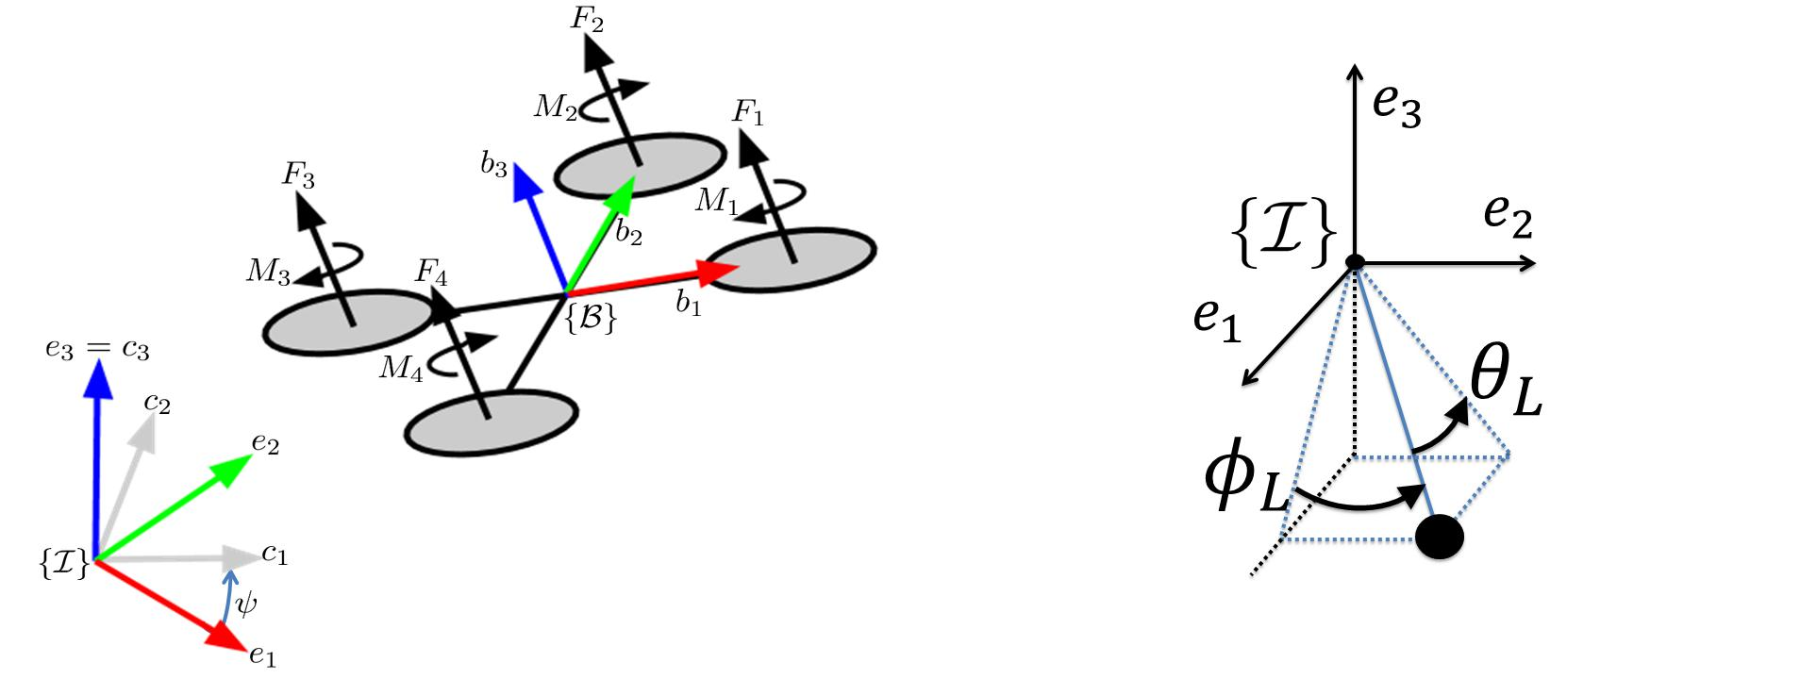

(a) Quadrotor model representation (b) Load angles

Figure A-1: Model representation

The Z-X-Y Euler angles rotate fBg , as can be seen in Figure A-1a. The rst rotation by yaw angle is around the z-axis of fIg . Next is the rotation by roll angle , and the last rotation is by pitch angle .

The unit vector q from the QR to the load is represented in fBg . De ne _{L} as the rotation ~

of the load around the z-axis, measured from b₁, and _{L} is the angle between the cable and the z-axis of fBg , see Figure A-1b. The Cartesian coordinates can be retrieved through
 |  |  |  |  |  | x_{L} = x_{Q} + qL |  |  |  |  | (A-24)
where |  |  |  |  |  | 2 | ^{s} _{L} ^{c} _{L} |  | 3
 |  |  |  |  |  | q = 4s _{L} s _{L} |  |  | 5 |  | (A-25)
 |  |  |  |  |  |  | ^{c} _{L}
Di erentiating Equation A-24 and A-25 gives
x•_{L} = x•_{Q} + qL•
q• = | 2 | • | • |  |  | _2 |  |  | _2 | _ _ | 3
q• = | 2 | •L^{c} _{L} ^{s} _{L} | ^{+ •}L^{s} _{L} ^{c} _{L} |  |  | __{L}²s _{L} s _{L} |  | __{L}²s _{L} s _{L} |  | + 2 __{L} __{L}c _{L} c _{L} | 3
 | 4 | L^{c} _{L} ^{c} _{L} | L^{s} _{L} ^{s} _{L} |  |  | _{L}^{s} _{L} ^{c} _{L} |  |  | _{L}^{s} _{L} ^{c} _{L} | ² L L^{c} _{L} ^{s} _{L} | (A-26)
 | 4 |  |  |  |  | •_{L}s _{L} + __{L}²c _{L} |  |  |  |  | 5
 |  |  | x•_{Q} = | 1 | (f(c s + c s s ) Ts _{L} c _{L} )
 |  |  | x•_{Q} = | m_{Q}
 |  |  | y•_{Q} = | 1 | (f(s s c c s ) Ts _{L} s _{L} ) |  |  |  |  |  | (A-27)
 |  |  | y•_{Q} = | m_{Q} |  |  |  |  |  |  | (A-27)
 |  |  | z•_{Q} = | 1 | (f(c c ) Tc _{L} ) g
 |  |  | z•_{Q} = | m_{Q}

A-5 Figures

M.Sc. Thesis N.N. Vo

58 Appendix


Figure A-2: Simulink Command Filter

N.N. Vo M.Sc. Thesis

Bibliography

- K. Sreenath, Taeyoung Lee, and V. Kumar, \Geometric control and di erential atness of a quadrotor UAV with a cable-suspended load," in 52nd IEEE Conference on Decision and Control, pp. 2269{2274, IEEE, dec 2013.

- R. P. K. Jain and T. Keviczky, \MSc Thesis: Transportation of Cable Suspended Load

using Unmanned Aerial Vehicles: A Real-time Model Predictive Control approach," 2015.

- S. Sadr, S. Ali, A. Moosavian, and P. Zarafshan, \Dynamics Modeling and Control of a Quadrotor with Swing Load," Journal of Robotics, Hindawi Publishing Corporation, vol. 2014.

- T. Lee, Computational Geometric Mechanics and Control of Rigid Bodies. PhD thesis, The University of Michigan, 2008.

- T. Lee, M. Leok, and N. H. Mcclamroch, \Geometric Tracking Control of a Quadrotor UAV on SE(3)," 49th IEEE Conference on Decision and Control, no. 3, pp. 5420{5425, 2010.

- F. Goodarzi, D. Lee, and T. Lee, \Geometric nonlinear PID control of a quadrotor UAV on SE (3)," Control Conference (ECC), 2013 European, pp. 3845{3850, 2013.

- K. Sreenath, N. Michael, and V. Kumar, \Trajectory generation and control of a quadro-tor with a cable-suspended load - A di erentially- at hybrid system," in Proceedings - IEEE International Conference on Robotics and Automation, pp. 4888{4895, 2013.

- K. Sreenath, T. Lee, and V. Kumar, \Geometric control and di erential atness of a quadrotor UAV with a cable-suspended load," in Proceedings of the IEEE Conference on Decision and Control, pp. 2269{2274, 2013.

- S. Tang, \Aggressive Maneuvering of a Quadrotor with a Cable-Suspended Payload," tech. rep., University of Pennsylvania Philadelphia, Pennsylvania, 2014.

- N. Chaturvedi, A. Sanyal, and N. McClamroch, \Rigid-Body Attitude Control," IEEE Control Systems, vol. 31, no. 3, pp. 30{51, 2011.

M.Sc. Thesis N.N. Vo

60 Bibliography

- R. M. Murray, Z. Li, and S. S. Sastry, A Mathematical Introduction to Robotic Manipu-lation, vol. 29. 1994.

- T. L. T. Lee, N. McClamroch, and M. Leok, \A lie group variational integrator for the attitude dynamics of a rigid body with applications to the 3D pendulum," Proceedings of 2005 IEEE Conference on Control Applications, 2005. CCA 2005., pp. 962{967, 2005.

- T. Lee, M. Leok, and N. H. McClamroch, \Lagrangian mechanics and variational inte-grators on two-spheres," International Journal for Numerical Methods in Engineering, vol. 79, no. 9, pp. 1147{1174, 2009.

- T. Lee, M. Leok, and N. H. McClamroch, \Stable Manifolds of Saddle Points for Pendu-lum Dynamics on S^2 and SO(3)," p. 9, 2011.

- T. Lee, M. Leok, and N. H. McClamroch, \Lie group variational integrators for the full body problem in orbital mechanics," Celestial Mechanics and Dynamical Astronomy, vol. 98, no. 2, pp. 121{144, 2007.

- F. Bullo and A. D. Lewis, Geometric control of mechanical systems: modeling, analysis, and design for simple mechanical control systems. Springer, 2005.

- J. H. Gillula, H. Huang, M. P. Vitus, and C. J. Tomlin, \Design of guaranteed safe ma-neuvers using reachable sets: Autonomous quadrotor aerobatics in theory and practice," in Proceedings - IEEE International Conference on Robotics and Automation, pp. 1649{ 1654, 2010.

- N. A. Chaturvedi, T. Lee, M. Leok, and N. H. McClamroch, \Nonlinear dynamics of the 3D pendulum," Journal of Nonlinear Science, vol. 21, no. 1, pp. 3{32, 2011.

- T. Lee, M. Leok, and N. McClamroch, \Control of complex maneuvers for a quadrotor UAV using geometric methods on SE (3)," arXiv, 2010.

- R. Mahony, V. Kumar, and P. Corke, \Multirotor Aerial Vehicles: Modeling, Estimation, and Control of Quadrotor," IEEE Robotics & Automation Magazine, vol. 19, no. 3, pp. 20{32, 2012.

- I. Kanellakopoulos, P. V. Kokotovic, and A. S. Morse, \Systematic Design of Adap-tive Controllers for Feedback Linearizable Systems," IEEE Transactions on Automatic Control, vol. 36, no. 11, pp. 1241{1253, 1991.

- U. A. V. Cornelis and M. Vlaar, \Incremental Nonlinear Dynamic Inversion ight con-trol," no. November, 2014.

- J. A. Farrell, M. Polycarpou, M. Sharma, and W. Dong, \Command Filtered Backstep-ping," pp. 1923{1928, 2008.

- J. Farrell, M. Polycarpou, and M. Sharma, \Backstepping-Based Flight Control with Adaptive Function Approximation," Journal of Guidance, Control, and Dynamics, vol. 28, no. 6, pp. 1089{1102, 2005.

- B. M. Borra, \Nonlinear UAV Flight Control Using Command Filtered Backstepping," Simulation, no. March, pp. 1{161, 2012.

N.N. Vo M.Sc. Thesis

Bibliography | 61

- E. Reyes-Valeria, R. Enriquez-Caldera, S. Camacho-Lara, and J. Guichard, \LQR con-trol for a quadrotor using unit quaternions: Modeling and simulation BT - Electron-ics, Communications and Computing (CONIELECOMP), 2013 International Conference on," pp. 172{178, 2013.

- D. Mellinger and V. Kumar, \Minimum snap trajectory generation and control for quadrotors," in Proceedings - IEEE International Conference on Robotics and Automa-tion, pp. 2520{2525, 2011.

- S. Tang and V. Kumar, \Mixed Integer Quadratic Program Trajectory Generation for a Quadrotor with a Cable-Suspended Payload," IEEE International Conference on Robotics and Automation (ICRA), pp. 2216{2222, 2015.

- J. D. A. Becker, Modeling and Control of a Quadrotor with Dynamic Inertia. PhD thesis, 2013.

M.Sc. Thesis N.N. Vo

62 Bibliography

N.N. Vo M.Sc. Thesis

Nomenclature

 | Tuning parameter to enable rapid exponential convergence of e_{R}; e
_{M} ( ) | Maximum eigenvalue

!_{i} Angular speed of rotor i

fb₁; b₂; b₃g Unit vectors along the axes of fBg

fe₁; e₂; e₃g Unit vectors along the axes of fIg

fBg Body Frame

fIg Inertial World Frame

- Thrust factor

- Drag factor

- Total thrust in direction of b₃, expressed in fBg . f =

F_{i} Force generated by rotor i

- Gravitation constant

J 2 R³ ³ Inertia tensor of QR

- Length of the cable

- Distance from the rotor to the QR CM

- Total moment around axes of fBg , expressed in fBg .

M_{i} Drag moment generated by each propellor

q 2 S² Unit vector from QR to Load

x_{L} 2 R³ Position of the load

^{P}4
_{i=1} ^{F}i

M = M M M ^{T}

M.Sc. Thesis N.N. Vo

64 | Bibliography
x_{Q} 2 R³ | Position of the QR CM
^{x}CM | Position CM of QR-Load system

N.N. Vo M.Sc. Thesis

Acronyms

QR Quadrotor

UAV Unmanned Aerial Vehicle

CM Center of Mass

DOF Degree of Freedom

PID Proportional-Integral-Derivative (Controller)

LQR Linear Quadratic Regulator

MPC Model Predictive Control

NGC Nonlinear Geometric Control

QP Quadratic Programming

M.Sc. Thesis N.N. Vo

