WEEK 4
Advanced Chart Techniques
and Calculation Insights
Tableau Technical Analysis Project
Project detail | Information
Dataset | HR Employee Attrition
Tool | Tableau Public
Focus | Advanced charts, calculated fields and table calculations
Stage | Week 4 of Tableau Internship
A professional technical and design guide for Week 4.

1. Executive Summary
Week 4 extends the Tableau project from basic exploratory charts into advanced visualization techniques and calculated analysis. The HR Employee Attrition dataset is used because its employee-level structure supports meaningful analysis of attrition, income, job level, department and job role.
Three advanced techniques form the core of the analysis: a heat map for attrition rate by department and job role, a dual-axis chart comparing average monthly income with attrition rate by job level, and a box-and-whisker plot showing monthly-income distributions by job role. A second calculated field, Income Band, and a Percent of Total table calculation are also documented to demonstrate deeper Tableau functionality.

2. Task Objective
- Apply advanced Tableau visualization techniques beyond standard charts.
- Create and document calculated fields that add meaningful analytical metrics or categories.
- Use a table calculation to express workforce composition as a percentage of total employees.
- Explain the rationale, formula, implementation and analytical impact of each calculation.
- Integrate the advanced views into a coherent, user-centered dashboard strategy.

3. Dataset and Analytical Context
The selected HR Employee Attrition dataset contains 1,470 employee records and 35 fields. Relevant fields for this assignment include Attrition, Department, Job Role, Employee Number, Monthly Income, Job Level, Over Time, Job Satisfaction, Performance Rating and Years at Company.
Field | Purpose | Type
Attrition | Identify employees marked as having left | Categorical
Employee Number | Count employees at employee level | Identifier
Department | Department comparison | Dimension
Job Role | Role comparison and income distribution | Dimension
Monthly Income | Compensation analysis | Measure
Job Level | Seniority comparison | Dimension
Years at Company | Potential tenure analysis | Measure
Over Time | Supporting HR segmentation | Categorical

4. Advanced Visualization Techniques Selected
Technique | Implementation | Analytical value
Heat Map | Department × Job Role; color = Attrition Rate | Highlights high- and low-attrition combinations.
Dual-Axis Chart | Job Level; bars = Avg Income; line = Attrition Rate | Compares two measures with different units.
Box Plot | Job Role × Monthly Income; Employee Number on Detail | Shows median, quartiles, spread and unusual observations.

5. Advanced Visualization 1 — Attrition Heat Map
Chart title: Employee Attrition Rate by Department and Job Role
- Rows → Department
- Columns → Job Role
- Marks → Square
- Color → Attrition Rate
- Label → Attrition Rate
- Format Attrition Rate as Percentage
Calculated field:
SUM(IF [Attrition] = "Yes" THEN 1 ELSE 0 END) / COUNT([Employee Number])
Impact: This converts the binary Attrition field into a comparable rate. A rate is more informative than a simple attrition count when workforce sizes differ between departments or roles.

6. Advanced Visualization 2 — Dual-Axis Income vs Attrition
Chart title: Income vs Attrition by Job Level
- Columns → Job Level
- Rows → AVG(Monthly Income) and Attrition Rate
- Dual Axis → enabled
- AVG(Monthly Income) → Bar
- Attrition Rate → Line
- Attrition Rate labels → percentage
- Keep the axes separate because income and attrition use different units
This visualization allows the user to compare compensation progression with attrition across Job Levels. It supports descriptive comparison and should not be interpreted as evidence that income causes or prevents attrition.

7. Advanced Visualization 3 — Income Distribution Box Plot
Chart title: Income Distribution by Job Role
- Columns → Job Role
- Rows → Monthly Income
- Employee Number → Detail
- Analytics pane → Box Plot
- Retain individual observations so spread and unusual values remain visible
Analytical value: Averages can hide dispersion. The box plot makes the median, middle 50% of observations, broader range and potential unusual observations visible across job roles.

8. Calculated Field — Income Band
Income Band converts the continuous Monthly Income field into three project-defined analytical categories.
IF [Monthly Income] < 3000 THEN "Low Income"
ELSEIF [Monthly Income] < 7000 THEN "Medium Income"
ELSE "High Income"
END
- Creates an interpretable categorical dimension from a numerical field.
- Can be used in filters, bars, heat maps and workforce segmentation.
- Supports the Percent of Total table calculation.
- The thresholds are analytical bands for this project, not official HR salary grades.

9. Table Calculation — Percent of Total Employees
The Income Band distribution chart uses Employee Number as a count and applies Tableau's Quick Table Calculation → Percent of Total. This expresses each income band's share of the total employee population.
- Columns → Income Band
- Rows → CNT(Employee Number)
- Quick Table Calculation → Percent of Total
- Marks → Bar
- Label → Show Mark Labels
- Format → Percentage with one decimal place
Analytical impact: Percentages communicate workforce composition more clearly than raw counts when the objective is to compare the relative share of each group.

10. Calculation Framework
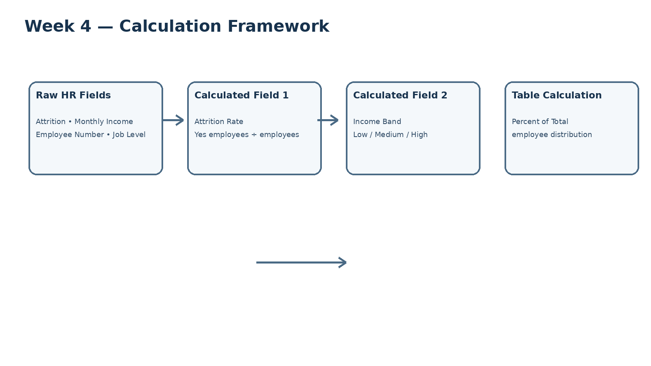
Figure 1. Flow from raw HR fields to calculated metrics and the table calculation.

11. Dashboard Integration Strategy
The advanced views are designed as a connected analytical sequence rather than isolated charts.
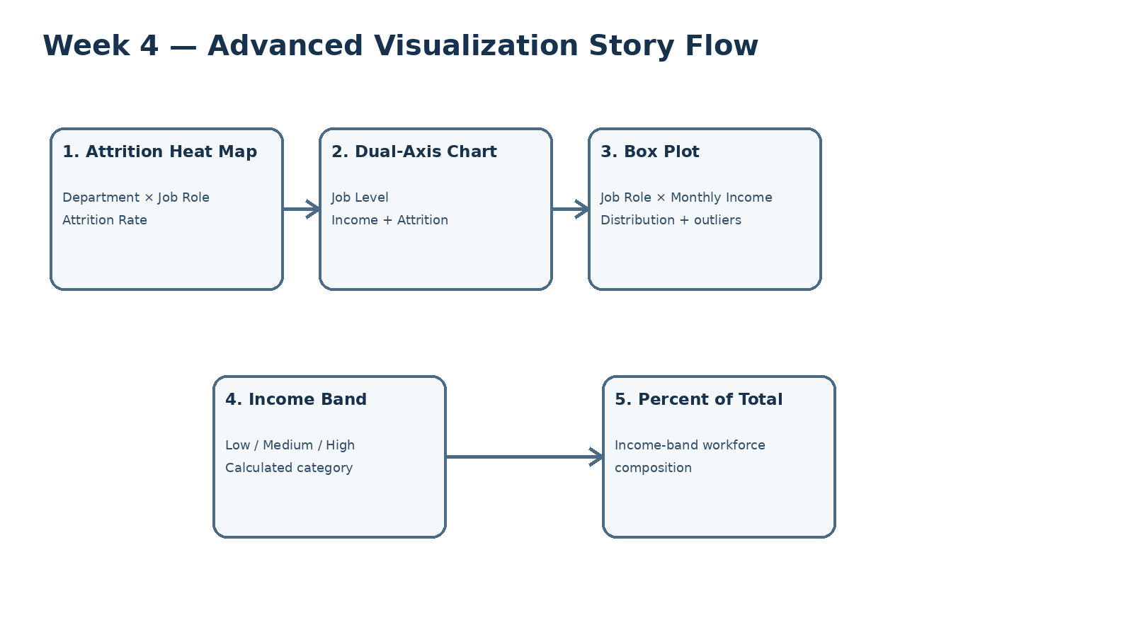
Figure 2. Proposed advanced visualization sequence.
- Start with the heat map to identify where attrition is concentrated.
- Move to the dual-axis view to compare income and attrition by job level.
- Use the box plot to investigate income distribution by job role.
- Use Income Band to segment employees into interpretable groups.
- Use Percent of Total to quantify the workforce composition of those groups.

12. Interaction and User-Centered Design
- Department filter for focused organizational analysis.
- Job Role filter for role-specific investigation.
- Job Level selection for focused compensation/attrition comparison.
- Tooltips showing employee count, attrition rate and average income where relevant.
- Highlight actions so selections in one view emphasize the same category in related views.
- Progressive disclosure so summary patterns are visible first and deeper details appear through interaction.

13. Tableau Implementation Procedure
- Connect the HR dataset and verify field types.
- Create and validate Attrition Rate.
- Build the Department × Job Role heat map.
- Build the Job Level dual-axis chart with income bars and attrition line.
- Build the Job Role income box plot with Employee Number on Detail.
- Create the Income Band calculated field.
- Build the Income Band chart and apply Percent of Total.
- Format percentages, titles, tooltips and axes consistently.
- Integrate the views into a dashboard without overcrowding.
- Test filters, selections, labels and tooltips before submission.

14. Analytical Interpretation and Limitations
- Attrition Rate is descriptive and does not establish causation.
- Dual-axis charts must clearly label both units and should not imply a shared scale.
- A box-plot outlier is not automatically an error; it is an observation that may warrant investigation.
- Income Band thresholds are project-defined analytical categories.
- Percent of Total depends on the table's addressing and partitioning and should be tested after filters are applied.
- The dataset is an analytical HR dataset and should not be presented as a current workforce report for a specific real organization.

15. Evaluation Criteria Alignment
Criterion | How the project addresses it | Evidence
Innovative advanced charting | Three advanced visualization techniques | Sections 5–7
Correct calculations | Formulas, formatting and rationale documented | Sections 5, 8–9
Thorough documentation | Implementation, design and limitations included | Sections 10–14
Technical depth | Calculated fields, aggregation, detail and table calculations | Sections 5–9
User-centered design | Filters, highlighting, tooltips and progressive disclosure | Section 12

16. Conclusion
Week 4 demonstrates how Tableau can move from basic visualization to more technical analytical storytelling. The heat map reveals attrition patterns across organizational segments, the dual-axis chart compares compensation with attrition, and the box plot reveals the distribution and spread of employee income. The Attrition Rate and Income Band calculated fields convert raw columns into decision-oriented metrics and categories, while Percent of Total demonstrates a table calculation.
Together, the techniques provide both technical depth and user-centered design. The final dashboard should prioritize clarity, consistent formatting and meaningful interaction rather than simply maximizing the number of charts.

17. Final Submission Checklist
- ☐ Heat map completed and formatted as percentage.
- ☐ Dual-axis chart completed with income bars and attrition line.
- ☐ Box plot completed with employee-level detail.
- ☐ Attrition Rate calculated field documented.
- ☐ Income Band calculated field documented.
- ☐ Percent of Total table calculation completed and tested.
- ☐ Dashboard integration and interaction strategy documented.
- ☐ Advanced visualization flow diagram included.
- ☐ Calculation framework diagram included.
- ☐ DOCX reviewed for formatting and consistency before upload.
Appendix A — Additional Week 4 Analysis: Tenure Band
An additional calculated field, Tenure Band, was created to segment Years At Company into four service-length categories. The resulting Attrition Rate by Tenure Band chart adds a direct HR retention perspective to the advanced-analysis work.
Calculated field: Tenure Band
IF [Years At Company] <= 2 THEN "0–2 Years"
ELSEIF [Years At Company] <= 5 THEN "3–5 Years"
ELSEIF [Years At Company] <= 10 THEN "6–10 Years"
ELSE "10+ Years"
END
Chart configuration: Tenure Band on Columns, Attrition Rate on Rows, Bar marks, and percentage labels. The observed rates were 29.82% for 0–2 Years, 13.82% for 3–5 Years, 12.28% for 6–10 Years, and 8.13% for 10+ Years.
Tenure Band | Observed Attrition Rate
0–2 Years | 29.82%
3–5 Years | 13.82%
6–10 Years | 12.28%
10+ Years | 8.13%
Interpretation: the shortest-tenure group shows the highest observed attrition rate in this dataset, while attrition declines across the longer-tenure bands. This is descriptive evidence only and should be investigated alongside factors such as overtime, job role, satisfaction and age before making HR decisions.
Optional Tableau extension — Running Total
A Running Total table calculation can be added to the tenure-band employee-count view as an optional extension. If implemented, Compute Using should be Table (Across), and the final cumulative value should equal the full employee population of 1,470. This extension is not required for the core Week 4 submission.

