Deployment note

Account
- Admin:
  - admin@w.w
  - 12345
- Moderator
  - mod@w.w
  - 12345
- Staff
  - staff@w.w
  - 12345
- Woodworker
  - ww@w.w
  - 12345
- Customer
  - cus@w.w
  - 12345

Third-party configuration
vnp_secretKey: QHRX1ELPYEDJQ2OE8WHORG63N9QZ8ZGQ
vnp_TmnCode: 74B7NM0Y
GHN_Shop_ID: 196376
GHN_Token_API: aad4b91c-f670-11ef-bb13-2a342a4da1fb
Vercel blob storage read write token: vercel_blob_rw_oBb8igIpJjS3UoHo_qXlZPxnWA1gORE71C0BEAiVb4TcBqJ
mail.host: smtp.gmail.com
mail.port: 587
mail.username: namndpse171442@fpt.edu.vn
mail.password: mqmk okcr vxaj kxcy

Database
Deployment platform: Railway
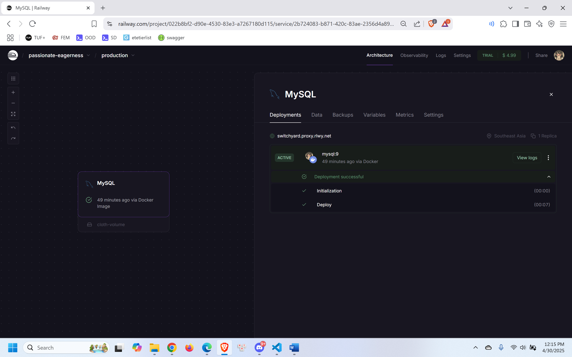
Configuration value:
MYSQL_DATABASE="wdcrbp"
MYSQL_PUBLIC_URL="mysql://${{MYSQLUSER}}:${{MYSQL_ROOT_PASSWORD}}@${{RAILWAY_TCP_PROXY_DOMAIN}}:${{RAILWAY_TCP_PROXY_PORT}}/${{MYSQL_DATABASE}}"
MYSQL_ROOT_PASSWORD="ezBrmFLmiKLYQsgHbWubQGNPmYoTzhBg"
MYSQL_URL="mysql://${{MYSQLUSER}}:${{MYSQL_ROOT_PASSWORD}}@${{RAILWAY_PRIVATE_DOMAIN}}:3306/${{MYSQL_DATABASE}}"
MYSQLDATABASE="${{MYSQL_DATABASE}}"
MYSQLHOST="${{RAILWAY_PRIVATE_DOMAIN}}"
MYSQLPASSWORD="${{MYSQL_ROOT_PASSWORD}}"
MYSQLPORT="3306"
MYSQLUSER="root"

Backend
Link: https://sp25se026gsp48wdcrbpapi-production.up.railway.app/
Deployment platform: Railway
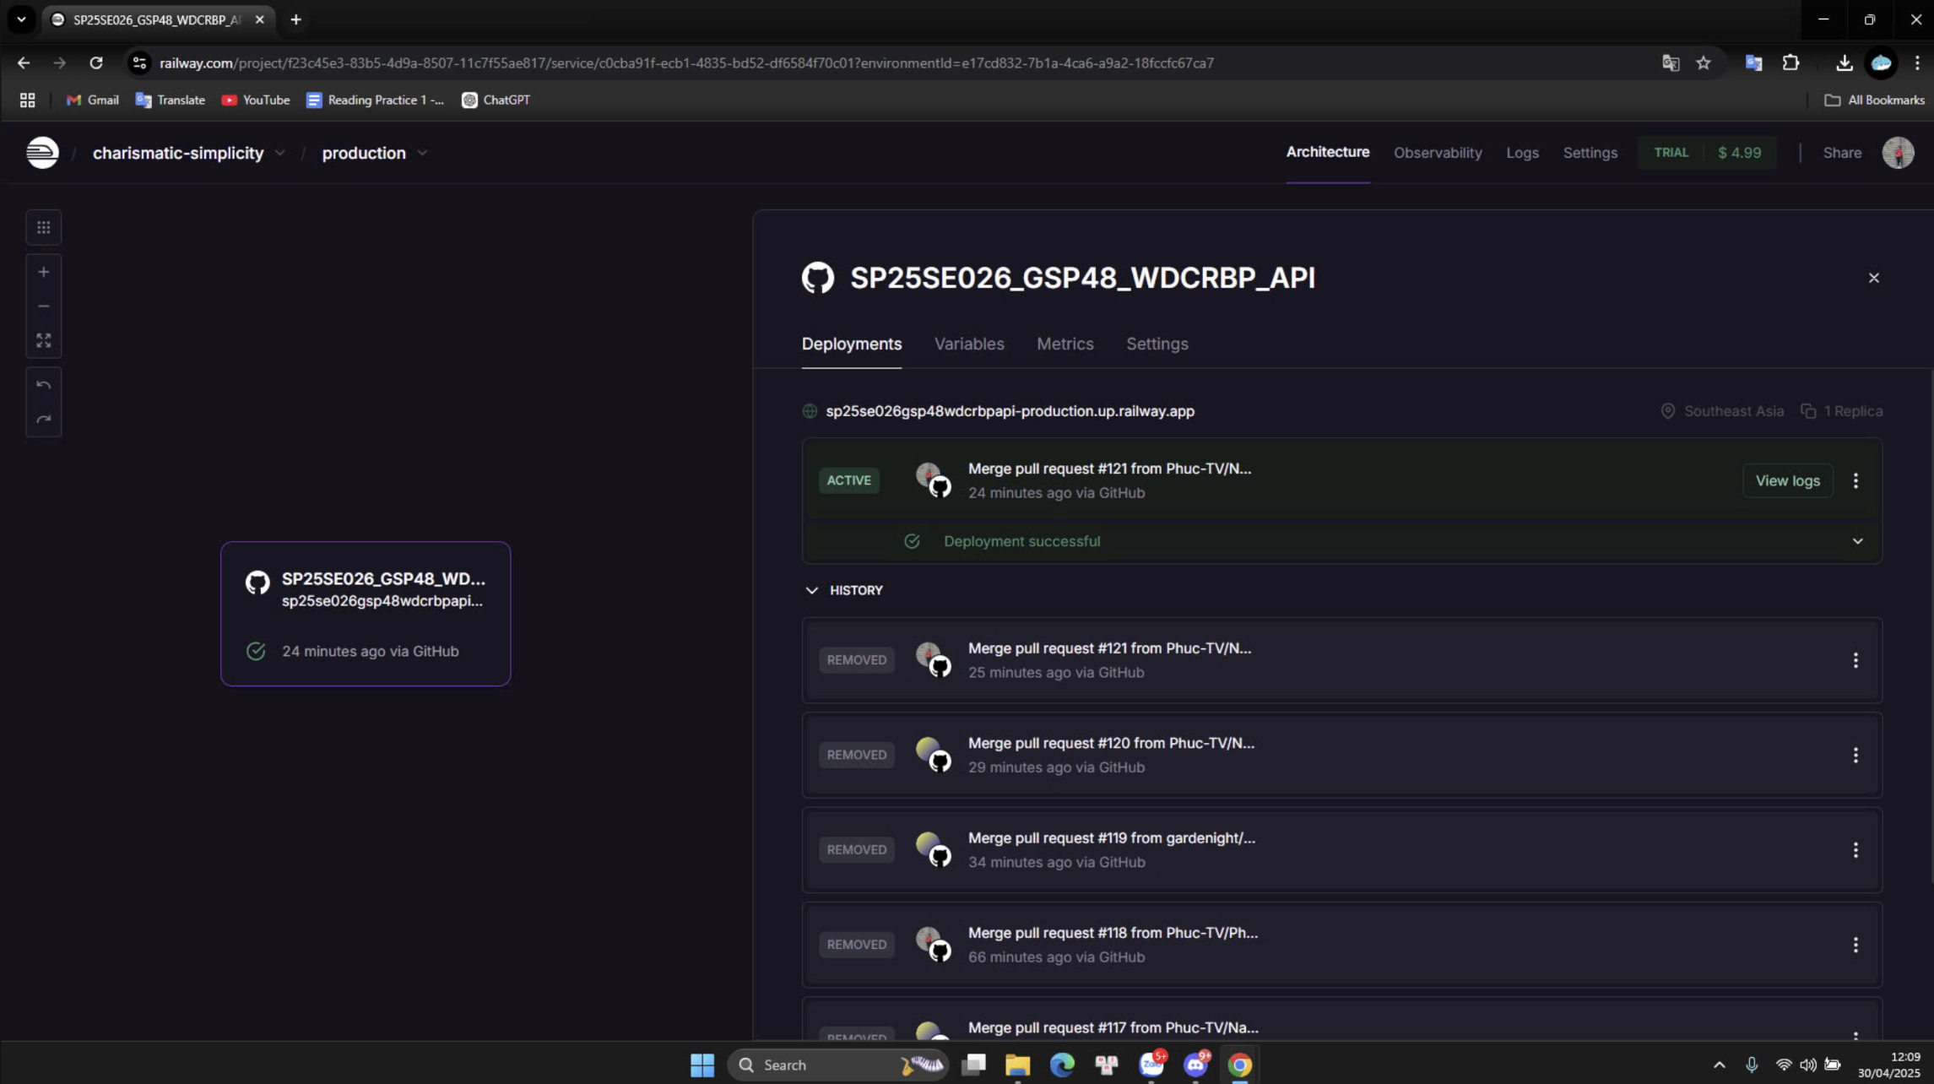

Database configuration:
spring.datasource.url=jdbc:mysql://switchyard.proxy.rlwy.net:35845/wdcrbp?useSSL=false&allowPublicKeyRetrieval=true&serverTimezone=UTC
spring.datasource.username=root
spring.datasource.password=ezBrmFLmiKLYQsgHbWubQGNPmYoTzhBg
Email configuration:
spring.mail.host=smtp.gmail.com
spring.mail.port=587
spring.mail.username=namndpse171442@fpt.edu.vn
spring.mail.password=mqmk okcr vxaj kxcy

Web-Frontend
Link: https://wdcrbp.vercel.app/
Deployment platform: Vercel
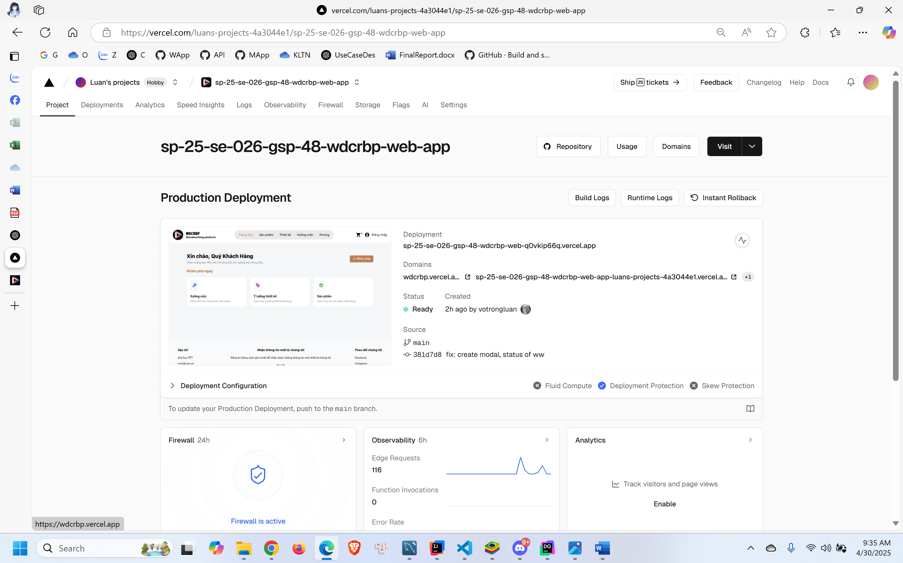
Environment Variables
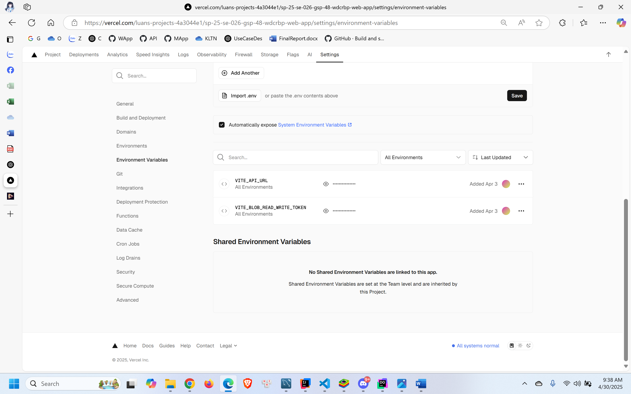

VITE_API_URL: https://sp25se026gsp48wdcrbpapi-production.up.railway.app
VITE_BLOB_READ_WRITE_TOKEN: vercel_blob_rw_oBb8igIpJjS3UoHo_qXlZPxnWA1gORE71C0BEAiVb4TcBqJ

Mobile-Frontend
Link: https://expo.dev/accounts/luanvtse171436/projects/woodworker/builds/7ad2c115-f91b-4ec9-9a2e-034a27edd048
Deployment platform: Expo
