

Capstone Project Report
Report 4 – Software Design Document

- Ho Chi Minh, 04/2025 -

Table of Contents
I. Record of Changes 3
II. Software Design Description 4
1. System Design 4
1.1 System Architecture 4
1.2 Package Diagram 5
2. Database Design 8
3. Detailed Design 26
3.1 Woodworker registration feature 26
3.2 Customization service booking feature 30
3.3 Personalization service booking feature 34
3.4 Guarantee service booking feature 36

I. Record of Changes
Date | A*  M, D | In charge | Change Description
30/04/2024 | A | Luân | Add document from final report.
*A - Added M - Modified D - Deleted

II. Software Design Description

1. System Design

1.1 System Architecture
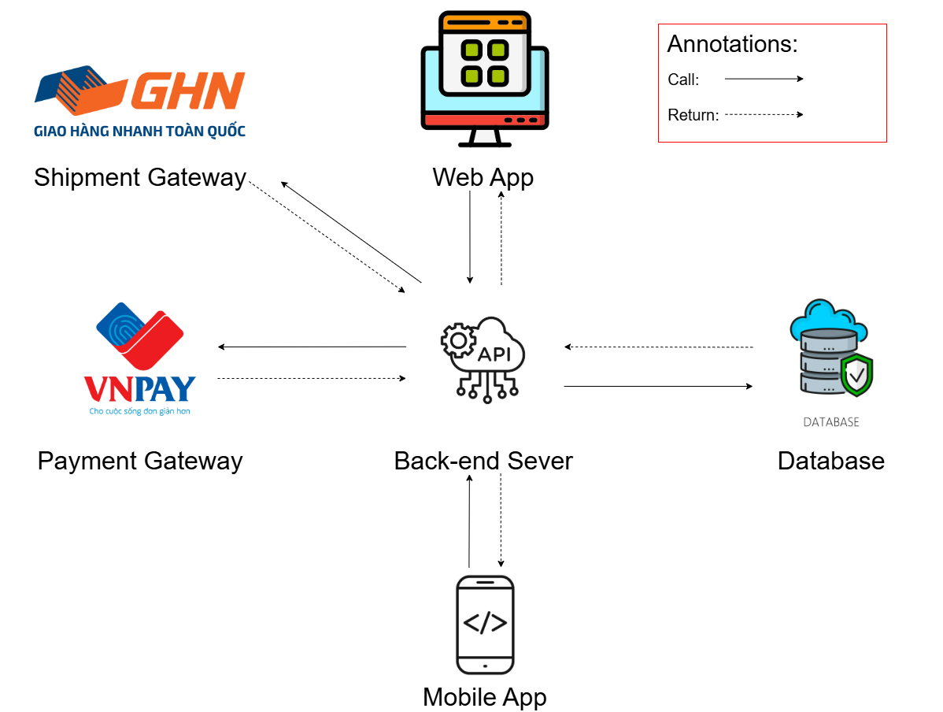
The WDCRBP System includes a Back-end Server built with Java Spring Boot, which exposes APIs to support interactions between clients and third-party services. The Web App (built using React) is used by admins, moderators, customers, and woodworker for managing translation workflows. A Mobile App (built using React Native) is also available for users with similar functionalities, adapted for the mobile experience.

1.2 Package Diagram

1.2.1 Web API package diagram
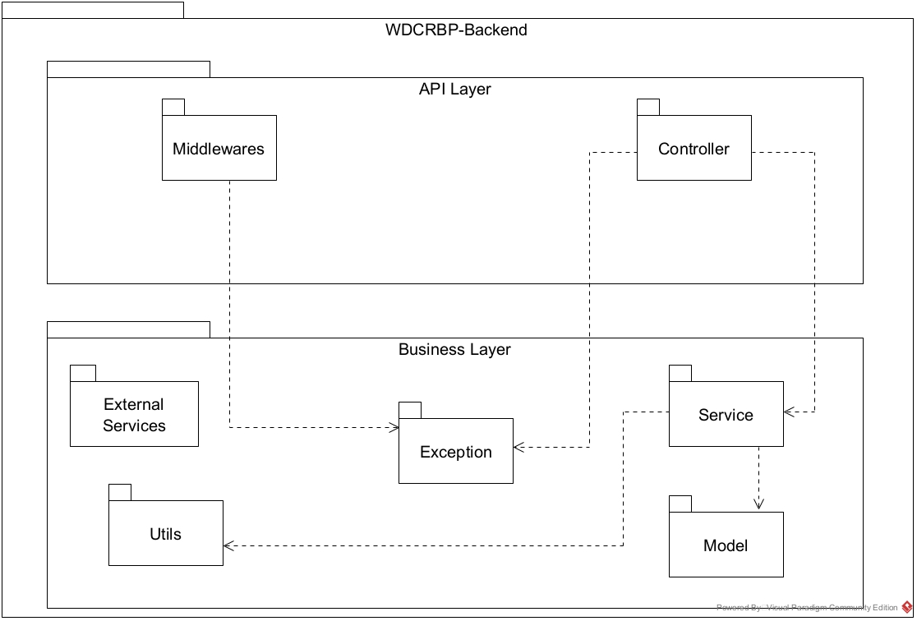

1.2.2 Web application package diagram
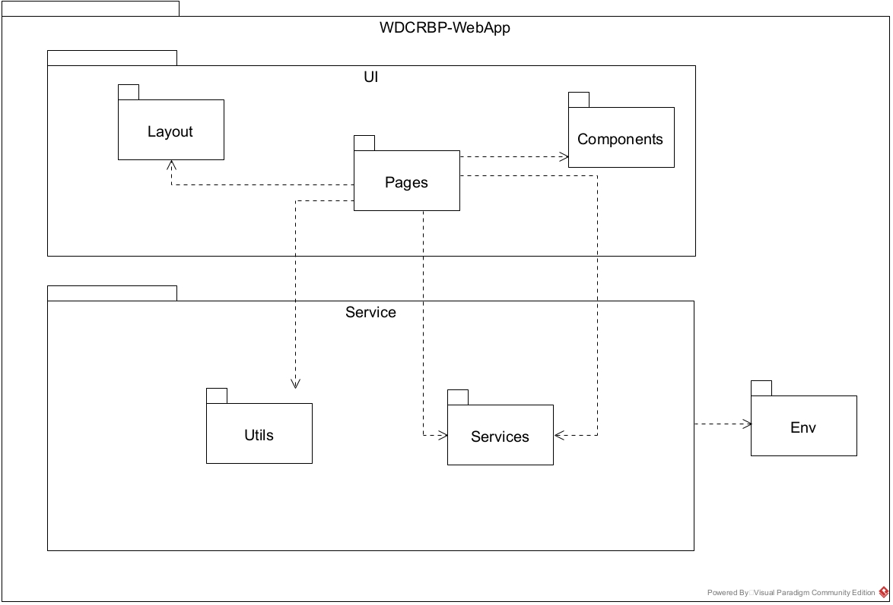

1.2.3 Mobile application package diagram
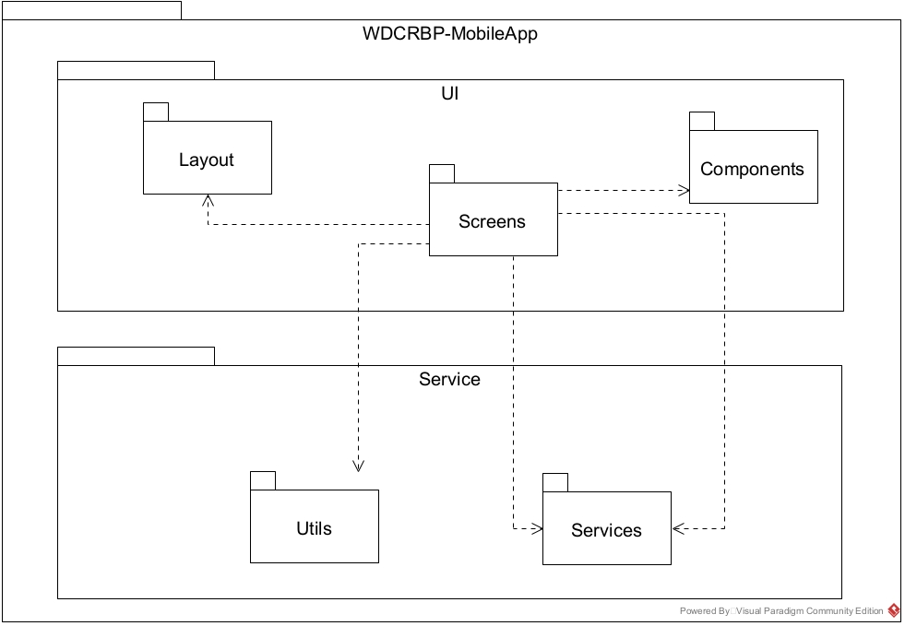

2. Database Design
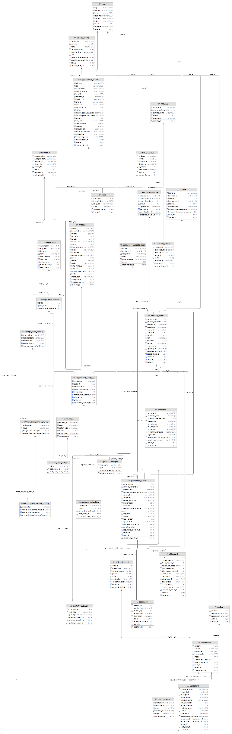

Data Dictionary
Entity name | Attributes | Data type | Description
Category | category_id | bigint | Unique identifier for each category.
 | category_level | varchar(255) | Level of the category in the hierarchy.
 | category_name | varchar(255) | Name of the category.
 | created_at | datetime(6) | Timestamp when the category was created.
 | description | varchar(255) | Description of the category.
 | parent_id | bigint | The parent category ID if applicable.
 | status | bit | Current status of the category (active/inactive).
 | updated_at | datetime(6) | Timestamp when the category was last updated.
Configuration | configuration_id | bigint | Unique identifier for each configuration.
 | created_by | datetime(6) | Timestamp when the configuration was created.
 | description | varchar(255) | Description of the configuration.
 | name | varchar(255) | Name of the configuration.
 | updated_at | datetime(6) | Timestamp when the configuration was last updated.
 | value | varchar(2000) | Value of the configuration.
ConsultantAppointment | appointment_id | bigint | Unique identifier for each consultant appointment.
 | content | varchar(2000) | Content or details of the appointment.
 | created_at | datetime(6) | Timestamp when the appointment was created.
 | date_time | datetime(6) | Date and time of the appointment.
 | form | varchar(255) | Form or medium of the appointment (e.g., in-person, online).
 | meet_address | varchar(2000) | The location where the meeting will take place.
 | status | bit | Current status of the appointment.
Service | service_id | bigint | Unique identifier for each service.
 | created_at | datetime(6) | Timestamp when the service was created.
 | number_of_deposits | smallint | Number of deposits required for the service.
 | service_name | varchar(255) | Name of the service.
 | status | bit | Current status of the service (active/inactive).
 | updated_at | datetime(6) | Timestamp when the service was last updated.
ServiceDeposit | service_deposit_id | bigint | Unique identifier for each service deposit.
 | created_at | datetime(6) | Timestamp when the deposit record was created.
 | deposit_number | smallint | Number of deposits required for the service.
 | description | varchar(255) | Description of the deposit.
 | percent | smallint | Percentage of the total amount for the deposit.
 | status | bit | Current status of the deposit.
 | updated_at | datetime(6) | Timestamp when the deposit record was last updated.
 | service_id | bigint | The service ID related to the deposit.
ServicePack | service_pack_id | bigint | Unique identifier for each service pack.
 | description | varchar(255) | Description of the service pack.
 | duration | smallint | Duration for which the service pack is valid.
 | name | varchar(255) | Name of the service pack.
 | personalization | bit | Indicates if the service pack includes personalization.
 | post_limit_per_month | smallint | Limit on the number of posts allowed per month under the pack.
 | price | float | Price of the service pack.
 | product_management | bit | Indicates if the service pack includes product management.
 | search_result_priority | smallint | Priority of the service pack in search results.
TechSpec | tech_spec_id | bigint | Unique identifier for each technical specification.
 | created_at | datetime(6) | Timestamp when the specification was created.
 | name | varchar(255) | Name of the technical specification.
 | option_type | varchar(255) | Type of option (e.g., dropdown, text input).
 | status | bit | Current status of the specification (active/inactive).
 | updated_at | datetime(6) | Timestamp when the specification was last updated.
TechSpecValue | tech_spec_value_id | bigint | Unique identifier for each technical specification value.
 | value | varchar(255) | The value associated with the specification.
 | tech_spec_id | bigint | The technical specification ID this value belongs to.
User | user_id | bigint | Unique identifier for each user.
 | otp | varchar(255) | One-Time Password for user authentication.
 | created_at | datetime(6) | Timestamp when the user was created.
 | email | varchar(255) | User's email address.
 | password | varchar(255) | User's password (hashed).
 | phone | varchar(255) | User's phone number.
 | role | varchar(255) | User's role (e.g., admin, customer).
 | status | bit | Current status of the user (active/inactive).
 | username | varchar(255) | User's chosen username.
Review | review_id | bigint | Unique identifier for each review.
 | comment | varchar(255) | The comment or feedback provided by the reviewer.
 | created_at | datetime(6) | Timestamp when the review was created.
 | rating | int | Rating given by the reviewer.
 | response_at | datetime(6) | Timestamp when the response to the review was made.
 | status | bit | Current status of the review (approved/rejected).
 | updated_at | datetime(6) | Timestamp when the review was last updated.
 | woodworker_response | varchar(255) | Response provided by the woodworker.
 | woodworker_response_status | bit | Status of the woodworker’s response (e.g., pending, resolved).
 | user_id | bigint | The ID of the user who wrote the review.
UserAddress | user_address_id | bigint | Unique identifier for each user address.
 | address | varchar(255) | Full address of the user.
 | city_id | varchar(255) | City associated with the user's address.
 | created_at | datetime(6) | Timestamp when the user address was created.
 | district_id | varchar(255) | District associated with the user's address.
 | is_default | bit | Indicates if this is the user's default address.
 | ward_code | varchar(255) | Ward or subdistrict code of the user's address.
 | user_id | bigint | The ID of the user associated with the address.
Wallet | wallet_id | bigint | Unique identifier for each wallet.
 | balance | float | The current balance in the wallet.
 | created_at | datetime(6) | Timestamp when the wallet was created.
 | updated_at | datetime(6) | Timestamp when the wallet was last updated.
 | user_id | bigint | The ID of the user associated with the wallet.
WoodworkerProfile | woodworker_id | bigint | Unique identifier for each woodworker profile.
 | address | varchar(255) | Address of the woodworker.
 | bio | varchar(2000) | Bio or description of the woodworker.
 | brand_name | varchar(255) | Name of the woodworker's brand.
 | business_type | varchar(255) | Type of business the woodworker operates (e.g., individual, company).
 | city_id | varchar(255) | City of the woodworker.
 | created_at | datetime(6) | Timestamp when the woodworker profile was created.
 | district_id | varchar(255) | District of the woodworker.
 | img_url | varchar(2000) | URL to the profile image of the woodworker.
 | no_order | varchar(255) | Number of orders completed by the woodworker.
 | public_status | bit | Indicates whether the woodworker's profile is public.
 | rating | int | Rating of the woodworker based on reviews.
 | service_pack_end_date | datetime(6) | End date of the woodworker's service pack.
 | service_pack_start_date | datetime(6) | Start date of the woodworker's service pack.
 | status | bit | Current status of the woodworker's profile (active/inactive).
 | tax_code | varchar(255) | Tax identification number of the woodworker.
 | total_reviews | smallint | Total number of reviews received by the woodworker.
 | total_star | smallint | Total star rating of the woodworker.
 | updated_at | datetime(6) | Timestamp when the woodworker profile was last updated.
 | verification_status | varchar(255) | Status of the woodworker's verification (e.g., verified, unverified).
 | ward_code | varchar(255) | Ward code for the woodworker's address.
 | warranty_policy | varchar(2000) | Warranty policy for the woodworker's products/services.
 | service_pack_id | bigint | Service pack ID associated with the woodworker's profile.
 | user_id | bigint | User ID of the associated woodworker profile.
AvailableService | available_service_id | bigint | Unique identifier for each available service.
 | created_at | datetime(6) | Timestamp when the service was created.
 | description | varchar(2000) | Detailed description of the available service.
 | operating_status | bit | Current operating status of the service.
 | status | bit | Current status of the service (active/inactive).
 | updated_at | datetime(6) | Timestamp when the service details were last updated.
 | service_id | bigint | Service ID associated with the available service.
 | woodworker_id | bigint | Woodworker ID who offers the available service.
DesignIdea | design_idea_id | bigint | Unique identifier for each design idea.
 | description | varchar(2000) | Detailed description of the design idea.
 | img_urls | varchar(2000) | URLs of images related to the design idea.
 | is_install | bit | Indicates if the design idea requires installation.
 | name | varchar(255) | Name of the design idea.
 | total_reviews | smallint | Total number of reviews for the design idea.
 | total_star | smallint | Total star rating for the design idea.
 | category_id | bigint | Category ID associated with the design idea.
 | woodworker_id | bigint | Woodworker ID associated with the design idea.
DesignIdeaConfig | design_idea_config_id | bigint | Unique identifier for each design idea configuration.
 | description | varchar(255) | Description of the design idea configuration.
 | specifications | varchar(255) | Specifications related to the design idea configuration.
 | updated_at | datetime(6) | Timestamp when the configuration was last updated.
 | design_idea_id | bigint | Foreign key linking to the associated design idea.
DesignIdeaConfigValue | design_idea_config_value_id | bigint | Unique identifier for each design idea configuration value.
 | updated_at | datetime(6) | Timestamp when the configuration value was last updated.
 | value | varchar(255) | The value of the configuration.
 | design_idea_config_id | bigint | Foreign key linking to the associated design idea configuration.
DesignIdeaVariant | design_idea_variant_id | bigint | Unique identifier for each design idea variant.
 | price | float | Price of the design idea variant.
 | design_idea_id | bigint | Foreign key linking to the associated design idea.
DesignIdeaVariantConfig | design_idea_variant_config_id | bigint | Unique identifier for each design idea variant configuration.
 | updated_at | datetime(6) | Timestamp when the variant configuration was last updated.
 | design_idea_config_value_id | bigint | Foreign key linking to the associated configuration value.
 | design_idea_variant_id | bigint | Foreign key linking to the associated design idea variant.
Post | post_id | bigint | Unique identifier for each post.
 | created_at | datetime(6) | Timestamp when the post was created.
 | description | varchar(2000) | Description or content of the post.
 | img_urls | varchar(2000) | URLs for images associated with the post.
 | title | varchar(255) | Title of the post.
 | woodworker_id | bigint | Foreign key linking to the woodworker who created the post.
Product | product_id | bigint | Unique identifier for each product.
 | color | varchar(255) | Color of the product.
 | description | varchar(2000) | Description of the product.
 | height | smallint | Height of the product.
 | is_install | bit | Indicates if installation is required.
 | length | smallint | Length of the product.
 | media_urls | varchar(2000) | URLs for media files (images/videos) of the product.
 | price | float | Price of the product.
 | product_name | varchar(255) | Name of the product.
 | scent | varchar(255) | Scent of the product (if applicable).
 | sculpture | varchar(255) | Indicates if the product is a sculpture.
 | special_feature | varchar(255) | Special features of the product.
 | status | bit | Current status of the product (active/inactive).
 | stock | smallint | Number of items in stock.
 | style | varchar(255) | Style of the product.
 | total_reviews | smallint | Total number of reviews for the product.
 | total_star | smallint | Average star rating of the product.
 | warranty_duration | smallint | Duration of the product's warranty.
 | width | smallint | Width of the product.
 | wood_type | varchar(255) | Type of wood used for the product.
 | category_id | bigint | Foreign key linking to the product category.
 | woodworker_id | bigint | Foreign key linking to the woodworker.
ServiceOrder | order_id | bigint | Unique identifier for each service order.
 | amount_paid | float | Amount already paid for the service order.
 | amount_remaining | float | Amount remaining to be paid for the service order.
 | created_at | datetime(6) | Timestamp when the service order was created.
 | description | varchar(255) | Description of the service order.
 | feedback | varchar(255) | Feedback or notes regarding the service order.
 | is_install | bit | Indicates if installation is part of the service.
 | quantity | smallint | Quantity of the service or products ordered.
 | role | varchar(255) | Role of the person responsible for the order (e.g., customer).
 | ship_fee | float | Shipping fee associated with the service order.
 | status | varchar(255) | Current status of the service order.
 | total_amount | float | Total amount for the service order.
 | updated_at | datetime(6) | Timestamp when the service order was last updated.
 | available_service_id | bigint | Foreign key linking to the available service.
 | appointment_id | bigint | Foreign key linking to the associated appointment.
 | review_id | bigint | Foreign key linking to the associated review.
 | user_id | bigint | Foreign key linking to the user who made the order.
Contract | contract_id | bigint | Unique identifier for each contract.
 | complete_date | datetime(6) | Date when the contract was completed.
 | contract_total_amount | float | Total amount specified in the contract.
 | created_at | datetime(6) | Timestamp when the contract was created.
 | cus_address | varchar(255) | Customer's address in the contract.
 | cus_full_name | varchar(255) | Customer's full name.
 | cus_phone | varchar(255) | Customer's phone number.
 | customer_signature | varchar(2000) | Signature of the customer.
 | sign_date | datetime(6) | Date when the contract was signed.
 | woodworker_signature | varchar(2000) | Signature of the woodworker.
 | woodworker_terms | varchar(2000) | Terms agreed by the woodworker in the contract.
 | order_id | bigint | Foreign key linking to the associated order.
 | agreement | varchar(255) | General agreement terms.
RequestedProduct | requested_product_id | bigint | Unique identifier for each requested product.
 | created_at | datetime(6) | Timestamp when the requested product was created.
 | quantity | tinyint | Quantity of the requested product.
 | total_amount | float | Total amount for the requested product.
 | warranty_duration | smallint | Duration of the warranty for the requested product.
 | category_id | bigint | Foreign key linking to the product category.
 | design_idea_variant_id | bigint | Foreign key linking to the design idea variant.
 | product_id | bigint | Foreign key linking to the specific product.
 | order_id | bigint | Foreign key linking to the associated order.
CustomerSelection | customer_selection_id | bigint | Unique identifier for each customer selection.
 | created_at | datetime(6) | Timestamp when the customer selection was created.
 | value | varchar(255) | Value selected by the customer for a product option.
 | requested_product_id | bigint | Foreign key linking to the requested product.
 | tech_spec_id | bigint | Foreign key linking to the technical specification.
GuaranteeOrder | guarantee_order_id | bigint | Unique identifier for each guarantee order.
 | amount_paid | float | Amount already paid for the guarantee order.
 | amount_remaining | float | Amount remaining to be paid for the guarantee order.
 | created_at | datetime(6) | Timestamp when the guarantee order was created.
 | current_product_img_urls | varchar(2000) | URLs of images for the current product.
 | description | varchar(2000) | Description of the guarantee order.
 | feedback | varchar(255) | Feedback or comments related to the guarantee order.
 | guarantee_error | varchar(255) | Any error encountered during the guarantee process.
 | is_guarantee | bit | Indicates whether the product is under guarantee.
 | is_install | bit | Indicates if installation is required for the guarantee.
 | product_current_status | varchar(255) | Current status of the product under guarantee.
 | role | varchar(255) | The role associated with the guarantee order.
 | ship_fee | float | Shipping fee associated with the guarantee order.
 | status | varchar(255) | Current status of the guarantee order.
 | total_amount | float | Total amount for the guarantee order.
 | updated_at | datetime(6) | Timestamp when the guarantee order was last updated.
 | available_service_id | bigint | Foreign key linking to the available service.
 | appointment_id | bigint | Foreign key linking to the associated appointment.
 | requested_product_id | bigint | Foreign key linking to the requested product.
 | review_id | bigint | Foreign key linking to the associated review.
 | user_id | bigint | Foreign key linking to the user associated with the guarantee order.
OrderDeposit | order_deposit_id | bigint | Unique identifier for each order deposit.
 | amount | float | The amount of the deposit for the order.
 | created_at | datetime(6) | Timestamp when the deposit was created.
 | deposit_number | smallint | The number of deposits required for the order.
 | percent | smallint | The percentage of the total amount for the deposit.
 | status | bit | Current status of the deposit (e.g., paid, pending).
 | updated_at | datetime(6) | Timestamp when the deposit details were last updated.
 | guarantee_order_id | bigint | Foreign key linking to the guarantee order.
 | order_id | bigint | Foreign key linking to the service order.
ProductImages | product_images_id | bigint | Unique identifier for each product image.
 | media_urls | varchar(2000) | URLs of the media files associated with the product.
 | type | varchar(255) | Type of the image (e.g., main, thumbnail).
 | requested_product_id | bigint | Foreign key linking to the requested product.
OrderProgress | progress_id | bigint | Unique identifier for each progress record.
 | created_by | bigint | The user or entity who created the progress record.
 | created_time | datetime(6) | Timestamp when the progress record was created.
 | deleted_by | bigint | The user or entity who deleted the progress record.
 | deleted_time | datetime(6) | Timestamp when the progress record was deleted.
 | description | varchar(255) | Description of the progress made on the order.
 | status | varchar(255) | Current status of the progress (e.g., in progress, completed).
 | guarantee_order_id | bigint | Foreign key linking to the associated guarantee order.
 | order_id | bigint | Foreign key linking to the associated service order.
QuotationDetail | quotation_detail_id | bigint | Unique identifier for each quotation detail.
 | cost_amount | float | The cost amount for the quotation detail.
 | cost_type | varchar(255) | The type of cost (e.g., labor, materials).
 | quantity_required | varchar(255) | The quantity of the requested product for the quotation.
 | guarantee_order_id | bigint | Foreign key linking to the associated guarantee order.
 | requested_product_id | bigint | Foreign key linking to the requested product.
Shipment | shipment_id | bigint | Unique identifier for each shipment record.
 | fee | float | The fee associated with the shipment.
 | from_address | varchar(255) | The address from where the shipment is sent.
 | from_district_id | int | The district ID from where the shipment is sent.
 | from_ward_code | varchar(255) | The ward code from where the shipment is sent.
 | ghn_service_id | int | The service ID associated with the shipment.
 | ghn_service_type_id | int | The type ID of the shipping service.
 | order_code | varchar(255) | The code associated with the order being shipped.
 | ship_type | varchar(255) | The type of shipping method used (e.g., standard, expedited).
 | shipping_unit | varchar(255) | The shipping unit or carrier handling the shipment.
 | to_address | varchar(255) | The destination address for the shipment.
 | to_district_id | int | The district ID of the destination.
 | to_ward_code | varchar(255) | The ward code of the destination.
 | guarantee_order_id | bigint | Foreign key linking to the associated guarantee order.
 | order_id | bigint | Foreign key linking to the associated service order.
Transaction | transaction_id | bigint | Unique identifier for each transaction.
 | amount | float | The amount of money involved in the transaction.
 | created_at | datetime(6) | Timestamp when the transaction was created.
 | description | varchar(255) | Description of the transaction.
 | payment_for | varchar(255) | The purpose of the payment (e.g., service order).
 | status | bit | Current status of the transaction (e.g., completed, failed).
 | transaction_type | varchar(255) | Type of transaction (e.g., debit, credit).
 | order_deposit_id | bigint | Foreign key linking to the order deposit associated with the transaction.
 | user_id | bigint | Foreign key linking to the user who made the transaction.
 | wallet_id | bigint | Foreign key linking to the wallet involved in the transaction.
Complaint | complaint_id | bigint | Unique identifier for each complaint record.
 | complaint_type | varchar(255) | Type of complaint (e.g., service issue, product issue).
 | created_at | datetime(6) | Timestamp when the complaint was created.
 | description | varchar(500) | Detailed description of the complaint.
 | proof_img_urls | varchar(2000) | URLs of images or proof related to the complaint.
 | refund_amount | float | Amount of refund requested due to the complaint.
 | staff_response | varchar(500) | Response from the staff regarding the complaint.
 | status | varchar(255) | Current status of the complaint (e.g., pending, resolved).
 | updated_at | datetime(6) | Timestamp when the complaint was last updated.
 | woodworker_response | varchar(500) | Response from the woodworker regarding the complaint.
 | refund_credit_transaction_id | bigint | Foreign key linking to the refund credit transaction.
 | refund_debit_transaction_id | bigint | Foreign key linking to the refund debit transaction.
 | order_id | bigint | Foreign key linking to the order associated with the complaint.
 | staff_user_id | bigint | Foreign key linking to the staff who handled the complaint.
 | order_status | varchar(255) | Status of the order associated with the complaint.
 | refund_percent | int | Percentage of refund requested.

3. Detailed Design

3.1 Woodworker registration feature

3.1.1 Class diagram
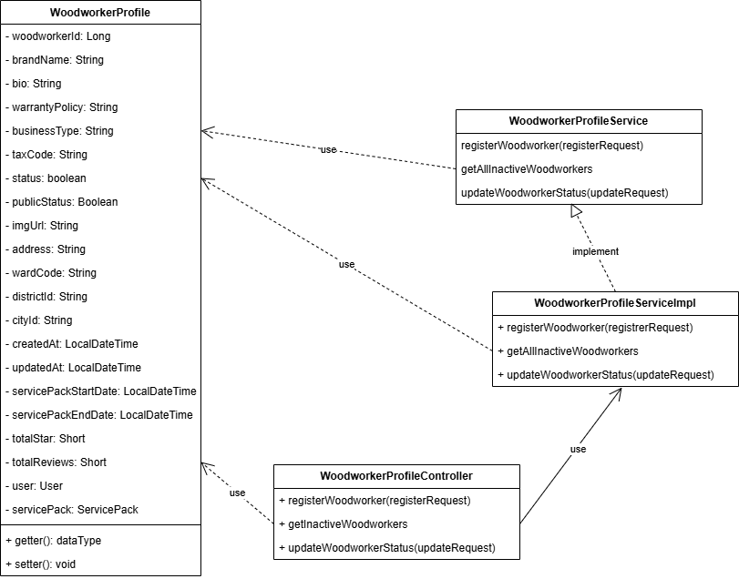

3.1.2 Activity diagram
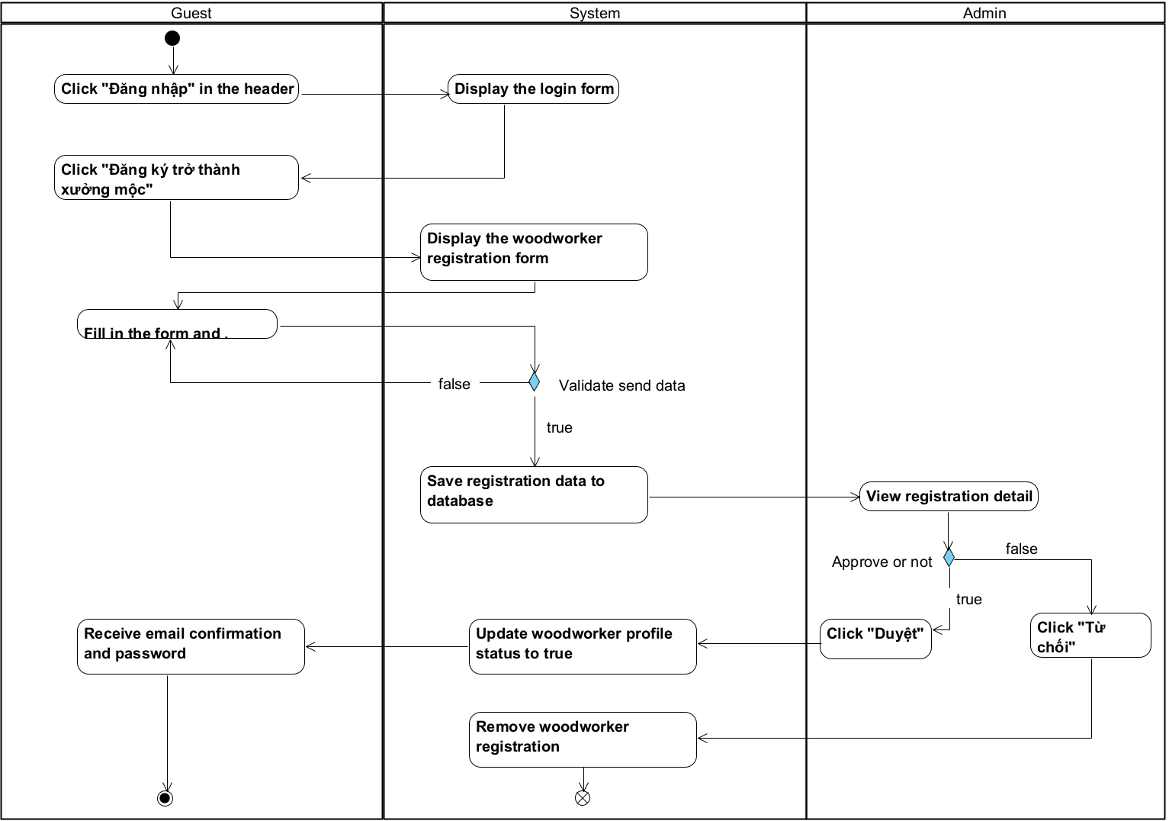

3.1.3 Sequence diagram

3.1.3.1 Register sequence diagram
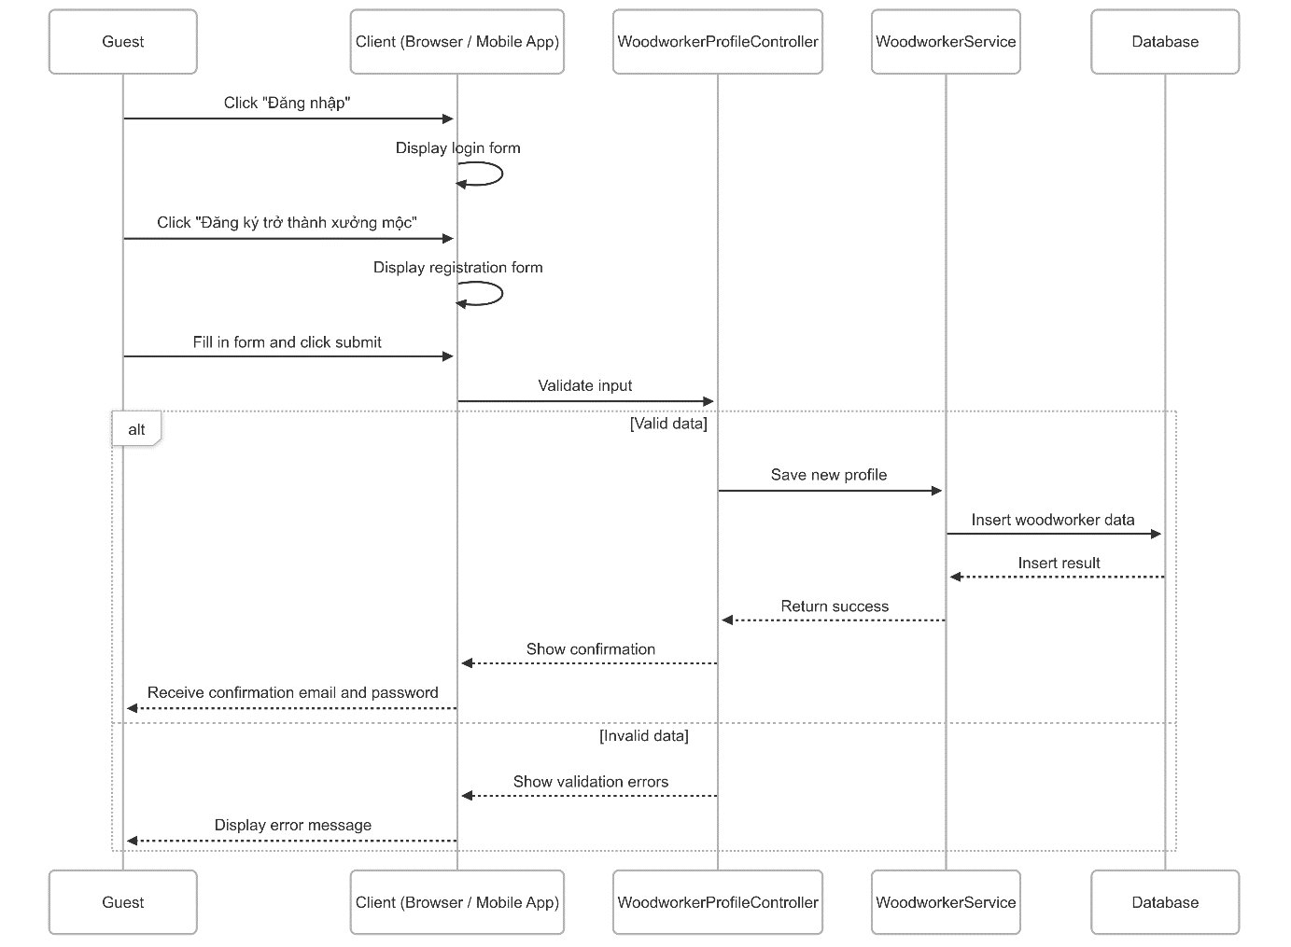

3.1.3.2 Approval sequence diagram
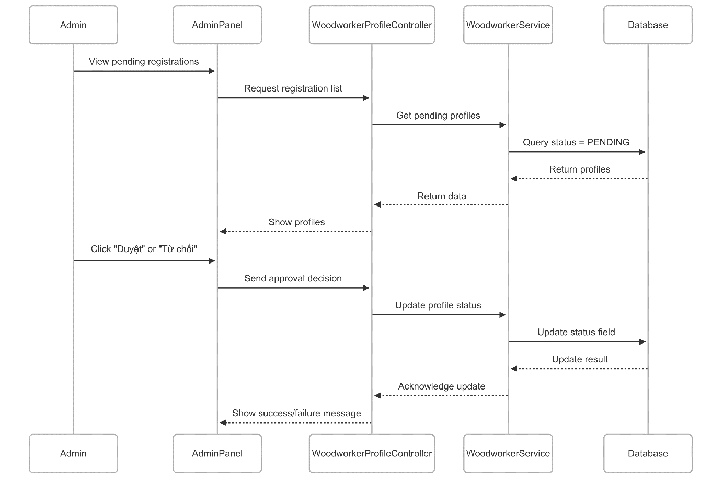

3.2 Customization service booking feature

3.2.1 Class diagram
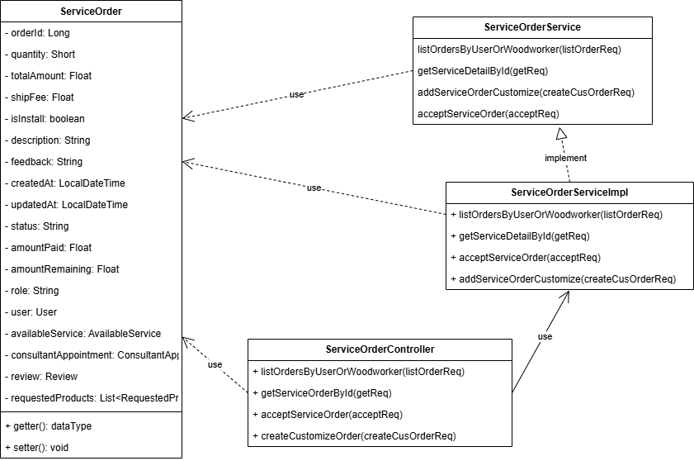

3.2.2 Activity diagram
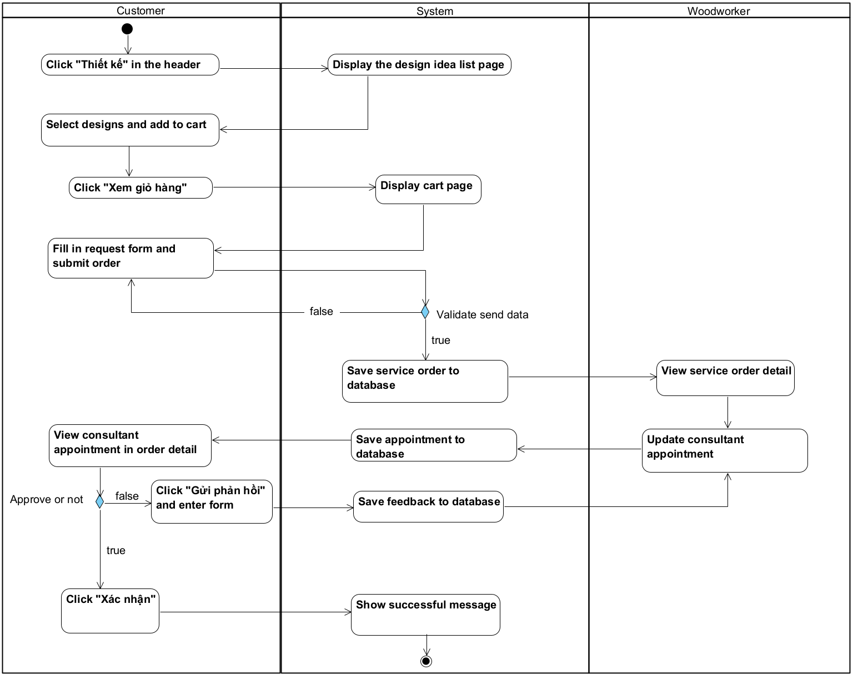

3.2.3 Sequence diagram

3.2.3.1 Book customization service sequence diagram
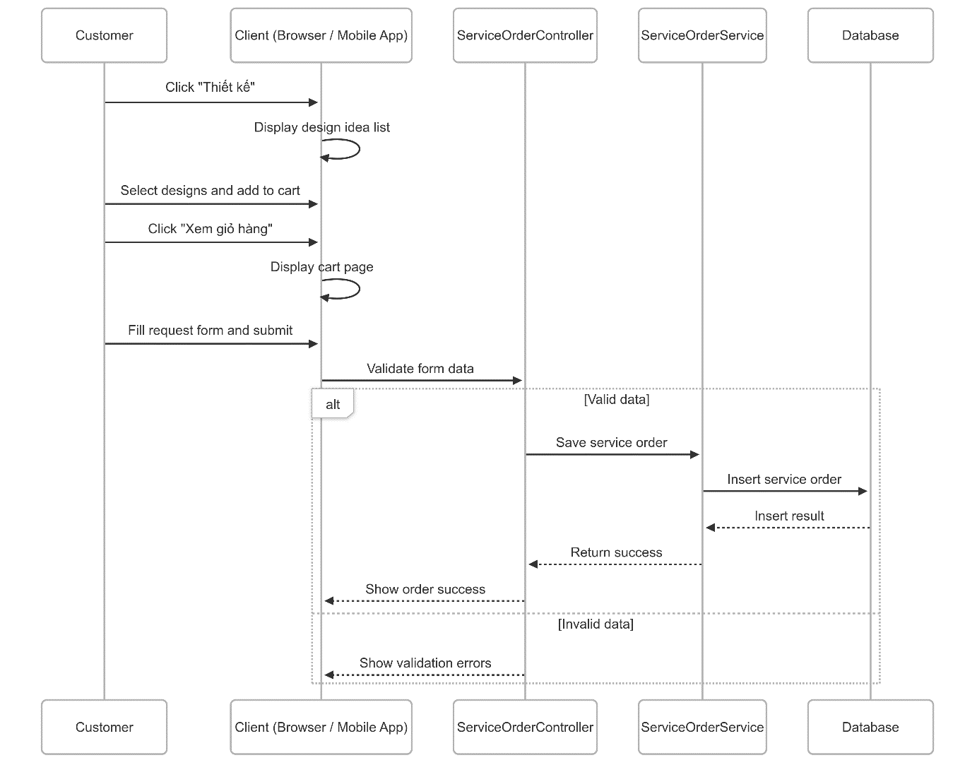

3.2.3.2 Update consultant appointment for customization service sequence diagram
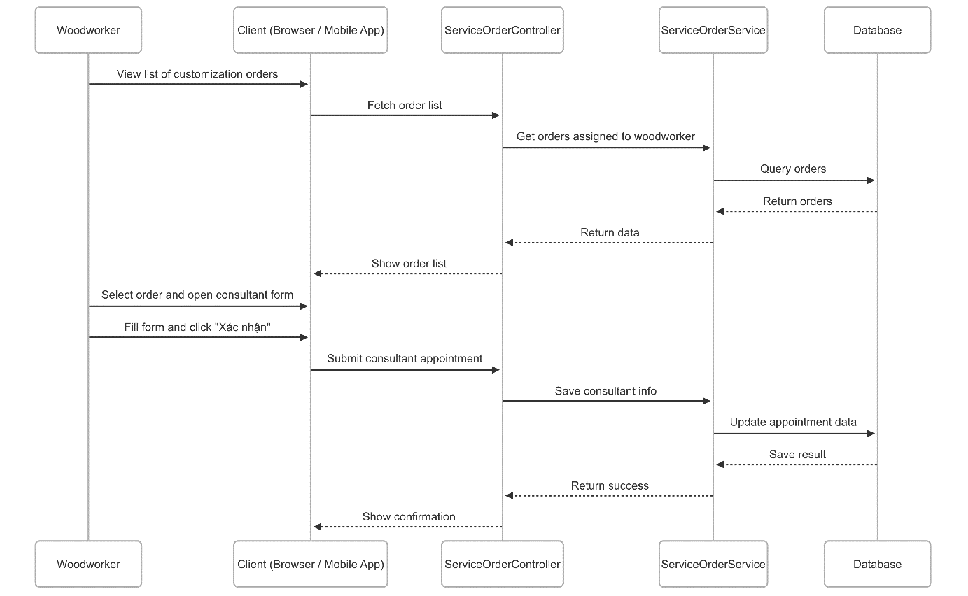

3.2.4 Customization order state machine diagram
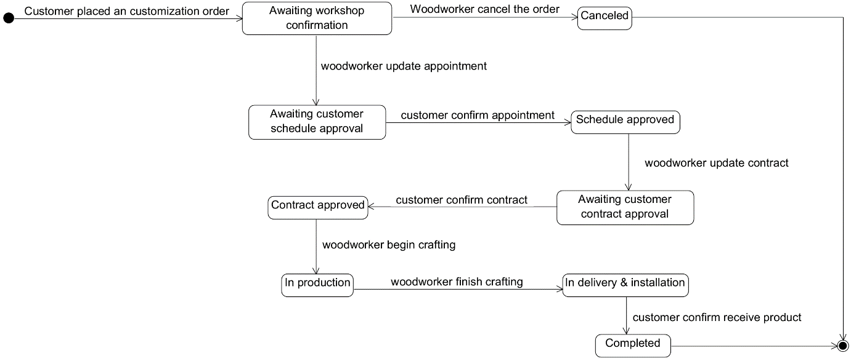

3.3 Personalization service booking feature

3.3.1 Class diagram
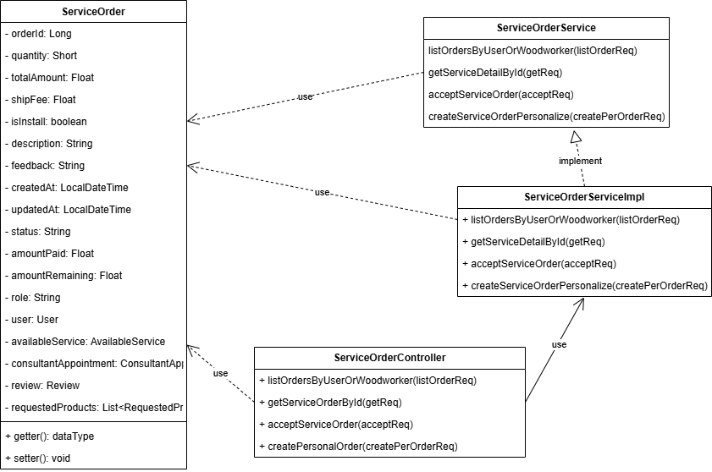

3.3.2 Activity diagram
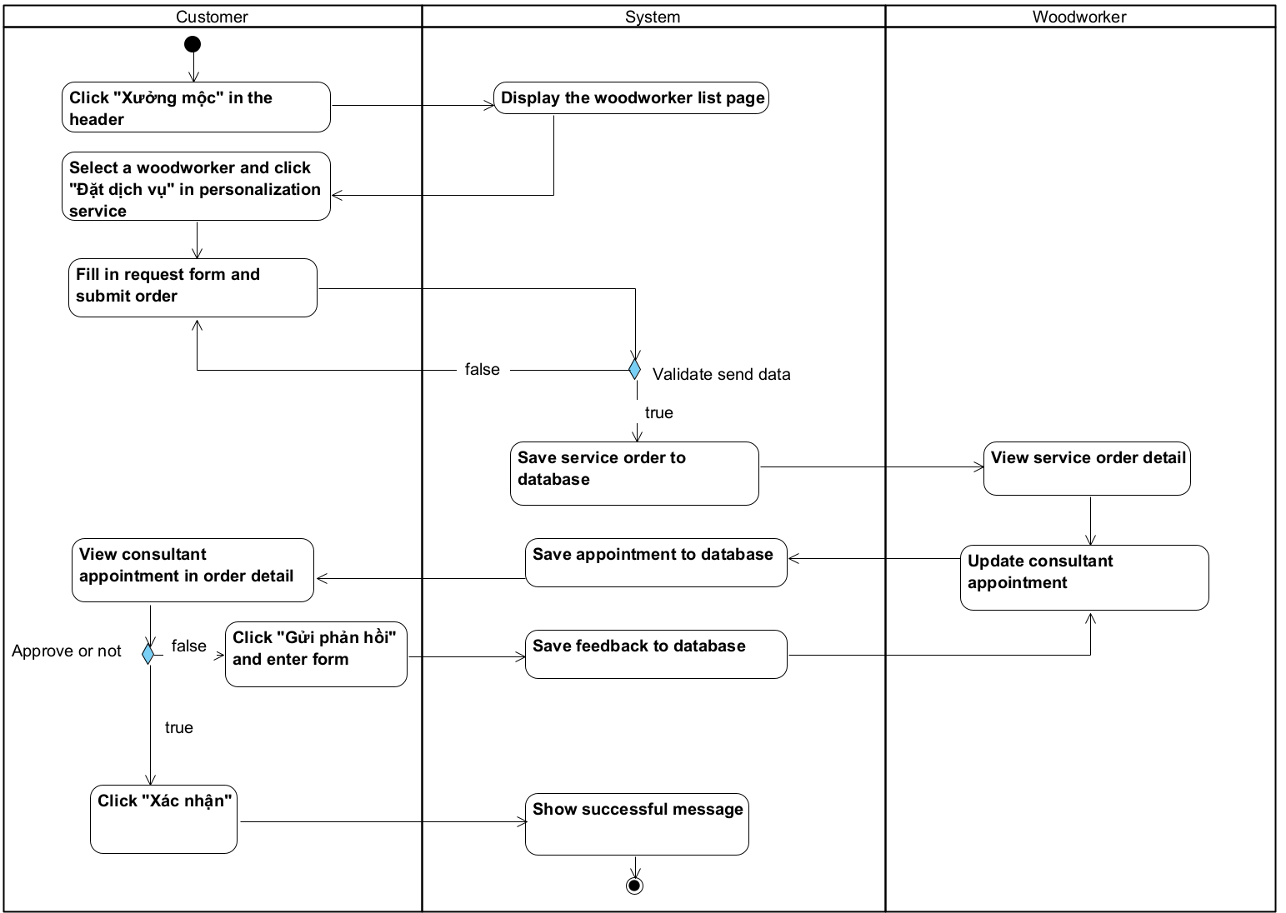

3.3.3 Sequence diagram
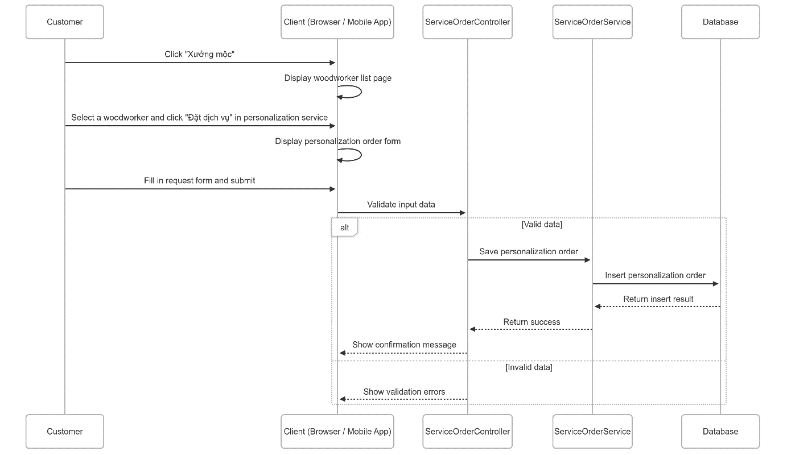

3.3.4 Personalization order state machine diagram
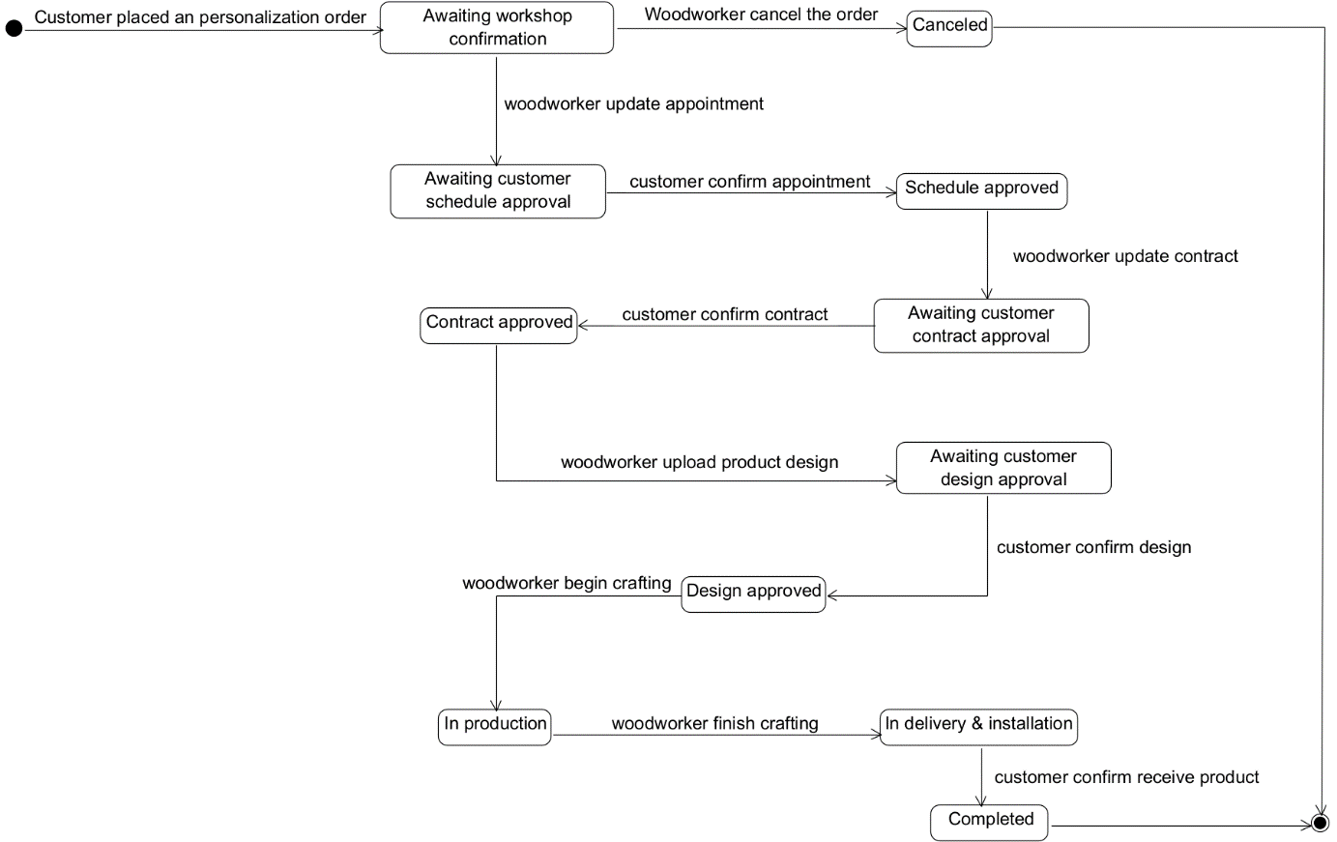

3.4 Guarantee service booking feature

3.4.1 Class diagram
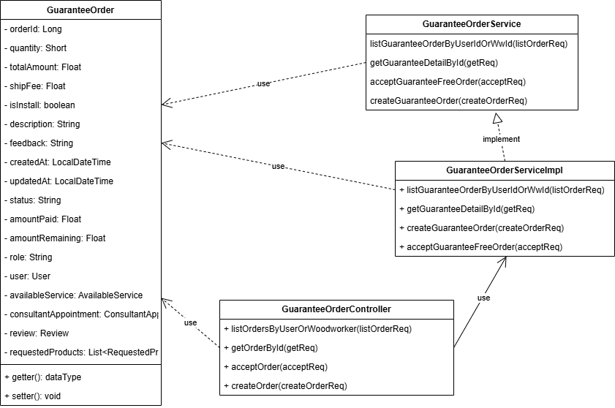

3.4.2 Activity diagram
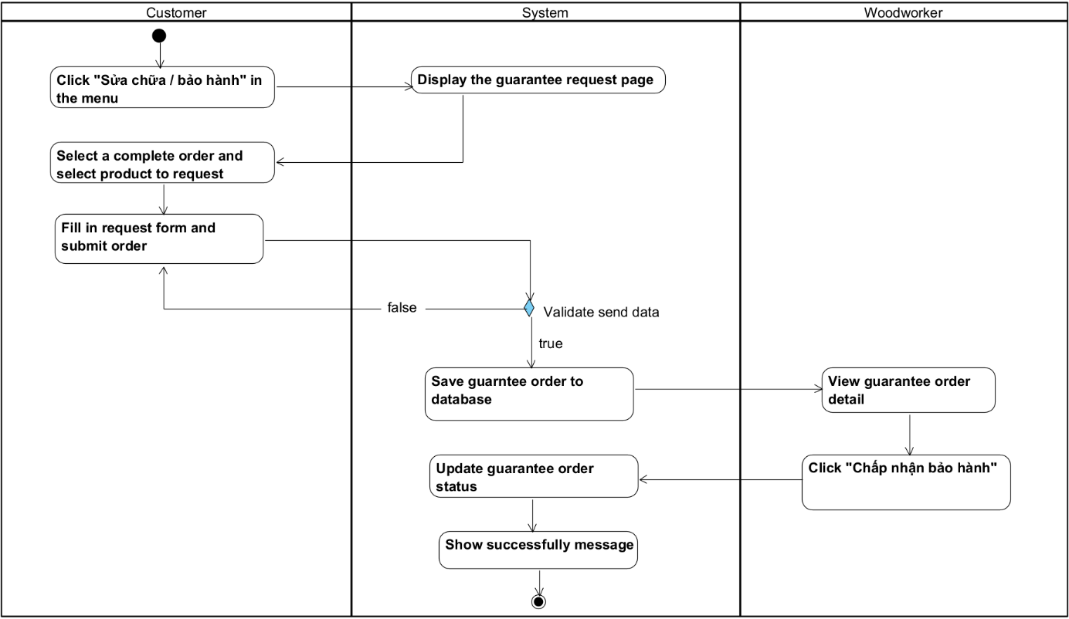

3.4.3 Sequence diagram

3.4.3.1 Request guarantee order sequence diagram
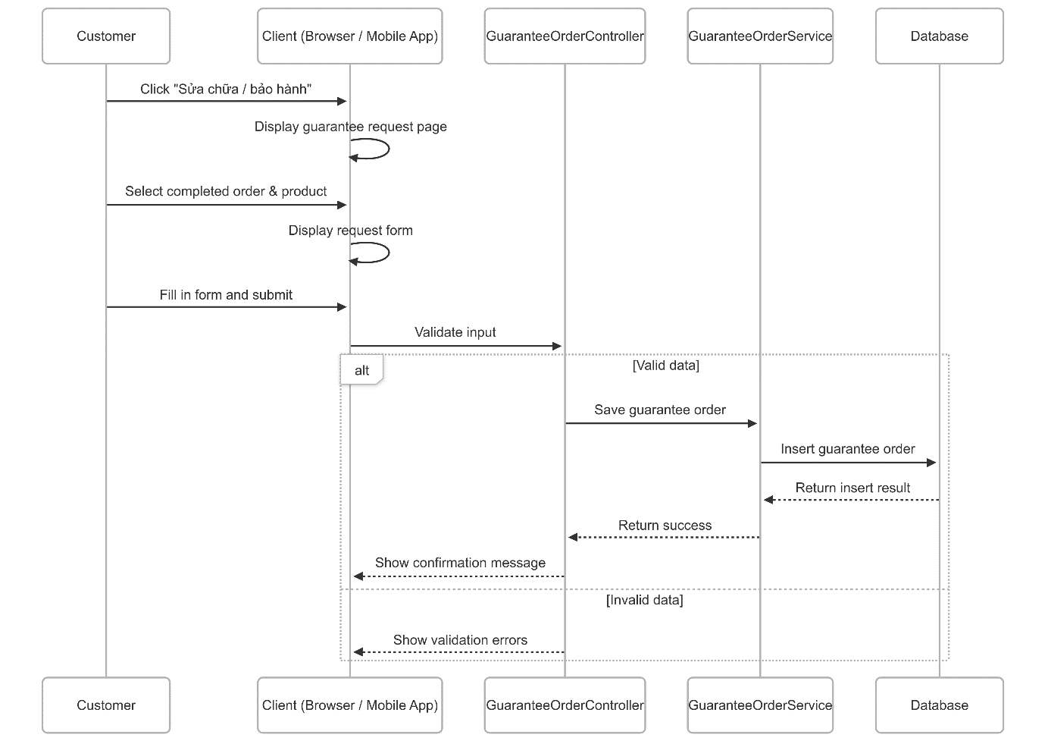

3.4.3.2 Accept guarantee order sequence diagram
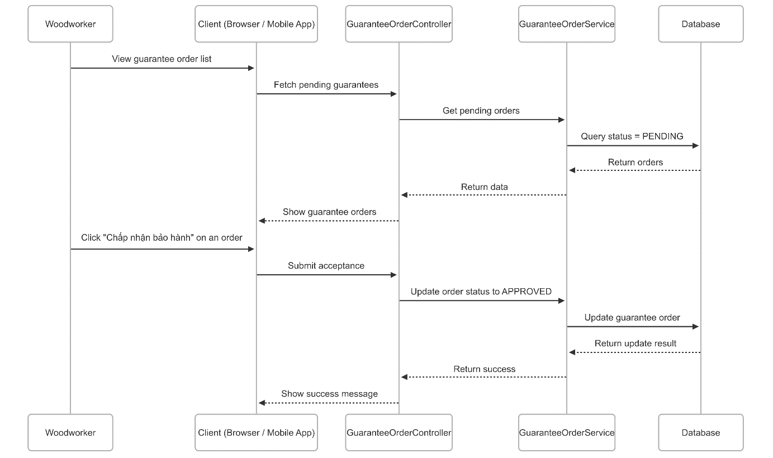

3.4.4 Guarantee order state machine diagram
