Capstone Project Week 2 Report
SP25SE026_GSP48

Prepared by GSP48
Võ Trọng Luân
Trần Việt Phúc
Nguyễn Đặng Phương Nam
Lê Nguyên An

Ho Chi Minh City, 2025
Table of Contents
Business goal 3
User classes 3
Guest 3
Customer 4
Woodwork company (owner, salesperson, designer, craftsmen) / individual woodworker 5
Woodwork company owner 5
Woodwork company salesperson 5
Woodwork company designer 6
Woodwork company craftsmen 6
Platform staff (moderator, support staff, administrator, chief accountant) 6
Moderator 6
Support staff 6
Chief accountant 7
Administrator 7
Context diagram 7
Main flow 8
Order available product 8
Book customization service 9
Book personalization service 9

Business goal
Customer: Obtain woodwork product based on need.
- Providing crafting services for woodwork products.
- Meeting the demand for personalization woodwork products.
Woodworker: Expand the customer base to increase revenue.
- Promoting personal branding.
- Reaching customers more easily.
- Increasing revenue by fulfilling diverse requests.

User classes

Guest
Goal: Browse the platform to explore woodworking services, products, and provider profiles, gaining valuable insights and confidence in quality without needing to register.
- Browse services, products and woodworker profiles.
  - View the list of services offered by woodworkers.
  - Access detailed service information, including the catalog.
  - Explore design options with available variants for specific designs within the service catalog.
  - Browse the list of woodworkers.
  - View detailed profiles of woodworkers, their skills, experience, and portfolio.
  - View the list of products offered by woodworkers.
  - Access detailed product information.
- Read reviews and ratings for products, services, and woodworkers.
  - View reviews and ratings for individual services.
  - View reviews and ratings for personalization services offered by a woodworker.
  - View reviews and ratings for available products offered by a woodworker.
  - View reviews and aggregate ratings for each woodworker.
- Search and filter services, woodworkers.
  - Search for services or woodworkers using keywords.
  - Filter services by location, or service category.
- Register.
  - Register with personal information as a customer.
  - Register with personal information and some extra information as a woodworker.

Customer
Goal: Obtain a woodwork product tailored to customer's needs by booking woodwork services.
- Book service and track progress, status of service order.
  - Book a service with customization base on available design.
  - Cancel a service booking.
  - View the history of customization service orders.
  - View customization service order details, including status and progress.
  - View quotes and schedules for customization service orders.
  - Confirm or adjust completion and installation dates for customization service orders.
  - Book a personalization service with a detailed requirement input form for a specific woodworker.
  - View the history of personalization service orders.
  - View personalization service order details, including status and progress.
  - Access personalization requirements and designs provided by the woodworker, with adjustments organized by date.
  - Confirm or provide feedback on personalization designs from the woodworker.
  - View quotes and schedules for personalization service bookings.
  - Confirm or adjust completion and installation dates for personalization service orders.
  - Leave ratings and feedback after service completion.
- Buy available product and track progress.
  - Add products to the cart.
  - Place an order for cart products.
  - View product order history.
  - View product order details, including progress and status.
- Manage wallet.
  - View transaction history and account balance.
  - View invoice list.
  - View invoice detail.
  - Deposit money to wallet.
  - Link bank account to wallet.
  - Request withdrawals to your bank account.
- Manage personal profile.
  - Reset passwords via email and update personal information.
  - Change passwords in profile settings.
- Communicate with woodworkers.
  - Send and receive message with woodworker for consultant.

Woodwork company (owner, salesperson, designer, craftsmen) / individual woodworker

Woodwork company owner
Goal: Offer service and showcase portfolio to attract client.
- Manage service, product.
  - Create and manage service.
  - Assign a price range to each design variant in the service catalog.
  - Create and manage product.
- Mange profile page.
  - Upload a post with photos, a text description, and videos to showcase skills, experience, and certifications.
  - Edit and update an existing post.
  - Delete a post.
- Respond to review.
  - View customer reviews in a dashboard.
  - Respond to reviews to address concerns or express gratitude to customers.
- Mange wallet.
  - View transaction history and account balance.
  - Link bank account to wallet.
  - Request withdrawals to your bank account.

Woodwork company salesperson
Goal: Mange product order, provide quote to customization, personalization service order.
- Mange product order.
  - View the list of product orders.
  - Confirm an order and submit a shipment request.
- Provide quote.
  - View the list of customization service order requests submitted by customers.
  - View detailed information about a customization service order and provide a quote.
  - View personalization service orders where the customer has accepted the woodworker's suggestions and designs.
  - View detailed information about a personalization service order and provide a quote.

Woodwork company designer
Goal: Collaborate with customers on personalization service orders and manage service catalog.
- Respond to customer’s request.
  - Refine customer requirements to ensure feasibility and provide solutions and provide notes explaining the reasons for any adjustments made to the customer’s requirements.
  - Upload design assets, including images or 3D models, tailored to the customer’s needs.
- Manage service catalog.
  - View the list of services.
  - View detailed information about each service.
  - Create and manage the service catalog.

Woodwork company craftsmen
Goal: Manage woodworking and installation requests and update their status.
- View work schedule.
  - View a calendar that organizes all crafting and installation requests.
  - View detailed specifications for crafting requests.
  - Update the status of completed products.

Platform staff (moderator, support staff, administrator, chief accountant)

Moderator
Goal: Monitor the quality and efficiency of services and woodworkers.
- View performance and satisfaction reports.
  - View all reviews and rating for specific services.
  - View all reviews and rating for specific woodworkers.
  - View charts on customer satisfaction and service performance.
  - Send email to woodworkers regarding performance or quality issues.

Support staff
Goal: Support customers and woodworkers with platform-related issues.
- Resolve help requests and respond feedback.
  - Provide assistance to customers and woodworkers via a support pop-up.
  - Approve or disapprove customer feedback.
  - Approve or disapprove woodworker response.
  - Respond to feedback.

Chief accountant
Goal: Manage system cash flow.
- Manage platform cash flow.
  - View transaction history and account balance.
  - View financial charts to gain insights into financial trends.
- Manage refunds for canceled orders from customers.
  - View a list of customer-canceled orders.
  - Access detailed information about canceled orders, including the date and reason for cancellation.
  - Approve the refund and deposit the amount into the customer’s wallet.
  - Hoan tien khi xử lý khiếu nại.
- Manage withdrawal requests to bank accounts.
  - View a list of withdrawal requests from customers or woodworkers.
  - Approve and process withdrawal requests.

Administrator
Goal: Oversee platform operations and manage users.
- Manage user accounts.
  - Create user accounts with any role.
  - Update user accounts with new roles or information.
  - Delete user accounts when necessary.
- Monitor platform activity.
  - View the platform dashboard, including key insights.
- Configure platform.
  - Set up the platform’s payment receiving bank.

Context diagram
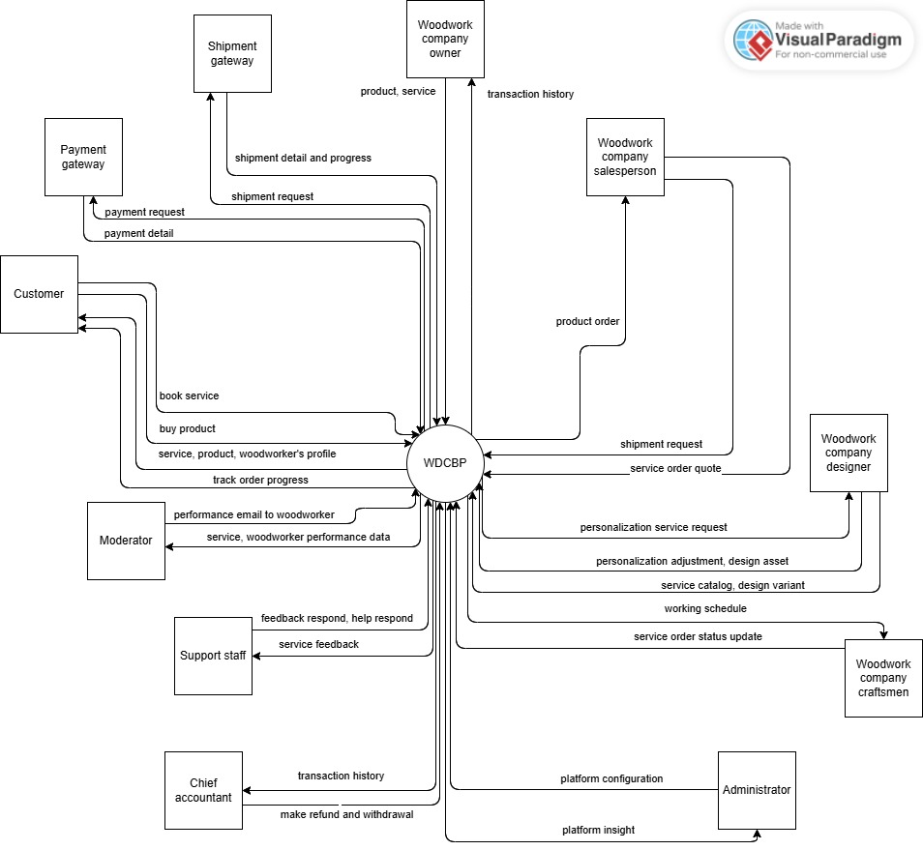

Main flow

Order available product
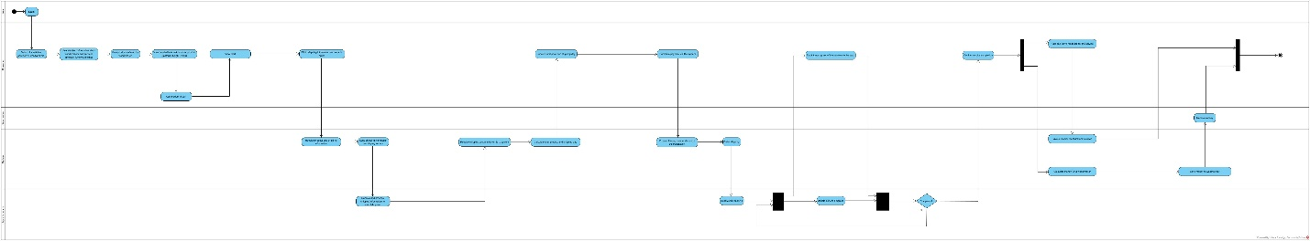

Book customization service
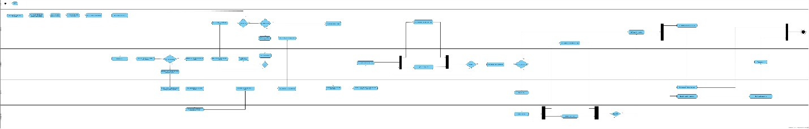

Book personalization service
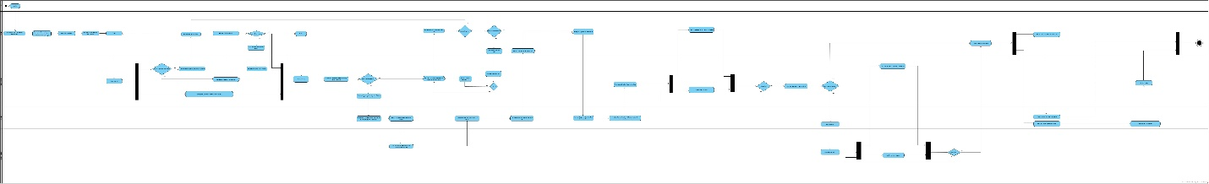

End.

