Capstone Project Week 3 Report
SP25SE026_GSP48

Prepared by GSP48
Võ Trọng Luân
Trần Việt Phúc
Nguyễn Đặng Phương Nam
Lê Nguyên An

Ho Chi Minh City, 2025
Table of Contents
Business goal 3
User classes 3
Guest 3
Customer 4
Woodworkers 5
Moderator 6
Support staff 6
Chief accountant 6
Administrator 7
Context diagram 7
Main flow 8
Order available product 8
Book customization service with option 8
Book customization service with change 9
Book personalization service 9
Cancel order 9
Use case diagram 9
State machine diagram 10
Product order 10
Service order 11
Account 12
Feedback 13
Product 13
Woodwork property 14

Business goal
Customer: Obtain woodwork product based on need.
- Exploring crafting services for woodwork products.
- Meeting the demand for personalization woodwork products.
Woodworker: Expand the customer base to increase revenue.
- Promoting personal branding.
- Reaching customers more easily.
- Increasing revenue by fulfilling diverse requests.

User classes

Guest
Goal: Browse the platform to explore woodworking services, products, and provider profiles, gaining valuable insights and confidence in quality without needing to register.
- Browse services, products and woodworker profiles.
  - View the list of services offered by woodworkers.
  - Access detailed service information, including the catalog.
  - Explore design options with available options for specific designs within the service catalog.
  - Browse the list of woodworkers.
  - View detailed profiles of woodworkers, their skills, experience, and portfolio.
  - View the list of products offered by woodworkers.
  - Access detailed product information.
- Read reviews and ratings for products, services, and woodworkers.
  - View reviews and ratings for individual services.
  - View reviews and ratings for personalization services offered by a woodworker.
  - View reviews and ratings for available products offered by a woodworker.
  - View reviews and aggregate ratings for each woodworker.
- Search and filter services, woodworkers, products.
  - Search for services, woodworkers or products using keywords.
  - Filter services by location, or service category.
- Register.
  - Register with personal information as a customer.
  - Register with personal information and some extra information as a woodworker.

Customer
Goal: Obtain a woodwork product tailored to customer's needs by booking woodwork services.
- Book service and track progress, status of service order.
  - Book a service with customization base on available design.
  - Cancel a service order.
  - View the history of customization service orders.
  - View customization service order details, including status and progress.
  - View quote and schedules for customization service orders.
  - Confirm or adjust woodworker’s offer for customization service orders.
  - Book a personalization service with a detailed requirement input form for a specific woodworker.
  - View the history of personalization service orders.
  - View personalization service order details, including status and progress.
  - Access personalization requirements and designs provided by the woodworker, with adjustments organized by date.
  - View quote and schedules for personalization service orders.
  - Confirm or provide feedback on personalization designs from the woodworker.
  - Confirm or adjust woodworker’s offer for personalization service orders.
  - Leave ratings and feedback after service completion.
- Buy available product and track progress.
  - Place an order.
  - Cancel an order.
  - View product order history.
  - View product order details, including progress and status.
- Complaint problem about product
  - Request a refund with proof.
- Manage wallet.
  - View transaction history and account balance.
  - View transaction detail.
  - Deposit money to wallet.
  - Link bank account to wallet.
  - Request withdrawals to bank account.
- Manage personal profile.
  - Reset passwords via email and update personal information.
  - Change passwords in profile settings.
  - Update personal information.
- Communicate with woodworkers and support staff.
  - Send and receive message with woodworker for consultant.
  - Create Q&A and view the answer.

Woodworkers
Goal: Offer service, product and showcase portfolio to attract client.
- Manage service, product.
  - Create and manage service.
  - Create and manage product.
  - Create and manage the service catalog.
  - Assign price to each configuration in the service catalog.
- Mange profile page.
  - Upload a post with photos, a text description, and videos to showcase skills, experience, and certifications.
  - Edit and update an existing post.
  - Delete a post.
- Respond to review.
  - View customer reviews in a dashboard.
  - Respond to reviews to address concerns or express gratitude to customers.
- Mange wallet.
  - View transaction history and account balance.
  - View transaction detail
  - Link bank account to wallet.
  - Request withdrawals to your bank account.
- Mange product order.
  - View the list of product orders.
  - Confirm an order.
- Provide quote and configuration options.
  - View the list of customization service order requests submitted by customers.
  - View detailed information about a customization service order and provide product configuration include price.
  - View personalization service orders where the customer has accepted suggestions and designs.
  - View detailed information about a personalization service order and provide product configuration include price.
- Respond to customer’s request.
  - Create and manage form for customer’s requirements for each service request.
  - Refine customer requirements to ensure feasibility and provide solutions and provide notes explaining the reasons for any adjustments made to the customer’s requirements.
  - Upload design assets, including images or 3D models, tailored to the customer’s needs.
- View work schedule.
  - View a calendar that organizes all crafting and installation requests.
  - View detailed specifications for crafting requests.
  - Update the status of completed products.

Moderator
Goal: Monitor the quality and efficiency of services and woodworkers.
- View performance and satisfaction reports.
  - View all reviews and rating for specific services.
  - View all reviews and rating for specific woodworkers.
  - View charts on customer satisfaction and service performance.
  - Send email to woodworkers regarding performance or quality issues.

Support staff
Goal: Support customers and woodworkers with platform-related issues.
- Control customer and woodworker comments.
  - Control customer feedback.
  - Control woodworker response.
- Manage Q&A.
  - View Q&A list.
  - View Q&A detail
  - Reply to Q&A.

Chief accountant
Goal: Manage system cash flow.
- Manage platform cash flow.
  - View transaction history and account balance.
  - View financial charts to gain insights into financial trends.
- Manage refund.
  - View a list of customer-canceled orders.
  - View detailed information about canceled orders, including the date and reason for cancellation.
  - View a list of customer complaint about product problem.
  - View detailed information about complaint, including the proof.
  - Request explanation from woodworker about product problem.
  - View detailed information about woodworker’s explanation.
  - Approve the refund and deposit the amount into the customer’s wallet.
- Manage withdrawal requests to bank accounts.
  - View a list of withdrawal requests from customers or woodworkers.
  - Approve and process withdrawal requests.

Administrator
Goal: Oversee platform operations and manage users.
- Manage user accounts.
  - View account list and detail.
  - Update user accounts with new roles or information.
  - Unactive user accounts when necessary.
- Monitor platform activity.
  - View the platform dashboard, including key insights.
- Configure platform.
  - Set up the platform’s payment receiving bank.

Context diagram
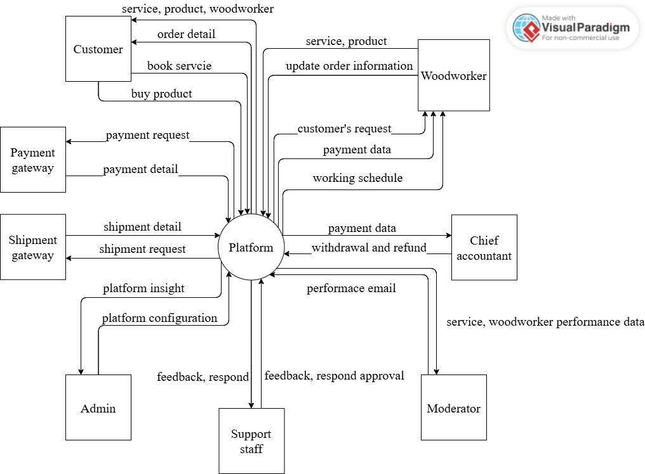

Main flow

Order available product
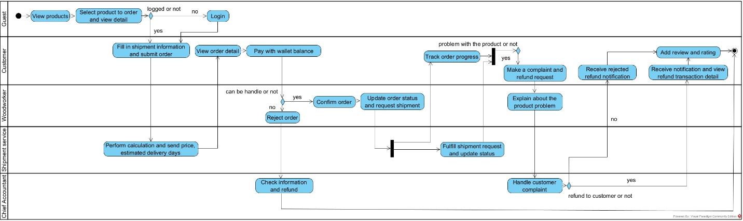

Book customization service with option
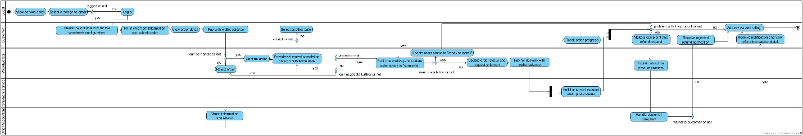

Book customization service with change
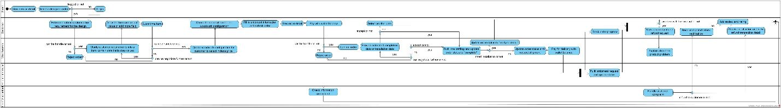

Book personalization service
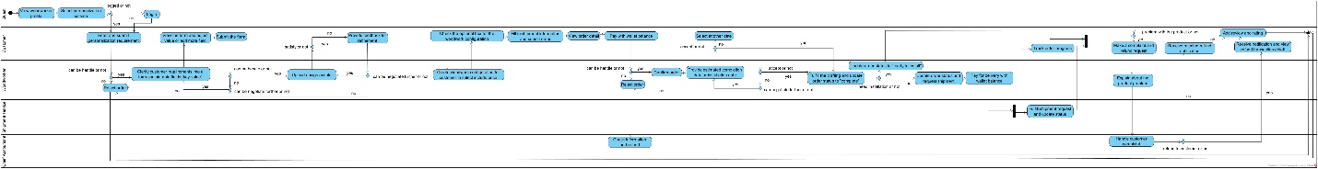

Cancel order
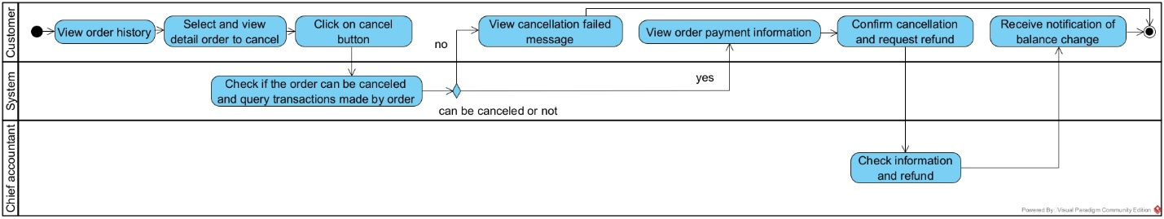

Use case diagram
https://drive.google.com/file/d/1WUTZ9REzMyxlnWvfd_Bdxh-BvrJc1qqS/view?usp=sharing
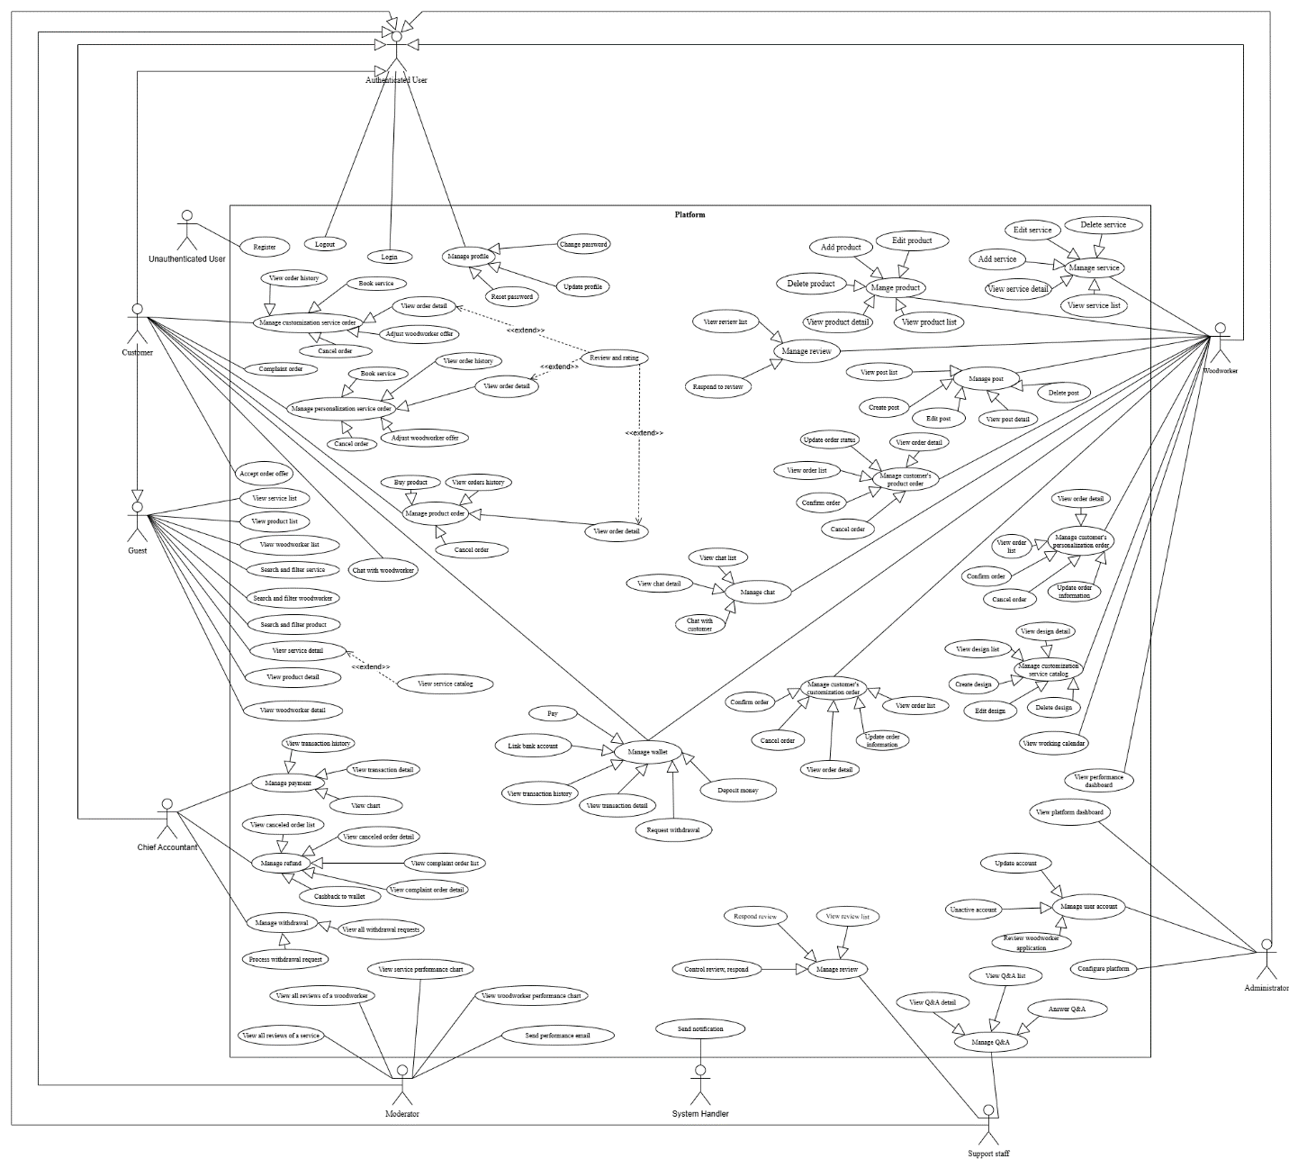

State machine diagram

Product order
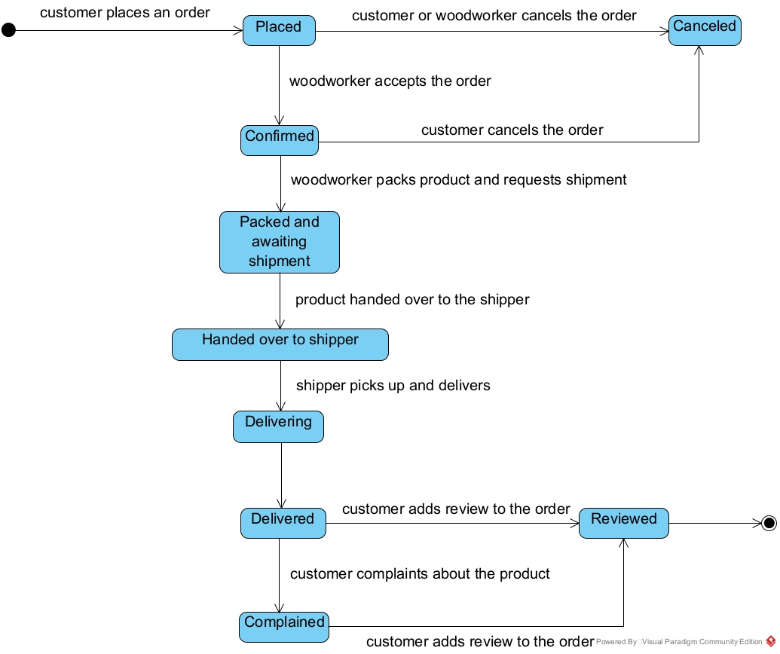

Service order
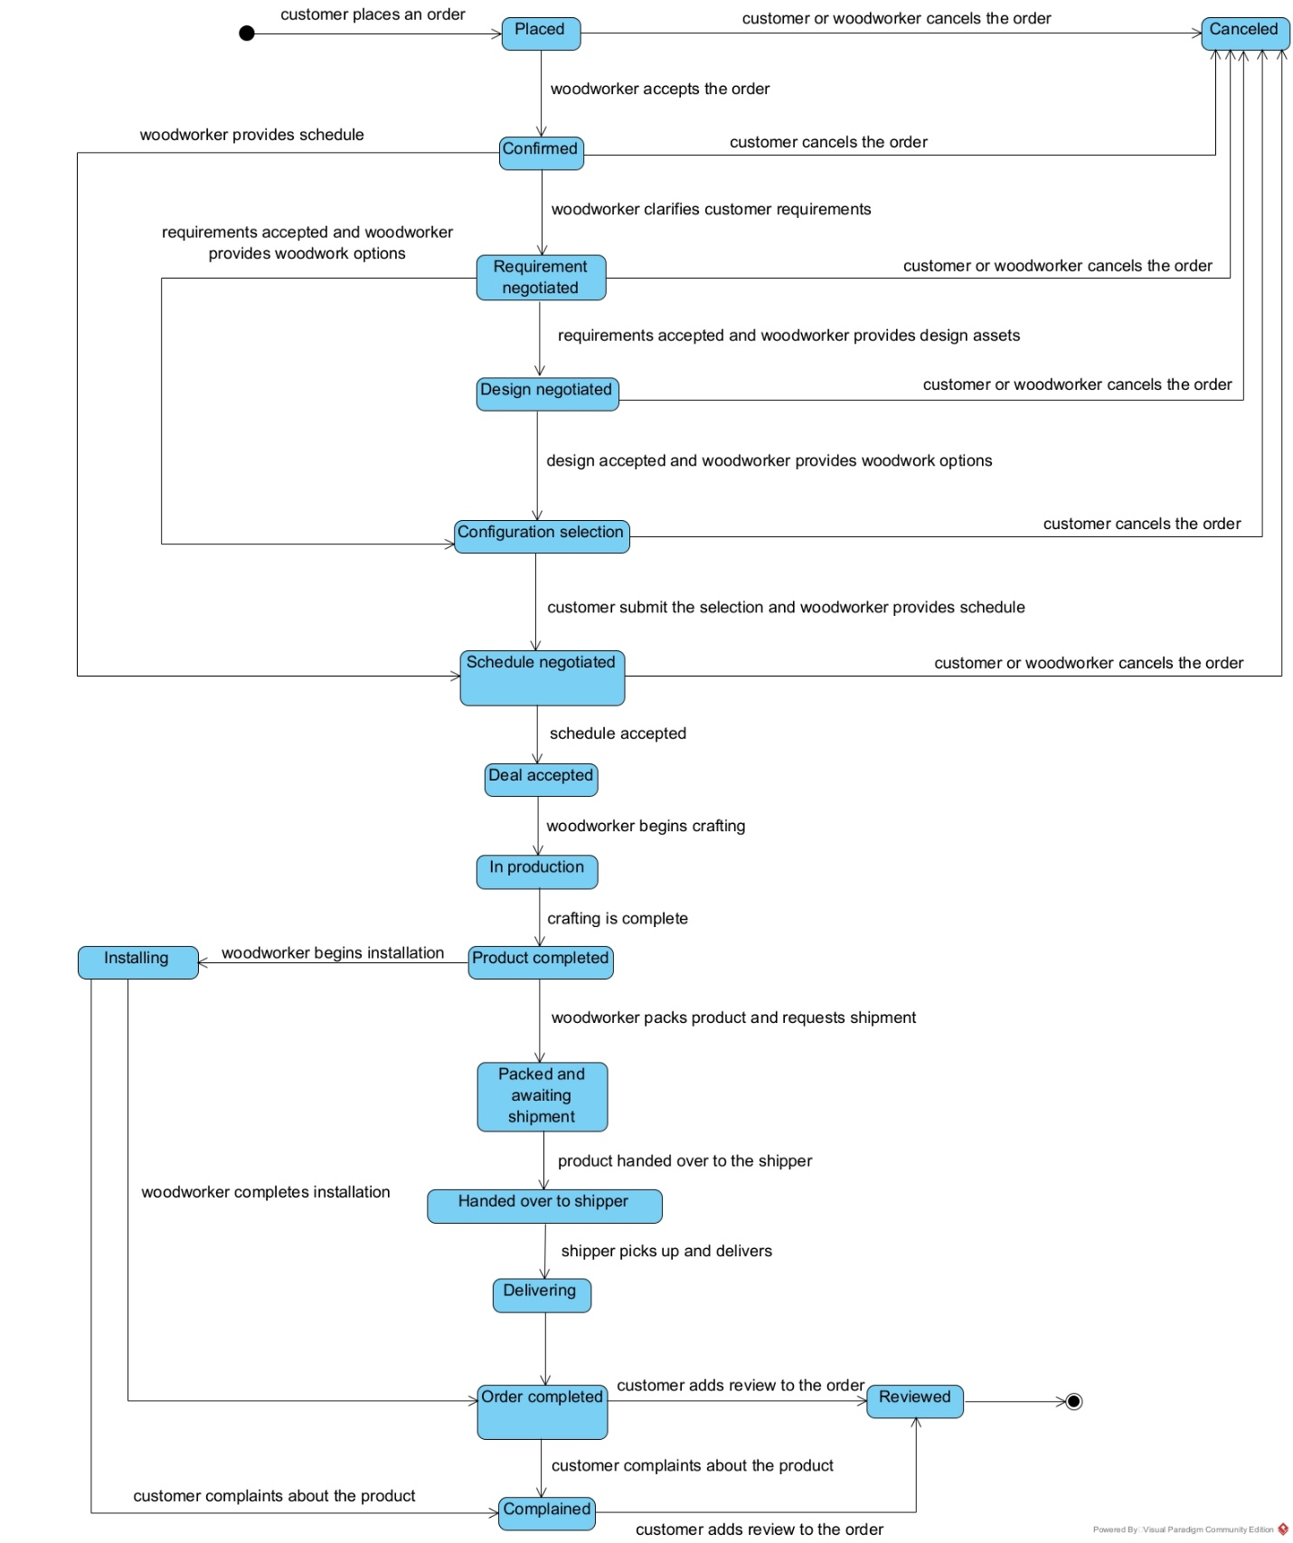

Account
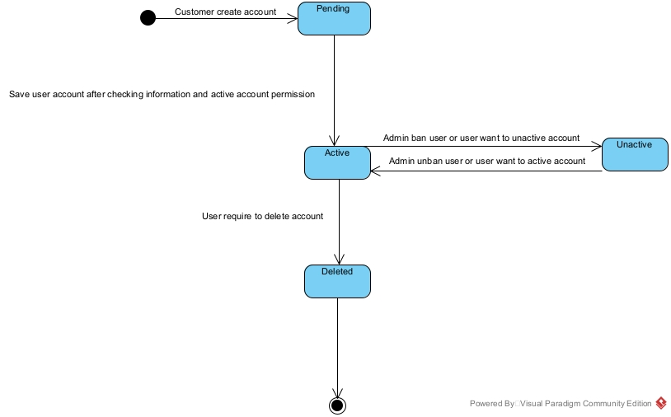

Feedback
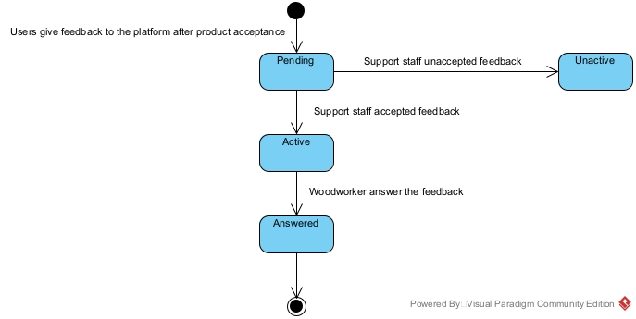

Product
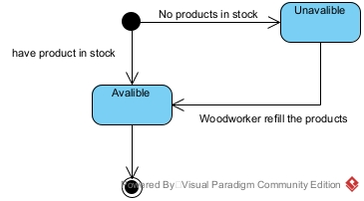

Woodwork property
- Kích thước tổng thể: (Dài x Rộng x Cao - cm).
- Trọng lượng sản phẩm: Quan trọng để khách biết khi vận chuyển.
- Chi tiết kích thước từng phần: Nếu sản phẩm có ngăn kéo, kệ, chân gập, v.v.
- Bản vẽ thiết kế 3D, bóc tách 2D từng phần.
- Loại gỗ: Gỗ tự nhiên (sồi, óc chó, xoan đào, gụ, teak, v.v.) hay gỗ công nghiệp (MDF, HDF, Plywood, v.v.).
- Xử lý bề mặt: Sơn PU, dầu lau, phủ laminate, veneer, melamine, v.v.
- Màu sắc: Màu gỗ tự nhiên, trắng, đen, v.v.
- Độ bền & khả năng chống nước, mối mọt: Nếu có.
- Phong cách: Hiện đại, tối giản, cổ điển, vintage, rustic, v.v.
- Tính năng đặc biệt: Gấp gọn, có bánh xe, điều chỉnh chiều cao, chống ẩm, chống xước, v.v.
- Công năng sử dụng: Để làm việc, trang trí, lưu trữ, v.v.
- Loại ghép gỗ, kỹ thuật gia công: Gỗ nguyên khối hay ghép thanh.
- Mùi hương đặc trưng (nếu có): Mùi thơm tùy theo từng loại gỗ khác nhau.
- Vân gỗ: Mỗi loại gỗ có vân đặc trưng (vân núi, vân xoáy, vân thẳng…).
- Kết cấu bề mặt: gỗ tự nhiên có bề mặt ấm áp, mềm mịn khi được xử lý tốt.
- Khả năng tùy biến, chạm khắc.
- Tính thẩm mỹ: hoa văn điêu khắc hình rồng.
- Thân thiện với môi trường: có thể tái chế để sản xuất sản phẩm khác.

End.

