Capstone Project Week 3 Report
SP25SE026_GSP48

Prepared by GSP48
Võ Trọng Luân
Trần Việt Phúc
Nguyễn Đặng Phương Nam
Lê Nguyên An

Ho Chi Minh City, 2025
Table of Contents
Business goal 3
User classes 3
Guest 3
Customer 3
Woodworkers 4
Moderator 4
Support staff 4
Administrator 4
Context diagram 5
Main flow 6
Order available product 6
Book customization service with option 6
Book customization service with change 6
Book personalization service 6
Cancel order 6
Use case diagram 7
State machine diagram 8
Product order 8
Service order 8
Account 9
Feedback 10
Product 10
Woodwork property 11

Business goal
Customer: Obtain woodwork product based on need.
- Exploring crafting services for woodwork products.
- Meeting the demand for personalization woodwork products.
Woodworker: Expand the customer base to increase revenue.
- Promoting personal branding.
- Reaching customers more easily.
- Increasing revenue by fulfilling diverse requests.

User classes

Guest
Goal: Browse the platform to explore woodworking services, products, and provider profiles, gaining valuable insights and confidence in quality without needing to register.
- Search, filter, view all, view woodworker.
- Search, filter, view all, view product offered by woodworker.
- Search, filter, view all, view service offered by woodworker.
- Register.

Customer
Goal: Obtain a woodwork product tailored to customer's needs by booking woodwork services.
- Order product and manage order: view all, view, cancel, complain, send feedback.
- Book and manage customization service order: view all, view, cancel, complain, send feedback.
- Book and manage personalization service order: view all, view, cancel, complain, send feedback.
- Book and manage repair service order: view all, view, cancel, complain, send feedback.
- Manage wallet.
- Manage chat.
- Manage contract.
- Manage appointment.
- Manage account: update profile, change password, reset password.

Woodworkers
Goal: Offer service, product, handle customer request and showcase portfolio to attract client.
- Manage service: create, update, delete, view all, view.
- Manage design catalog: create, update, delete, view all, view.
- Manage product: create, update, delete, view all, view.
- Manage post: create, update, delete, view all, view.
- Manage product order: view all, view, update information, cancel.
- Manage customization order
- Manage personalization order
- Manage contract
- Manage appointment
- Manage wallet
- Manage customer complaint
- Manage chat
- Manage review
- View performance dashboard
- Manage account

Moderator
Goal: Monitor the quality and efficiency of services and woodworkers.
- View performance data
- Send performance email

Support staff
Goal: Support customers and woodworkers with platform-related issues.
- Control customer and woodworker comments.
  - Control customer feedback.
  - Control woodworker response.
- Manage Q&A.
  - View all Q&A.
  - View Q&A detail
  - Reply to Q&A.

Administrator
Goal: Oversee platform operations and manage users.
- Manage user accounts.
  - View account list and detail.
  - Update user accounts with new roles or information.
  - Unactive user accounts when necessary.
- Monitor platform activity.
  - View the platform dashboard, including key insights.
- Configure platform.
  - Set up the platform’s payment receiving bank.

Context diagram
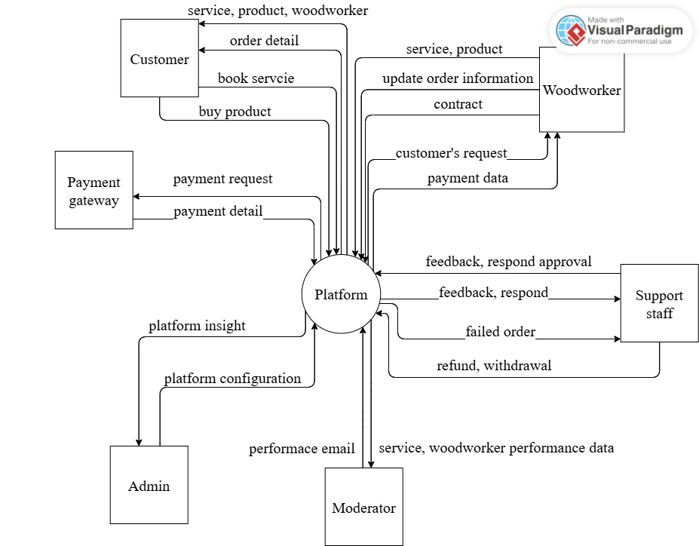

Main flow

Order available product
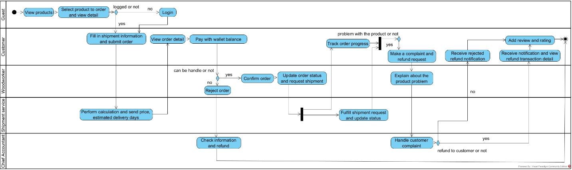

Book customization service with option
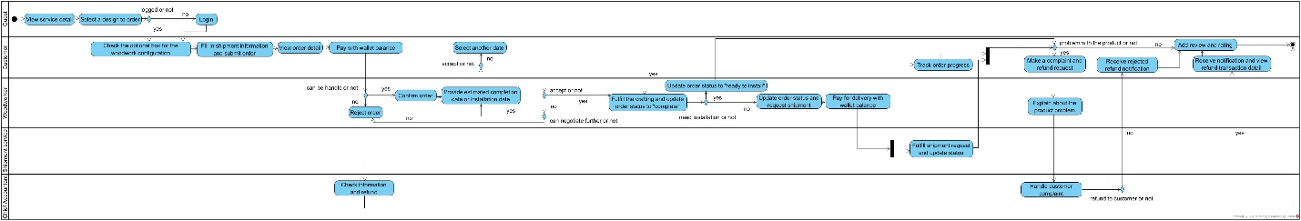

Book customization service with change
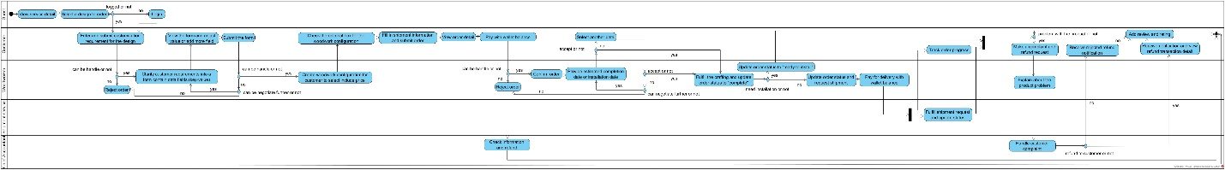

Book personalization service
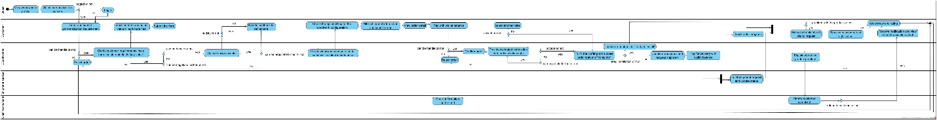

Cancel order
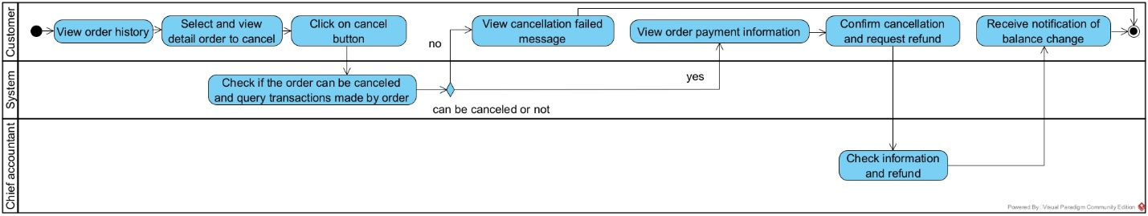

Use case diagram
https://drive.google.com/file/d/1WUTZ9REzMyxlnWvfd_Bdxh-BvrJc1qqS/view?usp=sharing
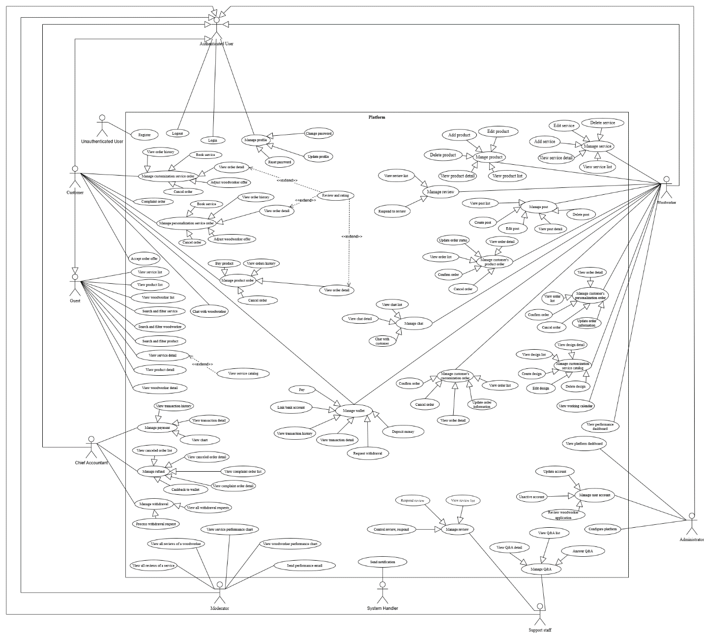

State machine diagram

Product order
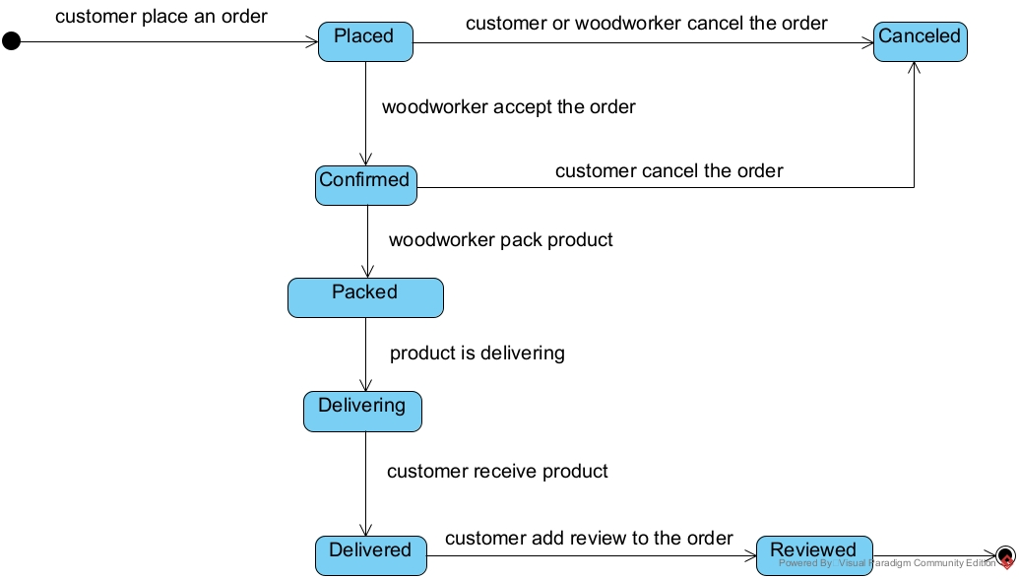

Service order
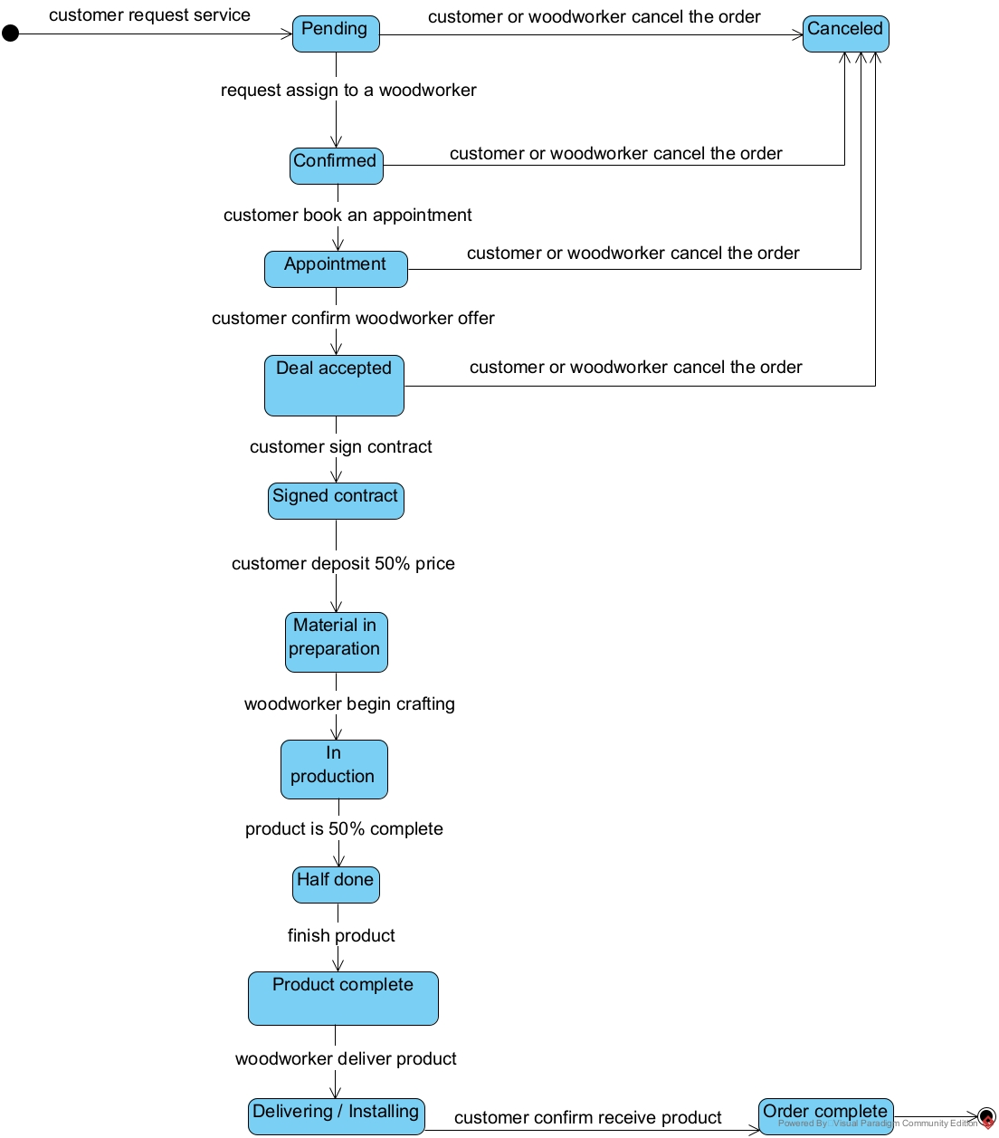

Account
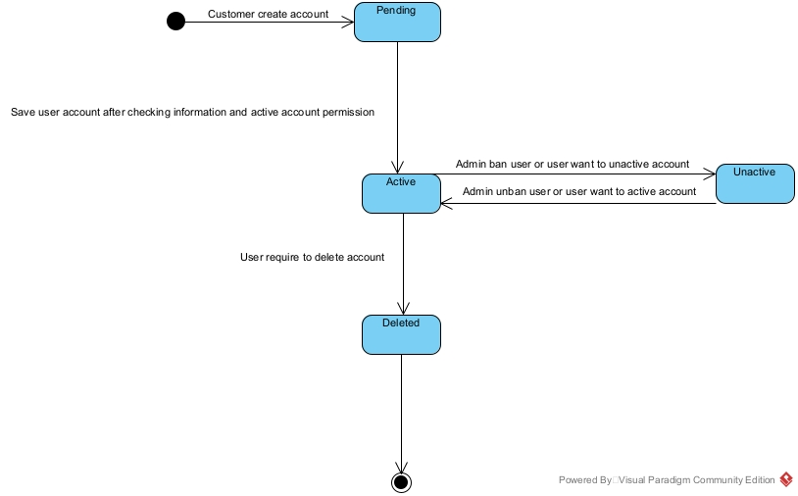

Feedback
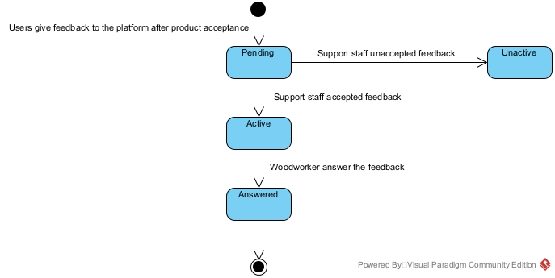

Product
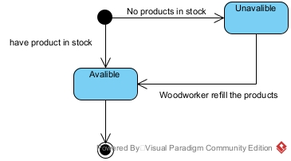

Woodwork property
- Kích thước tổng thể: (Dài x Rộng x Cao - cm).
- Trọng lượng sản phẩm: Quan trọng để khách biết khi vận chuyển.
- Chi tiết kích thước từng phần: Nếu sản phẩm có ngăn kéo, kệ, chân gập, v.v.
- Bản vẽ thiết kế 3D, bóc tách 2D từng phần.
- Loại gỗ: Gỗ tự nhiên (sồi, óc chó, xoan đào, gụ, teak, v.v.) hay gỗ công nghiệp (MDF, HDF, Plywood, v.v.).
- Xử lý bề mặt: Sơn PU, dầu lau, phủ laminate, veneer, melamine, v.v.
- Màu sắc: Màu gỗ tự nhiên, trắng, đen, v.v.
- Độ bền & khả năng chống nước, mối mọt: Nếu có.
- Phong cách: Hiện đại, tối giản, cổ điển, vintage, rustic, v.v.
- Tính năng đặc biệt: Gấp gọn, có bánh xe, điều chỉnh chiều cao, chống ẩm, chống xước, v.v.
- Công năng sử dụng: Để làm việc, trang trí, lưu trữ, v.v.
- Loại ghép gỗ, kỹ thuật gia công: Gỗ nguyên khối hay ghép thanh.
- Mùi hương đặc trưng (nếu có): Mùi thơm tùy theo từng loại gỗ khác nhau.
- Vân gỗ: Mỗi loại gỗ có vân đặc trưng (vân núi, vân xoáy, vân thẳng…).
- Kết cấu bề mặt: gỗ tự nhiên có bề mặt ấm áp, mềm mịn khi được xử lý tốt.
- Khả năng tùy biến, chạm khắc.
- Tính thẩm mỹ: hoa văn điêu khắc hình rồng.
- Thân thiện với môi trường: có thể tái chế để sản xuất sản phẩm khác.

End.

