VUNGU RURAL DISTRICT COUNCIL
SpartialIQ Information System
System Actors and Use-Cases Handbook
A one-page guide to every person who uses the system, split into internal council operations and external client operations
Internal operations | External client operations | Flowcharts

1. How to read this handbook
This handbook explains, in plain English, every person who works with the Vungu Rural District Council information system (known in the project as SpartialIQ). It is written from the roles and workflows that actually exist in the software, and it is organised around one clear split:
- Internal operations are the council's own protected workflow, where council staff receive records, carry out technical work, and make or support decisions. Citizens do not take part in this side directly.
- External operations are the public-facing services used by clients - residents, landowners, businesses and their representatives - who apply, pay, upload documents, communicate and track their own cases.
The two sides meet through controlled hand-offs: a receipted application, an assigned task, a recorded decision, a formal notice, a payment, and a status update the client can see. Each actor below is given a full page covering who they are, what the law and good local-authority practice expect of them, exactly what they do inside the system, and the limits of their role.
A role is a category of system account. It does not replace the legal authority, professional judgement or appointment of the person holding it. Council resolutions, adopted by-laws and the current wording of Acts always come first; this document is a training and supervision aid, not legal advice.

1.1 The legal backbone
Every activity in the system traces back to Zimbabwean law and to the council's own procedures. The main instruments are:
Instrument | Why it matters here
Regional, Town and Country Planning Act [Chapter 29:12] | Master and local plans, development permits, subdivision, enforcement and appeals
Rural District Councils Act [Chapter 29:13] | Council powers, committees and the administration of the district
Urban Councils Act [Chapter 29:15] | Building permits and by-laws that shape inspection practice
Public Health Act, 2018 | The council must appoint environmental health officers; premises, nuisances, food and burial
Environmental Management Act [Chapter 20:27] | Environmental impact and consultation requirements for certain developments
Land Survey Act [Chapter 20:12] & Land Surveyors Act [Chapter 27:06] | Licensed land surveyors; the Surveyor-General examines cadastral surveys

1.2 Five best-practice principles built into the system
- Separation of duties - the person who assesses a case is not always the person who finally decides it.
- A complete file before determination - decisions are not recorded on incomplete or unregistered files.
- Records that survive staff change - everything is stored in the central database, not on one officer's computer.
- One spatial Single Source of Truth - no invented or duplicated map geometry.
- A lawful cadastral chain - planning permit, then licensed survey, then Surveyor-General, then Deeds. SpartialIQ supports this chain; it does not replace it.

2. The full actor map
The system recognises eleven account roles. Three are citizen-side access levels (public, registered, viewer) and eight are council staff roles. The table below is the master index for the rest of the handbook. Governance participants such as committee members and a Director of Planning appear in the statutory workflow but are not separate login accounts; they are covered at the end of the internal section.

2.1 External operations - clients and the public
Actor (account role) | Landing area | Main responsibility
Public visitor (public) | Citizen landing page | Browse public information and services; begin an account or application where enabled
Registered applicant (registered) | Citizen portal | Maintain an account and submit, pay for and follow their own service requests
Viewer (viewer) | Citizen landing page (read-only) | Read permitted public or shared information without the full applicant workflow
Citizen / client | Citizen portal | The main service user: prove residency, apply, upload, pay, communicate and track outcomes

2.2 Internal operations - council staff
Actor (account role) | Landing area | Main responsibility
Planning Clerk (planning_clerk) | Planning Clerk portal | Intake, records, fees, notices, registers, correspondence and dispatch
Planner (planner) | Planner workspace / Planning Studio | Assessment, due diligence, technical circulation, land-use planning, recommendations
Environmental Officer / EHO (env_officer) | Environmental Health Officer workspace | Environmental appraisal, inspections, surveillance, health clearances and specialist responses
Surveyor (surveyor) | Surveyor map console / task manager | Assigned field survey, beacons, measurements, Reports on Survey and diagrams
GIS Officer (gis_officer) | GIS Officer portal | Authoritative spatial data, zoning and constraints, map publication, QGIS coordination
Executive Officer (eo) | EO planner portal | Statutory review and determination within the configured decision controls
Building Inspector (building_inspector) | Inspector workspace | Construction-stage inspections, compliance records, enforcement, occupation certificate
System Administrator (admin) | Admin console | User access, configuration, content, platform health and system governance

The eleven roles are exactly the values permitted by the users_role_check rule in the database. A role that is not in that list cannot exist on any account, so the software cannot accidentally depend on a role that does not exist. Admin is deliberately treated as an IT role: several planning screens are kept out of the administrator's way so that the IT desk cannot quietly make a planning decision.

Part A - External operations: clients and the public
External operations are the services the council offers to the people it serves. These are the actors who do not sit inside the council's protected workflow but who start it, feed it, pay for it and receive its outcomes. Each is given a full page below.

A.1 The public visitor (account role: public)
Who they are. A public visitor is a person who has not yet completed the account or residency steps needed for a full client workflow. This may be a resident curious about services, a prospective investor researching the district, a student, a journalist, or an ordinary member of the public checking public information. In practice it is anyone who opens the council portal without being signed in to a verified account.
What the system lets them do. The public-facing system gives this person a starting point for understanding council services, finding public information, registering or logging in, and beginning a service request where the relevant route is available. Public information includes service descriptions and permitted map or layer information. Crucially, it does not expose private application records, internal staff comments, personal details, or anyone's work queue. If the person proceeds to a service that requires an identity or district-residency check, the system directs them into the appropriate account and evidence process rather than letting them carry on unprotected.
Their use case in one line. Discovery and entry: understand what the council offers, provide the minimum information needed to establish an account, and move into a protected client space before submitting any sensitive material.
What they cannot do. A public visitor does not make council decisions, verify another person's evidence, edit official land or permit records, or restyle or publish any map layer. Once they authenticate, their practical actor category becomes a registered applicant or a citizen/client, depending on the account status and the service being used.
Typical activities:
- Read service descriptions, guidance and public maps or layers.
- Register for an account (with CAPTCHA protection) or sign in.
- Start a service request where the route is open to them.
- Be routed to identity or residency proofing when the service requires it.

A.2 The viewer (account role: viewer)
Who they are. The viewer is an account holder who needs read-only access to information the system permits them to see, but who does not need - or has not yet chosen - the full registered-applicant workflow. This might be a consultant, a researcher, a neighbouring landowner, a partner agency, or a resident who simply wants to consult information before deciding whether to transact with the council.
What the system lets them do. The viewer role supports inspecting public-facing information, maps, service guidance, or shared records without the authority to submit or manage the full client application workflow. A viewer can use the information to understand the district, locate relevant public data, or review a service before deciding whether to register and apply. The role is deliberately different from an internal staff role.
What they cannot do. A viewer cannot edit authoritative GIS layers, update a permit, access another applicant's private file, record an inspection, or issue a decision. If a viewer needs to transact with the council, they must use the registration and application path and satisfy any identity or residency requirements for that service. This separation lets the council provide genuinely useful information while keeping personal and operational records inside authenticated, role-appropriate workspaces.
Why the role exists. It gives the council a safe middle ground: enough access to be transparent and useful, not enough access to create risk. It keeps read-only public data available to people who should see it, without forcing every one of them into a full applicant account they do not need.

A.3 The registered applicant (account role: registered)
Who they are. A registered applicant is an external user who has created an account and can carry out the client-side steps the portal makes available. They have moved beyond anonymous browsing and now have a persistent identity in the system: a place where their contact details, their documents and the history of their dealings with the council are kept together.
What the system lets them do. They use their account to maintain contact and identity information, start and submit applications, upload plans and supporting documents, arrange payment, review receipts, respond to requests for more information, and follow the progress of their own cases. Where residency verification applies, an unverified account must provide acceptable proof, or complete the available deed-check process, before relying on services restricted to verified residents.
Life after submission. Once the application is submitted it becomes an official work item for council staff. From that point the applicant can see the permitted status and next-step information on their own case, while internal recommendations and restricted staff notes remain internal. A registered applicant is responsible for the accuracy and completeness of what they submit, and for responding to notices or document requests. The system provides a traceable communication and status channel, but the applicant does not route cases between council departments and cannot grant themselves a permit.
Where the relationship ends. Their interaction ends with a recorded council outcome, delivery of the permitted documents or service, and any follow-up obligations such as construction-stage inspections. Good practice expects them to keep copies of what they submit, to respond when the council asks for missing documents, and not to start illegal building while a file is still pending.

A.4 The citizen / client (resident, landowner, business or representative)
Who they are. The citizen/client is the main external service user, whether the underlying account is public or registered. Depending on the service, a client may act as an owner, occupier, business, applicant, or authorised representative. This is the person at the centre of the council's promise: to serve its own residents lawfully and transparently.
Starting a service. The client begins by selecting the service, completing the requested application fields, identifying the relevant property or stand, attaching plans and evidence, and submitting the request. For residency-controlled services, the client supplies a deed reference for a logged registry check, or uploads acceptable proof such as an occupation certificate, a lodger's permit, a settlement or offer letter, a rates or utility statement, or a chief or councillor confirmation letter.
Paying and participating. The client pays applicable fees through an available payment route and keeps the receipt and reference. During processing, the client uses the application timeline to see the current stage and may answer a request for more information, review a notice, or lodge a permitted objection or appeal. If a neighbour applies during a formal notice period, an affected client may object in the way the notice explains, with their name and grounds.
Building and close-out. If a development permit is approved, the client follows its conditions, requests inspections at the required stages, and receives the occupation certificate only after the applicable inspection process is complete. The portal gives the client a clear view of their own case; statutory assessment, internal circulation and decision authority remain with council officers and the configured governance steps. The client is not expected to edit council maps, approve their own permit, or treat an online map or a demonstration registry screen as their title deed.

A.5 External flowcharts

A.5.1 Proving you belong to the district (residency verification)
The council serves its own residents, so a new citizen-tier account must prove it belongs before it can use restricted services. On first login, any account whose residency is not yet verified is routed to the residency page. There it can either enter a deed number for an instant check against the Deeds Registry (a logged lookup against a simulated Ministry of Lands service), or upload acceptable proof - an occupation certificate, a lodger's permit, a settlement or offer letter, a rates or utility statement, or a chief or councillor confirmation letter. Uploaded documents go into a review queue that authorised staff can verify or reject. A deed check that matches the holder's national ID verifies residency instantly; an uploaded document is verified by a reviewing officer. Until verification succeeds, restricted services stay locked.
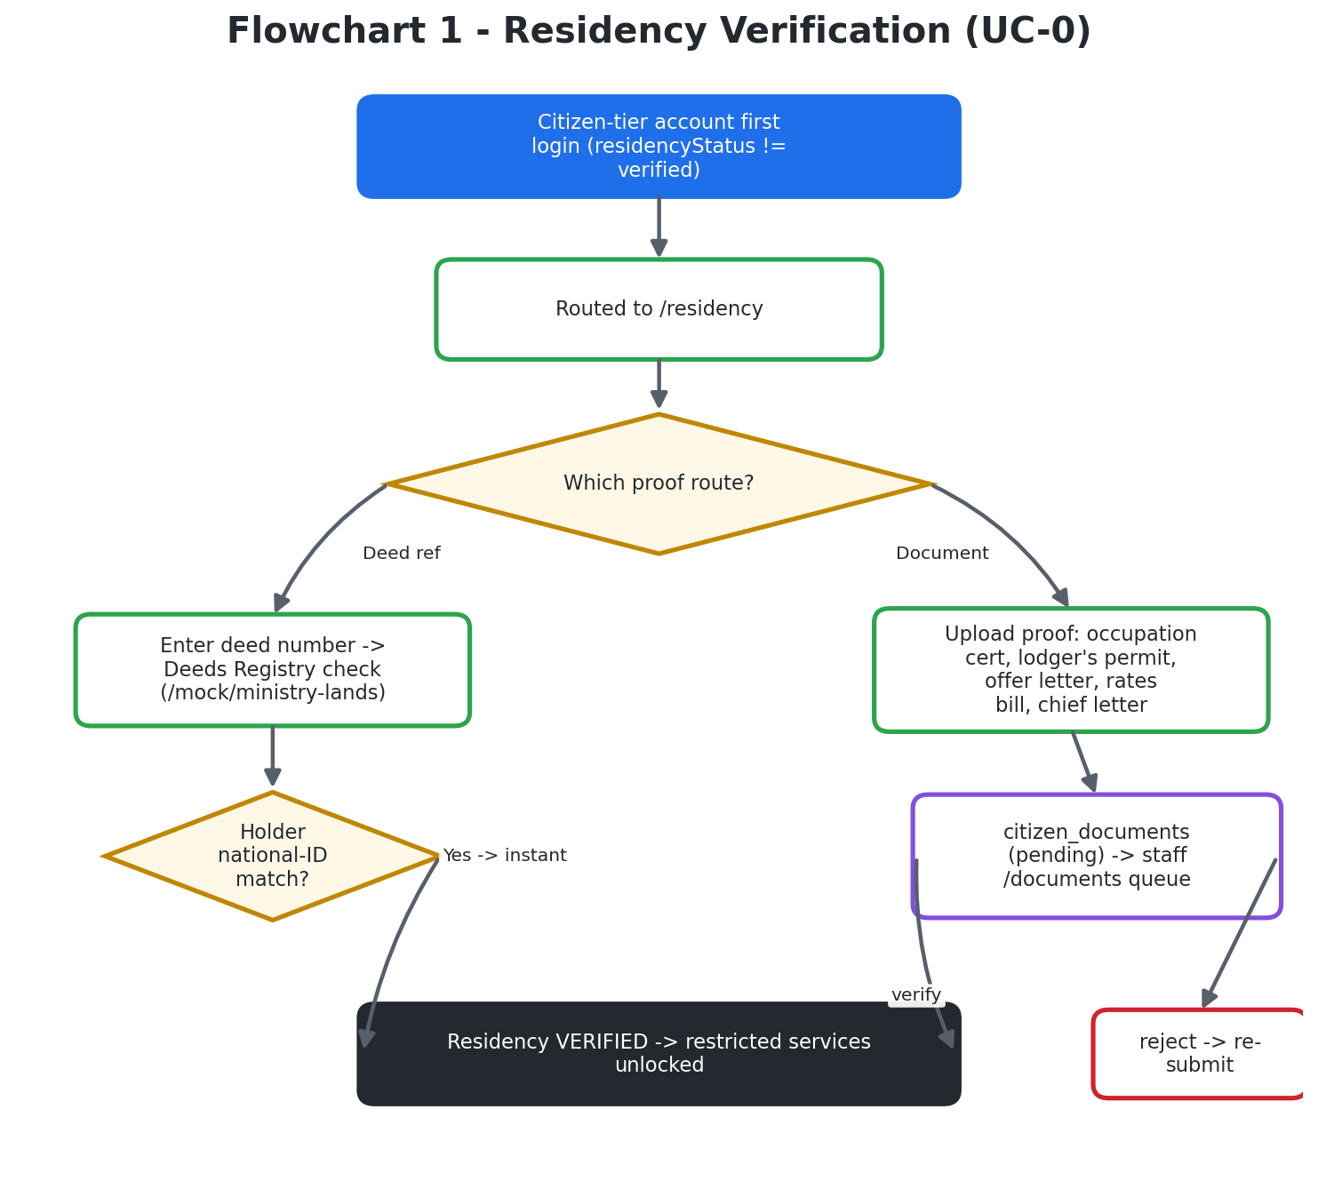
Figure 1. Residency verification (UC-0): the deed-check and document-upload routes to a verified account.

A.5.2 From a public visitor to a council determination
This end-to-end view shows the whole external journey and where it hands over to the internal team. A visitor explores public information; if they need a protected service they register and prove residency; they complete and pay for an application; the Planning Clerk receipts and routes it; the Planner assesses and circulates it to specialists; the Clerk records the public notice; and finally the committee gate (where required) and the Executive Officer produce a determination, which the Clerk dispatches and the client sees on their own case.
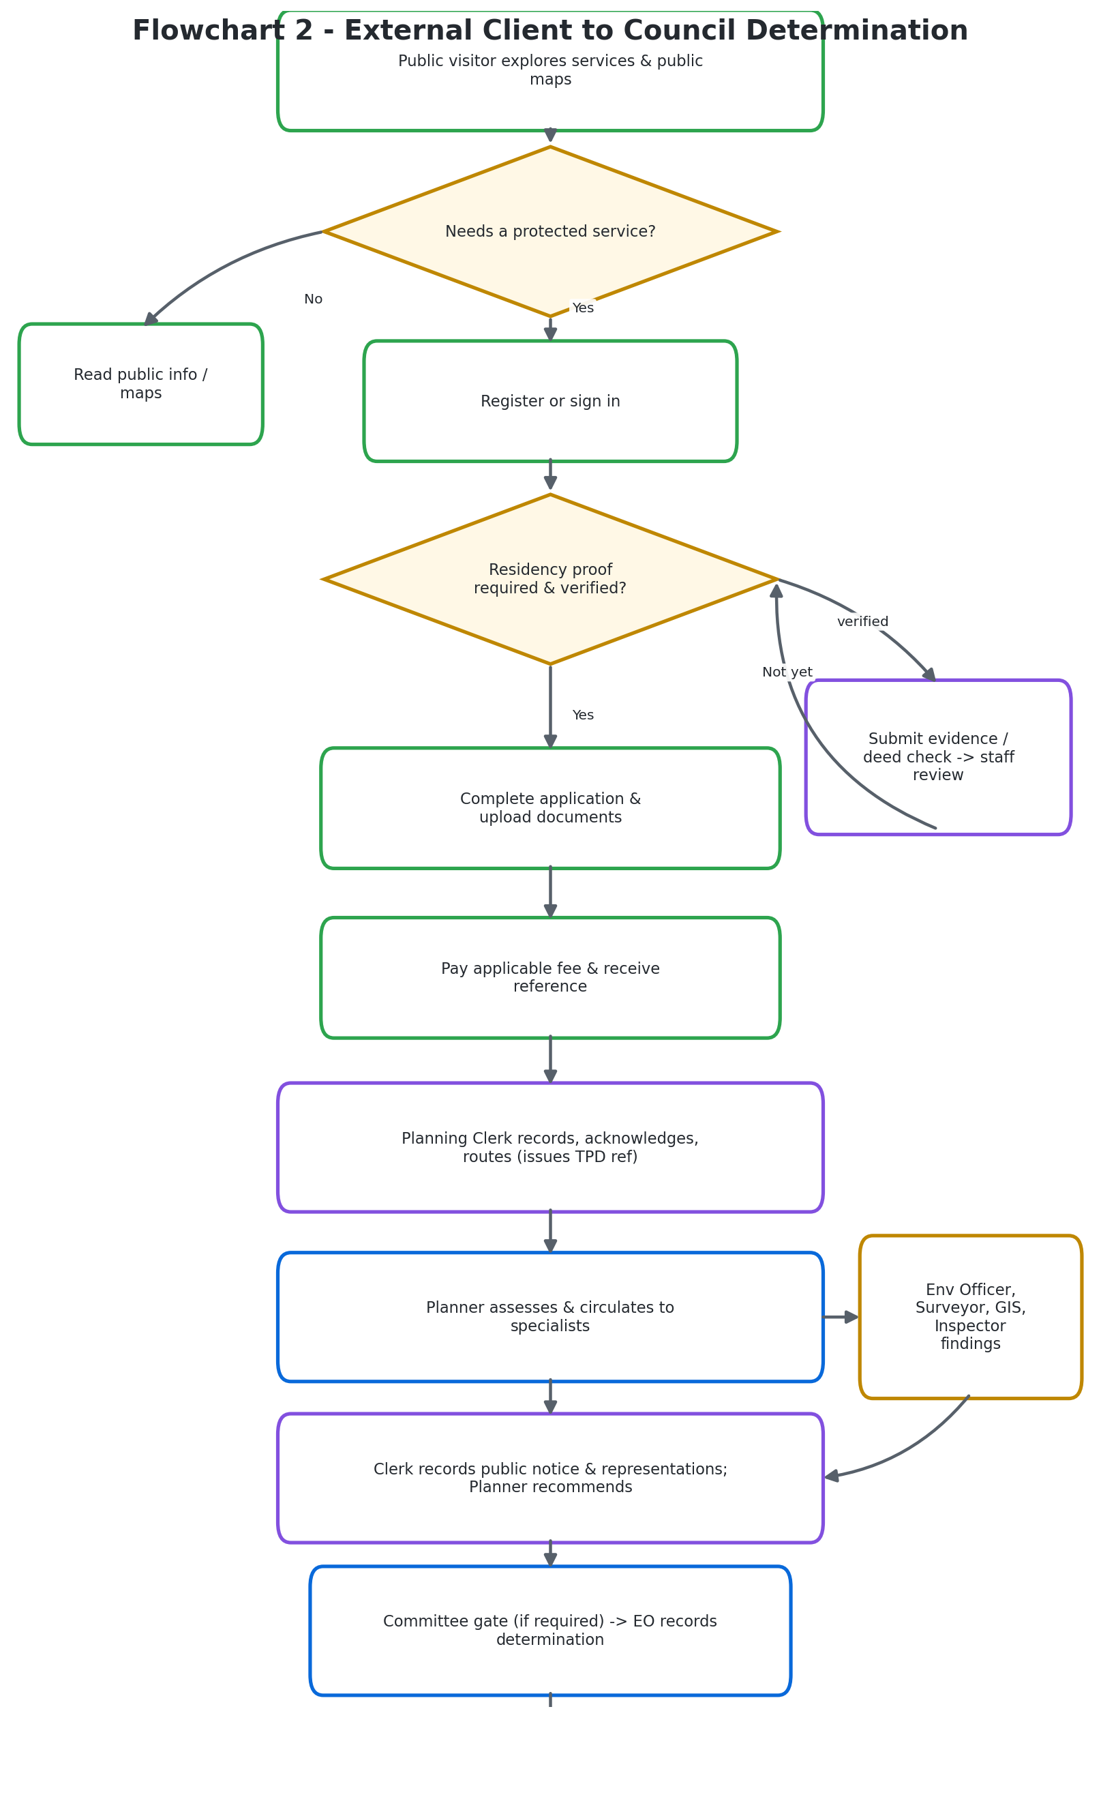
Figure 2. The external client journey from discovery through to a recorded council determination.

Part B - Internal operations: council staff
Internal operations are the council's protected workflow. Citizens do not act here directly; they send work into it and receive its results. Each staff role below is given a full page covering the legal and practical expectations, the exact activities performed in the system, and the boundaries of the role. 'Internal' does not mean that every record is visible to every staff member - access stays role- and route-controlled throughout.

B.1 The Planning Clerk (account role: planning_clerk)
Who they are. Planning clerks in Zimbabwean local authorities are the records and reception spine of development control. Job models and office practice expect them to receive applications, check that the pack is complete enough to register, issue receipts for fees, keep the development register, and write formal letters. The clerk is the person who makes the file exist in council memory. In the system they are the administrative custodian of the record from intake through outward correspondence and register maintenance.
What the law and good practice expect. Under sound RTCP office practice, acknowledgement of a valid application starts or supports the statutory clock. The system encodes a five-working-day acknowledgement target and a seven-day refusal-letter target after determination, and the clerk is expected to meet those clocks or record why they could not - late silence is a governance failure, not a small admin slip. The clerk files public-notice certificates and neighbour notifications when required, dispatches approved permits with proof of delivery, and sends refusal letters with clear reasons.
What they do in the system. When a client submits a request, the clerk checks that it arrived, records and acknowledges receipt, assigns or confirms the official reference (the TPD reference), and flags missing administrative items for follow-up. They maintain the fee and payment record, reconcile receipts, keep the statutory and development registers current, and file notices and case documents against the correct application. At the public notice stage they prepare or record the notice, observe the objection period, attach representations to the case, and route them to the responsible planner. Once a decision is ready they support preparation and dispatch of the permit, refusal or other formal correspondence and record when it was sent.
Boundaries of the role. The clerk must never approve or refuse the development, change map geometry, or delete history to hide a mistake - they add a correcting note instead. Any money taken at the counter must appear in the fee register the same day. Their central use case is continuity and auditability: every incoming item is receipted, every outgoing item is traceable, and the file shows what is awaiting action and which office owns the next step.

B.2 The Planner (account role: planner)
Who they are. The Planner owns the technical planning assessment of development and land-use cases. Zimbabwean planner posts and the RTCP Act expect the planner to help prepare and update master and local plans, process development permits, subdivisions, consolidations, changes of use and special consents, advise committees, and support the enforcement of planning law. The work splits into plan-making and development control; the system supports both.
Assessment and circulation. On development control the planner reviews the submitted proposal against the operative plan, zoning, site context, policy and statutory requirements; identifies deficiencies; and records the case analysis. Where more expertise is needed, the planner creates and coordinates technical circulation to the Environmental Officer, Surveyor, GIS Officer, Building Inspector and other bodies. The planner reads the responses together, resolves questions with the applicant through formal requests, evaluates representations received during public notice, and develops the recommendation for the configured committee and Executive Officer process.
Spatial and layout work. For subdivision, consolidation and stand-layout work, the planner uses the in-browser Planning Studio tool, or exports a georeferenced DXF for editing in QGIS, AutoCAD or Civil 3D and re-imports it. They validate the resulting lots and roads, and coordinate survey pegging and GIS updates. The planner is expected to use spatial evidence - running site-context checks against the map layers and filing a screening document - and to refer to GIS when layers are wrong and to surveyors when boundaries need a licensed survey.
Boundaries of the role. Separation of duties is a deliberate control against error and corruption: in this deployment, final approval is gated to the Executive Officer decision path. The planner is expected to recommend and complete the assessment pack, not to bypass the gate with someone else's password. When the system returns an 'EO decision required' response, the planner has reached the correct hand-off. The planner's records provide the reasoned technical basis for the next authority; the recommendation is not itself the final statutory determination.

B.3 The Environmental Officer / Environmental Health Officer (account role: env_officer)
Who they are. This role carries two connected duties under one account. As an environmental officer it contributes specialist environmental judgement to planning applications. As an environmental health officer (EHO) it carries the public-health duties the Public Health Act, 2018 places on the local authority. The two functions share one workspace in the system.
Environmental appraisal. On receiving a circulated case, the officer reviews the proposal, site context, supporting material and relevant environmental constraints, then records an appraisal, requested mitigation, conditions, or a reasoned response for the planner and the decision file. The officer may conduct environmental inspections or surveillance connected to a site, record observations and evidence, identify non-compliance, and recommend follow-up action. The environmental response is recorded so it can be considered alongside planning, survey, GIS and building comments before a decision is made.
Public-health duties. The EHO inspects trading and food premises before or during licensing (an online ticket is not a licence), investigates nuisances and infectious-disease risks, checks water points, and serves abatement, prohibition or closure notices using lawful methods, following up until compliance, escalation or withdrawal is documented. Health clearances gate certain licences, and burial, food-handler and related clearances are handled through dated registers with identifiable officers and no back-dating.
Boundaries of the role. The officer does not issue RTCP development permits by virtue of this role; the environmental and health responses inform the authorised decision-maker and become part of the auditable case history. If the council has not filled an EHO post, the Act's appointment duties still sit with the local authority - software cannot replace a missing statutory officer.

B.4 The Surveyor (account role: surveyor)
Who they are. The Surveyor performs assigned ground-truth and cadastral or engineering survey work needed to establish reliable site and boundary information. Cadastral survey for registration in Zimbabwe is the work of a licensed land surveyor under the Land Surveyors Act [Chapter 27:06], with examination and approval by the Surveyor-General under the Land Survey Act [Chapter 20:12]. The lawful chain is: planning permit, then licensed survey, then Surveyor-General approval, then Deeds. SpartialIQ must respect that chain and supports it without replacing the Surveyor-General or the Deeds Registry.
What they do in the system. A planner, EO, clerk or other permitted assigner creates a survey task with a case, property, purpose and requested deliverable. The Surveyor reviews the task, plans the field work, captures relevant beacons, control points, traverses, measurements and site observations, and checks geometry and area calculations. They prepare the appropriate outputs - a Report on Survey, a diagram, a GeoPDF or DXF, or a supporting certificate where applicable. Findings are submitted to the assigning officer, who can accept them, ask for clarification or correction, or cancel the task with a recorded reason.
How their work is used. Accepted geometry and documents inform the planning case and, where approved, the spatial record. When a planner approves a subdivision conceptually, the surveyor still surveys to the Act and regulations; when the GIS Officer wants a layer update, the surveyor supplies controlled files that GIS imports only after checks. The surveyor's main contribution is defensible spatial evidence that lets staff and clients act on the same measured understanding of the property.
Boundaries of the role. The surveyor does not independently make the planning decision or assign official stand numbers outside the controlled allocation process. They must refuse instructions that ask them to fake boundaries to match an illegal building - public boundary truth comes above client convenience. They must not tell clients the council app has replaced the Surveyor-General.

B.5 The GIS Officer (account role: gis_officer)
Who they are. The GIS Officer maintains and publishes the council's authoritative spatial information, used by planning staff, service users and connected GIS tools. RDC GIS and spatial-planning posts are expected to maintain district spatial data, layouts and maps that support the RTCP Act and the council's infrastructure programmes, and to stop divergent 'map copies' of the same zone.
What they do in the system. Their work includes validating parcel and stand geometry, managing zoning and environmental-constraint layers, supporting abutting-owner and location analysis, maintaining spatial-database quality, and coordinating the connection between the web map, QGIS Server and desktop GIS. When a planning or survey change is authorised, the GIS Officer checks that the submitted geometry is valid, correctly attributed and consistent with authoritative identifiers before updating or publishing it. They govern map symbology through a versioned style workflow so that the published web and GIS views use one consistent visual meaning - one zone name, one colour, one geometry.
Guarding the Single Source of Truth. International and regional models stress one legal and spatial story: planning, survey and deeds must not invent three different boundaries for one stand. The system therefore treats its zoning master data as the peri-urban single source of truth for both the map and permits, and the GIS Officer is expected to defend it - importing only authoritative data, dry-running imports first, and leaving registers empty rather than drawing fake roads or water points.
Boundaries of the role. The officer may provide a spatial due-diligence response to a case, but map data is not a substitute for a statutory planning determination or for a field survey where one is required. Write APIs are staff-locked: anonymous internet users must never be able to restyle or publish layers.

B.6 The Executive Officer (EO) (account role: eo)
Who they are. The Executive Officer is the senior statutory decision actor in the development-permit workflow. In Zimbabwean local planning authorities a senior planning officer or designated decision-maker determines applications after assessment, subject to schemes of delegation and committee oversight set by Council. The RTCP framework assumes decisions are reasoned, timed and appealable, and the system's EO role is that determination seat for day-to-day permits.
What they do. The EO reviews the complete case file: the planner's assessment, the technical responses, the public representations, the committee or agenda record where required, payment and process prerequisites, and any proposed conditions. The configured decision action records an outcome - approval, approval with conditions, refusal, deferral, or a return for further work - with reasons and conditions attached to the official case. The EO may also oversee technical circulation, due diligence, committee reporting and enforcement decisions according to the permissions available.
Decision controls. Two independent, server-enforced gates guard a determination. First, a resolution is required: an EO decision is rejected unless it is backed by a recorded committee resolution (or an audited delegated-authority override). Second, a quorum is required: a resolution cannot be recorded on a meeting where the number present is below the required quorum. These controls exist so that an outcome cannot be recorded when the required governance evidence is absent.
Boundaries of the role. The EO must refuse incomplete packs - approving an empty file creates liability for the council - and must write reasons a citizen and an appeal body can understand. Conditions must be precise; refusals must state grounds linked to the plan or standards, not personal preference. The EO must not share their login, and planner self-approval is blocked on purpose. Where Council requires committee determination for certain classes of application, the EO follows that resolution: software does not cancel a Council resolution.

B.7 The Building Inspector (account role: building_inspector)
Who they are. The Building Inspector protects public safety and verifies construction compliance after the relevant permit has been issued. Building inspectors in Zimbabwean local authorities inspect construction stages against approved plans and by-laws, sign off key stages with Engineering or Works where required, and act on illegal building.
What they do. The client or the authorised workflow requests an inspection at the appropriate stage; the inspector reviews the permitted plans and conditions, schedules or reschedules the visit, attends the site, records observations, captures supporting photographs or evidence, and marks checklist items as passed, failed or requiring correction. The inspector communicates deficiencies and the next action to the client through the permitted case channel, then re-inspects when corrections are reported. The nine statutory inspection stages are drawn from the DM Handbook 2021 v1.2: setting out; foundation trenches and footing levels; foundation brickwork to floor level; brickwork and window level; brickwork to wall plate; roof trusses; drainage and sewerage work; final inspection; and the certificate of occupation.
Occupation certificate and enforcement. The system maintains stage history and, server-side, prevents the occupation certificate from being issued until all required earlier stages have passed. The inspector may also identify unauthorised work or enforcement concerns and route them into the appropriate enforcement record, keeping a clear chain of custody for photos and notes and coordinating with Roads & Works and the EHO when a defect is structural, drainage or health-related.
Boundaries of the role. The inspector's findings relate to observed work and approved requirements; changes to the planning permission itself remain with the authorised planning decision process. The inspector does not quietly 'approve' a planning file from the field. Inspector evidence feeds the occupation and compliance chain, but title and diagram approval still sit with the Surveyor-General and Deeds.

B.8 The System Administrator (account role: admin)
Who they are. The System Administrator keeps the application available, secure and correctly configured for council operations. Under the RDC Act framework the executive administration runs day-to-day council business, and ICT and records support must keep systems available, secure and auditable so the technical departments can meet their planning and public-health duties. The council's CEO and executive officers remain the human authority; Admin in SpartialIQ is the digital keyring and platform steward.
What they do. Their principal use cases include managing user accounts and invitations, assigning approved access roles, supporting account recovery, removing leavers, maintaining system content and configuration, running migrations from an allow-list, restoring basemap data when needed, monitoring operational health, and administering technical integration or map-style settings where permitted. They support content editors for council website pages (committees, rates information, contacts) without changing planning decisions, and they help the GIS Officer with symbology-registry access.
Security and honesty. The administrator is expected to keep secrets strong (secure tokens and CAPTCHA), keep transport encryption on, keep backups tested, and keep status pages honest - faking an 'all green' status when the spatial database is down is a professional failure. They must never leave demonstration passwords on the public internet, and they refuse requests to open mutating GIS or planning APIs to the anonymous public.
Boundaries of the role. Because this role has broad technical access, changes should be attributable and limited to the administrative purpose. The role is not a substitute for a Planner, EO, Surveyor or Inspector and does not itself create technical or statutory authority. The project explicitly treats admin as an IT role, and route-level controls keep administrative accounts out of certain planning actions. Any exceptional support action that affects a live case should keep a clear audit trail and respect the applicable business approval, and legal questions are escalated to the proper executive officer or council lawyer rather than invented in a configuration file.

B.9 Committee and governance participants (workflow participants, not login accounts)
Who they are. Committee members, a committee chair and a Director of Planning may be involved in statutory review, quorum, resolution or recommendation steps represented by the application workflow. They are not part of the active account taxonomy, so this handbook does not imply that each has a separate login or portal. Councillors set policy and approve budgets and certain planning items under resolutions, working through committees such as finance, roads and works, social services and health portfolios, and development-planning structures such as the Rural District Development Committee.
How they interact with the system. SpartialIQ does not replace committee minutes. Officers are expected to bring system-printed registers, maps and documents to committee, then record the resolution back into the case. Where a committee resolution is required, authorised staff record or verify the governance evidence through the configured process, and the system uses that evidence as a prerequisite to the EO decision.
Their use case. Collective consideration and accountable resolution: review the material placed before the committee, record the result through the council's authorised procedure, and ensure the case file contains enough evidence for the decision stage. Best governance keeps politics in the chamber and evidence in the file. Citizens and staff should know which decisions are delegated to the EO and which must wait for committee - that split is a Council document decision. Future implementation of individual accounts for these participants would require matching backend role issuance, route permissions and audit controls.

Internal flowcharts

B.10 Internal council application processing
This view follows a receipted application through the internal team. The Planning Clerk takes intake and creates the official record; the Planner assesses and, where needed, circulates the case in parallel to the Environmental Officer, Surveyor, GIS Officer and Building Inspector. Their responses are consolidated by the Planner, the Clerk records the public notice and representations, the Planner makes a recommendation, a governance record is made where required, the EO determines the outcome, and the Clerk dispatches it and updates the register.
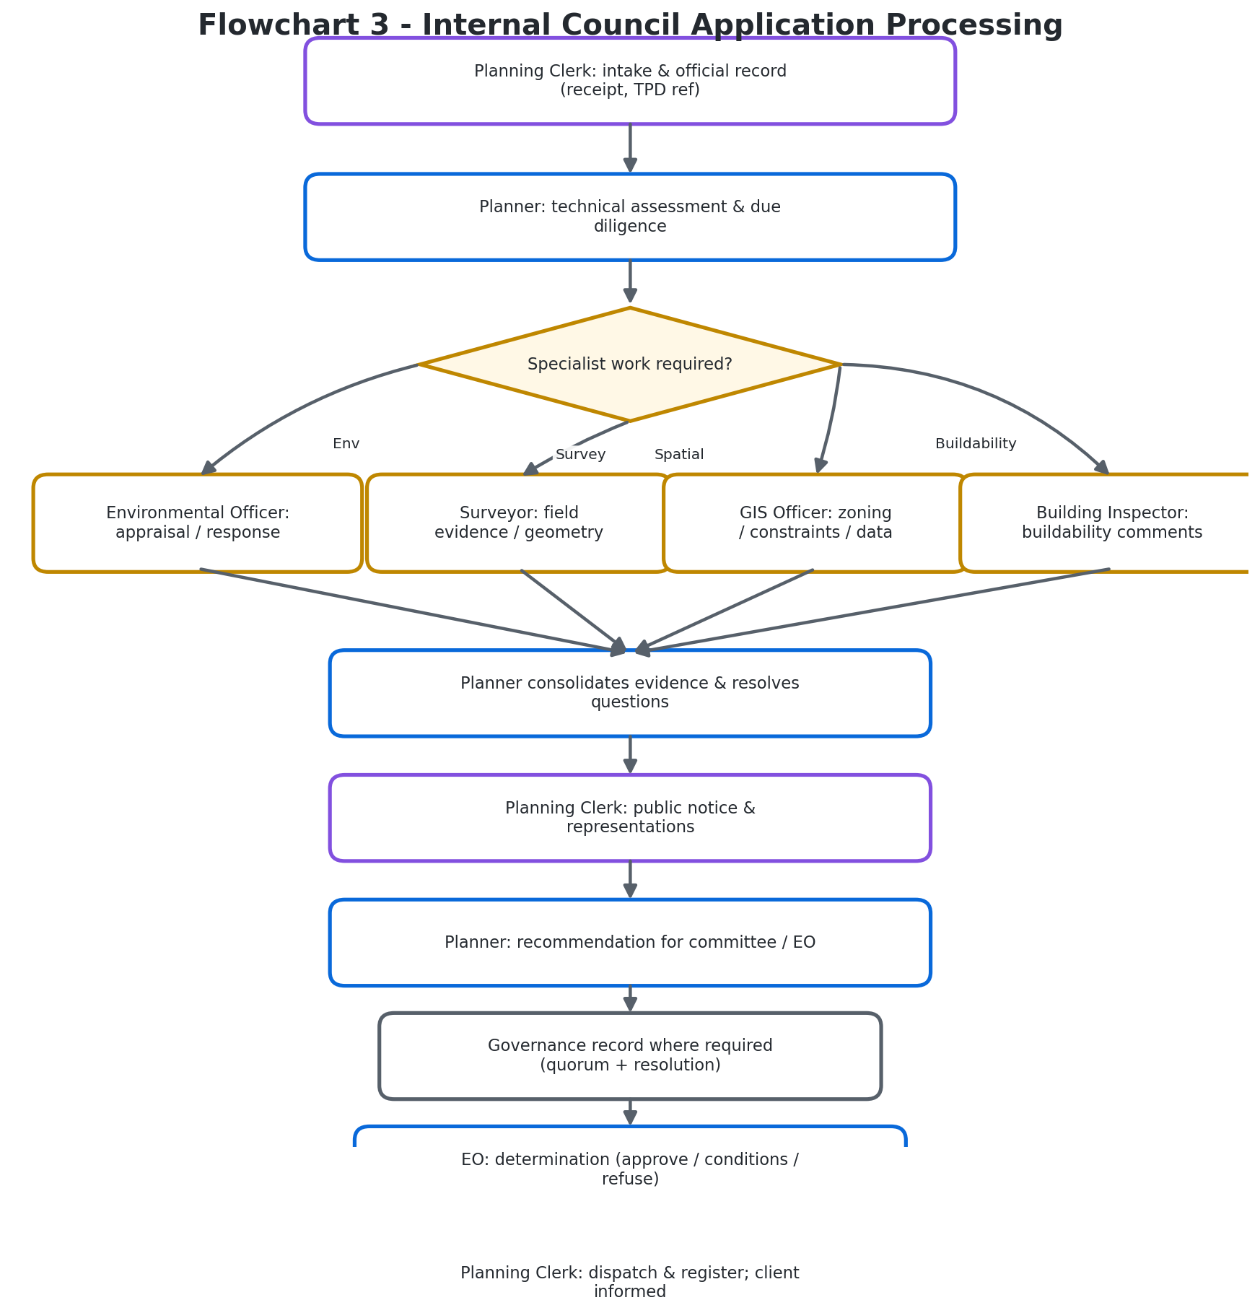
Figure 3. Internal processing: parallel specialist circulation through to determination and dispatch.

B.11 Permit, construction inspections and occupation certificate
Once a permit is issued and dispatched, a separate inspection lifecycle begins. The client builds to the approved plans and conditions, requests each required inspection (booking and paying), and the Building Inspector schedules the visit. If a stage complies it is recorded as passed; if not, the failure, evidence and required correction are recorded and the client corrects and re-books. The system will not allow the final stage or the occupation certificate until all required earlier stages have passed.
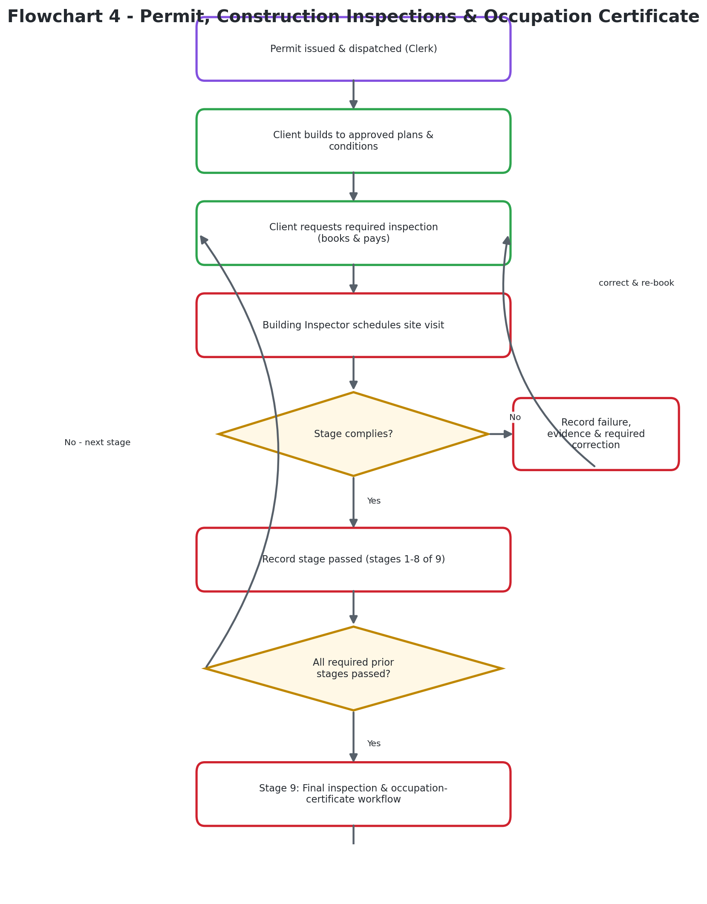
Figure 4. The nine-stage construction inspection lifecycle through to the occupation certificate.

B.12 Survey and spatial-data hand-off
When a case needs ground truth, authorised staff assign a survey task. The Surveyor captures and validates field evidence - beacons, control points, traverses and areas - and submits a Report on Survey with diagrams. The assigning officer can accept the findings or return them for correction. Accepted evidence is used by the Planner in the case assessment and, in parallel, validated by the GIS Officer before it updates the authoritative spatial database and published map layers.
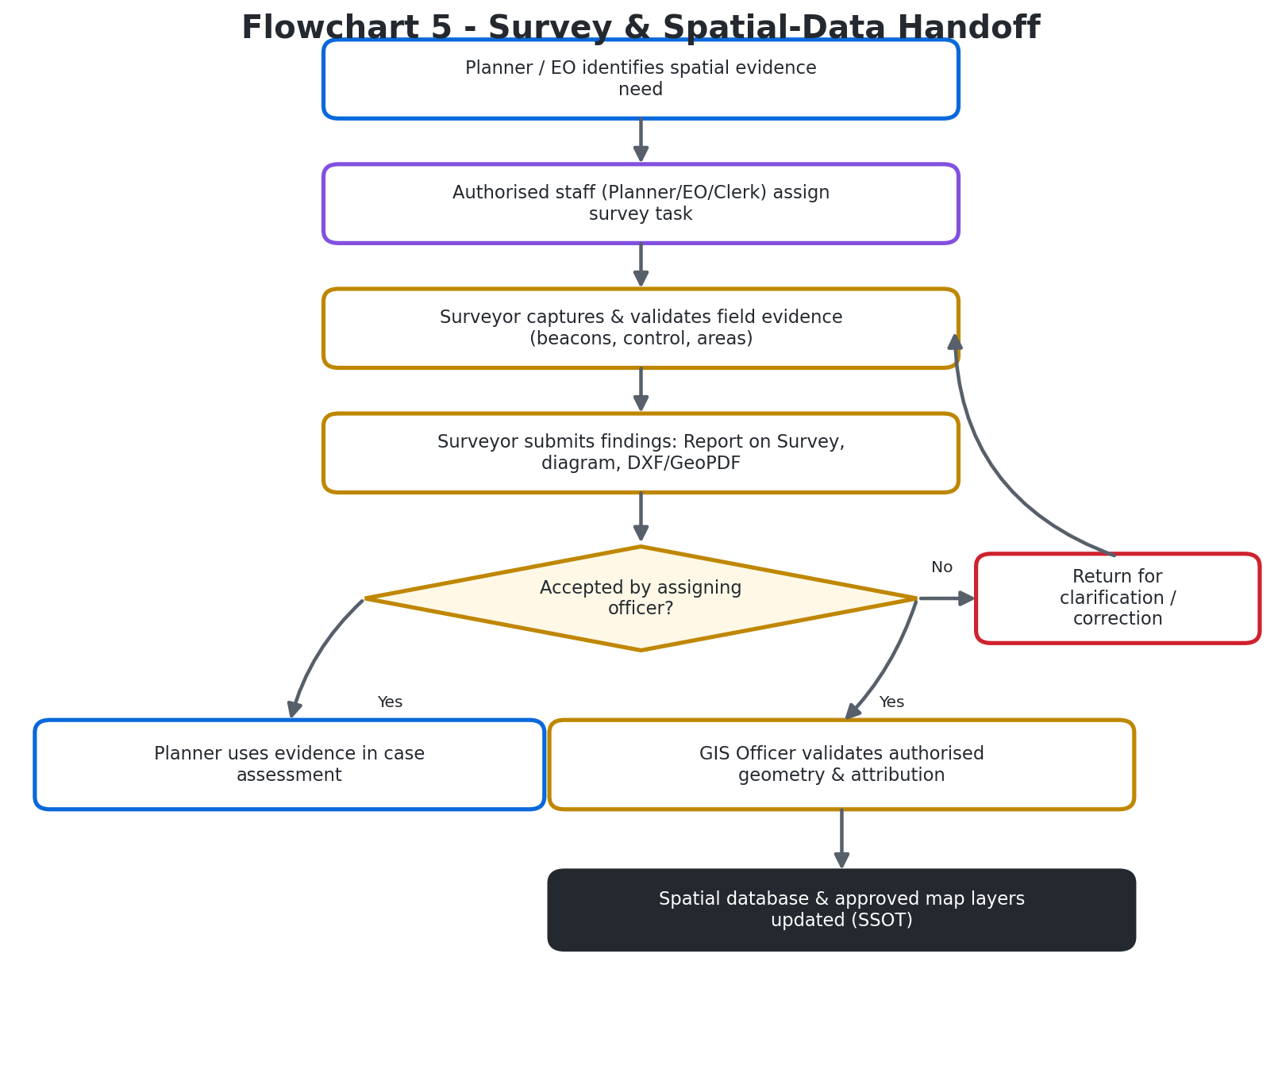
Figure 5. The survey-to-GIS hand-off that keeps spatial evidence authoritative.

B.13 Payments and receipts
A client starts a payment for a fee or inspection through a payment provider or an authorised manual route. If the payment is confirmed, the system records the transaction and issues a receipt, the Planning Clerk's fees ledger reflects it, and eligible application processing continues. If it is not confirmed, the client sees a pending or failed state and can retry or seek help.
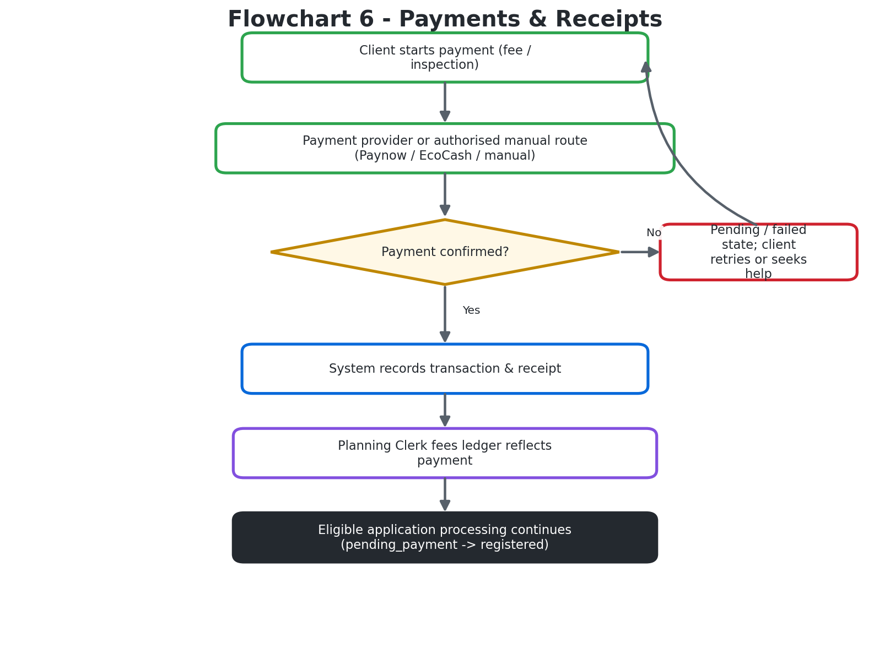
Figure 6. The payment and receipt loop that unblocks application processing.

Appendix A - Master use-case catalogue
This table summarises the main use cases, who performs them, and the result each one produces. It is the quick-reference companion to the actor pages.
Use case | Primary actors | Result
Discover council services and public maps | Public visitor, viewer | Client understands available information and services
Create account and verify residency | Citizen/client; reviewing staff; registry | Account and residency state support eligible service access
Submit development application | Citizen/client, Planning Clerk | A referenced and receipted case enters the council workflow
Assess development proposal | Planner, specialists, EO | A reasoned recommendation and a recorded statutory outcome
Publish notice and process representations | Clerk, Planner, public/client | Notice period and received representations become part of the file
Pay application fees | Citizen/client, payment service, Clerk | Transaction and receipt are recorded and reconciled
Subdivide or consolidate land | Planner, GIS Officer, Surveyor | A validated proposed spatial arrangement and related records
Complete survey task | Surveyor, assigning officer, Planner/GIS | Accepted measurements, findings and spatial deliverables
Inspect construction and issue occupation certificate | Client, Inspector, Clerk | Passed inspection history and a final certificate where eligible
Record environmental appraisal or surveillance | Env Officer, Planner, EO | Environmental findings and follow-up attached to the case or site
Maintain GIS data and published styles | GIS Officer, Planner, Admin | Consistent authoritative spatial records and map presentation
Maintain users and system configuration | System Administrator | Correctly provisioned access and reliable system operation
Record governance prerequisite and determination | Governance participants; EO | Auditable resolution evidence and an authorised case outcome

Appendix B - The lawful end-to-end chain
The council's planning work sits inside a longer legal chain that extends beyond this one system. Keeping the chain clear protects both the council and the client:
- RTCP development permit or subdivision permission - granted by the local planning authority (the council, through its Planner and EO).
- Licensed land surveyor field survey - under the Land Surveyors Act [Chapter 27:06].
- Surveyor-General examination and approval - under the Land Survey Act [Chapter 20:12].
- Deeds registration - at the Deeds Registry.
SpartialIQ covers the council's planning and operations spine. It does not replace the Surveyor-General or the Deeds Registry, and no screen in the system should be read as a substitute for those statutory approvals.

Appendix C - Important interpretation notes
- Internal means the council's protected operational workflow; it does not mean every record is visible to every staff member. Access stays role- and route-controlled.
- External operations include clients and other public users. A client sees their own permitted case status, receipts, notices and outcomes; internal technical notes and restricted personal records are not public information.
- A system role describes available application permissions. It does not, by itself, create legal authority beyond the user's actual appointment and the council's procedures.
- Governance roles shown as workflow participants are not active user roles in the current system. Their portal capabilities should be treated as future or separately configured until backend role issuance and access controls exist.
- The application lifecycle and the construction-inspection lifecycle are connected in the user's journey but have separate records and status transitions. A permit decision is not the same event as passing an inspection or issuing an occupation certificate.

Appendix D - Source references
- docs/ACTOR_USE_CASES.md - actor-by-actor descriptions and cross-system flowcharts.
- docs/USE_CASES.md - plain-language use cases and the routing loop for each document.
- docs/COUNCIL_OPERATIONS_FLOW.md - the code-level stage-by-stage trace and role capability matrix.
- Vungu_Zimbabwe_Role_Expectations.docx - what Zimbabwe law and good RDC practice expect of each role.
- frontend/src/services/types.ts - the active account-role taxonomy.
- frontend/src/router/index.ts - landing area per role and route access controls.

- End of the System Actors and Use-Cases Handbook -

