VUNGU RURAL DISTRICT COUNCIL
Digital Planning Portal
Progress Report
for the Board & Planning Committee
How the new system works, and what has been built so far — explained in plain language, with screenshots of the working system.
Prepared for: Members of the Board and Planning Committee
Prepared by: Theophelos Madzinga — Project Team
Date: 9 June 2026
Status: Working demonstration build (end-to-end)

CONTENTS
What this report covers
This report is written for committee members who are not technical. It avoids computer jargon and walks through the system the way a member of the public, and then each council officer, actually uses it.
1. Summary — what we set out to do and where we are
2. The problem we are solving — from paper files to one shared system
3. The journey of an application — the seven official stages
4. The public front door — the website and the map
5. The resident's portal — applying and tracking online
6. The planner's workspace — running the statutory process
7. The specialist officers — surveys, GIS, environment, building control
8. The front office — the planning clerk's register
9. Executive oversight — the E.O. command centre
10. Administration & security — accounts and access
11. What works today
12. What comes next

SECTION 1
Summary — what we set out to do and where we are
Vungu Rural District Council has, until now, managed development control on paper. Applications to build, subdivide, change land use or transfer a stand have moved between offices as physical files. That makes it hard to know where an application is, easy to lose paperwork, and slow for residents to get an answer.
We have built a single digital system that replaces that paper process from end to end. A resident can apply online; the council's officers each see the part of the work that belongs to them; and at every moment the council knows exactly which stage an application has reached and who is responsible for the next step.
Where we are today
The system is built and works from start to finish in our demonstration environment. Every screen shown in this report is the real, running system — not a drawing or a mock-up. A resident can submit an application, a clerk can register it, specialists can check it, the planner can take it through committee, and a permit can be issued — all in one place.

The rest of this report shows each part of the system with a screenshot and a short, plain explanation of what it does and who uses it.

SECTION 2
The problem we are solving
The new system is built around one idea: there should be a single, shared record for every application and every stand, that everyone works from. The table below contrasts the old way of working with the new one.
The old paper process | The new digital system
Files carried by hand between offices; easy to misplace. | One shared record; nothing is lost or carried around.
No quick way to see where an application is. | The exact stage and the next responsible officer are always visible.
Residents must visit or phone to ask for an update. | Residents apply, pay and track progress online, at any time.
Maps and stand records kept separately from the file. | The application is linked to its stand on the map automatically.
Hard to produce reports or spot delays. | Registers, fees and turnaround times are summarised instantly.

Importantly, the system follows the council's real legal process under the Regional, Town and Country Planning Act. The stages in the system are the same stages an application must legally pass through — the computer simply keeps track of them and makes sure nothing is skipped.

SECTION 3
The journey of an application — the seven official stages
Every development application travels through seven stages. The system shows these as a row of numbered steps along the top of the planner's screen, so anyone can see at a glance how far an application has come.
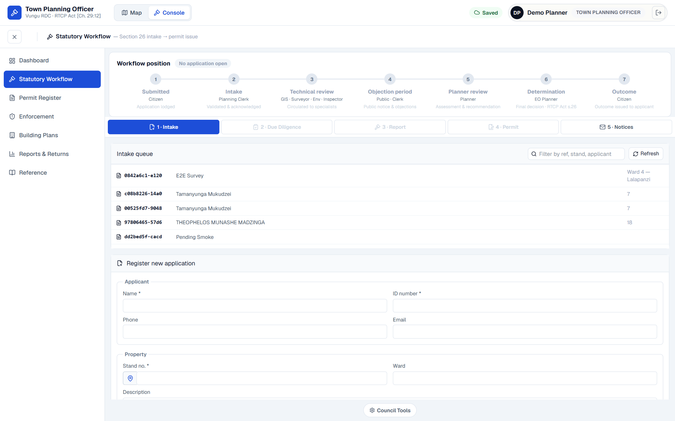
Figure 1. The planner's workflow screen. The seven stages run across the top; the live list of applications waiting at the current stage is shown below, ready to be opened and worked on.
The seven stages, in plain terms:
Stage 1 — Submitted. A resident lodges the application (online or at the office).
Stage 2 — Intake. The planning clerk checks it is complete and registers it officially.
Stage 3 — Technical review. The specialists check it — the surveyor, GIS officer, environmental officer and building inspector.
Stage 4 — Objection period. The proposal is advertised so neighbours and the public can raise objections within the legal period.
Stage 5 — Planner review. The town planner weighs everything up and writes a recommendation.
Stage 6 — Determination. The Executive Officer makes the final, formal decision under the Act.
Stage 7 — Outcome. The decision — and the permit, if approved — is issued back to the applicant.
Why this matters to the committee
Because the council and the applicant can both see which stage an application has reached, delays become obvious and accountability is clear. The legal steps cannot be accidentally missed, and the paper trail is automatic.

SECTION 4
The public front door — the website and the map
Anyone can visit the council's portal without logging in. The home page introduces the service in clear language and points visitors to the map and to the application service.
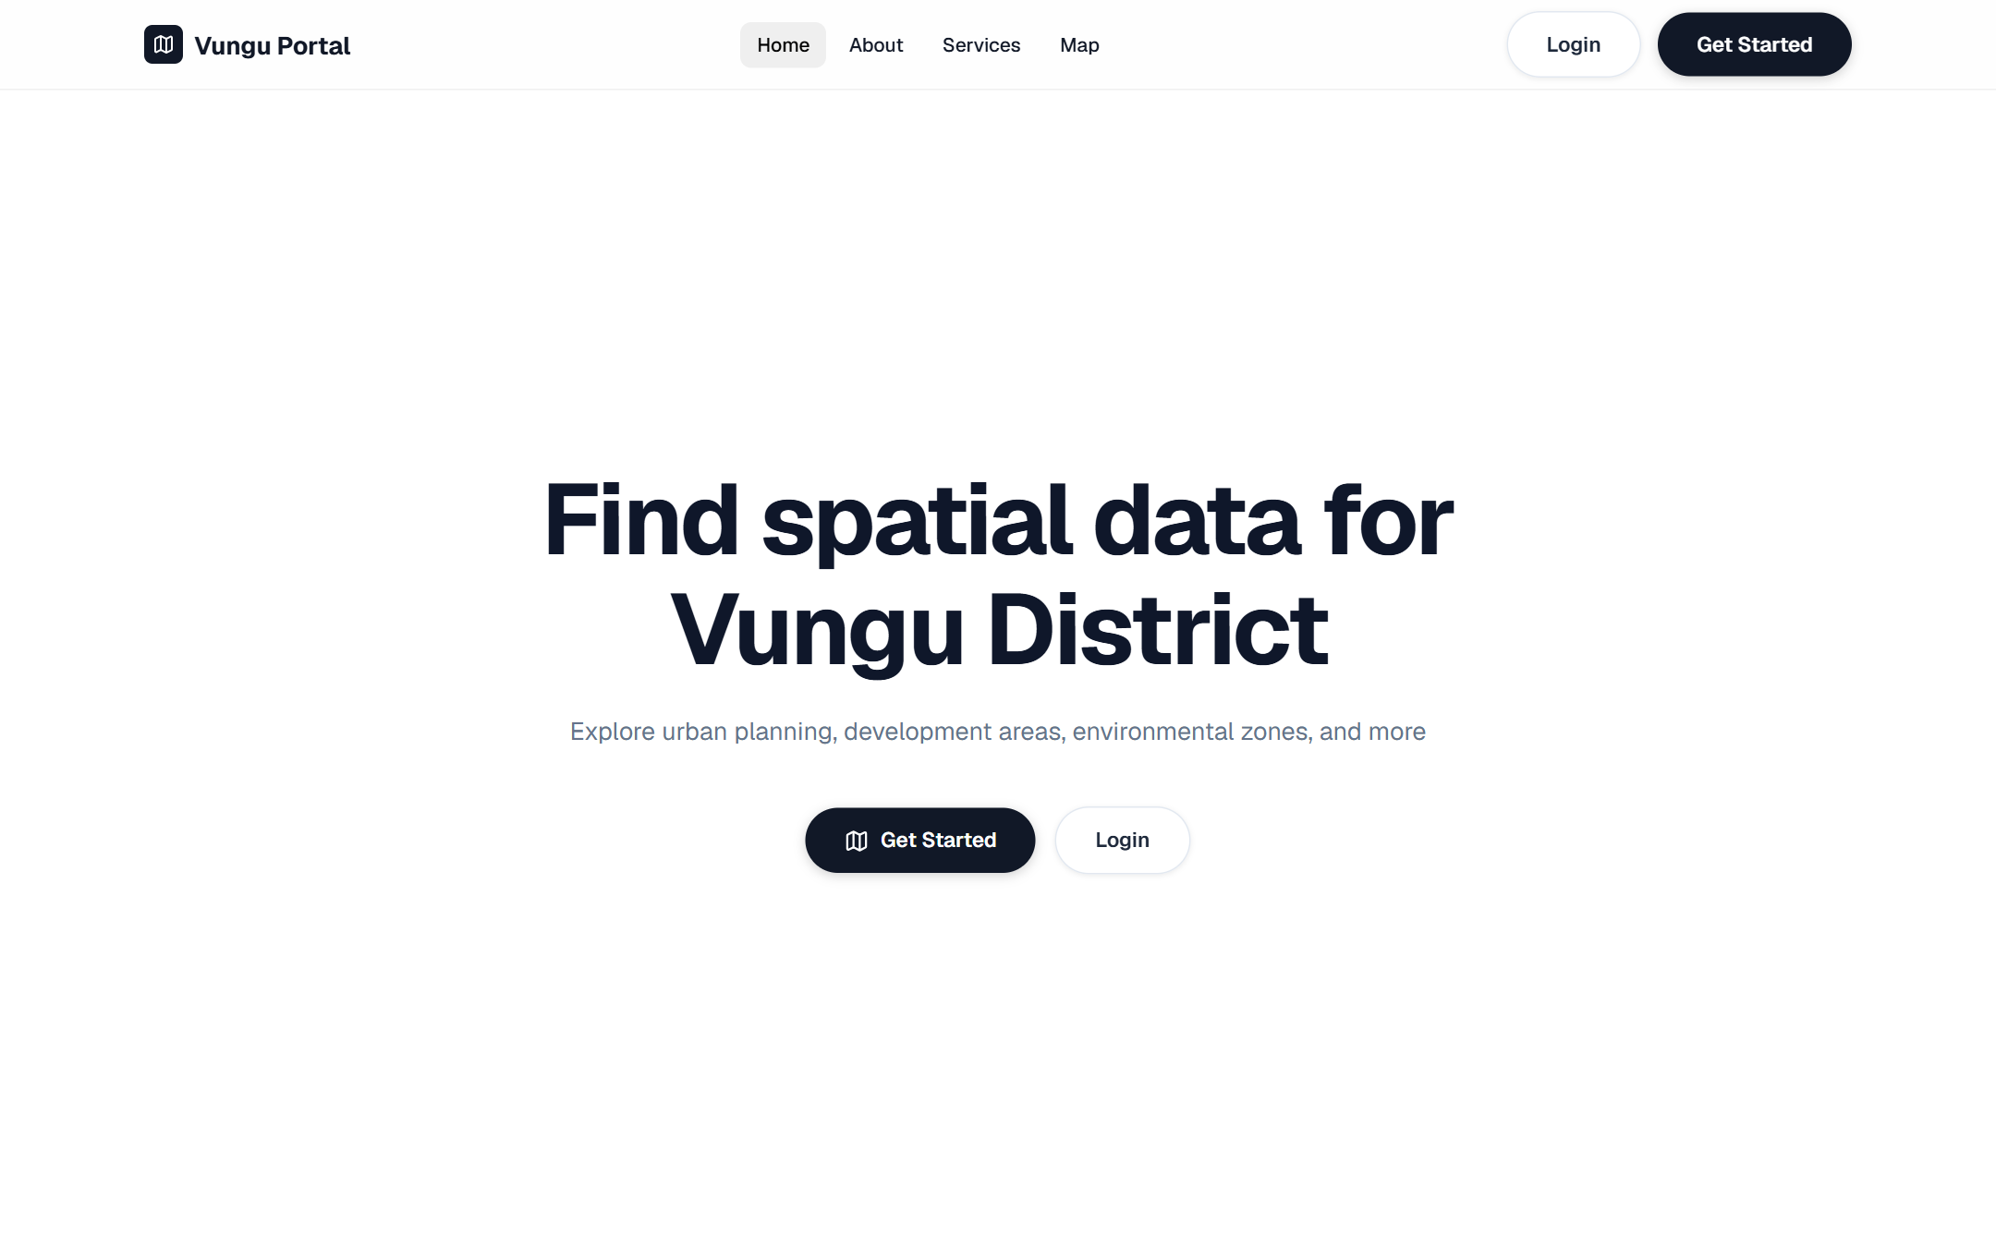
Figure 2. The public home page. Calm, official, and free of clutter — it invites residents to explore the district or get started with an application.
The portal also publishes the council's mapping for the whole country — provinces, districts, wards, roads, buildings and land use — on a single interactive map. Residents can search for a place and switch between a street map, a satellite view and a terrain view.
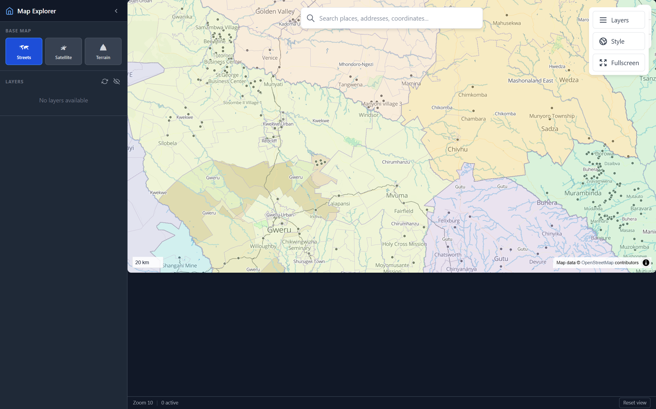
Figure 3. The public map explorer, showing district and ward boundaries over the national base map. The same mapping underpins every officer's screen.
When a resident is ready to apply, or an officer needs to do their work, they sign in. Each person has their own secure account, and the system shows each role only the tools that belong to it.
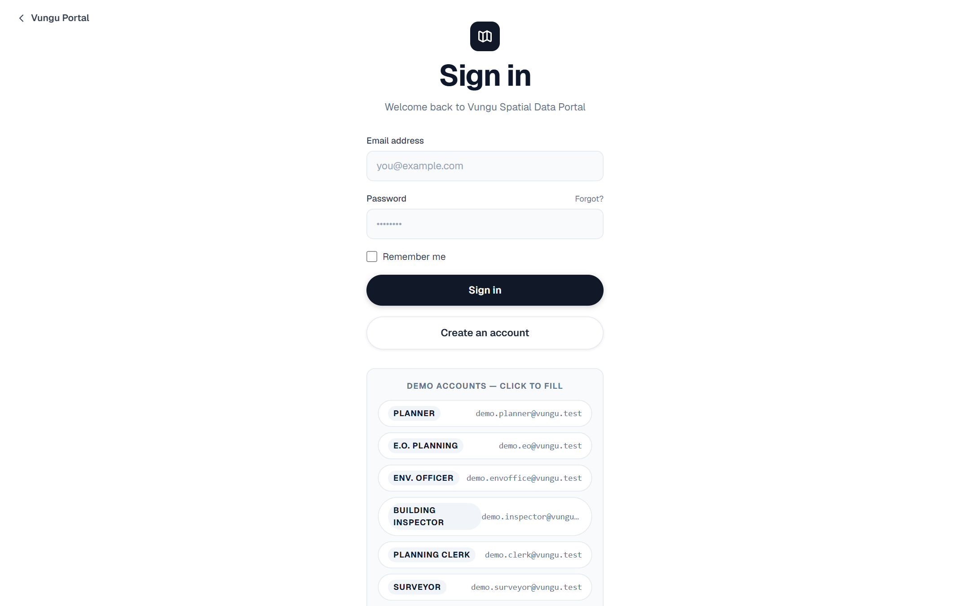
Figure 4. The secure sign-in screen. The labelled accounts at the bottom (planner, clerk, surveyor, inspector, and so on) show the range of staff roles the system supports — each one sees a different, purpose-built workspace.

SECTION 5
The resident's portal — applying and tracking online
Once signed in, a resident lands on a personal dashboard. It tells them, in plain numbers, how many applications they have, what they owe, and crucially whether anything is waiting on them.
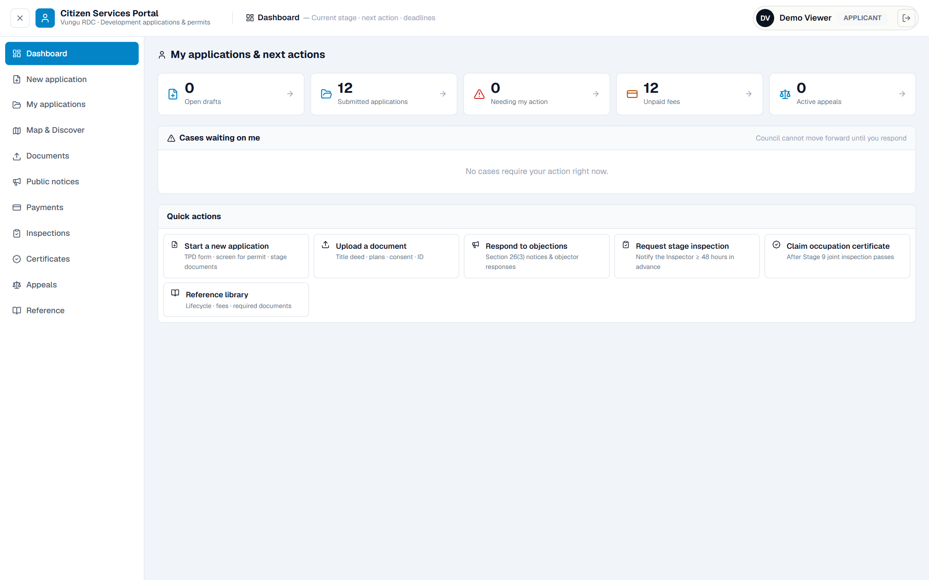
Figure 5. The resident's dashboard. The line 'the council cannot move forward until you respond' makes it obvious when the resident, rather than the council, is holding things up.
Applying is done by choosing from a catalogue of council services — a new stand, a transfer, a lease, a resettlement plot, and so on. Each service states its fee and how many working days it usually takes, so residents know what to expect before they start.
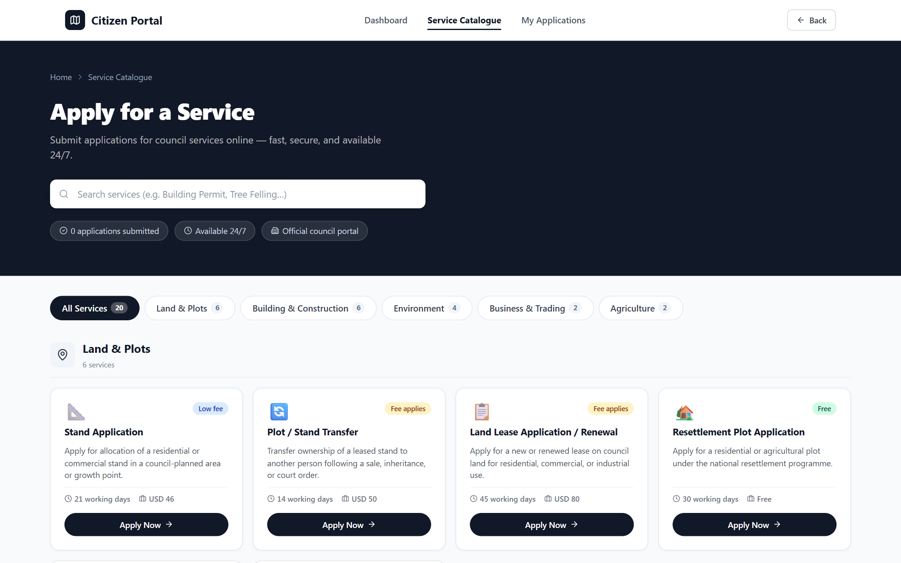
Figure 6. The online service catalogue. Services are grouped (land, building, environment, business, agriculture) with clear fees and timeframes.
Residents do not need to phone or visit the council to ask how an application is progressing. The 'My applications' page lists every case a resident has lodged, each showing its reference number, the stand it relates to, and the stage it has reached. Selecting any case opens its full history — from the day it was submitted, through the council's checks and decision, to the inspections and occupation certificate where building follows.
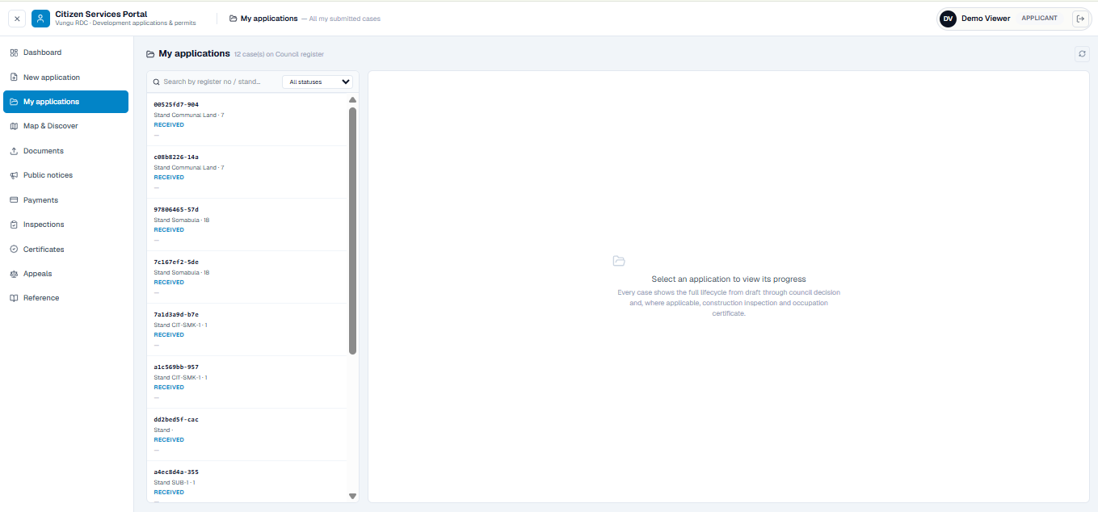
Figure 7. The resident's 'My applications' list. Every case the resident has lodged appears here with its reference number, the stand it relates to, and its current status; selecting one opens its complete progress through the council's process.
The portal also lets a resident explore the district on a map before applying. They can search for a place or stand, turn map layers on or off — ward boundaries, land-use zoning, roads and the stands currently available — and see their own applications marked on the map. The council's address, telephone number and the standard application fee are shown alongside, so a resident knows who to contact and what to expect.
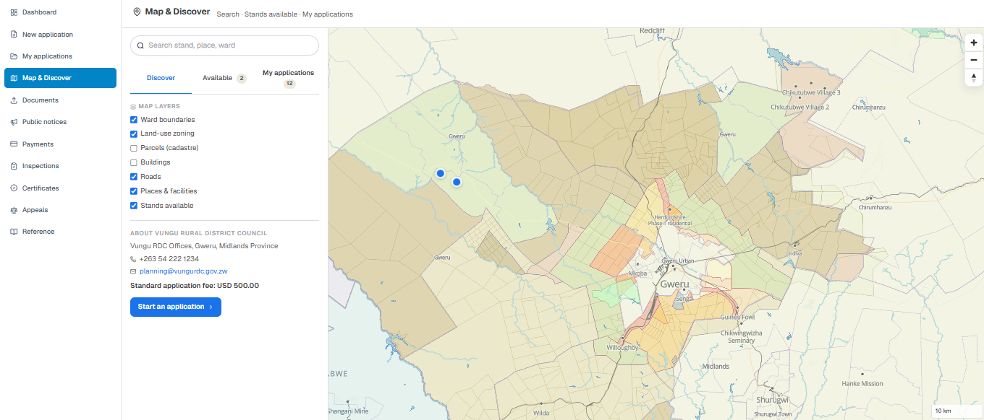
Figure 8. The resident's 'Map & Discover' view. Residents can search the district, switch map layers on and off, see available stands and their own applications on the map, and begin an application — with the council's contact details and standard fee shown alongside.
What this changes for residents
A resident no longer needs to travel to the council offices to apply or to ask 'where is my application?'. They apply, pay, upload documents and follow progress from home or a phone — and the council receives a complete, correctly-filed application every time.

SECTION 6
The planner's workspace — running the statutory process
The town planner is at the centre of the process. Their workspace has two sides: a map for looking at the land itself, and the workflow console (shown earlier in Section 3) for moving applications through the stages.
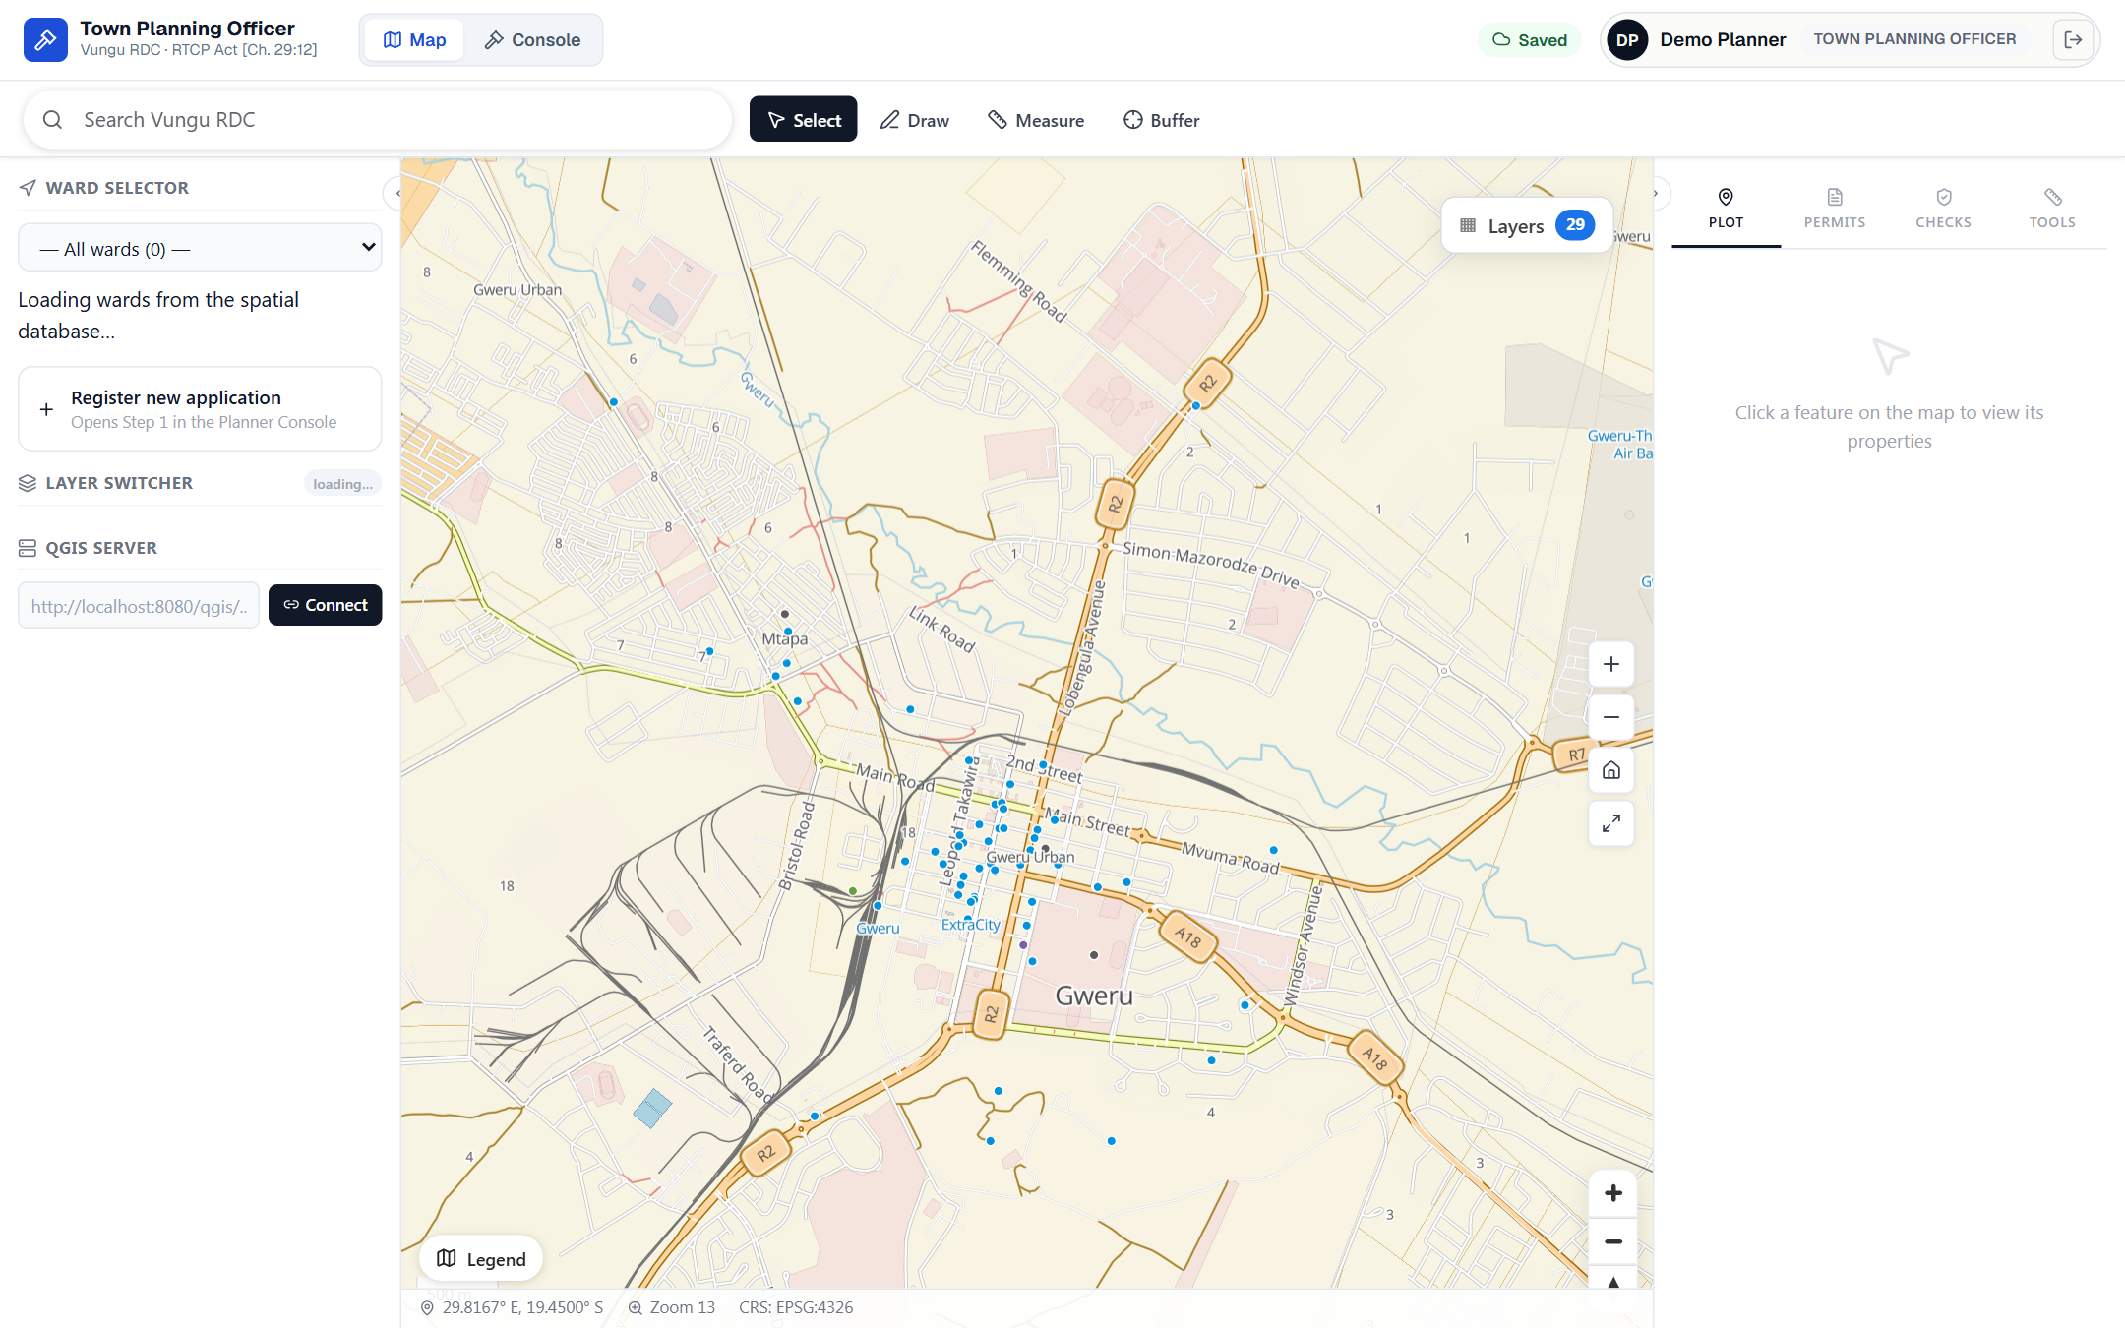
Figure 9. The planner's map workspace, centred on Gweru. The planner can select a ward, see every application as a point on the map, and click a stand to open its record — the map and the paperwork are joined together.
From here the planner registers new applications, opens any case to review it, records the committee's report, and drafts the permit. Everything the planner does is saved against the application's history, so there is a complete and automatic record of who did what, and when.

SECTION 7
The specialist officers
During the technical-review stage, four specialists each examine the application from their own angle. Each has a dedicated workspace that shows only their tasks, on the same shared map and records.
GIS Officer — putting applications on the map
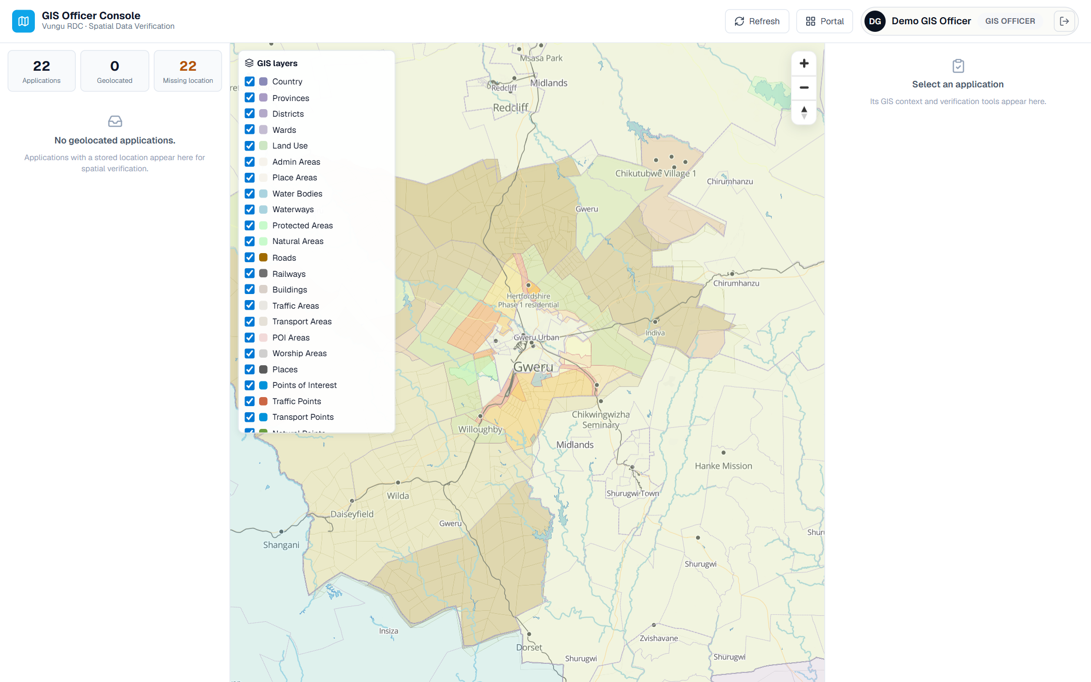
Figure 10. The GIS officer's console. They confirm exactly where each application sits on the ground and pin any that arrived without a location.
The GIS officer makes sure every application is correctly placed on the map and can be seen against wards, boundaries, roads and existing land use. Their counters show how many applications still need a location.
Surveyor — verifying the land and boundaries
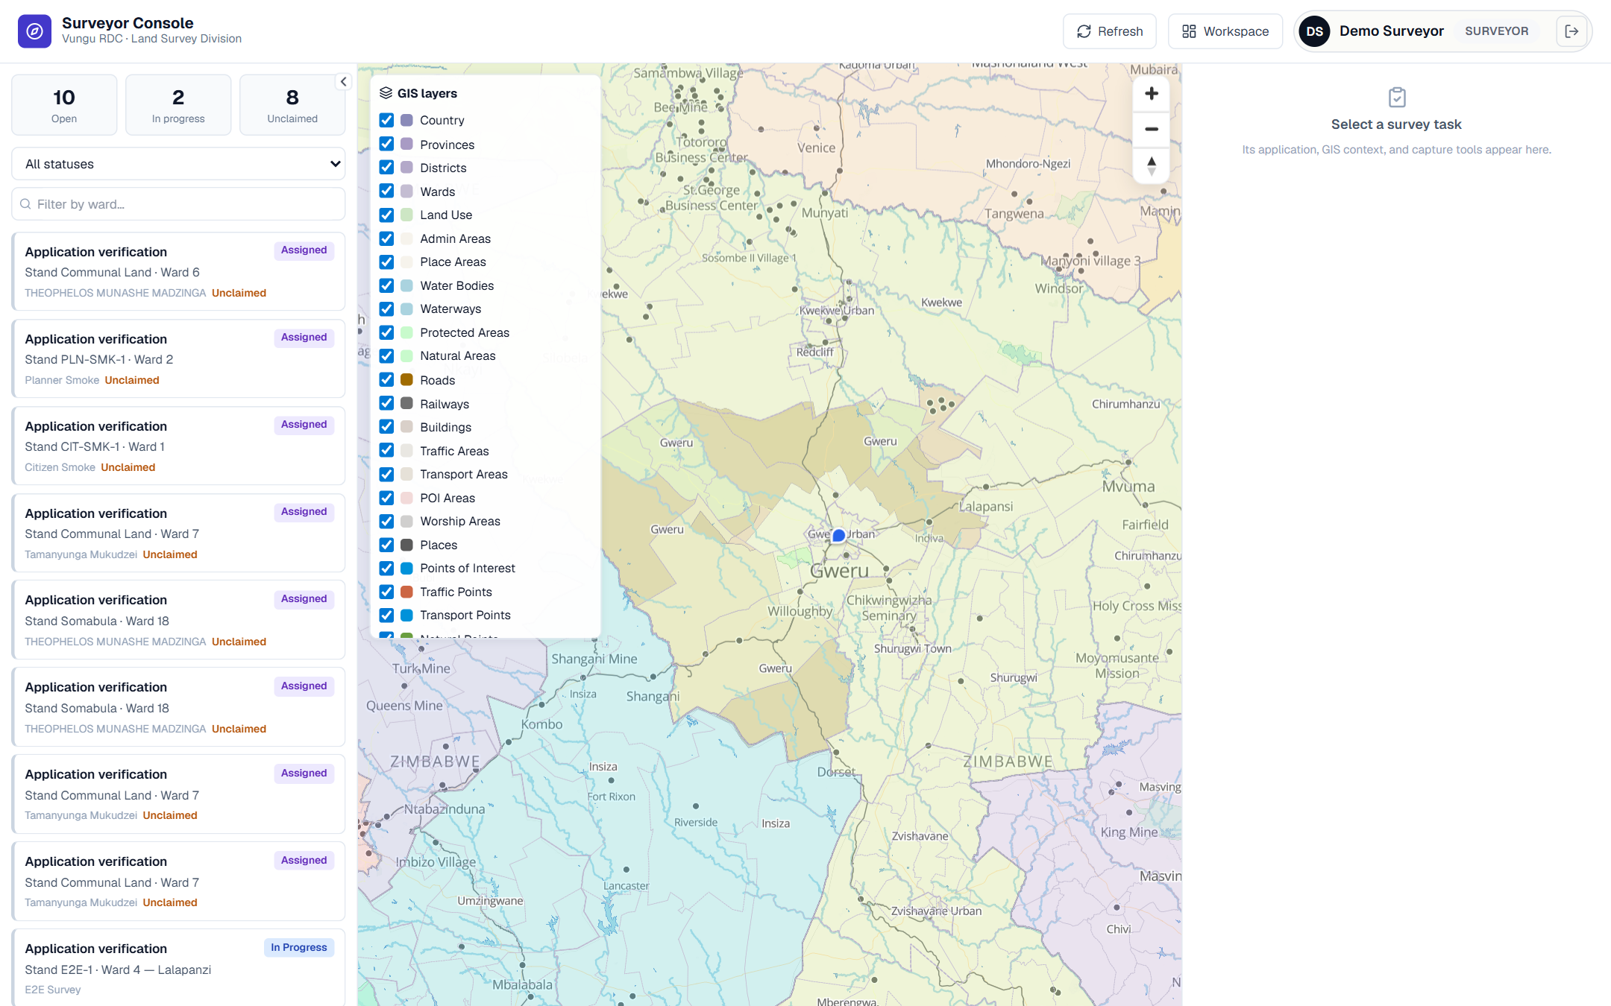
Figure 11. The surveyor's console, with a queue of stands awaiting verification and a count of those still to be located on the ground.
The surveyor checks the stand boundaries and confirms the parcel exists as described. Their task list keeps verifications from being forgotten.
Environmental Officer — checking environmental constraints
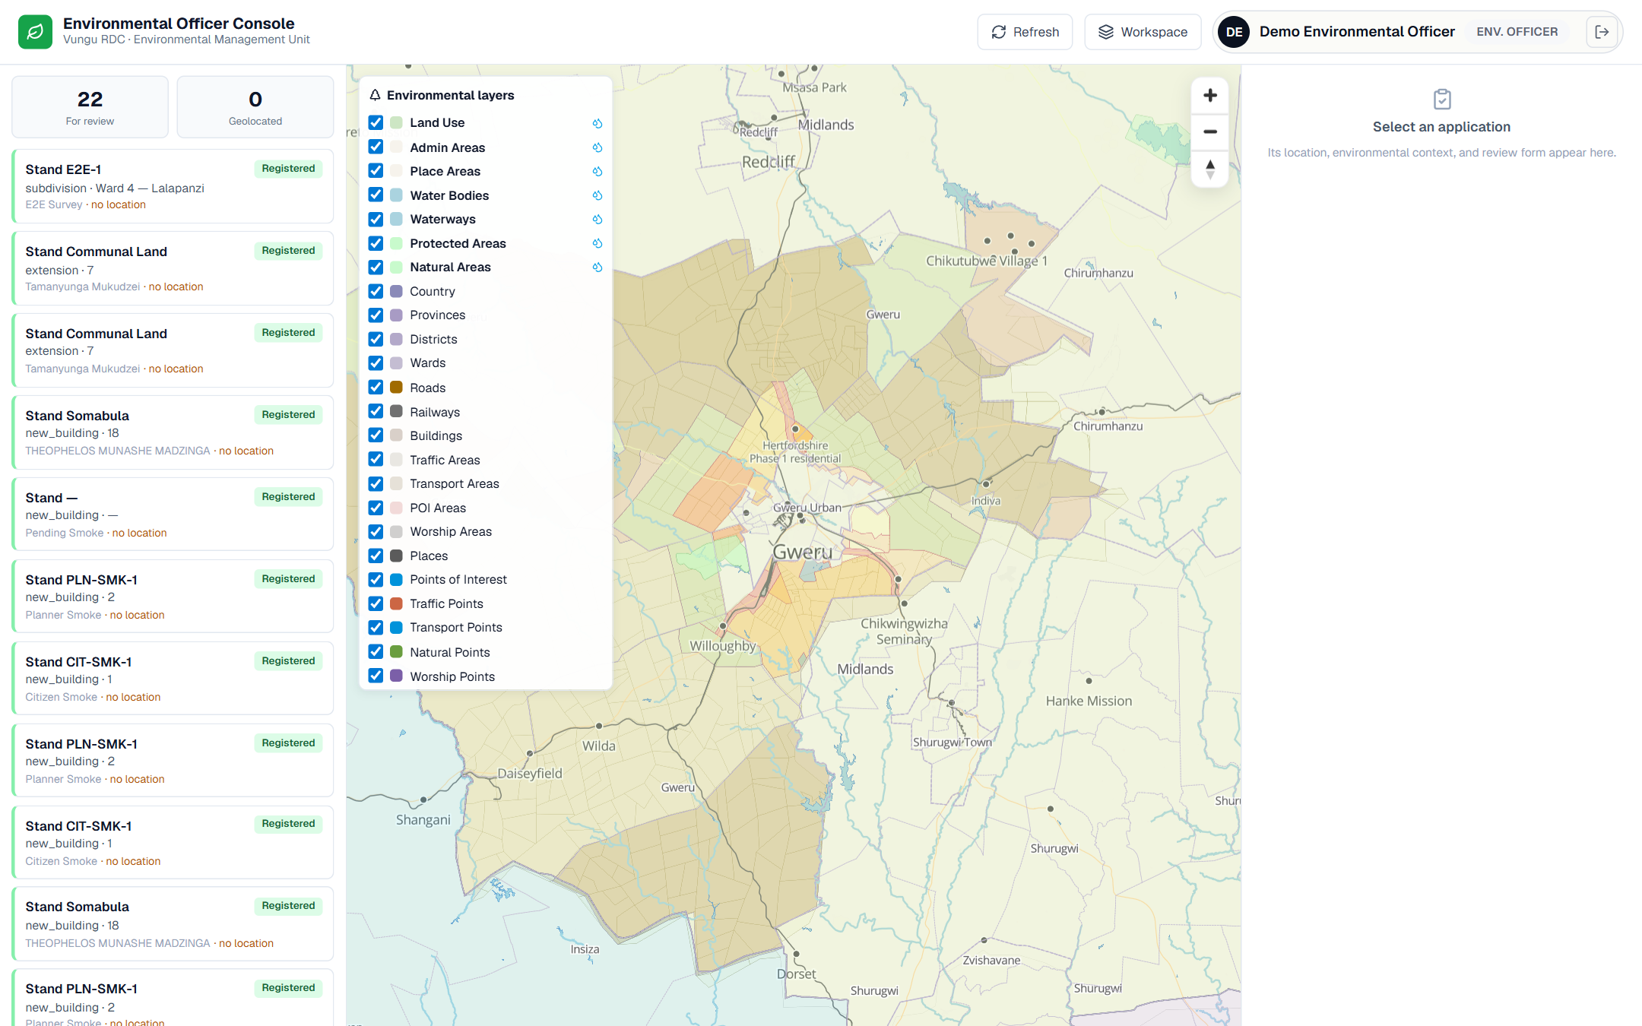
Figure 12. The environmental officer's console, showing protected areas, water bodies and natural areas as map layers alongside the applications to review.
The environmental officer reviews each proposal against environmentally sensitive areas — wetlands, water bodies and protected land — so that harmful developments are flagged early.
Building Inspector — inspections and compliance
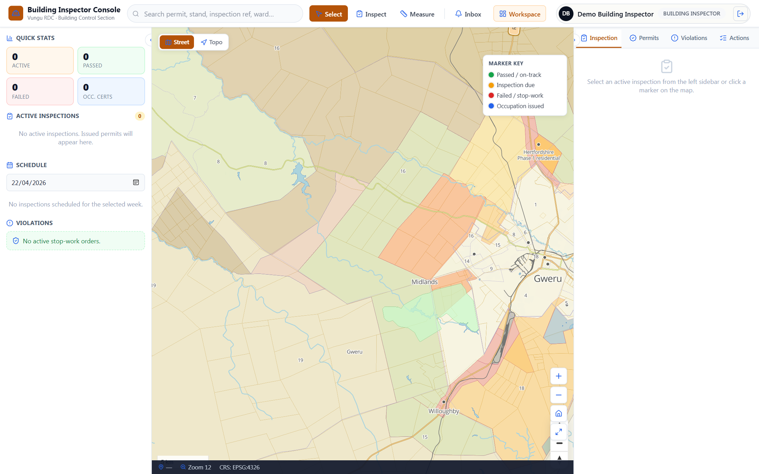
Figure 13. The building inspector's console. A colour key tracks each site — on track, inspection due, failed/stop-work, or occupation certificate issued.
Once building begins, the inspector schedules and records site inspections, raises stop-work orders where needed, and issues the occupation certificate at the end. The map shows the status of every site at a glance.

SECTION 8
The front office — the planning clerk's register
The planning clerk runs the council's front office. Every application that comes in — online or over the counter — is registered here, given a reference number, and tracked until it is approved.
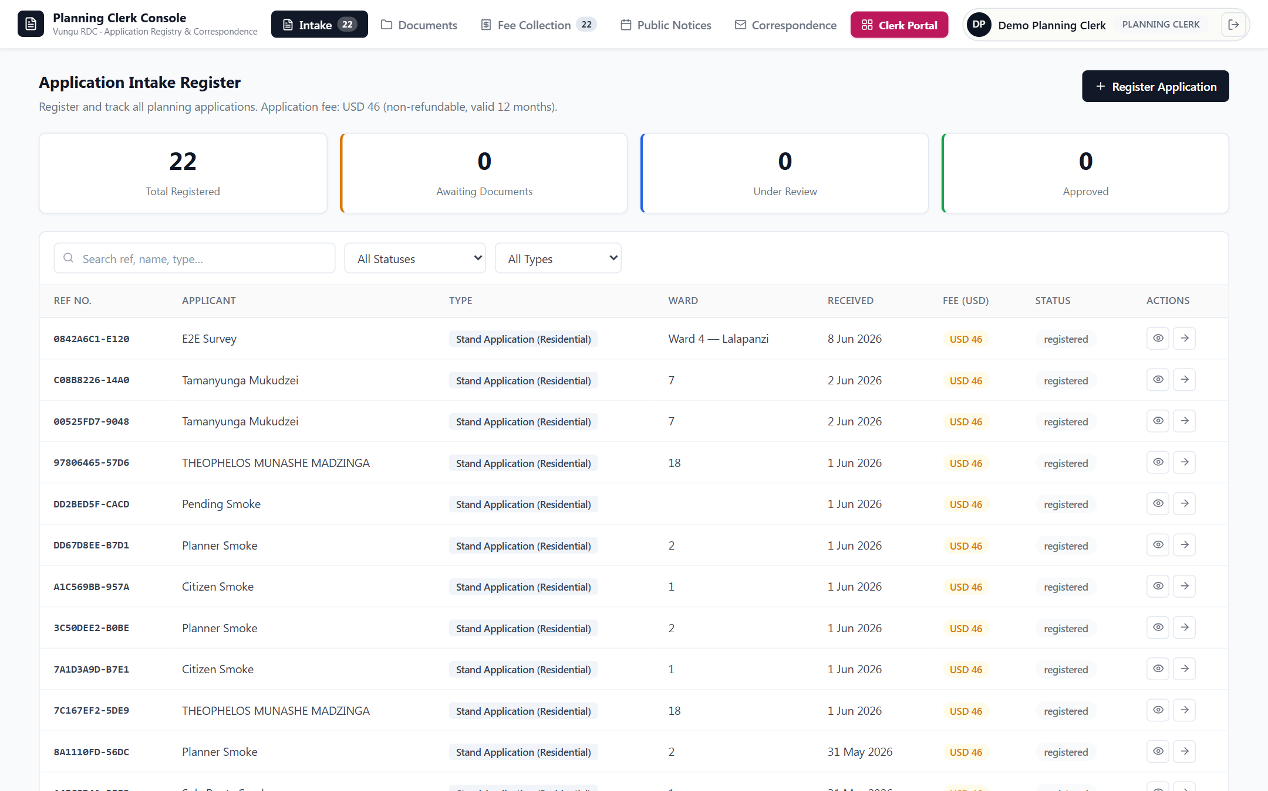
Figure 14. The planning clerk's intake register. Each row is a real application with its reference, applicant, type, ward, date received, fee and status. The counters at the top summarise the whole register.
The clerk also collects fees, manages documents, publishes the public notices for the objection period, and handles correspondence — the administrative backbone of the whole process, now in one organised place.

SECTION 9
Executive oversight — the E.O. command centre
The Executive Officer makes the final decision on each application. Their command centre brings the whole department onto one screen: the map of activity, the queue of applications awaiting a decision, and summary figures such as turnaround time, active projects and revenue.
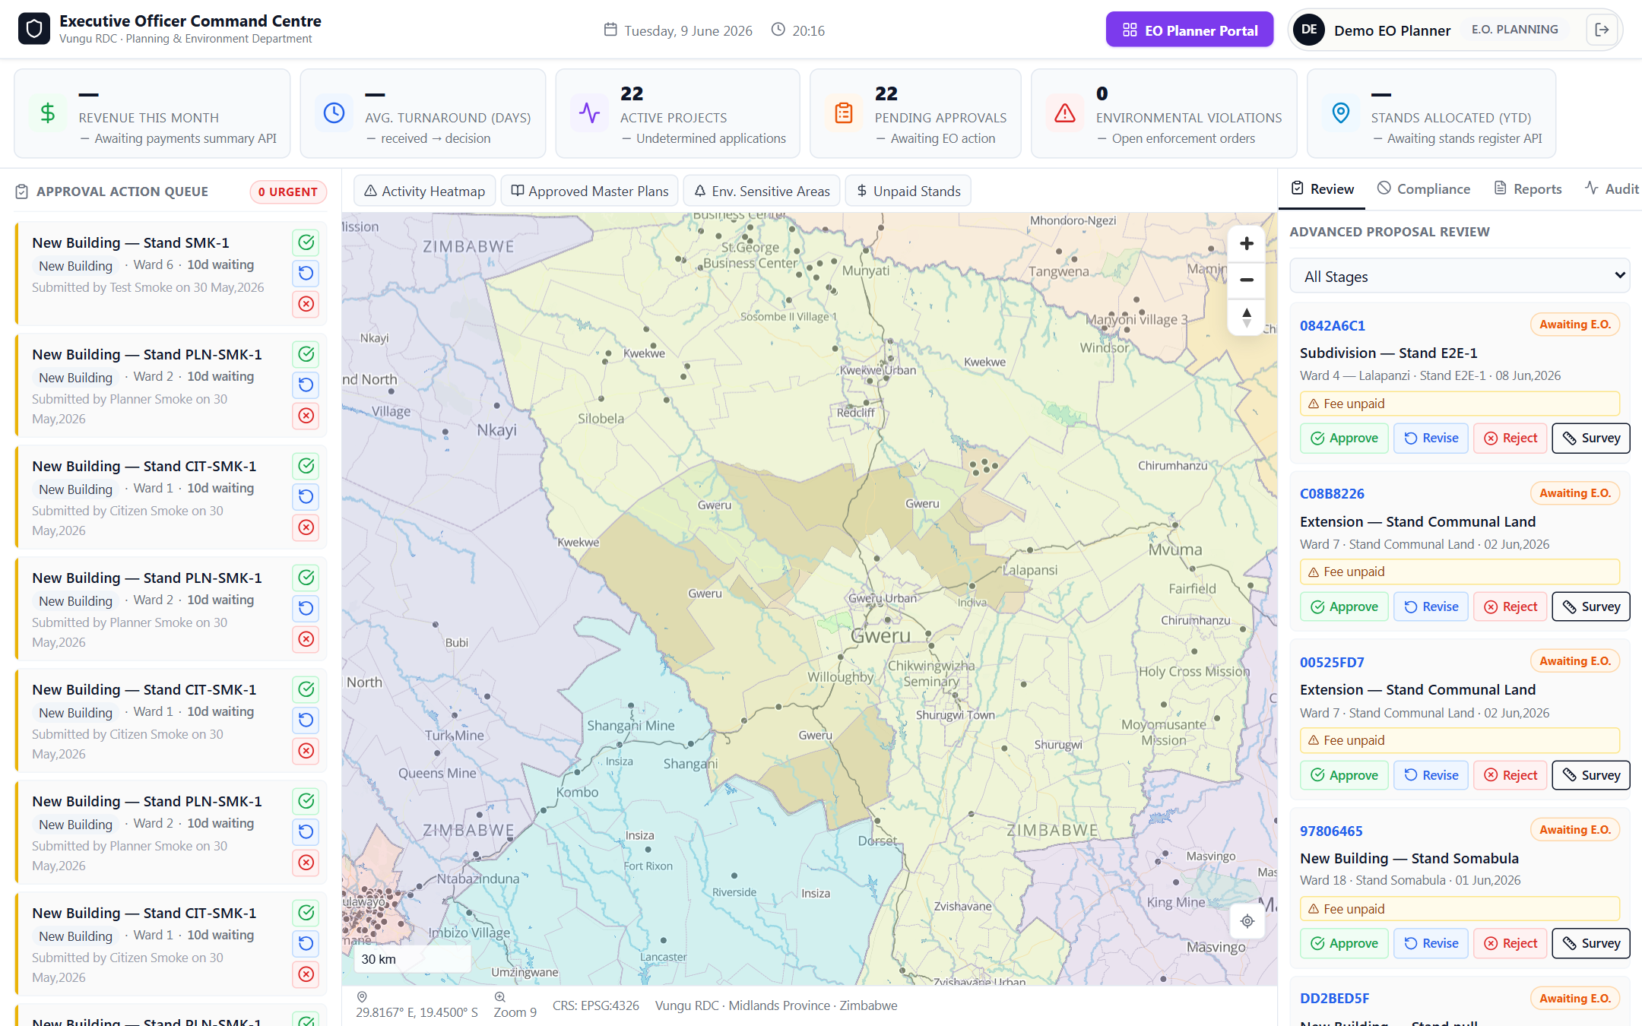
Figure 15. The Executive Officer's command centre. Applications awaiting approval are listed on the right with clear actions — approve, revise, reject, or send for survey — each one tied to its place on the map.
This gives leadership a single, real-time view of how the department is performing and where applications are getting stuck — the kind of oversight that was impossible with paper files.

SECTION 10
Administration & security
Access to the system is controlled. An administrator manages staff accounts and decides which role each person has — and therefore which tools and information they can see.
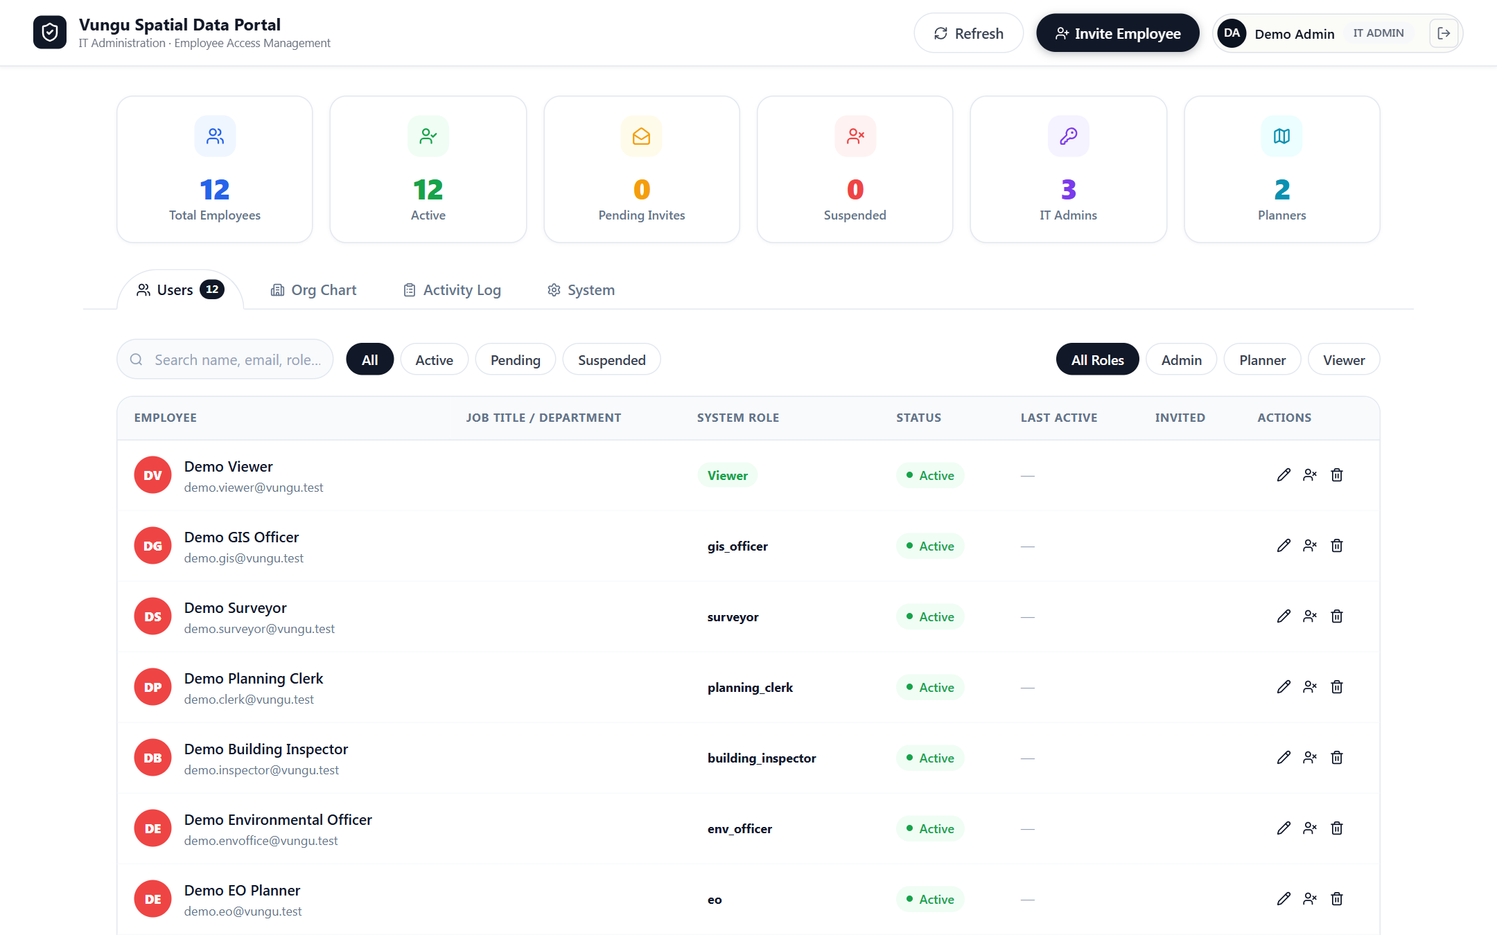
Figure 16. The administrator's staff-management screen. Each employee has a single account and a defined role (planner, clerk, surveyor, inspector, and so on), with their status visible at a glance.
Security in plain terms
Everyone signs in with their own account, and the system only lets each person do the job that belongs to their role. Sensitive information — such as residents' personal details — is only shown to the council officers who need it. Permissions are checked by the system on every action, not left to trust.

SECTION 11
What works today
The following are built and working in the demonstration system shown in this report:
- A public website and a country-wide interactive map, open to everyone.
- Secure sign-in with a separate, purpose-built workspace for each role.
- An online service catalogue where residents apply, with clear fees and timeframes.
- A resident dashboard for tracking applications, fees and required actions.
- The full seven-stage statutory workflow, from intake to permit issue.
- Dedicated consoles for the GIS officer, surveyor, environmental officer and building inspector.
- The planning clerk's intake register, fee collection and public notices.
- The Executive Officer's command centre for final decisions and oversight.
- Administrator control of staff accounts, roles and access.
- Applications linked to their stand on the map, with an automatic history of every action.

SECTION 12
What comes next
With the core system working end to end, the next steps focus on preparing it for everyday use by the council and the public:
- Loading real records. Bringing the council's existing stands, applications and registers into the system.
- Online payments. Connecting a payment method so residents can pay fees directly through the portal.
- Staff training. Short, role-by-role training so each officer is confident in their own workspace.
- A controlled pilot. Running a limited number of real applications through the system alongside the current process, to build confidence.
- Going live. Switching over fully once the pilot confirms the system is reliable and staff are comfortable.

In one sentence
The system that replaces the council's paper planning process is built and working from end to end; what remains is loading real data, connecting payments, training staff, and a careful pilot before going live.

We would welcome the committee's questions and guidance on priorities for the pilot.

