VUNGU RURAL DISTRICT COUNCIL
GIS-Integrated Municipal Planning Information System
FRONTEND SYSTEM DESIGN DOCUMENT
Conceptual Model • Logical Model • Physical Model
Application Windows • User Roles • Report Formats
Document Title | Frontend System Design Document
Organisation | Vungu Rural District Council (Vungu RDC)
System | GIS-Integrated Municipal Planning Information System
Version | 1.0
Date | April 2026

1. SYSTEM OVERVIEW
The GIS-Integrated Municipal Planning Information System (hereafter "the System") is a web-based geospatial platform developed for Vungu Rural District Council (Vungu RDC), Gweru Rural, Zimbabwe. The system digitalises and integrates the Council's planning, land use management, development application processing, environmental oversight, and reporting functions into a single, role-aware, map-centric application.
The system serves the Council's five departments and two units: Finance, Planning and Environment, Social Services, Roads and Works, Human Resources and Administration, Internal Audit, and Procurement Management. It also provides a public-facing portal through which landowners, developers, and citizens may submit development applications, track permit status, and access authorised spatial datasets.
1.1 Technology Stack
Layer | Technology | Purpose
Frontend | Vue 3 + Vite + TypeScript | Single-page application, component framework
State Management | Pinia | Global authentication and spatial data stores
Routing | Vue Router | Client-side navigation with role-based guards
Map Engine | MapLibre GL JS | WebGL map rendering, GeoJSON layer display
Spatial Analysis | Turf.js | Client-side area, distance, buffer calculations
Animations | GSAP + ScrollTrigger | Scroll-triggered UI animations
HTTP Client | Axios | JWT-authenticated API communication
Icons | Lucide Vue Next | UI icon library
Styling | Tailwind CSS + Scoped CSS | Utility classes and component styles
Backend API | Node.js + Fastify | RESTful JSON API with OGC proxy
Spatial DB | PostgreSQL + PostGIS | Geometry storage, spatial queries
Map Tiles / OGC | QGIS Server / GeoServer | WMS tile serving, WFS feature serving
Deployment | Nginx + PM2 + Docker | Reverse proxy, process management, containers

1.2 Geographic Scope
The system covers the full spatial extent of Vungu Rural District Council, comprising 20 wards across the Gweru Rural area.

2. SYSTEM PLAYERS — ROLES AND JOB DESCRIPTIONS
The system recognises the following user roles, derived from the Vungu RDC organisational structure. Each role has a defined set of permissions, a primary landing screen, and specific functions within the system.
Role Name | System Role Code | Org. Position | Landing Screen
System Administrator | admin | IT / CEO office | /admin/users
E.O. Planning & Environment | eo | Dept Head — Planning | /eo-planner
Planning Officer | planner | Under E.O. Planning | /planner
Building Inspector | inspector | Under Planning Officer | /planner
Environment Officer | environment | Under E.O. Planning | /eo-planner
Council Treasurer | treasurer | Finance Dept Head | /finance
E.O. Income | finance_income | Under Council Treasurer | /finance/income
E.O. Expenditure | finance_expenditure | Under Council Treasurer | /finance/expenditure
Revenue Clerk | revenue_clerk | Under E.O. Income | /finance/revenue
Debtor's Clerk | debtors_clerk | Under Revenue Clerk | /finance/debtors
Accounts Clerk | accounts_clerk | Under E.O. Expenditure | /finance/accounts
Auditor | auditor | Internal Audit Unit | /audit
Audit Clerk | audit_clerk | Under Auditor | /audit
HR & Admin Officer | hr_admin | HR & Administration Dept | /admin/users
Ass. E.O. Social Services | social_services | Under HR & Admin | /analytics
Salaries Officer | salaries | Under HR & Admin | /analytics
Roads Engineer | roads_engineer | Roads & Works Dept | /planner
Civil Technician | roads_tech | Under Roads Engineer | /planner
CEO | ceo | Chief Executive | /analytics
Public User | user | External / Public | /

2.1 Chief Executive Officer (CEO)
System Role Code: ceo
The CEO is the head of Vungu Rural District Council and bears overall accountability for the Council's administration, service delivery, and statutory compliance. Within the system, the CEO is a read-only executive user who accesses high-level dashboards, ward-level statistics, and consolidated reports prepared by departmental officers. The CEO does not create, edit, or approve spatial data directly.
Permissions
• View executive dashboard (application volumes, ward statistics, approval rates)
• View and download all departmental reports
• View the interactive GIS map in read-only mode
• View user account list (read-only)
• Cannot create or modify any records
Reports Generated / Accessed
• Monthly Executive Summary Report
• Ward Development Progress Report
• Annual Permit Statistics Report

2.2 E.O. Planning and Environment
System Role Code: eo
The Executive Officer (E.O.) Planning and Environment is the head of the Planning and Environment Department. This is the primary decision-making role in the planning workflow. The E.O. receives planning proposals prepared by Planning Officers for final departmental approval before they proceed to Council. The E.O. also oversees environmental compliance, monitors development activity across all 20 wards, and is responsible for the department's statutory reporting obligations to the Ministry of Local Government. Within the system, the E.O. uses the dedicated E.O. Planning Command Centre — a full-screen, map-centric interface with access to satellite EO imagery layers, environmental overlays, and the application approval queue.
Permissions
• Access the E.O. Planning Command Centre (/eo-planner)
• Review and approve or reject planning proposals (stage: awaiting_eo → approved / rejected)
• Review and make decisions on development applications
• View and toggle all GIS layers including environmental overlays
• View satellite EO imagery layers (Sentinel-2 NDVI, True Colour, Thermal)
• Run spatial conflict checks on any ward or proposal geometry
• View and download all planning and environmental reports
• View all wards' planning statistics
• Cannot create new proposals (that is the Planning Officer's role)
Reports Generated / Accessed
• Monthly Planning Department Report
• Proposal Approval Summary
• Environmental Compliance Report
• Development Activity by Ward Report

2.3 Planning Officer
System Role Code: planner
The Planning Officer is responsible for the day-to-day spatial planning operations of the Council. Duties include preparing residential and commercial layout schemes, processing development applications received from the public, conducting spatial analysis (conflict checks, yield calculations), managing planning tasks and deadlines per ward, and preparing proposals for the E.O.'s approval. Within the system, the Planning Officer uses the Vungu Planner — a three-pane GIS workstation with a full MapLibre GL map, spatial draw/measure/buffer tools, a layer panel, a task list, an approval tracker, and a yield analysis table.
Permissions
• Access the Vungu Planning Command Centre (/planner)
• Create, edit, and submit planning proposals (stage: draft → circulating → awaiting_eo)
• Draw polygons, measure distances, and generate buffer zones on the map
• Run yield calculations on drawn layout polygons
• Run spatial conflict checks on proposed layouts
• Review and process development applications in their assigned wards
• Create and update planning tasks
• View and toggle GIS layers (land use, infrastructure, ward boundaries)
• Export yield tables as CSV
• View ward statistics and search geographic locations
Reports Generated / Accessed
• Development Application Status Report
• Planning Task Progress Report
• Ward Yield Analysis Report
• Conflict Check Report (per proposal)
• Quarterly Ward Planning Summary

2.4 Building Inspector
System Role Code: inspector
The Building Inspector conducts on-site inspections of development works to verify compliance with approved plans, building regulations, and planning conditions. Inspection findings are recorded in the system, linked to the relevant development application, and used to update compliance status. The Building Inspector operates within the planner interface but with a focus on the inspection management and compliance tracking modules.
Permissions
• Access the Vungu Planner in inspection mode (/planner)
• View assigned development applications and their approved plans
• Record inspection findings (date, result, observations, photos)
• Update application compliance status (compliant / non-compliant / pending)
• View the GIS map to locate stands and access property information
• Cannot approve or reject planning proposals
Reports Generated / Accessed
• Inspection Report (per application)
• Monthly Inspection Activity Report
• Non-Compliance Summary Report

2.5 Environment Officer
System Role Code: environment
The Environment Officer is responsible for environmental assessment and oversight within the Planning and Environment Department. Key functions include maintaining environmental overlay layers (wetlands, river buffers, protected areas), conducting environmental impact assessments on proposed developments, and ensuring compliance with the Environmental Management Act (Zimbabwe). The Environment Officer uses the E.O. Planning Command Centre with a focus on environmental layers and the EO satellite imagery stack.
Permissions
• Access the E.O. Planning Command Centre (/eo-planner)
• View and update environmental overlay GIS layers
• Run conflict checks against environmental buffers
• View satellite EO imagery (NDVI, Land Cover, Thermal)
• Record environmental assessment findings on proposals
• View all wards' environmental compliance data
Reports Generated / Accessed
• Environmental Compliance Report
• Environmental Impact Assessment Summary
• Wetland and Buffer Zone Status Report

2.6 Council Treasurer
System Role Code: treasurer
The Council Treasurer is the head of the Finance Department and is responsible for all financial management of the Council including revenue collection, expenditure control, and financial reporting. Within the system, the Treasurer accesses financial dashboards linked to development application fees, yield revenue estimates from planning proposals, and debtor accounts.
Permissions
• Access the Finance Dashboard (/finance)
• View all revenue reports and fee collection summaries
• View yield revenue estimates generated by Planning Officers
• View and manage debtor accounts
• View and download all financial reports
• Cannot create or modify planning or spatial data
Reports Generated / Accessed
• Monthly Revenue Collection Report
• Application Fee Collection Report
• Debtor's Ledger Report
• Annual Financial Summary

2.7 Revenue Clerk / E.O. Income
System Role Code: revenue_clerk
The Revenue Clerk records payments received for development application fees, permit issuance, and other Council charges. Payments are linked to specific applications and stands in the system, providing a full audit trail. The E.O. Income supervises the Revenue Clerk and reviews the revenue collection dashboard.
Permissions
• Record payments against development applications
• View the revenue dashboard and daily collection summaries
• Search applications by applicant or stand number
• Print payment receipts
• Cannot modify application status or spatial data
Reports Generated / Accessed
• Daily Revenue Collection Summary
• Outstanding Fees Report

2.8 Debtor's Clerk
System Role Code: debtors_clerk
The Debtor's Clerk manages outstanding accounts and follows up on unpaid development fees and rates. The system provides a debtor management view listing all stands and applications with outstanding balances, aged debt summaries, and the ability to record partial payments and payment arrangements.
Permissions
• View and manage the debtors list
• Record partial payments and payment arrangements
• Generate aged debtor reports
• Cannot modify spatial data or application decisions
Reports Generated / Accessed
• Aged Debtors Report
• Outstanding Fees by Ward Report

2.9 Auditor / Audit Clerk
System Role Code: auditor
The Auditor and Audit Clerk are responsible for the Internal Audit Unit. They perform independent reviews of financial transactions, planning decisions, and system activity. The system provides the Auditor with a read-only audit log view covering all user actions, application status changes, proposal approvals, and payment records.
Permissions
• View the full system audit log (all user actions, timestamps)
• View all development applications, proposals, and decisions (read-only)
• View all financial records (read-only)
• Export audit logs as CSV or PDF
• Cannot create, modify, or delete any record
Reports Generated / Accessed
• System Activity Audit Report
• Application Decision Audit Trail
• Financial Transaction Audit Report

2.10 HR & Admin Officer
System Role Code: hr_admin
The HR and Administration Officer manages staff records, payroll coordination, and general administration. Within the system, this role has access to the user management module to create, modify, and deactivate staff accounts, assign roles, and send invitation emails to new staff members.
Permissions
• Create, edit, and deactivate user accounts
• Assign system roles to staff members
• Send invitation emails to new users
• View staff activity summaries
• Cannot access planning, finance, or GIS modules beyond basic viewing
Reports Generated / Accessed
• User Account Activity Report
• Role Assignment Summary

2.11 Roads Engineer / Civil Technician
System Role Code: roads_engineer
The Roads Engineer and Civil Technician are responsible for roads infrastructure planning and maintenance. Within the system, they have access to the GIS map for viewing road reserve layers, infrastructure overlays, and proposed development layouts that may affect road alignments. The Roads Engineer can flag road reserve conflicts on planning proposals.
Permissions
• View the GIS map and all infrastructure layers (read-only)
• View planning proposals and flag road reserve conflicts
• View ward statistics and infrastructure data
• Cannot create or approve proposals
Reports Generated / Accessed
• Road Reserve Conflict Report
• Infrastructure Layer Status Report

2.12 Public User (Applicant / Citizen)
System Role Code: user
A Public User is any member of the public who accesses the system via the public-facing portal. This includes property owners, developers, architects, legal representatives, and general citizens. Public Users may register a free account to submit development applications, track the status of their applications, and download approved plans. Unauthenticated visitors may view public GIS data and the layer catalogue without registering.
Permissions
• View the public landing page, about page, and layer catalogue (unauthenticated)
• View the public GIS data explorer map (unauthenticated)
• Register a public account
• Submit development applications (authenticated)
• Track the status of submitted applications (authenticated)
• Download approved plans and compliance certificates (authenticated)
• Cannot access any internal planning, finance, or admin modules
Reports Generated / Accessed
• Application Submission Confirmation (auto-generated PDF)
• Application Status Notification (email)
• Compliance Certificate (when issued by Building Inspector)

3. CONCEPTUAL DATA MODEL
The conceptual model defines the high-level entities in the system and the relationships between them, independent of implementation details. It represents the real-world objects that the system must manage.
3.1 Core Entities
Entity | Description
USER | Any person who interacts with the system — staff, officers, or public applicants.
ROLE | A named permission set assigned to users (e.g. planner, eo, admin).
WARD | One of the 20 administrative divisions of Vungu RDC, each with a defined spatial boundary.
STAND | An individual land parcel (lot) within a ward, identified by a stand number and registered geometry.
ZONE | A land use classification (Residential, Commercial, Industrial, Open Space, Agricultural).
DEVELOPMENT_APPLICATION | A formal request by a property owner or developer to carry out development work on a stand.
PROPOSAL | An internal planning layout scheme prepared by a Planning Officer, covering multiple stands.
INSPECTION_RECORD | A record of a Building Inspector's on-site visit to a stand under an active application.
ENVIRONMENTAL_OVERLAY | A spatial layer representing an environmental constraint (wetland, river buffer, protected area).
GIS_LAYER | A map layer available in the system, sourced from GeoServer or PostGIS.
PAYMENT | A financial transaction recording a fee paid against a development application.
NOTIFICATION | A system message sent to a user (approval, rejection, inspection scheduled, etc.).
REPORT | A generated document summarising data for a specific user, period, or geographic area.
AUDIT_LOG | A timestamped record of every create, update, or delete action performed in the system.

3.2 Key Relationships
Relationship | Cardinality | Description
USER — ROLE | Many-to-one | Each user is assigned exactly one role; a role may be held by many users.
USER — WARD | Many-to-one (optional) | A staff user may be assigned to a primary ward; public users are not ward-specific.
WARD — STAND | One-to-many | A ward contains many stands; each stand belongs to exactly one ward.
STAND — ZONE | Many-to-one | Each stand has one land use zone; a zone applies to many stands.
STAND — DEVELOPMENT_APPLICATION | One-to-many | A stand may have multiple applications over time (e.g. change of use, extension).
USER — DEVELOPMENT_APPLICATION | One-to-many | A public user (applicant) may submit many applications.
DEVELOPMENT_APPLICATION — INSPECTION_RECORD | One-to-many | An application may have multiple inspection records at different stages.
INSPECTION_RECORD — USER | Many-to-one | Each inspection is conducted by one Building Inspector.
PROPOSAL — WARD | Many-to-one | Each proposal belongs to a ward.
PROPOSAL — USER (creator) | Many-to-one | Each proposal is created by one Planning Officer.
PROPOSAL — STAND | Many-to-many | A proposal covers a set of stands (via a junction entity PROPOSAL_STAND).
PAYMENT — DEVELOPMENT_APPLICATION | Many-to-one | Multiple payments may be recorded against one application (partial payments).
NOTIFICATION — USER | Many-to-one | Notifications are addressed to a specific user.
AUDIT_LOG — USER | Many-to-one | Each audit entry records the user who performed the action.
GIS_LAYER — WARD | Many-to-many (optional) | Layers may have ward-level filters or extents.

4. LOGICAL DATA MODEL
The logical model normalises the conceptual entities into structured tables, defines all attributes and their data types, and specifies primary keys, foreign keys, and constraints. This model is independent of any specific database engine.
4.1 USERS
Stores all system user accounts — staff and public applicants.
Attribute | Data Type | Constraint | Description
id | UUID | PK | Unique user identifier
email | VARCHAR(255) | UNIQUE, NOT NULL | Login email address
password_hash | VARCHAR(255) | NOT NULL | bcrypt-hashed password (cost factor 12)
full_name | VARCHAR(150) | NOT NULL | User's full name
role_id | INTEGER | FK → ROLES | Assigned system role
ward_id | INTEGER | FK → WARDS (opt) | Primary ward assignment (staff only)
phone | VARCHAR(20) | NULL | Contact phone number
status | VARCHAR(20) | NOT NULL | active | suspended | pending_verification
invite_token | VARCHAR(64) | NULL | Token for staff invitation emails
last_login_at | TIMESTAMPTZ | NULL | Timestamp of most recent successful login
created_at | TIMESTAMPTZ | NOT NULL | Account creation timestamp
updated_at | TIMESTAMPTZ | NOT NULL | Last profile update timestamp

4.2 ROLES
Defines all named permission sets.
Attribute | Data Type | Constraint | Description
id | SERIAL | PK | Role identifier
name | VARCHAR(50) | UNIQUE | Role code: admin, eo, planner, inspector, etc.
label | VARCHAR(100) | NOT NULL | Human-readable label (E.O. Planning and Environment)
permissions | JSONB | NOT NULL | Array of permission strings granted to this role
landing_path | VARCHAR(100) | NOT NULL | Default redirect path after login

4.3 WARDS
The 20 administrative wards of Vungu RDC.
Attribute | Data Type | Constraint | Description
id | SERIAL | PK | Ward identifier
name | VARCHAR(100) | NOT NULL | Ward name (e.g. Somabhula, Lalapanzi)
ward_number | INTEGER | UNIQUE | Official ward number (1–20)
population | INTEGER | NULL | Estimated ward population
area_sqkm | NUMERIC(10,2) | NULL | Ward area in square kilometres
stand_count | INTEGER | NULL | Total number of registered stands
center_lng | NUMERIC(12,8) | NOT NULL | Longitude of ward centroid
center_lat | NUMERIC(12,8) | NOT NULL | Latitude of ward centroid
geometry | GEOMETRY(MultiPolygon,4326) | NULL | Ward boundary polygon (WGS84)
created_at | TIMESTAMPTZ | NOT NULL | Record creation timestamp

4.4 STANDS
Individual land parcels within wards.
Attribute | Data Type | Constraint | Description
id | SERIAL | PK | Stand identifier
ward_id | INTEGER | FK → WARDS | Ward containing this stand
zone_id | INTEGER | FK → ZONES | Current land use zone
stand_number | VARCHAR(30) | NOT NULL | Official stand number
owner_name | VARCHAR(150) | NULL | Registered owner full name
owner_id_number | VARCHAR(30) | NULL | National ID or company reg number
area_sqm | NUMERIC(12,2) | NULL | Stand area in square metres
street_address | VARCHAR(255) | NULL | Physical address
title_deed_ref | VARCHAR(50) | NULL | Title deed reference number
status | VARCHAR(30) | NOT NULL | vacant | occupied | under_development
geometry | GEOMETRY(Polygon,4326) | NULL | Stand boundary polygon (WGS84)
created_at | TIMESTAMPTZ | NOT NULL | Record creation timestamp
updated_at | TIMESTAMPTZ | NOT NULL | Last update timestamp

4.5 ZONES
Land use zone classifications.
Attribute | Data Type | Constraint | Description
id | SERIAL | PK | Zone identifier
name | VARCHAR(100) | NOT NULL | Zone name (e.g. Residential Low Density)
type | VARCHAR(50) | NOT NULL | residential | commercial | industrial | open_space | agricultural | institutional
colour_code | VARCHAR(7) | NOT NULL | Hex colour for map rendering (e.g. #4ade80)
description | TEXT | NULL | Permitted uses and restrictions
max_coverage | NUMERIC(5,2) | NULL | Maximum site coverage percentage
min_setback | NUMERIC(6,2) | NULL | Minimum building setback in metres

4.6 DEVELOPMENT_APPLICATIONS
Formal development requests submitted by property owners.
Attribute | Data Type | Constraint | Description
id | VARCHAR(20) | PK | Application reference (e.g. DA-2026-0001)
applicant_id | UUID | FK → USERS | Submitting user
stand_id | INTEGER | FK → STANDS | Stand subject to the application
application_type | VARCHAR(50) | NOT NULL | new_build | extension | change_of_use | subdivision | demolition
description | TEXT | NOT NULL | Applicant's description of proposed works
submitted_at | TIMESTAMPTZ | NOT NULL | Submission timestamp
status | VARCHAR(30) | NOT NULL | submitted | under_review | awaiting_inspection | approved | rejected | withdrawn
decision_notes | TEXT | NULL | Officer's decision rationale
decided_by | UUID | FK → USERS (NULL) | Officer who made the decision
decided_at | TIMESTAMPTZ | NULL | Decision timestamp
fee_required | NUMERIC(10,2) | NOT NULL | Total application fee due
fee_paid | NUMERIC(10,2) | NOT NULL DEFAULT 0 | Total amount paid to date
documents_path | TEXT[] | NULL | Array of uploaded document file paths
created_at | TIMESTAMPTZ | NOT NULL | Record creation timestamp
updated_at | TIMESTAMPTZ | NOT NULL | Last status update timestamp

4.7 PROPOSALS
Internal planning layout schemes prepared by Planning Officers.
Attribute | Data Type | Constraint | Description
id | VARCHAR(20) | PK | Proposal reference (e.g. PRO-2026-001)
title | VARCHAR(200) | NOT NULL | Descriptive title of the proposal
creator_id | UUID | FK → USERS | Planning Officer who created it
ward_id | INTEGER | FK → WARDS | Ward the proposal falls within
stage | VARCHAR(30) | NOT NULL | draft | circulating | awaiting_eo | approved | rejected | billed
geometry | GEOMETRY(Polygon,4326) | NULL | Drawn layout boundary polygon (WGS84)
area_ha | NUMERIC(10,4) | NULL | Calculated area in hectares
stand_count | INTEGER | NULL | Total planned stands in the layout
notes | TEXT | NULL | Planning Officer's notes
approved_by | UUID | FK → USERS (NULL) | E.O. who approved the proposal
approved_at | TIMESTAMPTZ | NULL | Approval timestamp
created_at | TIMESTAMPTZ | NOT NULL | Record creation timestamp
updated_at | TIMESTAMPTZ | NOT NULL | Last update timestamp

4.8 PROPOSAL_STANDS
Junction table linking proposals to the individual stands they include.
Attribute | Data Type | Constraint | Description
proposal_id | VARCHAR(20) | PK, FK → PROPOSALS | Proposal reference
stand_id | INTEGER | PK, FK → STANDS | Stand included in this proposal
stand_type | VARCHAR(30) | NOT NULL | residential | commercial | industrial | open_space
plot_size_sqm | NUMERIC(10,2) | NULL | Planned stand size
app_fee | NUMERIC(10,2) | NULL | Application fee for this stand type

4.9 INSPECTION_RECORDS
On-site inspection records by Building Inspectors.
Attribute | Data Type | Constraint | Description
id | SERIAL | PK | Inspection record identifier
application_id | VARCHAR(20) | FK → DEVELOPMENT_APPLICATIONS | Associated application
inspector_id | UUID | FK → USERS | Building Inspector who conducted the visit
scheduled_date | DATE | NOT NULL | Scheduled inspection date
conducted_date | DATE | NULL | Actual inspection date
stage | VARCHAR(50) | NOT NULL | foundation | slab | walling | roofing | completion
result | VARCHAR(30) | NULL | pass | fail | conditional_pass | not_conducted
observations | TEXT | NULL | Inspector's field observations
defects | TEXT | NULL | Listed defects or non-compliance items
photos_path | TEXT[] | NULL | Array of inspection photo file paths
created_at | TIMESTAMPTZ | NOT NULL | Record creation timestamp

4.10 ENVIRONMENTAL_OVERLAYS
Spatial constraint layers managed by the Environment Officer.
Attribute | Data Type | Constraint | Description
id | SERIAL | PK | Overlay identifier
name | VARCHAR(100) | NOT NULL | Overlay name (e.g. Gweru River Wetland Buffer)
type | VARCHAR(50) | NOT NULL | wetland | river_buffer | protected_area | road_reserve | heritage
buffer_distance_m | NUMERIC(8,2) | NULL | Buffer zone width in metres (for line/point sources)
geometry | GEOMETRY(MultiPolygon,4326) | NOT NULL | Overlay boundary or buffer polygon
description | TEXT | NULL | Regulatory basis for the overlay
colour_code | VARCHAR(7) | NOT NULL | Hex colour for map display
opacity | NUMERIC(3,2) | NOT NULL DEFAULT 0.35 | Layer fill opacity (0–1)
created_by | UUID | FK → USERS | Officer who created the overlay
created_at | TIMESTAMPTZ | NOT NULL | Record creation timestamp

4.11 GIS_LAYERS
All map layers available in the system layer panel.
Attribute | Data Type | Constraint | Description
id | SERIAL | PK | Layer identifier
name | VARCHAR(100) | NOT NULL | Display name
description | TEXT | NULL | Layer description for the UI
type | VARCHAR(30) | NOT NULL | wms | wfs | geojson | raster | eo_satellite
source_url | TEXT | NOT NULL | GeoServer WMS/WFS endpoint or tile URL
style_name | VARCHAR(100) | NULL | GeoServer SLD style name
colour_code | VARCHAR(7) | NULL | Fallback colour for the layer legend dot
access_level | VARCHAR(20) | NOT NULL | public | authenticated | staff | eo_only
is_visible_default | BOOLEAN | NOT NULL DEFAULT FALSE | Whether the layer is on by default
display_order | INTEGER | NOT NULL | Sort order in the layer panel
created_at | TIMESTAMPTZ | NOT NULL | Record creation timestamp

4.12 PAYMENTS
Fee payments recorded against development applications.
Attribute | Data Type | Constraint | Description
id | SERIAL | PK | Payment identifier
application_id | VARCHAR(20) | FK → DEVELOPMENT_APPLICATIONS | Associated application
amount | NUMERIC(10,2) | NOT NULL | Payment amount in USD
payment_date | DATE | NOT NULL | Date payment was received
payment_method | VARCHAR(30) | NOT NULL | cash | bank_transfer | mobile_money
reference | VARCHAR(50) | NOT NULL | Bank reference or receipt number
recorded_by | UUID | FK → USERS | Revenue Clerk who recorded it
created_at | TIMESTAMPTZ | NOT NULL | Record creation timestamp

4.13 NOTIFICATIONS
System messages sent to users.
Attribute | Data Type | Constraint | Description
id | SERIAL | PK | Notification identifier
user_id | UUID | FK → USERS | Recipient user
type | VARCHAR(50) | NOT NULL | application_submitted | approved | rejected | inspection_scheduled | payment_due | system
title | VARCHAR(200) | NOT NULL | Short notification title
message | TEXT | NOT NULL | Notification body text
reference_id | VARCHAR(30) | NULL | Related record ID (application, proposal, etc.)
is_read | BOOLEAN | NOT NULL DEFAULT FALSE | Whether user has read the notification
created_at | TIMESTAMPTZ | NOT NULL | Timestamp notification was generated

4.14 AUDIT_LOGS
Immutable record of all system actions.
Attribute | Data Type | Constraint | Description
id | BIGSERIAL | PK | Log entry identifier
user_id | UUID | FK → USERS | User who performed the action
action | VARCHAR(20) | NOT NULL | CREATE | UPDATE | DELETE | LOGIN | LOGOUT | VIEW
table_name | VARCHAR(50) | NOT NULL | Database table affected
record_id | VARCHAR(50) | NULL | Primary key of the affected record
old_values | JSONB | NULL | Previous field values (UPDATE/DELETE)
new_values | JSONB | NULL | New field values (CREATE/UPDATE)
ip_address | VARCHAR(45) | NULL | Client IP address
timestamp | TIMESTAMPTZ | NOT NULL | Exact timestamp of the action

5. PHYSICAL DATA MODEL
The physical model specifies how the logical entities are implemented in the PostgreSQL + PostGIS database. All geometry columns use the WGS84 coordinate reference system (SRID 4326). Spatial indexes use the GiST (Generalized Search Tree) method for efficient bounding box and nearest-neighbour queries.
5.1 Indexes
Table | Index | Purpose
users | idx_users_email | B-tree on email — fast login lookup
users | idx_users_role_id | B-tree on role_id — role filtering
wards | idx_wards_geometry | GiST on geometry — spatial queries
stands | idx_stands_ward_id | B-tree on ward_id — ward filtering
stands | idx_stands_geometry | GiST on geometry — bounding box queries
stands | idx_stands_zone_id | B-tree on zone_id — zone filtering
development_applications | idx_da_applicant_id | B-tree on applicant_id — user application list
development_applications | idx_da_stand_id | B-tree on stand_id — stand application history
development_applications | idx_da_status | B-tree on status — status filtering
proposals | idx_proposals_ward_id | B-tree on ward_id — ward proposals
proposals | idx_proposals_stage | B-tree on stage — stage filtering
proposals | idx_proposals_geometry | GiST on geometry — spatial overlap queries
environmental_overlays | idx_env_overlay_geometry | GiST on geometry — conflict checks
audit_logs | idx_audit_timestamp | B-tree on timestamp — log chronological queries
audit_logs | idx_audit_user_id | B-tree on user_id — per-user audit trail
payments | idx_payments_application_id | B-tree on application_id — fee balance queries

5.2 Constraints and Business Rules
• A user's email must be globally unique across the users table.
• A stand can have at most one active development application at a time (status not in (approved, rejected, withdrawn)).
• A proposal's geometry must fall within the boundary of its assigned ward (enforced via PostGIS ST_Within trigger).
• Payment amounts must be positive (CHECK amount > 0).
• application fee_paid must never exceed fee_required (enforced in the Fastify API layer).
• Audit log records are append-only — no UPDATE or DELETE is permitted on the audit_logs table.
• Role assignments can only be made by users with the admin or hr_admin role.
• Environmental overlay geometries must be valid PostGIS geometries (ST_IsValid enforced at insert).
• All timestamps are stored in UTC (TIMESTAMPTZ) and converted to Africa/Harare (UTC+2) in the API response.

6. APPLICATION WINDOWS AND SCREENS

This section catalogues every screen in the frontend application. Each screen entry describes its purpose, primary users, and key functions. A blank layout space is provided after each entry for wireframes or screenshots to be inserted. 1 Design Principles
Principle | Implementation
Map-centric | Maplibrie.js interactive map is the primary workspace; all ward, stand, and layout data visible on map
Role-aware | Navigation menus, dashboard tiles, available tools, and visible GIS layers change based on role (admin/eo/planner/user)
Responsive | Full functionality on desktop; simplified view on tablet for field-use by Building Inspectors
Accessibility | WCAG 2.1 AA; keyboard navigation; sufficient colour contrast
Bilingual-ready | Interface designed to accommodate both English and Shona/Ndebele label additions
Low-bandwidth friendly | GeoServer tile caching minimises data transfer for rural areas with limited connectivity

6.2 Screen Descriptions

9.2.1 /development-application — Public Permit Submission
The public application screen is accessible without login. It is the primary interface for community members submitting permit requests to Vungu RDC.
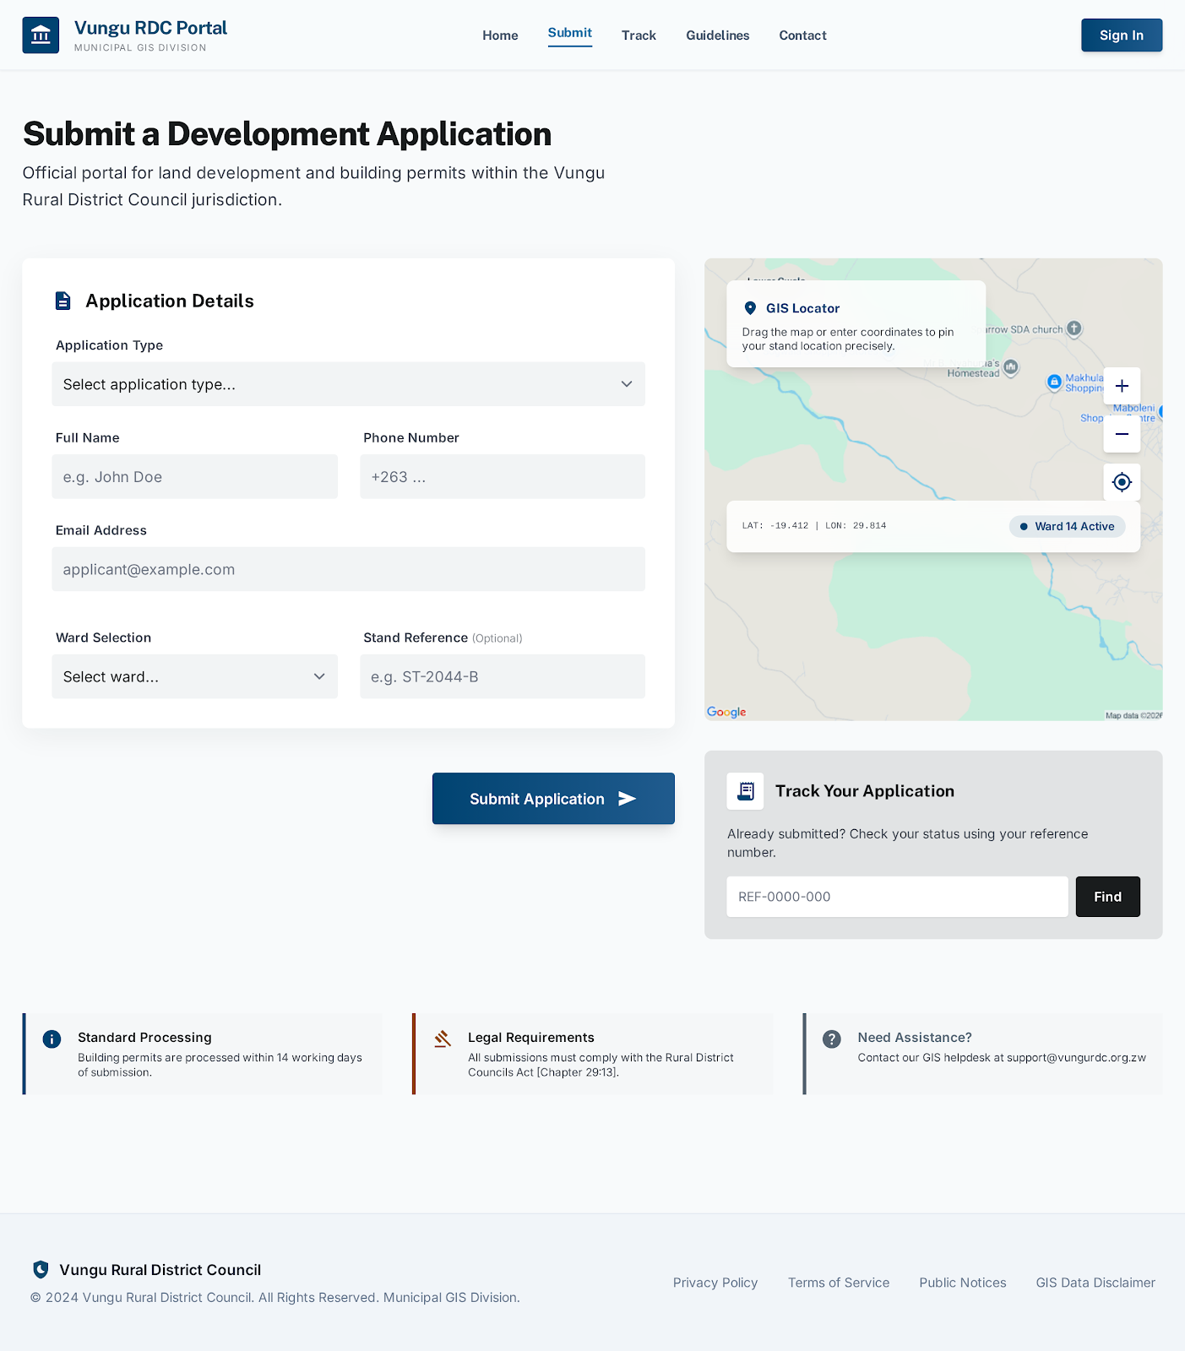

6.2.2 /planner — Planning Officer Workstation
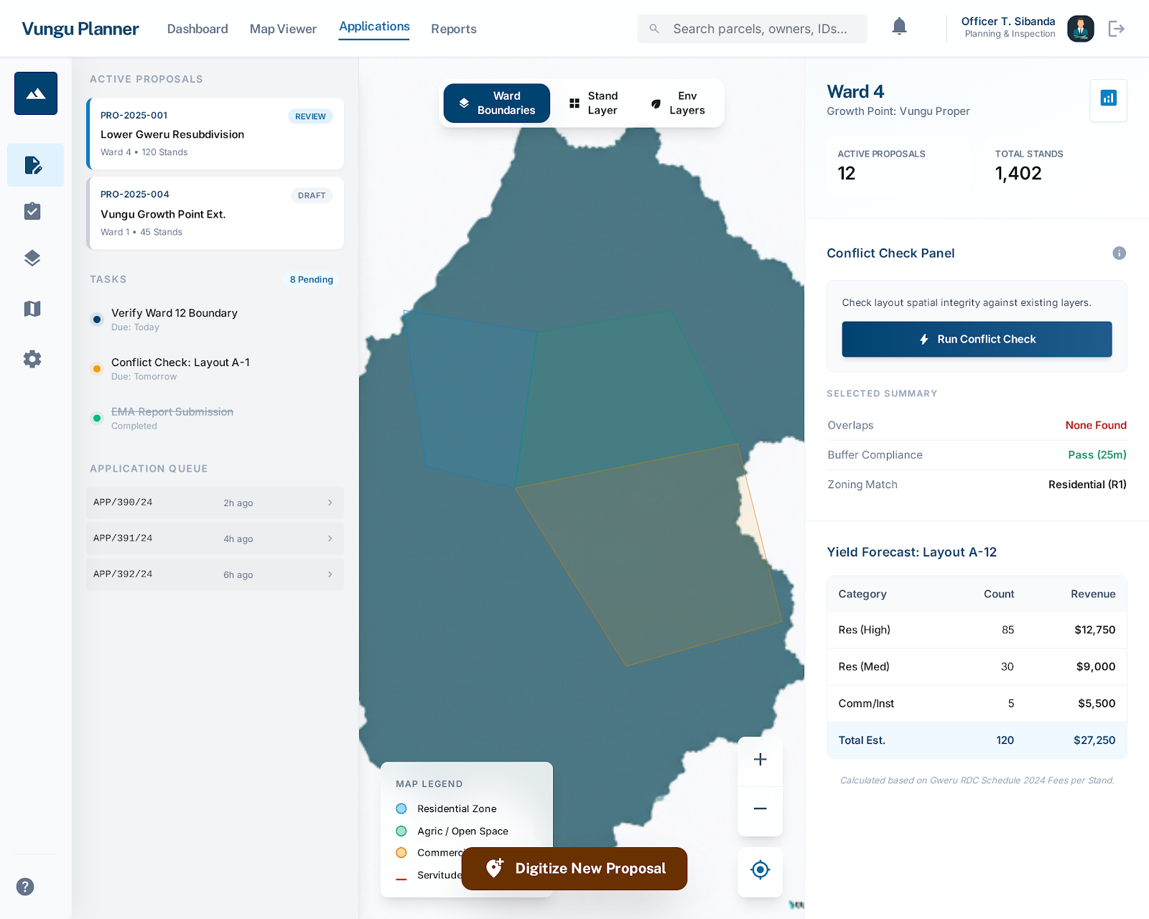

6.2.3 /eo-planner — E.O. Command Centre
The /eo-planner is the executive interface for the E.O. Planning & Environment and the Environment Officer.
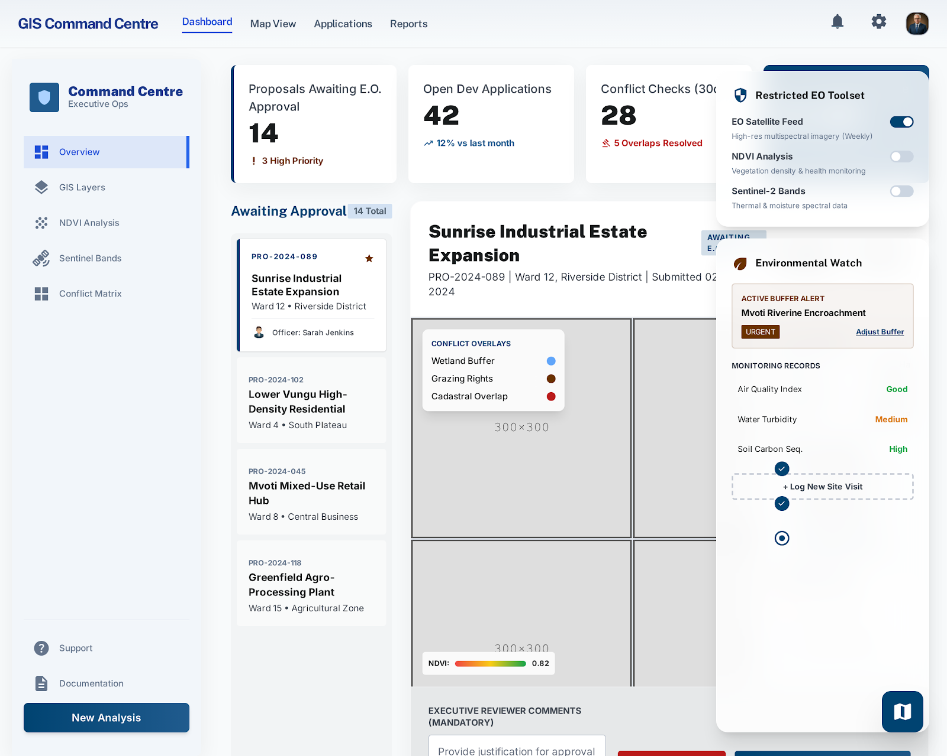

6.2.4 /explorer — Public GIS Viewer
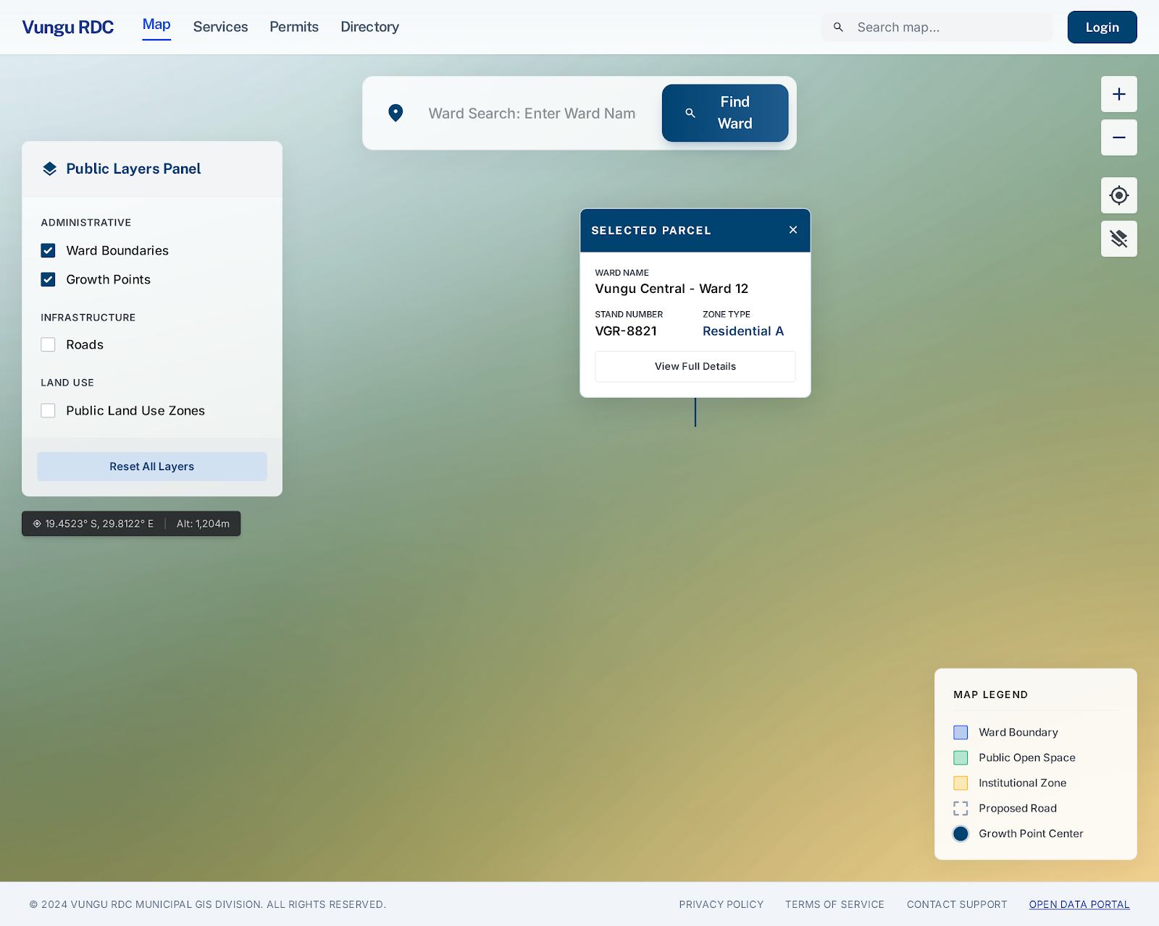

7. REPORTS — FORMAT AND FIELD SPECIFICATIONS
This section defines every report generated by the system: who generates it, when, in what format it is delivered, and what fields it contains.
7.1 Development Application Status Report
Property | Value
Generated By | Planning Officer, E.O. Planning and Environment
Trigger | On demand; also auto-generated monthly on the 1st of each month
Format | On-screen HTML table + downloadable PDF / CSV
Filters | Date range, ward, application type, status, assigned officer
Scope | All development applications within the selected filters

Field / Column | Type | Description
Application Reference | String | Unique application ID (e.g. DA-2026-0001)
Applicant Name | String | Full name of the submitting applicant
Stand Number | String | Stand number subject to the application
Ward | String | Ward name and number
Application Type | String | new_build | extension | change_of_use | subdivision | demolition
Submitted Date | Date | Date the application was submitted
Current Status | String | submitted | under_review | awaiting_inspection | approved | rejected
Days in Current Status | Integer | Number of calendar days since last status change
Decision Date | Date | Date the final decision was made (if applicable)
Decision Officer | String | Name of officer who made the decision
Fee Required | Currency | Total application fee due (USD)
Fee Paid | Currency | Total amount paid to date (USD)
Outstanding Balance | Currency | fee_required minus fee_paid

7.2 Proposal Approval Summary Report
Property | Value
Generated By | E.O. Planning and Environment, Planning Officer
Trigger | On demand; monthly summary auto-generated
Format | On-screen table + downloadable PDF
Scope | All proposals within the selected period and ward filter

Field / Column | Type | Description
Proposal Reference | String | Unique proposal ID (e.g. PRO-2026-001)
Title | String | Proposal descriptive title
Ward | String | Ward name
Prepared By | String | Planning Officer full name
Date Created | Date | Proposal creation date
Current Stage | String | draft | circulating | awaiting_eo | approved | rejected | billed
Approved / Rejected By | String | E.O. who made the decision
Decision Date | Date | Date approved or rejected
Total Stands | Integer | Total planned stands in the layout
Total Area (ha) | Decimal | Drawn layout area in hectares
Estimated Revenue | Currency | Sum of application fees across all planned stands (USD)
Decision Notes | Text | E.O.'s written rationale for approval or rejection

7.3 Ward Yield Analysis Report
Property | Value
Generated By | Planning Officer
Trigger | Auto-generated when a planning polygon is closed on the map; also on demand
Format | On-screen table in the Yield tab of the Vungu Planner + downloadable CSV
Scope | A single drawn polygon on the map (layout area)

Field / Column | Type | Description
Proposal Reference | String | Associated proposal ID
Ward | String | Ward name
Total Layout Area (ha) | Decimal | Polygon area calculated by Turf.js
Stand Type | String | Residential | Commercial | Industrial | Open Space
Land Use Percentage (%) | Integer | Percentage of total area allocated to this stand type
Estimated Stand Count | Integer | Number of stands derivable from area and minimum plot size
Average Plot Size (m²) | Integer | Average stand size for this type
Application Fee / Stand | Currency | Statutory fee per stand for this type (USD)
Estimated Revenue | Currency | Stand count × application fee for this type (USD)
% of Total Revenue | Decimal | This type's revenue as a percentage of total
TOTAL | Row | Sum row: total stand count and total estimated revenue

7.4 Conflict Check Report
Property | Value
Generated By | Planning Officer, E.O. Planning and Environment, Environment Officer
Trigger | On demand when the user clicks "Run Conflict Check" in the Planner
Format | On-screen panel with colour-coded result (green/amber/red) + downloadable PDF
Scope | Currently drawn polygon or selected feature against all active environmental overlays

Field / Column | Type | Description
Check Reference | String | Auto-generated reference (CHK-2026-XXXXX)
Proposal / Geometry Ref | String | Proposal ID or drawn polygon identifier
Check Date | DateTime | Timestamp when the check was run
Run By | String | Officer who ran the check
Overall Result | String | CLEAR | WARNING | CONFLICT
Overlay Name | String | Environmental overlay that intersected (if any)
Overlay Type | String | wetland | river_buffer | road_reserve | protected_area
Intersection Area (m²) | Decimal | Area of overlap between the geometry and the overlay
Buffer Distance (m) | Decimal | Required buffer distance from the constraint
Encroachment (m) | Decimal | Distance by which the geometry exceeds the buffer
Recommended Action | Text | System-generated guidance (e.g. "Adjust north-eastern edge by 20 m")

7.5 Inspection Report
Property | Value
Generated By | Building Inspector
Trigger | Generated when the inspector submits a completed inspection record
Format | On-screen view + printable PDF (A4, formal letterhead)
Scope | A single on-site inspection visit

Field / Column | Type | Description
Inspection Reference | String | Unique inspection ID (INS-2026-XXXXX)
Application Reference | String | Associated development application
Stand Number | String | Stand number inspected
Ward | String | Ward name
Applicant Name | String | Property owner / applicant
Inspector Name | String | Building Inspector full name
Inspection Stage | String | foundation | slab | walling | roofing | completion
Scheduled Date | Date | Planned inspection date
Conducted Date | Date | Actual inspection date
Result | String | pass | fail | conditional_pass | not_conducted
Observations | Text | Inspector's field observations and measurements
Defects / Non-Compliance | Text | List of identified defects with required remediation
Next Inspection Stage | String | Next required inspection (if applicable)
Inspector Signature | Image | Digital or hand-signed signature block
Photos | Image[] | Attached inspection photographs

7.6 Monthly Revenue Collection Report
Property | Value
Generated By | Revenue Clerk, E.O. Income, Council Treasurer
Trigger | Auto-generated on the 1st of each month for the previous month
Format | On-screen table + downloadable PDF / Excel
Scope | All payments recorded in the selected month

Field / Column | Type | Description
Report Period | String | Month and year (e.g. March 2026)
Payment Reference | String | Bank reference or receipt number
Application Reference | String | Associated development application
Stand Number | String | Stand subject to the application
Ward | String | Ward name
Applicant Name | String | Payer full name
Application Type | String | new_build | extension | change_of_use | etc.
Amount Paid | Currency | Payment amount (USD)
Payment Date | Date | Date payment was received
Payment Method | String | cash | bank_transfer | mobile_money
Recorded By | String | Revenue Clerk who recorded the payment
Running Total | Currency | Cumulative total for the month to this row
TOTAL COLLECTED | Row | Grand total of all payments in the period
Total Applications | Integer | Count of distinct applications with payments this period
Outstanding (all apps) | Currency | Total outstanding fees across all active applications

7.7 Environmental Compliance Report
Property | Value
Generated By | Environment Officer, E.O. Planning and Environment
Trigger | Quarterly; also on demand
Format | On-screen view + downloadable PDF including embedded map snapshot
Scope | All development applications and proposals within the reporting period

Field / Column | Type | Description
Report Period | String | Quarter and year (e.g. Q1 2026)
Ward | String | Ward name (one row per ward)
Total Applications Reviewed | Integer | Total applications reviewed for environmental compliance
Applications Cleared | Integer | Applications with no environmental conflicts
Applications with Warnings | Integer | Applications encroaching within buffer zones
Applications with Hard Conflicts | Integer | Applications overlapping protected areas or road reserves
Most Common Conflict Type | String | Overlay type most frequently triggered
Total Buffer Encroachment Area (m²) | Decimal | Total area of buffer zone encroachments detected
Proposals Rejected (Env. Grounds) | Integer | Proposals rejected by E.O. on environmental grounds
NDVI Change (%) | Decimal | Vegetation index change in the ward year-on-year (from satellite data)
Overlay Updates This Period | Integer | Number of environmental overlay modifications
Officer Notes | Text | Environment Officer's observations and recommendations

7.8 CEO Executive Summary Report
Property | Value
Generated By | System (auto-generated); distributed to CEO
Trigger | Auto-generated monthly on the 1st; available in the CEO dashboard
Format | Dashboard view with charts and KPI cards + downloadable PDF (formal report format)
Scope | All 20 wards, all departments, for the preceding month

Field / Column | Type | Description
Report Month | String | Month and year
Total Applications Received | Integer | New applications submitted this month
Total Applications Approved | Integer | Applications approved this month
Total Applications Rejected | Integer | Applications rejected this month
Total Applications Pending | Integer | Applications currently under review
Average Processing Time (days) | Decimal | Average days from submission to decision
Revenue Collected (USD) | Currency | Total development fees collected this month
Outstanding Revenue (USD) | Currency | Total outstanding fees across all active applications
Proposals Approved | Integer | Planning proposals approved by E.O. this month
Inspections Conducted | Integer | Total building inspections this month
Inspection Pass Rate (%) | Decimal | Percentage of inspections that passed
Most Active Ward | String | Ward with highest application volume
Environmental Conflicts Detected | Integer | Total conflict check warnings/errors issued
New Registered Users | Integer | Public users who registered this month
System Uptime (%) | Decimal | Frontend/backend availability percentage

7.9 Audit Trail Report
Property | Value
Generated By | Auditor, Audit Clerk, System Administrator
Trigger | On demand; filters by user, date range, action type, or table
Format | On-screen paginated table + downloadable CSV / PDF
Scope | All create/update/delete actions within the selected filter criteria

Field / Column | Type | Description
Log ID | Integer | Unique audit log entry identifier
Timestamp | DateTime | Exact date and time of the action (UTC+2)
User | String | Full name and role of the user who acted
Action | String | CREATE | UPDATE | DELETE | LOGIN | LOGOUT | VIEW
Module / Table | String | System module or database table affected
Record ID | String | Primary key of the affected record
Previous Values | JSON | Field values before the change (UPDATE/DELETE only)
New Values | JSON | Field values after the change (CREATE/UPDATE only)
IP Address | String | Client IP address at time of action
Session ID | String | Browser session identifier

8. NAVIGATION FLOW AND USER WORKFLOWS
8.1 Authentication Flow
Step | Action | System Behaviour
1 | User visits the system URL | Vue Router checks if a valid JWT token exists in localStorage
2 | No token present | User is redirected to the Login page (/login)
3 | User submits credentials | Frontend sends POST /api/auth/login with email and password
4 | Backend validates | Fastify verifies bcrypt hash; if valid, issues HMAC-SHA256 JWT
5 | JWT stored | Token stored in localStorage; Pinia auth store updated
6 | Role-based redirect | Vue Router reads user.role and redirects to the role's landing_path
7 | On each page load | initializeAuth() restores session from localStorage on app startup
8 | Token expiry / logout | Auth store is cleared; user redirected to /login with session-expired message

8.2 Development Application Workflow
Step | Actor | Action
1 | Public User | Submits application via the 5-step form (/development-application)
2 | System | Generates application reference (DA-YYYY-XXXX); sets status to submitted; sends confirmation notification to applicant
3 | Planning Officer | Receives notification; opens application in the Application Review queue
4 | Planning Officer | Reviews plans and description; runs spatial conflict check; changes status to under_review
5 | Planning Officer | Schedules a building inspection (status: awaiting_inspection)
6 | Building Inspector | Conducts on-site inspection; records result in the system
7 | Planning Officer | Reviews inspection result; prepares decision recommendation
8 | E.O. Planning | Reviews recommendation; approves or rejects application; records decision notes
9 | System | Updates application status; sends notification to applicant with decision and any conditions
10 | Revenue Clerk | Records application fee payment when received (if approved)
11 | System | Updates fee_paid; marks application as paid when balance is cleared

8.3 Planning Proposal Workflow
Step | Actor | Action
1 | Planning Officer | Opens Vungu Planner; draws a layout polygon on the map for a specific ward
2 | System (Turf.js) | Automatically calculates area, perimeter, and opens the Yield Table in the right sidebar
3 | Planning Officer | Reviews yield table; adjusts layout polygon as needed; runs conflict check
4 | Planning Officer | Saves the proposal (status: draft) with title, ward, notes, and geometry
5 | Planning Officer | Submits proposal for circulation (status: circulating) — circulates to Roads Engineer and other departments for comment
6 | Roads Engineer / Dept Officers | Reviews and adds comments in the Comments tab; flags any road reserve conflicts
7 | Planning Officer | Addresses comments; advances to awaiting_eo (status: awaiting_eo)
8 | E.O. Planning | Reviews proposal in the E.O. Command Centre; runs final conflict check on environmental overlays
9 | E.O. Planning | Approves or rejects the proposal (status: approved / rejected); records decision notes
10 | Planning Officer | On approval: prepares final layout plan documents; links to application billing
11 | Council Treasurer / Revenue Clerk | Bills applicants for application fees based on the approved yield table (status: billed)

9. SYSTEM PERMISSIONS MATRIX
The table below defines which roles have access to each major system module. R = Read, W = Write/Create, U = Update, D = Delete, — = No Access.
Module | Admin | CEO | E.O. | Planner | Inspector | Env. Officer | Treasurer | Revenue Clerk | Auditor | HR Admin | Roads Eng. | Public
Home / Public Map | R | R | R | R | R | R | R | R | R | R | R | R
Apply for Development Permit (public form) | — | — | — | — | — | — | — | — | — | — | — | W
Application Status Tracker (own applications) | — | — | — | — | — | — | — | — | — | — | — | R
Vungu Planner (full GIS workstation) | — | — | R | RWU | RWU | R | — | — | — | — | R | —
E.O. Command Centre | — | — | RWU | — | — | RWU | — | — | — | — | — | —
Approve / Reject Proposals (E.O. decision) | — | — | U | — | — | — | — | — | — | — | — | —
Approve / Reject Applications (officer decision) | — | — | U | U | — | — | — | — | — | — | — | —
Create & Submit Planning Proposals | — | — | — | W | — | — | — | — | — | — | — | —
Inspection Records (create & update) | — | — | R | R | RWU | — | — | — | R | — | — | —
Environmental Overlays (create & update) | — | — | RWU | — | — | RWU | — | — | R | — | — | —
Yield Analysis Tool | — | — | R | RW | — | — | R | — | R | — | — | —
Conflict Check Tool | — | — | RW | RW | — | RW | — | — | R | — | — | —
Finance Dashboard | R | R | — | — | — | — | R | R | R | — | — | —
Record Payments | — | — | — | — | — | — | R | RW | — | — | — | —
Debtor Management | — | — | — | — | — | — | R | RWU | R | — | — | —
Analytics Dashboard | R | R | R | R | R | R | R | — | R | R | R | —
User Management (create / edit users) | RWU | — | — | — | — | — | — | — | — | RWU | — | —
Role Assignment | RWU | — | — | — | — | — | — | — | — | RWU | — | —
Audit Log Viewer | R | — | — | — | — | — | — | — | R | — | — | —
CEO Executive Dashboard | R | R | — | — | — | — | R | — | — | — | — | —
GIS Layer Management (admin) | RWU | — | — | — | — | — | — | — | — | — | — | —

Key: R = Read only W = Create/Write U = Update RW = Read + Create RWU = Full access — = No access

END OF DOCUMENT
Vungu Rural District Council • GIS-Integrated Municipal Planning Information System • Frontend System Design Document • Version 1.0 • April 2026

