Software Requirements Specification
for
Unauthorized Arcade
Version 1.0
Prepared by Arjunn Shetty, Namya Patiyal, Archit Gupta
Manipal Institute of Technology, Manipal

15thMay,2023
Table of Contents
Table of Contents
1. Introduction…………………………………………………………………………………..1
1.1 Purpose……………………………………………………………………………………………..1
1.2 Document Conventions…………………………………………………………………………….1
1.3 Intended Audience and Reading Suggestions……………………………………………………...1
1.4 Product Scope……………………………………………………………………………………...2
1.5 References…………………………………………………………………………………………2
2. Overall Description…………………………………………………………………………..3
2.1 Product Perspective………………………………………………………………………………...3
2.2 Product Functions………………………………………………………………………………….3
2.3 User Classes and Characteristics…………………………………………………………………..3
2.4 Operating Environment…………………………………………………………………………….4
2.5 Design and Implementation Constraints…………………………………………………………...4
3. External Interface Requirements…………………………………………………………...4
3.1 User Interfaces……………………………………………………………………………………..4
3.2 Interfaces…………………………………………………………………………………………...5
4. System Features……………………………………………………………………………...5
4.1 User Manage……………………………………………………………………………………….5
4.2 adding game to library…………………………………………………………………….5

5. Other Nonfunctional Requirements……….……….…………………………………………...6
5.1 Security Requirements……………………………………………………………………………..6
5.2 Business Rules……………………………………………………………………………………..6

1.Introduction

Purpose
The purpose of the Game Library project is to develop a mobile application that serves as a comprehensive platform for gamers to explore, purchase, and manage their game collections. This project aims to enhance the gaming experience by providing users with a user-friendly interface and a wide range of features. The project focuses on simplifying the process of browsing and searching for games, providing detailed information about each game, enabling secure game purchases, offering wishlist functionality, managing the user's game library, and facilitating profile management. By implementing this project, the goal is to revolutionize the gaming industry, improve accessibility to games, and foster a vibrant gaming community. The project utilizes Flutter and MySQL technologies to ensure a robust and scalable solution. Overall, the project aims to enhance user convenience, offer a comprehensive gaming platform, and contribute to the advancement and growth of the gaming industry.

1.2 Document Conventions
This Game Library SRS document follows the standard typographical conventions for headings and subheadings. Headings are formatted in size 22 font, subheadings are formatted in size 18 font, secondary subheadings are formatted in size 12 font, and regular text is formatted in size 10 font.

Each requirement statement will have its own priority level assigned based on its importance and urgency. Priorities for higher-level requirements will not necessarily be inherited by detailed requirements.

The SRS is organized into sections that cover various aspects of the Game Library. The sections are arranged in a logical order, starting with the introduction and then moving on to the system overview, functional requirements, non-functional requirements, and finally, the appendices.

Intended Audience and Reading Suggestions

The Game Library SRS document is intended for a diverse group of readers, including developers, project managers, marketing staff, users, testers, and documentation writers. Each reader type will be interested in different aspects of the system and will require information specific to their role in the project.

The SRS document contains an overview of the Game Library project, including the purpose, scope, and objectives. It also includes detailed functional and non-functional requirements, system architecture, and design constraints.

For developers, the SRS provides information on the system's technical requirements, including programming languages, software tools, and database management systems. It also includes detailed system architecture and design specifications.

Project managers will be interested in the project timeline, budget, and resource allocation. The SRS document outlines the project's milestones and deliverables, as well as any risks or potential issues that may arise during development.

Marketing staff will want to know how the Game Library will benefit users, and the SRS document explains the system's features and how they will enhance the user experience. It also includes information on how the system will be marketed and promoted.

Users will be interested in the system's functionality and ease of use. The SRS document provides a detailed overview of the game browsing, purchasing, and library management features, including any user interfaces and interactions.

Testers will require information on the system's testing requirements, including test plans, test cases, and expected results. The SRS document provides detailed test cases and expected outcomes for each feature of the Game Library.

Documentation writers will need to understand the system's technical and functional requirements to create user manuals and other documentation. The SRS document provides a comprehensive overview of the system, including technical specifications and user requirements.

Product Scope

The Game Library software is a web application designed to provide users with a comprehensive platform for exploring, purchasing, and managing their game collections. The main purpose of the software is to enhance the gaming experience by offering a user-friendly interface and convenient features for game enthusiasts.
The software's primary benefits include:
Game Exploration: The application allows users to browse and search for games based on various criteria such as genre, platform, price, and ratings, providing an extensive catalog for users to explore.
Game Purchase: The software enables users to purchase games directly from the library, simplifying the process of acquiring new games.
Library Management: Users can easily manage their game collections, view purchased games, track gameplay statistics, and remove games if desired, providing a centralized hub for organizing and accessing their games.
Wishlist: Users can create a wishlist of games they are interested in, facilitating future reference and easy access to desired games.
The objective of the Game Library software is to provide a seamless and enjoyable gaming experience for users. By offering a platform that simplifies game exploration, purchasing, and library management, the software aims to enhance convenience and accessibility for game enthusiasts.
The software is directly aligned with business strategies as it aims to attract and retain users, fostering a vibrant gaming community. Additionally, the software aligns with the evolving digital landscape and the increasing popularity of mobile gaming, catering to the needs of modern gamers.

References
- Flutter Documentation:
- Website: https://flutter.dev/
- Flutter API Documentation: https://api.flutter.dev/
- Flutter Games and Graphics: https://flutter.dev/docs/development/ui/widgets/layout
- Flutter Animation: https://flutter.dev/docs/development/ui/animations

- pub.dev Documentation:
- Website: https://pub.dev/
- pub.dev Package Documentation: https://pub.dev/help
- Mysql1 plugin: https://pub.dev/packages/mysql1
- Sqflite plugin: https://pub.dev/packages/sqflite
- Cupertino dependency : https://api.flutter.dev/flutter/cupertino/cupertino-library.html

- Color Theory Documentation:
- Color Theory for Designers: https://www.smashingmagazine.com/2010/02/color-theory-for-designer-part-3-creating-your-own-color-palettes/

- SQL Documentation:
- MySQL Statements: https://dev.mysql.com/doc/refman/8.0/en/sql-statements.html
- ER Diagrams: https://erdplus.com/

Overall Description

Product Perspective
The online games library is a digital platform that offers a comprehensive collection of games for users to explore, discover, and play. It serves as a centralized hub for accessing a wide range of games, catering to the diverse interests and preferences of gamers. The product perspective for an online games library focuses on providing convenience, variety, and an immersive gaming experience for users.

Product Functions
- Extensive Game Collection: The online games library offers a vast selection of games from various genres.
- Easy Search and Navigation: The platform provides intuitive search and navigation features.
- Social Features: The online games library may include social features such as the ability to connect with friends, join gaming communities.
- Game Reviews and Ratings: Users can provide feedback, write reviews, and rate games.

User Classes and Characteristic
Access to Games: Consumers have access to the games library where they can browse, search, and play games.
User Profile: Consumers can create and manage their user profiles, including personal information, avatar, and preferences.
Game Ratings: Consumers can rate and provide feedback for the games they have played, contributing to the overall rating system.
Wishlist: Consumers can create and manage a wishlist of games they are interested in playing in the future.
Friend Connections: Consumers can add other consumers as friends and interact with them within the platform.
Game Publishing: Consumers may have the ability to submit their own games to be considered for inclusion in the library, subject to admin approval.
Admin User:

Library Supervision: Admins are responsible for managing and supervising the games library.
Game Curation: Admins curate the collection of games available in the library, ensuring high-quality and diverse content.
Game Approval: Admins review and approve games submitted by consumers for publishing, ensuring they meet the platform's standards.
User Management: Admins oversee user accounts, handle user reports, and enforce platform rules and policies.
Content Management: Admins handle game updates, patches, and ensure compliance with legal and copyright regulations.
Platform Administration: Admins maintain the platform's infrastructure, security, and performance.

Operating Environment
The game library software will operate in a distributed computing environment. The hardware platform for the system will depend on the deployment option chosen by the user. The software should be designed to operate on various hardware configurations and support multiple operating systems, including Windows and Linux. The following software components and applications must be installed and functioning correctly on the target environment for the software to operate as intended:

• Web Browsers: Users will access the game library through web browsers such as Google Chrome, Mozilla Firefox, Microsoft Edge, or other popular browsers. The software should be compatible with these browsers and provide a seamless browsing experience.

• Database Management System: The game library software will require a database management system (DBMS) to store and retrieve game-related data, user information, and other relevant details. Popular DBMS options include MySQL, PostgreSQL, or Oracle. The choice of DBMS will depend on the specific requirements and scalability needs of the game library project.

• Web Server Software: To serve web pages and handle user requests, the game library software will require web server software. Commonly used web server software includes Apache HTTP Server, Microsoft Internet Information Services (IIS), or Nginx. The software should be compatible with these web server applications to ensure proper functioning and reliable performance.

It is essential to consider the compatibility and proper configuration of these software components to ensure the smooth operation of the game library system. By supporting various hardware configurations and operating systems, the software can cater to a wider user base and provide a seamless experience across different platforms.

Design and Implementation Constraints
1. Security Considerations: The game library software must prioritize the security of user data, including personal information and payment details. All data transmission should be encrypted using appropriate security protocols, such as SSL/TLS, to ensure secure communication between the client and server.

2. Compliance with Regulations: The game library software must comply with relevant laws and regulations, including those related to user privacy, data protection, and online transactions. It should adhere to industry standards and best practices for data security and privacy, ensuring that user information is handled in a responsible and legal manner.

3. User Interface Design: The software should follow modern user interface design principles to provide an intuitive and visually appealing user experience. It should be designed with a focus on usability, accessibility, and responsiveness. While there may not be specific guidelines established by a governing authority, it is important to consider the expectations and preferences of the target audience.

4. Database Management System: The game library software may need to integrate with a specific database management system (DBMS) or utilize a compatible technology stack. The choice of DBMS should consider factors such as scalability, reliability, and performance to ensure efficient data storage and retrieval.

5. Performance Optimization: The software should be designed and implemented to handle a large number of concurrent users and provide optimal performance. Techniques such as caching, efficient database queries, and server-side optimization should be employed to minimize response times and maximize system throughput.

6. Cross-Platform Compatibility: The game library software should be compatible with multiple operating systems, including Windows, macOS, and potentially other platforms such as Linux or mobile devices. This requires utilizing cross-platform frameworks or technologies that support the targeted operating systems.

It is important to note that the specific design and implementation constraints may vary based on the requirements and target platforms of the game library project. Adhering to industry best practices and considering the needs of the intended users will help ensure a successful and well-performing
software solution.

External Interface Requirements

User Interfaces
For the consumer, the interface between the software product and the user will be a web-based interface where users can search for games, buy games, Wishlist games, and view their library. The interface will include standard web design elements such as input forms, drop-down menus, buttons, and clickable icons. The layout of the web pages will be intuitive and user-friendly, with clear instructions and error messages displayed when necessary.
For the admin, the interface will be a desktop application where they can view the list of games. The interface will include standard desktop design elements such as menus, buttons, and input forms.

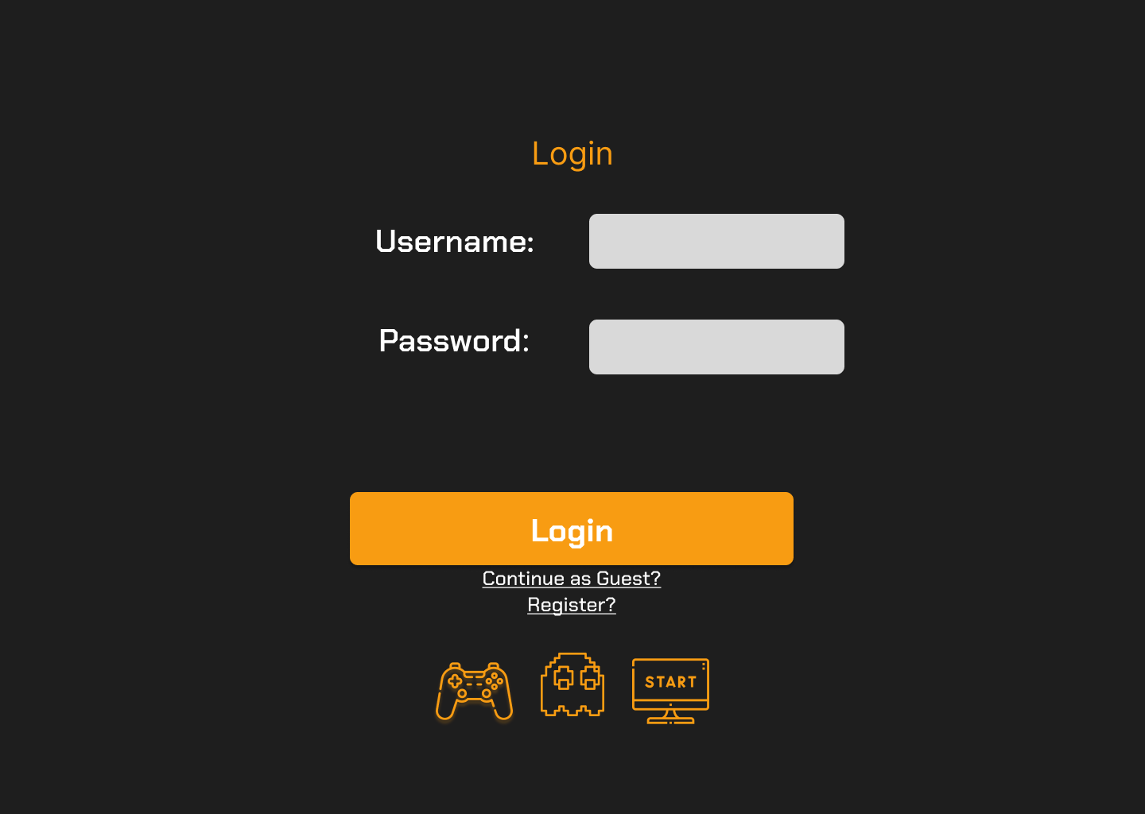

Fig 3.1 – Login Page
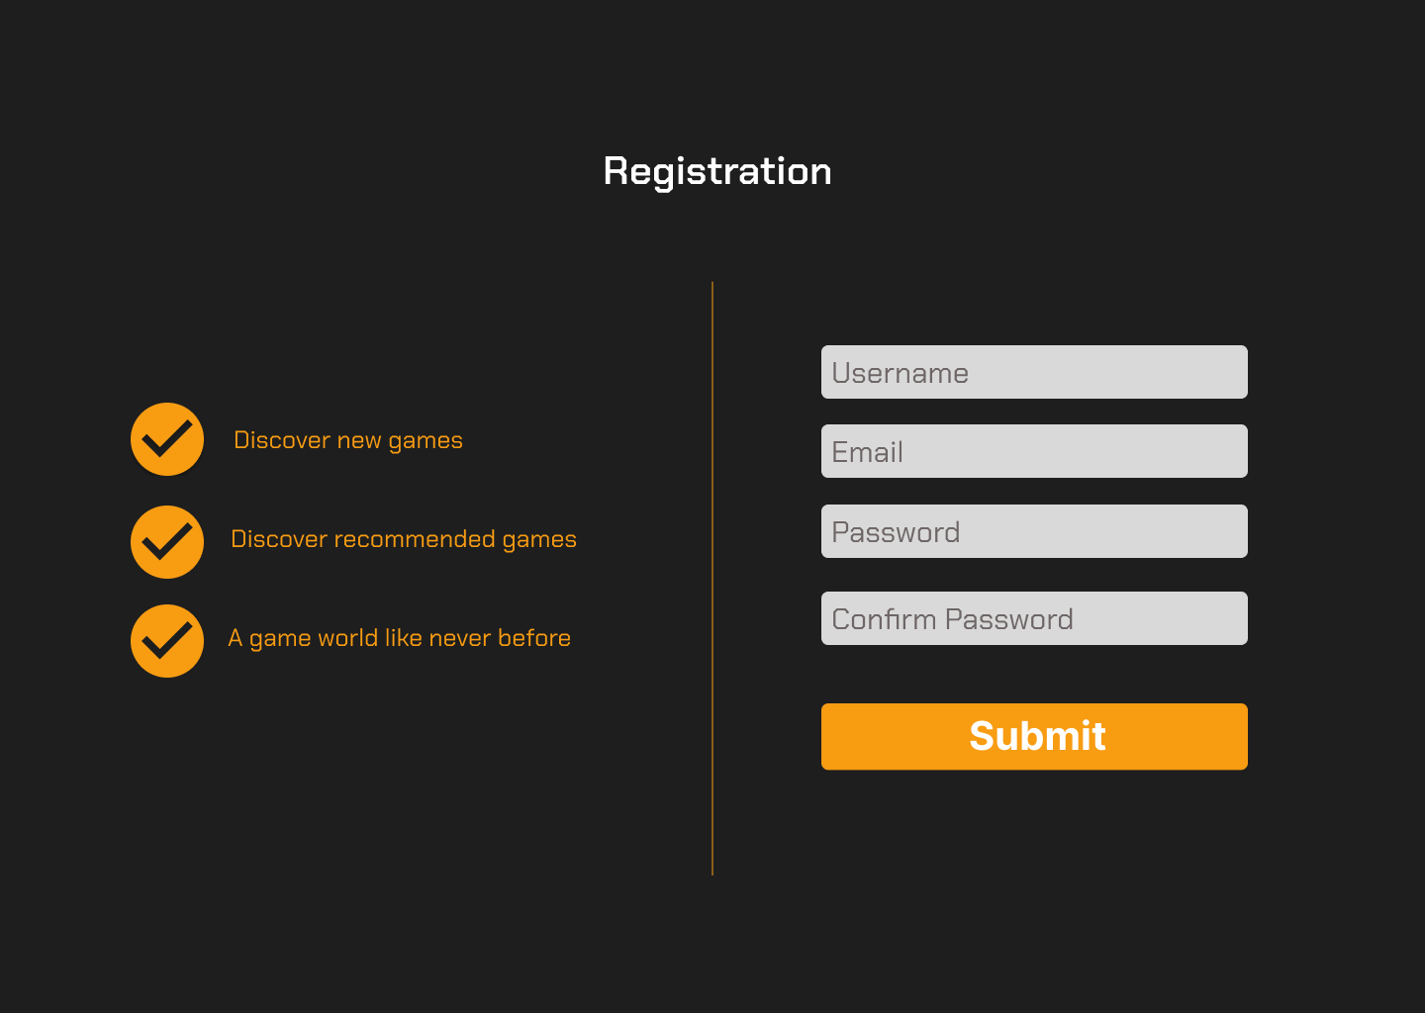

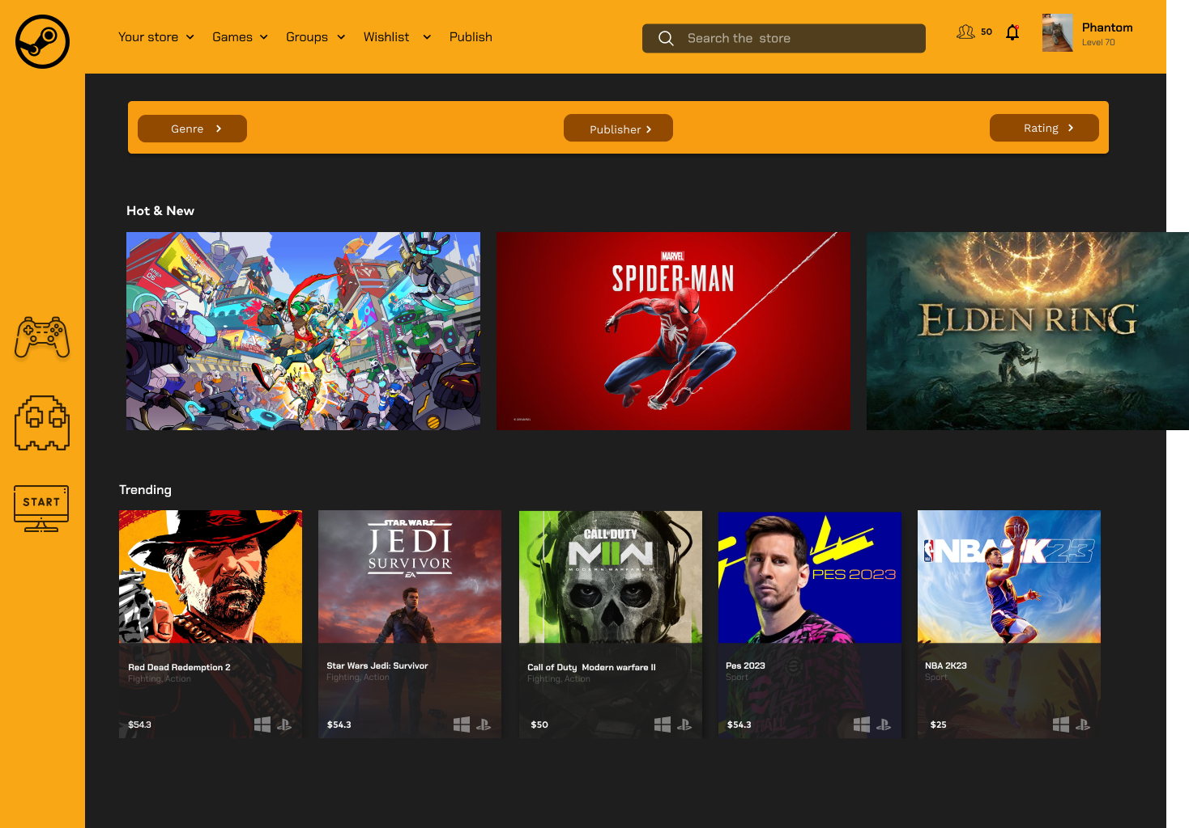
Fig 3.2 - Registration

Fig 3.3 – Consumer Desktop

Interfaces
- The software will utilize the capabilities of the laptop's operating system, such as its file system, network capabilities, and other relevant hardware features. The software must be compatible with the operating systems commonly used on laptops, including Windows and Linux, to ensure seamless operation and functionality.

- In terms of communication protocols, the game library software will primarily rely on standard internet protocols, such as TCP/IP and HTTP, to communicate with external servers and services. This includes interactions with online game stores, APIs for game data retrieval, and user authentication.

- Security considerations should also be taken into account, and the software should support the necessary encryption protocols, such as HTTPS, to ensure secure communication with external servers and protect user data..

System Features
  - User Management
- The system shall allow users to sign in and create an account.
- The system shall allow users to log in to their account.
- The system shall allow users to reset their password.
- The system shall provide different access levels for different types of users.

  - Adding game to library

• The system shall allow users to browse and search for available games.
• The system shall provide detailed information about each game, including the title, description, genre, platform, price, and ratings.
• The system shall allow users to add games to their library.
• The system shall provide the option for users to remove games from their library.

Other Nonfunctional Requirements

Security Requirements
- User authentication: Users must provide valid login credentials to access the system.
- Data confidentiality: The system shall ensure the confidentiality of the data entered by users during the booking process.
- Data integrity: The system shall ensure the integrity of data by preventing unauthorized modification.
- Access control: The system shall have different access levels for different user roles such as passengers, ticket collectors, and administrators.
- Secure communication: The system shall use secure communication protocols to protect data transmission between the client and server.
- Protection against unauthorized access: The system shall be protected against unauthorized access, including but not limited to, denial of service attacks and intrusion attempts.
- Compliance with regulations: The system shall comply with all relevant regulations regarding data privacy and security.
- Data retention: The system shall retain data only for the necessary period of time, and securely dispose of it when it is no longer needed.
- Privacy: The system shall respect the privacy of user information, and shall not share it with third parties without explicit user consent.

Business Rules
- Only registered users can access the games.
- Users must provide valid username and password to register.
- Users can only buy games for themselves or their friends.
- Administrators can update game library and user accounts.

