## [2. Overview of a relational database](https://developer.android.com/codelabs/basic-android-kotlin-training-sql-basics?continue=https%3A%2F%2Fdeveloper.android.com%2Fcourses%2Fpathways%2Fandroid-basics-kotlin-unit-5-pathway-1%23codelab-https%3A%2F%2Fdeveloper.android.com%2Fcodelabs%2Fbasic-android-kotlin-training-sql-basics" \l "1)

 A relational database is a common type of database that organizes data into tables, columns, and rows.

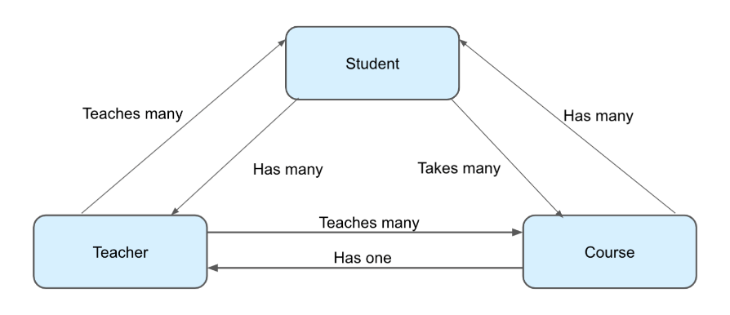

A column consists of a name, and a data type. Each row has data corresponding to each column.

|  |  |  |  |
| --- | --- | --- | --- |
| id | species | name | color |
| 1 | Camellia Sinensis | Tea Plant | green |
| 2 | Echinacea Purpurea | Purple Coneflower | purple |
| 3 | Ferula Foetida | Asafoetida | green |

## Primary Key

it's important for rows in a data table to have some sort of unique identifier.

unique to each row in the table. This is useful if you need to reference rows in one data table from another table.

Primary keys make it possible to have the relationships in a relational database.

## Data Types

A column can represent a character, string, number (with or without a decimal), or binary data.

## SQL

When accessing a relational database, whether on its own or using a library such as Room, you'll need something called SQL

SQL (sometimes pronounced "sequel") stands for Structured Query Language, and allows you to read and manipulate data in a relational database. SQL consists of just a few types of statements for reading and writing from a database.

|  |  |
| --- | --- |
| SELECT | Gets specific information from a data table and results can be filtered and sorted in various ways. |
| INSERT | Adds a new row to a table. |
| UPDATE | Updates an existing row (or rows) in a table. |
| DELETE | Removes an existing row (or rows) from a table. |

SELECT name FROM park  
WHERE type != "recreation_area"  
AND area_acres > 100000

LIMIT 5

## [5. Common SQL functions](https://developer.android.com/codelabs/basic-android-kotlin-training-sql-basics?continue=https%3A%2F%2Fdeveloper.android.com%2Fcourses%2Fpathways%2Fandroid-basics-kotlin-unit-5-pathway-1%23codelab-https%3A%2F%2Fdeveloper.android.com%2Fcodelabs%2Fbasic-android-kotlin-training-sql-basics#4)

COUNT(), SUM(), MAX() and MIN(), DISTINCT

SELECT COUNT(DISTINCT type) FROM park

## [6. Ordering and grouping query results](https://developer.android.com/codelabs/basic-android-kotlin-training-sql-basics?continue=https%3A%2F%2Fdeveloper.android.com%2Fcourses%2Fpathways%2Fandroid-basics-kotlin-unit-5-pathway-1%23codelab-https%3A%2F%2Fdeveloper.android.com%2Fcodelabs%2Fbasic-android-kotlin-training-sql-basics#5)

ORDER BY, ASC or DESC/ GROUP BY

SELECT type, COUNT(*) FROM park  
GROUP BY type  
ORDER BY type

## [7. Inserting and deleting rows](https://developer.android.com/codelabs/basic-android-kotlin-training-sql-basics?continue=https%3A%2F%2Fdeveloper.android.com%2Fcourses%2Fpathways%2Fandroid-basics-kotlin-unit-5-pathway-1%23codelab-https%3A%2F%2Fdeveloper.android.com%2Fcodelabs%2Fbasic-android-kotlin-training-sql-basics#6)

INSERT INTO table_name  
VALUES (column1, column2, ...)

UPDATE table_name  
SET column1 = ...,  
column2 = ...,  
...  
WHERE column_name = ...  
...

DELETE FROM table_name  
WHERE <column_name> = ...

## [9. Congratulations](https://developer.android.com/codelabs/basic-android-kotlin-training-sql-basics?continue=https%3A%2F%2Fdeveloper.android.com%2Fcourses%2Fpathways%2Fandroid-basics-kotlin-unit-5-pathway-1%23codelab-https%3A%2F%2Fdeveloper.android.com%2Fcodelabs%2Fbasic-android-kotlin-training-sql-basics#8)

In summary:

* Relational databases allow you to store data, organized into tables, columns, and rows.
* You can retrieve data from a database using the SQL SELECT statement.
* You can use a variety of clauses in a SELECT statement including WHERE, GROUP BY, ORDER BY, and LIMIT to make your queries more specific.
* You can use aggregate functions to combine data from multiple rows into a single column.
* You can add, update, and delete rows in a database using the SQL INSERT, UPDATE, and DELETE statements respectively.