X Y Gradient/Final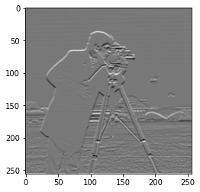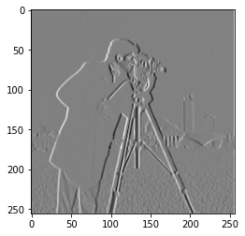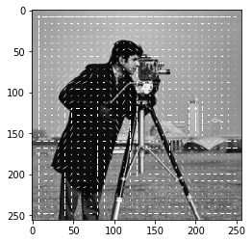

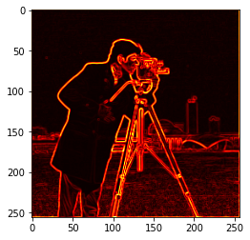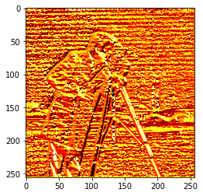

Magnitude Angle

There weren’t many issues with the first part, I used the Sobel filter and I see some details that don’t precisely line up with the image posted in discord but overall it’s pretty similar. I think if I changed either the filter or some of my code, it would line up better.

When I attempted the 2nd part, the face detection, I ran into some issues integrating the HOG size with the face recognition image size and didn’t have enough time to finish.