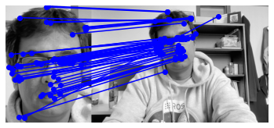

The sift feature mapping has some slight errors, but overall works great. Increasing the KNN value from 2 would probably improve the results but may increase the runtime a little bit.

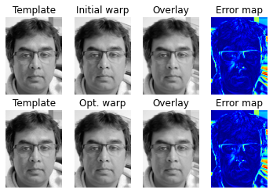

I see some slight differences between the template and the warped images, the error map looks great, so I’m pretty sure it’s correct.

The error plot seems to be around 7.4 after 200 iterations. It took roughly 30 minutes for it to run 200 iterations or around 10 seconds per iteration. It could probably be sped up by turning some of the math functions into numpy functions.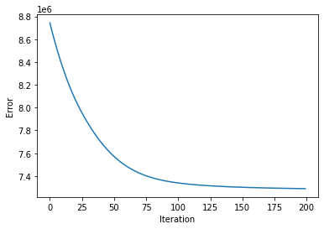

For the multiframe tracking, I only did this with 10-iterations in the aligned-image because it was taking too long to run. It works, it doesn’t mesh well with the warped-image.