Sorry it’s late, I’ve had COVID for one and a half weeks now at this point so I’m not feeling the best, especially since one of the symptoms is a giant headache.

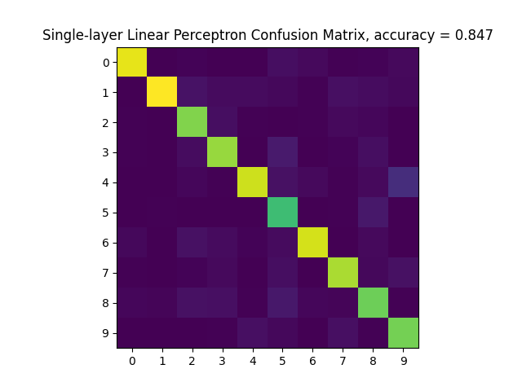

Linear SLP, set learning rate to 0.05 and decay rate to 0.9 with normal distribution. Training over 20000 iterations it has 85% accuracy.

SLP, set learning rate to 0.05 and decay rate to 0.9 with normal distribution. Training over 20000 iterations, achieved 89% accuracy.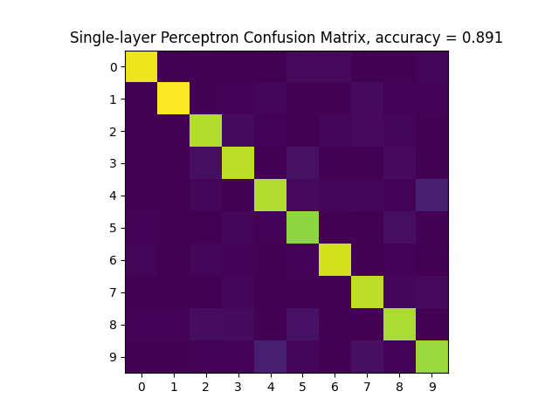

MLP, set learning rate to 0.05 and decay rate to 0.9 with normal distribution. Training over 20000 iterations, 92% accuracy.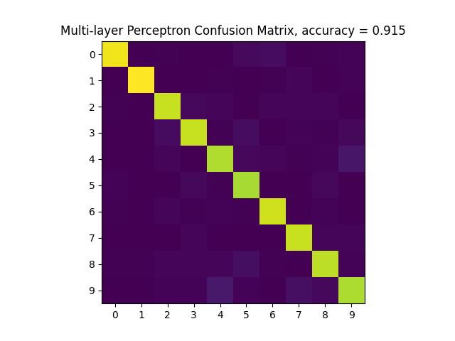

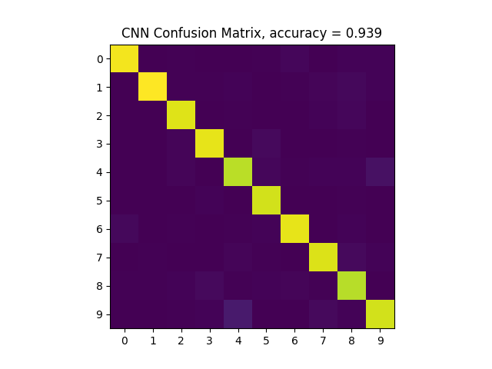

CNN, set learning rate to 0.1 and decay rate to 0.9 with normal distribution. Training over 10000 iterations, 94% accuracy. This one was the slowest by far.