Real-Time Data Streaming Platform
Agile and DevOps Project Documentation
Student: Evans Ankomah
Date: 2026-03-05
Repository: https://github.com/nana-evansankomah/Agile-and-Devops-Lab
------------------------------------------------------------

1. Executive Summary
This report documents the end-to-end delivery of a real-time cryptocurrency data platform using an Agile sprint model and DevOps engineering practices. The project was executed in three phases: Sprint 0 (planning), Sprint 1 (initial delivery), and Sprint 2 (improvement and monitoring).
- Product domain: Real-time cryptocurrency ingestion, processing, and dashboard visualization.
- Delivery model: One planning sprint and two execution sprints.
- DevOps focus: CI/CD automation, test integration, and operational monitoring.

2. Project Scope and Vision (Sprint 0)
Sprint 0 established the product vision, backlog, estimation, Definition of Done, and Sprint 1 planning baseline.

2.1 Product Vision
Build a resilient real-time data streaming platform that ingests live cryptocurrency market data, performs validation and transformation, and presents results through a clear dashboard with measurable operational quality.

2.2 Backlog Summary
The product backlog includes 7 user stories:
- Data Stream Ingestion
- Data Transformation and Validation
- Basic Dashboard Display
- Data Quality Monitoring and Alerts
- Automated Testing Framework
- CI/CD Pipeline Setup
- Monitoring and Logging
Backlog items include acceptance criteria, priority, and story point estimates.

2.3 Definition of Done
- Code quality and maintainability standards met.
- Tests implemented and passing.
- Documentation updated.
- CI/CD pipeline execution successful.
- Feature behavior verified against acceptance criteria.
------------------------------------------------------------

3. Sprint 1 Plan and Delivery

3.1 Sprint 1 Plan
Sprint Goal: Deliver a working real-time data pipeline with a basic dashboard and CI/CD automation.
Planned scope: 21 story points.
- Story 1: Data Stream Ingestion (8 points)
- Story 3: Basic Dashboard Display (5 points)
- Story 6: CI/CD Pipeline Setup (8 points)

3.2 Sprint 1 Outcomes
Sprint 1 delivered all planned stories.
- Stories completed: 3 of 3.
- Story points completed: 21 of 21.
- Commit discipline: 8 meaningful commits.
- Testing target met: >70% coverage.
- CI/CD pipeline established and running.

3.3 Sprint 1 Retrospective Highlights
- Strengths: clear user stories, iterative commits, and fast CI feedback.
- Improvements identified: test organization, API response consistency, and error-handling reuse.
- Process decisions for Sprint 2 were documented and actioned.
------------------------------------------------------------

4. Sprint 2 Plan and Delivery

4.1 Sprint 2 Plan
Sprint 2 incorporated Sprint 1 retrospective feedback.
- Story 4: Data Quality Monitoring and Alerts
- Story 5: Enhanced Integration Testing
- Story 7: Advanced Monitoring and Logging
- Process improvements from Sprint 1 retrospective

4.2 Sprint 2 Outcomes
- Stories completed: 3 of 3 (Stories 4, 5, and 7).
- Commit discipline improved: 12 meaningful commits.
- Test suite growth: 61 total tests with reported full pass in sprint evidence.
- Monitoring capabilities delivered: metrics tracking, health endpoints, and logging.
- Quality monitoring delivered: quality scoring, null/duplicate detection, and alerts.

4.3 Sprint 2 Retrospective Highlights
- Retrospective-driven improvements were implemented.
- Architecture scaled effectively from Sprint 1 foundation.
- Future priorities identified: API specification, performance testing, and security hardening.
------------------------------------------------------------

5. DevOps Implementation
- GitHub Actions workflows configured for CI/CD and smoke checks.
- Automated test execution integrated in pipelines.
- Coverage reporting and build verification steps configured.
- Operational logging and monitoring integrated in the backend.

6. Testing and Quality Evidence
- Test modules include ingestion, transformation, integration, monitoring, and quality monitoring.
- Pipeline evidence captures both early failures and later successful workflow runs.
- Dashboard evidence confirms functional UI for overview, data quality, details, and charts.
------------------------------------------------------------

7. Screenshot Evidence
The following screenshots are included as visual evidence of CI/CD history, test execution, and functional application behavior.
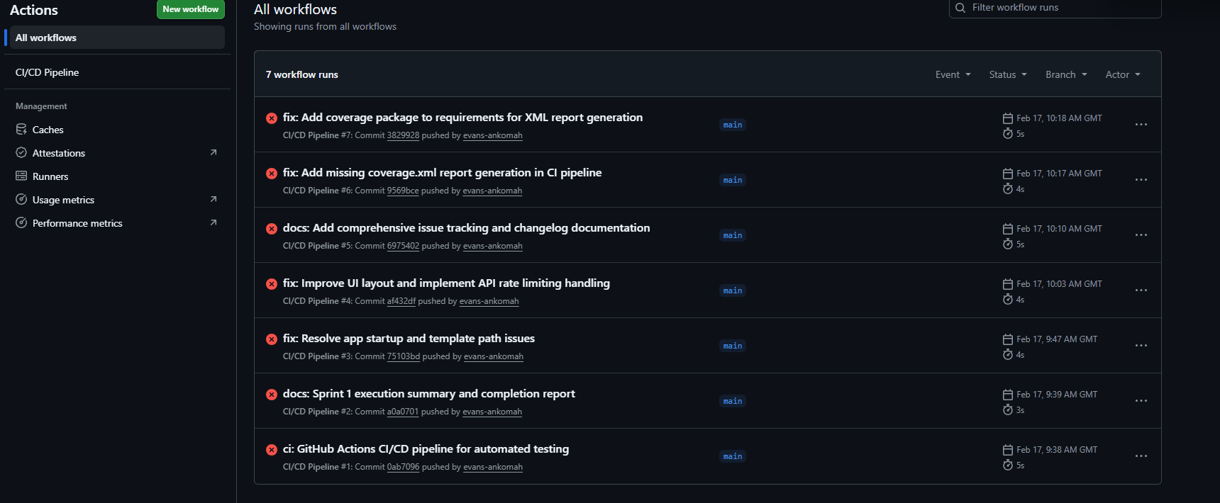
Figure 1: Early CI/CD workflow failures.

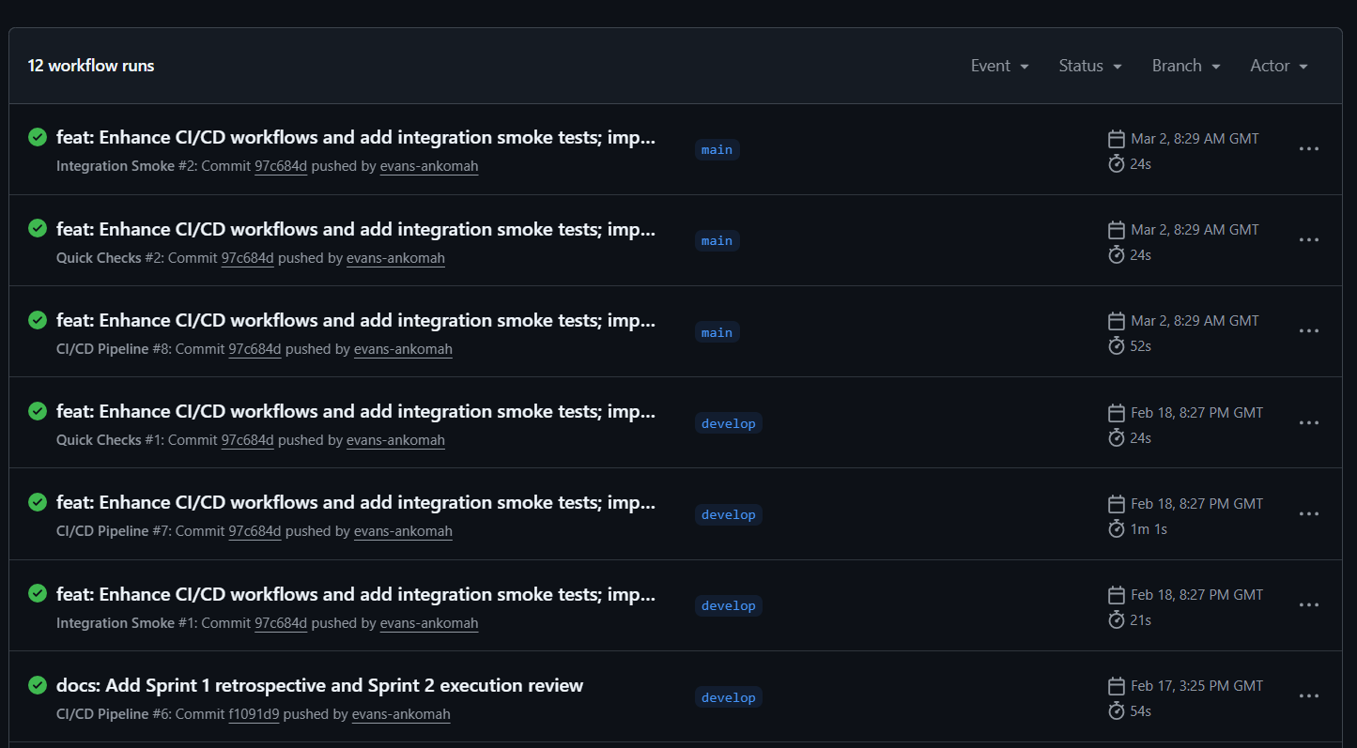
Figure 2: Workflow runs showing successful executions (top view).

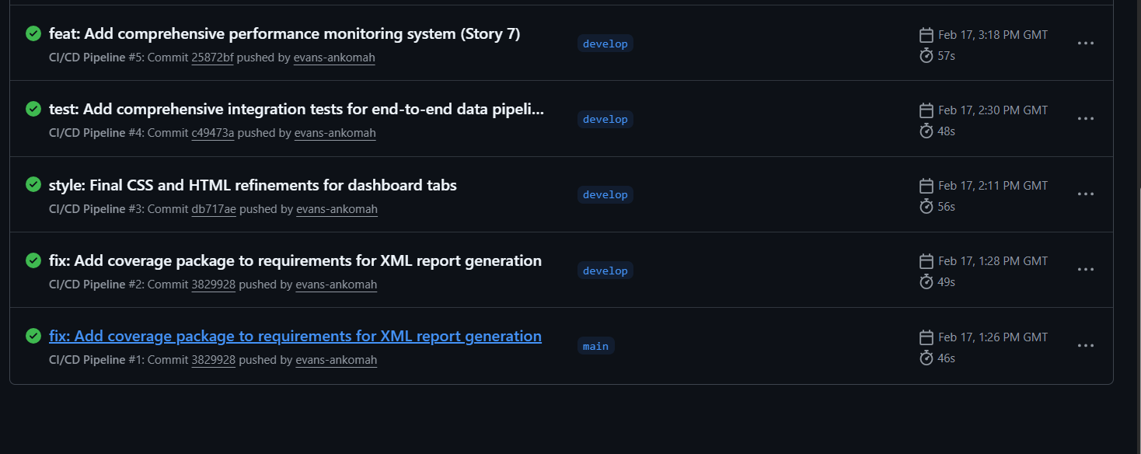
Figure 3: Workflow runs showing successful executions (bottom view).

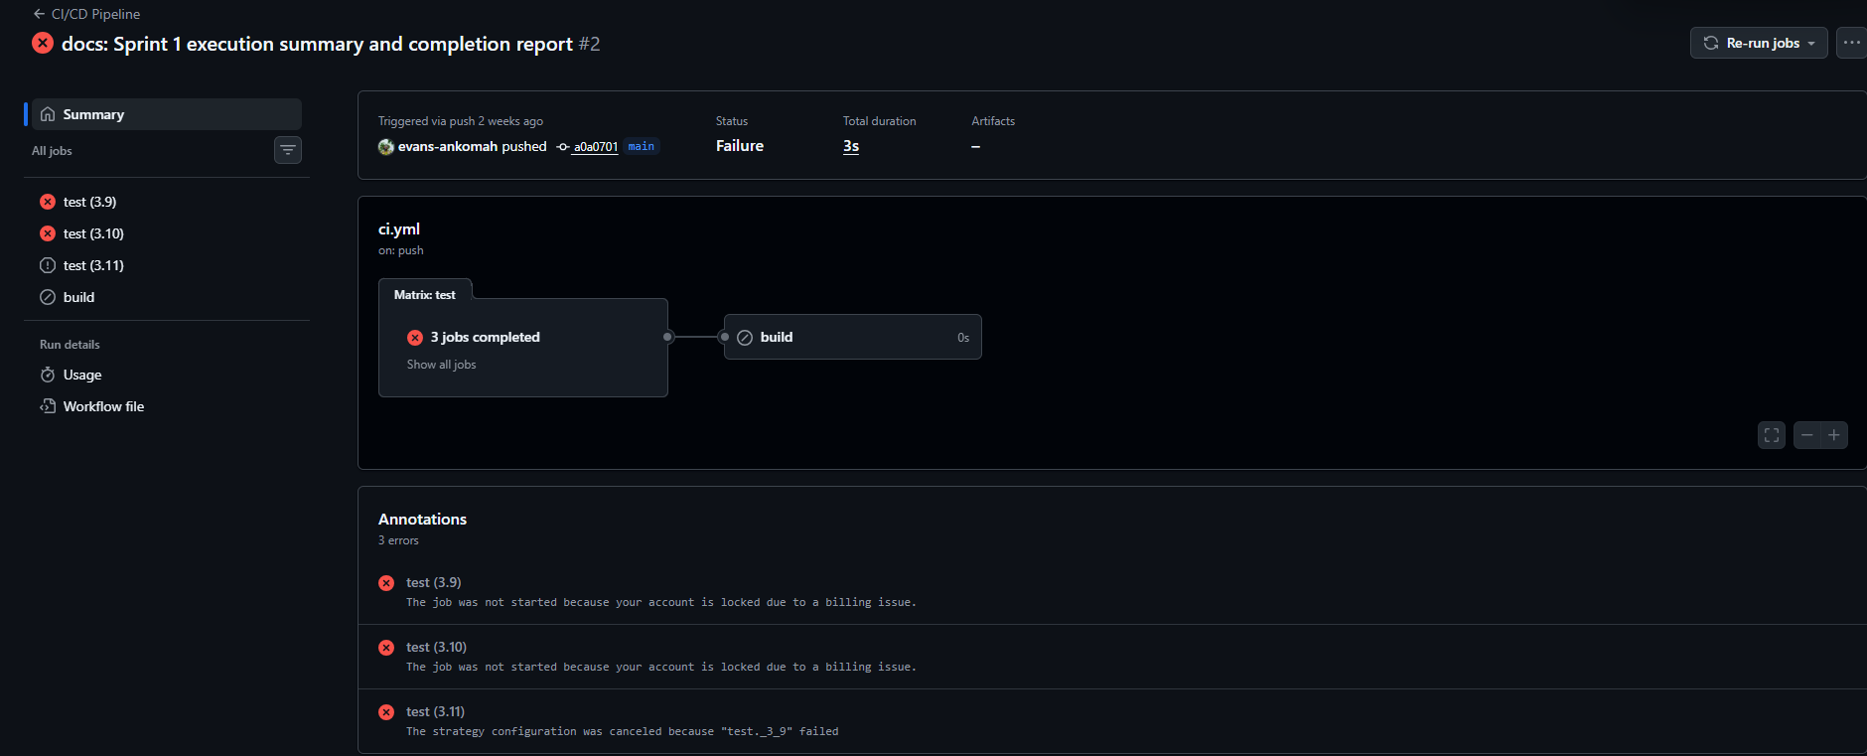
Figure 4: Example failed CI run for Sprint 1 docs commit.

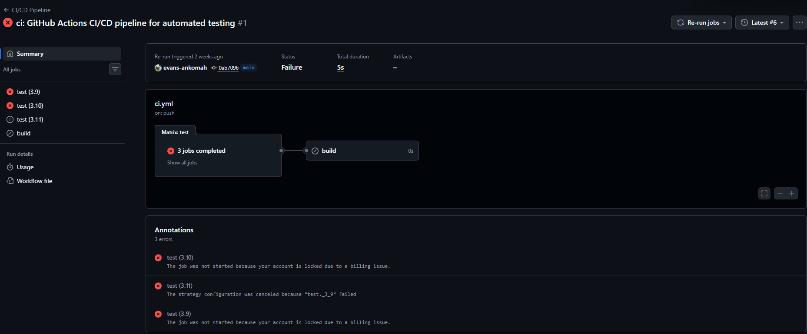
Figure 5: Example failed CI pipeline run details.

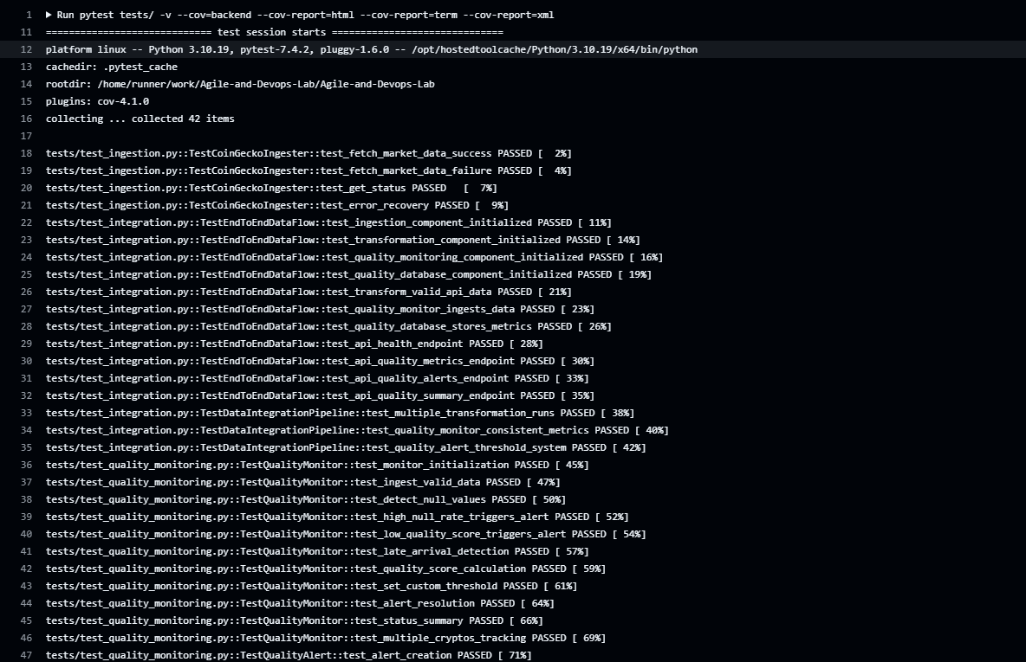
Figure 6: Pytest run with coverage output in CI.

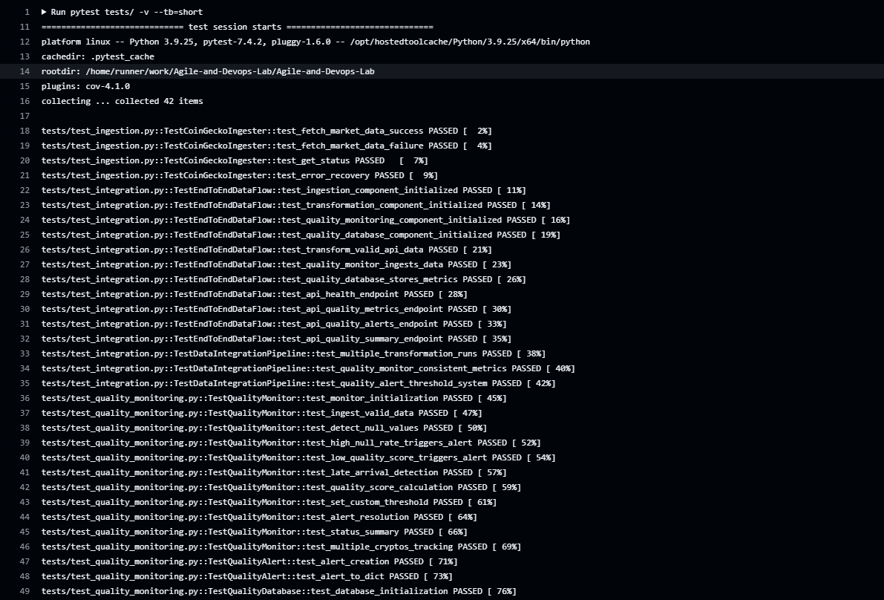
Figure 7: Pytest short output run in CI.

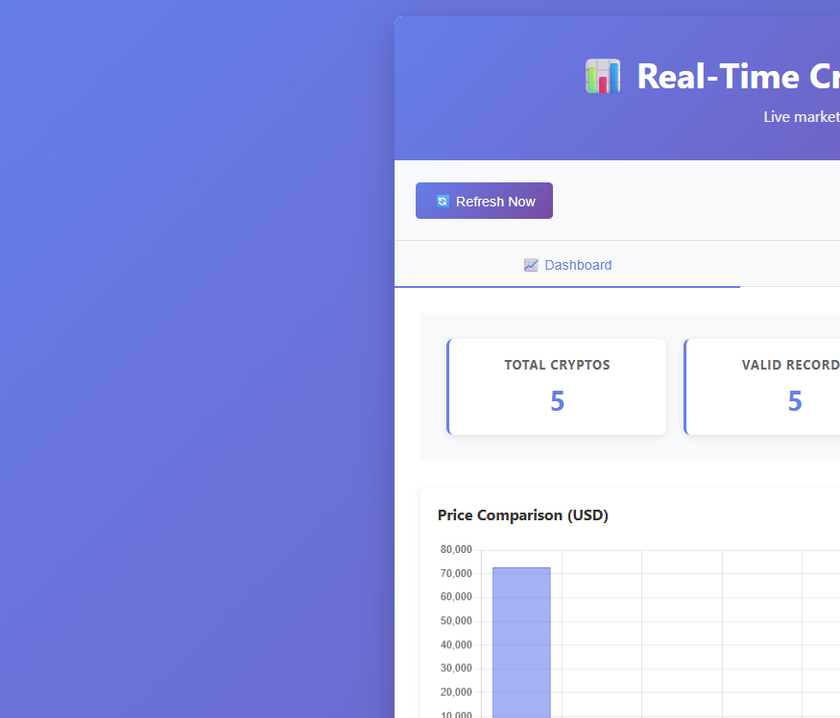
Figure 8: Dashboard tab interface (partial view).

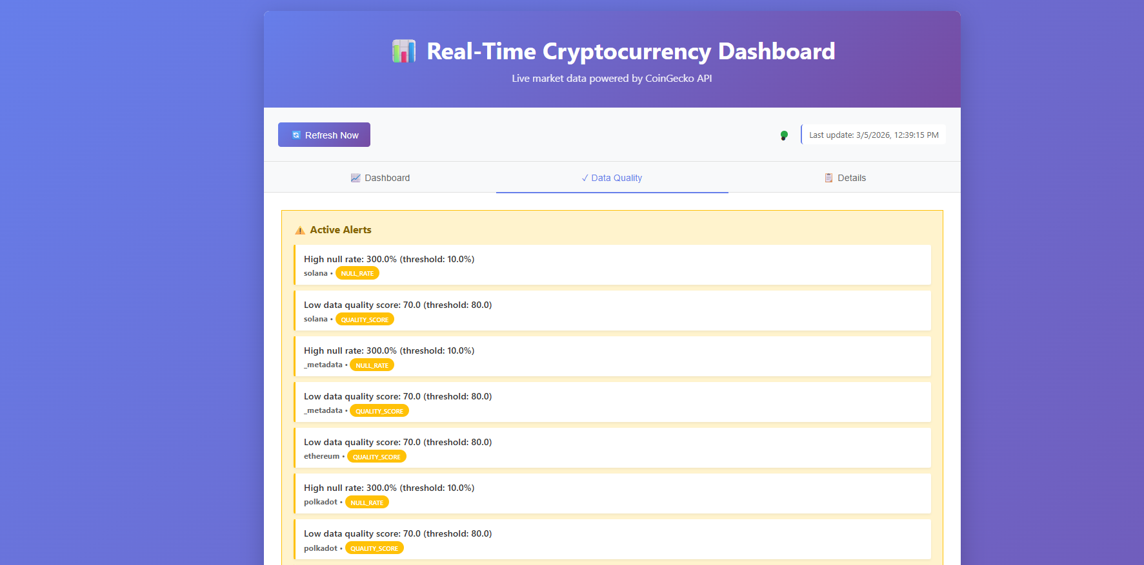
Figure 9: Data Quality tab showing active alerts.

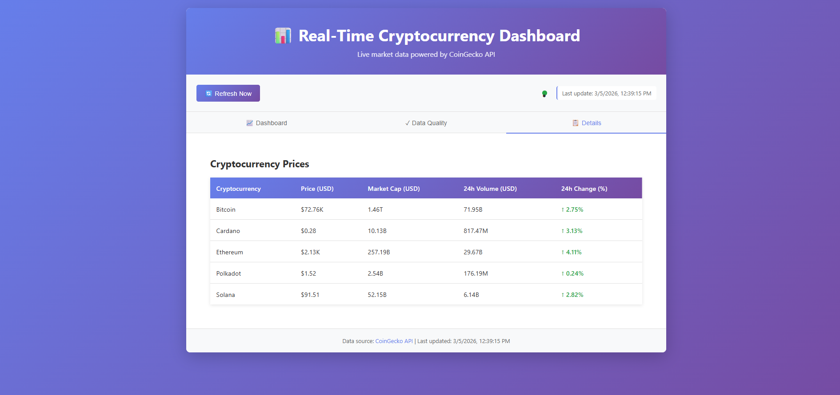
Figure 10: Details tab with cryptocurrency pricing table.

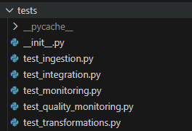
Figure 11: Test folder/module structure.

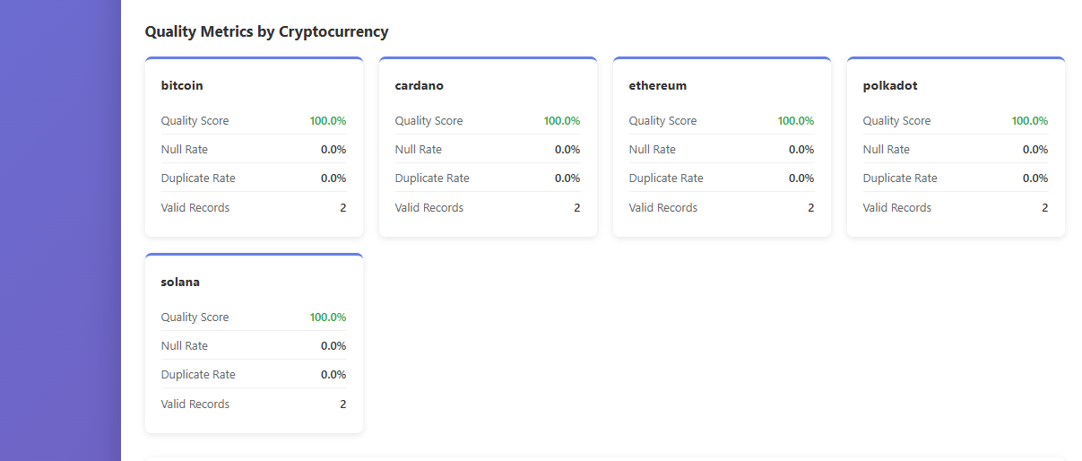
Figure 12: Quality metric cards by cryptocurrency.

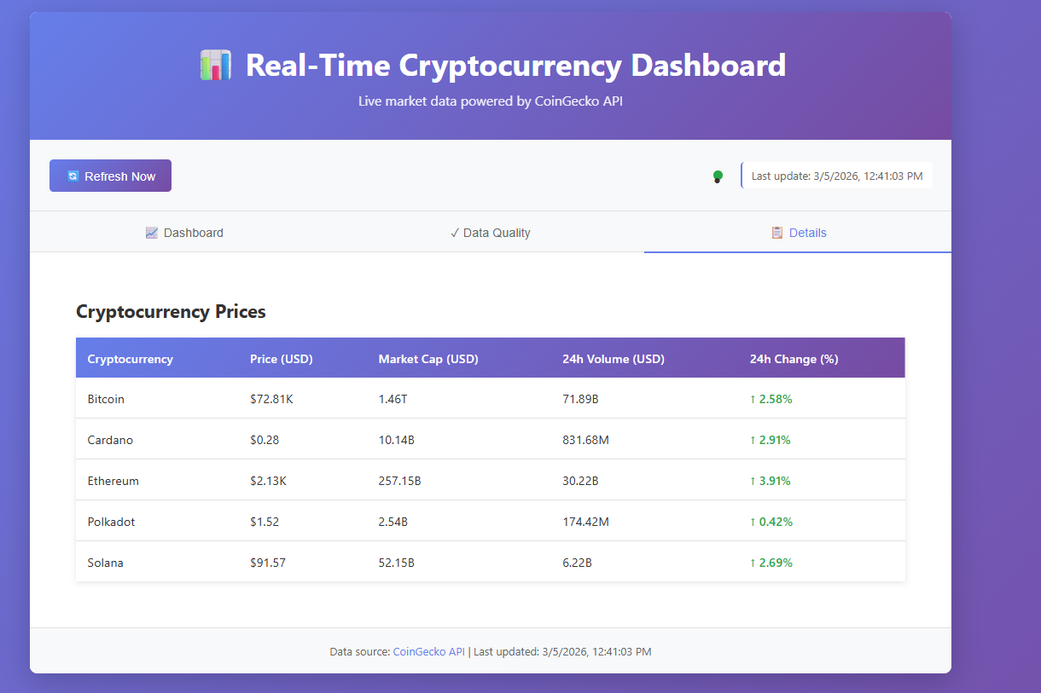
Figure 13: Details tab alternative snapshot.

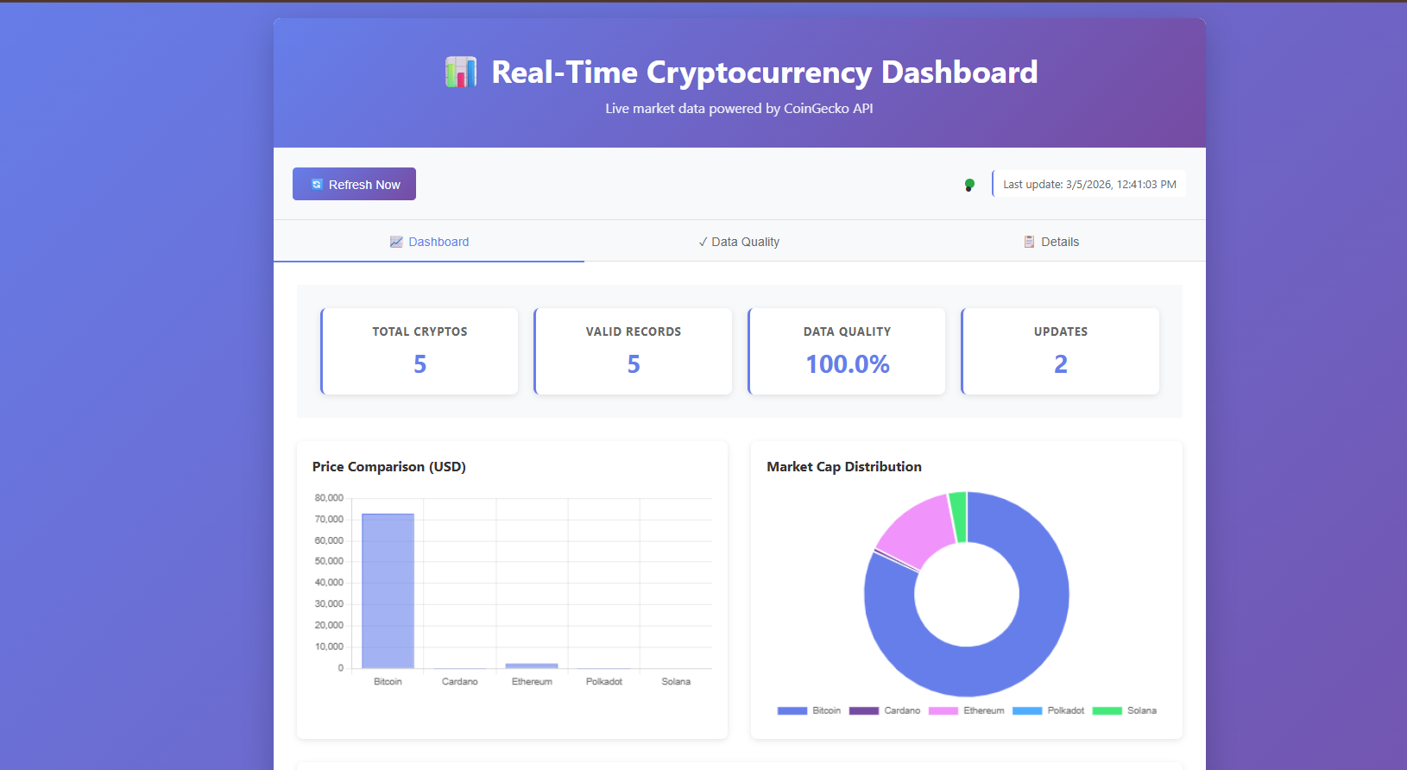
Figure 14: Dashboard summary with KPI cards and charts.

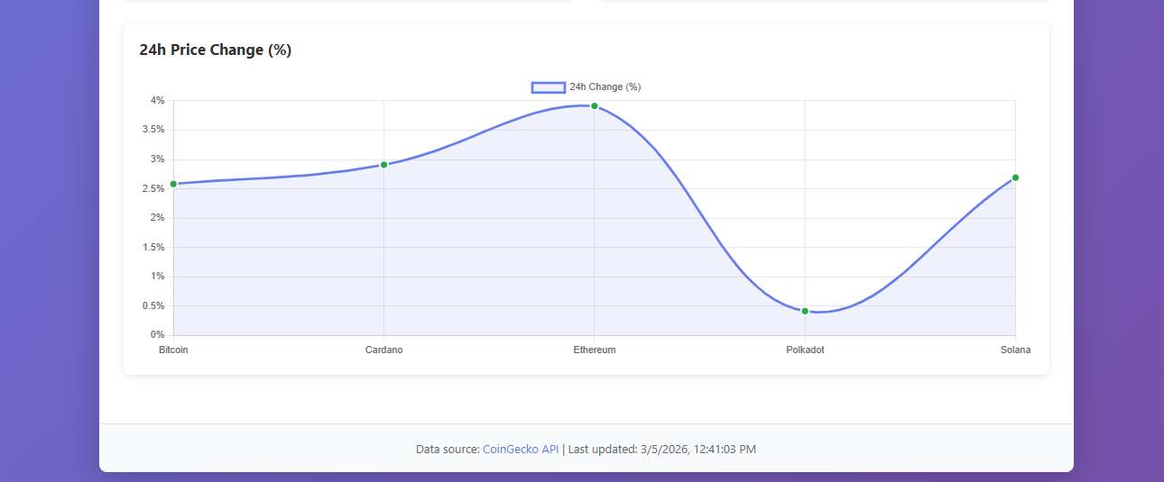
Figure 15: 24-hour price change chart.

------------------------------------------------------------

8. Deliverables Checklist
- Backlog, sprint plans, and Definition of Done documented.
- Sprint 1 and Sprint 2 execution reports documented.
- Sprint 1 and Sprint 2 retrospectives documented.
- CI/CD workflow files and evidence captured.
- Testing assets and screenshots organized in docs/screenshots.

9. Conclusion
The project demonstrates structured Agile execution, incremental delivery, and practical DevOps implementation. Sprint outcomes and retrospective feedback show a clear progression in engineering discipline, automation maturity, and product quality over time.

