# WeGoodCharger APP User Manual

1. Download the "WeGoodCharger" APP

You can scan the QR code with your browser to download.

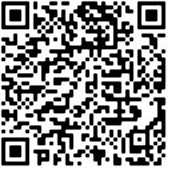 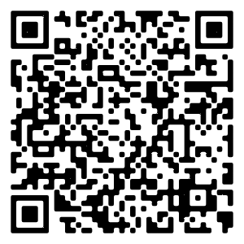

Android download QR code

Apple download QR code

You can also copy the link to your browser to download:

**Android** phones can copy links to the browser to download

<https://ev.weguyun.com/device/downUrl>

**Apple** phones need to search and download "WeGoodCharger" in the app store

<https://apps.apple.com/cn/app/wegoodcharger/id6466698087>

Note:

Please allow and trust this application when downloading.

If the download is blocked by Google Play, please try uninstalling Google Play and re downloading

WeGoodCharger

Go to phone settings → turn on Bluetooth, and allow nearby devices 'WeGoodCharger'

permissions and location permissions in “Apps & notifications” or “Application manager” or "Privacy

and Security".

Language support:

Chinese, English, French, Spain, Russian, Israeli Hebrew, Brazil, Thai, Japanese, Italian, Arabic.

To change the app language, go to Profile > Language.

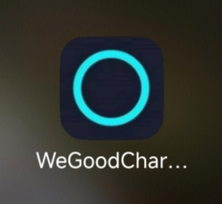

1. Sign Up & Log In

Open the APP → Tap " Sign Up" → Enter email and password → Tap "Register” →Complete

verification.

Enter your email and password → Tap "Login" → Enter the Home page.

If you forget your password, Tap "Forgot Password?" → Reset password via email verification.

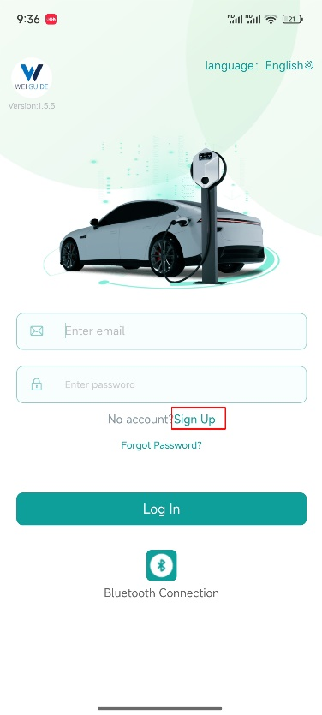 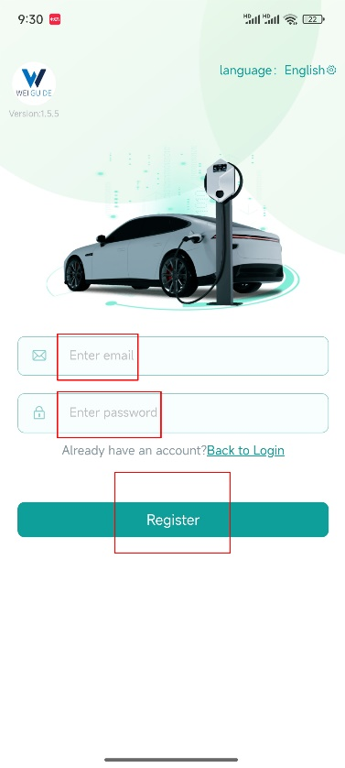 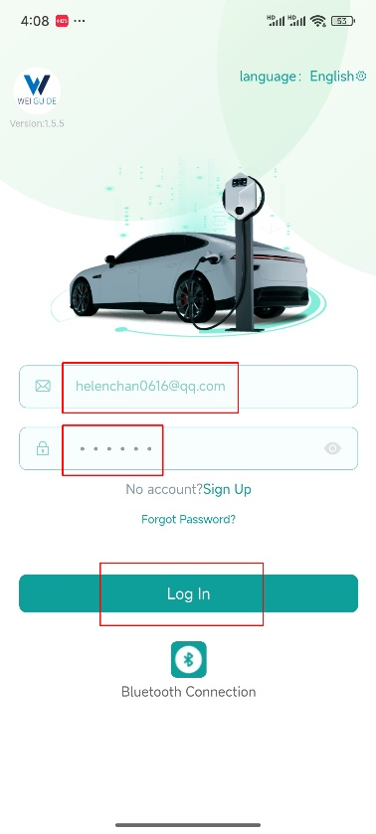

3. Bluetooth connection

Turn on the power of the device → Enter the “WeGoodCharger” application → Tap

"Bluetooth Connection " → Select a device whose name starts with "WGD" from the list. You can

also tap “BLUETOOTH” on the Home page after logging in to your account.

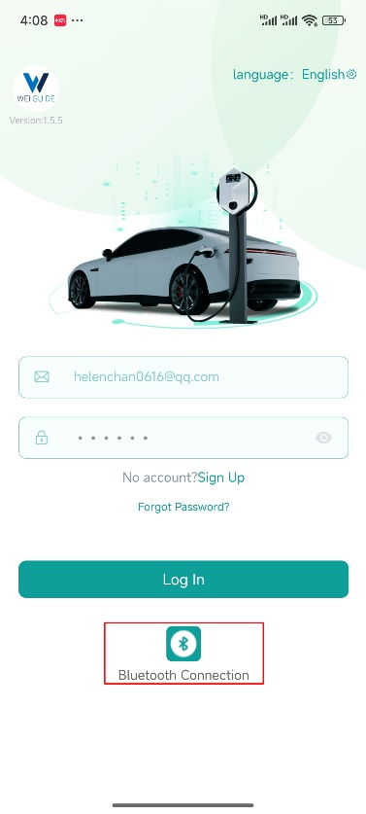 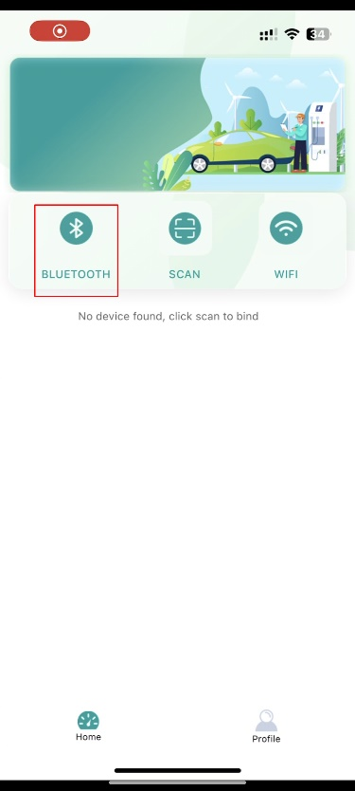 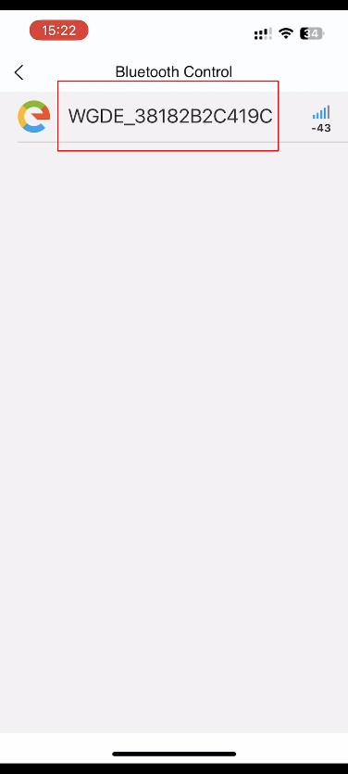

Enter the default 6-digit operation password "*123456*" for the first time →To successfully pair Bluetooth →When the message ‘Please change the password’ pops up →Set a new 6-digit password to ensure security →Important: Forgetting Bluetooth password cannot reset on its own. Contact the seller to provide the device ID code for resetting.

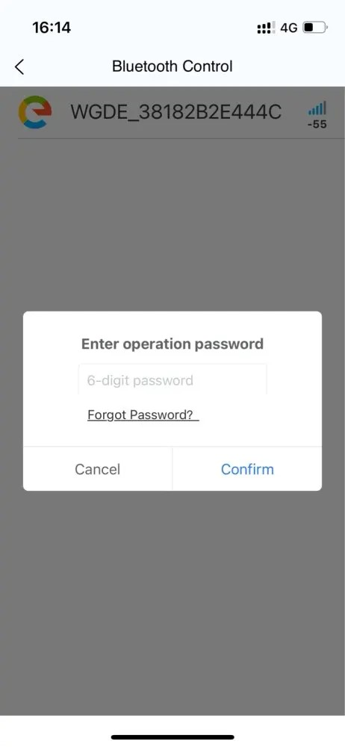 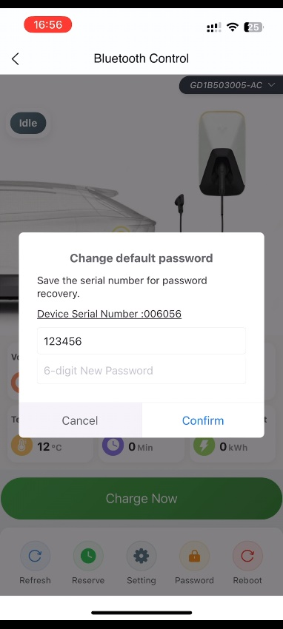

Bluetooth connection successful → Go directly to the Bluetooth control page → Insert the charging connector into your vehicle → Tap “Charge Now” to start charging. The device will

automatically stop once the vehicle is fully charged. You can also tap “Stop Charging” at any time to

stop charging.

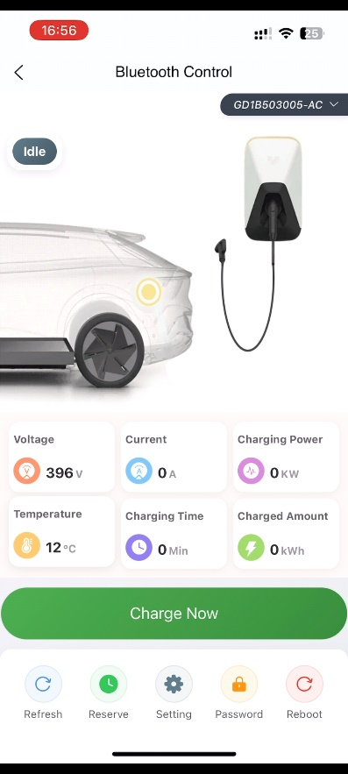 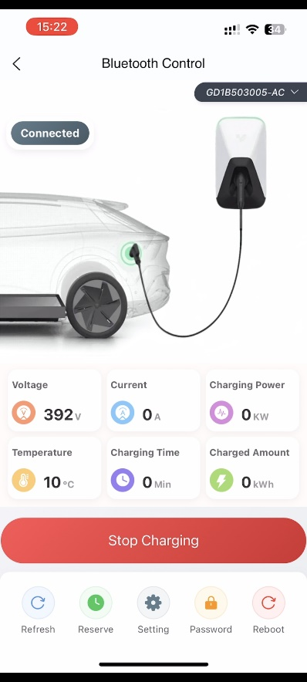 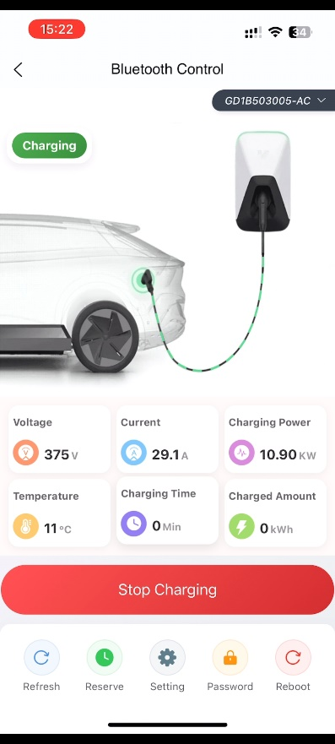

State: Idle→Connected→Charging

If Bluetooth connection fails, ensure:

1. Turn on Bluetooth on your phone.
2. Allow nearby devices and location permissions for this application in "Apps & Notices" or "Application Manager" or "Privacy and Security".
3. Verify Bluetooth password (123456 for first use or your modified password)
4. Turn off and restart the charger and application.

Charging data connected via Bluetooth will not be saved, it is recommended to prioritize using WiFi

connection.

1. WIFI connection
2. SCAN

Tap "SCAN " →Scan the QR code on the right side of the device. The application will prompt

success or failure.

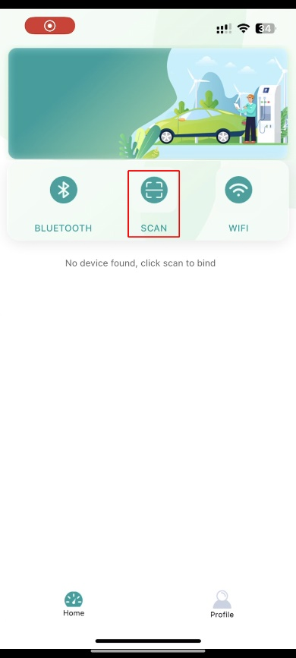 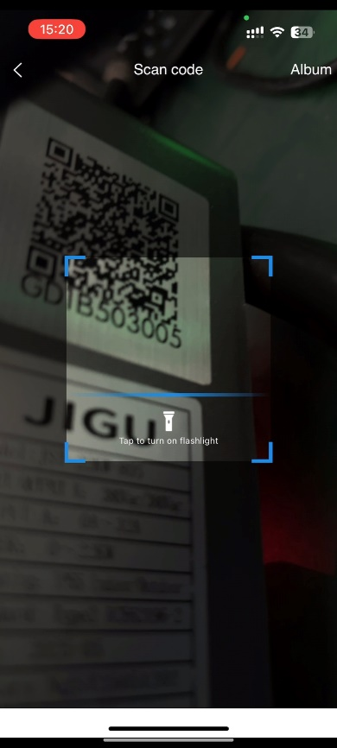 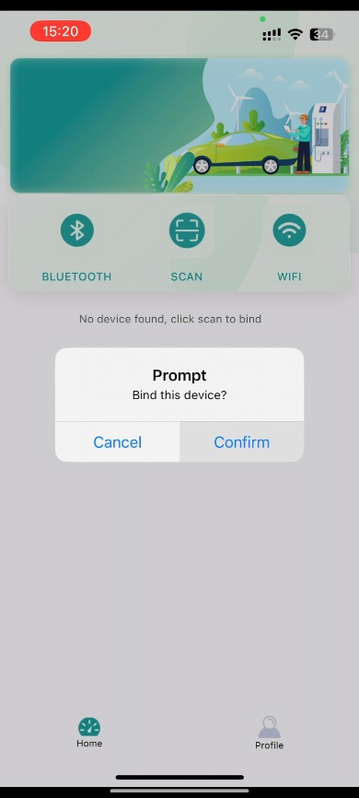

1. WIFI

Turn on the power of the device → Tap "WiFi"→select a device whose name starts with

“WGD……” from the list → Enter operation password “123456”. (This step may not exist) →

Select WiFi (2.4GHz only), Manually enter WIFI account and password if failed → Confirm. The

application will prompt success or failure.

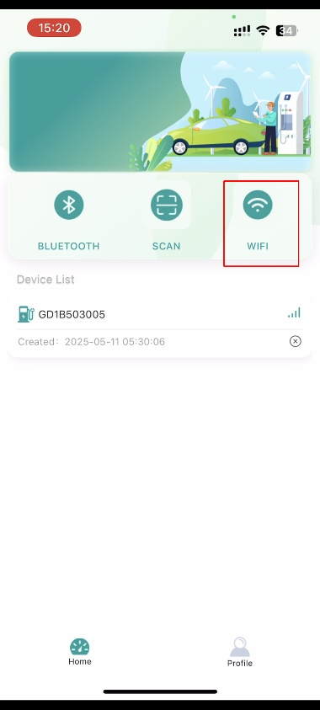 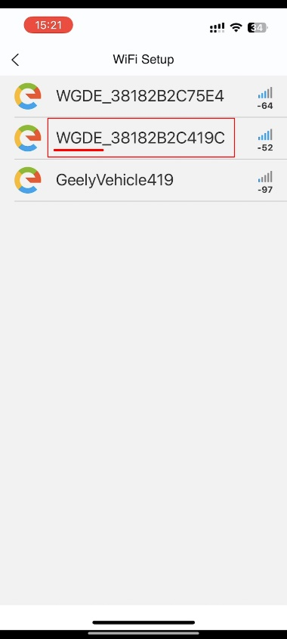 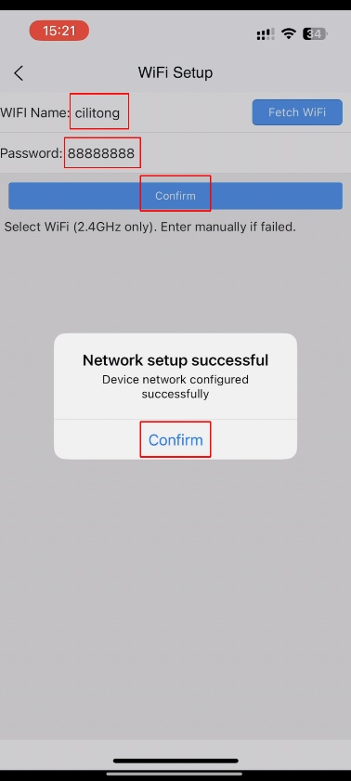

WiFi connection successful → Tap “WIFI” to go directly to WiFi control page → Insert the

Charging connector into your vehicle → Tap “Charge Now” to start charging. The device will

automatically stop once the vehicle is fully charged. You can also tap “Stop Charging” at any time to

stop charging.

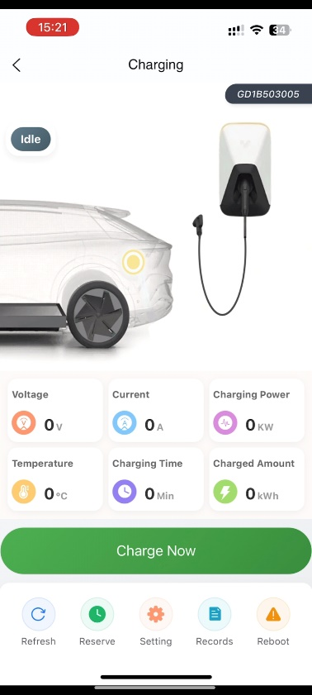 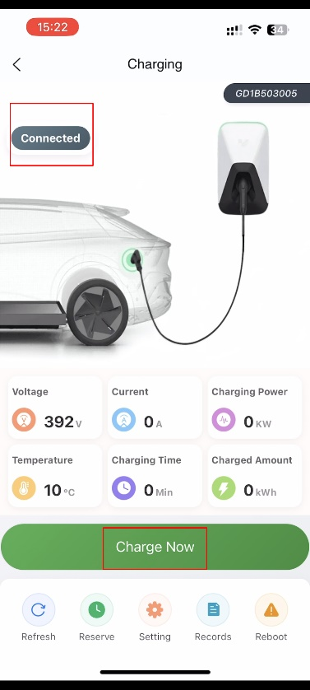 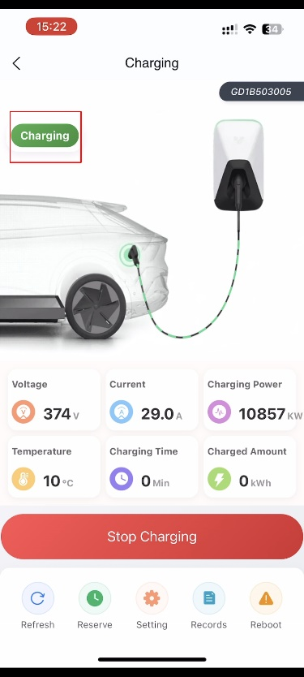

State: Idle→Connected→Charging

If WIFI connection fails, ensure:

1. Connect 2.4GHz WIFI.

2. The device is within WiFi range.

3. The password does not contain special Characters (e.g., spaces).

4. Check signal strength between device and router.

5. The phone turned on Bluetooth and successfully connected to WIFI.

6. Allow nearby devices and location permissions for this application in "Apps & Notices" or

"Application Manager" or "Privacy and Security".

7. Turn off and restart the device and applications.

1. Other functions

Device list

Tap “Device List” to view the online/offline status of the bound devices, and perform device control, or unbind the currently bound devices.

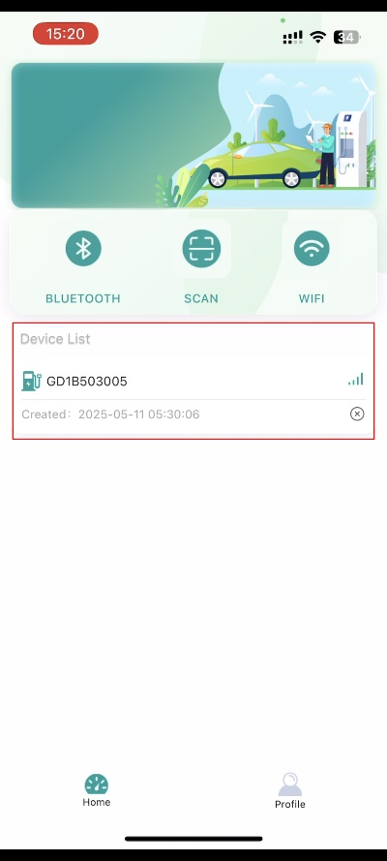 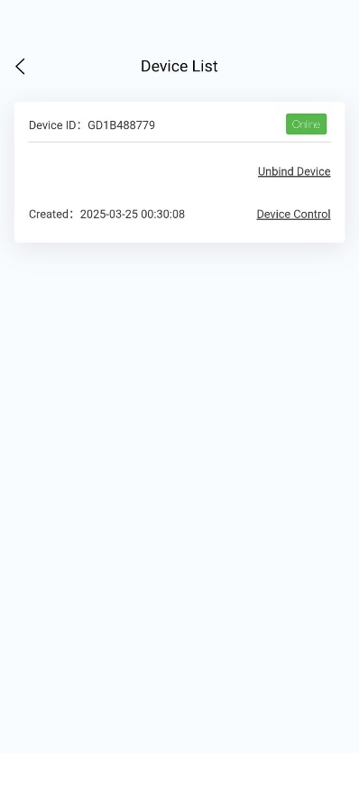

Device control

Tap "Device Control" to view real-time data of the device, including Voltage(V), Current(A), Charging power(KW), Temperature(℃), Charging time(Min), Charged Amount(kWh) and other information.

Tap “Charge Now” to start charging. Tap “Stop Charging” to stop charging.

 

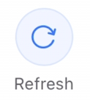

**Refresh:**

Tap “Refresh” to get the latest status of the device.

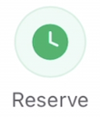

**Reserve:**

Please tap "Reserve" after the device port is in the 'Connected' state.

When WiFi is connected, You can choose "single" and "custom" to schedule charging time.

Single:

Tap “Single” → Select date/time → Confirm → Prompt 'reservation successful' → Status changes to "Reserved".

Custom:

Tap "Custom" → Select Repeat Date/Time → Confirm → Prompt 'reservation successful' →Status changes to " Reserved ".

Edit/Cancel:

Tap the Reserved task to edit or cancel it.

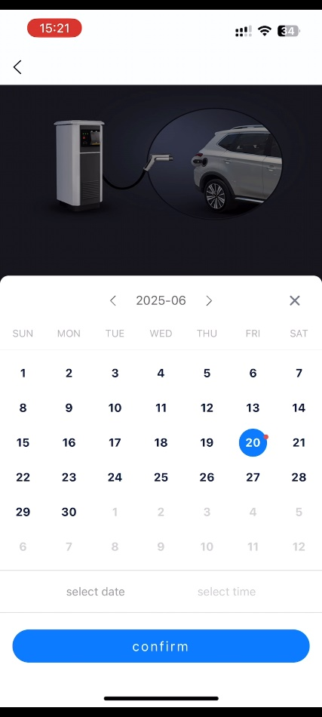 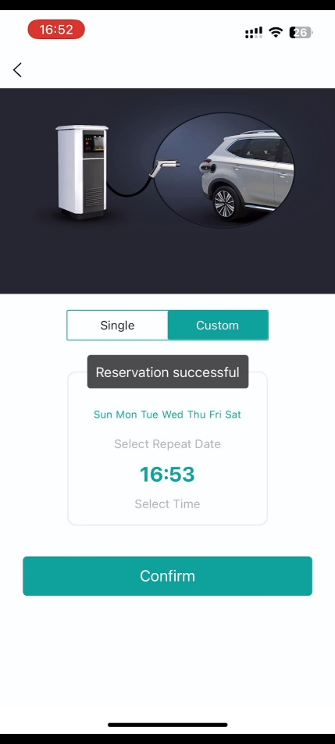 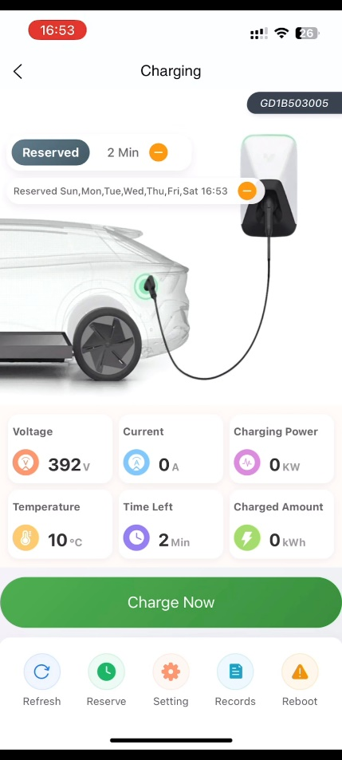

When connecting via Bluetooth, you can choose today and tomorrow to set the charging start time.

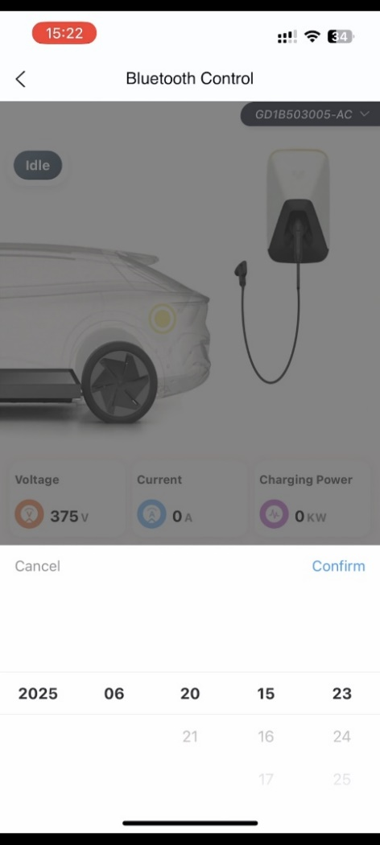

We cannot set the charging end time, as the device will automatically stop charging when the vehicle is fully charged.

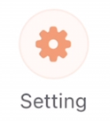

**Setting:**

Plug and Charge

Turn on this option, This means that simply plug the charging connector into the vehicle to start charging without any operation.

Charging Current

Before inserting the charging connector (with the device in Idle state), you can set the maximum charging current based on the input current. Optional 8A 9A 10A 11A 12A 13A 14A 15A 16A……32A.

Warning:

Do not exceed the maximum charging current of the input cable and input socket.

If the charging is interrupted → Confirm that the vehicle charging interface is in good contact → Check for overload protection → Attempt to reduce charging current.

Auto charge via Bluetooth: Turn on this option, and the device port is in the" connected "state, simply connect to Bluetooth and the device will automatically start charging. (This option is only available for Bluetooth connections).



**Records:**

Only record the charging history connected through WIFI. (Device ID,xx.xkWh,Charging time, End time)

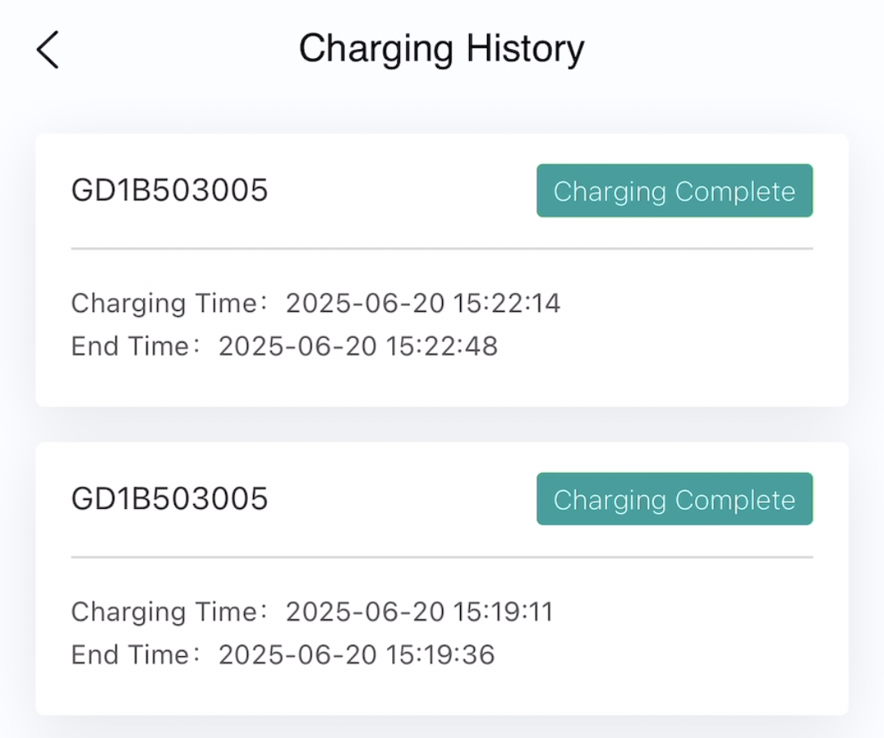

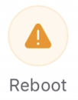

**Reboot:** Reset the device status. Reset to wake up the status of vehicle and device ports.

Resolve abnormal conditions and restart charging without unplugging the charging connector.



**Platform:**

Support configuring overseas OCPP (1.6) communication protocol. To configure the platform, enter

the server address, server port number, and platform pile ID provided by your operator for OCPP 1.6

protocol connectivity.

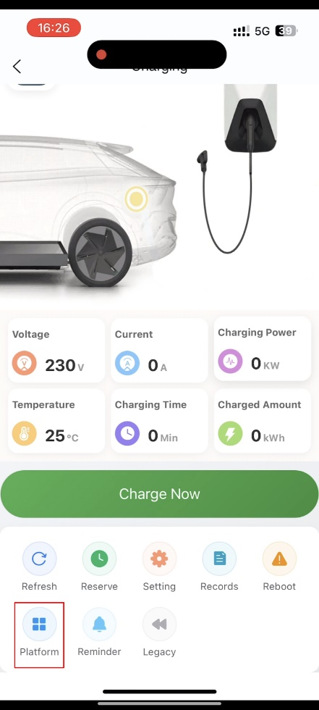 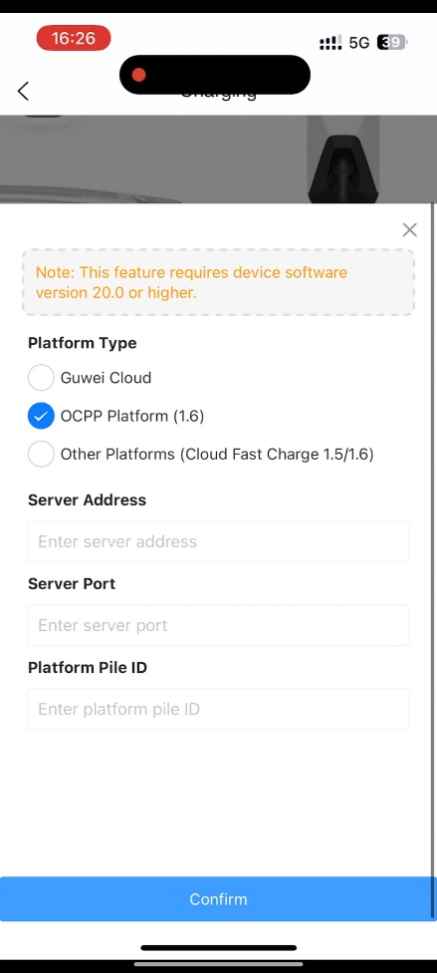

1. Profile

Account Settings

Change the password of the email registered account. (Not the Bluetooth password.)

Charging History

Only record the charging history (time, battery level, device ID) connected through WIFI.



Reservation History

Only record the reservation history (single/repeat) connected through WIFI.

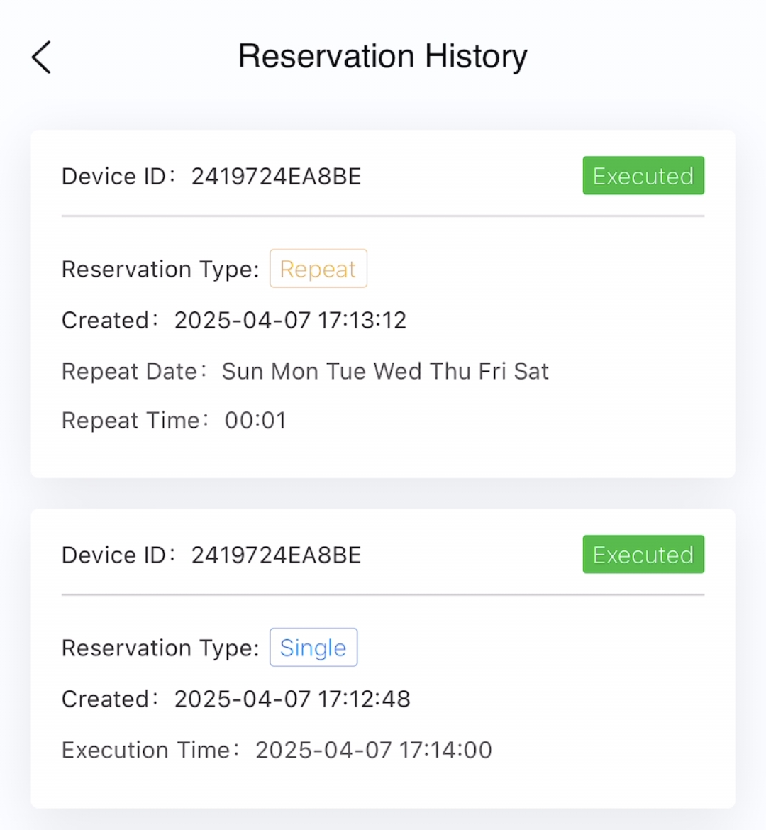

Language

Options include: Chinese, English, French, Spain, Russian, Israel Hebrew, Brazil, Thai, Japanese,

Italiano, Arabic.

1. Version updates

Regularly check the app store for updates on new features and security fixes.