PyCity Schools Analysis

The purpose of this assignment is to assist Maria who is the Chief Data Scientist for city Schools in the district to provide the leaders of schools with results which would detail how each school performance is related to budgeting for the district schools and how to funds needs to be distributed among schools in the district. She is tasked to prepare all standardized testing in the district for analysis, reporting and presentations comparing the insight on performance trends and pattern of the city school system. The concluded analysis was derived results on student's funding, test scores that would enable the district to make strategic decisions on budget allotments, and performance patterns in the schools in the district. To ensure that the report was based on data without errors, this project initial responsibility was to clean the data collected from the district areas was cleaned and that was what is used for this report.

How is the district summary affected?

The district summary Data



The district summary overall went down to 64.9 slightly because if did not have all the student in the analysis since the ninth graders score of Thomas High school was dropped in the cleaned district summary.

How is the school summary affected?

It looks like THOMAS HIGH SCHOOL had been doing well based on the below result from the data for ninth graders, but their performances could be compared to other ninth graders due to lack of data and the reduction of students enrolled.

THS passing math percentage - 93.18568994889267

THS passing reading percentage - 97.01873935264055

THS overall passing percentage - 90.63032367972743

How does replacing the ninth graders’ math and reading scores affect Thomas High School’s performance relative to the other schools?

Thomas High School maintained its performance and was one of the top schools in the district with an impressive second position above Wilson High School which had the highest listing of student in the group.

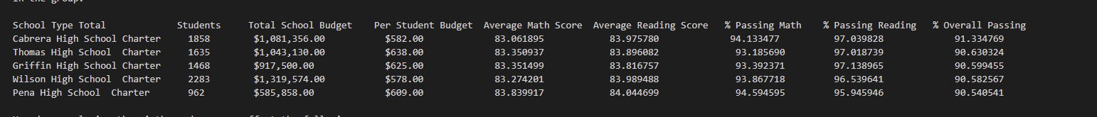

How does replacing the ninth-grade scores affect the following:

Math and reading scores by grade 9 were affected based on the new data below because of the new data which did not include Thomas High School with NAN in its columns

**New reading scores by grade**

9th 10th 11th 12th

school name

Bailey High School 81.3 80.9 80.9 80.9

Cabrera High School 83.7 84.3 83.8 84.3

Figueroa High School 81.2 81.4 80.6 81.4

Ford High School 80.6 81.3 80.4 80.7

Griffin High School 83.4 83.7 84.3 84.0

Hernandez High School 80.9 80.7 81.4 80.9

Holden High School 83.7 83.3 83.8 84.7

Huang High School 81.3 81.5 81.4 80.3

Johnson High School 81.3 80.8 80.6 81.2

Pena High School 83.8 83.6 84.3 84.6

Rodriguez High School 81.0 80.6 80.9 80.4

Shelton High School 84.1 83.4 84.4 82.8

Thomas High School nan 84.3 83.6 83.8

Wilson High School 83.9 84.0 83.8 84.3

Wright High School 83.8 83.8 84.2 84.1

**New math scores by grade**

9th 10th 11th 12th

Bailey High School 77.1 77.0 77.5 76.5

Cabrera High School 83.1 83.2 82.8 83.3

Figueroa High School 76.4 76.5 76.9 77.2

Ford High School 77.4 77.7 76.9 76.2

Griffin High School 82.0 84.2 83.8 83.4

Hernandez High School 77.4 77.3 77.1 77.2

Holden High School 83.8 83.4 85.0 82.9

Huang High School 77.0 75.9 76.4 77.2

Johnson High School 77.2 76.7 77.5 76.9

Pena High School 83.6 83.4 84.3 84.1

Rodriguez High School 76.9 76.6 76.4 77.7

Shelton High School 83.4 82.9 83.4 83.8

Thomas High School nan 83.1 83.5 83.5

Wilson High School 83.1 83.7 83.2 83.0

Wright High School 83.3 84.0 83.8 83.6

Scores by school spending for the schools had impact on reading scores from the previous data analysis performed where there was a fall in group of students spending rage of $630-644 with 77 % passing rate

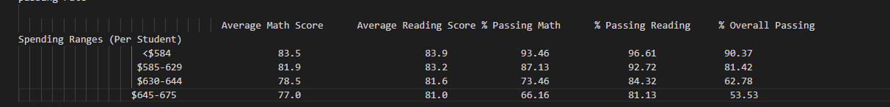

Scores by school size was the only thing which did not affect the scores of the results when THOMAS HIGH SCHOOL'S reading and math scores was removed. This is because the group in the medium group had a fall in their scores

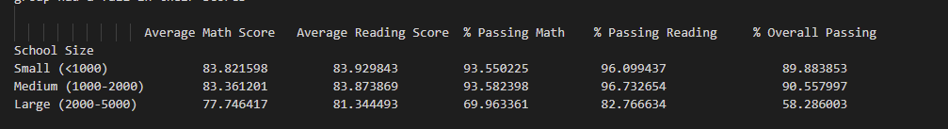

Scores by school type was impacted in the reading score was lower because of the elimination of the ninth grade of THOMAS HIGH SCHOOL



Summary: Summarize four changes in the updated school district analysis after reading and math scores for the ninth grade at Thomas High School have been replaced with NaN.

The 9th graders of THOMAS HIGH SCHOOL were replaced with NAN for both math and reading

Due to the elimination, it reduced the number of students by 461 which was not included in the calculation of the overall average with a reduced total size from 39170 to 38700.

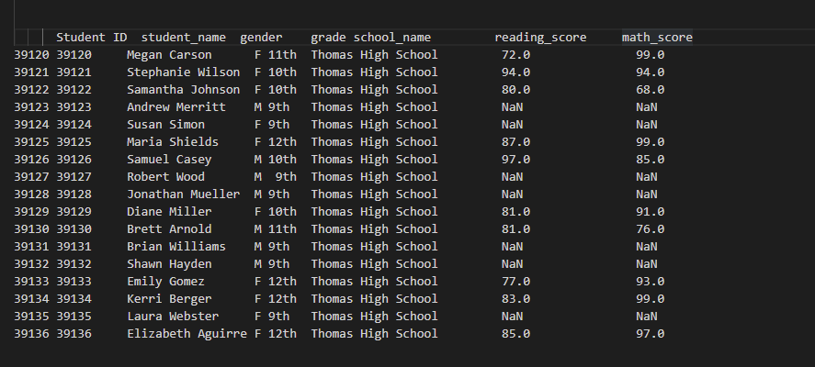

Summary:

The percentage of scores for the district was lower because of the elimination of THOMAS HIGH SCHOOL ninth graders scores.

Spending Ranges (Per Student)

<$586

$586-630

$631-645 - This is the group which had a reduction in spending per student

$646-675