**UFO**

**Deliverable 2 Requirements**

The written analysis has the following

1. Overview of the analysis:
   * The purpose is well defined
2. Results:

There is a description of how to perform a search, with images.

If there is UFO in a city whenever a browser put in the state of interest it would retrieve the information for the state of interest

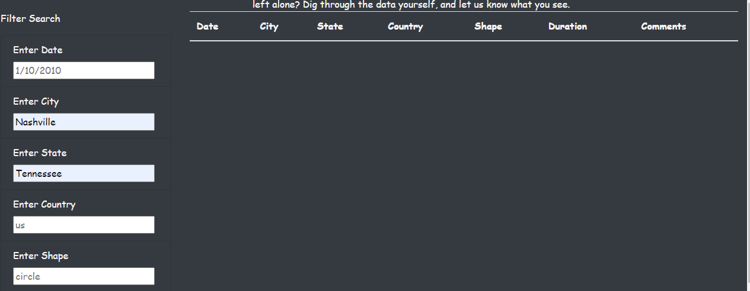

1. Summary:

1. The updates to the website would always require update of the data.js file and the data is from static file
2. The recommendation for this project is to store the UFO’S into database anytime there are changes in the data
3. It would be important for more new data which would broaden the search for UFO