# IT Helpdesk Portfolio – Case Study Report

Prepared by: Justin Asamoah

This report contains a collection of resolved IT support tickets, demonstrating troubleshooting, documentation, and resolution skills relevant to IT Helpdesk and Administrator roles.

## ****Introduction****

This portfolio has been developed to demonstrate my practical skills in IT support and helpdesk operations.  
It simulates real-world scenarios using a ticketing system (Spiceworks) to log, track, and resolve issues.

Each case study highlights:

* Problem analysis and troubleshooting approach.
* Clear documentation of steps taken.
* Use of evidence (screenshots, logs).
* Final resolution and user outcome.

The tickets included cover a range of issues across hardware, software, networking, and account administration, reflecting the scope of responsibilities in a typical IT Helpdesk role.

# Ticket #3 – Laptop not powering on

## Ticket Summary

• User: John Smith  
• Category: Hardware  
• Priority: High  
• Status: Closed

## Issue Description

User reports device won’t boot. No fan noise, no lights. Tried power button reset with no success.

## Actions Taken

- Verified power adapter and outlet working correctly.

- Performed hard reset (power button 30s).

- No response – issued spare laptop.

- Logged faulty device for repair/replacement.

## Resolution

User operational with replacement device. Faulty laptop sent for repair.

## Outcome

Issue resolved. Ticket closed successfully.

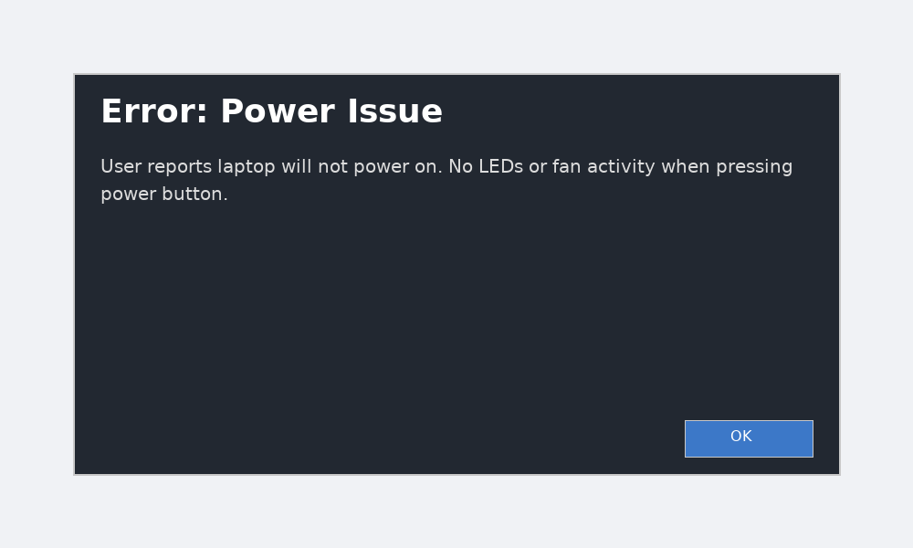

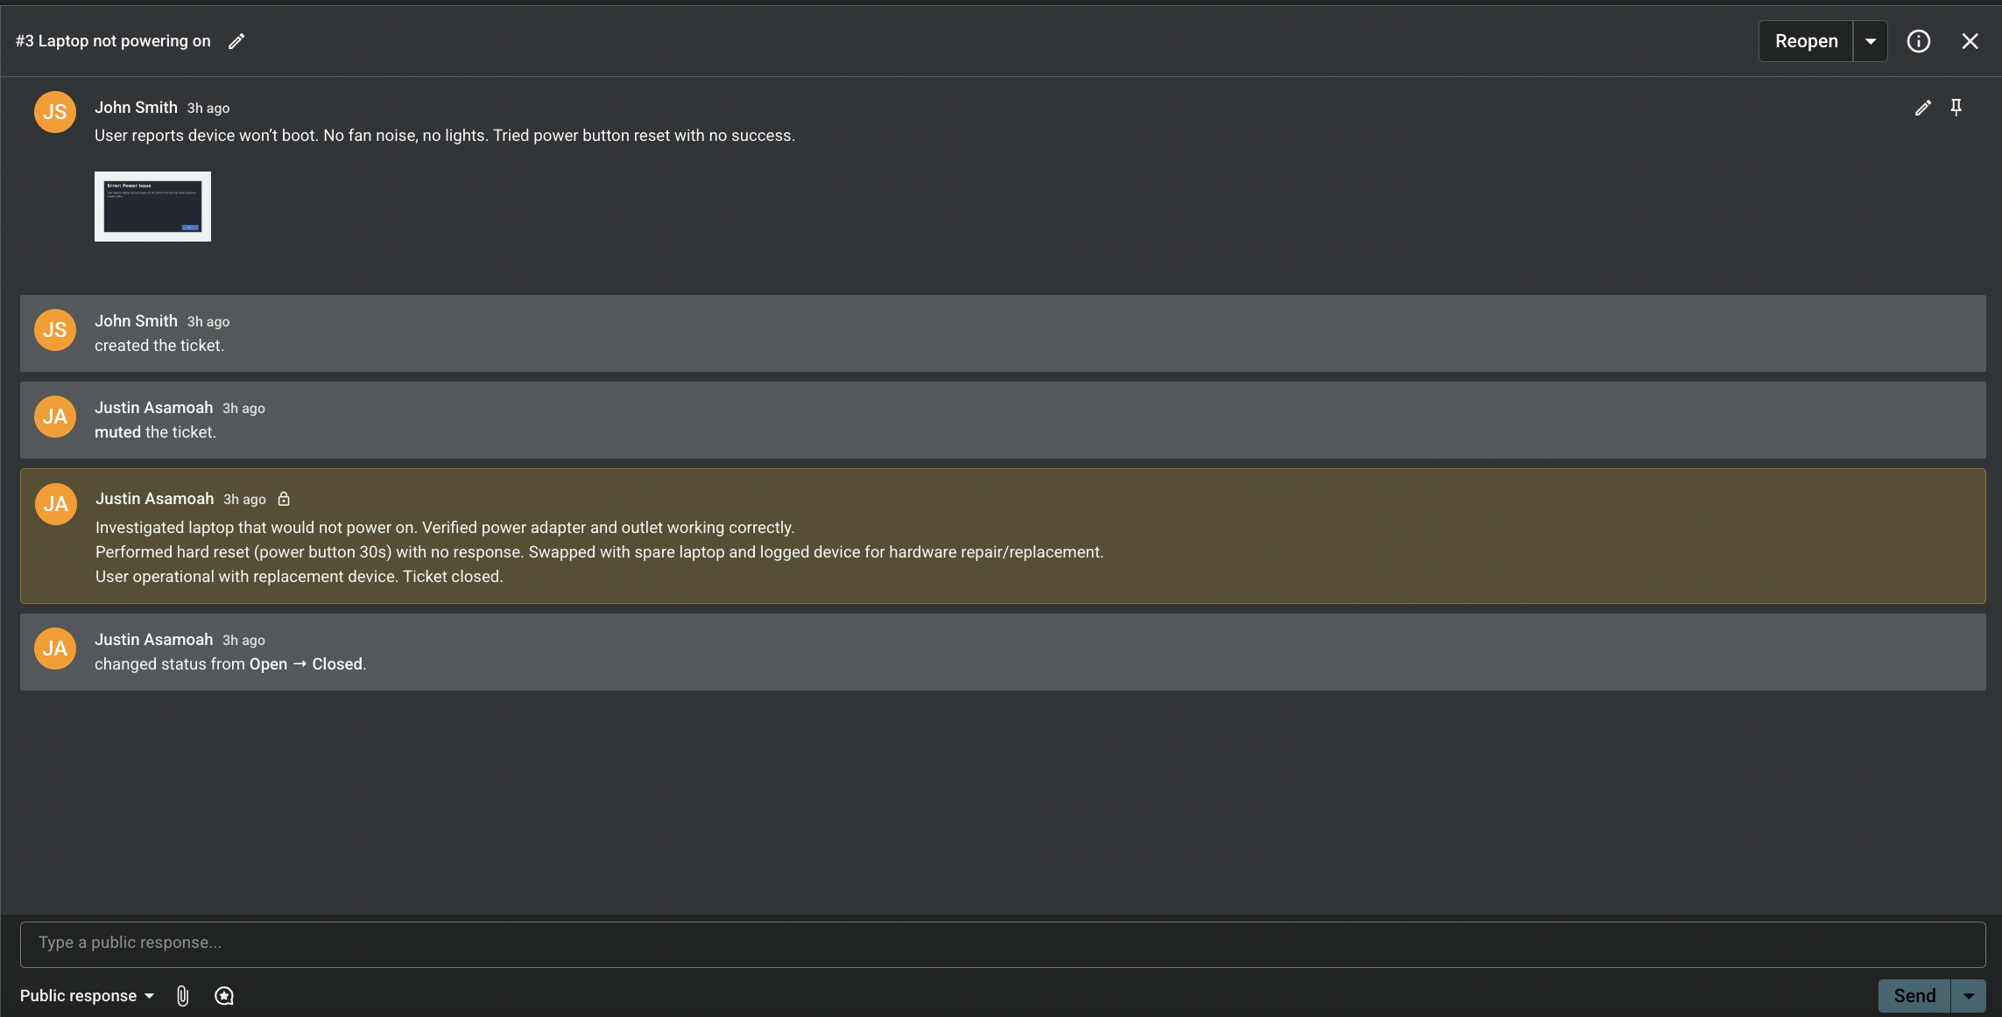

# Ticket #4 – Outlook not syncing with O365

## Ticket Summary

• User: Jane Doe  
• Category: O365 / Software  
• Priority: Medium  
• Status: Closed

## Issue Description

User’s Outlook inbox is not updating. Restarted app, but emails only appear in webmail.

## Actions Taken

- Confirmed user could access email via O365 webmail.

- Cleared cached credentials in Windows Credential Manager.

- Recreated Outlook profile.

- Forced manual sync and tested email send/receive.

## Resolution

Outlook desktop client re-synced successfully.

## Outcome

User confirmed issue resolved. Ticket closed.

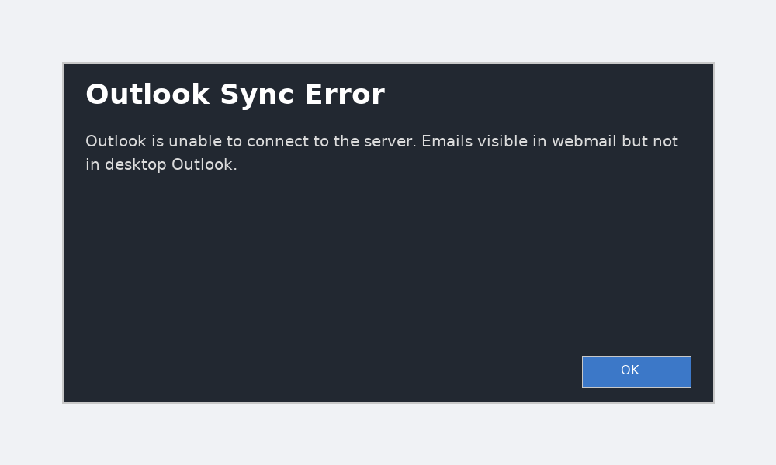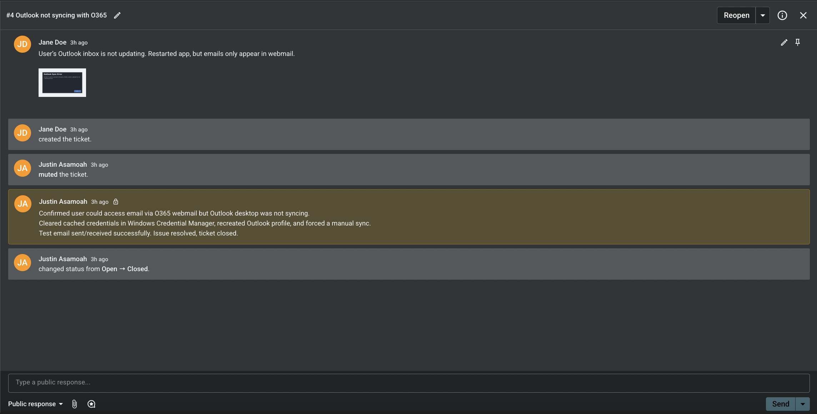

# Ticket #5 – Wi-Fi disconnects every 5 minutes

## Ticket Summary

• User: Michael Lee (Sales)  
• Category: Network  
• Priority: High  
• Status: Closed

## Issue Description

User complains of unstable Wi-Fi connection in meeting room. Drops video calls.

## Actions Taken

- Tested Wi-Fi in meeting room – confirmed intermittent drops.

- Checked router logs for errors.

- Updated wireless adapter driver on affected device.

- Moved user to stable 5GHz band.

## Resolution

Signal stabilised and video call tested successfully without drops.

## Outcome

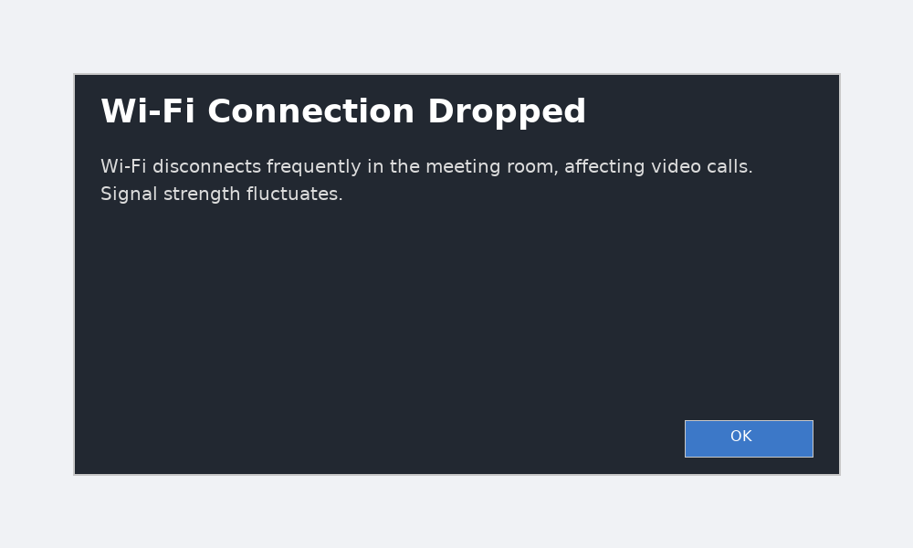Escalated issue to network team for monitoring. User confirmed resolution.

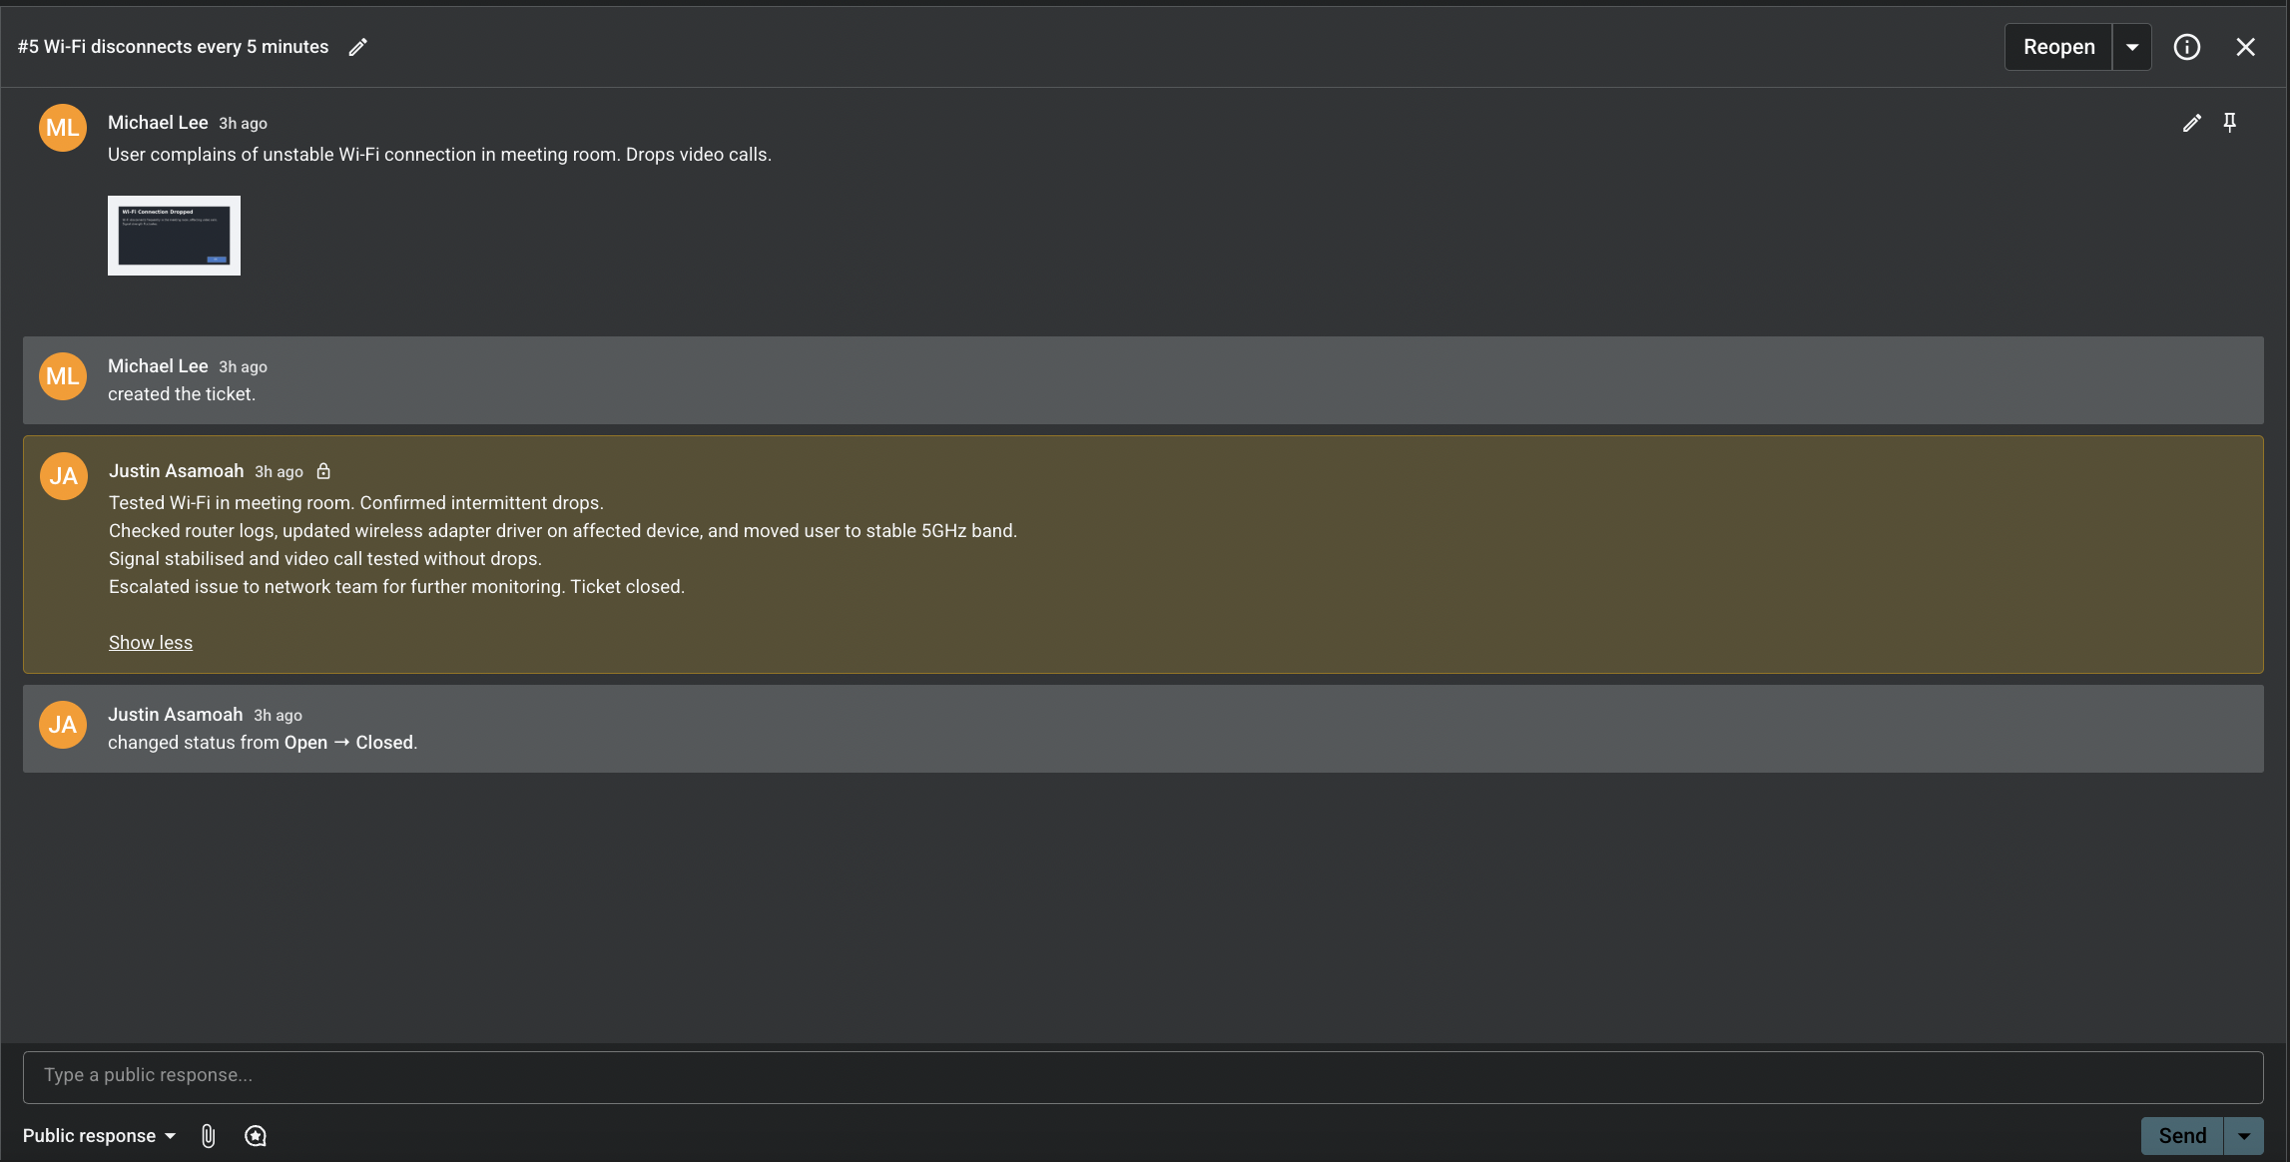

# Ticket #6 – Shared printer unavailable

## Ticket Summary

• User: John Smith (Finance)  
• Category: Hardware  
• Priority: Low  
• Status: Closed

## Issue Description

User unable to print to shared printer. Device showing 'offline.'

## Actions Taken

- Verified printer powered on and connected to network.

- Restarted Print Spooler service on print server.

- Re-added printer to affected system.

- Printed test page successfully.

## Resolution

Printer now available and functional.

## Outcome

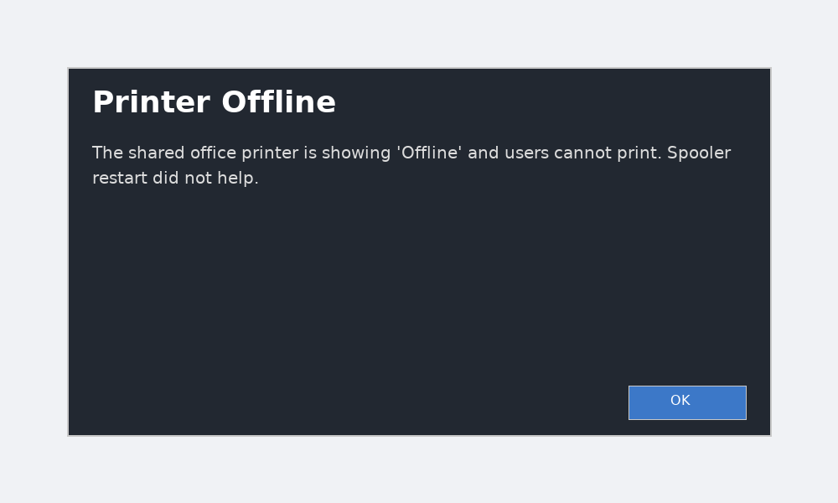Ticket closed successfully.

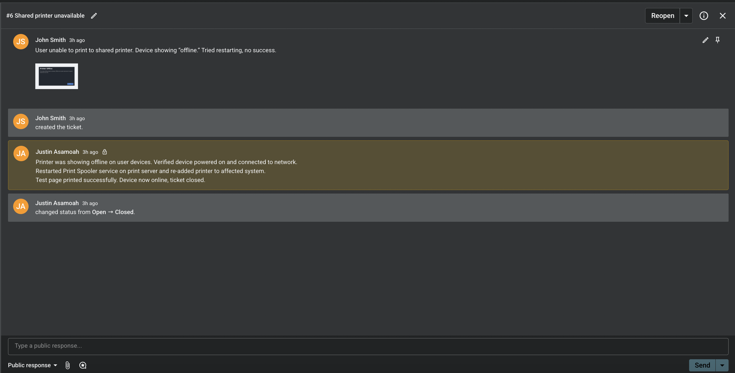

# Ticket #7 – New starter account required

## Ticket Summary

• User: Jane Doe (HR)  
• Category: User Accounts / Admin  
• Priority: Medium  
• Status: Closed

## Issue Description

HR requested account setup for new joiner requiring O365 license, Teams access, and SharePoint permissions.

## Actions Taken

- Created new user account in Microsoft Entra ID.

- Assigned O365 license.

- Configured Teams and SharePoint access.

- Tested login and confirmed mailbox/Teams access.

## Resolution

New starter fully onboarded with required access.

## Outcome

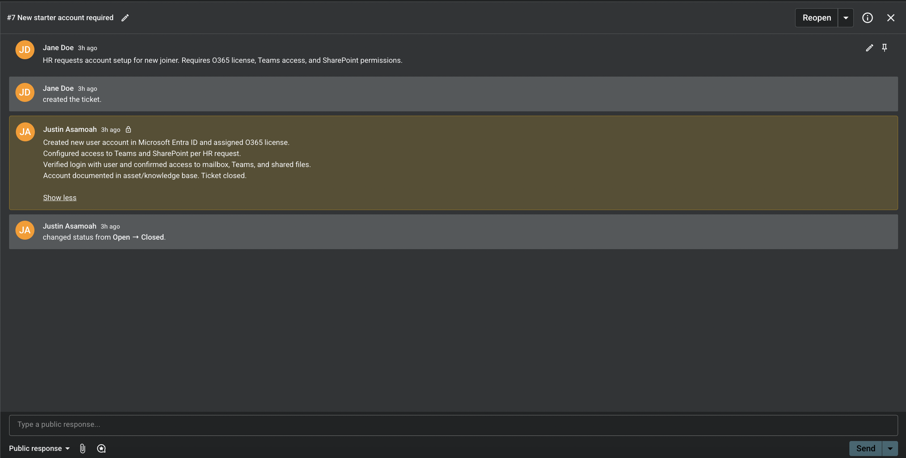Account documented. Ticket closed successfully.

## ****Conclusion****

Through this portfolio, I have shown my ability to:

* Diagnose and resolve technical issues.
* Communicate solutions clearly with end users.
* Document actions and maintain accurate records.
* Work across different areas of IT, from user support to system administration.

This case study collection demonstrates not only my technical knowledge but also the soft skills needed in IT support — problem-solving, adaptability, and user-focused service delivery.  
It serves as evidence of my readiness to take on an IT Helpdesk or IT Administrator role and continue developing into more advanced IT and cybersecurity positions.