AI-POWERED
FINANCIAL HEALTH ADVISOR
Credit Assistant: Intelligent Credit Monitoring and Personalized Financial Guidance

PROJECT DOCUMENTATION
Technology Stack: FastAPI • React.js • SQLAlchemy • SQLite • Recharts • Google Gemini AI

Prepared as a project report
Name: Amruta Nanappa Kanbale
Div: A(AI&DS)
Roll No:22147

Table of Contents
1. Abstract
2. Introduction
3. Problem Statement
4. Aim and Objectives
5. Scope of the Project
6. Proposed System
7. Technology Stack
8. System Architecture
9. Functional Modules
10. Database Design
11. System Workflow
12. Security, Privacy and Responsible AI
13. Testing and Validation
14. Deployment and Execution
15. Expected Outcomes
16. Limitations
17. Future Enhancements
18. Conclusion
19. References

1. Abstract
AI-Powered Financial Health Advisor, implemented as Credit Assistant, is a full-stack financial wellness platform designed to help users understand and improve their credit health. The application combines a FastAPI backend, React.js frontend, SQLAlchemy object-relational mapping, SQLite database, Recharts visualizations, and Google Gemini AI to deliver credit monitoring, financial metric calculations, interactive dashboards, and personalized educational guidance.
Users can maintain a financial profile, record credit-score history, review indicators such as credit utilization and debt-to-income ratio, track active loans and missed payments, and receive AI-generated suggestions based on the information they provide. The platform is designed around the Indian credit ecosystem, including CIBIL score awareness. It is an educational decision-support tool and does not replace a regulated financial adviser, official credit bureau report, or lender decision.

2. Introduction
Financial health is influenced by several factors, including repayment behaviour, outstanding debt, credit utilization, income, savings habits, and the ability to plan for future expenses. Many users find it difficult to interpret these indicators or understand which actions may help improve their credit profile. Financial data may also be spread across statements, loan accounts, and credit reports, making progress difficult to follow.
Credit Assistant aims to make these concepts easier to understand through a unified dashboard and an AI-powered guidance interface. Users enter or update relevant financial information, the application calculates selected indicators, and visualizations present trends over time. Gemini AI can then help explain the indicators and suggest practical next steps, with recommendations clearly presented as general guidance rather than guarantees.

3. Problem Statement
Users may lack a simple, centralized way to monitor credit-related indicators, understand changes in their financial profile, and identify habits that deserve attention. Manual calculations and generic online advice may not reflect an individual’s recorded debt, income, utilization, or payment history. The project addresses this problem by providing a secure profile, structured financial tracking, visual analytics, and contextual AI-assisted explanations in one application.

4. Aim and Objectives

4.1 Aim
To design and develop an AI-powered financial health advisor that helps users monitor credit-related metrics, understand their financial position, and plan practical steps toward healthier financial habits.

4.2 Objectives
- Build a full-stack application with a React.js user interface and FastAPI backend.
- Provide registration, login, logout, protected routes, and secure handling of user profiles.
- Store credit profiles, financial metrics, and score-history records using SQLAlchemy and SQLite.
- Calculate indicators such as credit utilization and debt-to-income ratio from validated user inputs.
- Visualize score history and selected financial metrics using Recharts.
- Integrate Google Gemini AI to explain financial indicators and generate personalized educational suggestions.
- Validate API behaviour, database integrity, security controls, and end-to-end workflows.
- Present limitations and uncertainty transparently, avoiding guarantees about credit-score outcomes.

5. Scope of the Project
The project focuses on user-entered or otherwise authorized financial information and the following capabilities:
- Credit profile and score-history management.
- Financial health indicators and basic calculations.
- Tracking of declared loans, repayments, and missed-payment events.
- Dashboard charts, trends, and progress summaries.
- AI-assisted explanations and goal-oriented recommendations.
- A modular API structure that can be expanded in later versions.
The initial version does not automatically access bank accounts or official bureau records unless a separately authorized integration is implemented. Users should verify important information against their lender statements and official credit reports.

6. Proposed System
The proposed system has four cooperating layers: a React.js presentation layer, a FastAPI service layer, a SQLAlchemy persistence layer backed by SQLite, and an external Gemini AI service. The frontend sends requests to the backend through REST APIs. The backend validates the requests, applies business rules, reads or writes records in the database, and calls the AI service only when a recommendation or explanation is requested.
- Presentation layer: forms, dashboard cards, charts, and advisor chat interface.
- Application layer: authentication, validation, financial calculations, API endpoints, and orchestration.
- Data layer: user accounts, financial profiles, score history, loans, metrics, and recommendation records.
- AI layer: context-limited prompts and generated explanations based on relevant user-provided values.

7. Technology Stack
Technology | Role in the Application
FastAPI | Creates REST endpoints, validates requests, and serves backend functionality.
React.js | Builds interactive screens, forms, dashboard cards, and the advisor interface.
SQLAlchemy | Maps Python objects to database tables and manages database operations.
SQLite | Provides lightweight relational storage for a local or prototype deployment.
Recharts | Displays score history, utilization, and financial trends through charts.
Google Gemini AI | Generates contextual explanations and educational financial suggestions.
Pydantic | Validates request and response data structures.
Python-dotenv | Loads local environment variables during development.
HTML/CSS/JavaScript | Supports frontend layout, styling, and client-side behaviour.

Version compatibility should be checked during setup. API keys and other secrets must be kept in environment variables or a managed secret store and must never be committed to source control or exposed in frontend code.

8. System Architecture
A typical request follows this sequence:
- The user interacts with the React.js frontend and submits a form or opens a dashboard section.
- The frontend sends an HTTPS request to a FastAPI endpoint.
- FastAPI validates the request and checks the user’s authentication and authorization.
- Business logic calculates metrics or retrieves relevant records through SQLAlchemy.
- SQLite stores or returns the relevant structured information.
- For AI assistance, the backend prepares a minimal, relevant context and sends it to Gemini using a server-side API key.
- The backend validates and returns the result; the frontend displays the data or recommendation.
In a production deployment, HTTPS, rate limiting, monitoring, robust secret management, database backups, and a production-grade database may be required depending on the expected user volume and risk profile.

9. Functional Modules

9.1 Environment Setup and AI Configuration
- Create separate backend and frontend project environments.
- Install and configure FastAPI, SQLAlchemy, Pydantic, Python-dotenv, the Gemini SDK, React.js, and Recharts.
- Store the Gemini API key and database configuration in environment variables.
- Configure application settings, dependency injection, database sessions, and error logging.
- Use a sample environment file containing placeholder values only; do not publish real secrets.

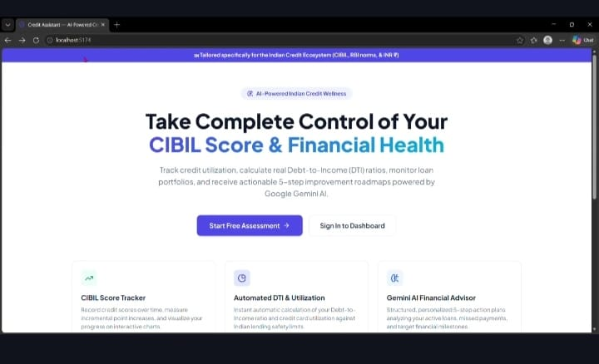

9.2 User Authentication and Financial Profile Management
- Registration and login with validated input.
- Password hashing using a modern password-hashing algorithm rather than plain-text storage.
- Session or token-based authentication with secure expiry and logout behaviour.
- Protected routes and server-side authorization checks.
- Profile creation and updates for relevant income, debt, and credit information.
- Ownership checks so users can access only their own records.

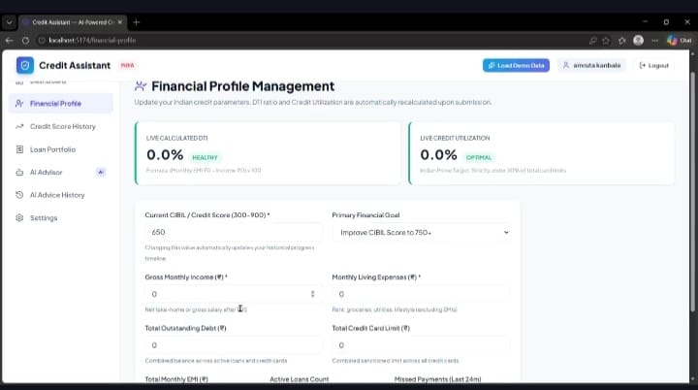

9.3 Credit Monitoring and Financial Analytics Engine
- Credit-score entry and historical score tracking.
- Credit utilization calculation: reported revolving balance divided by total available revolving credit limit, multiplied by 100.
- Debt-to-income calculation: monthly debt obligations divided by gross monthly income, multiplied by 100, where the required inputs are available.
- Loan and repayment tracking based on user-provided information.
- Missed-payment event tracking and financial health summaries.
- Score change calculation between recorded dates, without implying that a specific action guarantees a score increase.
Calculations must handle missing values, zero denominators, inconsistent dates, and invalid negative amounts. Metric definitions should be displayed in the interface so users understand exactly what is being measured.

9.4 AI-Powered Financial Advisor
- Summarize the user’s supplied financial indicators in plain language.
- Suggest general credit-health habits, such as paying bills on time and reviewing credit utilization.
- Explain debt-management concepts and encourage realistic budgeting.
- Help users define measurable financial goals and review progress.
- Identify patterns or missing information that may deserve attention.
- Provide clear uncertainty statements and encourage users to verify important decisions with official sources or qualified professionals.
The AI prompt should provide only the minimum context needed for the task. Avoid sending names, account numbers, full card details, passwords, or other unnecessary identifiers to the AI provider. The output should be treated as generated guidance, not as a verified financial fact.

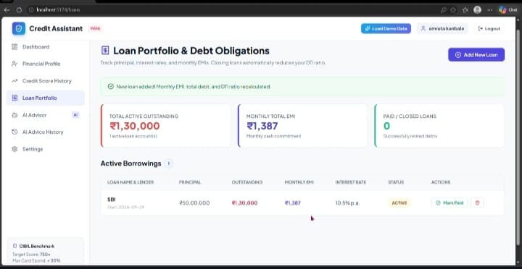

9.5 Dashboard, Data Visualization and Progress Tracking
- Credit score overview and recent change indicators.
- Credit utilization chart with a clear denominator and date.
- Line chart showing score history over recorded dates.
- Summary cards for debt-to-income ratio, declared loans, and repayment events.
- AI recommendation panel with date and relevant context.
- Progress indicators that compare user-entered metrics over time.

9.6 Database Management and Financial Data Processing
- Define relational tables and foreign-key relationships.
- Use transactions where multiple related records must be updated together.
- Validate data types, required fields, ranges, and date ordering.
- Provide controlled update and deletion operations.
- Keep a clear distinction between user-entered values, calculated metrics, and AI-generated suggestions.

9.7 Frontend-Backend Integration
- Create REST endpoints for authentication, profile management, score history, financial metrics, and recommendations.
- Use consistent response formats and appropriate HTTP status codes.
- Handle loading states, validation messages, network errors, and expired authentication.
- Configure development CORS rules narrowly and use HTTPS in deployed environments.
- Avoid placing private API keys or authorization logic in the React frontend.

9.8 Deployment and Application Verification
- Configure environment variables and initialize the database.
- Start the FastAPI backend and React development server.
- Verify API documentation and endpoint responses during development.
- Check that the frontend can read and update the user’s own records.
- Confirm that AI calls succeed safely and that failures do not break the rest of the dashboard.
- For deployment, configure secure hosting, logging, backups, and secret management.

10. Database Design
The following logical tables are suitable for an initial implementation. Fields can be refined during development.
Table | Example Fields | Purpose
users | id, email, password_hash, created_at, is_active | Stores account identity and authentication metadata.
financial_profiles | id, user_id, monthly_income, monthly_debt_obligations, updated_at | Stores financial profile inputs.
credit_profiles | id, user_id, current_score, available_credit_limit, revolving_balance, updated_at | Stores the latest credit-related snapshot.
score_history | id, user_id, score, recorded_at, source_note | Maintains historical score entries.
loans | id, user_id, loan_type, outstanding_balance, monthly_payment, status | Tracks loans declared by the user.
payment_events | id, user_id, event_date, event_type, notes | Records payment events supplied by the user.
financial_metrics | id, user_id, metric_name, metric_value, calculated_at | Stores selected calculated indicators.
recommendations | id, user_id, category, content, created_at, model_version | Stores AI-generated or curated guidance.

Use unique constraints for account identifiers, foreign keys for user-owned records, indexes for commonly queried fields, and migration tooling as the schema evolves. SQLite is appropriate for a small prototype; a larger multi-user deployment may benefit from PostgreSQL or another managed relational database.

11. System Workflow
- A new user registers and signs in.
- The user completes a financial profile and enters available credit information.
- The backend validates the data and saves it to the database.
- The analytics engine calculates supported indicators and records dated snapshots where appropriate.
- The dashboard retrieves the latest profile and historical records.
- Charts display score history and selected financial indicators.
- When requested, the advisor sends a minimal context to Gemini and receives a draft recommendation.
- The application displays the recommendation with an appropriate disclaimer and allows the user to review progress later.

12. Security, Privacy and Responsible AI
- Never store passwords in plain text; use a recognized password-hashing library.
- Use secure, expiring sessions or tokens and enforce authorization on every private endpoint.
- Keep API keys on the backend and outside version control.
- Collect only the data required for the application’s stated purpose.
- Use HTTPS in production and apply secure cookie settings when cookie-based sessions are used.
- Limit logs so they do not expose passwords, tokens, account identifiers, or unnecessary financial details.
- Define retention and deletion policies and explain them clearly to users.
- Treat AI output as potentially incomplete or incorrect; validate structure and avoid presenting generated content as guaranteed advice.
- Do not promise a particular CIBIL score increase or make lending, eligibility, or investment decisions solely from AI output.
- Test for prompt injection, inappropriate disclosure, malformed responses, service outages, and rate-limit failures.
This project is intended for education and financial awareness. It is not a substitute for official CIBIL or other credit-bureau records, lender terms, tax or legal advice, or individualized advice from a qualified professional.

13. Testing and Validation
Test Area | Example Test | Expected Result
Registration | Submit valid and invalid account details. | Valid input creates an account; invalid input returns a clear error.
Authentication | Attempt login with correct and incorrect credentials. | Correct credentials authenticate; incorrect credentials are rejected.
Authorization | Try to access another user’s profile. | The server denies unauthorized access.
Financial calculations | Check utilization and debt-to-income with known values. | Results match the documented formulas and handle zero or missing inputs safely.
Score history | Add multiple dated score records. | Records are saved and returned in chronological order.
AI advisor | Request guidance with valid context and simulate provider failure. | Valid output is shown with caveats; failures are handled gracefully.
Dashboard | Load charts with empty and populated histories. | Charts display accurately without crashing on empty data.
Database integrity | Update or delete related records. | Relationships remain consistent and invalid operations are rejected.
API integration | Call endpoints with valid and invalid payloads. | Responses use expected data structures and status codes.
End-to-end | Register, add profile data, view dashboard, request guidance. | The complete workflow functions as expected.

Testing should include unit tests for calculation functions, API tests for endpoint behaviour, integration tests for database operations, and end-to-end tests for the user journey. Record actual test results during implementation rather than claiming tests have passed before they are run.

14. Deployment and Execution

Backend Setup
- Create a Python virtual environment.
- Install the backend dependencies from a maintained requirements file.
- Create a local .env file containing the database URL and Gemini API key; exclude it from version control.
- Initialize database tables or apply migrations.
- Start the FastAPI application using an ASGI server such as Uvicorn.
Example development command: uvicorn main:app --reload

Frontend Setup
- Install Node.js and the package manager supported by the project.
- Install frontend dependencies.
- Configure the frontend API base URL for the backend service.
- Start the React development server and open the local application URL.
Example development command: npm run dev
These commands are examples and may need adjustment to match the actual file names, scripts, and project structure. For production, disable development reloaders, configure allowed origins, use managed secrets, and enable HTTPS.

15. Expected Outcomes
- A working full-stack prototype for credit-health monitoring and financial awareness.
- A secure account and financial profile workflow.
- A database-backed record of credit-score history and selected financial metrics.
- Interactive charts that help users interpret trends.
- AI-generated explanations and practical, personalized educational suggestions.
- Improved understanding of REST APIs, ORM-based persistence, frontend-backend integration, prompt engineering, and testing.
- A modular foundation that can be extended with additional analytics and authorized data integrations.

16. Limitations
- The quality of analysis depends on the accuracy and completeness of user-entered data.
- A score entered manually is not independently verified by a credit bureau.
- Credit scoring models and lender policies may differ; the application cannot guarantee a specific score outcome.
- Gemini-generated content may be incomplete or inaccurate and requires cautious presentation.
- SQLite is best suited to lightweight use and may not meet the needs of a high-concurrency production system.
- The prototype does not automatically connect to bank or bureau systems unless separately integrated with appropriate authorization.

17. Future Enhancements
- Migrate to PostgreSQL and introduce schema migrations for a larger deployment.
- Add multi-factor authentication, password recovery, and stronger session controls.
- Provide optional notifications for user-defined payment reminders and financial goals.
- Add exportable monthly summaries and downloadable reports.
- Introduce explainable rules alongside AI recommendations so users can see the reason behind each suggestion.
- Integrate with authorized financial data providers only after reviewing consent, security, contractual, and regulatory requirements.
- Add accessibility improvements, multilingual support, and mobile-responsive dashboard layouts.
- Create automated monitoring for latency, failures, cost, and AI response quality.
- Use anonymized, consented test data to evaluate recommendation quality and reduce unsafe or misleading outputs.

18. Conclusion
AI-Powered Financial Health Advisor (Credit Assistant) brings together credit-related data tracking, financial calculations, interactive visualization, and generative AI in a single full-stack application. FastAPI supports structured backend services, React.js provides the user interface, SQLAlchemy and SQLite support persistence, Recharts makes financial trends easier to interpret, and Gemini AI provides contextual educational explanations.
By combining these components with careful validation, privacy controls, and transparent limitations, the project can help users build awareness of credit health and make more informed financial plans. Its value depends on responsible implementation: protecting sensitive information, clearly defining calculations, verifying important facts, and never treating AI-generated suggestions as guaranteed financial outcomes.

19. References
- FastAPI Documentation. https://fastapi.tiangolo.com/
- React Documentation. https://react.dev/
- SQLAlchemy Documentation. https://docs.sqlalchemy.org
- SQLite Documentation. https://www.sqlite.org/docs.html
- Recharts Documentation. https://recharts.org/
- Google AI for Developers – Gemini API Documentation. https://ai.google.dev/gemini-api/docs
- Pydantic Documentation. https://docs.pydantic.dev/
- Python-dotenv Documentation. https://saurabh-kumar.com/python-dotenv/

