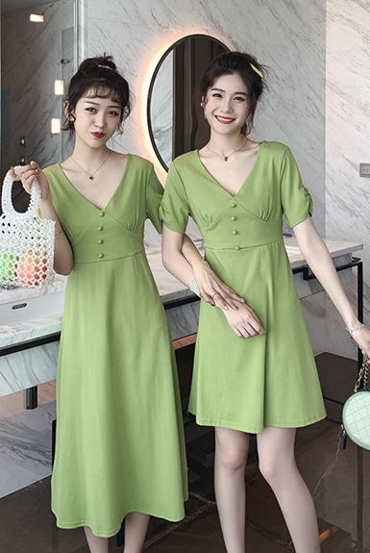Mã sản phẩm: Vay-nu-xanh

Name: Blue Women Dress

Brand: Hermes

Price: 350$

Category: Áo nữ

Color: Blue

Size: XS

Description:

In the dark night

Single mate alone

The thought that I have suppressed has ignited the love given to you