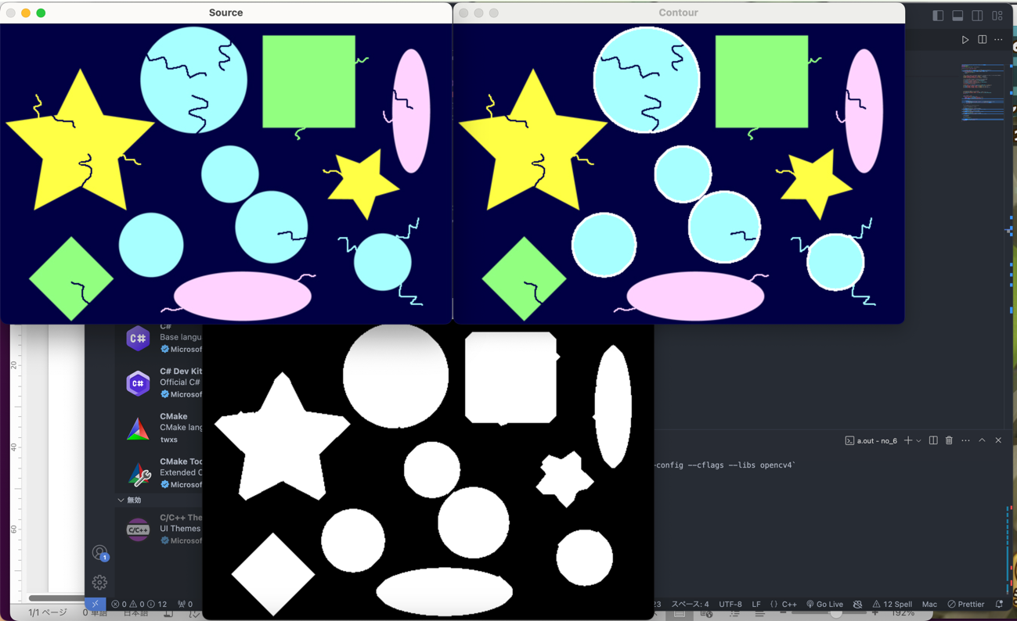

2回膨張12回収縮9回膨張

円形度閾値85％

1 length:457.688380 Area:14920.500000 enn:89.506272

2 length:239.622364 Area:4097.000000 enn:89.664624

3 length:307.563489 Area:6706.000000 enn:89.084850

4 length:271.178713 Area:5253.500000 enn:89.773345

5 length:241.036578 Area:4119.500000 enn:89.102208