AAPL Stock Market Analysis
Insight Summary Report — Week 6 Internship Project
Nanahawah | AnalystLab Africa, Batch B (June-August 2026)

1. Dataset Overview
This analysis uses 5 years of daily historical stock data for Apple Inc. (AAPL), pulled directly via the yfinance Python library into Google Colab, covering July 12, 2021 to July 10, 2026.
Metric | Value
Total trading days | 1,255
Date range | July 12, 2021 - July 10, 2026
Starting closing price | $140.85
Ending closing price | $315.32
Average daily volume | ~65.1 million shares
Missing values / duplicates | 0 (dataset was clean at source)

2. Data Transformation Techniques Applied
- Cleaned and validated the dataset: checked for missing values, duplicate dates, non-positive prices, and logical inconsistencies (High always >= Open/Low/Close) — none found.
- Sorted data chronologically and set Date as the index to enable time-series operations.
- Created calculated columns: Daily Price Change, Daily % Change, and Daily Trading Range (High - Low).
- Extracted Year, Month, and Year-Month fields to support grouping and aggregation.
- Aggregated data by year and by month to summarize average price, volume, and volatility trends.

3. Trends Identified
AAPL's closing price grew substantially across the 5-year window, more than doubling from its starting value.
Metric | Value
Total return (5 years) | +123.87%
$1 invested at the start would now be worth | $2.24
Average closing price, 2021 | $149.55
Average closing price, 2026 (YTD) | $275.03
Best month | July 2022 (+18.86%)
Worst month | December 2022 (-12.23%)
Share of positive months | 55.7%
Highest single-day volume | ~318.7M shares (Sep 20, 2024)
The 30-day moving average consistently confirms a long-term uptrend, while the 7-day moving average captures more frequent short-term reversals. Average daily volatility (measured by daily trading range) also grew over time — from $2.89 in 2021 to $6.15 in 2026 — showing that price swings became larger in dollar terms as the stock price itself grew. Rolling 30-day volatility of daily returns shows a notable exception: rather than a brief spike, volatility stayed unusually elevated (around 4.0-4.5%) for an extended stretch in mid-2025, pointing to a sustained period of market uncertainty rather than a single shock event.

4. Features Created
- Daily Price Change and Daily % Change — day-to-day momentum indicators.
- Daily Trading Range — a simple proxy for intraday volatility.
- 7-Day and 30-Day Moving Averages — short- and medium-term trend smoothing.
- Monthly Returns — percentage change in closing price from month-end to month-end.
- 30-Day Rolling Volatility — standard deviation of daily returns, a standard risk measure.
- Cumulative Return — tracks the growth of a hypothetical $1 investment over the full period.

5. Key Visualizations
Closing Price Trend — shows the overall upward trajectory of AAPL over 5 years.
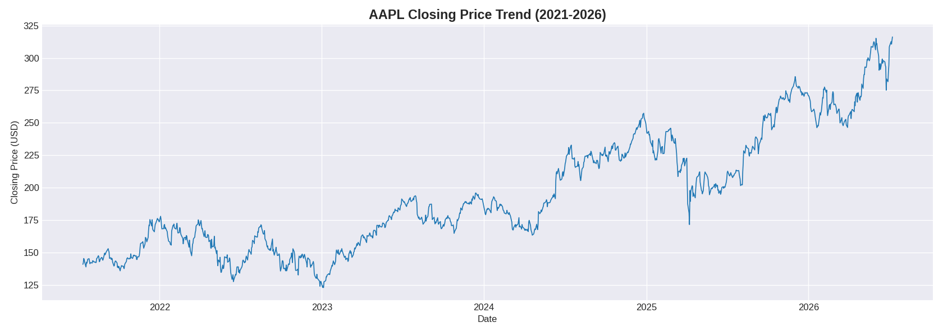
Trading Volume Trend — highlights periods of unusually high trading activity, most notably a spike around September 2024.
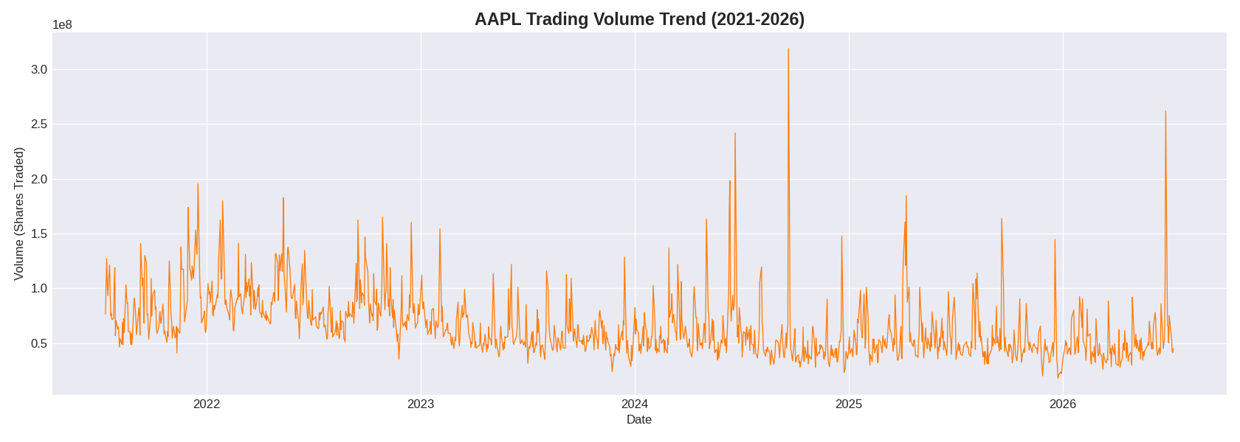
Moving Average Analysis — compares the daily close against 7-day and 30-day moving averages.
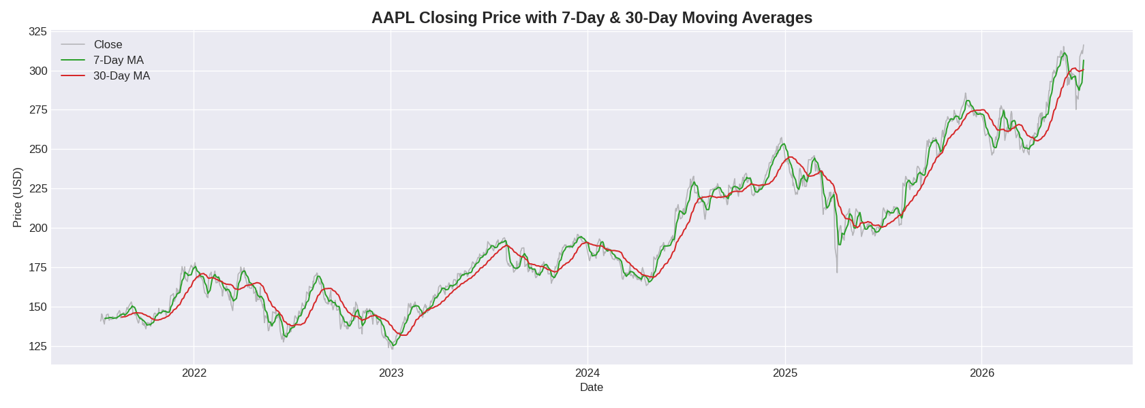
Monthly Returns Analysis — visualizes month-by-month performance, with green bars for gains and red for losses.
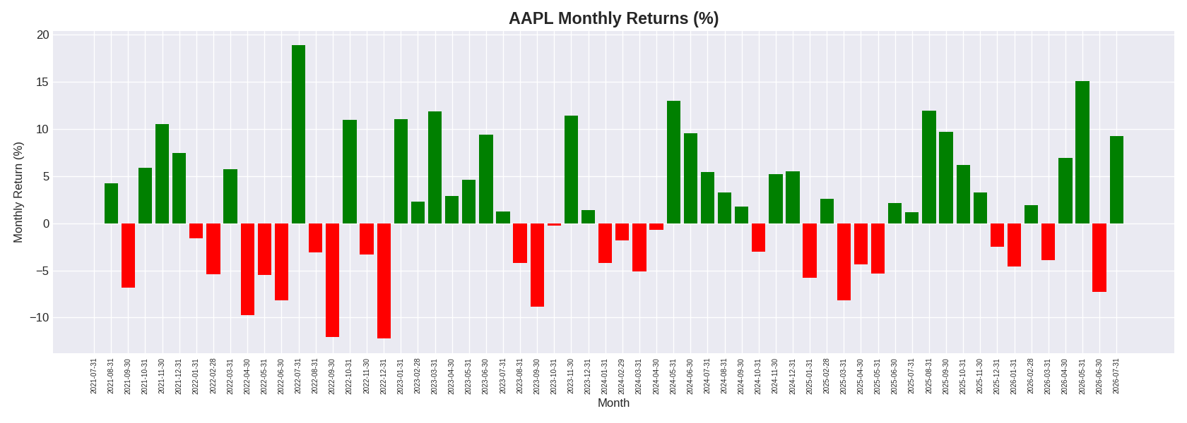
30-Day Rolling Volatility (bonus chart) — reveals the extended high-volatility plateau around mid-2025.
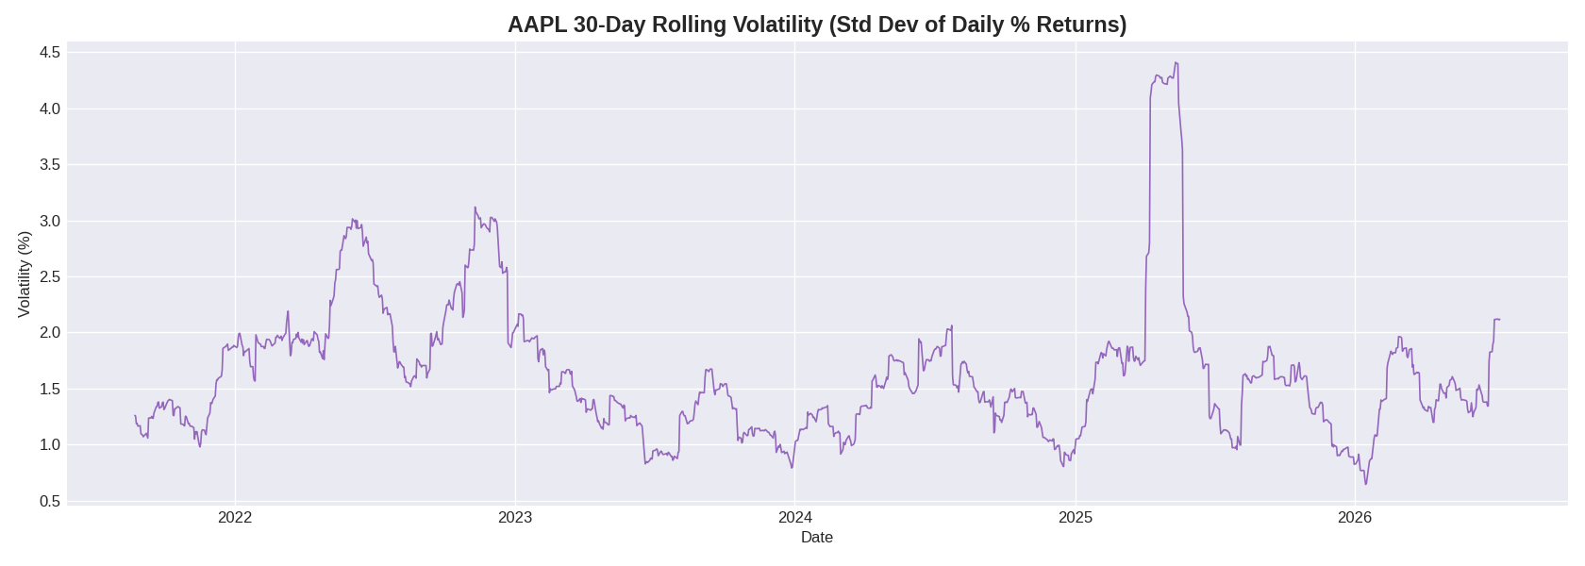

6. Key Insights
- AAPL delivered strong long-term growth (+123.87%) despite short-term volatility, reflecting sustained investor confidence over the 5-year period.
- The stock's performance was not linear — nearly 45% of months were negative — underscoring the importance of a long holding horizon for investors.
- Volume spikes are a useful early signal of significant company events; the largest spike (~318.7M shares) likely corresponds to an earnings release or major news event.
- The mid-2025 volatility plateau stands out as an unusual pattern — sustained elevated volatility rather than a brief shock — worth further investigation against company or macroeconomic news from that period.
- Moving average crossovers (7-day vs 30-day) provide a simple, visual way to identify potential trend shifts.

7. Recommendations
- Long-term investors were well rewarded for holding through short-term dips; short-term traders should pay close attention to volatility spikes for risk management.
- Use the 7-day/30-day moving average crossover as a simple supplementary signal alongside fundamental research, not as a standalone strategy.
- Extend this analysis by benchmarking AAPL against a broader index (e.g., S&P 500) to assess relative performance and correlation.
- Investigate the mid-2025 sustained volatility period against news/earnings timelines to understand its cause.
- Incorporate earnings-date annotations into future versions of the volume and volatility charts to directly link spikes to specific events.

