1. Feasible set is shown in the picture below. (The x-axis represents $x_{1}$, and the y-axis represents $x_{2}$.)

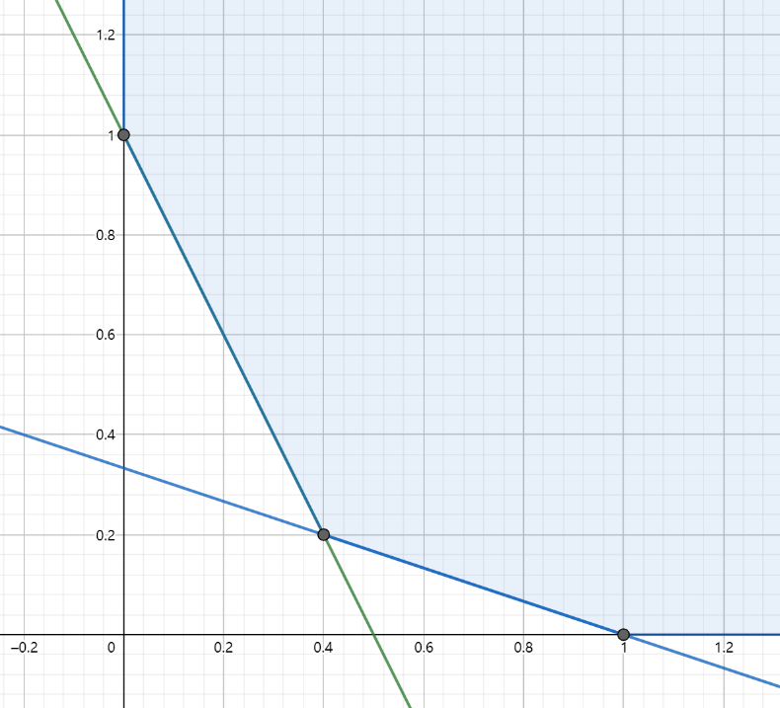

1. From the picture below we know that the optimal point is the intersection of lines $2x_{1}+x_{2}≥1$ and $x_{1}+3x_{2}≥1$, which is $(0.4, 0.2)$.

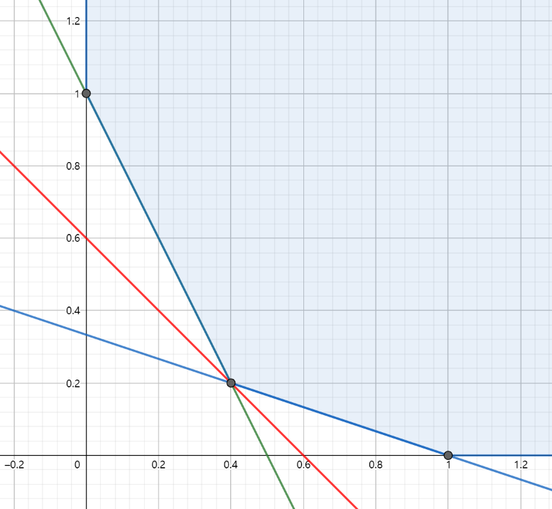

The output of the program using CVXPY is shown in the screenshot below.

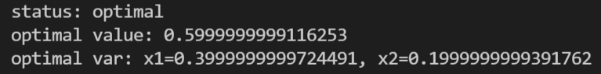

1. The line $x_{1}+x_{2}=a$ can go up infinitively, so the optimal point does not exist.

The output of the program using CVXPY is shown in the screenshot below.

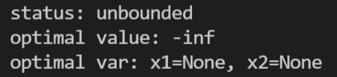

1. From the picture below we know that the optimal points are on the y-axis, so $x^{*}∈\{(0,x_{2})∣x_{2}≥1\}$.

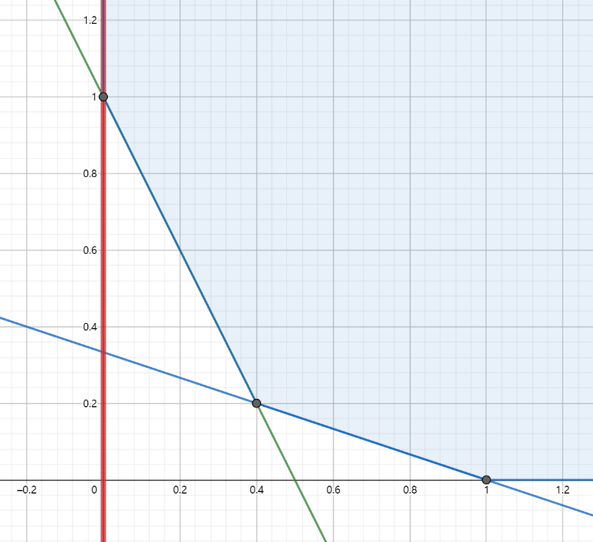

The output of the program using CVXPY is shown in the screenshot below.

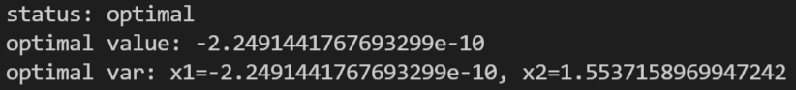

1. The output of the program using CVXPY is shown in the screenshot below.

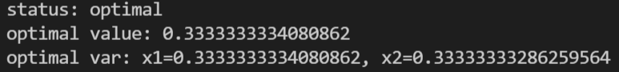

1. The output of the program using CVXPY is shown in the screenshot below.

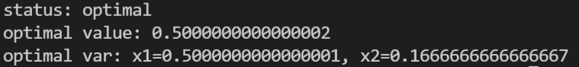

2. ${\left\|x\right\|}_{∞}≤1$ is equivalent to $-1≤x≤1$. We introduce new variables $t∈R^{m}$. Then the problem (1) is equivalent to
$$\min{1^{T}t}$$

$$s.t. -t≤Ax-b≤t$$

$$-1≤x≤1$$

3. The output of the program using CVXPY is shown in the screenshot below.

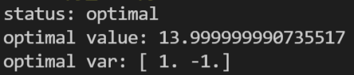

1. The output of the program using CVXPY is shown in the screenshot below.

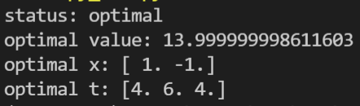

2. The normal equation is $X^{T}Xw=X^{T}y$. $w^{*}={\left(X^{T}X\right)}^{-1}X^{T}y={\left(1.5, 2\right)}^{T}$.
3. When $t=1$, the output is

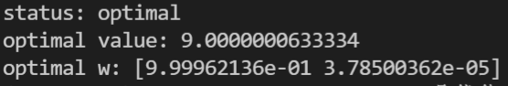

The solution is different from that of (a), and it has one zero component.

When $t=10$, the output is

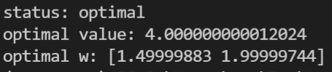

The solution is the same as that of (a), and it has no zero components.

1. When $t=1$, the output is

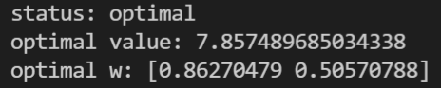

The solution is different from that of (a), and it has no zero components.

When $t=100$, the output is

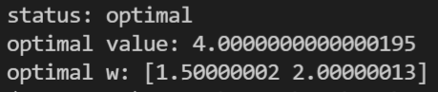

The solution is the same as that of (a), and it has no zero components.