2. $f(x)$ is convex, $∇^{2}f\left(x\right)=Q$, $λ\left(Q\right)=\{γ,1\}$, $L≥λ_{max}(Q)$, so $L_{min}=\max{\{γ,1\}}$.
3. $m≤λ_{min}(Q)$, so $m_{max}=\min{\{γ,1\}}$.
4. The result is shown in the table below.

|  |  |
| --- | --- |
| Step Size | Number of Iterations |
| 2.2 | Do not converge |
| 1 | 88 |
| 0.1 | 917 |
| 0.01 | 9206 |

1. The result is shown in the table below.

|  |  |
| --- | --- |
| $$γ$$ | Number of Iterations |
| 1 | 1 |
| 0.1 | 88 |
| 0.01 | 688 |
| 0.001 | 4603 |

The number of iterations increases as $γ$ decreases.

1. The output is my implementation is

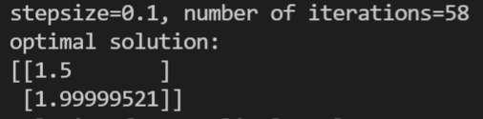

The solution I have found in HW5 is ${\left(1.5,2\right)}^{T}$.

The output of np.linalg.solve is

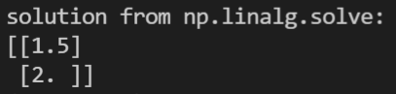

Ignoring the numeric error, they agree with each other.

1. The output of the program is

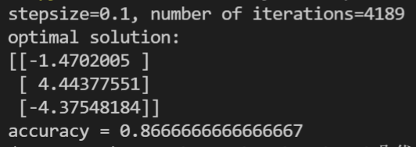

1. $f(x)$ is differentiable and $α$-strongly convex, so

$$f\left(y\right)-f\left(x\right)-∇f{\left(x\right)}^{T}\left(y-x\right)≥\frac{α}{2}{\left\|x-y\right\|}^{2}$$

$g(x)$ is $β$-smooth, so

$$g\left(y\right)-g\left(x\right)-∇g{\left(x\right)}^{T}\left(y-x\right)≤\frac{β}{2}{\left\|x-y\right\|}^{2}$$

Therefore,

$$h\left(y\right)-h\left(x\right)-∇h{\left(x\right)}^{T}\left(y-x\right)≥\frac{α-β}{2}{\left\|x-y\right\|}^{2}≥0$$

which shows that $h(x)$ is convex.