**[RTAPPLES.COM](http://RTAPPLES.COM)**

Apple teams up with Corporate companies to give back to the community

# **Table of Contents/Outline**

# 

# **I. Executive Summary**

# **a.** Giving back to the Community

# **b.** Going Green

# **II. Apple’s Current Analysis/S.W.O.T.**

# **a.** How

# **III. Implementation**

# **a. Overall Summary/Pitch for Program**

# **i.** Extensive detail on program

# **ii.** Day in the Life with flow chart

# **iii.** Why this program will benefit Apple overall

# **b.** Contracts

# **c.** Price structure

# 

# **IV. Teachers Love Apples Analysis/After S.W.O.T.**

# **a.** Strengths

# **i.** Increase of Sales

# **ii.** corporate tax write-offs

# **iii.** Brand awareness

# 

# **b.** Weaknesses

# **i.** Discounted prices

# **ii.** Cut in profit

**iii.** Schools currently have computer labs

**c.** Opportunities

# **i.** Increasing brand awareness in corporate America and school systems

# **d.** Threats

# **i.** Competitive Prices

# **ii.** Competing companies may be able to offer cheaper products and offer a higher discount

# **V. Risk Mitigation**

# **a.** Competing loyalty programs (i.e. – Dell)

# **b.** Contract length

# **c.** Maintenance/IT support

# **VI. Final Summary/closing remarks**

# **VII. Bibliography**

# 

# **Executive Summary**

Who loves Apple products more than American consumers? No one, but there is a certain group of Americans that do not always get what they deserve, teachers. Like most people, teachers love apples so why not give them the apples they deserve? With the Teachers Love Apples program we will make sure to allow teachers and their students to receive only the best computers available for use in the classroom and computer labs. The Teachers Love Apples program is a loyalty program for our customers who buy in bulk. They purchase our Apple computers in bulk for their employees, at a discounted price, and after 3-5 years they send their used computers to one of our local warehouses and repurchase current models again at a discounted price. The computers sent back to us will be refurbished and donated to a school of the corporate company’s choice. Not only will this program benefit America’s teachers by giving them the necessary tools they need to teach science and technology in their classrooms, but this will also benefit the American corporate companies by allowing companies to give their employees the most updated and efficient computers to work on. As we dive deeper into this proposal we will discuss more of the benefits of the Teachers Love Apples program for not only Apple Computers but for the overall good of America.

# **Apple’s Current SWOT Analysis**

Before we explore more into our proposed program, being Teachers Love Apples, we need to address where Apple currently stands such as what their strengths, weaknesses, opportunities, and threats are. Below we have done a thorough SWOT analysis of Apple before the influence of our proposed program.

# Strengths

* **Customer loyalty combined with an expanding closed ecosystem:** Customer loyalty is one of the most important competitive advantage a company can have over its competitors. Apple’s loyal customers are willing to buy anything and everything that Apple puts out into the market because the customers know they are getting the best and reliable products when purchasing from Apple. In the beginning Apple's closed ecosystem was a weakness but over time it became a strength. Apple was able to produce a full range of software, mobile applications, and products that are, or could be, interlinked with each other.
* **Apple is a leading innovator in mobile device technology:** Apple took a leap in innovation of mobile technology when they introduced the iPhone, and they have maintained this lead ever since. A company’s core competency of producing innovative products is the strength the company builds upon, with which it is able to bring the most innovative products to the market. Apple is so well known for being highly innovative that they have been chosen as the most innovative business in the world 3 times thus far. Being innovative is a key concept, or core component, in Apple’s business with an emphasis on mobile technology.
* **Strong financial performance:** Apple's financial performance is proven to be one of the best in the world. By the end of the year 2012 they had 10 billion dollars in cash which has the capability to be used for buying back company shares, or allowing them to acquire other companies, as well as many other things in order to benefit the company.
* **Brand reputation:** Apple has a reputation for highly innovative, well designed, well-functioning products and sound business performance. Apple brand is valued at $76.5 billion and was the second most valuable brand in the world in 2012. Making Apple a very wanted product for all consumers.

# Weaknesses

* **High price:** Unfortunately, since Apple focuses on innovation so much to produce top quality products, their prices tend to be higher than their competitors**.** Looking at how much it cost to produce a unit of their products,some critics argue that the price is not justified. When there’s such a fierce competition, Apple’s high prices become a weakness due to the fact that consumers can easily opt for similar quality but lower priced products.
* **Patent infringements:** Apple is often accused for infringing on other companies' patents. Some of these trials Apple has lost which in turn tarnishes their brand name.
* **Increase of component prices:** Apple is in a high tech industry where component prices are high to begin with. Analysts for Apple fear and predict, that component prices for their products are going to increase in the future. If this occurs, then Apple’s current high margins will not be sustained.

# Opportunities

* **Tablet and smartphones markets are growing:** Since there is growth in these markets, it gives Apple a good opportunity to expand the firm's share in these markets.
* **The iTV:** The launch of the iTV will open up a new market segment for Apple to try and generate more revenue. The launch of the iTV will also strengthen the closed ecosystem that Apple has.
* **Acquisitions:** Apple has been doing so well that they have generated enough revenue and profit, giving them the ability to take over companies. Acquiring other companies can prove to be beneficial in many different ways from increasing manufacturing size, lowering cost on materials, and/or acquiring patents that can be of use to them.
* **Strong growth of mobile advertising market:** Apple has developed the iAd advertising platform, which allows advertising on Apple iPhone, iPad and iPod touch. The growth of mobile advertising market is an opportunity which could be further seized upon.
* **Increase demand in cloud based services:** A relatively new advancement is cloud based services. Apple could expand its range of iCloud services and software as the demand for cloud-based services is expanding.

# Threats

* **Rapid technological change.** One of the most severe threats Apple and the other tech companies are facing is rapid technological change. Companies are under the pressure to release new products faster and faster. The one that cannot keep up with the competition soon fails. This is especially hard when a business wants to introduce something new, innovative and successful. Apple was able to bring highly innovative products to the market so far but for the moment, even Apple has yet to unveil any plans for the new products (except iTV) and may lack new introductions to keep up with competition. The Teachers Love Apples program will be a great way to increase consumer awareness on Apple and what the company is able to do for the communities affected.
* **Tax increases:** Tax increases in USA in 2013 has negatively affected Apple, and increases in taxes in the future could do the same again. This program is geared towards thinking ahead. Since corporate partners will be donating their old computers prior to purchasing new ones, they will be entitled to a large tax writeoff.
* **Android OS growth:** Android OS is the main competitor against Apple in the mobile device market, and unfortunately for Apple the demand for Android OS has been increasing. Since demand of Android OS is increasing, the demand for iOS has been decreasing and ultimately their market share will be decreasing. With a forecast for market shares to decrease, the Teachers Love Apples program is a way to once again increase the cost per share.
* **Rising pay levels/Affected brand name:** Foxconn is a company that is a main manufacturer for Apple products. Now, Foxconn has raised the pay rate of their workers 3 times from 2010 to 2012 which will in turn will cause Foxconn to charge Apple a higher price for producing the products to cover the expenses. This, in effect will cause Apple to raise their prices in order to cover those differences that arose from the pay increases. The worker riots at Foxconn created a negative effect on the brand name of not only Foxconn, but as well as Apple. Should the cost to Apple for parts increase, the Teachers Love Apples program will still benefit corporate partners by offering the generous discount towards the computers.

# **Implementation**

Teacher and companies register with rtapple.com with email and password, and after, account would be created. Reapple maintain a database of all clients where we can share information. To help improve Apple’s reputation which was affected by Foxconn’s low wages, poor working environments, and workers riots, Apple would introduce the Teachers Love Apples program which would give back to the community. The implementation of this program allows Apple to prove that they are for the good of the people and that they are trying to make a difference in the world for the better.

The Teachers Love Apples program starts with a corporate company looking to purchase Apple computers for their employees. The core target group to market this program towards would be tech companies, financial companies, and advertising agencies. Apple computers are high quality computers that would satisfy the needs of employees in those industries. When a company is looking to purchase computers in bulk, they would contact our sales department and obtain a quote based on the numbers of computers they plan to purchase. As displayed in the table below, discounts are determined by the amount of computers purchased.

|  |  |
| --- | --- |
| Number of Computers | % Discount |
| 100-300 units | 25% |
| 301-600 units | 35% |
| 601+ units | 40% |

Once a company decides to place a bulk order and sign up for the Teachers Love Apples program, they will place the order and have their computers shipped from one of the many Apple suppliers around the world. Typically the shipping will take 2-3 days, if all the computers within the order are in stock. After a company receives their computers, their IT staff will be held responsible for the architecture of the units and the software installation, unless the company purchases the Enterprise Apple-Care. Three years after the purchase date, and up to only five years after, the company can order new models in bulk at the same discount and send their old models to one of Apple’s refurbishing facilities. Once the computers are refurbished, they are sent to a school of the company’s choosing where the computers can be used as either an individual classroom computer, or to fill up a computer lab. Should the company decide to keep the computers they purchased for more than five years, the computers can be shipped back to one of Apples facilities to be recycled, but they can no longer be donated.

The Board of Education of a school district must apply for computer donations through the Teachers Love Apples program website. The Board of Education will be responsible to submit a request form which will explain their need for the computers, their plans for the computers (computer lab or classroom computers), and information about the school district. Corporate companies will be able to see parts of these requests upon deciding on what schools to donate their computers to. Once a company chooses a recipient school and the computers are sent out to them, the company will be recognized for their donation through an Apple Keynote, an article, or a press release. A plaque will also be provided to the computer lab to mention the company which donated through the Teachers Love Apples program.

The overall goal of the Teachers Love Apples program is to incorporate Apple computers in schools, not only just in the United States, but schools all over the world after its proven success in the United States. By giving back to students and teachers, Apple’s reputation will change from a money hungry monstrosity, to a caring and giving innovative company.

**Day In Life Flow Chart**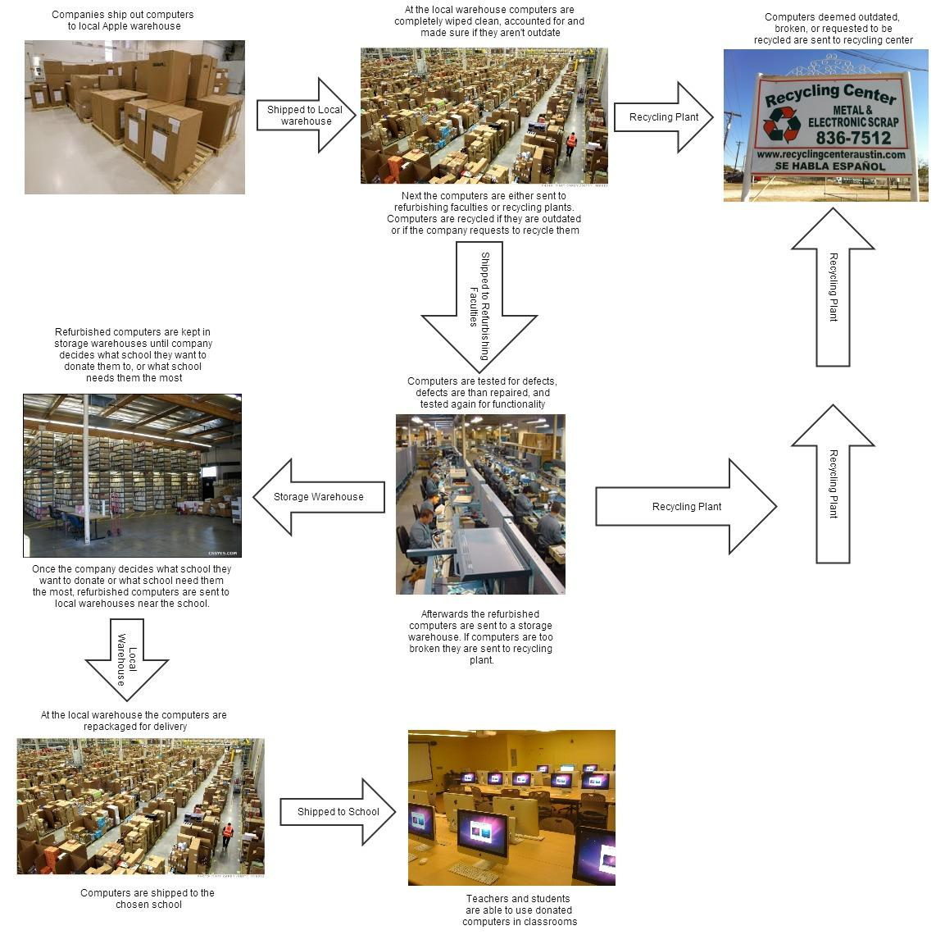

As mentioned above, after a donation cycle is complete, the donating company will be recognized through a keynote or an article, and a plaque will be presented to the school with name of the company who donated the computers through the Teachers Love Apples program. This will serve to give corporate partners publicity and contribute to their corporate social responsibility initiatives.

Corporate partners will also be able to receive a tax incentive from their donation. All purchases will qualify as charitable donations at the end of the contract. Purchases cannot be claimed as such prior to the end of the contract.

# **Teachers Love Apples SWOT Analysis**

# (Loyalty program for large corporate companies)

We have now addressed how the Teachers Love Apples program will be implemented and ways on how to mitigate any risk that comes along with it. We will now inquire into the SWOT analysis of our Teachers Love Apples program because it is very essential to do this analysis for a proposal. A SWOT analysis will help to discover, and analyze, the benefits versus the risks to see which one weighs more for Apple.

# Strengths

* **Increase of Sales every 3-5 years:** Corporate Companies will provide Apple with a massive amount of business over the course of a few years by purchasing 100+ computers every 3-5 years.
  + Teachers Love Apples works with their corporate partners offering a flex-time contract.
* **Minimum support/maintenance costs:** Apple products are known for being virus free and having little to no issues, which is very appealing to corporate companies that want to keep their computing issues minimal.
* **Tax write-off:** Corporate Companies will be able to use their donations as a tax write-off.
* **Reliable products:** According to Consumer Reports Apple still tops in reliability.
  + zdnet reports on the Consumer Reports cover story that looked on the best electronics, and in the ranking for customer satisfaction, Apple received a rating of 78% vs their competitors (Dell & Lenovo) both of whom tied at an overall rating of 59%.
  + Apple also received the highest tech support rating as well, with a 75% rating to fix user problems vs Dell only fixing 61% of their user problems.

# **Schools Have Computer Labs:** Most schools have already purchased cheaper computers for their student labs thus eliminating a need for new equipment.

# Opportunities

* **Introduce Apple computers in schools lead to kids interest in Apple:** Kids in the school systems where the computers are donated will be learning and getting exposed to Apple Computers at a young age which in turn will lead to them purchasing Apple products.

# Threats

* **Competitors’ prices:** PC’s can be bought at a much cheaper price than Apple computers.
* **Contract Length:** Some companies may view the contract length to be a problem either as too long or too short a time period.
* **Discount Amount not a high enough percent:** Even though Teachers Love Apples is offering a generous discount for their products, corporate companies may still try and barter for a higher percentage off each computer they are purchasing.

# **Risk Mitigation**

As with all new projects, ideas, or programs there are the possibilities of risk being involved. If there are risks, there should be a way of mitigating them or resolving them completely. We have identified what the risks are with our program Teachers Love Apples and we also have figured out a way, for each one, on how to mitigate those risks.

**1. Competing loyalty programs (ie: Dell)**

Price structures from competing manufacturers can take away loyal customers. (The 25% discount results in per unit price of $1250). Business interests usually support the cheaper option before considering/recognizing value and long term intangible benefits to employees (ie. increased uptime & higher quality of work). Teachers Love Apples would mitigate this risk by demonstrating the true value of an Apple vs. lower end product: better processor, graphics, etc. which would bring IT/ maintenance savings to the organization. In addition to IT savings, employees morale would be boosted by knowing they are being afforded a premium ‘cutting edge’ product which will be replaced every 3-5 years.

**2. Contract length**

If the required length of the contract is too short, large businesses will not have as much interest since they would have to change computers so often. This will add to overall IT costs and can affect employees who usually take some time to fully adopt a new product or technology. However, a contract length which is too long will not benefit the donee schools, who will not benefit from the “old” technology. Teachers loves Apples can mitigate this risk by providing a ‘flex’ contract which can offer different incentives based on the length of time they keep the computers.

**3. Maintenance/IT support**

Due to the discount afforded to the corporate partners, the Teachers Love Apples program will not be providing Apple-Care as a part of the purchase. This may be risky since support is usually included with such a large purchase. To mitigate this risk, Teachers Love Apples will offer an enterprise-wide version of Apple Care at a fixed cost. A Windows computer running Windows 7 will experience 57.6 hours of downtime on average compared to an iMac, which cuts down by about half that time. This means that Apple’s product will result in restoring 50% of a week’s productivity, translating to less IT spending.

# **Summary**

The Teachers Love Apple Program is overall designed to benefit both corporate contractors and the general public school system. This program will give opportunities to those that are less fortunate or unable to provide the necessary technology to our nation’s youth. Offering new technology to America’s youth today, will provide a brighter tomorrow for this country. We strongly believe that the Teachers Love Apple program will greatly improve the brand name for Apple while being able to generate more revenue for the company and it’s consistent loyal customers. As stated above, the strengths greatly outweigh the weaknesses of this program proving it to bring successful results upon implementation.

# **Bibliography:**

*Websites:*

Author Unknown. “Dell Official Site - The Power To Do More |

Dell” *Dell.* N.p., 1 Jan 2014. Web. 2 Mar. 2014.

< <http://www.dell.com>>

Author Unknown. “Dell Reviews, Ratings, and Pricing |

Computer Shopper” *Dell.* N.p., 9 Dec. 2013. Web. 01 Apr. 2014.

<<http://www.computershopper.com/brands/dell>>

Dess, Lumpkin, Eisner& McNamara, Strategic Management: Text and case, 6th edition, 2012

http://www.strategicmanagementinsight.com

Morgenstern, David. "Consumer Reports: Apple Still Tops in Reliability |

ZDNet." *ZDNet*. N.p., 22 Nov. 2012. Web. 01 Apr. 2014. <<http://www.zdnet.com/consumer-reports-apple-still-tops-in-reliability-7000007770/>>

*Books/Magazines/Articles:*

Fallows, James. "China makes, the world takes." *Atlantic Monthly* 300 (2007): 48-72.