Predicting MLB Pitcher Injury Risk

Nana Noda-Morgan
Data Science, Bellevue University
DSC 680-T302: Applied Data Science
Professor Iranitalab
April 11, 2026

Business Problem
When looking at the rankings of highest paid players in the National League (NL) for the past six years, five of the six are pitchers, with an average annual salary of $37M. Similarly, for the American League (AL) four of the six are pitchers, with an average annual salary of $42M. (Sports Reference, n.d.) Given these significant investments in pitching, pitcher injuries are among the most disruptive and costly events in baseball. Specifically, Ulnar Collateral Ligament (UCL) tears, which require Tommy John surgery, are the most common injury that is also difficult to predict. This project will aim to identify which workload, and biomechanical features correlate the most with a pitcher appearing on the Injured List (IL), with the goal of providing actionable early warning signals for team coaching and medical staff.
The key research questions addressed in this project are: Do pitchers with higher average pitch counts per game face greater injury risk? Is cumulative inning load within a season correlated with IL placement? Does high pitch velocity correlate with injury? Does a significant velocity drop later in the season indicate imminent IL placement? Does pitch mix diversity or heavy reliance on high-stress pitch types correlate with injury?

Background/History
Pitcher injury prediction is a growing area of research when it comes to baseball analytics. Since Statcast tracking technology was introduced in 2015, teams and researchers now have access to very granular pitch-level data that includes velocity, spin rate, movement profiles, and release points for every single pitch thrown in Major League Baseball from Spring Training to Post-Season. MLB as an organization has published a report in the past on pitcher injuries in 2024 between workload metrics and injury. There have also been other academic studies looking at predictors of UCL reconstruction using machine learning and have identified workload accumulation and biomechanical stress as contributing factors. But most of these existing models have either relied on biomechanical data from motion capture systems or a simple statistical approach. In this project, I hope to strike a balance by using publicly available Statcast data and applying modern machine learning techniques, ensuring that the process is reproducible for anyone.

Data Explanation: Sources
I initially set out to download CSV files from Baseball Savant of the Statcast data. However, I found limitations to the number of records I could download at a time, so I did some searching and found that I can obtain the same pitch-level data using the pybaseball Python library, which uses the Baseball Savant API. This dataset has one row per pitch thrown in all Major League Baseball games, and includes very detailed metrics such as release speed, spin rate, pitch type, and other game context. The data I am using is for the 2021 through 2025 seasons, which had approximately 3.1 million pitch records in total.
Similarly, the Injury List (IL) data was originally going to be scraped from a website, but I was able to find the MLB Stats API, which provided structured JSON data that included player data, transaction dates, team information, and injury descriptions. This was a major improvement in the reliability of data and allowed clean joins with the Statcast data on player identifiers. A total of 8,149 pitcher related IL transactions were captured for the 2022 through 2025 seasons.
Data Explanation: Preparation
To simplify the data, I decided to remove postseason, All-Star, and spring training records from the data, and filtered to only use regular season games. There were also some columns that were marked as deprecated which I removed, as well as standardizing date fields. Finally, I aggregated the pitch-level data into per-game summaries, which created one row per pitcher per game with corresponding metrics such as total pitches, average velocity, pitch mix percentages, and strike percentage. This aggregation helped condense that data into 87,000 pitcher-game appearances across the seasons.
For modeling, I created snapshots of 30 days pre-injury. For each IL placement event, the pitcher’s game-level data from the preceding 30 days was aggregated into a single feature vector that captured workload trends, velocity patterns, and mechanical details leading up to the injury. I also created a control group of healthy pitchers. I chose a random 30-day window from pitchers who remained healthy all season, as well as healthy windows from pitchers who eventually went on the IL but were sampled from periods well before their injury. The final modeling dataset had 3,730 records with 16 features.
Data Explanation: Feature Dictionary
The features used in the final model were: total pitches in the 30-day window, number of games pitched, average pitches per game, total batters faced, average fastball velocity, average velocity across all pitch types, maximum fastball velocity, velocity trend (change from first half to second half of window), average spin rate, average horizontal break, average vertical break, number of pitch types used, fastball usage percentage, strike percentage, average days between appearances, and finally, a binary starter/reliever indicator I derived from actual game-level pitching data.

Methods
The approach for this project followed a standard pipeline of data collection, feature engineering, exploratory data analysis, and predictive modeling. The data collection portion leveraged the pybaseball library as well as the MLB Stats API. Feature engineering focused heavily on the 30-day period before pitchers were placed on the IL. The starter/reliever classification was determined from actual game data by seeing which pitcher appeared in inning 1 of the game.
Exploratory data analysis focused on comparing the distribution between injured and healthy pitcher groups for various metrics. In addition, correlation analysis and independent t-tests were performed to check for statistical significance. For the modeling portion, three predictive models were trained and evaluated. Logistic Regression as the interpretable baseline, Random Forest with 15 original features, and then another round of Random Forest with the additional starter/reliever feature. All models used an 80/20 stratified train-test split with 5-fold stratified cross-validation to check for stability. The model evaluation mainly used AUC-ROC as the metric, as well as precision, recall, and confusion matrices.

Analysis
Exploratory analysis showed several statistically significant differences between the injured and healthy pitchers. Most notably, the velocity trend feature showed that injured pitchers recorded a mean velocity decline of -0.11mph in the 30 days prior to landing on the IL, while healthy players showed an increase of 0.02 mph (p<0.001). Injured pitchers also appeared in fewer games during the 30-day lookback window (5.9 compared to 6.9, p<0.001), and they also threw fewer strikes (45% vs 46%, p<0.001). Still notable but less significant differences include injured pitchers having a slightly lower average fastball velocity (93.1 mph vs 93.5 mph, p<0.01) and injured pitchers threw more pitches per appearance (44.7 vs 42.4, p<0.05) which show they were not as dominant during their outing.
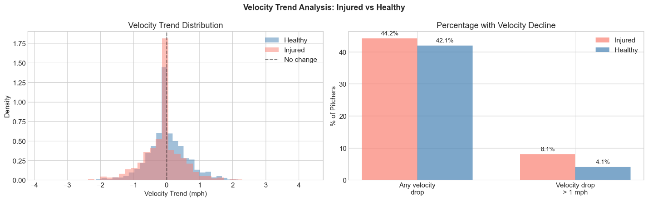
Figure 1: Velocity trend analysis comparing injured and healthy pitcher groups

The correlation heatmap confirmed that most features had weak correlations with injury status, with the number of games (-0.14) and velocity trends (-0.11) being some of the strongest. This is consistent with the understanding that injury prediction from workload data alone is very difficult as many factors outside the scope of the available data can be a driver.
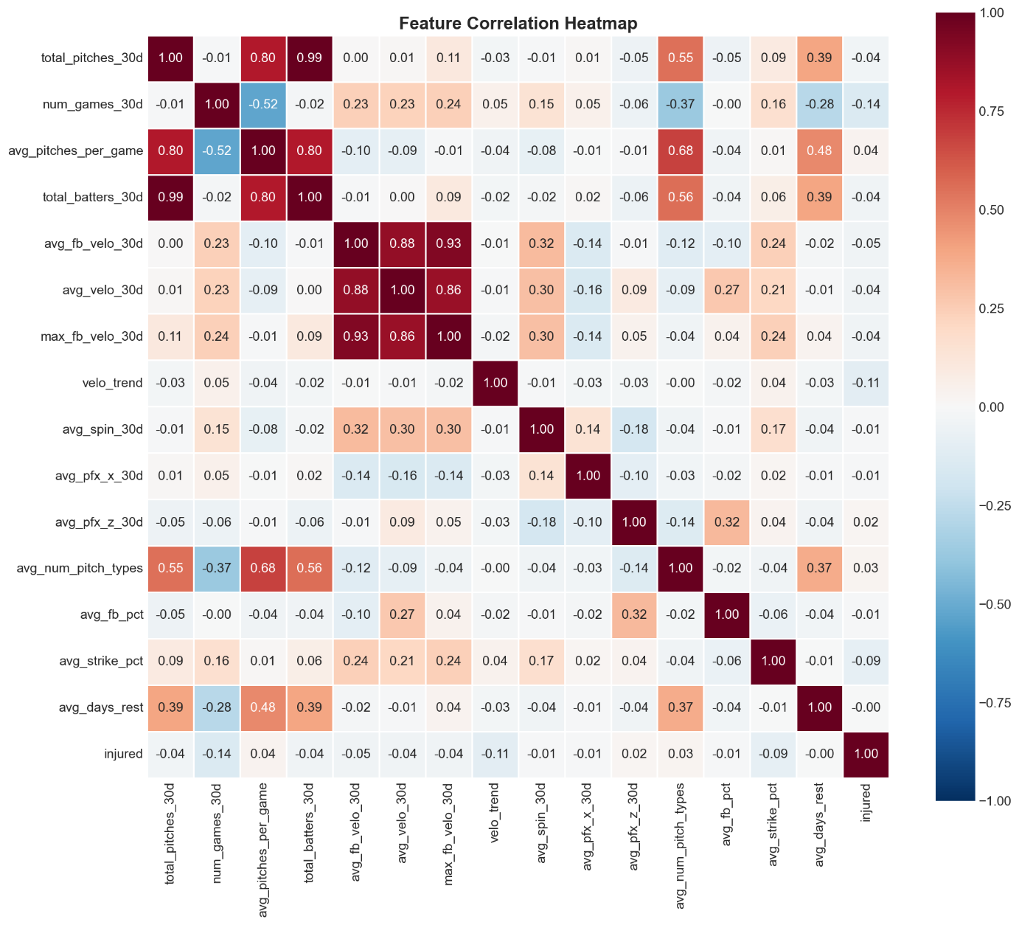
Figure 2: Correlation heatmap showing relationships between features and injury status

Model performance confirmed this difficulty. The Logistic Regression model achieved a test AUC of 0.6132, while Random Forest improved it to 0.6541 and a cross validated AUC of 0.6516, which indicated the possibility of non-linear feature interactions. And finally, the addition of the starter/reliever feature in the second Random Forest model showed further improvement with a test AUC of 0.6582 and a cross-validated AUC of 0.6578. The consistent outcome between test and cross-validation scores for all models suggests that it is stable and not likely to be overfitting.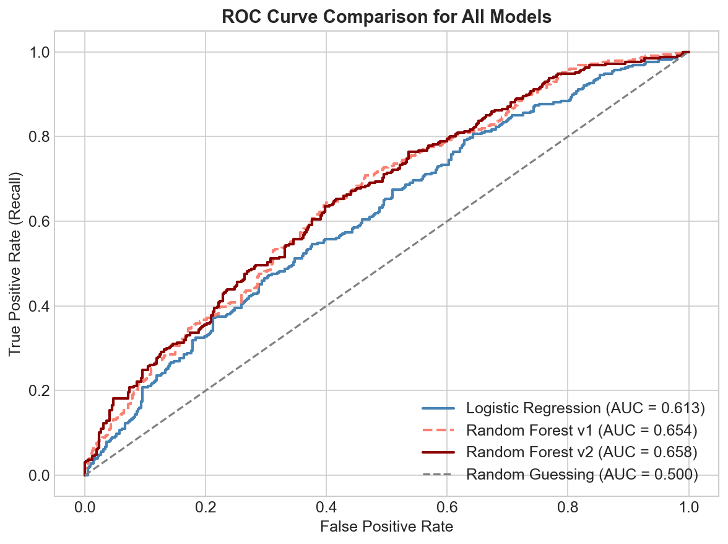
Figure 3: ROC curve comparison for all three models

Looking at the feature importance analysis from the second Random Forest model helped to identify the most important predictors. The model consistently ranked workload related features such as total pitches, games pitched, batters faced, and velocity metrics as the top contributors to prediction accuracy.
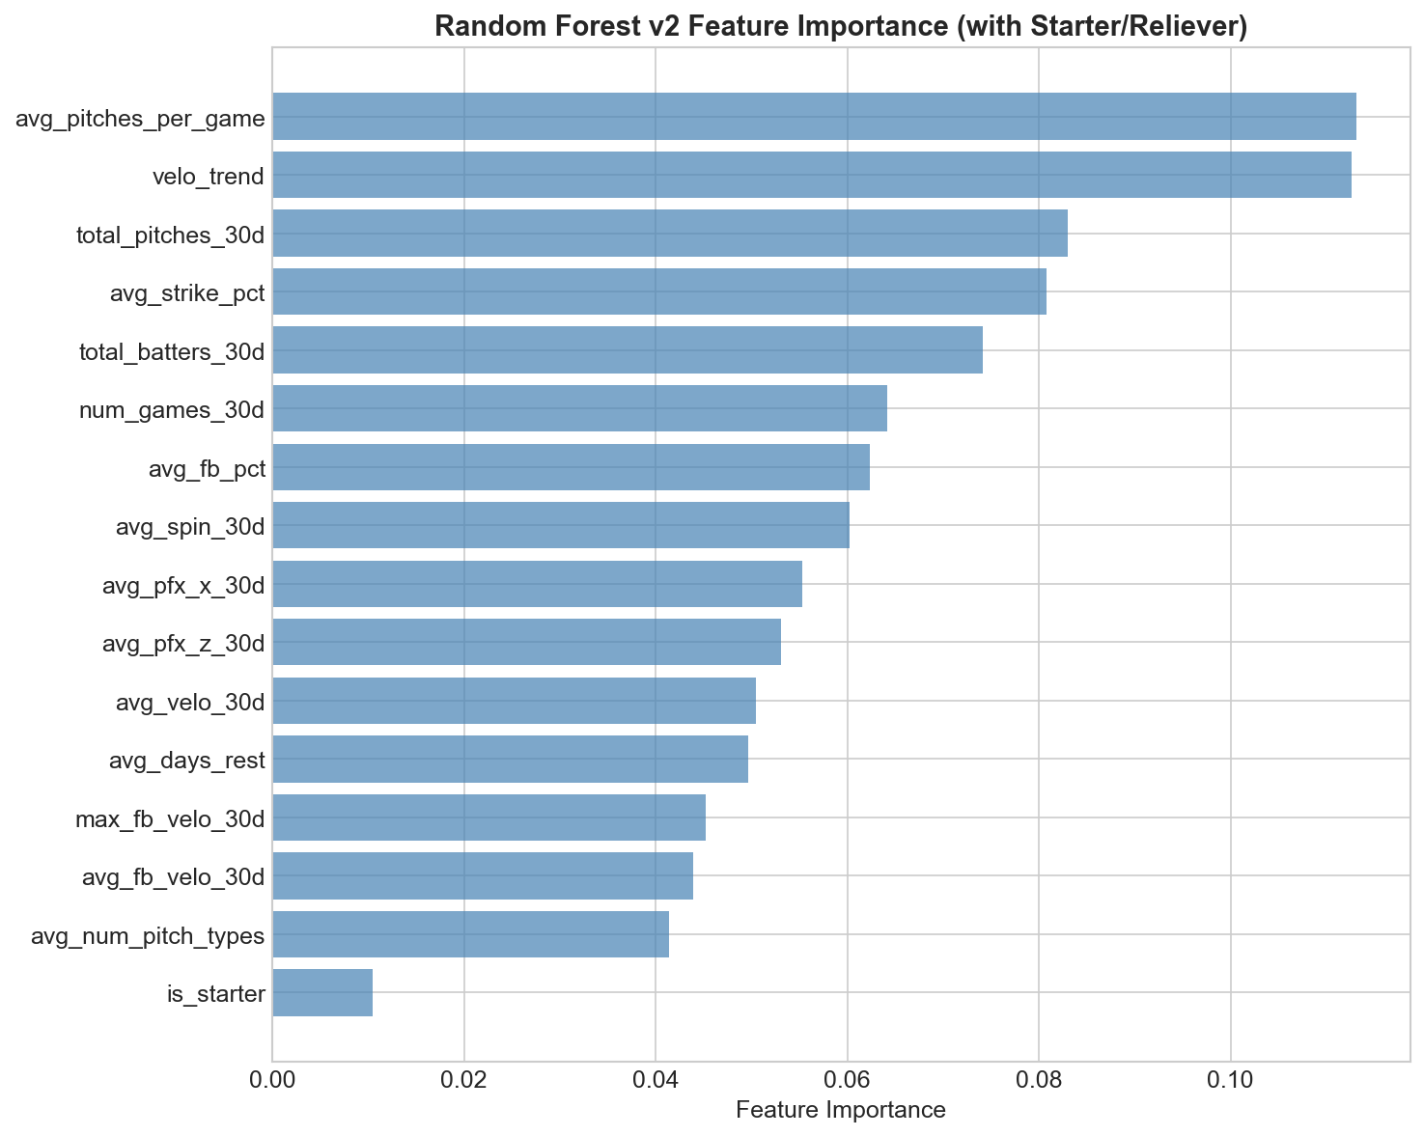
Figure 4: Second Random Forest feature importance ranking
Finally, analyzing the injury type revealed that arm-related injuries, such as elbow strain, shoulder impingement, and forearm tightness, were the most common in the data which is expected for pitchers. The most common injuries aligned with the types of biomechanical stress that would be expected from the repetitive throwing motions performed by a pitcher.
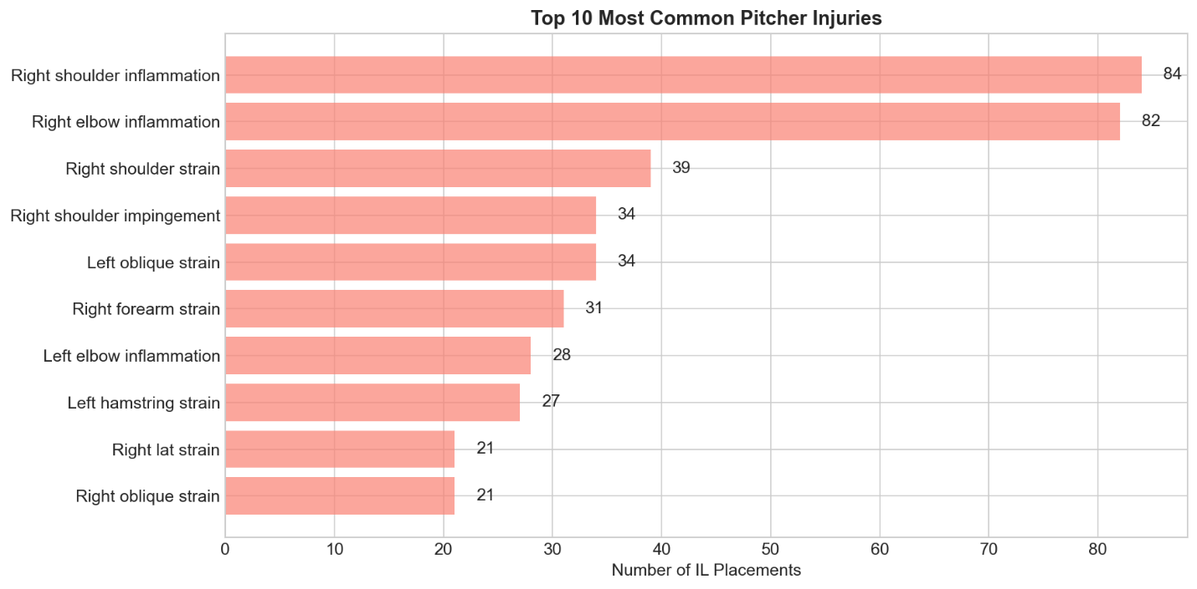
Figure 5:Top 10 most common pitcher injuries in the dataset

Conclusion
This project showed that, although moderate, publicly available Statcast pitching data contains measurable predictability of pitcher injury risk. The best performing model, which was the second Random Forest with the starter/reliever feature, achieved an AUC of 0.6582, which is an improvement from random guessing, albeit still far from a definitive predictor. The most actionable finding is with the velocity trend that showed pitchers whose fastball velocity declines over a 30-day period might have an elevated risk of landing on the IL. This is a simple metric that is observable during the season and could serve as one of the early warning indicators for the team of medical and coaching staff.

Assumptions
There were several assumptions made in this analysis. The first is that a 30-day window is enough to capture pre-injury workload patterns. Different lengths of this lookback period may yield different results. Second, the starter/reliever classification assumed that pitchers who start 50% or more of their games function primarily as starters. This does not happen frequently, but there are specific scenarios such as for Opening Day, or during a bullpen game, where managers might opt to use a reliever in the first inning. Third, the way the control group was created assumed that a random date selection within a healthy season gave a good baseline. And finally, it was assumed that IL placement meant injury occurrence. Some injuries may be dealt with without IL placement, and conversely, IL placement could be a strategic move by the club as well.

Limitations
The biggest limitation is that not all injury causing factors are captured in the Statcast data. Data on training (intensity, duration), medical history, sleep quality, nutrition, and off-season workload can all influence injury risk. The moderate AUC of 0.65 reflects this limitation. Also, 61% of IL placements were excluded from modeling because the pitcher didn’t have Statcast data in the 30-day window before placement. Finally, it is important to note that the 2020 season, which was shortened due to COVID, was excluded since the workload was significantly different.

Challenges
The first challenge came early in the data collection phase. The initial plan to scrape injury data had to be reevaluated when the JavaScipt-rendered page was unreliable for automated scraping. Downloading the Statcast data for multiple full seasons also proved to be a challenge due to the 25,000 row limit per query.

Future Use and Additional Applications
The methodology explored in this project could be extended to incorporate biomechanical data from high-speed cameras or wearable sensors to improve predictive accuracy. Alternatively, time-series modeling or Cox proportional hazards survival analysis could capture temporal patterns that the snapshot approach used in this project may have missed. This framework can also be applied to position player injuries, or even to other sports with similar tracking and data. Finally, the 30-day period could be optimized with further experimentation of varying lookback periods.

Recommendations
There are three main recommendations for MLB team operations. First, velocity trend monitoring should be integrated and routinely assessed for every pitcher. A decline in fastball velocity over a month-long window is the most actionable early sign identified in this analysis and easily observable throughout the season. Second, per-game workload should be monitored in addition to cumulative season totals. The data showed that high pitch counts per individual appearance may be a more significant risk factor compared to total season counts, especially for starting pitchers. Lastly, the model should be used as one component of a multi-factor risk assessment that includes medical evaluation and input from coaching staff. The model alone is not suitable as a decision-making tool, but it can be a valuable supplementary data point in creating a comprehensive program for players.

Implementation Plan
In the first phase, the data pipeline should be operationalized to automatically pull the Statcast data on a nightly basis during the baseball season. In the second phase, the model output can be integrated into a dashboard that the coaching and medical staff have access to. It should display each pitcher’s risk score and underlying feature values with a big emphasis on the velocity trend. And lastly ongoing, the model should be retrained at the start of each season by adding the previous year’s data and tracking the model’s performance against the actual IL placements to identify any opportunities for improvement. Costs for this implementation are estimated to be minimal as the data sources are publicly available and the computational requirements are low.

Ethical Assessment
First and foremost, as a professional athlete whose livelihood depends on their
performance, being labeled as high risk for injury could significantly impact their career and
earning potential. The results should be contextualized carefully, and model results should be
framed to be probabilistic rather than deterministic. Additionally, the model can only show correlation and not causation between workload metrics and injury. Using this output to justify decisions about pitcher usage without further medical input would be inappropriate. Lastly, the data used in this project is all publicly available, but if teams were to add proprietary medical or biomechanical data, that would require appropriate consent and additional data governance.

References
Baseball Savant / Statcast. (2026). Statcast Search CSV Documentation. MLB Advanced Media. https://baseballsavant.mlb.com/csv-docs

FanGraphs. (2026). Roster Resource: Injury Report. https://www.fangraphs.com/roster-resource/injury-report

MLB. (2024). MLB releases report on pitcher injuries. https://www.mlb.com/news/mlb-releases-report-on-pitcher-injuries-2024

Sports Reference. (n.d.). Yearly League Leaders & Records for Salary. Baseball Reference. https://www.baseball-reference.com/leaders/Salary_leagues.shtml

Roberts, T. (n.d.). MLB-StatsAPI: Python wrapper for MLB Stats API. GitHub. https://github.com/toddrob99/MLB-StatsAPI

LeDoux, J. (n.d.). pybaseball: Pull current and historical baseball statistics using Python. GitHub. https://github.com/jldbc/pybaseball

Appendix
Appendix A: Supporting Documentation
Table A1: Feature Dictionary
Feature | Description | Source
total_pitches_30d | Total number of pitches thrown in the 30-day window | Statcast (aggregated)
num_games_30d | Number of games the pitcher appeared in during the 30-day window | Statcast (aggregated)
avg_pitches_per_game | Average pitches thrown per game appearance | Statcast (aggregated)
total_batters_30d | Total number of batters faced in the 30-day window | Statcast (aggregated)
avg_fb_velo_30d | Average fastball velocity (mph) across all games in the window | Statcast (release_speed)
avg_velo_30d | Average velocity across all pitch types (mph) | Statcast (release_speed)
max_fb_velo_30d | Maximum fastball velocity (mph) recorded in the window | Statcast (release_speed)
velo_trend | Change in avg fastball velocity from first half to second half of window (mph) | Derived
avg_spin_30d | Average spin rate (rpm) across all pitches in the window | Statcast (release_spin_rate)
avg_pfx_x_30d | Average horizontal movement/break (inches) | Statcast (pfx_x)
avg_pfx_z_30d | Average vertical movement/break (inches) | Statcast (pfx_z)
avg_num_pitch_types | Average number of distinct pitch types used per game | Statcast (pitch_type)
avg_fb_pct | Average percentage of pitches that were fastballs (FF, SI, FC, FA) | Derived
avg_strike_pct | Average strike percentage per game (called/swinging strikes only) | Statcast (type)
avg_days_rest | Average number of days between consecutive appearances | Derived
is_starter | Binary indicator: 1 = starting pitcher, 0 = relief pitcher | Derived from inning data

Table A2: Model Comparison Summary
Metric | Logistic Regression | Random Forest v1 | Random Forest v2
Features | 16 | 15 (no starter flag) | 16 (with starter flag)
Test AUC-ROC | 0.6132 | 0.6541 | 0.6582
CV Mean AUC-ROC | — | 0.6516 | 0.6578
CV Std Dev | — | 0.0206 | See results
Feature Scaling | StandardScaler | None required | None required
Class Weight | Default | Balanced | Balanced
Hyperparameters | max_iter=1000 | n_estimators=200, max_depth=10 | n_estimators=200, max_depth=10

Table A3: Statistical Significance Test Results
Independent two-sample t-tests comparing the injured vs healthy pitchers on each feature.
Feature | Injured Mean | Healthy Mean | t-statistic | p-value | Significant?
total_pitches_30d | 217.33 | 228.17 | -2.36 | 0.0185 | * (p<0.05)
num_games_30d | 5.91 | 6.89 | -8.83 | <0.0001 | *** (p<0.001)
avg_pitches_per_game | 44.75 | 42.44 | 2.18 | 0.0295 | * (p<0.05)
avg_fb_velo_30d | 93.14 | 93.47 | -2.82 | 0.0048 | ** (p<0.01)
velo_trend | -0.11 | 0.02 | -6.51 | <0.0001 | *** (p<0.001)
avg_spin_30d | 2252.05 | 2255.91 | -0.54 | 0.5898 | No
avg_fb_pct | 0.55 | 0.56 | -0.90 | 0.3696 | No
avg_strike_pct | 0.45 | 0.46 | -5.41 | <0.0001 | *** (p<0.001)
avg_days_rest | 4.13 | 4.14 | -0.09 | 0.9280 | No

