Assignment 5

Experiment 1

1. Host-to-Host (Back-to-Back) Connection
Set up the connection between PC0 (192.168.1.1/24) and PC1 (192.168.1.2/24)
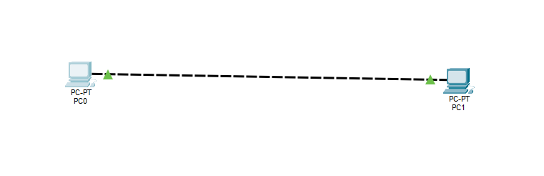
Pinging PC1 from PC0’s terminal
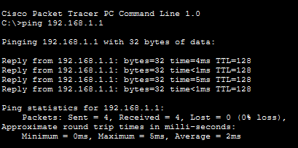

2. LAN-A Setup (Hub-Based)
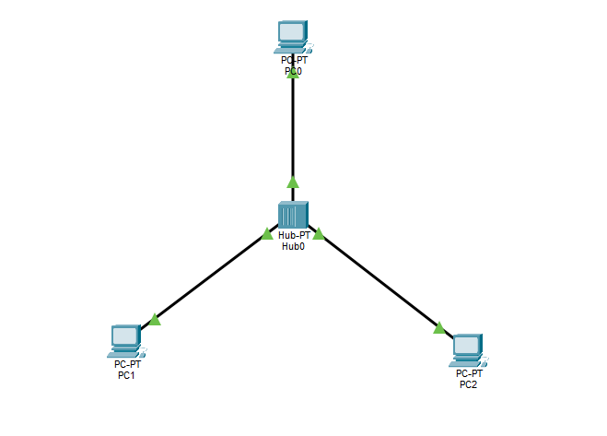
Creating a LAN with a Hub and connecting 3 PCs to it. PC0 (192.168.10.1), PC1 (192.168.10.2), and PC2 (192.168.10.3) can communicate with each other through the hub.
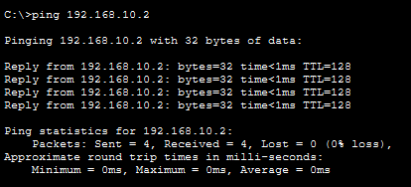
3. LAN-B Setup (Switch-Based) & Table Tracking
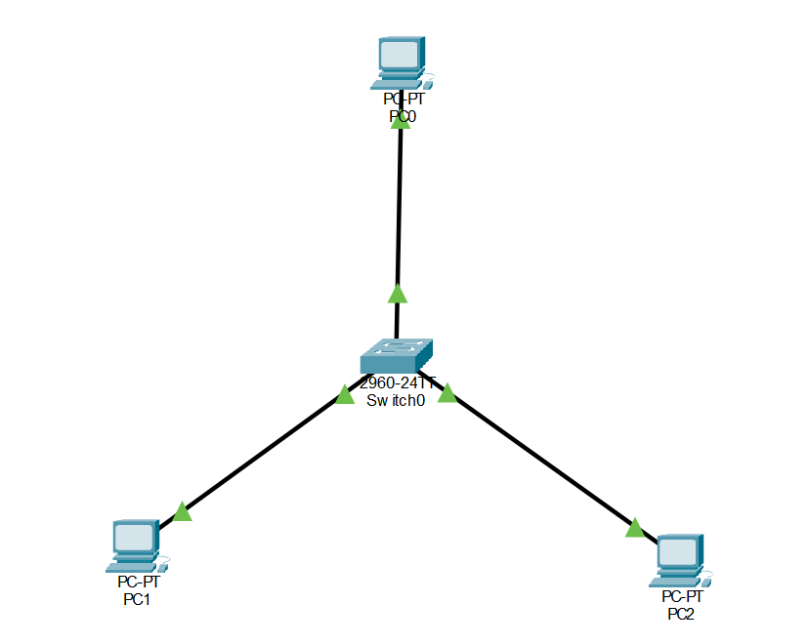
All 3 PCs and the Switch have empty tables at the start
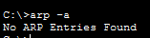
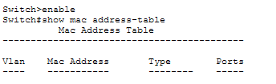

After pinging the other 2 PCs from all the PCs, the tables are updated as follows
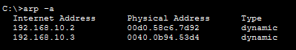
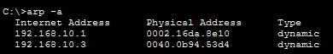
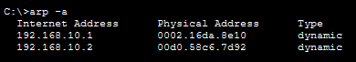
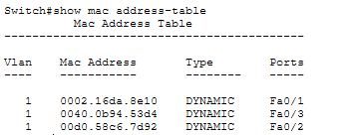

4. Connecting LAN-A and LAN-B
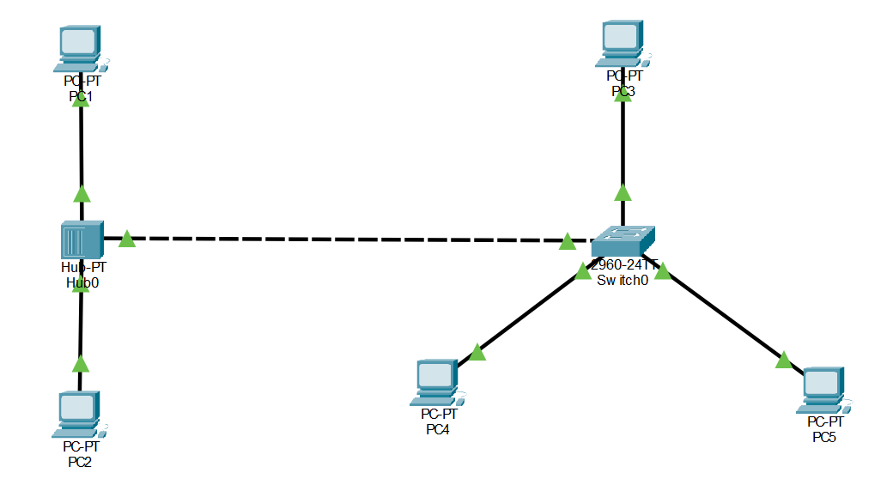
Pinging the PCs connected to the Hub, PC1 (192.168.10.1) and PC2 (192.168.10.2), from the PCs connected to the Switch, all the tables of the PCs connected to the Hub
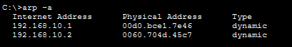
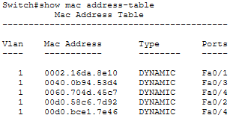

Experiment 2
Creating a LAN, JU-MAIN (192.168.120.1) with 3 hosts PC0 (192.168.120.2), PC1 (192.168.120.3), and PC2 (192.168.120.4)
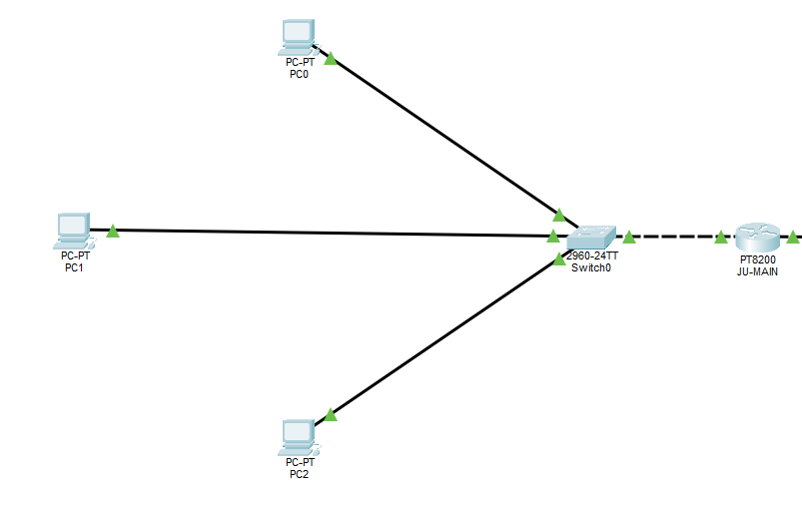
The default gateway of all the PCs is set to 192.168.120.1 or the JU-MAIN Router’s IP address, this makes the Router the default gateway for any communication between any PCs of this network with any PC of some other network.
Creating a LAN, JU-SL (192.168.130.1) with 3 hosts PC3 (192.168.130.2), PC4 (192.168.130.3), and PC5 (192.168.130.4)
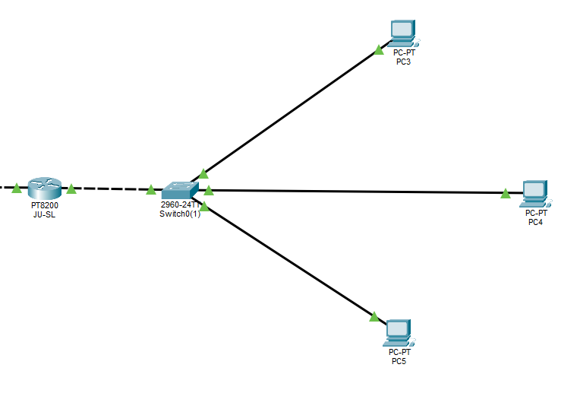
The default gateway of all the PCs is set to 192.168.130.1 or the JU-SL Router’s IP address, this makes the Router the default gateway for any communication between any PCs of this network with any PC of some other network.
Connecting the two Routers using a Copper Cross-Over to create a WAN and setting the IPs of the WAN interface of the Routers as 192.168.150.1 and 192.168.150.2
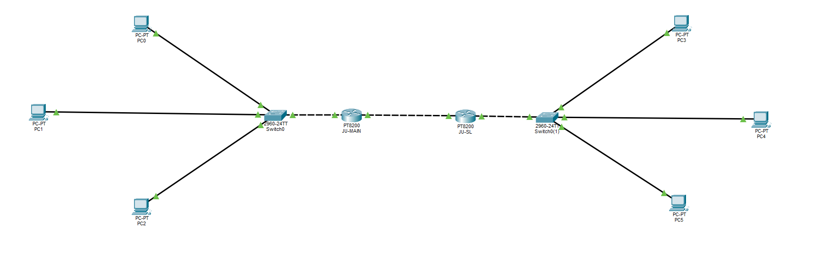

For JU-MAIN router, we set a static routing to 192.168.130.0/24 via 192.168.150.2 and similarly for JU-SL router, we set a static routing to 192.168.120.0/24 via 192.168.150.1.
Testing the configuration by pinging one of the PCs on the JU-SL network (192.168.130.2) from one of the PCs on the JU-MAIN network (192.168.120.2)
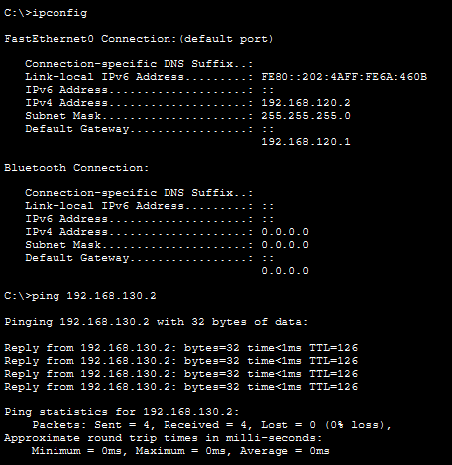

Experiment 3
Creating a new LAN, JU-3C (192.168.140.1) with 3 hosts PC6 (192.168.140.2), PC7 (192.168.140.3), and PC8 (192.168.140.4)
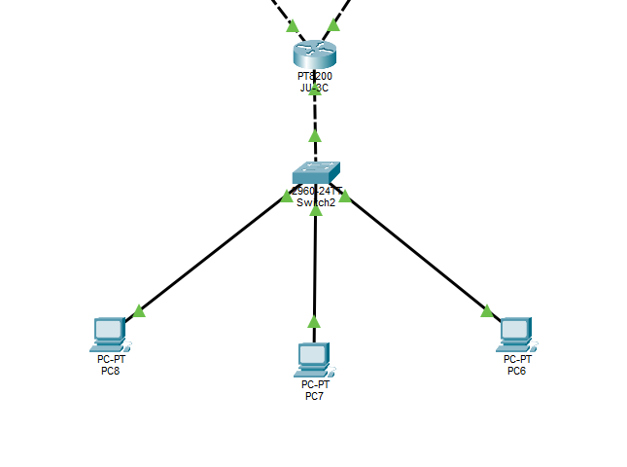
The default gateway of all the PCs is set to 192.168.140.1 or the JU-3C Router’s IP address, this makes the Router the default gateway for any communication between any PCs of this network with any PC of some other network.
We add in some new interfaces to the Routers and add in some new Copper Cross-Over connections to connect the 3 Routers in a mesh.
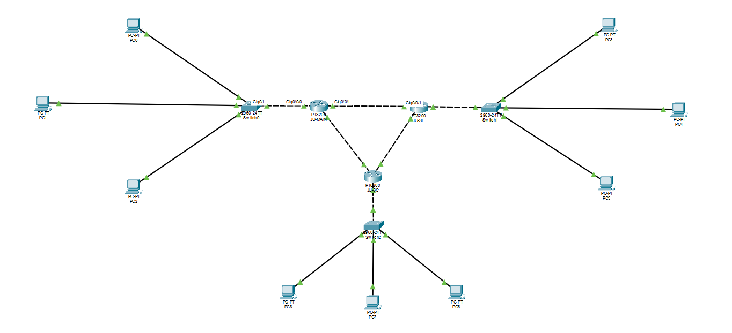
Then we create static routing configurations in this way to correctly router traffic from one LAN to another.
JU-MAIN (192.168.150.1) <-> JU-SL (192.168.150.2)
JU-SL (192.168.160.1) <-> JU-3C (192.168.160.2)
JU-3C (192.168.170.1) <-> JU-MAIN (192.168.170.2)
Pinging a PC on the JU-SL network (192.168.130.2) and another PC on the JU-3C network (192.168.140.2) from a PC on the JU-MAIN network (192.168.120.2) to verify their connection. We also ping a PC on the JU-3C network (192.168.140.2) from a PC on the JU-SL network (192.168.130.2) to verify the remaining connection.
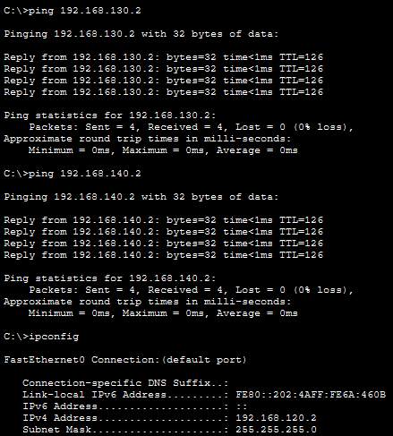
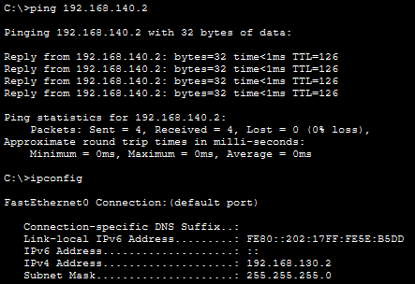

Experiment 4
Adding Server-PT to each of the Switches in networks JU-MAIN, JU-SL, JU-3C, and configuring them as DHCP server with each serving the default gateway as the Router’s address and starting the IP assignment from 192.168.120.10, 192.168.130.10, and 192.168.140.10 respectively.
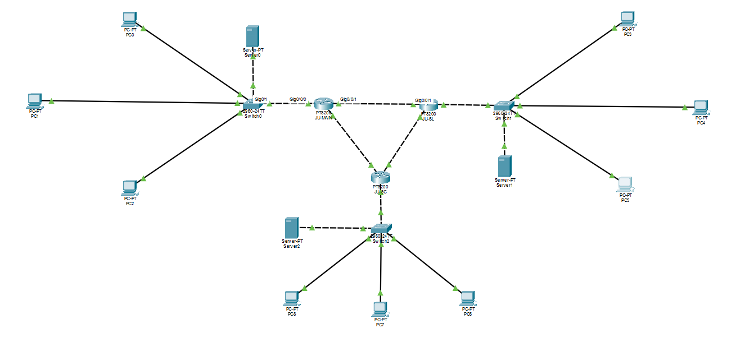

After the servers are set up, changing the IP configuration of all the PCs in all the network to DHCP and verifying that the IPs are being assigned properly, we verify the functioning of the WAN, by pinging a PC inside the LAN (192.168.120.11) and another two PCs outside the LAN (192.168.130.10 and 192.168.140.12) from a PC in the JU-MAIN network (192.168.120.10)
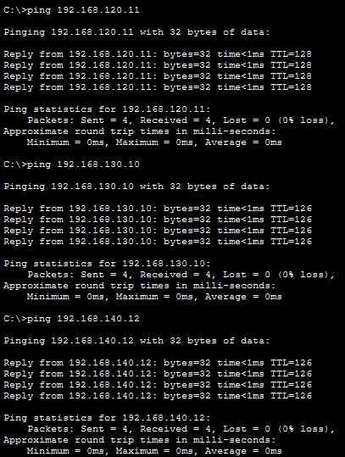

Experiment 5
Creating a LAN (JU-PCLAB1) and adding 6 hosts in it (L1-PC0, L1-PC1, L1-PC2, L1-PC3, L1-PC4, L1-PC5)
Setting their IPs to follows
L1-PC0 - 192.168.10.1
L1-PC1 - 192.168.10.2
L1-PC2 - 192.168.10.3
L1-PC3 - 192.168.20.1
L1-PC4 - 192.168.20.2
L1-PC5 - 192.168.20.3
Then creating two VLANs in the router 10 - Student and 20 - Teacher and assigning L1-PC0, L1-PC1, and L1-PC2 to VLAN 10 and L1-PC3, L1-PC4, and L1-PC5 to VLAN 20.
Putting the FastEthernet0/24 port of the Switch to trunk mode on VLAN 1-1005
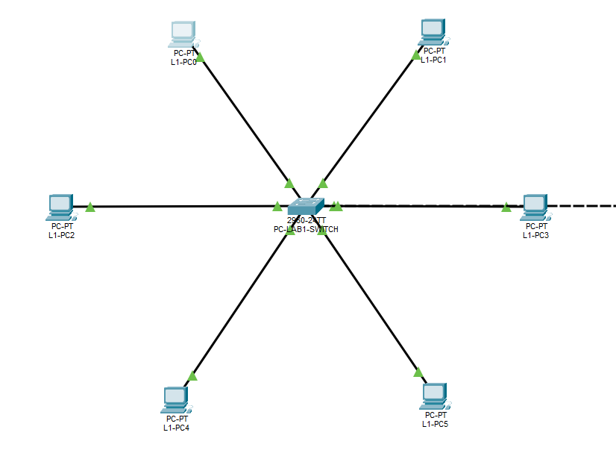
Similarly creating a LAN (JU-PCLAB2) and adding 6 hosts in it (L2-PC0, L2-PC1, L2-PC2, L2-PC3, L2-PC4, L2-PC5)
Setting their IPs to follows
L2-PC0 - 192.168.10.4
L2-PC1 - 192.168.10.5
L2-PC2 - 192.168.10.6
L2-PC3 - 192.168.20.4
L2-PC4 - 192.168.20.5
L2-PC5 - 192.168.20.6
Then creating two VLANs in the router 10 - Student and 20 - Teacher and assigning L2-PC0, L2-PC1, and L2-PC2 to VLAN 10 and L2-PC3, L2-PC4, and L2-PC5 to VLAN 20.
Putting the FastEthernet0/24 port of the Switch to trunk mode on VLAN 1-1005
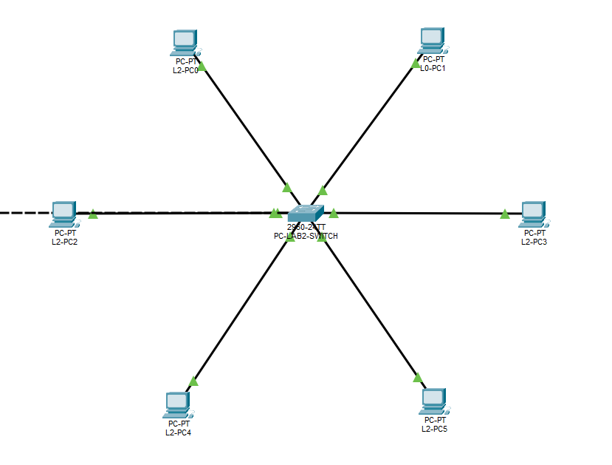
Using a Copper Cross-Over connection we connect the ports FastEthernet 0/24 of both the Switches to each other.
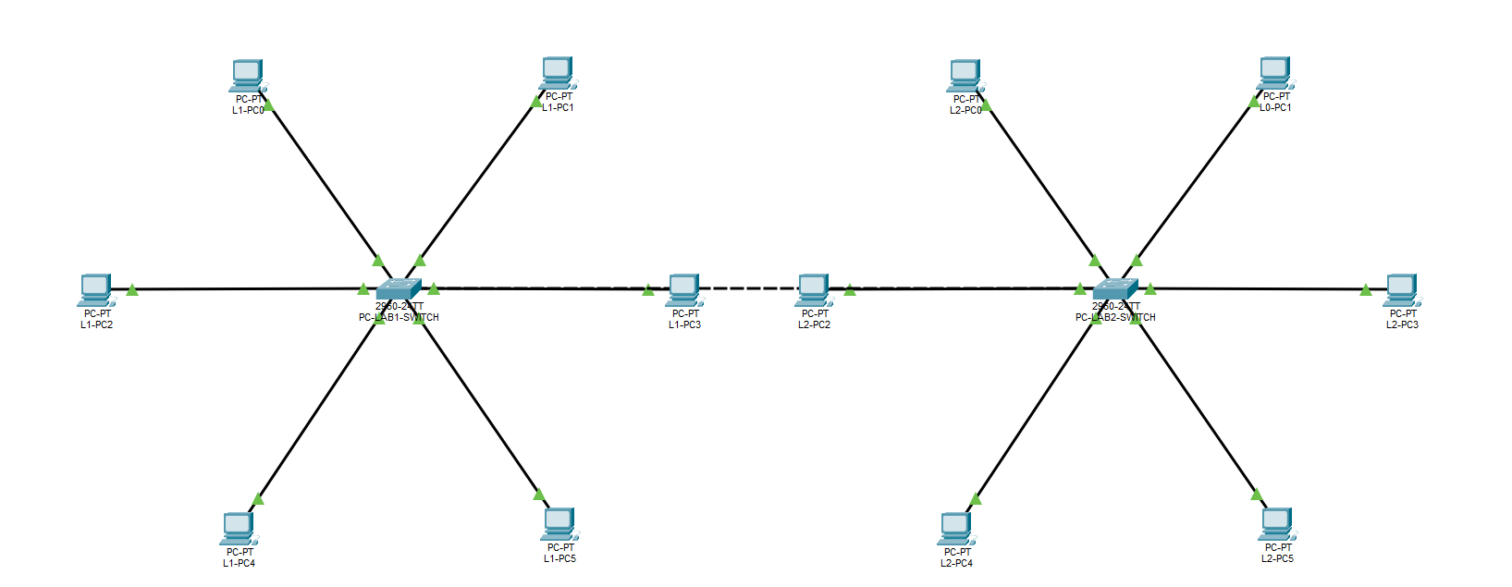
Verifying the VLAN connection establishment on both the Switches
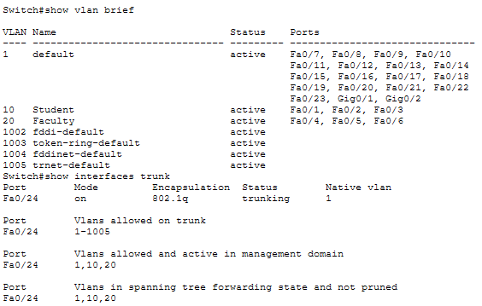

Pinging L2-PC0 (192.168.10.4) from L1-PC0 (192.168.10.1) results in 0% loss as they are in the same VLAN (10 - Student).
Pinging L2-PC3 (192.168.20.4) from L1-PC0 (192.168.10.1) results in 100% loss as they are in different VLANs (10 - Student, 20 - Teacher).
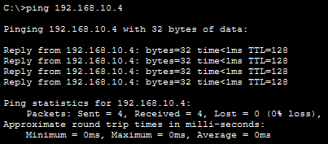
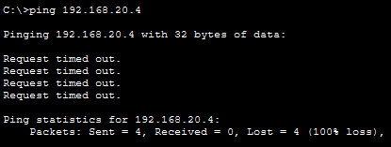

Experiment 6
Connecting 3 hosts (IPs assigned by the DHCP server starting at 192.168.1.10), 1 DHCP Server (192.168.1.2), 1 DNS Server (192.168.1.53), 1 Web Server (192.168.1.10), and 1 FTP Server (192.168.1.11) to a Switch called CSE-SWITCH.
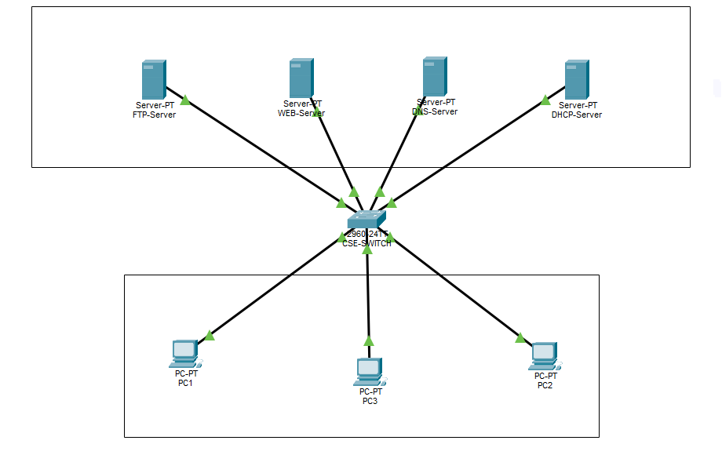
Adding two A Records to the DNS Server, one for the FTP Server (ftp.cse.jadavpuruniversity.in) and one for the Web Server (cse.jadavpuruniversity.in).

Testing the servers by opening the Web Server url in the web browser of one of the PCs (PC1).
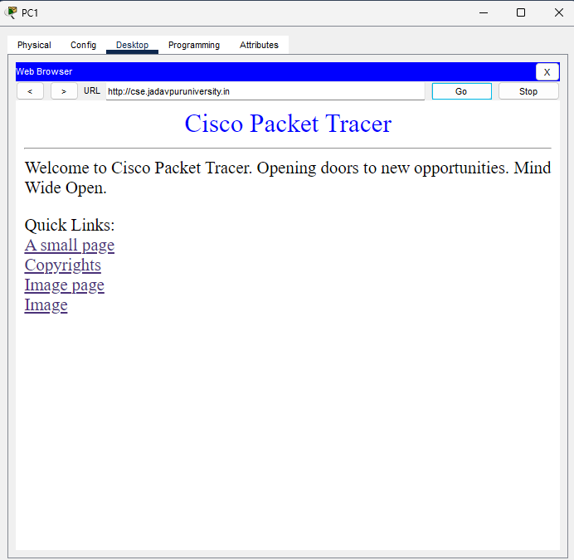

Testing the FTP server by running [ftp ftp.cse.jadavpuruniversity.in] in the terminal
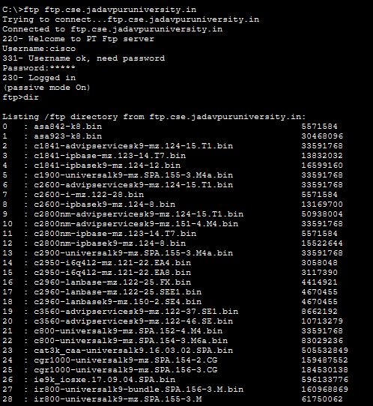

Experiment 7
Recreating the topology
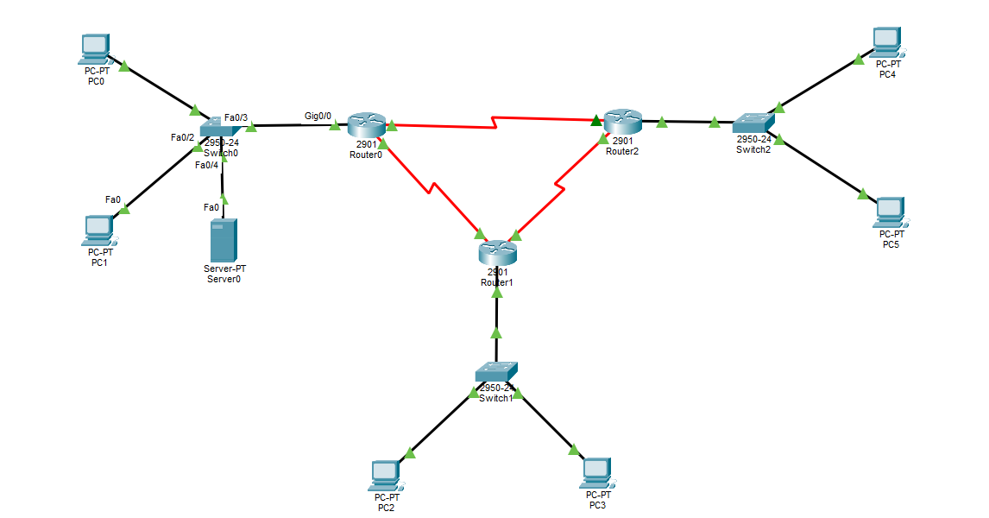
Assigning the LAN connected to Router 0 192.168.10.0/24, the LAN connected to Router 1 192.168.20.0/24, and the LAN connected to Router 2 192.168.30.0/24.
Assigning the connection between the routers as follows:
Router 0 <-> Router 2 – 192.168.40.0/24
Router 2 <-> Router 1 – 192.168.50.0/24
Router 1 <-> Router 0 – 192.168.60.0/24
Then, adding the following IPs to the RIP of the Routers:
Router 0 – 192.168.10.0, 192.168.40.0, 192.168.60.0
Router 1 – 192.168.20.0, 192.168.60.0, 192.168.50.0
Router 2 – 192.168.20.0, 192.168.50.0, 192.168.40.0

After skipping the time for a bit for the Routers to converge, pinging each set of hosts:
PC0 -> PC2 and PC0 -> PC4
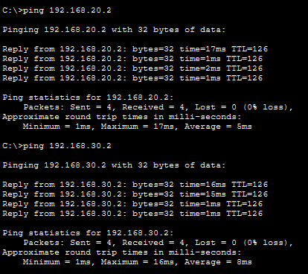
PC2 -> PC5
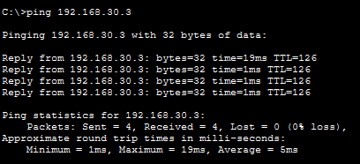
Server0 -> PC3
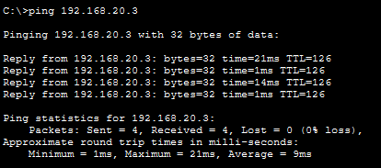
All pings succeed with 0% packet loss, confirming active RIP dynamic routing across the 3-domain topology.

