Assignment 6

Problem Statement
This experiment involves analyzing Network Layer protocols using Wireshark. Experiment 1 focuses on analysing ICMP Echo Request and Echo Reply packets generated by the ping utility between two hosts. Experiment 2 analyses IP datagram fragmentation by transmitting ICMP packets with payloads of 2000 bytes and 5000 bytes, exceeding the Standard Ethernet Maximum Transmission Unit (MTU) of 1500 bytes.

Concept of ICMP and IP Fragmentation
- Internet Control Message Protocol (ICMP): Operating at the Network Layer, ICMP is used by network devices and hosts to communicate operational status and error conditions. The ping command utilizes ICMP Echo Request (Type 8) and Echo Reply (Type 0) to evaluate host reachability and time to go to one host and back. ICMP packets are directly encapsulated within IP datagrams without using transport layer port numbers.
- IP Fragmentation: Standard Ethernet frames carry a Maximum Transmission Unit (MTU) of 1500 bytes. When an IP datagram's total size exceeds the interface MTU, the IP layer fragments the datagram into smaller, independent packets. The destination host reassembles these fragments using three key IP header fields:
  - Identification (groups fragments of the same datagram)
  - Flags (specifically the More Fragments / MF bit)
  - Fragment Offset (specifies the relative position of payload in 8-byte blocks).

Description of Header Fields

IP Header Fields (20-byte Base Header)
- Version (4 bits): Indicates the IP protocol version (e.g., 4 for IPv4).
- Header Length (IHL) (4 bits): Specifies the length of the IP header in 32-bit words (typically 5, representing 20 bytes).
- Type of Service / DSCP (8 bits): Defines packet priority and Quality of Service (QoS).
- Total Length (16 bits): Entire datagram length in bytes, including header and payload.
- Identification (16 bits): Unique sequence identifier used to associate all fragments belonging to the same original IP datagram.
- Flags (3 bits):
  - Bit 0: Reserved (must be 0).
  - Bit 1 (DF - Don't Fragment): Prevents fragmentation if set to 1.
  - Bit 2 (MF - More Fragments): Set to 1 for all fragments except the last fragment (which has MF = 0).
- Fragment Offset (13 bits): Position of the fragment payload relative to the start of the original datagram, measured in 8-byte (64-bit) units.
- Time to Live (TTL) (8 bits): Maximum hop count to prevent infinite routing loops.
- Protocol (8 bits): Identifies the higher-layer payload protocol (e.g., 1 for ICMP, 6 for TCP, 17 for UDP).
- Header Checksum (16 bits): Error detection value calculated for the IP header.
- Source IP Address (32 bits): IP address of the transmitting host.
- Destination IP Address (32 bits): IP address of the intended recipient host.

ICMP Header Fields (8-byte Base Header)
- Type (8 bits): Identifies the message category (e.g., 8 for Echo Request, 0 for Echo Reply).
- Code (8 bits): Provides diagnostic sub-details for the message type (e.g., 0 for Echo Request/Reply).
- Checksum (16 bits): Error checks the ICMP header and payload.
- Identifier (16 bits): Session ID used to correlate ping requests with their corresponding responses.
- Sequence Number (16 bits): Monotonically increasing count for tracking packet delivery and loss.
- Data Payload: Arbitrary byte sequence echoed back from destination to source.

Experiment 1
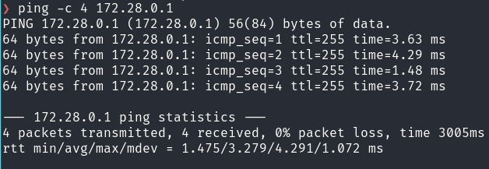
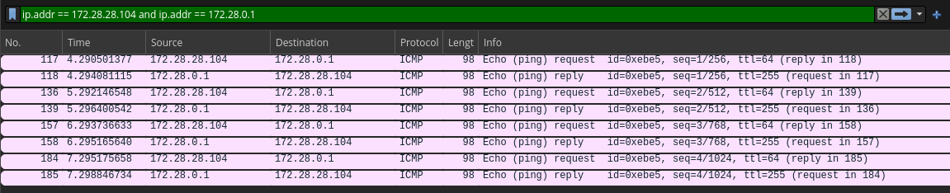
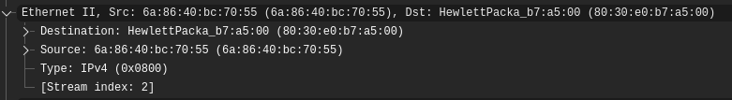
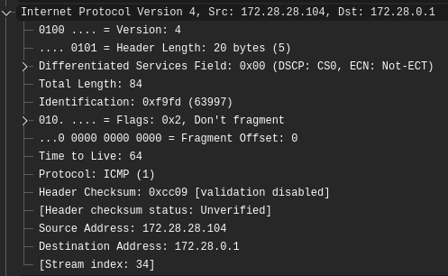
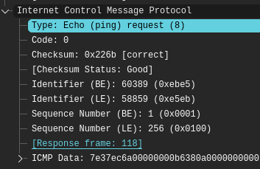 | 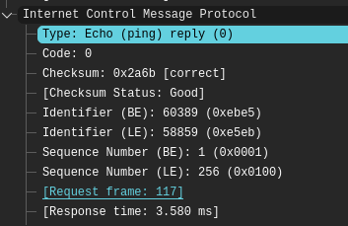
- What is the 48-bit Ethernet address of your computer? 6a:86:40:bc:70:55
- What is the 48-bit destination address in the Ethernet frame? 80:30:e0:b7:a5:00
- Give the hexadecimal value for the two-byte Frame type field. 0x0800
- What is the hexadecimal value of the CRC field in this Ethernet frame?
CRC field bytes are stripped by Network Interface Card (NIC) hardware and OS drivers prior to passing packets to Wireshark.
- What is the IP address of your host? What is the IP address of the destination host?
Source address: 172.28.28.104
Destination address: 172.28.0.1
- Why is it that an ICMP packet does not have source and destination port numbers?
Port numbers are Transport Layer concepts used by TCP/UDP to direct data to specific application processes. ICMP functions at Network Layer as a network management and diagnostic tool. It communicates host-to-host rather than process-to-process, eliminating the need for port numbers.
- Examine one of the ping request packets sent by your host. What are the ICMP type and code numbers? What other fields does this ICMP packet have? How many bytes are the checksum, sequence number and identifier fields?
  - Type: 8 (Echo Request)
  - Code: 0
  - Other Fields & Byte Sizes:
    - Checksum: 2 bytes (16 bits)
    - Identifier: 2 bytes (16 bits)
    - Sequence Number: 2 bytes (16 bits)
    - Data: 32 bytes (Windows) or 56/64 bytes (Linux default payload).
- Examine the corresponding ping reply packet. What are the ICMP type and code numbers? What other fields does this ICMP packet have? How many bytes are the checksum, sequence number and identifier fields?
  - Type: 0 (Echo Reply)
  - Code: 0
  - Other Fields & Byte Sizes:
    - Checksum: 2 bytes (16 bits - Identical to request packet)
    - Identifier: 2 bytes (16 bits - Identical to request packet)
    - Sequence Number: 2 bytes (16 bits - Identical to request packet)
    - Data: Exact replica of the payload bytes sent in the request.

Experiment 2

Part A: 2000 byte
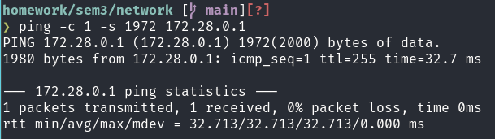
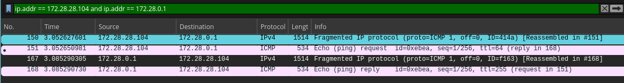
Total IP Datagram Size: 20(IP Header) + 8 (ICMP Header) + 1972 (Payload) = 2000 bytes Maximum Transmission Unit (MTU): 1500 bytes (1500 - 20 (IP Header) = 1480 bytes payload per fragment limit)
Fragment Index | Total IP Length | IP Header | Data Payload | Flags (MF) | Fragment Offset | Byte Range
1 | 1500 | 20 | 1480 | 1 | 0 | 0-1479
2 | 520 | 20 | 500 | 0 | 185 | 1480-1979

First Fragment
- Fragmentation Indicator: More Fragments (MF) flag = 1 (Flags: 0x2000).
- First Fragment vs. Latter Fragment Indicator: Fragment Offset = 0 combined with MF = 1 proves this is the initial fragment.
- Length of IP Datagram: 1500 bytes.

Second Fragment
- Not First Fragment Indicator: Fragment Offset = 185 (non-zero value indicating bytes starting at offset 185 x 8 = 1480).
- Are there more fragments?: No. The More Fragments (MF) flag is 0 (Flags: 0x0000).

Changing Header Fields between First and Second Fragments
- Total Length: Decreases from 1500 to 520.
- Flags (MF): Changes from 1 (Set) to 0 (Not set).
- Fragment Offset: Changes from 0 to 185.
- Header Checksum: Recalculated for fragment 2 due to changed length, offset, and flag values.

Part A: 5000 byte
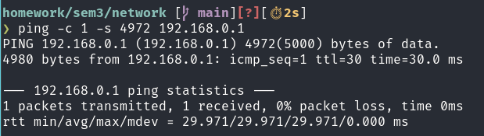

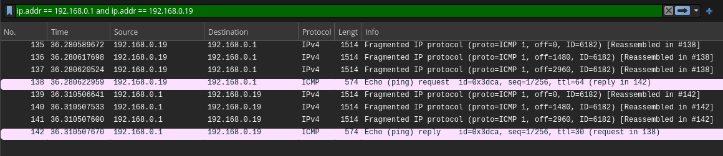

Total IP Datagram Size: 20(IP Header) + 8 (ICMP Header) + 4972 (Payload) = 5000 bytes
Fragment Index | Total IP Length | IP Header | Data Payload | Flags (MF) | Fragment Offset | Byte Range
1 | 1500 | 20 | 1480 | 1 | 0 | 0-1479
2 | 1500 | 20 | 1480 | 1 | 185 | 1480-2959
3 | 1500 | 20 | 1480 | 1 | 370 | 2960-4439
4 | 540 | 20 | 520 | 0 | 555 | 4440-4979

- How many fragments were created from the original datagram?
4 fragments (3 fragments of 1500 bytes and 1 remaining fragment of 608 bytes).
- What fields change in the IP header among the fragments?
- Total Length: 1500 for fragments 1–3, changing to 540 for fragment 4.
- Flags (MF): Set to 1 for fragments 1–3, changing to 0 for fragment 4.
- Fragment Offset: Increments across fragments (0 -> 185 -> 370 -> 555).
- Header Checksum: Recomputed uniquely for every individual fragment header.

