Assignment 7

Problem Statement
This assignment requires implementing a custom HTTP/1.0 client and server using Python's standard socket module to demonstrate low-level connection-oriented network communication.
- The HTTP Client: Takes command-line arguments (server host/IP, port, HTTP method, path), opens a TCP socket connection, constructs and transmits a formatted HTTP request, and prints the server response.
- The HTTP Server: Accepts a port number as a command-line argument, listens for incoming TCP client connections, parses HTTP request headers, serves local static files for GET requests (returning 200 OK or 404 Not Found), handles file uploads for PUT requests (returning 200 OK File Created), and processes incoming requests iteratively in a loop.

HTTP Protocol & Architecture
- Transport Mechanism: Connection-oriented TCP sockets (socket.AF_INET, socket.SOCK_STREAM).
- Connection Model: Non-persistent HTTP/1.0 with explicit socket closure after each exchange (Connection: close).
- Delimiters: Request and response headers terminate with CRLF sequences (\r\n), with an empty double CRLF (\r\n\r\n) separating headers from payload data.

HTTP Client Implementation
import os
import socket
import sys

BUFFER_SIZE = 4096

if len(sys.argv) < 5:
print(f"Usage: python {sys.argv[0]} <server_ip_or_host> <port> <method> <path>")
sys.exit(1)

host = sys.argv[1]
port = int(sys.argv[2])
method = sys.argv[3].upper()
path = sys.argv[4]
client_socket = socket.socket(socket.AF_INET, socket.SOCK_STREAM)
try:
client_socket.connect((host, port))
except ConnectionError as e:
print(f"Error connecting to server {host}:{port} -> {e}")
sys.exit(1)
if method == "GET":
request = (
f"GET {path} HTTP/1.0\r\n"
f"Host: {host}\r\n"
f"User-Agent: CustomPythonClient/1.0\r\n"
f"Connection: close\r\n\r\n"
)
client_socket.sendall(request.encode("utf-8"))

elif method == "PUT":
filename = path.lstrip("/")
body = b""
if os.path.exists(filename):
with open(filename, "rb") as f:
body = f.read()
else:
print(f"Warning: Local file '{filename}' not found. Transmitting empty body.")
header = (
f"PUT {path} HTTP/1.0\r\n"
f"Host: {host}\r\n"
f"Content-Length: {len(body)}\r\n"
f"Connection: close\r\n\r\n"
)
client_socket.sendall(header.encode("utf-8") + body)
else:
print(f"Unsupported HTTP Method: {method}")
client_socket.close()
sys.exit(1)
response = b""
while True:
data = client_socket.recv(BUFFER_SIZE)
if not data:
break
response += data
client_socket.close()
print(response.decode("utf-8", errors="replace"))

HTTP Server Implementation
import os
import socket
import sys

BUFFER_SIZE = 8192

def handle_client(client_socket):
try:
request_data = b""
while b"\r\n\r\n" not in request_data:
chunk = client_socket.recv(1024)
if not chunk:
break
request_data += chunk

if not request_data:
return

parts = request_data.split(b"\r\n\r\n", 1)
header_text = parts[0].decode("utf-8", errors="replace")
body_initial = parts[1] if len(parts) > 1 else b""

lines = header_text.split("\r\n")
if not lines or not lines[0]:
return

request_tokens = lines[0].split()
if len(request_tokens) < 3:
return

method, path, _ = request_tokens[0], request_tokens[1], request_tokens[2]

filename = "index.html" if path == "/" else path.lstrip("/")

if method.upper() == "GET":
if os.path.isfile(filename):
with open(filename, "rb") as f:
file_content = f.read()

header = (
"HTTP/1.0 200 OK\r\n"
"Content-Type: text/html\r\n"
f"Content-Length: {len(file_content)}\r\n"
"Connection: close\r\n\r\n"
)
client_socket.sendall(header.encode("utf-8") + file_content)
else:
error_body = b"<html><body><h1>404 Not Found</h1><p>The requested file does not exist.</p></body></html>\r\n"
header = (
"HTTP/1.0 404 Not Found\r\n"
"Content-Type: text/html\r\n"
f"Content-Length: {len(error_body)}\r\n"
"Connection: close\r\n\r\n"
)
client_socket.sendall(header.encode("utf-8") + error_body)

elif method.upper() == "PUT":
content_length = 0
for line in lines[1:]:
if line.lower().startswith("content-length:"):
content_length = int(line.split(":")[1].strip())
break

body_data = body_initial
remaining = content_length - len(body_data)

while remaining > 0:
chunk = client_socket.recv(min(4096, remaining))
if not chunk:
break
body_data += chunk
remaining -= len(chunk)

with open(filename, "wb") as f:
f.write(body_data)

res_body = b"File created successfully.\n"
header = (
"HTTP/1.0 200 OK File Created\r\n"
"Content-Type: text/plain\r\n"
f"Content-Length: {len(res_body)}\r\n"
"Connection: close\r\n\r\n"
)
client_socket.sendall(header.encode("utf-8") + res_body)

finally:
client_socket.close()

if len(sys.argv) < 2:
print(f"Usage: python {sys.argv[0]} <port>")
sys.exit(1)

port = int(sys.argv[1])
server_socket = socket.socket(socket.AF_INET, socket.SOCK_STREAM)
server_socket.setsockopt(socket.SOL_SOCKET, socket.SO_REUSEADDR, 1)

server_socket.bind(("0.0.0.0", port))
server_socket.listen(10)

print(f"[SERVER ACTIVE] Listening on port {port}...")

while True:
try:
client_socket, _ = server_socket.accept()
handle_client(client_socket)
except KeyboardInterrupt:
print("\n[SERVER SHUTDOWN] Stopping server.")
break
except ConnectionError as e:
print(f"Error accepting connection: {e}")

server_socket.close()

Verification

Using the Python client to retrieve a resource from httpbin.org
python http_client.py httpbin.org 80 GET /ip
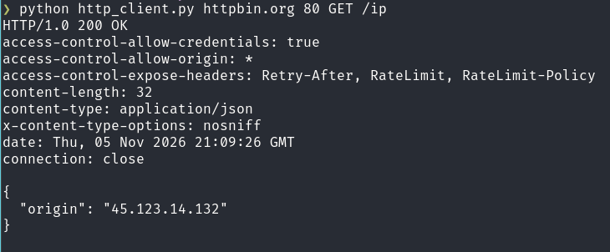

Requesting Existing File
python http_client.py 127.0.0.1 5000 GET /index.html
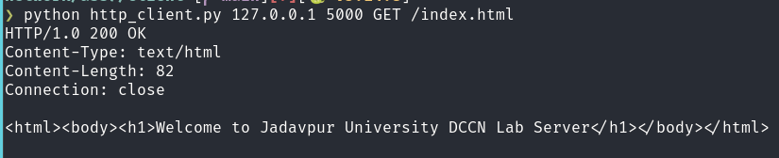

Requesting Non-Existent File
python http_client.py 127.0.0.1 5000 GET /home.html
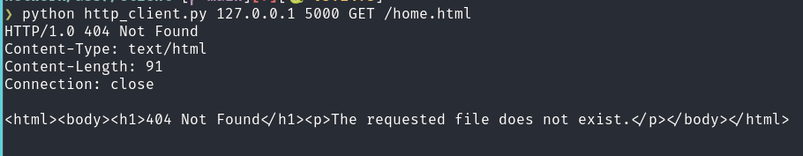

Uploading a file to the server
python http_client.py 127.0.0.1 5000 PUT /text.txt

Web Browser Access



