Assignment 2

Experiment 1: TCP Analysis
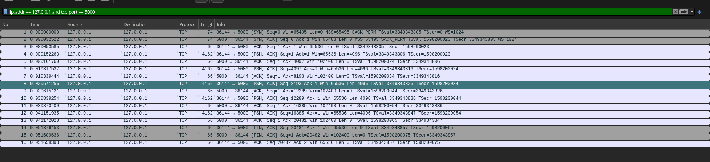
Part | Sl no. | Src | Dest | Seq | Ack | Flags | Length | Window
Connection Establishment | 1 | 36144 | 5000 | 0 | - | SYN | 0 | 65495
Connection Establishment | 2 | 5000 | 36144 | 0 | 1 | SYN, ACK | 0 | 65483
Connection Establishment | 3 | 36144 | 5000 | 1 | 1 | ACK | 0 | 65536
Data Transfer | 4 | 36144 | 5000 | 1 | 1 | PSH, ACK | 4096 | 65536
Data Transfer | 5 | 5000 | 36144 | 1 | 4097 | ACK | 0 | 102400
Data Transfer | 6 | 36144 | 5000 | 4097 | 1 | PSH, ACK | 4096 | 65536
Data Transfer | 7 | 5000 | 36144 | 1 | 8193 | ACK | 0 | 102400
Data Transfer | 8 | 36144 | 5000 | 8193 | 1 | PSH, ACK | 4096 | 65536
Data Transfer | 9 | 5000 | 36144 | 1 | 12289 | ACK | 0 | 102400
Data Transfer | 10 | 36144 | 5000 | 12289 | 1 | PSH, ACK | 4096 | 65536
Data Transfer | 11 | 5000 | 36144 | 1 | 16385 | ACK | 0 | 102400
Data Transfer | 12 | 36144 | 5000 | 16385 | 1 | PSH, ACK | 4096 | 65536
Data Transfer | 13 | 5000 | 36144 | 1 | 20481 | ACK | 0 | 102400
Connection Termination | 14 | 36144 | 5000 | 20481 | 1 | FIN, ACK | 0 | 65536
Connection Termination | 15 | 5000 | 36144 | 1 | 20482 | FIN, ACK | 0 | 102400
Connection Termination | 16 | 36144 | 5000 | 20482 | 2 | ACK | 0 | 65536

Selecting a sequence of TCP segments carrying application data.
Sl no. | Src | Dest | Seq | Ack | Flags | Length | Window
4 | 36144 | 5000 | 1 | 1 | PSH, ACK | 4096 | 65536
5 | 5000 | 36144 | 1 | 4097 | ACK | 0 | 102400
6 | 36144 | 5000 | 4097 | 1 | PSH, ACK | 4096 | 65536
7 | 5000 | 36144 | 1 | 8193 | ACK | 0 | 102400
8 | 36144 | 5000 | 8193 | 1 | PSH, ACK | 4096 | 65536
9 | 5000 | 36144 | 1 | 12289 | ACK | 0 | 102400
10 | 36144 | 5000 | 12289 | 1 | PSH, ACK | 4096 | 65536
11 | 5000 | 36144 | 1 | 16385 | ACK | 0 | 102400
12 | 36144 | 5000 | 16385 | 1 | PSH, ACK | 4096 | 65536
13 | 5000 | 36144 | 1 | 20481 | ACK | 0 | 102400
14 | 36144 | 5000 | 20481 | 1 | FIN, ACK | 0 | 65536

- Bytes Acknowledged: In TCP, the acknowledgment number indicates the next expected byte.
  - Ack 4097 acknowledges receipt of bytes 1 through 4096.
  - Ack 8193 acknowledges receipt of bytes 4097 through 8192.
  - Ack 12289 acknowledges receipt of bytes 8193 through 12288.
  - Ack 16385 acknowledges receipt of bytes 12289 through 16384.
  - Ack 20481 acknowledges receipt of bytes 16385 through 20480.
- Segment to Acknowledgment Ratio: In this trace, each acknowledgment corresponds to exactly one data segment. The server replies with an ACK immediately after receiving every 4096-byte chunk, showing a 1:1 ratio with no delayed acknowledgments observed.
- Cumulative Acknowledgment: TCP inherently uses cumulative acknowledgments. Every ACK number generated by the server confirms the successful receipt of all data bytes prior to that sequence number.

Timing Diagram:
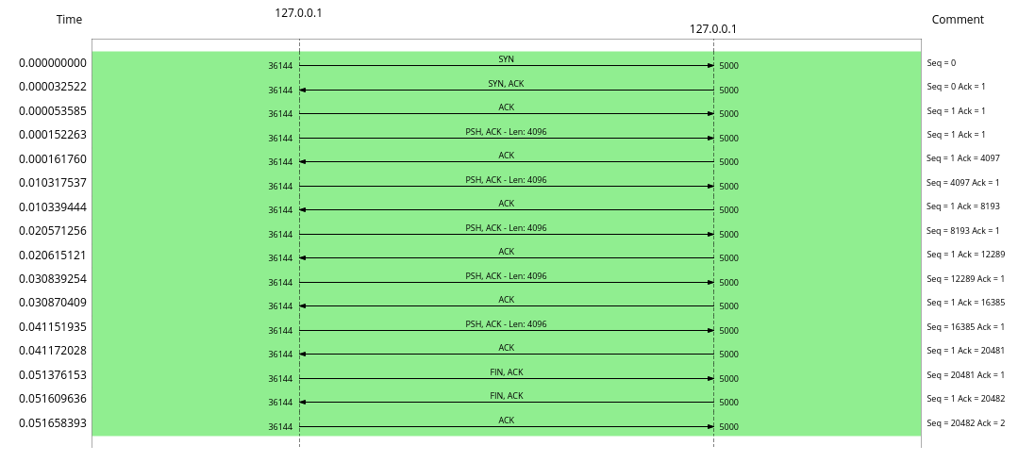
- Does the advertised receive window remain constant?
- The advertised receive window from the server remains strictly constant at 100 across all data acknowledgment segments (Packets 5, 7, 9, 11, and 13). (Note: Because wscale 10 was negotiated during the SYN phase, this raw value of 100 technically scales to an effective window of 102,400 bytes).
- If it changes, what could be the reason?
- While it did not change in this trace, a changing receive window occurs when the application layer on the receiving machine reads data out of the TCP buffer at a different rate than the sender is transmitting it. If the buffer fills, the window decreases and as the application empties the buffer, the window increases.
- What is the purpose of the TCP receive window?
- It advertises the amount of available buffer space on the receiving host. It acts as an indicator to the sender of how much additional data the receiver can currently accept.
- How does the receive window contribute to TCP flow control?
- It prevents a fast sender from overwhelming a slow receiver. By tracking the receiver's window size, the sender restricts its number of "in-flight" (unacknowledged) bytes. If the advertised window reaches zero, the sender will pause transmission until the receiver advertises a non-zero window.

Experiment 2: UDP Analysis
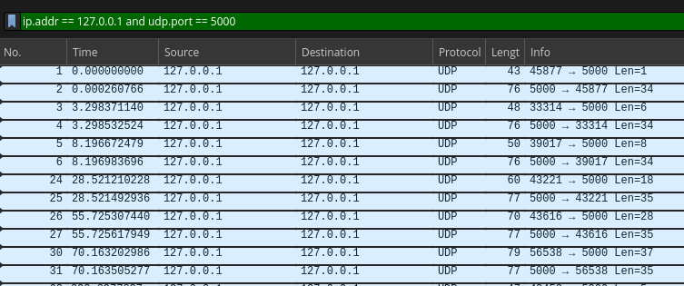
Tabulated form:
Sl no. | Src | Dest | Application Data Length | UDP Length | UDP Checksum | IP total length
1 | 45877 | 5000 | 1 | 9 | 0xfe20 | 33
2 | 5000 | 45877 | 34 | 42 | 0xfe3d | 62
3 | 33314 | 5000 | 6 | 14 | 0x0204 | 1028
4 | 5000 | 33314 | 34 | 42 | 0xfe3d | 62
5 | 39017 | 5000 | 8 | 16 | 0x252c | 10028
6 | 5000 | 39017 | 34 | 42 | 0xfe3d | 62
7 | 43221 | 5000 | 18 | 26 | 0xfe2d | 46
8 | 5000 | 43221 | 35 | 43 | 0xfe3e | 63
9 | 43616 | 5000 | 28 | 36 | 0xfe37 | 56
10 | 5000 | 43616 | 35 | 43 | 0xfe3e | 63
11 | 56538 | 5000 | 37 | 45 | 0xfe40 | 65
12 | 5000 | 56538 | 35 | 43 | 0xfe3e | 63

As we can notice from this table, the UDP length is always 8 more than the Application Data Length. 8 bytes have to be then the header length for UDP.

And we verify that UDP Length = UDP Header Length + Application Data Length.
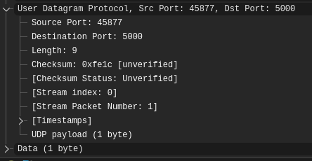
Timing Diagram:
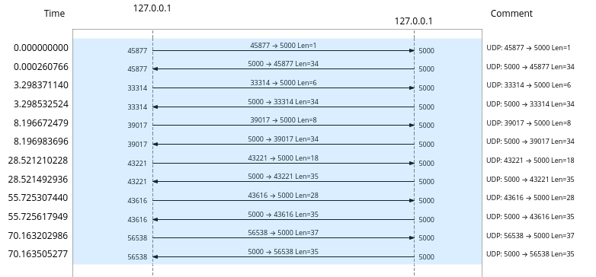

Sending 3 messages, 1 short (5 bytes), 1 medium (1000 bytes), and 1 large (10000 bytes) we capture the following
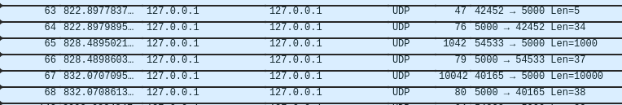
Stream Index | Source | Destination | Length
26 | 42452 | 5000 | 5
26 | 5000 | 42452 | 34
27 | 54533 | 5000 | 1000
27 | 5000 | 54533 | 37
28 | 40165 | 5000 | 10000
28 | 5000 | 40165 | 38

Observations
In TCP, if a client sends multiple messages one after the other, the server cannot differentiate between the messages because TCP doesn’t preserve message boundaries. As UDP is connectionless, every message is treated as its own unit with their own headers.

After stopping the server and sending a message from one of the clients, we capture this
1. Whether the UDP client can still send the datagram.
UDP is connectionless. The client does not need to establish a connection before transmitting a datagram.
2. Whether any UDP acknowledgment is received.
UDP does not contain a transport-layer acknowledgment mechanism.
The response received when the server is running is an application-level response, not a UDP ACK.
3. Whether an ICMP message is generated.
When the destination UDP port is closed/unavailable, the operating system can generate an ICMP Destination Unreachable message.
4. If an ICMP message is generated, record its Type and Code and explain its meaning.
Type 3 → Destination Unreachable
Code 3 → Port Unreachable
This indicates that there is no server listening on the destination UDP port.

Comparison of TCP and UDP Behaviour
In Experiment 1, TCP demonstrated reliable, connection-oriented communication. The three-way handshake established the connection before data transfer, sequence numbers tracked transmitted bytes, and acknowledgment numbers confirmed the bytes received. The advertised receive window demonstrated flow control, while FIN and ACK packets were used for connection termination.
In Experiment 2, UDP demonstrated connectionless communication. Datagrams were transmitted without a connection-establishment handshake or transport-layer acknowledgments. Each datagram contained its own UDP header, and the message boundaries were preserved. When the UDP server was unavailable, an ICMP Port Unreachable message could be generated.
Feature | TCP | UDP
Connection | Connection Oriented | Connectionless
Data Transfer | Continuous Byte Stream | Independent Datagrams
Reliability | Uses acknowledgments and retransmissions | No built-in delivery guarantee
Sequence numbers | Present | Absent
Flow Control | Uses advertised receive window | No built-in flow control
Message boundaries | Not preserved | Preserved
Header Size | Minimum 20 bytes | 8 bytes
Connection termination | Uses FIN and ACK | No connection termination required

