Experiment 1: Analysis of TCP Data Transfer, Segmentation and Flow
Step 1 and 2:
Part | Sl no. | Src | Dest | Seq | Ack | Flags | Length | Window
Connection Establishment | 1 | 36144 | 5000 | 0 | - | SYN | 0 | 65495
Connection Establishment | 2 | 5000 | 36144 | 0 | 1 | SYN, ACK | 0 | 65483
Connection Establishment | 3 | 36144 | 5000 | 1 | 1 | ACK | 0 | 65536
Data Transfer | 4 | 36144 | 5000 | 1 | 1 | PSH, ACK | 4096 | 65536
Data Transfer | 5 | 5000 | 36144 | 1 | 4097 | ACK | 0 | 102400
Data Transfer | 6 | 36144 | 5000 | 4097 | 1 | PSH, ACK | 4096 | 65536
Data Transfer | 7 | 5000 | 36144 | 1 | 8193 | ACK | 0 | 102400
Data Transfer | 8 | 36144 | 5000 | 8193 | 1 | PSH, ACK | 4096 | 65536
Data Transfer | 9 | 5000 | 36144 | 1 | 12289 | ACK | 0 | 102400
Data Transfer | 10 | 36144 | 5000 | 12289 | 1 | PSH, ACK | 4096 | 65536
Data Transfer | 11 | 5000 | 36144 | 1 | 16385 | ACK | 0 | 102400
Data Transfer | 12 | 36144 | 5000 | 16385 | 1 | PSH, ACK | 4096 | 65536
Data Transfer | 13 | 5000 | 36144 | 1 | 20481 | ACK | 0 | 102400
Connection Termination | 14 | 36144 | 5000 | 20481 | 1 | FIN, ACK | 0 | 65536
Connection Termination | 15 | 5000 | 36144 | 1 | 20482 | FIN, ACK | 0 | 102400
Connection Termination | 16 | 36144 | 5000 | 20482 | 2 | ACK | 0 | 65536

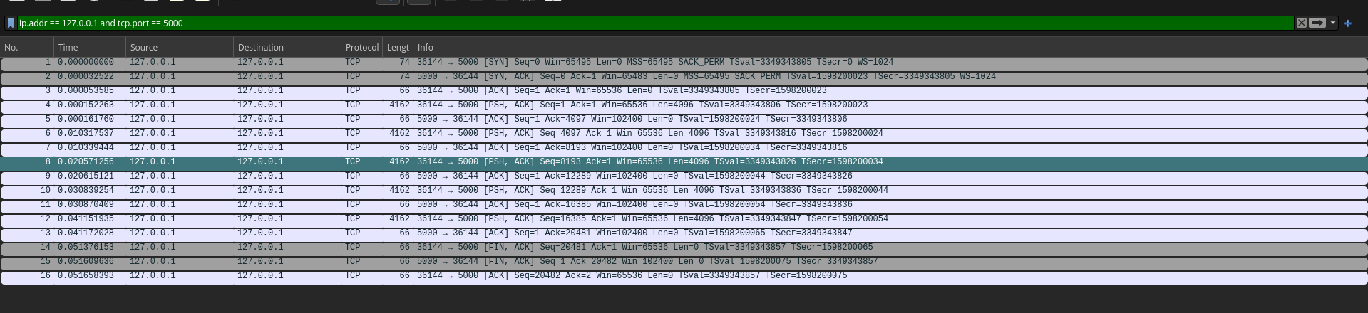
Step 3: Analyse TCP Segmentation
Select a sequence of TCP segments carrying application data.
Sl no. | Src | Dest | Seq | Ack | Flags | Length | Window
4 | 36144 | 5000 | 1 | 1 | PSH, ACK | 4096 | 65536
5 | 5000 | 36144 | 1 | 4097 | ACK | 0 | 102400
6 | 36144 | 5000 | 4097 | 1 | PSH, ACK | 4096 | 65536
7 | 5000 | 36144 | 1 | 8193 | ACK | 0 | 102400
8 | 36144 | 5000 | 8193 | 1 | PSH, ACK | 4096 | 65536
9 | 5000 | 36144 | 1 | 12289 | ACK | 0 | 102400
10 | 36144 | 5000 | 12289 | 1 | PSH, ACK | 4096 | 65536
11 | 5000 | 36144 | 1 | 16385 | ACK | 0 | 102400
12 | 36144 | 5000 | 16385 | 1 | PSH, ACK | 4096 | 65536
13 | 5000 | 36144 | 1 | 20481 | ACK | 0 | 102400
14 | 36144 | 5000 | 20481 | 1 | FIN, ACK | 0 | 65536

Step 4:
- Bytes Acknowledged: In TCP, the acknowledgment number indicates the next expected byte.
  - Ack 4097 acknowledges receipt of bytes 1 through 4096.
  - Ack 8193 acknowledges receipt of bytes 4097 through 8192.
  - Ack 12289 acknowledges receipt of bytes 8193 through 12288.
  - Ack 16385 acknowledges receipt of bytes 12289 through 16384.
  - Ack 20481 acknowledges receipt of bytes 16385 through 20480.
- Segment to Acknowledgment Ratio: In this trace, each acknowledgment corresponds to exactly one data segment. The server replies with an ACK immediately after receiving every 4096-byte chunk, showing a 1:1 ratio with no delayed acknowledgments observed.
- Cumulative Acknowledgment: TCP inherently uses cumulative acknowledgments. Every ACK number generated by the server confirms the successful receipt of all data bytes prior to that sequence number.

Timing Diagram:
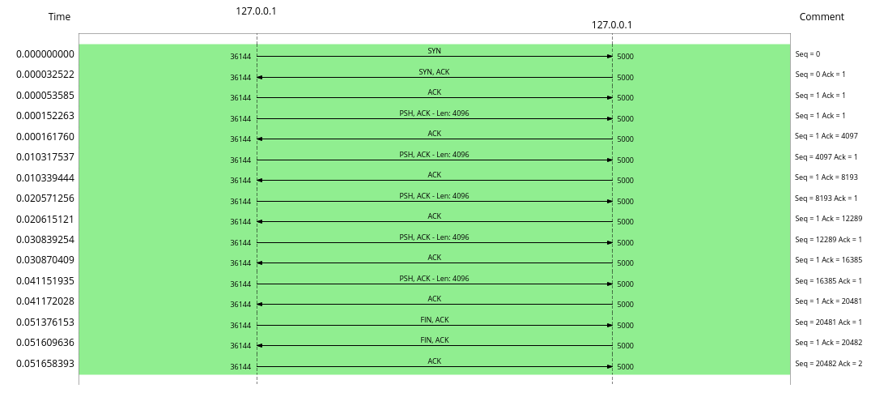
Step 5:
- Does the advertised receive window remain constant?
- The advertised receive window from the server remains strictly constant at 100 across all data acknowledgment segments (Packets 5, 7, 9, 11, and 13). (Note: Because wscale 10 was negotiated during the SYN phase, this raw value of 100 technically scales to an effective window of 102,400 bytes).
- If it changes, what could be the reason?
- While it did not change in this trace, a changing receive window occurs when the application layer on the receiving machine reads data out of the TCP buffer at a different rate than the sender is transmitting it. If the buffer fills, the window decreases and as the application empties the buffer, the window increases.
- What is the purpose of the TCP receive window?
- It advertises the amount of available buffer space on the receiving host. It acts as an indicator to the sender of how much additional data the receiver can currently accept.
- How does the receive window contribute to TCP flow control?
- It prevents a fast sender from overwhelming a slow receiver. By tracking the receiver's window size, the sender restricts its number of "in-flight" (unacknowledged) bytes. If the advertised window reaches zero, the sender will pause transmission until the receiver advertises a non-zero window.

