Experiment 2: UDP Request–Response and Datagram Analysis
Step 1 and 2:
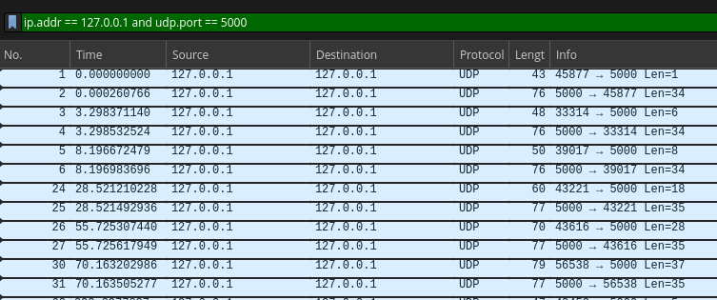
Sl no. | Src | Dest | Application Data Length | UDP Length | UDP Checksum | IP total length
1 | 45877 | 5000 | 1 | 9 | 0xfe20 | 33
2 | 5000 | 45877 | 34 | 42 | 0xfe3d | 62
3 | 33314 | 5000 | 6 | 14 | 0x0204 | 1028
4 | 5000 | 33314 | 34 | 42 | 0xfe3d | 62
5 | 39017 | 5000 | 8 | 16 | 0x252c | 10028
6 | 5000 | 39017 | 34 | 42 | 0xfe3d | 62
7 | 43221 | 5000 | 18 | 26 | 0xfe2d | 46
8 | 5000 | 43221 | 35 | 43 | 0xfe3e | 63
9 | 43616 | 5000 | 28 | 36 | 0xfe37 | 56
10 | 5000 | 43616 | 35 | 43 | 0xfe3e | 63
11 | 56538 | 5000 | 37 | 45 | 0xfe40 | 65
12 | 5000 | 56538 | 35 | 43 | 0xfe3e | 63

As we can notice from this table, the UDP length is always 8 more than the Application Data Length. 8 bytes have to be then the header length for UDP.

And we verify that UDP Length = UDP Header Length + Application Data Length.
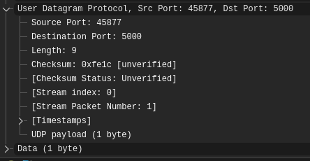
Step 3:
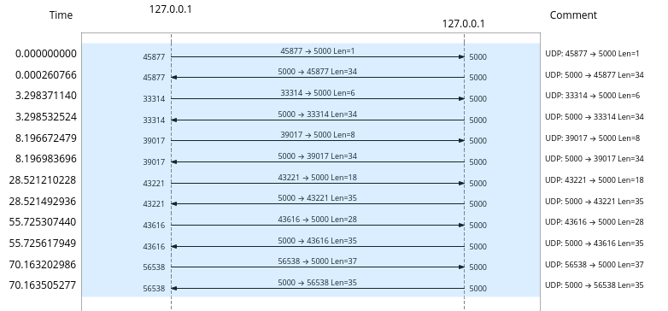

Step 4:
Sending 3 messages, 1 short (5 bytes), 1 medium (1000 bytes), and 1 large (10000 bytes) we capture the following
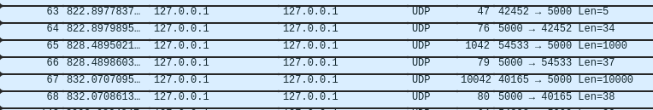
Stream Index | Source | Destination | Length
26 | 42452 | 5000 | 5
26 | 5000 | 42452 | 34
27 | 54533 | 5000 | 1000
27 | 5000 | 54533 | 37
28 | 40165 | 5000 | 10000
28 | 5000 | 40165 | 38

Observations:
In TCP, if a client sends multiple messages one after the other, the server cannot differentiate between the messages because TCP doesn’t preserve message boundaries. As UDP is connectionless, every message is treated as its own unit with their own headers.

Step 5:
After stopping the server and sending a message from one of the clients, we capture this
1. Whether the UDP client can still send the datagram.
UDP is connectionless. The client does not need to establish a connection before transmitting a datagram.
2. Whether any UDP acknowledgment is received.
UDP does not contain a transport-layer acknowledgment mechanism.
The response received when the server is running is an application-level response, not a UDP ACK.
3. Whether an ICMP message is generated.
When the destination UDP port is closed/unavailable, the operating system can generate an ICMP Destination Unreachable message.
4. If an ICMP message is generated, record its Type and Code and explain its meaning.
Type 3 → Destination Unreachable
Code 3 → Port Unreachable
This indicates that there is no server listening on the destination UDP port.

