Assignment 3

Experiment 1: TCP Flag Behaviour Analysis

Aim
To study how a receiving TCP implementation responds to different combinations of TCP flags by crafting TCP segments using Scapy, sending them to a specified destination IP address and TCP port, and analysing the responses using Wireshark.

Theory
TCP flags control connection establishment, acknowledgment, termination, and reset behaviour.
The experiment examines five TCP flag combinations:
- Synchronize (SYN) -> Initiates a TCP connection
- Acknowledgment (ACK) -> Acknowledges received TCP data or control information
- Finish + Acknowledgment (FIN + ACK) -> Requests an orderly connection termination
- Reset (RST) -> Resets or rejects a TCP connection
- Synchronize + Finish (SYN + FIN) -> An unusual combination requesting conflicting TCP actions
The response depends on the destination port's state, the receiving system's TCP implementation, firewall rules, and whether a matching connection already exists.
- An open port responds to a SYN with SYN+ACK.
- A closed port responds to a SYN with RST+ACK.
- A packet that does not belong to an existing connection may be reset or silently discarded, depending on its flags and the system's behaviour.
- Invalid or unusual flag combinations may be rejected, ignored, or handled differently by different implementations.

Source Code
import sys
from scapy.layers.inet import ICMP, IP, TCP
from scapy.sendrecv import sr1
from scapy.volatile import RandShort

def analyze_tcp_flags(dst_ip, dst_port):
test_flags = {"SYN": "S", "ACK": "A", "FIN+ACK": "FA", "RST": "R", "SYN+FIN": "SF"}
src_port = RandShort()
timeout_val = 2
print(f"\nTarget: {dst_ip}:{dst_port}")
print("-" * 50)
for flag_name, flag_val in test_flags.items():
print(f"[*] Sending {flag_name} (Flags: {flag_val}) segment...")
packet = IP(dst=dst_ip) / TCP(sport=src_port, dport=dst_port, flags=flag_val)
reply = sr1(packet, timeout=timeout_val, verbose=0)
if reply is None:
print(" -> No response received within the timeout period (Dropped/Filtered).\n")
elif (tcp_layer := reply.get_layer(TCP)) is not None:
print(f" -> Received TCP response. Flags: {tcp_layer.flags}\n")
elif (icmp_layer := reply.get_layer(ICMP)) is not None:
print(f" -> Received ICMP response. Type: {icmp_layer.type}, Code: {icmp_layer.code}\n")
else:
print(f" -> Received other type of response: {reply.summary()}\n")

if __name__ == "__main__":
try:
target_ip = input("Enter destination IP address: ")
target_port = int(input("Enter destination TCP port number: "))
analyze_tcp_flags(target_ip, target_port)
except ValueError:
print("Invalid port number. Please enter an integer.")
except KeyboardInterrupt:
print("\nExperiment aborted.")
sys.exit(0)

Output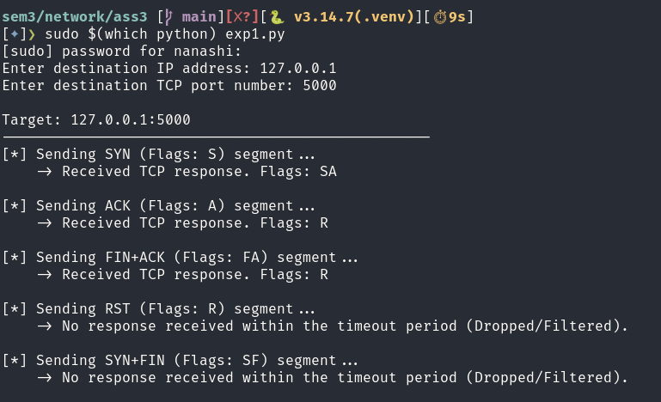

Wireshark Verification
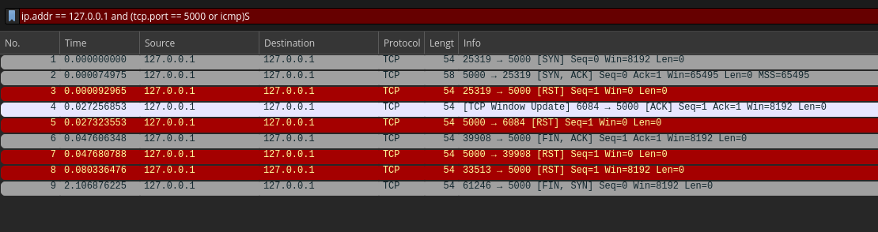

Observations
Sent Flags | Received Flags | Explanation
SYN | SYN + ACK | Because the port is open and listening, the server accepts the request to initiate a 3-way handshake and reserves resources for the incoming connection.
ACK | RST | Even though the port is open, we are acknowledging data for a specific connection that hasn't been established yet. The OS rejects this "out-of-state" packet.
FIN + ACK | RST | Attempted to gracefully close a connection. Because the target has no established connection with your source port, it cannot "finish" it, resulting in a Reset.
RST | No Response | The OS dropped this packet. TCP stacks are hardcoded to never respond to an RST packet to prevent infinite loops of resets bouncing across the network.
SYN + FIN | No Response | This is an invalid packet (asking to open and close a connection simultaneously). Many modern TCP stacks (like Linux) will simply process the SYN, ignore the anomalous FIN, and send a SYN+ACK. Stricter systems or firewalls will detect the anomaly and silently drop the packet.

Experiment 2: TCP Sequence and Acknowledgment Number Experiment

Aim
To study the relationship between TCP sequence numbers and acknowledgment numbers by crafting a TCP SYN segment, receiving a SYN+ACK response, and manually constructing the final ACK segment using Scapy. The complete exchange is verified using Wireshark.

Theory
TCP uses sequence and acknowledgment numbers to ensure reliable, ordered data transmission.
- Sequence number (SEQ) -> Identifies the position of a segment's data in the TCP byte stream.
- Acknowledgment number (ACK) -> Indicates the next sequence number expected from the other endpoint.
- Initial Sequence Number (ISN) -> The starting sequence number selected by a TCP endpoint when establishing a connection.
- Three-way handshake -> The process of establishing a TCP connection using SYN, SYN+ACK, and ACK segments.
The handshake follows these rules:
Segment | Sequence number | Acknowledgment number
Client → Server: SYN | Client ISN | Not valid
Server → Client: SYN+ACK | Server ISN | Client ISN + 1
Client → Server: ACK | Client ISN + 1 | Server ISN + 1
A SYN consumes one sequence number even though it carries no application data. Therefore, both endpoints acknowledge the other endpoint's SYN by adding one to its sequence number.

Source Code
import random
import sys
from scapy.layers.inet import ICMP, IP, TCP
from scapy.sendrecv import send, sr1

def main():
dst_ip = input("Enter destination IP address: ").strip()
try:
dst_port = int(input("Enter destination TCP port: "))
if not 1 <= dst_port <= 65535:
raise ValueError
except ValueError:
print("Invalid TCP port.")
sys.exit(1)
src_port = random.randint(49152, 65535)
client_isn = random.randint(0, 2**32 - 1)
timeout = 3
print("\n--- Sending SYN ---")
print(f"Client ISN = {client_isn}")
syn = IP(dst=dst_ip) / TCP(sport=src_port, dport=dst_port, flags="S", seq=client_isn)
response = sr1(syn, timeout=timeout, verbose=0)
if response is None:
print("No response received.")
return
if response.haslayer(TCP):
tcp = response[TCP]
print(f"Response TCP flags = {tcp.flags}")
if int(tcp.flags) & 0x04: # RST flag
print("Connection refused/reset; no SYN+ACK.")
return
if not (int(tcp.flags) & 0x02 and int(tcp.flags) & 0x10):
print("Response is not SYN+ACK.")
return
server_isn = tcp.seq
received_ack = tcp.ack
expected_client_ack = (client_isn + 1) % (2**32)
expected_server_ack = (server_isn + 1) % (2**32)
print("\n--- Results ---")
print(f"Client ISN = {client_isn}")
print(f"Server ISN = {server_isn}")
print(f"SYN+ACK acknowledgment = {received_ack}")
print(f"Expected client acknowledgment = {expected_client_ack}")
if received_ack != expected_client_ack:
print("Unexpected SYN+ACK acknowledgment number.")
return
ack = IP(dst=dst_ip) / TCP(sport=src_port, dport=dst_port, flags="A", seq=expected_client_ack, ack=expected_server_ack,)
print("\n--- Sending final ACK ---")
ack.show()
send(ack, verbose=0)
print("Final ACK sent.")
print(f"ACK segment SEQ = {expected_client_ack}")
print(f"ACK segment ACK = {expected_server_ack}")
elif response.haslayer(ICMP):
icmp = response[ICMP]
print(f"ICMP Type = {icmp.type}, Code = {icmp.code}")
else:
print("Unexpected response:", response.summary())

if __name__ == "__main__":
main()

Output
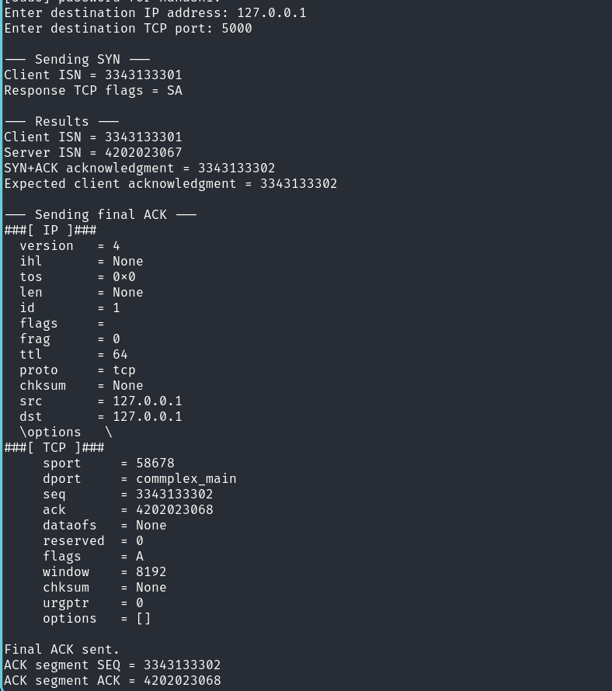

Wireshark Verification
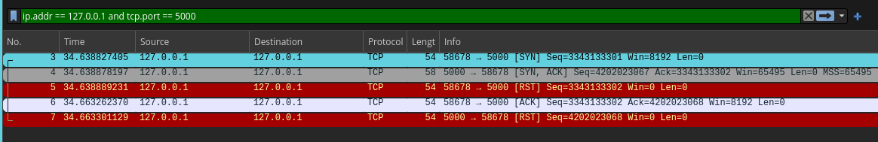

Observation
Packet | Direction | Flags | SEQ | ACK
1 | Client -> Server | SYN | 3343133301 | —
2 | Server -> Client | SYN + ACK | 4202023067 | 3343133302
3 | Client -> Server | ACK | 3343133302 | 4202023068

Conclusion
The client initiates the connection using the initial sequence number C. The server responds with its own initial sequence number S and acknowledges the client's SYN with C+1. The client then sends an ACK with sequence number C+1 and acknowledgment number S+1, acknowledging the server's SYN.
A SYN consumes one sequence number because TCP treats the SYN as occupying a position in the sequence space, even though it contains no application payload. Consequently, the acknowledgment advances by one. TCP data segments, in contrast, advance the sequence number by the number of payload bytes transmitted.

Experiment 3: ICMP TTL and Hop-Limit Investigation

Aim
To investigate how the IP Time To Live (TTL) field affects packet delivery by sending ICMP Echo Request packets with progressively increasing TTL values, analysing the responses, and identifying the routers along the path to a destination using Scapy and Wireshark.

Theory
Time To Live (TTL) is a field in the IPv4 header that limits how many router hops a packet can traverse before being discarded.
- The sender sets an initial TTL value in the IP header.
- Each router that forwards the packet decreases the TTL by at least one.
- When the TTL expires, a router typically discards the packet and sends an ICMP Time Exceeded message (Type 11, Code 0) to the sender.
- When an ICMP Echo Request reaches the destination, the destination may respond with an ICMP Echo Reply (Type 0, Code 0).
By sending packets with TTL values of 1, 2, 3, and so on, we can discover successive responding routers along the path.
- Echo Reply (Type 0, Code 0) -> Destination responded to the echo request
- Destination Unreachable (Type 3, Code Varies) -> Delivery failed for a reported reason
- Time Exceeded (Type 11, Code 0) -> TTL expired during forwarding
A router may not respond because of firewall rules, ICMP filtering, or rate limiting. Therefore, the responding IP addresses may not reveal every router on the path.

Source Code
import sys
from scapy.layers.inet import ICMP, IP
from scapy.sendrecv import sr1
def main():
dst_ip = input("Enter destination IP address: ").strip()
try:
max_ttl_input = input("Enter maximum TTL (1-64, default 30): ").strip()
max_ttl = int(max_ttl_input or "30")
if not 1 <= max_ttl <= 64:
raise ValueError
except ValueError:
print("Invalid maximum TTL. Enter a value from 1 to 64.")
sys.exit(1)
timeout = 3
print("\nTTL\tResponding IP\t\tICMP Type\tICMP Code")
print("-" * 65)
for ttl in range(1, max_ttl + 1):
packet = IP(dst=dst_ip, ttl=ttl) / ICMP(type=8, code=0)
try:
response = sr1(packet, timeout=timeout, verbose=0)
except PermissionError:
print("Permission denied. Run with sudo/root.")
sys.exit(1)
except OSError as exc:
print(f"Could not send packet at TTL {ttl}: {exc}")
continue
if response is None:
print(f"{ttl}\t*\t\t\t-\t\t- (timeout)")
continue

responder = response[IP].src if response.haslayer(IP) else "Unknown"
if response.haslayer(ICMP):
icmp_type = int(response[ICMP].type)
icmp_code = int(response[ICMP].code)
print(f"{ttl}\t{responder}\t\t{icmp_type}\t\t{icmp_code}")
if icmp_type == 0 and icmp_code == 0:
print("\nDestination reached.")
break
if icmp_type == 3:
print("Destination Unreachable received.")
break
else:
print(f"{ttl}\t{responder}\tOther response")
print("\nExperiment completed.")

if __name__ == "__main__":
main()

Output
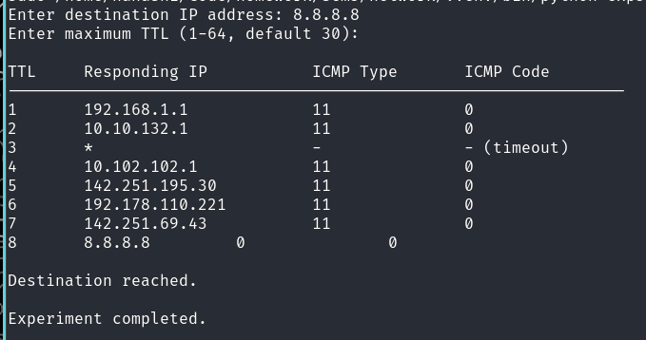

Wireshark Verification
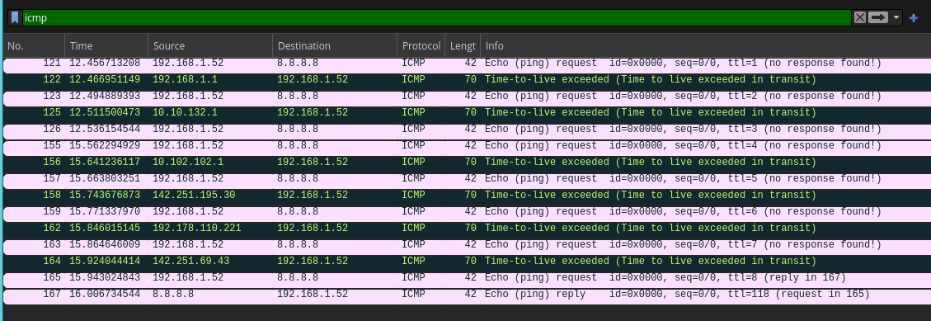

Observation
TTL | Responding IP | ICMP Type | ICMP Code | Observation
1 | 192.168.1.1 | 11 | 0 | First hop; TTL expired
2 | 10.10.132.1 | 11 | 0 | Second hop; TTL expired
3 | * | — | — | No response received (timeout)
4 | 10.102.102.1 | 11 | 0 | Fourth hop; TTL expired
5 | 142.251.195.30 | 11 | 0 | Fifth hop; TTL expired
6 | 192.178.110.221 | 11 | 0 | Sixth hop; TTL expired
7 | 142.251.69.43 | 11 | 0 | Seventh hop; TTL expired
8 | 8.8.8.8 | 0 | 0 | Echo Reply; Destination reached

How does this determine the router sequence?
When a packet's TTL reaches zero during forwarding, a router typically discards it and returns an ICMP Time Exceeded message. Increasing the TTL allows the packet to travel farther:
- TTL = 1 generally reveals the first responding router.
- TTL = 2 generally reveals the second responding router.
- TTL = 3 generally reveals the third responding router.
- This continues until the destination responds or the maximum TTL is reached.
This mechanism forms the basis of traceroute. However, it identifies responding interfaces, not necessarily every router, and the return path may differ from the forward path.

Experiment 4: UDP Response and ICMP Port-Unreachable Analysis

Aim
To investigate UDP response behaviour by sending UDP datagrams with an application payload to a range of destination ports using Scapy, analysing the responses, and distinguishing between UDP replies, ICMP Destination Unreachable messages, and timeouts.

Theory
UDP (User Datagram Protocol) is a connectionless transport-layer protocol. Unlike TCP, it does not establish a connection before sending data and does not guarantee delivery or acknowledgment.
In this experiment, UDP datagrams are sent to destination ports, and the resulting responses are classified into three categories:
- UDP response received -> An application or service returned a UDP datagram
- ICMP Type 3, Code 3 -> Destination port is unreachable; commonly indicates a closed UDP port
- No response (timeout) -> No matching response was received within the timeout period
ICMP Type 3 indicates Destination Unreachable. Code 3 specifically indicates Port Unreachable. A timeout is inconclusive: the port may be open but silent, or the request or response may have been filtered or lost.

Source Code
import random
import sys
from scapy.layers.inet import ICMP, IP, TCP, UDP
from scapy.packet import Raw
from scapy.sendrecv import sr1

def main():
dst_ip = input("Enter destination IP address: ").strip()
try:
start_port = int(input("Enter starting UDP port: "))
end_port = int(input("Enter ending UDP port: "))
if not (1 <= start_port <= 65535 and 1 <= end_port <= 65535 and start_port <= end_port):
raise ValueError
except ValueError:
print("Invalid port range.")
sys.exit(1)
src_port = random.randint(49152, 65535)
timeout = 3
payload = b"UDP Experiment 4"
print(f"\nDestination: {dst_ip}")
print(f"UDP port range: {start_port}-{end_port}")
print("\nPort\tResult\t\t\tDetails")
print("-" * 65)
for dst_port in range(start_port, end_port + 1):
packet = (IP(dst=dst_ip) / UDP(sport=src_port, dport=dst_port) / Raw(load=payload))
try:
response = sr1(packet, timeout=timeout, verbose=0)
except PermissionError:
print("Permission denied. Run with sudo/root.")
sys.exit(1)
except OSError as exc:
print(f"{dst_port}\tSend error: {exc}")
continue
if response is None:
print(f"{dst_port}\tNo response\t\tTimeout")
elif response.haslayer(ICMP):
icmp = response[ICMP]
icmp_type = int(icmp.type)
icmp_code = int(icmp.code)
if icmp_type == 3 and icmp_code == 3:
result = "Port unreachable"
elif icmp_type == 3:
result = "Destination unreachable"
else:
result = "ICMP response"
print(f"{dst_port}\t{result}\tType={icmp_type}, Code={icmp_code}")
elif response.haslayer(UDP):
udp = response[UDP]
print(f"{dst_port}\tUDP response\t\tSource port={udp.sport}")
elif response.haslayer(TCP):
print(f"{dst_port}\tUnexpected TCP response")
else:
print(f"{dst_port}\tOther response\t\t{response.summary()}")
print("\nExperiment completed.")

if __name__ == "__main__":
main()

Output
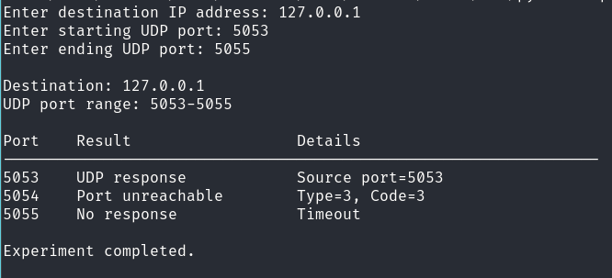

Wireshark Verification
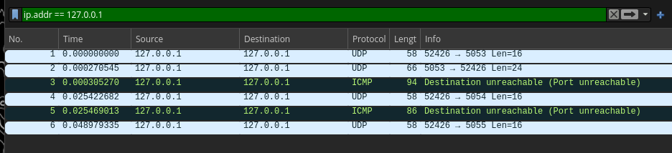

Observation
Destination | Response | ICMP Type | ICMP Code | Interpretation
5053 | UDP response | — | — | UDP service responded
5054 | ICMP Port Unreachable | 3 | 3 | Port reported unreachable
5055 | Timeout | — | — | No response received

Conclusion
TCP provides clearer feedback during connection establishment. For example, a TCP SYN commonly receives SYN+ACK from an open listening port or RST+ACK from a closed port.
UDP has no connection-establishment handshake. An application may respond to a datagram, a closed port may generate ICMP Port Unreachable, or a service or firewall may silently discard the packet. Consequently, a timeout cannot reliably distinguish an open but silent UDP service from a filtered or otherwise unresponsive port.

