WIMScare
Welfare Information Management System
A Multi-Tenant Contribution and Claims Management Platform for Welfare Associations

PROJECT DOCUMENTATION
Prepared by: Prince Charles Appiah
July 2026

DEDICATION
This documentation is dedicated to every volunteer treasurer, secretary and committee member who keeps a welfare association running on trust, a notebook and good faith — and to everyone who believes that better tools should make that work easier, not harder.

ACKNOWLEDGEMENT
I acknowledge everyone whose feedback, testing and domain knowledge shaped the requirements behind WIMScare, and everyone who reviews this documentation and offers the corrections and questions that make it more accurate and more useful.

TABLE OF CONTENTS
CHAPTER 1: PROJECT INTRODUCTION 7
1.1 What is a Welfare Information Management System? 7
1.2 Background of Study 7
1.3 Statement of the Problem 8
1.4 Project Aims 8
1.5 Project Objectives 8
1.6 Scope of the Project 9
1.7 Significance of the Project 10
1.8 Research Questions 11
1.9 Project Motivation 11
1.10 Overview Description of the Project 11
CHAPTER 2: APPROACHES TO WELFARE AND CONTRIBUTION MANAGEMENT 13
2.1 Approaches to Welfare and Contribution Management 13
2.2 Manual Ledger-Based Management 13
2.3 Spreadsheet-Based Management 13
2.4 Technology in Welfare Management 13
2.5 Mobile Money and Digital Payments 14
2.6 Document Management and Verification 14
2.7 Computers, Laptops and Mobile Devices 14
2.8 Communication Channels 14
2.9 Mobile Applications 14
2.10 Membership Management 15
2.11 Financial and Accounting Technology 15
2.12 Communication Technology 15
2.13 Welfare Management System 15
2.14 Computer-Aided Claims Assessment 15
CHAPTER 3: REVIEW OF LITERATURE AND TOOLS 17
3.1 Review of Related Works 17
3.1.1 Wild Apricot 17
3.1.2 QuickBooks Online 17
3.1.3 SusuPaa 17
3.1.4 SikaCircle 17
3.1.5 SUSU CRM 18
3.2 Case Study 18
3.2.1 Abstract 18
3.2.2 Background of Research 18
3.2.3 Is It New? 18
3.2.4 Implementation 19
3.2.5 Challenges 19
3.2.6 Advantages and Disadvantages 19
3.2.7 Challenges and Solutions 20
CHAPTER 4: METHODOLOGY 21
4.1 Abstract 21
4.2 Project Overview 21
4.3 Data Collection 21
4.4 User Class and Characteristics 21
4.4.1 Superadmin 21
4.4.2 Administrator 22
4.4.3 Supervisor and Accountant (Staff) 22
4.4.4 Member 22
4.5 Data Flow Diagram 22
4.6 Project Management Tools 23
4.7 Requirement Specifications 23
4.7.1 Hardware Requirements 23
4.7.2 Software Requirements 24
4.7.3 Functional System Requirements 24
4.7.3.1 Functional System Requirements (Admin) 24
4.7.3.2 Functional System Requirements (Supervisor / Accountant) 24
4.7.3.3 Functional System Requirements (Member) 24
4.7.4 Functional User Requirements 24
4.7.4.1 Functional User Requirements (Staff — Supervisor/Accountant) 24
4.7.4.2 Functional User Requirements (Member) 25
4.7.4.3 Functional User Requirements (Admin) 25
4.7.5 Non-Functional Requirements 25
4.7.6 Operational Requirements 25
4.7.7 Ethical Requirements 25
4.7.8 Regulatory Requirements 26
4.8 Unified Modeling Language (UML) 26
4.8.1 Use Case Diagram 26
4.8.2 Sequence Diagram 28
4.8.3 Activity Diagram 29
CHAPTER FIVE: PRODUCT DESIGN 30
5.1 Introduction 30
5.2 Interfaces of the Project 30
5.2.1 Member Interface 30
5.2.2 Admin Console Interface (Administrator / Supervisor / Accountant) 30
5.2.3 Developer (Superadmin) Interface 31
5.3 Components Design 31
5.3.1 User Interface 31
5.3.2 User Design 31
CHAPTER SIX: IMPLEMENTATION AND TESTING 33
6.1 System Description 33
6.1.1 Admin Console Application 33
6.1.2 Member Application 33
6.1.3 Developer (Superadmin) Application 33
6.1.4 Major Features 33
6.2 Implementation Support 33
6.2.1 Tools and Libraries 33
6.3 Database Implementation 34
6.3.1 Entity-Relationship Model 34
6.3.2 Class Diagram 36
6.4 Security Implementation 37
6.5 Testing 38
6.5.1 Unit-Level Testing 38
6.5.2 System Testing 39
6.6 Deployment Architecture and Scalability Considerations 41
CHAPTER SEVEN: CONCLUSION AND RECOMMENDATION 42
7.1 Conclusion 42
7.2 Overall Experience 42
7.3 Limitation 42
7.4 Scope for Future Works 43
7.5 Recommendation 43

CHAPTER 1: PROJECT INTRODUCTION

1.1 What is a Welfare Information Management System?
A welfare information management system is software that lets a members' association — a workplace welfare club, a church or community welfare society, a cooperative susu group, or a similar mutual-aid body — record who its members are, collect and track their periodic contributions (dues), receive and process claims for support (bereavement, medical, marriage, education and similar benefits), and keep an auditable financial record of everything that moves in and out of the association's funds.
Traditionally these associations run on paper ledgers, exercise books and spreadsheets kept by a treasurer or secretary. Contribution records live in one book, claim requests are handwritten and approved by whoever is around to sign, and there is no single, tamper-evident record of who approved what, when a member last paid, or how much of the welfare fund is committed to pending claims. As membership grows past a few dozen people, this manual approach becomes slow, error-prone and difficult to audit, and it offers no self-service channel for members to check their own contribution history or the status of a claim they have submitted.
WIMScare — the Welfare Information Management System documented in this report — digitises this process. It is a multi-tenant web application: a single deployment can host many independent welfare associations ("organizations"), each with its own members, staff, funds, contribution history, claim types and branding, completely isolated from every other organization on the platform.

1.2 Background of Study
WIMScare was built to replace the spreadsheet-and-notebook workflow described above with a structured, role-aware system. The core idea is a contribution tracker joined to a claims workflow and a double-entry accounting ledger, so that every cedi collected from a member and every cedi paid out as a benefit is traceable to a receipt, an approval chain, and a ledger posting.
The system is designed around a small association's real organisational structure rather than a generic "admin/user" split. It recognises that a welfare association typically has:
- a small executive/administrative team that runs the organisation (the Administrator),
- a supervisory role that reviews contributions and claims before they reach the administrator (the Supervisor),
- a finance role that records payments, prepares payouts and manages the books (the Accountant),
- ordinary Members who pay dues and submit claims, and
- in WIMScare's case, because the system is offered as a hosted product to multiple associations, a platform-level Superadmin who provisions organisations, issues licenses and operates the platform itself.

1.3 Statement of the Problem
Welfare associations that rely on manual or spreadsheet-based record keeping face several recurring problems:
Contribution records are kept in disconnected books or spreadsheets, so producing an accurate, up-to-date statement of a member's payment history or the association's cash position takes manual reconciliation.
Claims for benefits (bereavement, medical support, and similar) are approved informally, with no consistent workflow, no enforced eligibility rules (minimum membership period, arrears status, annual claim caps), and no document trail proving what was submitted and who approved it.
There is no separation between recording a transaction and authorising it — the same person who records a contribution or prepares a payment can also approve or reverse it, which is a control weakness.
Members have no self-service visibility into their own contribution history, claim status, or profile information, and must ask the treasurer directly for anything they want to know.
There is no backup or disaster-recovery process for the association's records; a lost notebook or corrupted spreadsheet can mean the permanent loss of financial history.
WIMScare addresses each of these gaps directly: it centralises contributions and claims in one system, enforces a configurable claim-eligibility and approval workflow, separates "prepare" from "approve"/"pay" duties in both claims and accounting, gives every member a self-service portal, and produces automatic, restorable backups of an organisation's data.

1.4 Project Aims
The aim of the project is to design and implement a secure, multi-tenant, role-based web application that allows welfare associations to manage member records, track contributions, process benefit claims through a configurable approval workflow, and maintain a transparent, auditable accounting ledger of all fund movements — replacing manual, paper-based welfare administration.

1.5 Project Objectives
1. To design a multi-tenant data model in which every welfare association ("organization") is fully isolated from every other organization sharing the platform.
2. To implement role-based access control for five user roles — superadmin, admin, supervisor, accountant and member — with an additional layer of fine-grained, per-user permission overrides.
3. To build a member contribution module that records payments against receipt numbers, payment modes and dates, and supports bulk entry, reversal requests and exports to Excel, CSV and PDF.
4. To build a claims module that carries a claim from draft through submission, review, approval/rejection, document-review and payout, with a configurable approval chain per claim type and a full activity timeline per claim.
5. To implement a double-entry accounting ledger that automatically posts entries for contributions, claim payouts, reversals and manual adjustments, organised by fund account.
6. To implement a licensing model that lets the platform operator (superadmin) control which features and capacity tiers each organization has access to.
7. To implement automated and on-demand backup/restore of an organization's data.
8. To provide separate, purpose-built web interfaces for members, association staff (admin/supervisor/accountant) and the platform superadmin.
9. To secure the system with authenticated, cookie-based sessions, hashed passwords, tenant-scoped queries and audit logging of sensitive actions.

1.6 Scope of the Project
WIMScare covers the full lifecycle of welfare-association administration for a single deployment serving multiple organizations:
In scope:
- Organization onboarding (self-registration of a new organization and its first administrator, or superadmin-created organizations).
- User lifecycle: invitation, email-token activation, login (including disambiguation when the same email belongs to more than one organization), password reset, and role/permission management.
- Member profile management: personal details, bank/mobile-money details, emergency contact and dependants ("family members" who may be marked as beneficiaries), and profile photo.
- Contribution recording, statistics, bulk entry, reversal requests, and export to XLSX/CSV/PDF.
- Claim types configuration (benefit limit, limit period, waiting period, maximum claims per year, required documents, approval chain).
- Claim submission, document upload, multi-step review/approval, a separate "prepare payout / release payout" disbursement workflow, and rejection/withdrawal.
- Accounting: a chart-of-accounts ledger, fund accounts, operating-expense/reimbursement entries with their own approval workflow, and account balance reporting.
- Reporting: dashboard summaries for both staff and members, and exportable reports.
- Licensing: plan tiers (Free, Standard, Pro) and per-feature flags, seat limits for staff and members, license renewal requests and superadmin issuance/suspension/revocation.
- Backups: manual and nightly scheduled organization backups (as gzipped JSON including uploaded files), downloadable, and destructively restorable.
- A superadmin ("developer") portal for platform-wide oversight: organizations, licenses, backups, system updates and audit trail.
- Branding customization (logo, colours) for organizations on a plan that includes it.
- Reversible account and organization lifecycle management: a member requests deletion of their own account from their administrator, and an administrator requests deletion of their own account or of the whole organization from the superadmin — both gated by an explicit approval step and a confirmation dialog, and implemented as a soft-delete/archive rather than a permanent erasure, so contribution, claim and ledger history is preserved.
- A versioned Terms & Data Policy: acceptance is required by checkbox at registration and at account activation, and any existing account that has not yet accepted the current version is shown a one-time, blocking acceptance prompt the next time it signs in.
Out of scope:
- Native mobile applications (the system is a responsive web application only).
- Online/card payment gateway integration — contributions are recorded by staff after a payment is received by cash, bank transfer or mobile money, rather than collected in-app.
- Multi-currency accounting (the organization has a single configured currency).
- Public multi-tenant self-service billing (license issuance is performed by the superadmin, not purchased automatically).

1.7 Significance of the Project
For a welfare association, WIMScare replaces error-prone manual bookkeeping with a single source of truth for membership, contributions and claims, reducing disputes over who paid what and when. Because every contribution, claim decision and ledger posting is timestamped and attributed to a specific user, the system produces an audit trail that a manual system cannot offer, which strengthens financial accountability to the membership. Members gain a self-service portal to check their own standing and claim status without needing to contact an officer directly. Because the platform is multi-tenant, a single WIMScare deployment can serve many independent associations at once, each configured to its own rules (currency, claim-eligibility rules, claim types, branding), which makes it viable as a shared hosted product rather than a one-off, bespoke build per association.

1.8 Research Questions
1. How can a single web application securely host multiple independent welfare associations while guaranteeing that no organization can see or affect another organization's data?
2. What role and permission model best fits the real division of Labour inside a small association (administrator, supervisor, accountant, member) without over-engineering the access-control system?
3. How should a claims-approval workflow be structured so that it is configurable per benefit type, enforces eligibility rules automatically, and still leaves a clear separation between approving a claim and paying it out?
4. What accounting structure is simple enough for non-accountant volunteers to use, while still producing a correct, auditable double-entry ledger?
5. How can an association's data be protected against loss, given that these organizations typically do not have dedicated IT support?

1.9 Project Motivation
Welfare and mutual-aid associations are common in many communities, but the software available to run them is either generic spreadsheet templates or accounting packages that were never designed for the specific combination of membership dues, benefit-claim workflows and small-committee approval structures these groups use. The motivation for WIMScare was to build a purpose-fit system for this specific domain — one that understands what a "claim type" or a "contribution reversal" means to a welfare association — and to make it available as a multi-tenant product so that the effort of building it benefits many associations rather than one.

1.10 Overview Description of the Project
WIMScare is a Node.js/Express server backed by MongoDB, serving a set of role-specific vanilla HTML/CSS/JavaScript front ends over the same origin: a member portal (dashboard, claims, profile, preferences), an admin console (dashboard, users, invitations, permissions, contributions, claims processing, claim-type configuration, accounts, reversals, reports, organization profile) shared by the admin/supervisor/accountant roles with role-appropriate visibility, and a developer portal used exclusively by the platform superadmin to manage organizations, licenses, backups and system-wide announcements.
Authentication is session-based via a JSON Web Token stored in an HTTP-only cookie. Every tenant-scoped database query is filtered by `organizationId`, so the same codebase and database serve every organization without any risk of cross-tenant data leakage. A scheduled job sweeps expired licenses and invitations hourly and takes a full backup of every active organization nightly. The remaining chapters of this report describe the domain background, related tools, the methodology and requirements behind the system, its interface and component design, its implementation and testing, and finally the conclusions and recommendations drawn from building it.

CHAPTER 2: APPROACHES TO WELFARE AND CONTRIBUTION MANAGEMENT

2.1 Approaches to Welfare and Contribution Management
Welfare associations manage the same underlying problem — collecting dues, tracking membership standing and paying out benefits — through a range of approaches that differ mainly in how much of the process is manual versus system-enforced. These range from paper registers kept by a treasurer, through general-purpose spreadsheets, to purpose-built software such as WIMScare that encodes the association's rules directly into the system. This chapter surveys these approaches and the underlying technologies they depend on, before Chapter 3 reviews specific existing tools.

2.2 Manual Ledger-Based Management
The oldest and still most common approach is a physical ledger or exercise book in which a treasurer records each member's payments by hand, and a separate minute book records claim approvals decided at committee meetings. This approach requires no technology investment and is easy for non-technical volunteers to operate, but it does not scale: cross-referencing a member's payment history against arrears rules, or checking whether a claim type's annual limit has already been used, requires manually searching past entries. There is also a single point of failure — the physical book — and no built-in mechanism for a second person to verify an entry without physically inspecting the same book.

2.3 Spreadsheet-Based Management
Many associations graduate from paper to a spreadsheet (commonly Microsoft Excel or Google Sheets), using one sheet per year or per contribution type, and manually calculated formulas for running totals. This improves speed of calculation and makes it possible to filter and sort records, but it inherits most of the weaknesses of the paper approach: there is no access control (anyone with the file can edit any row), no enforced workflow (nothing stops a single person from both entering a payment and marking a claim approved), and version control is usually informal — file copies named "contributions_final_v3.xlsx" being a familiar failure mode. Spreadsheets also do not naturally support a self-service member portal.

2.4 Technology in Welfare Management
Purpose-built software addresses these gaps by combining a persistent database, defined user roles, and enforced business rules (eligibility checks, approval chains, double-entry postings) into one system that every stakeholder accesses through their own account. WIMScare sits in this category: contributions, claims and accounting are all stored in a shared MongoDB database and accessed only through role- and permission-gated API endpoints, so no single interaction can bypass the association's configured workflow.

2.5 Mobile Money and Digital Payments
In many of the communities welfare associations serve, mobile money (e.g. MTN Mobile Money, Vodafone Cash) is now as common a payment channel as cash or bank transfer. A welfare management system needs to record which channel a contribution or payout moved through, because each channel reconciles against a different real-world account. WIMScare models this directly: `PaymentMode` records are configured per organization and mapped to a ledger account (`cash`, `bank`, or `mobile_money`), member profiles capture a mobile-money provider and number for receiving benefit payouts, and both contributions and claim disbursements record which payout account was used.

2.6 Document Management and Verification
Claims for benefits such as medical or bereavement support typically require supporting evidence — a death certificate, a hospital bill, an invitation card. A digital system needs a secure way to accept, store and later retrieve these documents against the claim they support. WIMScare accepts PDF and image uploads (up to 8 MB, up to ten files) against a claim, storing them under an organization-scoped, non-web-accessible upload directory, and exposes a download endpoint gated by the same authentication and tenant checks as every other route.

2.7 Computers, Laptops and Mobile Devices
Because welfare-association officers are volunteers rather than dedicated IT staff, the tools they use to run the system must work on whatever device they already have — most often a shared office laptop for the treasurer, and a personal smartphone for members checking their status. WIMScare is delivered as a single responsive web application (no native app to install), so it runs in any modern browser on desktop or mobile without a separate mobile codebase to maintain.

2.8 Communication Channels
Timely communication — a receipt after a contribution, a notification when a claim's status changes, an activation link for a new account — keeps members engaged with the system rather than needing to ask an officer directly. WIMScare sends transactional email (via SMTP through Nodemailer) for account activation, password reset, contribution receipts and claim status changes; in development, where no SMTP server is configured, these emails are printed to the server console instead of being sent, so the flow can still be tested end-to-end.

2.9 Mobile Applications
A dedicated native mobile app is a heavier engineering and maintenance commitment than a responsive website, and for an association's relatively low daily transaction volume (a handful of contributions and claims per day) it is rarely justified. WIMScare instead relies on a responsive web front end that mobile users reach through their browser, deferring a native app to future work (see Chapter 7, Scope for Future Works) rather than the initial build.

2.10 Membership Management
Underlying every welfare system is a membership register: who belongs to the association, what role they hold, and whether their account is active. WIMScare's `User` model captures this — first/last name, contact details, a member number, department, role and account status — and separates it from the richer `Profile` model (date of birth, national ID, address, bank/mobile-money details, emergency contact and family/dependants), so that core identity/authentication data and optional personal-profile data can evolve independently.

2.11 Financial and Accounting Technology
Beyond simply logging that money moved, a credible welfare system needs to show where it moved from and to, in a form an external auditor would recognise. This is the domain of double-entry bookkeeping — every transaction is recorded as a debit in one account and an equal credit in another, so the books always balance. WIMScare implements this through its `LedgerEntry` model, which posts a debit/credit pair for every contribution, claim payout, reversal and manual adjustment, scoped to both a chart-of-accounts category and a named fund account.

2.12 Communication Technology
Role-appropriate visibility is itself a form of internal communication technology: a member should see their own records, a supervisor should see records awaiting their review, and an administrator should see everything for their organization. WIMScare implements this through server-side role checks (`requireRoles`) and a finer per-user permission catalogue (`requirePermission`) layered on top of role defaults, so an administrator can, for example, grant one supervisor extra visibility without changing that person's role.

2.13 Welfare Management System
A welfare management system, in the sense used throughout this report, is the union of the approaches above into one coherent platform: membership records, a configurable claims workflow, a contribution ledger, and role-based access, delivered as a single web application. WIMScare is one instance of this category, built specifically as a multi-tenant system so that one deployment can serve many independent welfare associations, each with data fully isolated by an `organizationId` scope enforced on every query.

2.14 Computer-Aided Claims Assessment
Just as computer-aided assessment automates the marking of a test against defined criteria, WIMScare automates part of claim assessment against the eligibility rules an organization configures: a claim type's benefit limit and limit period (per claim, per year, or lifetime), waiting period since joining, and maximum claims per year. These rules do not remove human judgement from the approval chain — every claim still passes through the configured chain of supervisor/accountant/admin/committee review — but they surface eligibility information (arrears status, membership tenure) to the reviewer automatically, rather than requiring the reviewer to look it up by hand.

CHAPTER 3: REVIEW OF LITERATURE AND TOOLS

3.1 Review of Related Works
Five existing tools were reviewed to understand how the wider market approaches the pieces of WIMScare's problem — general association/membership management, nonprofit-style accounting, and Ghana-specific susu/welfare contribution tracking.

3.1.1 Wild Apricot
Wild Apricot (by Momentive Software) is one of the most widely used membership-management platforms for clubs, associations and nonprofits. It stores a searchable member database in the cloud, automates renewals, invoicing and recurring payments, includes event registration with waitlists and member pricing, a built-in website builder with member-gated content, and a mobile app for administrators. It is a strong general-purpose association-management tool, but it is not domain-specific to welfare associations: it has no concept of a benefit "claim," an approval chain, or a double-entry ledger tied to welfare payouts — its payment features are built around dues invoicing and event fees rather than benefit disbursement.

3.1.2 QuickBooks Online
QuickBooks Online is a general small-business/nonprofit accounting package. Nonprofits use it to track membership dues by creating a dues "service item" linked to an income account, then billing members through invoices or recurring sales receipts, and it supports class/location/project tracking on its Plus tier. It is a capable, standards-compliant bookkeeping tool, but membership and dues tracking is bolted onto a generic invoicing model rather than purpose-built; it has no claims workflow at all, and organizations that need one typically integrate a separate membership tool (e.g. Join It, Findjoo) alongside it.

3.1.3 SusuPaa
SusuPaa is a Ghana-built digital susu/group-savings management product. It tracks member contributions, manages payout cycles, and gives members a self-service portal — the closest of the reviewed tools to WIMScare's contribution-tracking half. It is oriented around rotating-savings ("susu") payout cycles rather than an insurance-style benefit claim with an approval chain and eligibility rules, so it does not cover the claims and accounting-ledger side of WIMScare's scope.

3.1.4 SikaCircle
SikaCircle automates savings-group contributions with direct integration to MTN Mobile Money, Telecel Cash and AirtelTigo Money, aiming for full transparency of group funds collected over these channels. Its mobile-money-first design validates WIMScare's decision to model `cash`/`bank`/`mobile_money` as first-class payout accounts throughout contributions, claims disbursement and the ledger. Like SusuPaa, it is focused on savings-circle payouts, not claims processing or role-separated approval workflows.

3.1.5 SUSU CRM
SUSU CRM is a digital system built for susu vendors, savings groups and cooperatives to manage members, daily contributions and reports, aimed at eliminating disputes between collectors and members over what was paid. It demonstrates the value of an auditable contribution record — the same problem WIMScare solves with receipt numbers and a ledger — but, like the other susu tools, it is built around a collector visiting members daily rather than a committee-run association with multiple staff roles, claim types and a formal claims-approval chain.
Summary. None of the five tools combines all three of WIMScare's core capabilities — role-based multi-staff administration, a configurable benefit-claims workflow with document upload and multi-step approval, and a double-entry accounting ledger — in one product. Wild Apricot and QuickBooks Online cover general association administration and bookkeeping respectively but have no claims concept; the susu-focused Ghanaian tools cover contribution tracking well but are built around rotating-savings payout cycles rather than insurance-style benefit claims. This gap is what WIMScare's combined contribution/claims/ledger design is intended to close.

3.2 Case Study

3.2.1 Abstract
This case study examines the design and use of a claims-and-contributions system for a single welfare association, using WIMScare's seeded demonstration organization ("Unity Welfare Association") as the reference example. It looks at why such a system is needed, whether the approach taken is novel relative to the tools reviewed above, how it was implemented, what challenges arose, and the resulting trade-offs.

3.2.2 Background of Research
Welfare associations of the kind WIMScare targets are typically run by a small, rotating committee of volunteers: an administrator/secretary, one or two supervisors, and an accountant/treasurer, serving anywhere from a few dozen to a few thousand members. Their two core recurring activities are collecting monthly or periodic dues from members, and processing occasional benefit claims (bereavement, medical, marriage/childbirth support, etc.) against those accumulated funds. The research behind WIMScare's design centered on this specific organisational pattern rather than a generic "user manages records" system.

3.2.3 Is It New?
The individual techniques used in WIMScare — role-based access control, double-entry ledgers, multi-tenant SaaS architecture, document upload workflows — are all well established. What is comparatively novel, based on the tools reviewed in section 3.1, is combining them specifically around the welfare-association claim lifecycle: a claim type carries its own benefit limit, waiting period and approval chain; a claim's approval (whether the benefit is granted) is modelled separately from its disbursement (whether and how it has been paid); and every accepted claim automatically posts to the same ledger that contributions post to, so the books stay consistent without a manual reconciliation step. This combination was not found as a single product among the reviewed tools.

3.2.4 Implementation
The reference implementation (Unity Welfare Association, from the project's seed data) configures the standard five roles — superadmin, admin, supervisor, accountant, user — issues a Standard-tier license, and seeds representative claim types (each with its own benefit limit and approval chain), payment modes (cash, bank, mobile money), and a handful of demonstration members, contributions and claims. This let the claims and accounting workflows be exercised end-to-end — draft claim → document upload → submission → review → decision → payout — against realistic data before being used by an actual association.

3.2.5 Challenges
Several design challenges arose during implementation. Modelling tenant isolation correctly, so that a bug in one route could not leak another organization's data, required a discipline of always filtering queries through `organizationId` rather than relying on a single global check. Separating claim approval from claim disbursement — because in practice the person who approves a claim (a supervisor or committee) is often not the person who pays it (the accountant/administrator) — required an additional `disbursement` sub-document on the claim rather than overloading the claim's top-level `status`. Reconciling contribution reversals (a payment recorded in error) against an already-posted ledger entry required a recommend/decide workflow (accountant recommends, administrator decides) rather than allowing a simple delete, to preserve the audit trail. Supporting organizations with very different feature needs — some wanting only claims and contributions, others wanting the full accounting suite — led to the plan/feature-flag licensing model rather than a single fixed feature set.

3.2.6 Advantages and Disadvantages
Advantages: a single system of record for membership, contributions, claims and accounting; enforced separation of duties (recording vs. approving vs. paying); an audit trail for every sensitive action; self-service visibility for members; and multi-tenancy, which lets one deployment serve many associations at a fraction of the cost of a bespoke system per association.
Disadvantages: the system requires an internet-connected device and at least one comfortable computer user per association, which is a real barrier for some volunteer committees; there is no offline mode, so a connectivity outage stops both data entry and member self-service; and because contributions are recorded by staff after the fact rather than collected in-app, WIMScare depends on the association's existing payment channels (cash, bank, mobile money) rather than automating collection itself.

3.2.7 Challenges and Solutions
Challenge | Solution adopted
Cross-tenant data leakage risk in a shared database | Every tenant model carries an indexed `organizationId`; all queries pass through a shared `orgFilter()` helper, and the superadmin's cross-tenant access is explicit via an `X-Org-Id` header rather than implicit.
Same email address used by one person across multiple associations | `User` uses a compound unique index on `{ email, organizationId }`; login detects multiple matching accounts and asks the person which organization to sign into.
Volunteers without deep accounting knowledge need to keep a correct ledger | Ledger postings are generated automatically by the contribution, claim-payout and reversal workflows rather than requiring staff to enter debit/credit pairs by hand; only genuinely ad-hoc transactions use the manual posting endpoint.
Risk of data loss with no dedicated IT support | Automatic nightly backups per organization (gzipped JSON, including uploaded files) plus on-demand manual backups, downloadable and restorable from the admin/developer portals.
Needing different feature sets and capacity limits per organization without separate codebases | A single codebase gated by a per-organization license (plan tier plus additive feature flags) rather than maintaining separate builds.
Letting a member close their own account, or an administrator close their organization, without destroying financial audit history | A request/approve workflow mirroring the license-renewal pattern: members request deletion from their administrator, and administrators request deletion of their own account or the organization from the superadmin — both confirmation-gated and implemented as a soft-delete/archive rather than a physical removal, so contribution, claim and ledger records remain intact.
Ensuring every user has genuinely reviewed how their data is kept, including as the policy itself changes over time | A single TERMS_VERSION constant compared against each user's stored acceptance version: new accounts must accept the current Terms & Data Policy to register or activate, and any existing account is re-prompted once, with a blocking modal, the next time it signs in after the version changes.

CHAPTER 4: METHODOLOGY

4.1 Abstract
This chapter describes how WIMScare was built: the overall project approach, how requirements were gathered, the classes of user the system serves, how data flows through it, the tools used to manage the build, the formal requirement specification, and the UML models (use case, sequence and activity diagrams) that describe its behaviour.

4.2 Project Overview
WIMScare was developed as a server-rendered-data, client-side-rendered web application: an Express.js REST API backed by a MongoDB document database, consumed by a set of role-specific vanilla HTML/CSS/JavaScript front ends served from the same origin. The build followed an iterative approach — core tenancy, authentication and the user model were built first, followed by contributions, then claims and claim types, then the accounting ledger and fund accounts, then reversals, licensing, backups and the superadmin/developer portal, with reporting and profile/preferences features layered in throughout. Each module was implemented as a self-contained Express router (`routes/*.js`) backed by its own Mongoose model(s), which kept later modules (e.g. reversals, fund accounts) additive rather than requiring changes to earlier ones.

4.3 Data Collection
Requirements were derived from direct analysis of how a small welfare association's committee actually operates — the roles it typically fills (secretary/administrator, supervisor, treasurer/accountant), the records it needs to keep (a membership register, a contributions ledger, and a claims/benefits log), and the controls it needs (someone authorising a payment should not be the same person recording it). This domain analysis was supplemented by review of comparable existing tools (Chapter 3) to identify both proven approaches (mobile-money-aware payment tracking, self-service member portals) and gaps the market did not already cover (a combined claims-approval-and-ledger workflow purpose-built for benefit claims rather than savings-circle payouts).

4.4 User Class and Characteristics
WIMScare defines five user roles (`models/User.js`, `ROLES`), each with a distinct set of responsibilities and default permissions (`utils/permissions.js`).

4.4.1 Superadmin
The superadmin is the platform operator, not a member of any single association (`organizationId: null`). They provision organizations, issue and renew licenses, view platform-wide backups and audit logs, publish system updates/release notes, and — via the `X-Org-Id` header — can act on behalf of any organization for support purposes. They pass every role and permission gate in the system.

4.4.2 Administrator
The administrator is the senior officer of a single welfare association. They manage staff and member accounts, configure claim types and claim-eligibility rules, decide reversal requests, make final claims decisions, release claim payouts, manage the organization's profile/branding and system settings, and can perform every action available to supervisors and accountants within their organization.

4.4.3 Supervisor and Accountant (Staff)
Supervisors and accountants are operational staff. Both can record contributions and review claims as part of a configured approval chain. The accountant additionally manages the accounting ledger and fund-account entries, prepares (but cannot release) claim payouts, and can recommend a decision on a reversal request. The supervisor can likewise recommend on reversals and process claims, but — like the accountant — cannot make the final admin-level decision on a claim or a reversal, and cannot release funds. This reflects a deliberate separation of duties: staff who prepare or recommend a transaction are not the same staff who give it final authority.

4.4.4 Member
The member is an ordinary association member. They maintain their own profile (personal details, bank/mobile-money details, emergency contact, dependants), view their own contribution history, and create, document and submit their own benefit claims, tracking each claim's status through its full lifecycle. Members cannot see other members' records or any organization-wide administrative data.

4.5 Data Flow Diagram
Figure 4.1 shows how a request moves through the system: a browser request first passes through global Express middleware (CORS, JSON parsing, cookie parsing, security headers), then — for any authenticated route — the `protect` middleware, which verifies the JWT cookie, loads the user, and pins the request's organization scope. Role and permission middleware then gate the specific action before a route handler reads or writes MongoDB through a Mongoose model, always filtered by `organizationId`. Selected actions (e.g. approving a claim, restoring a backup) additionally write an `AuditLog` entry.
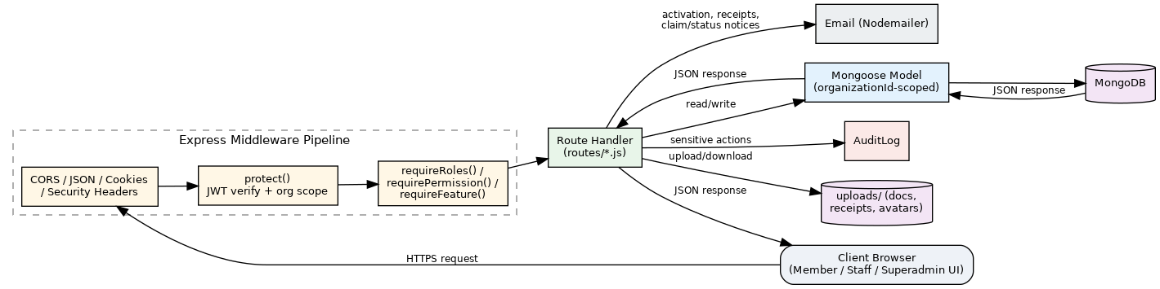
Figure 4.1 — WIMScare request / data flow diagram

4.6 Project Management Tools
The project was built using an iterative, module-by-module workflow consistent with a small, single-developer or small-team build: Git for source control; Visual Studio Code as the primary editor; MongoDB Compass for inspecting and verifying collection data during development; Postman (and the built-in `/api/health` check) for exercising API endpoints outside the browser; `npm` scripts (`dev`, `seed`, `start`) for local iteration, including `scripts/seed.js` to generate a realistic demonstration organization, users, contributions and claims for manual testing; and the project's own `README.md` as a living design reference documenting the folder structure, multi-tenancy rules and key workflows.

4.7 Requirement Specifications

4.7.1 Hardware Requirements
Server: any machine capable of running Node.js 18+ and MongoDB — in production, a small cloud VM (1+ vCPU, 1 GB+ RAM) is sufficient for a single organization or a modest number of tenants; larger deployments scale by increasing RAM/CPU and moving MongoDB to a managed cluster.
Client: any desktop, laptop, tablet or smartphone with a modern web browser and an internet connection; no specific hardware beyond that is required, since the front end is a responsive, vanilla HTML/CSS/JS application with no native client to install.

4.7.2 Software Requirements
Server-side: Node.js (≥ 18), Express 4, MongoDB with Mongoose 8 as the object-data mapper, and the supporting libraries `bcryptjs` (password hashing), `jsonwebtoken` (session tokens), `cookie-parser`, `cors`, `multer` (file uploads), `sharp` (image processing), `node-cron` (scheduled jobs), `nodemailer` (email), `pdfkit` (PDF generation) and `xlsx` (spreadsheet export).
Client-side: any evergreen web browser (Chrome, Edge, Firefox, Safari) with JavaScript enabled; no framework is required as the front end is written in vanilla HTML/CSS/JavaScript.
Development tooling: `npm` for dependency and script management; `dotenv` for environment configuration.

4.7.3 Functional System Requirements

4.7.3.1 Functional System Requirements (Admin)
The system shall allow an administrator to: create and manage user accounts and role/permission assignments; invite staff and members by email; configure claim types (benefit limits, waiting periods, approval chains, required documents); configure payment modes and fund accounts; decide reversal requests; make final decisions on submitted claims and release claim payouts; view and export contribution and accounting reports; manage the organization's profile, branding and system settings; request license renewal; and trigger or restore organization backups.

4.7.3.2 Functional System Requirements (Supervisor / Accountant)
The system shall allow supervisors and accountants to: record member contributions against a payment mode and generate a receipt; review submitted claims and act as a step in the configured approval chain; (accountant only) manage account entries and fund-account ledgers, and prepare claim payouts for administrator release; and (both) recommend a decision on a contribution reversal request.

4.7.3.3 Functional System Requirements (Member)
The system shall allow a member to: view and update their own profile, bank/mobile-money details, emergency contact and dependants; view their own contribution history; create a draft claim, attach supporting documents, and submit it; track a submitted claim's status and timeline through to payout or rejection; and manage their own notification preferences.

4.7.4 Functional User Requirements

4.7.4.1 Functional User Requirements (Staff — Supervisor/Accountant)
Staff users require a dashboard summarising items awaiting their action (pending claims to review, pending reversal recommendations), a searchable contribution ledger, and clear indication of which claims are within their authority to act on versus awaiting another approver.

4.7.4.2 Functional User Requirements (Member)
Members require a simple, self-explanatory portal to check their own standing (contributions paid, any arrears) and the exact status of any claim they have submitted, without needing to contact an officer for routine questions.

4.7.4.3 Functional User Requirements (Admin)
Administrators require a consolidated view across users, claims, contributions and accounts, together with the ability to configure the organization's rules (claim types, eligibility, branding) without needing developer involvement.

4.7.5 Non-Functional Requirements
Usability: role-specific interfaces show only the functions relevant to that role, reducing navigation complexity for non-technical volunteer staff.
Performance: all tenant-scoped collections are indexed on `organizationId` (and compound indexes such as ` {organizationId, status} ` or ` {organizationId, memberId, status} `) to keep list and dashboard queries fast as an organization's data grows.
Reliability: automatic nightly backups and on-demand manual backups protect against data loss; the error-handling middleware normalises validation, duplicate-key and cast errors into consistent API responses rather than exposing raw stack traces.
Availability: a maintenance-mode flag lets an administrator take a single organization offline for non-admin roles without affecting other organizations on the same deployment.

4.7.6 Operational Requirements
The system requires a running MongoDB instance reachable by the application server, a configured `JWT_SECRET` for signing session tokens, and — for outbound email (activation, password reset, receipts, claim notifications) — SMTP credentials; in their absence, the system logs emails to the console rather than failing, so it remains operable in a development or trial setting without a mail provider configured.

4.7.7 Ethical Requirements
Member personal data (national ID, date of birth, bank and mobile-money account details, emergency contacts) is collected only where the association needs it to administer contributions and claims, is scoped so that only authorised staff of that member's own organization can see it, and is excluded from JSON API responses where it represents credentials or tokens (`passwordHash`, `activationToken`, `resetToken` are stripped in `User.toJSON`). Sensitive administrative actions (approvals, payouts, backup restores, permission changes) are attributable to a specific user through the audit log.

4.7.8 Regulatory Requirements
As a system handling personal and financial data of association members, WIMScare is designed to support compliance with applicable data-protection expectations (e.g. Ghana's Data Protection Act, 2012, Act 843, for organizations operating in Ghana) through tenant data isolation, access control, and an audit trail of who accessed or changed what; each deploying organization remains responsible for its own regulatory obligations (e.g. any statutory record-keeping requirements for a registered association) which the system supports but does not itself certify compliance with.

4.8 Unified Modeling Language (UML)

4.8.1 Use Case Diagram
Figure 4.2 models the system's actors — Superadmin, Administrator, Supervisor, Accountant and Member — against their principal use cases: managing organizations and licenses (superadmin); managing users, claim types and organization settings (administrator); recording contributions and reviewing claims (supervisor/accountant); managing the accounting ledger (accountant); and managing profile, contributions and claims (member). Several use cases are shared through generalisation — for example, "Review Claim" is available to supervisor, accountant and administrator alike, each constrained to their position in the claim type's configured approval chain.
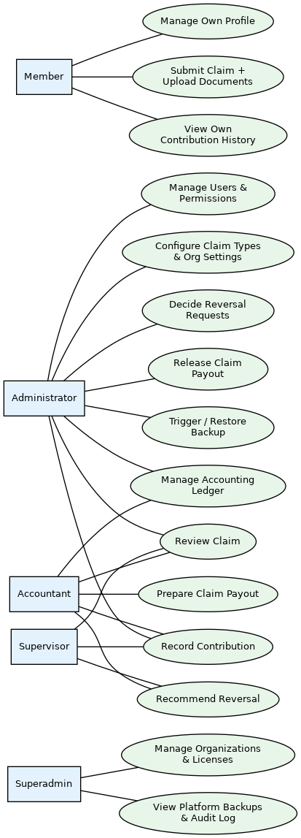
Figure 4.2 — Use case diagram

4.8.2 Sequence Diagram
Figure 4.3 traces the claim submission and approval sequence: the member creates a draft claim, uploads supporting documents, and submits it; the claim moves to `under_review` and appears in the queue of whichever role the claim type's approval chain names first; that reviewer calls the decide endpoint, which records an approval step and, once the chain is satisfied, moves the claim to `approved`; the accountant (or administrator) then marks documents reviewed and prepares the payout; finally the administrator releases the payout, which marks the claim `paid` and posts the corresponding debit/credit pair to the ledger.

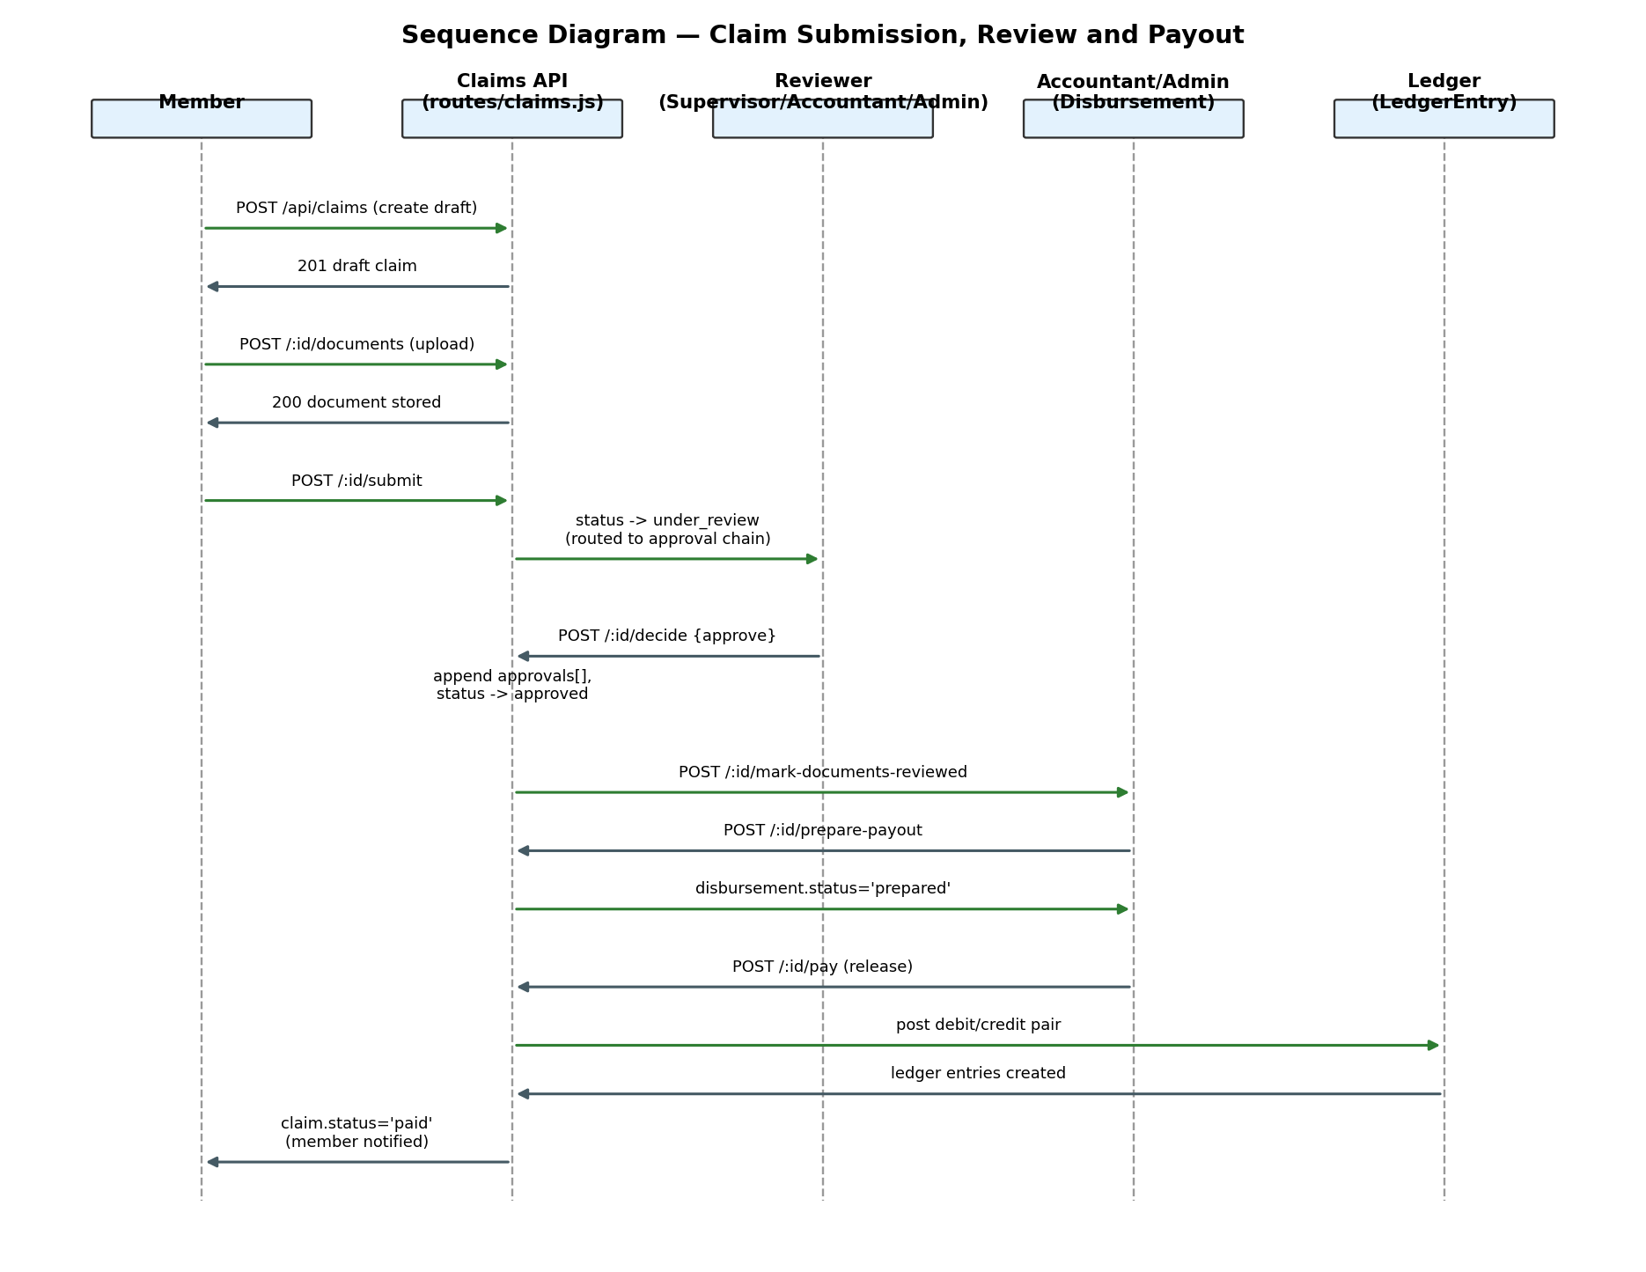
Figure 4.3 — Claim submission, review and payout sequence diagram

4.8.3 Activity Diagram
Figure 4.4 models the claim's full activity flow as a state/activity chart: Draft → Submitted → Under Review → (Approved | Rejected) → [if Approved] Documents Reviewed → Payout Prepared → Payout Released → Paid, with a Rejected branch ending the flow and a parallel "Request Info" activity that a reviewer can trigger at the Under Review stage without leaving that stage.
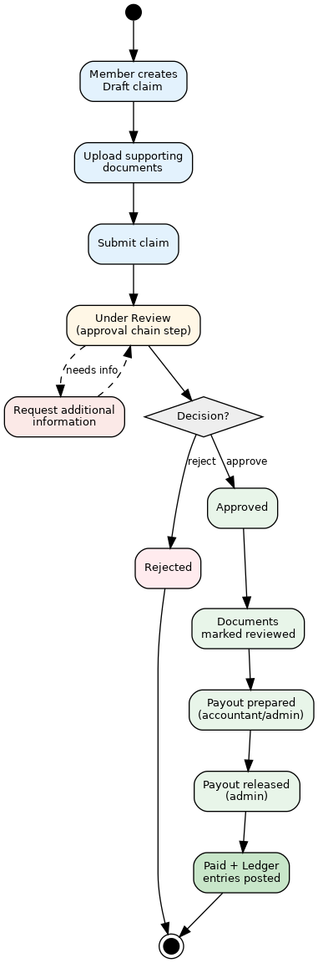
Figure 4.4 — Claim lifecycle activity diagram

CHAPTER FIVE: PRODUCT DESIGN

5.1 Introduction
WIMScare ships three distinct front-end areas from the same `public/` folder, each targeted at a different user class identified in Chapter 4: a member portal, a shared admin console used by administrators, supervisors and accountants, and a developer (superadmin) portal. All three are built as static, vanilla HTML pages styled by a single shared stylesheet (`public/css/app.css`, ~1,090 lines) and driven by a shared client script (`public/js/app.js`) that handles session bootstrapping, organization branding (logo/colour injection for Pro-plan tenants), and hiding navigation links to modules a license's plan does not include. This chapter describes each interface and the reusable components behind them.

5.2 Interfaces of the Project

5.2.1 Member Interface
The member interface consists of five pages: `dashboard.html` (contribution summary, recent claims with quick "View claim" links, and account standing), `claims.html` (list of the member's own claims with the ability to start a new draft claim), `claim-status.html` (a single claim's full detail: amount, claim type, status, uploaded documents, and its timeline of events from draft through payout), `profile.html` (personal details, bank/mobile-money details, emergency contact and family/dependant records) and `preferences.html` (email-notification toggles for claim updates, contribution receipts and monthly statements). Navigation across these pages is presented through a responsive drawer/menu component (`m-drawer`, with a hamburger `m-menu-btn` on narrow viewports) so the same markup works on both desktop and mobile. The dashboard additionally surfaces a read-only "Get in touch" card summarising the organization's own contact details and social links — phone, email, WhatsApp and address as clickable links, plus website/Facebook/Twitter/Instagram/LinkedIn — sourced from the same facility profile an administrator maintains, and shown only for the fields an organization has actually filled in.

5.2.2 Admin Console Interface (Administrator / Supervisor / Accountant)
The admin console is the largest interface, comprising thirteen pages under `public/admin/`: `dashboard.html` (organization-wide metrics), `users.html` and `invites.html` (staff/member account management and invitations), `permissions.html` (per-user permission grants), `contributions.html` (recording and browsing contributions), `claims.html` and `claim-processing.html` (the claims queue and the detailed review/decision/payout screen for an individual claim), `claim-type.html` and `claims-config.html` (defining claim types and organization-wide claim-eligibility rules), `accounts.html`/`accounts-v2.html` (accounting ledger and expenditure entries) and `reversals.html` (contribution reversal request review), `reports.html` (exportable summaries) and `profile.html` (organization facility profile, branding, system settings and license status). All pages share a consistent top navigation bar (Home, Admin Dashboard, Users, Accounts, Contributions, Claims Management, Reports, Profile) with the current page marked `active`; the front-end script hides links to any module the organization's license plan does not include, so a Free-plan organization never sees an "Accounts" link it cannot use. Although administrators, supervisors and accountants share these same pages, each page's data and available actions are filtered server-side to what that role and its permissions allow — a supervisor viewing `claims.html`, for example, can review claims but will not see the final "decide" action reserved for the claim's configured approval-chain authority.

5.2.3 Developer (Superadmin) Interface
The developer portal is a single, tab-structured page (`public/developer/index.html`) reserved for the superadmin role. It provides platform-wide oversight: an overview of all organizations and their license status, license issuance/renewal/suspension/revocation, cross-organization backup management (trigger, download, restore), the monthly rotating superadmin credential, publishing system updates/release notes surfaced to every organization's admin console, and the platform-wide audit log. Because the superadmin has no `organizationId` of their own, this portal is the only interface that operates across tenants rather than within a single organization's scope.

5.3 Components Design

5.3.1 User Interface
The interfaces share a small set of reusable visual components implemented in `app.css` and referenced across pages: a card-based layout for dashboard metrics and record lists, a consistent status-pill styling for claim/contribution/entry statuses (draft, submitted, under review, approved, paid, rejected, pending, reversed), a responsive top navigation bar that collapses into the member drawer pattern on mobile, form components with client-side validation feedback, and file-upload widgets for claim documents, receipts, avatars and organization logos. Organizations on a plan with `customBranding` enabled can override the primary/accent/background colours and logo, which `app.js` applies at runtime via CSS custom properties (`--navy`, `--nav-ink`, `--nav-sub`) so the same HTML/CSS serves every organization's branding without a server-side templating step.

5.3.2 User Design
The design separates what a role can see from what a role can do: the same admin-console pages are reused across administrator, supervisor and accountant, with the server enforcing the actual boundary (via `requireRoles`/`requirePermission`) rather than maintaining three separate front ends. This keeps the UI consistent for staff moving between roles or covering for one another, while the business rules that matter — who can approve a claim, who can release a payout, who can decide a reversal — remain enforced only on the server, so no amount of front-end tampering can grant a browser more authority than the signed-in user's role and permissions actually carry.

CHAPTER SIX: IMPLEMENTATION AND TESTING

6.1 System Description
WIMScare is implemented as one Express.js application serving three client applications from a shared origin and a shared MongoDB database.

6.1.1 Admin Console Application
Used by administrators, supervisors and accountants. It surfaces user/invitation management, claim-type and organization configuration, contribution recording, the claims review-and-payout queue, the accounting ledger, reversal-request handling, reports and the organization profile — with each page's available actions filtered to the signed-in user's role and permissions.

6.1.2 Member Application
Used by ordinary association members. It surfaces the member's own dashboard, claims (create, document, submit, track), profile and notification preferences.

6.1.3 Developer (Superadmin) Application
Used exclusively by the platform operator. It surfaces cross-tenant organization and license management, platform-wide backups, system update announcements, and the audit log.

6.1.4 Major Features
Multi-tenant data isolation; role- and permission-based access control; JWT cookie authentication with account activation and password reset by emailed token; member contribution recording with receipt numbering, bulk entry and XLSX/CSV/PDF export; configurable claim types with benefit limits, waiting periods and approval chains; a full claim lifecycle (draft → submit → review → approve/reject → document review → prepare payout → release payout → paid) with a per-claim activity timeline; a double-entry accounting ledger with fund accounts and an operating-expenditure approval workflow; contribution-reversal requests with a recommend/decide split; per-organization licensing (plan tiers and additive feature flags, seat limits); manual and nightly scheduled organization backups with destructive, confirmation-gated restore; and an append-only audit log of sensitive actions; a reversible, approval-gated account and organization deletion workflow protected by a confirmation step; and a versioned Terms & Data Policy acceptance gate enforced at registration, at activation, and once for any existing account after the policy changes.

6.2 Implementation Support

6.2.1 Tools and Libraries
Runtime and framework: Node.js (≥18) and Express 4 for the HTTP server and routing; Mongoose 8 as the ODM over MongoDB.
Authentication and security: `jsonwebtoken` for signing/verifying session tokens; `bcryptjs` (cost factor 12) for password hashing; `cookie-parser` for reading the HTTP-only session cookie; `cors` for cross-origin configuration; manually set security headers (`X-Content-Type-Options`, `X-Frame-Options`, `Referrer-Policy`).
File handling: `multer` for multipart file uploads (claim documents, receipts, avatars, logos), with per-upload MIME-type whitelists and size limits; `sharp` for server-side image processing (resizing and re-encoding avatars and organization logos to WebP, which also strips any non-image payload smuggled in an image file).
Reporting and export: `pdfkit` for generating PDF reports and receipts; the `xlsx` library for spreadsheet export/import.
Scheduling and email: `node-cron` for the hourly license/invitation-expiry sweep and nightly backup job; `nodemailer` for transactional email (activation, password reset, contribution receipts, claim-status notifications), falling back to console logging when no SMTP host is configured.
Configuration: `dotenv` for environment-variable loading (`.env`), covering the database URI, JWT secret, superadmin bootstrap credentials, SMTP settings and backup schedule.
Front end: vanilla HTML5, CSS3 and JavaScript (ES6+) with no client-side framework or build step, served directly as static files by Express.

6.3 Database Implementation
WIMScare uses MongoDB as a schema-flexible document store, with Mongoose enforcing structure, validation and indexes in the application layer. There are seventeen top-level collections/models: `Organization`, `User`, `Profile`, `Contribution`, `ClaimType`, `Claim`, `PaymentMode`, `LedgerEntry`, `AccountEntry`, `FundAccount`, `ReversalRequest`, `Invitation`, `License`, `Backup`, `AuditLog`, `SystemUpdate` and `SuperadminCredential`. Every tenant-scoped collection carries an indexed `organizationId` field, and most carry additional compound indexes matched to their most common query (e.g. `Claim` is indexed on `{organizationId, status, createdAt}` and on `{organizationId, memberId, status}`; `Contribution` on `{organizationId, year, month}`), so that per-organization dashboards and lists stay fast without full collection scans.

6.3.1 Entity-Relationship Model
Figure 6.1 shows the entity-relationship model. `Organization` is the tenancy root that every other tenant-scoped entity references. A `User` optionally owns one `Profile` and can be the member behind many `Contribution` and `Claim` records. `Contribution` links to a `PaymentMode` and can generate a `ReversalRequest`; both contributions and paid claims post one or more `LedgerEntry` records, which may in turn be attributed to a `FundAccount`. `Claim` links to a `ClaimType`, which defines its benefit rules and approval chain. `AccountEntry` (non-claim expenditure) also posts to the ledger once paid. `Organization` additionally owns its `Invitation`, `License`, `AuditLog` and `Backup` records.
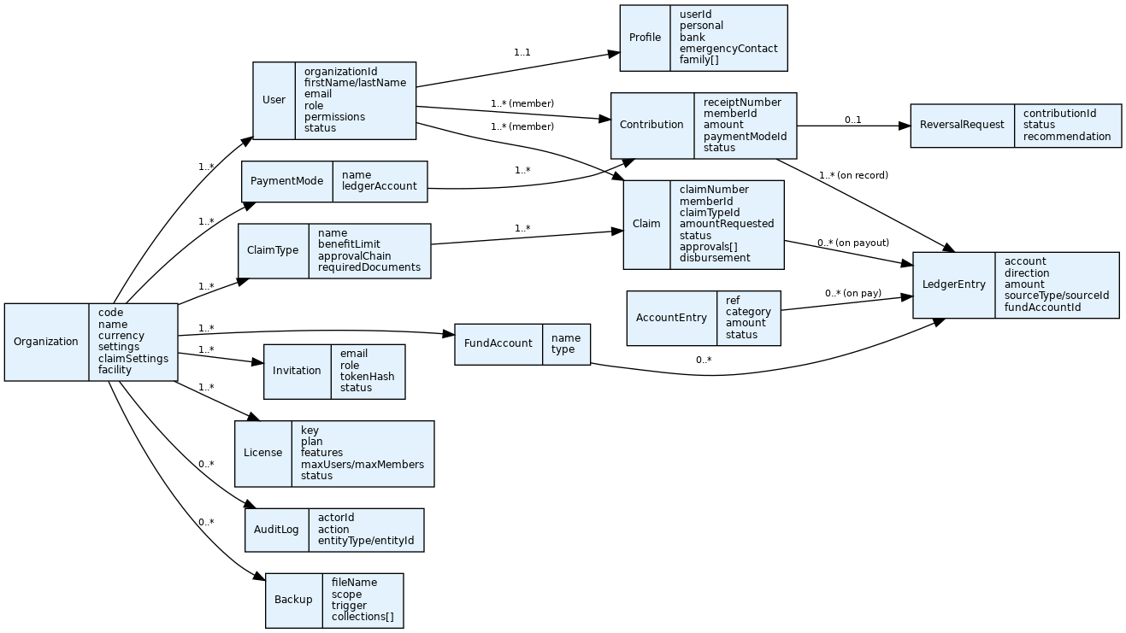
Figure 6.1 — Entity-relationship diagram

6.3.2 Class Diagram
Figure 6.2 shows a simplified class view of the core Mongoose models, including the key instance/static methods that encapsulate business logic on the model itself rather than scattering it through route handlers — for example, `Claim.nextClaimNumber()` and `Contribution.nextReceiptNumber()` generate organization-scoped, year-prefixed sequence numbers (`CLM-2026-0001`, `RCT-2026-00001`), `User.setPassword()`/`comparePassword()` encapsulate password hashing, and `License.isValid()` centralises the active/expiry check used everywhere a license needs to be verified.
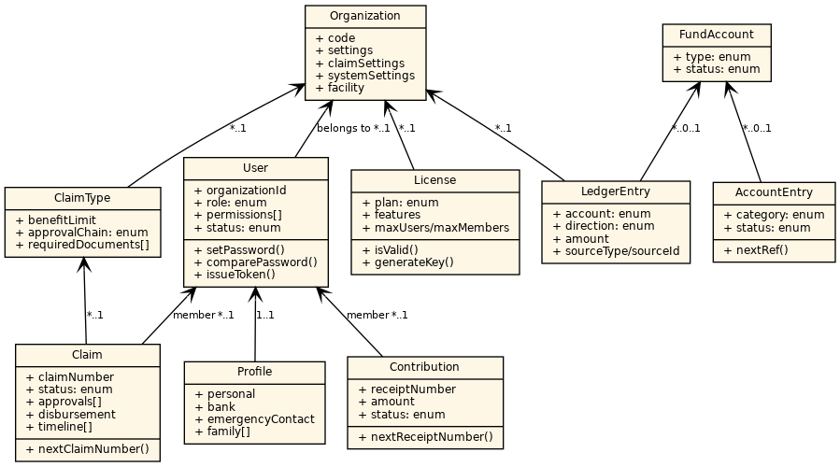
Figure 6.2 — Class diagram (core models)

6.4 Security Implementation
Sessions are stateless JWTs stored in an HTTP-only, `SameSite=Lax` cookie (marked `Secure` in production), so the token is inaccessible to client-side JavaScript and is not sent cross-site. Passwords are never stored in plain text; they are hashed with bcrypt at a cost factor of 12. Every authenticated request passes through `protect()`, which verifies the token, loads the user, confirms the account is `active`, and pins the request's `organizationId` — for the superadmin this comes from an explicit `X-Org-Id` header rather than a stored value, so cross-tenant access is always an explicit, auditable act rather than an accidental default. Route-level authorisation is enforced with `requireRoles()` (coarse role gate) and `requirePermission()` (fine-grained, per-user permission catalogue with role defaults), and license-gated modules are additionally protected by `requireFeature()`. Every database query that touches tenant data is filtered through a shared `orgFilter()` helper, so a route cannot accidentally omit the tenant scope. Uploaded files are validated by MIME type and size before being written to an organization-scoped, non-web-served directory; avatar and logo uploads are additionally re-encoded through `sharp` rather than stored as-submitted, which neutralises polyglot or malformed image payloads. A path-resolution guard (`resolveUploadPath`) refuses to serve any path that resolves outside the uploads root, preventing path-traversal. Sensitive fields (`passwordHash`, `activationToken`, `activationExpires`, `resetToken`, `resetExpires`) are excluded from every JSON response via a Mongoose `toJSON` transform. A centralised error handler normalises Mongoose validation errors, duplicate-key errors, cast errors and Multer errors into safe, consistent client-facing messages, and logs unexpected 5xx errors server-side without leaking stack traces to the client. Finally, sensitive actions — user creation, claim decisions, backup restores, license changes — are written to an append-only `AuditLog`, giving the organization (and the superadmin) a record of who did what and when.

6.5 Testing

6.5.1 Unit-Level Testing
At the time of writing, the project does not include an automated unit-test suite (there is no `test` script in `package.json` and no dedicated test directory); model- and route-level correctness was instead verified manually against the seeded demonstration data (`scripts/seed.js`), exercising each Mongoose model's validation rules and static helpers directly — for example, confirming that `Claim.nextClaimNumber()` and `Contribution.nextReceiptNumber()` produce correctly zero-padded, year-scoped, non-colliding sequence numbers, and that schema validation rejects an out-of-range `amount`, a missing required field, or an invalid `enum` value (e.g. an unrecognised claim `status`) with a 400 response rather than a raw stack trace. Table 6.1 lists representative unit-level checks performed.

# | Unit under test | Expected result | Observed result
1 | `User.setPassword()` / `comparePassword()` | A hashed password verifies against the original plaintext and rejects an incorrect one | Pass
2 | `Claim.nextClaimNumber()` | Sequential, year-prefixed, zero-padded claim numbers per organization | Pass
3 | `Contribution.nextReceiptNumber()` | Sequential, year-prefixed receipt numbers, unique per organization | Pass
4 | `License.isValid()` | Returns true only when `status === 'active'` and `expiresAt` is in the future | Pass
5 | Claim schema validation | Rejects `amountRequested` below the minimum and an invalid `status` enum value | Pass
6 | `hasPermission()` | Admin/superadmin pass every permission check; other roles pass only their role defaults or explicit grants | Pass

6.5.2 System Testing
System-level testing exercised complete, cross-module workflows end to end through the actual HTTP API and UI, using the seeded organization and its four demonstration accounts (admin, supervisor, accountant, member). Table 6.2 lists representative system test cases.
# | Scenario | Steps | Expected result | Observed result
1 | Tenant isolation | Sign in as a user of Organization A; request a claim ID belonging to Organization B | 404 / not found — no cross-tenant data returned | Pass
2 | Multi-organization login | Attempt login with an email registered under two organizations | System prompts for organization selection rather than logging into an arbitrary one | Pass
3 | Account activation | Admin creates a user; user follows the emailed (or console-logged) activation link | Password is set and the account becomes `active` | Pass
4 | Claim lifecycle | Member drafts a claim, uploads a document, submits; reviewer approves; accountant prepares payout; admin releases payout | Claim ends in `paid` status with a matching ledger debit/credit pair and a complete timeline | Pass
5 | Role boundary on claim decision | Supervisor attempts to call the final `decide` action outside their position in the approval chain | 403 Forbidden | Pass
6 | Contribution reversal | Accountant records a contribution in error, requests a reversal, a second accountant recommends it, admin approves | Original contribution marked `reversed`; mirror ledger entries posted | Pass
7 | License/feature gating | Free-plan organization's admin attempts to open the Accounts module | 403 with an "upgrade required" message; navigation link hidden client-side | Pass
8 | Maintenance mode | Admin enables maintenance mode; a non-admin user makes a request | 503 for the non-admin user; admin and superadmin remain unaffected | Pass
9 | Backup and restore | Admin triggers a manual backup, then restores it to a test organization | Restore requires typing `RESTORE` to confirm; collections and uploaded files match the backup snapshot afterward | Pass
10 | Seat limit enforcement | Admin invites more staff than the plan's `maxUsers` allows | Invitation rejected with a seat-limit error | Pass

The absence of an automated regression suite means these checks currently have to be re-run manually after significant changes; formalising them as an automated suite (e.g. with Jest and Supertest against a test MongoDB instance) is identified as future work in Chapter 7.

6.6 Deployment Architecture and Scalability Considerations
As deployed for this documentation, WIMScare runs as a single Node.js/Express process (node server.js) with no clustering, reverse proxy or load balancer in front of it. A typical deployment connects to exactly two external servers: a MongoDB instance (MONGO_URI) and an SMTP server for outbound email; SMS/OTP delivery is built as a third, pluggable integration (SMS_API_URL) that is optional and, when unconfigured, simply logs codes to the console instead of sending them.
Several of the system's fundamentals already support horizontal scaling. Authentication is fully stateless — a JSON Web Token in an HTTP-only cookie, with no server-side session store — so the application could run behind a load balancer across multiple instances with no sticky-session requirement. Every tenant-scoped collection is indexed on organizationId, list endpoints paginate rather than returning full collections, and both narrow (authentication/OTP) and broad (/api-wide) rate limiting are already in place.
Two pieces of runtime state, however, currently live in a single process's memory or local disk rather than a shared store, and would need to move before running more than one instance behind a load balancer. The orgStatusCache used by the authentication middleware to avoid re-querying an organization's maintenance/archived status on every request is a plain in-process map: a status change applied on one instance would not be visible to another until that instance's own cache separately expired. Uploaded files — claim documents, contribution receipts, avatars and organization logos — are written to local disk under the project's uploads/ directory via Multer's disk storage; a file uploaded through one instance would likewise be invisible to a request served by a different instance.
Recommended before scaling to multiple instances: move the organization-status cache to a shared store such as Redis (or shorten its TTL and accept the extra database reads), and move uploaded files to object storage such as an S3-compatible bucket rather than local disk. Outbound email is also currently sent synchronously within the request that triggers it (activation, receipts, claim-status updates); this is unnoticeable at low volume but should move to a background/queued job once contribution or claim volume — and therefore email volume — grows large enough for a slow SMTP response to visibly delay the request that sent it.

CHAPTER SEVEN: CONCLUSION AND RECOMMENDATION

7.1 Conclusion
WIMScare set out to replace the manual, spreadsheet-based way welfare associations track contributions and process benefit claims with a single, role-aware, multi-tenant web application. The finished system delivers on the objectives set in Chapter 1: it isolates each association's data behind an organization scope enforced on every query; it implements five distinct user roles with both coarse role gates and fine-grained per-user permissions; it carries a contribution record from receipt to ledger, and a claim from draft through a configurable, multi-step approval chain to a separately-controlled payout; it maintains a genuine double-entry ledger rather than a simple running total; it gates optional modules behind a per-organization license; and it protects an association's records with automatic backups. The review of comparable tools in Chapter 3 confirmed that no single existing product combines role-based multi-staff administration, a configurable claims workflow and a proper accounting ledger the way WIMScare does, which validates the original problem statement rather than merely re-implementing an existing solution.

7.2 Overall Experience
Building WIMScare surfaced how much of a system like this lives in the workflow, not the data model: getting the claim schema right — separating a claim's `status` (has it been approved?) from its `disbursement` sub-document (has it been paid, and how?) — mattered more to the system's correctness than any individual field. Likewise, the multi-tenancy discipline of always filtering through a shared `orgFilter()` helper, rather than trusting each route to remember the tenant scope, turned out to be the single most important architectural decision in the codebase, because it is the one thing that, if inconsistently applied, would silently leak one association's data into another's view.

7.3 Limitation
The system currently has no automated test suite, which was noted directly in Chapter 6 — correctness is currently verified by manual and exploratory testing rather than a repeatable, CI-enforced regression suite. There is no native mobile application; the responsive web front end covers mobile browsers but not an installable app experience. Contributions are recorded by staff after a payment is received rather than collected in-app, so WIMScare depends on the association's existing cash/bank/mobile-money channels rather than automating collection end to end. The system supports a single configured currency per organization, and license issuance is a manual superadmin action rather than a self-service purchase flow. Finally, because the front end is vanilla JavaScript with role-appropriate UI hiding rather than a build-time-separated client per role, all client code for a given portal (member or admin) ships to every user of that portal, relying on the server to be the true authority for what any specific request is allowed to do. The current deployment is also a single process with no load balancer in front of it, and two pieces of its runtime state — the organization-status cache and uploaded files — live in that process's own memory and local disk rather than a shared store, so running more than one instance would require addressing both first (section 6.6).

7.4 Scope for Future Works
Future iterations of WIMScare could add: an automated test suite (unit tests for model logic and permission checks, integration tests for the claim and contribution workflows) wired into continuous integration; a native or installable (PWA) mobile client, particularly for the member portal; in-app payment collection via a mobile-money aggregator, so a contribution can be initiated and confirmed without a staff member manually recording it after the fact; multi-currency support for organizations that need it; self-service license purchase and upgrade instead of superadmin-only issuance; push/SMS notifications alongside the existing email notifications, given that not every member reliably checks email; and richer reporting (configurable custom reports, scheduled report delivery) beyond the current fixed summary/export set; moving the organization-status cache to a shared store such as Redis and uploaded files to object storage so the application can run as multiple load-balanced instances rather than a single process; and queuing outbound email rather than sending it synchronously within the request that triggers it.

7.5 Recommendation
For an association considering WIMScare, it is recommended to start on the plan tier that matches actual need (Free for contributions/claims only, Standard once the accounting ledger and reports are needed) rather than defaulting to the highest tier, since the license/feature-flag model is designed specifically to let an organization grow into more modules over time. Associations should also assign the supervisor, accountant and administrator roles to genuinely different people wherever the committee size allows, since the system's separation-of-duties design (recommend vs. decide, prepare vs. release) only strengthens financial control when those steps are actually performed by different individuals. For continued development, the highest-priority recommendation is closing the automated-testing gap identified in section 7.3 before extending the claims or accounting workflows further, since untested changes to either module carry direct financial-correctness risk. Finally, given that these associations typically lack dedicated IT support, the nightly backup schedule should be verified periodically (by performing an actual test restore) rather than assumed to be working, since a backup that has never been restored is not yet a proven backup.

