Ms. Afful, Ashley 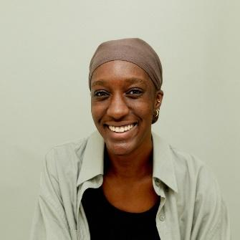
Teacher Qualification: Bachelor of Design in Environmental Design, OCAD University; Diploma in Graphic Design & Interactive Media, Toronto Film School
Teacher Details: As a graphic designer with diverse industry connections, Ashley brings bold, conceptual thinking to her work and teaching. Her interests lie in the intersection of visual storytelling, identity, and culture. She actively explores various art and design practices and integrates research, experimentation, and cross-disciplinary perspectives into her creative process.
Teaching Style: Ashley’s teaching philosophy is driven by curiosity, exploration, and critical thinking. She encourages students to investigate ideas deeply, experiment across mediums, and develop their own creative voice. Her classroom environment emphasizes creativity, research-informed practice, and meaningful visual expression, helping students build confidence and produce impactful, thoughtful design work.

Ms. Ali, Michelle 
Teacher Qualification: HBA., University of Toronto
Teacher Details: Ms. Ali graduated from the University of Toronto with an Honours Bachelor of Arts in English Literature and Sociology. She has been a high school English and Social Science teacher for over20 years. Ms. Ali specializes in individualizing lesson plans and teaching students with diverse learning needs.
Teaching Style: Ms. Ali's classes are educational, interactive, and customized to inspire creativity and captivate interest in learning. Ms. Ali's goal is to ensure that students are engaged, confident and encouraged to apply instructive strategies at school and in daily life to achieve academic success.

Mr. Chemello, Michael 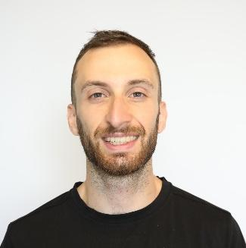
Teacher Qualification: BSc in Athletic Training, Florida Gulf Coast University; Diploma in Fitness and Health Promotion, Humber College.
Teacher Details: Michael Chemello specializes in human anatomy, physiology, injury assessment, rehabilitation, injury prevention, and strength and conditioning. He holds professional certifications in athletic therapy and has a strong interest in concussion research, pain science, and sport performance optimization.
Teaching Style: Mr. Chemello focuses on connecting scientific concepts with real-world applications. He helps students build a strong foundation in anatomy, physiology, and biomechanics while understanding how these concepts relate to sport performance, injury prevention, and everyday movement.

Mr. Dickinson, James 
Teacher Qualification: BA., University of New Brunswick (TESL)
Teacher Details: Mr. Dickinson graduated from the University of New Brunswick with a Bachelor's degree. He has over 30 years of teaching experience specializing in ESL, English, and IELTS training.
Teaching Style: Mr. Dickinson facilitates students' seamless integration into the English learning environment while taking a humorous approach, He maintains strict standards to emphasize the quality of students' daily assignments.

Mr. Dilag, Jayson 
Teacher Qualification: Educator and Sports Coach
Teacher Details: Mr. Jayson is a proud graduate of the Polytechnic University of the Philippines, holding a degree in Bachelor of Physical Education and Sports. Recognized for his dedication and excellence in athletics, he was honored with the prestigious Presidential Award as Athlete of the Year.
With over 20 years of experience in teaching Physical Education and coaching various sports such as Athletics, Basketball, Badminton, Table Tennis, Swimming, and Volleyball, Mr. Jayson has also extended his expertise to Special Education, helping diverse learners achieve their fullest potential.
Teaching Style: His teaching philosophy centers on the belief that loving one's work and being a blessing to others are vital. He balances kindness, care, and discipline in his approach, focusing on understanding each student’s strengths and areas for growth. Mr. Blue adapts his methods to suit different learning styles, such as visual and auditory learners, and firmly believes in "Learning by doing" and "Walk the Talk," striving to be a positive role model for his students every day.

Dr. Direkoglu, Daniel 
Teacher Qualification: University of Toronto M.A English Literature & Ph.D Philosophy
Teacher Details: Dr. Direkoglu has over eight years of experience teaching students in Ontario, and his research has been published in multiple prestigious academic journals, including Literature and Medicine. Many of his students have had successful academic careers and are now thriving in graduate schools across North America. The reading and writing skills he teaches his students set them up for long-lasting success in university courses and the world beyond.
Teaching Style: Dr. Direkoglu emphasizes critical reading and writing, encouraging students to think deeply, ask questions, and connect literature to broader contexts. His classes balance academic rigor with accessibility, helping students build strong skills for success in university and beyond.

Ms. Farley, Peyton 
Teacher Qualification: BFA, Toronto Metropolitan University; Diploma in Graphic Design & Interactive Media, Toronto Film School
Teacher Details: Peyton Farley is a multidisciplinary designer and creative educator based in Toronto. She holds a BFA in Performance Production from Toronto Metropolitan University and a Diploma in Graphic Design & Interactive Media from Toronto Film School. Her diverse background allows her to bring both artistic expertise and practical skills into the classroom.
Teaching Style: Peyton is dedicated to supporting each student’s unique learning journey. She strives to inspire and motivate her students, encouraging them to build confidence, develop their creativity, and achieve both academic and personal goals.

Dr. Hooti, Noorbakhsh 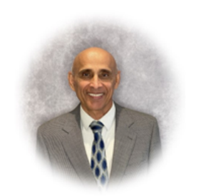
Teacher Qualification: PhD in English Language and Literature, Certified IELTS Speaking Examiner (TEFL)
Teacher Details: Mr. Hooti graduated with a PhD degree in English language & Literature. He has over 20 years of experience teaching English in private schools. He is also a certified IELTS speaking examiner and has been actively involved in helping students achieve their language proficiency goals. Currently, Mr. Hooti is an English teacher at Webtree Academy, where he places a strong emphasis on helping students develop critical thinking and analytical skills.
Teaching Style: Mr. Hooti is a detail-oriented and student-focused teacher. He is highly committed to respecting and celebrating diversity in education. Mr. Hooti has excellent knowledge of various critical methods in teaching. He tailors lessons to diverse learning styles.

Ms. Jamali, Sahar 
Teacher Qualification： MSc in Pure Mathematics, York University
Teacher Details： Sahar Jamali is a dedicated educator for Grades 7–12 with strong expertise in mathematics, including Advanced Functions. She combines rigorous academic training with a holistic perspective, supporting students through personalized attention and thorough preparation for university and beyond.
Teaching Style： Sahar believes in educating the whole student, fostering both academic excellence and personal growth. Her lessons emphasize understanding over memorization, encouraging students to explore connections, apply concepts to real-world problems, and reflect on their learning. She creates a classroom atmosphere of respect, inclusion, and collaboration, tailoring instruction and feedback to nurture student confidence, curiosity, and a lifelong love of learning.
Mr. Kadraoui, El Mahdi 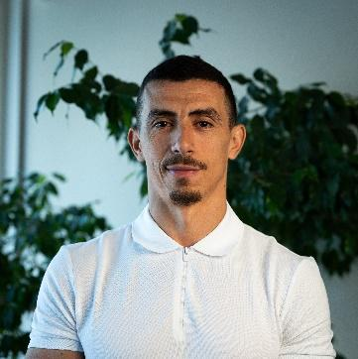
Teacher Qualification: French Teacher; BA in French & Physical Education
Teacher Details: As a native French speaker, El Mahdi holds a double degree in French and Physical Education and brings many years of experience teaching students from middle school through high school. Passionate about education, he is committed to fostering a supportive and motivating classroom environment where every student can thrive.
Teaching Style: His teaching philosophy focuses on inspiring students to build not only strong academic skills but also confidence, discipline, and a genuine love of learning. Believing that every child has unique strengths, El Mahdi adapts his teaching methods to meet individual needs while encouraging teamwork and collaboration.
In addition to academics, he places strong emphasis on physical well-being, cultural awareness, and effective communication, making learning engaging and meaningful for all his students.
Outside the classroom, El Mahdi enjoys exploring new sports, participating in community activities, and promoting lifelong learning through both language and fitness.
Ms. Li, Lexy 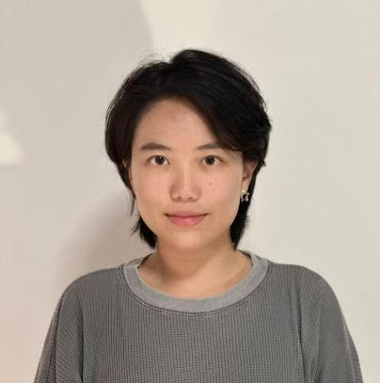
Teacher Qualification: BEd & BA in English Literature, Queen’s University (specializing in English and History)
Teacher Details: Lexy Li graduated from Queen’s University with a double degree in Education and English Literature, specializing in English and History. She also has strong expertise in ESL education and exam preparation. With her experience in teaching English, History, and ESL, Lexy is skilled at designing engaging, diverse lessons and tailoring her teaching to meet the unique needs of each student.
Teaching Style: Lexy is patient, responsible, and adaptable. She adjusts her teaching content and approach based on each student’s learning style, with a strong focus on sparking students’ interest in learning and helping them build confidence.
Mr. Mowbray, Colton 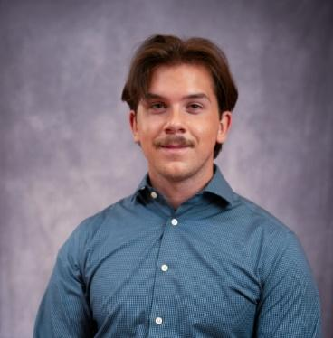
Teacher Qualification: Bachelor of Music, University of Toronto
Teacher Details: Colton is an experienced multi-instrumentalist and music educator who teaches guitar, drums, piano, clarinet, saxophone, and bass. He holds a Bachelor of Music in Jazz Drumming from the University of Toronto, with additional studies in History. Since 2021, he has taught music at the high school level and has performed extensively across Toronto and the GTA in jazz, funk, and rock ensembles.
Teaching Style: Colton provides structured, skill-focused instruction that supports students in developing strong technical foundations. He incorporates a variety of musical styles and emphasizes helping students build confidence, musical understanding, and their own artistic voice.

Mr. Nessimian, Yervant 
Teacher Qualification: MA. Economics, American University of Beirut Postgraduate Degree, Education, Ontario Tech University MEd Education, University of Toronto
Teacher Details： Mr. Nessimian is a passionate educator with over nine years of experience in international and Canadian education, including teaching, curriculum design, investigative research, grant writing, and project management.
He holds a master’s degree in economics from the American University of Beirut and is a certified IBDP (International Baccalaureate Diploma Program) teacher from DePaul University in Chicago, U.S.A. Currently, he is pursuing a Master of Education at University of Toronto.
Teaching Style： Inquiry-driven and student-centered, Mr. Nessimian integrates his background in economics and international education to create lessons that are both practical and globally relevant. He encourages critical thinking and problem-solving, helping students connect classroom learning to real-world issues while fostering independence and academic confidence.
Ms. Tahrirchi, Fatima 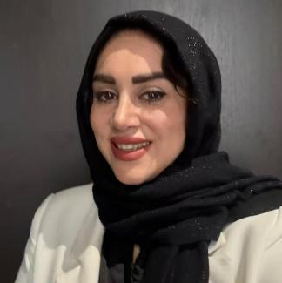
Teacher Qualification: Ryerson University Master of Data Science and Analytics; University of New Brunswick Bachelor of Computer Science
Teacher Details: My teaching philosophy is that every student—whether below, at, or above grade level—should develop a deep understanding of mathematical concepts. I emphasize conceptual learning through practice, experimentation, and interactive questioning. I incorporate a range of established resources, including the Ontario Curriculum, Smart Canadian Curriculum, Math Makes Sense, and Haese Mathematics (IB resources), along with technology and hands-on activities to support student engagement and understanding.
Teaching Style: My classes are structured, interactive, and student-centered. Each lesson begins with a short review, followed by the introduction of new concepts using slides, board explanations, videos, and occasional hands-on activities. Students complete in-class exercises and may present their solutions, followed by a brief recap of key concepts. Progress is monitored through biweekly assessments. Homework is assigned three times per week, with additional weekly practice on the IXL platform. Review sessions are held before tests, and monthly math Kahoot activities help create an engaging learning environment.
Dr. Titi, Atef 
Teacher Qualification: MSc, University Tennessee and PhD in Theoretical Physics and Applied Mathematics, University of Windsor
Teacher Details: Dr. Titi graduated from the University of Windsor with a PhD degree in Theoretical Physics and Applied Mathematics. He has over 20 years of experience teaching mathematics and physics in high schools in Ontario, and his research publications have been cited by major universities around the world. Dr. Titi has taught many students who received full scores in AP Calculus and AP Physics courses. He also trained students for Waterloo Math Contest and one of our students was ranked top 2%. in addition, he supported their applications to lvy League universities such as Brown University, Stanford University, and Cornell University.
Teaching Style: Dr. Titi employs a rigorous and meticulous teaching approach. He harnesses and creates an effective environment for learning which accommodates students' diverse cultural and educational backgrounds. He caters to a variety of learning styles and abilities, always balancing kindness and care with discipline. Dr. Titi takes great pride in developing excellence and helping students reach their goals.

Dr. Ullah, Ehsan 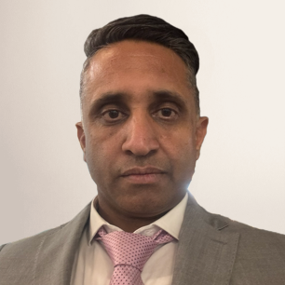
Teacher Qualification: PhD in Organic Chemistry, Greifswald University
Teacher Details: Dr. Ehsan Ullah holds a PhD in Organic Chemistry from Greifswald University in Germany and brings extensive academic, research, and industry experience across Canada and Europe. He has taught college-level chemistry since 2019 and has also worked as a professor and lead chemist, specializing in organic and analytical chemistry, spectroscopy, and quality management. His background includes postdoctoral research at McMaster University and the Leibniz Institute, as well as several years of industrial experience in chemical analysis and polymer development. With strong expertise in instrumentation such as GC-MS, LC-MS, ICP-AES, and FT-IR, he has published in peer-reviewed journals and supervised student research in synthesis, catalysis, and material characterization.
Teaching Style: Dr. Ullah’s teaching emphasizes hands-on learning, real-world applications, and building strong conceptual foundations in chemistry. He integrates industry-standard analytical techniques and green chemistry principles into his lessons to help students connect theory with practice. He is dedicated, structured, and supportive, ensuring students gain both confidence and practical skills in the subject.
Dr. Yang, Jeffery 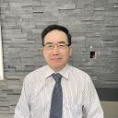
Teacher Qualification: PhD in Environmental Science, University of Mainz and Postdoc in Natural Science, McGill University
Teacher Details: Dr. Yang graduated from McGill University with a postdoctoral degree in Natural Science, he has worked in various international environmental science consulting firms in Canada as a senior scientist and a technical consultant. Dr. Yang has a profound foundation in mathematics, physics and chemistry. In addition to over 20 years high school teaching experience, he has years of expertise training our students for Canadian math and physics competitions.
Teaching Style: Dr. Yang is meticulous and patient, adept at breaking down complex theoretical knowledge into practical steps. he not only teaches the "what" but also delves into the "why" and "how" to ensure students gain a thorough and comprehensive understanding of the subject matter.

