
A
Project Report On
“janki jwellery”

Towards partial fulfillment of the requirement in
M.Sc. IT & CA
Submitted by

ACADEMIC YEAR: 2025-2026

NAME: NENSI KHATRA
SURAJ CHAVDA

M.Sc. ( IT & CA): SEM (1)

Enrollment No: 003303224062(Suraj)
003303224042(Nensi)

Project Guide

Prof. Mitalben Vaishnav



Submitted To:
Shri Matru Mandir College

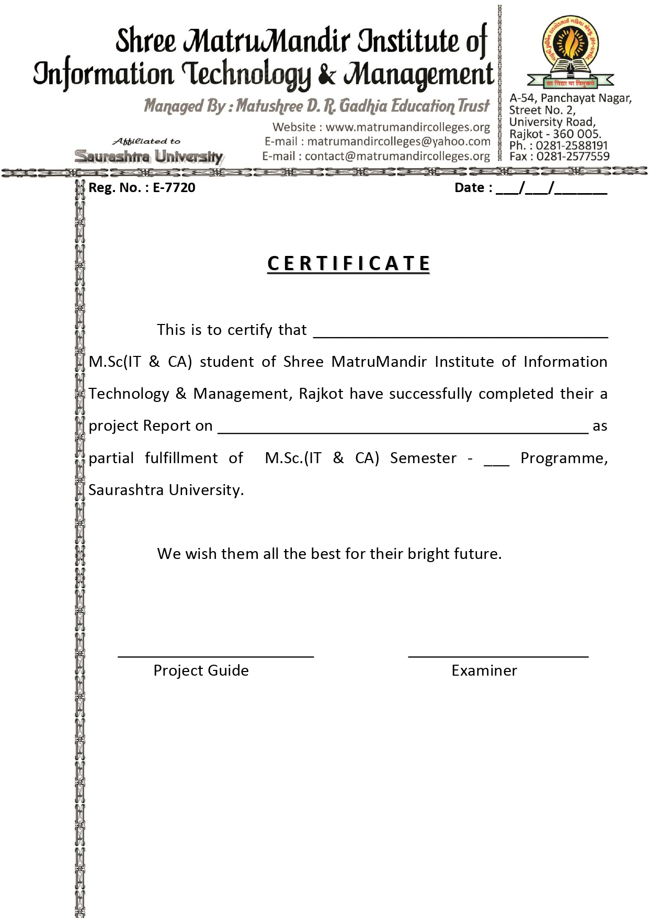
1
Janki jewellery
Chavda Suraj Mukeshbhai
1
Khatra Nensi Tejasbhai
Janki jewellery

ACKNOWLEDGEMENT
First and foremost, we would like to express our sincere gratitude to our respected guide, Prof. Mitalben Vaishnav, for her valuable guidance, continuous support, and motivation throughout the completion of this project. We are truly thankful to her for providing us with this wonderful opportunity to work on the project “JANKI JEWELLERY”.

This project has given us hands-on exposure to various concepts related to E-commerce systems, website development, and database management. Working on this project has enhanced our technical knowledge and improved our practical understanding of web technologies.

We are also thankful to all our faculty members of Shri Matru Mandir College for their constant encouragement and for sharing their knowledge, which helped us at every stage of this project.

Finally, we would like to thank our classmates, friends, and everyone who directly or indirectly supported us during the development and testing phase of this project.

PREFACE
The project “JANKI JEWELLERY” is designed to provide customers with a seamless online shopping experience for elegant and affordable jewellery. Our mission is to offer a curated selection of jewellery products that suit every customer’s taste, style, and occasion.
At JANKI JEWELLERY, we believe that online shopping should be simple, secure, and enjoyable. That is why the website is developed to be user-friendly and easy to navigate, allowing customers to browse, compare, and purchase products conveniently from anywhere.
Every product showcased on the platform is carefully categorized and selected to maintain high quality and authenticity. Our focus is on delivering both beauty and trust — ensuring that every customer receives value for their money.
We also value customer feedback and aim to continuously improve based on users’ needs and preferences. This project reflects our understanding of e-commerce systems and web development concepts, and it serves as a practical implementation of those learnings.
Thank you for taking the time to explore our project. We hope that JANKI JEWELLERY successfully represents a modern and efficient online jewellery shopping experience.

INDEX

No |  | Description | Page No.
1 |  | Project Summary
 | 1.1 | Project Profile | 7
 | 1.2 | Project Purpose | 8
 | 1.3 | Project Development Model | 9
 | 1.4 | Project Development Scheduling | 10
 | 1.5 | Project scope | 11
 | 1.6 | Technology used | 12
 | 1.7 | Feasibility study | 13
2 |  | System requirement & specification
 | 2.1 | User Characteristics | 14
 | 2.2 | User access flow | 15
 | 2.3 | Proposed system & advantage | 16
 | 2.4 | Hardware & Software requirement | 17
3 |  | Design System
 | 3.1 | Context Diagram | 18
 | 3.2 | Dataflow Diagram | 19
 | 3.3 | ER diagram | 20
 | 3.4 | Use Cases | 21
 | 3.5 | Flow Chart | 22
4 |  | System Design
 | 4.1 | Data dictionary | 24
 | 4.2 | Screenshot of application | 27
 | 4.3 | Conclusion | 33
 | 4.4 | Limitations. | 34
5 |  | Bibliography | 35
1. Project Summary

1.1 Project Profile.
1.2 Project Purpose.
1.3 Project Development Model.
1.4 Project Development Scheduling.
1.5 Project scope.
1.6 Technology Used.
1.7 Feasibility Study.

1.1 Project Profile:

Project Title : Janki Jewellery
Institution : Rajkot
Front End : HTML, CSS, JavaScript, Bootstrap
Back End : Laravel Framework (PHP), MySQL
Team Size : 2 Members
Project Guide : Prof. MITALBEN VAISHNAV
Submitted By : Khatra Nensi Tejasbhai
And Chavda Suraj Mukeshbhai
Submitted To : Shri Matru Mandir College

1.2 Project definition - purpose

The purpose of the JANKI JEWELLERY project is to provide customers with the best and most reliable online jewellery shopping experience. This website allows users to easily browse, select, and purchase jewellery products from the comfort of their homes.
The main goal of this project is to create a user-friendly and secure e-commerce platform where customers can explore a wide range of silver, gold, and diamond jewellery. It aims to make online shopping simple, convenient, and trustworthy by offering high-quality products with detailed descriptions, clear images, and smooth payment options.
Overall, the purpose of JANKI JEWELLERY is to build a modern, efficient, and customer-oriented website that delivers satisfaction, comfort, and confidence to online jewellery buyers.

1.3 Project Development Model
A software development model is a simplified description of the software process that shows how a project is planned and executed. The choice of a suitable model depends on the type of project, its requirements, tools, and the final deliverables expected.
For JANKI JEWELLERY, a systematic development model was followed to ensure smooth and organized progress at every stage. The project is treated as a problem-solving process that passes through four main stages:
- Status Quo: Represents the current situation, identifying the need for an online jewellery shopping system.
- Problem Definition: Defines the problem of limited offline accessibility and the need for an easy, online shopping platform.
- Technical Development: Develops the solution using technologies like HTML, CSS, JavaScript, Bootstrap, Laravel, and MySQL.
- Solution Integration: Delivers the final working website, including all features, data, and documentation, to fulfill the user’s needs.

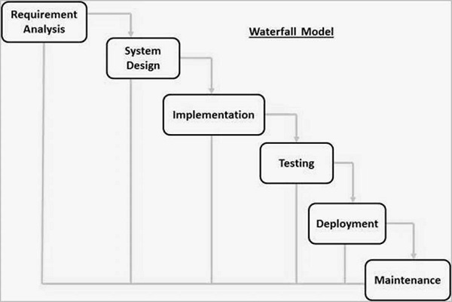

1.4 Project Development Scheduling:

Week  Month | Week 1 | Week 2 | Week3 | Week 4
1st Month | Requirement Gathering | Initial Design | Database Setup | Frontend Development
2nd Month | Backend Development | Integration of Modules | Testing (Phase 1) | Bug Fixes & Improvements
3rd Month | User Testing | Final Debugging | Project Deployment | Post-Deployment Support

1.5 Project scope.
The JANKI JEWELLERY project aims to develop a reliable and attractive online jewellery shopping platform that offers a smooth and enjoyable experience for customers. The website provides a user-friendly interface where customers can easily browse and search for various jewellery items with options to filter by price, metal type, or category. Registered users can create and manage their accounts to save favorite products, check order history, and get personalized recommendations based on their preferences and shopping behavior.
The platform includes secure and multiple payment options to ensure safe online transactions. Customers can track their orders in real time, receive updates on their order status, and contact support for help or queries. The scope also covers implementing a strong inventory management system for the admin to handle product listings, stock availability, and sales reports efficiently.
In addition, the project integrates customer reviews, ratings, and discount features to build trust and engagement. Loyalty points, promotional codes, and special offers are included to encourage repeat purchases and customer satisfaction. The website also focuses on a smooth logistics process to ensure timely and accurate delivery of jewellery items.
Overall, the scope of JANKI JEWELLERY is to create a complete, secure, and modern e-commerce solution that connects buyers and sellers, offering a convenient and trustworthy online shopping experience.
.

1.6 Technology Used.

What is PHP?
PHP (Hypertext Preprocessor) is a widely used server-side scripting language designed for web development. It allows developers to create dynamic and interactive web pages that can connect with databases, manage sessions, and handle forms. PHP is open-source, easy to learn, and supported by almost all web servers. It works smoothly with HTML, CSS, JavaScript, and MySQL to build complete, data-driven web applications. Laravel — one of the most popular frameworks — is built on PHP, offering faster and more secure development.

What is LARAVEL?
Laravel is a powerful and open-source PHP framework used for building modern web applications quickly and efficiently. It follows the Model–View–Controller (MVC) architecture, which helps developers organize code in a clean and maintainable way. Laravel includes many built-in features like authentication, routing, sessions, and caching that reduce development time. It also provides an expressive syntax and powerful tools for database management, email handling, and API integration. Laravel is beginner-friendly yet strong enough for large-scale enterprise applications, making it one of the most popular frameworks for PHP developers.

What is HTML?
HTML (Hypertext Markup Language) is the basic structure of any website. It defines the layout of content such as text, images, links, and forms on a web page. Web browsers read HTML documents and display them to users as visual web pages. HTML is easy to learn and forms the foundation upon which other technologies like CSS, JavaScript, and Bootstrap work together to make websites dynamic and attractive.

What is CSS?
CSS (Cascading Style Sheets) is used to design and format web pages created with HTML. It defines how the elements should look — including colors, fonts, layout, and spacing. By separating content from design, CSS makes it easier to manage and update website styling. A single CSS file can be used across multiple pages to ensure consistent design and improve website speed. CSS also helps make web pages responsive so they look good on all devices.

What is JAVASCRIPT?
JavaScript is a lightweight programming language that adds interactivity and dynamic features to web pages. It runs directly in the web browser, allowing actions like form validation, animations, and live content updates without reloading the page. JavaScript makes websites more engaging and user-friendly. It is supported by all modern browsers and works closely with HTML and CSS to create powerful front-end experiences.

What is MYSQL?
MySQL is an open-source Relational Database Management System (RDBMS) used to store and manage data efficiently. It organizes data into structured tables that can be easily accessed and updated using Structured Query Language (SQL). MySQL ensures data integrity, supports multiple users, and provides security features for safe access control. It works seamlessly with Laravel to handle backend operations like data storage, user authentication, and reporting in a fast and reliable way.

1.7 Feasibility Study.
A feasibility study is an essential step carried out before starting any project to determine whether it is practical, achievable, and worth pursuing. It helps in understanding if the project can be successfully developed with the available time, budget, and resources. This study involves analyzing several key aspects such as technical feasibility (whether the required technology and tools are available), economic feasibility (if the project is financially beneficial), legal feasibility (whether it complies with laws and regulations), operational feasibility (how effectively it can function within an organization), and schedule feasibility (if it can be completed within the planned timeline).
By carefully evaluating these factors, a feasibility study helps to identify potential challenges early, reduce risks, and ensure better decision-making. It also provides a clear picture of the project’s strengths, weaknesses, and opportunities. Overall, the main objective of conducting a feasibility study is to ensure that the proposed project is both technically sound and economically viable, leading to efficient use of resources and successful implementation.

2. System requirement & specification.

  - User Characteristics.
  - User access flow.
  - Current system.
  - Proposed system & advantage.
    - Proposed system.
    - Advantage of proposed system.
  - Hardware & Software requirement.
2.5.1 Hardware requirement.
2.5.2 Software requirement.

2.1 User characteristics
In this Janki Jewellery project, users can perform a variety of essential functions that make their shopping experience smooth and convenient:
- Browse and Search for Jewellery: Users can explore different categories of jewellery such as rings, earrings, necklaces, and bracelets. They can also use the search bar and filters to quickly find specific items.
- View Product Details: Each product has a dedicated page showing detailed information like price, description, material, weight, images, and customer reviews to help users make informed decisions.
- Add to Cart and Wishlist: Users can add selected items to their shopping cart for purchase or save them to their wish-list for future consideration.
- Place Orders: Customers can proceed to checkout, review their cart, select payment methods, provide delivery details, and confirm their purchase easily.
- Manage Orders: Users can view their order history, track ongoing deliveries, and cancel or modify orders when required.
- Feedback and Support: Users can share their shopping experience, rate products, and contact customer support for help with inquiries or issues.
This system ensures a simple, user-friendly, and efficient online shopping experience, guiding customers smoothly from product discovery to purchase and after-sales support.

2.2 User access Flow

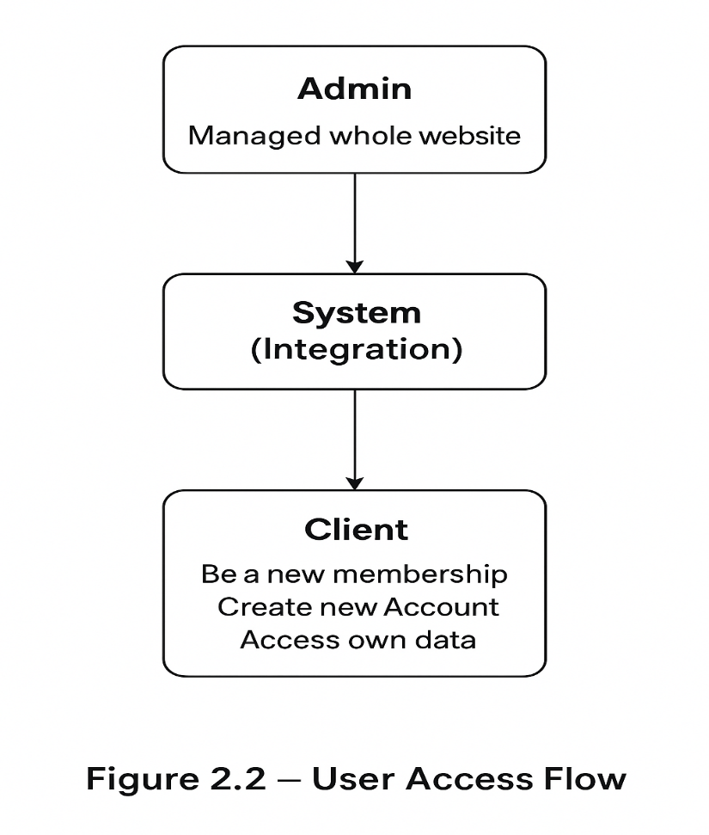

2.3 Proposed system & advantages

Proposed System
The proposed system is a modern, role-based e-commerce platform developed using Laravel. It includes both an administrative panel and a user-facing website, designed to ensure efficiency, security, and scalability.
The admin panel allows authorized users to manage key modules such as products, categories, subcategories, customers, and orders, all within a clean and organized interface.
On the other hand, customers can browse jewellery collections, add items to their cart or wishlist, and complete purchases easily. The system focuses on offering a secure, responsive, and user-friendly experience for all types of users.

Advantages of the Proposed System
1. Scalability:
The system is built to handle a large number of users, products, and transactions. As the business grows, new admins can be added and more product categories can be managed without affecting performance.
2. Security & Role Management:
Role-based access ensures that only authorized users can manage sensitive data. Admin privileges are restricted, reducing the risk of unauthorized changes. Regular users can still browse the website freely, encouraging engagement and product exploration.
3. User-Friendly Experience:
The system provides a smooth and intuitive user interface. Customers can easily browse products, add items to their cart, and complete purchases without confusion. Features like Wishlist, order tracking, and secure checkout enhance the overall shopping journey.
4. Efficient Management:
All operations—such as inventory updates, user registration, and order processing—are centralized, reducing manual work and improving accuracy.

2.4 Software& hardware requirement

2.4.1 Hardware requirement:
To run and test the project smoothly, the following minimum hardware configuration is required:
- Processor: Intel Core 2 Duo or higher
- RAM: Minimum 4 GB (8 GB recommended)
- Hard Disk: 500 GB or more
- Monitor: Standard Display (15” or higher)
- Keyboard & Mouse: Standard Input Devices

    - Software requirement:
The project is developed using modern web technologies along with the Laravel framework.
Below are the required software tools and versions for proper setup and execution:
- Operating System: Windows 10 / 11 or Ubuntu Linux
- Front-End Technologies: HTML, CSS, JavaScript, Bootstrap
- Back-End Technologies: PHP (Version 8.1 or higher), Laravel (Version 10.x)
- Database: MySQL (Version 8.0 or higher)
- Web Server: Apache or Nginx (via XAMPP / Laragon / WAMP)
- Composer: Dependency Manager for PHP (latest stable version)
- Code Editor: Visual Studio Code / Sublime Text / PHPStorm
- Browser: Google Chrome / Mozilla Firefox (latest version)

3. Design System
3.1 Context Diagram.
3.2 Dataflow Diagram.
3.3 ER diagram.
3.4 Use Cases
3.5 Flow Chart

3.1 Context Diagram:
Data flow diagrams can be used to provide a clear representation of any business function. The technique starts with an overall picture of the business and continues by analyzing each of the functional areas of interest. This analysis can be carried out to precisely the level of detail required. The technique exploits a method called top-down expansion to conduct the analysis in a targeted way.
- Customer (browsing jewellery, adding to cart, making payment)
- Admin (managing products, orders, categories, users)
- System (central website handling all operations)
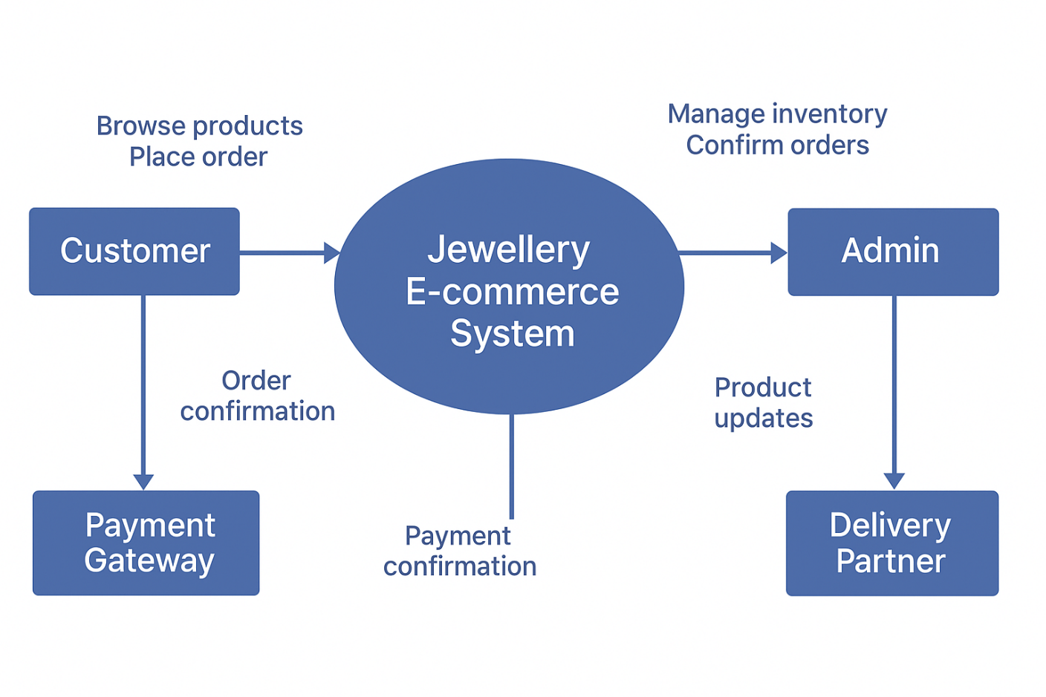
- Possibly Payment Gateway (for online payments)

1ST LEVEL DFD

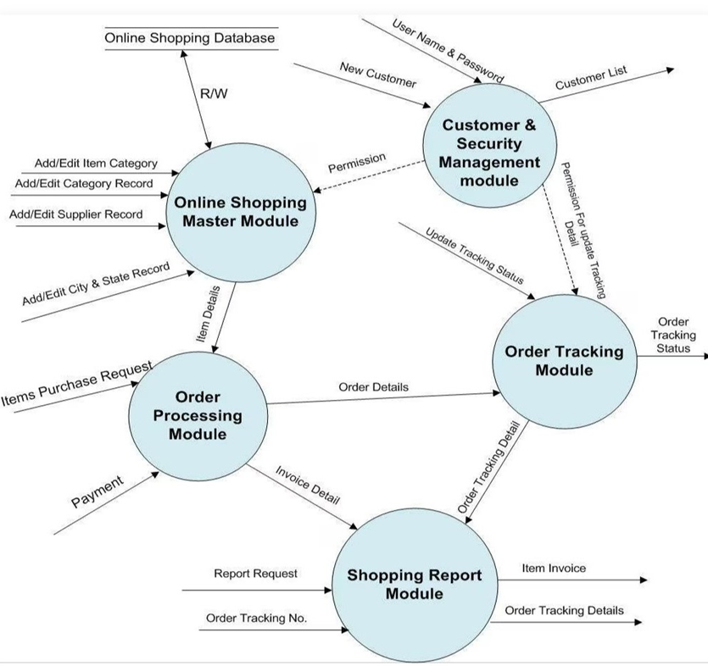

2ND LEVEL DFD
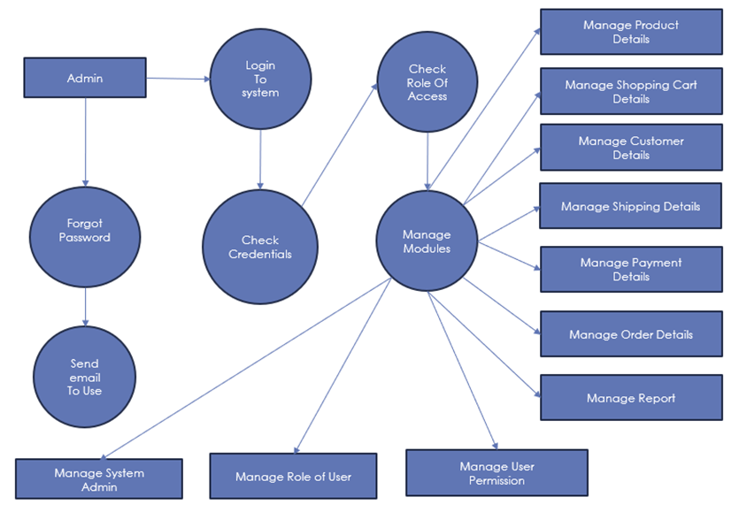

ER-Diagram:

The ER diagram model also called “An Entity Relationship Diagram” is a graphical representation of entities and their relationship to each other, typically used in computing in regard to organization of data within databases or information system.

An entity relationship diagram is a data modeling technique that can help define business process and can be used as foundation for relational database. The shapes we have used in E-R Diagrams are as follows.

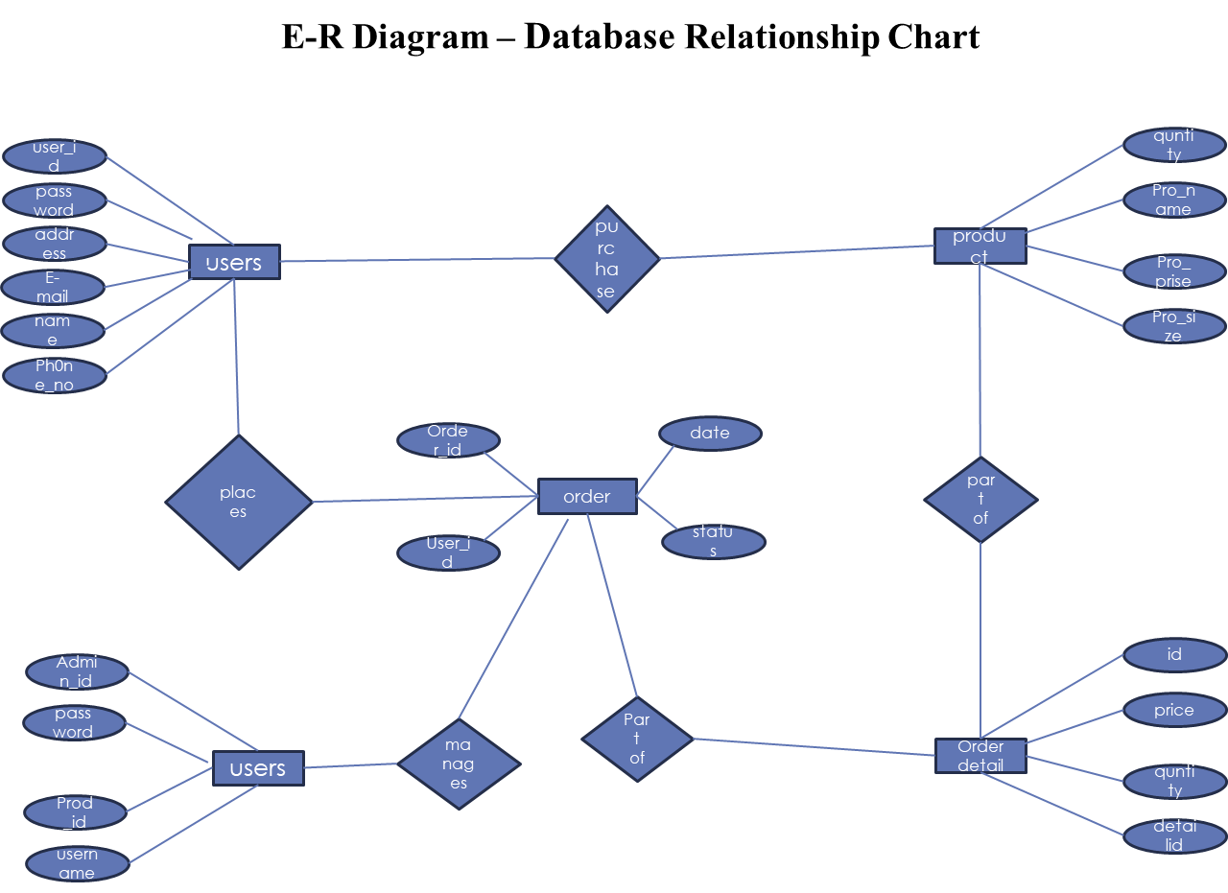

3.4 Use-Cases:

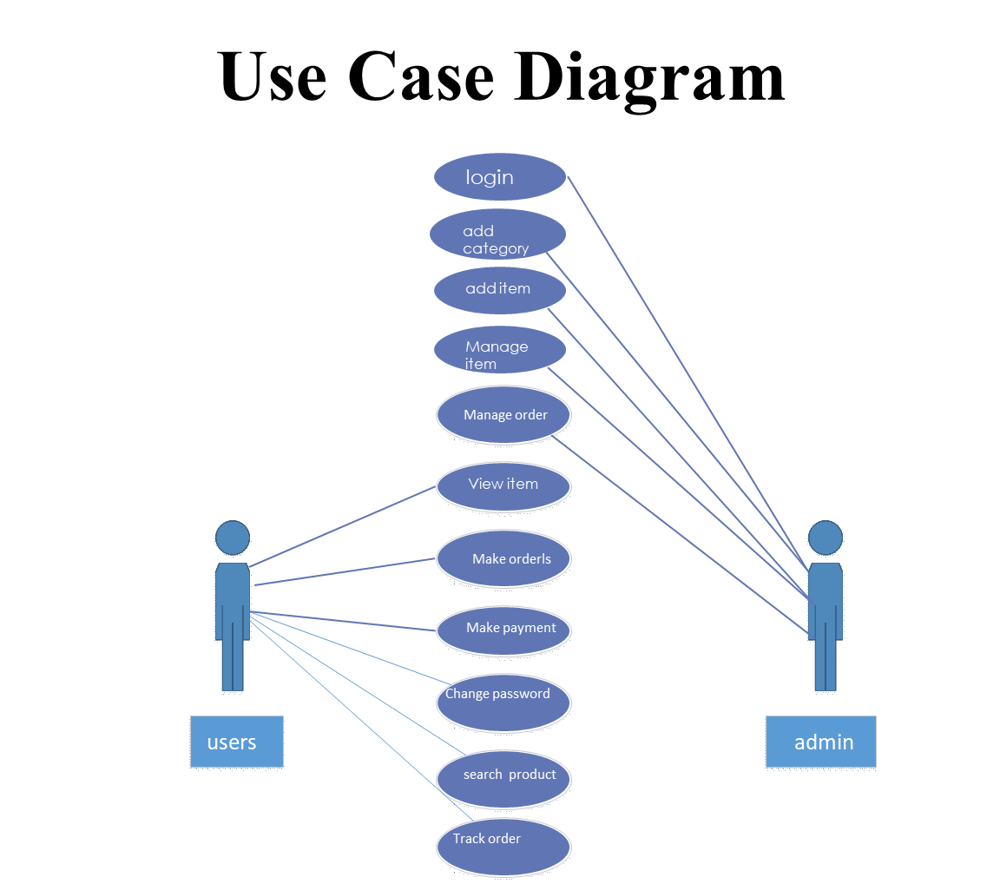

Flow Chart:

PROCESS FLOW DIAGRAM

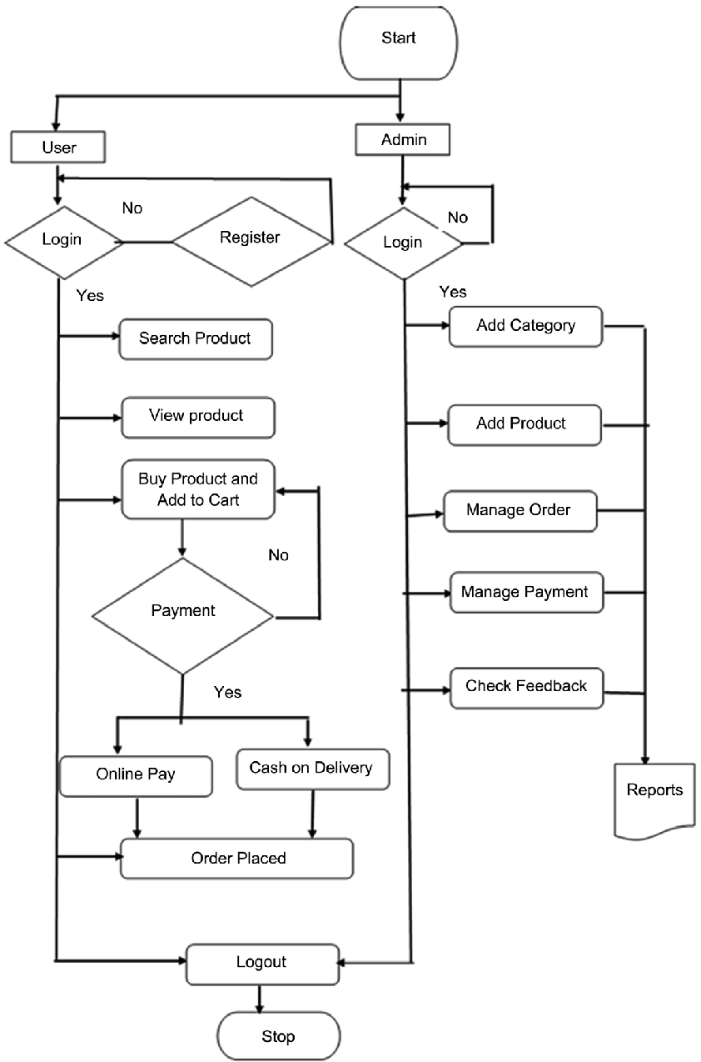

order detail

4. System Design
4.1 Data dictionary
User:

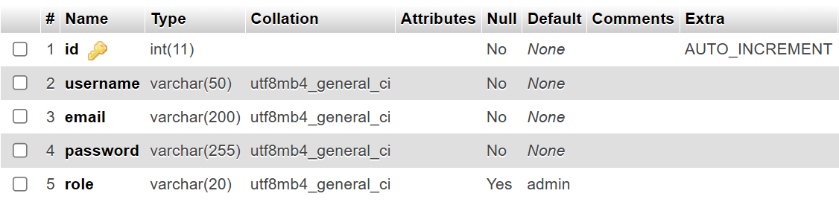
Student:

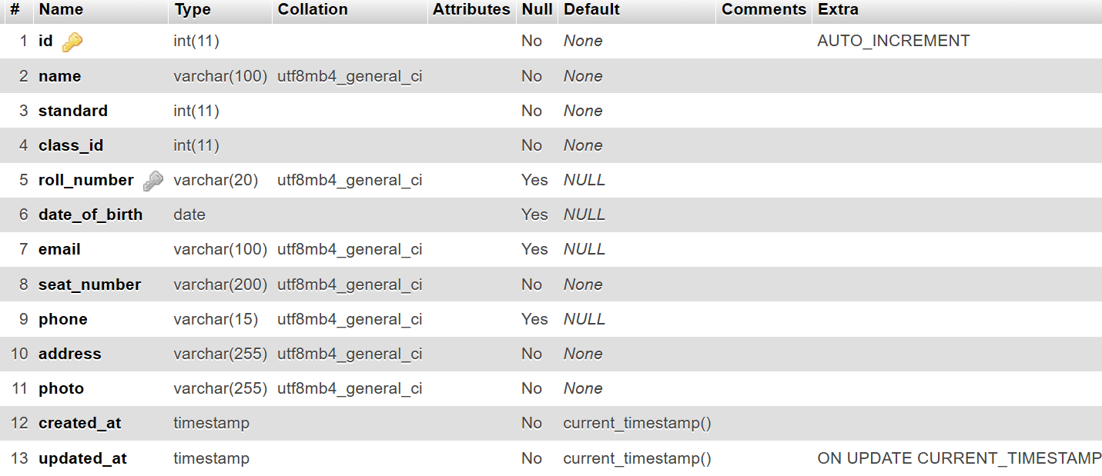
Exam:

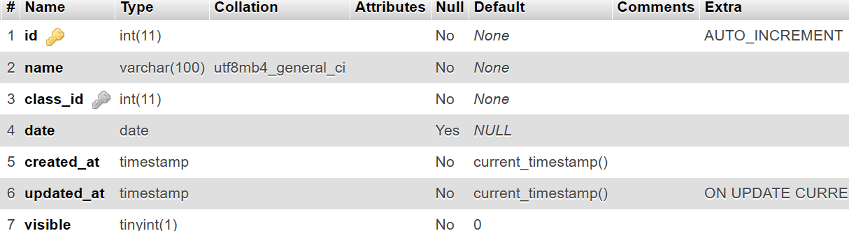
Teacher:

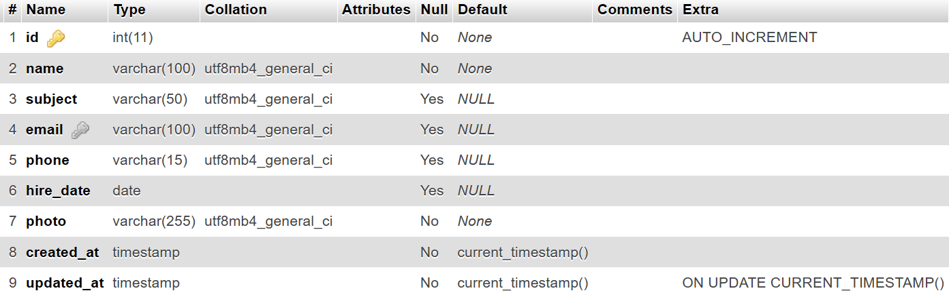

Settings:

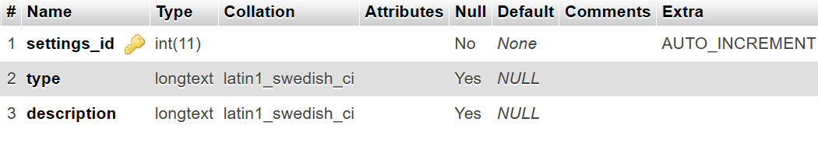
Classes:

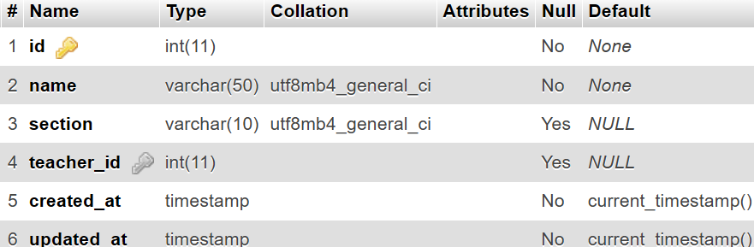

Photos:

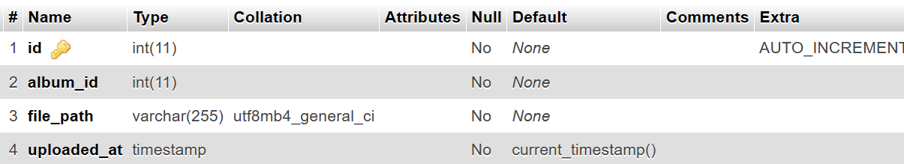

Notice:

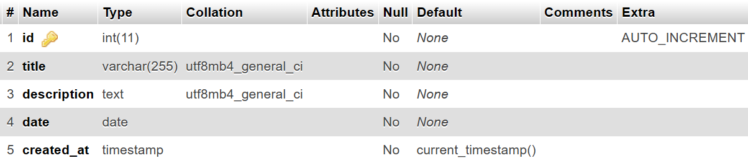

Announcements of Events:

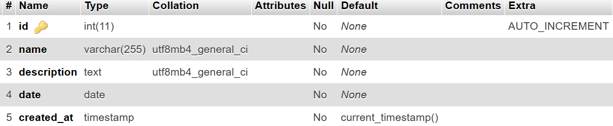

4.2 Screen shot of application:

At admins
Login/
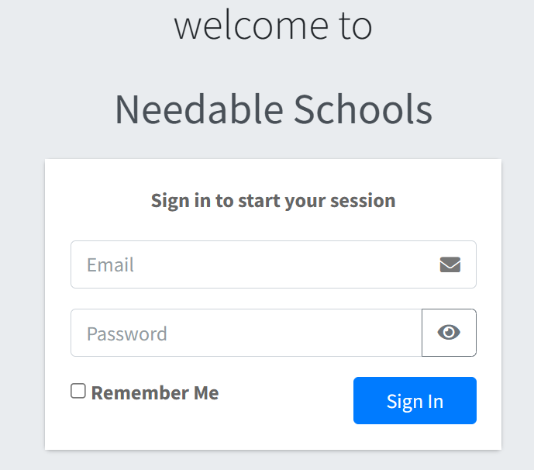
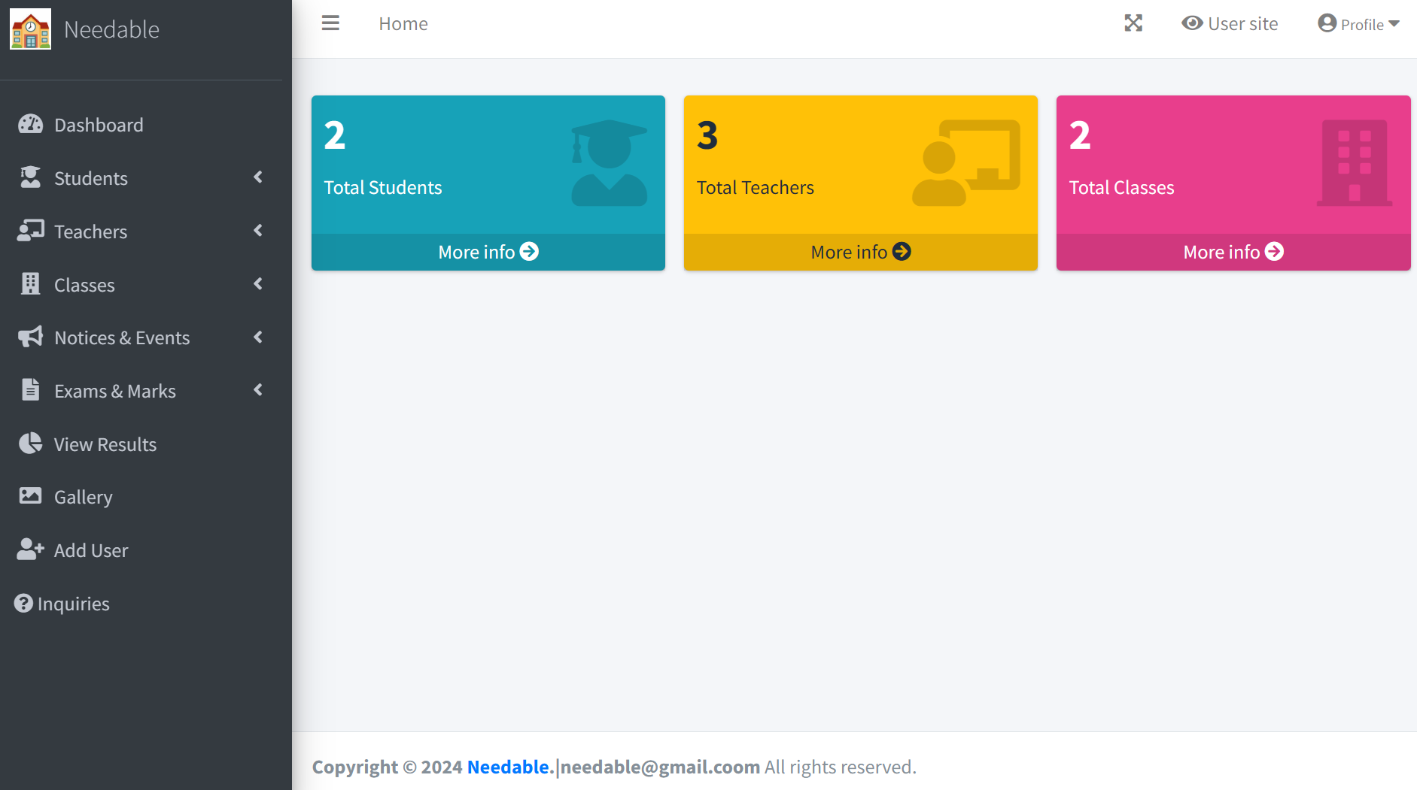

/manage_students
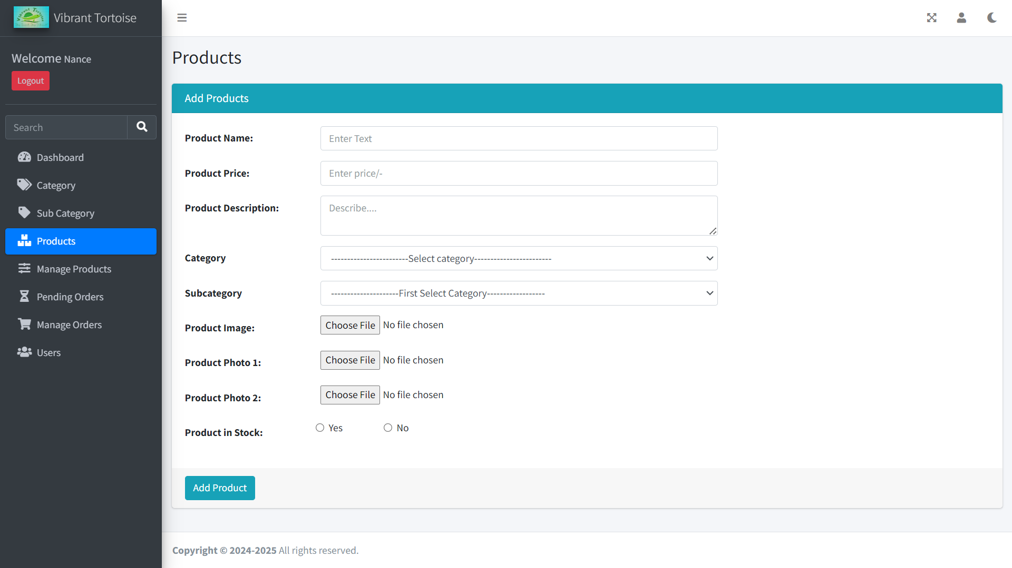

Profile.python(super admin)

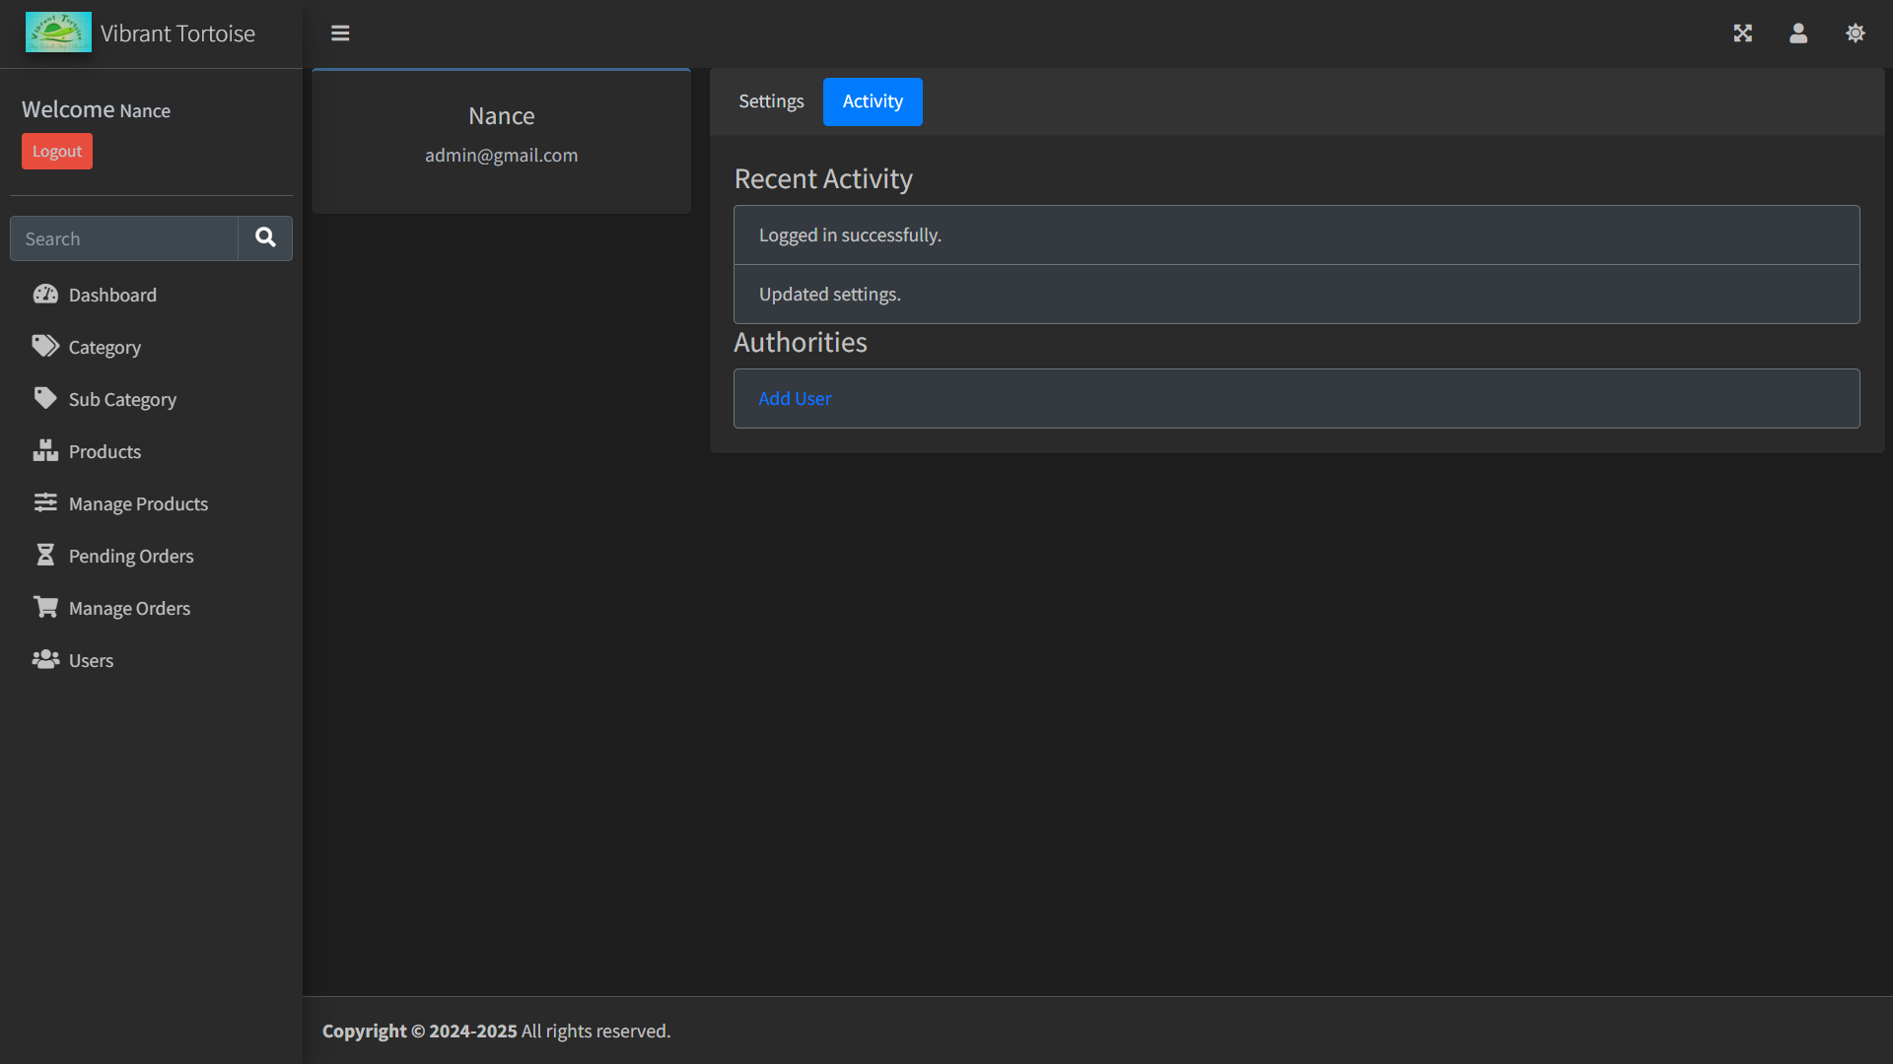

Register.python(add user)
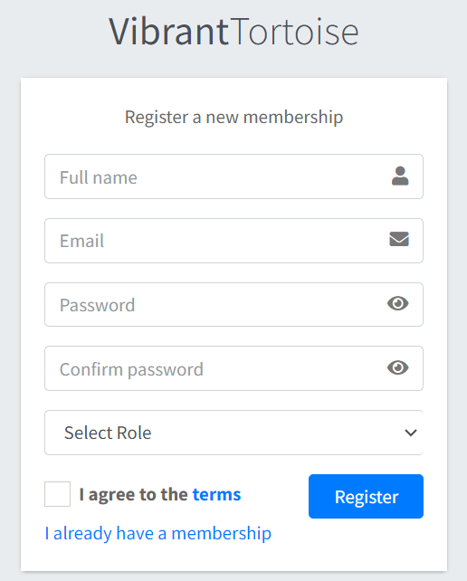

Profile.python(other’s)
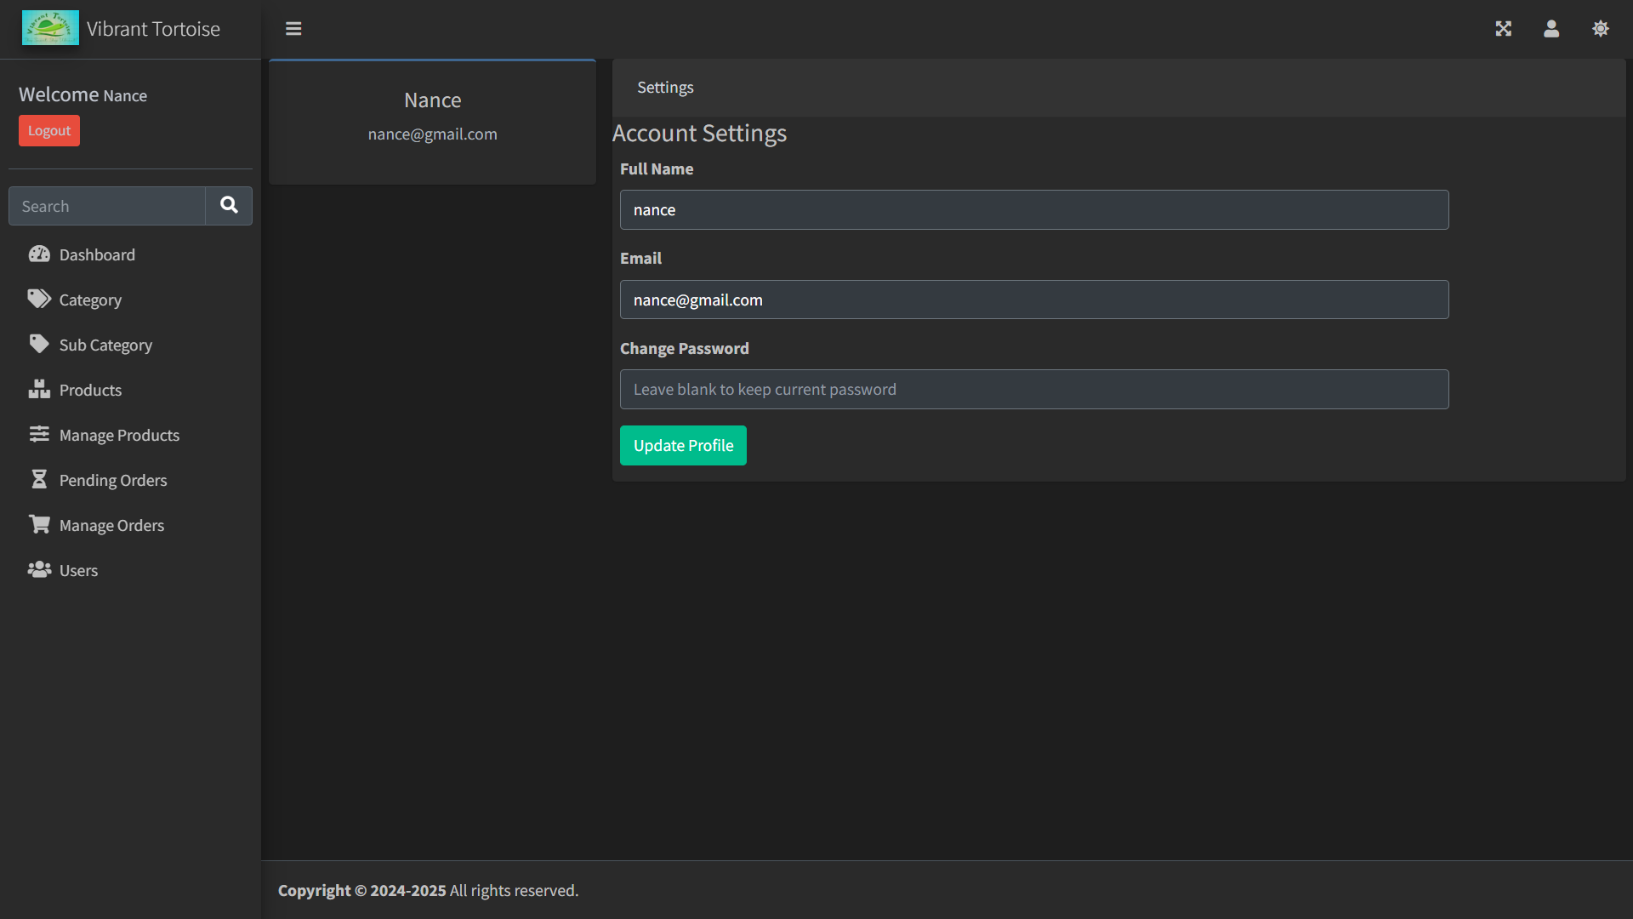
Client

Index.python product.python
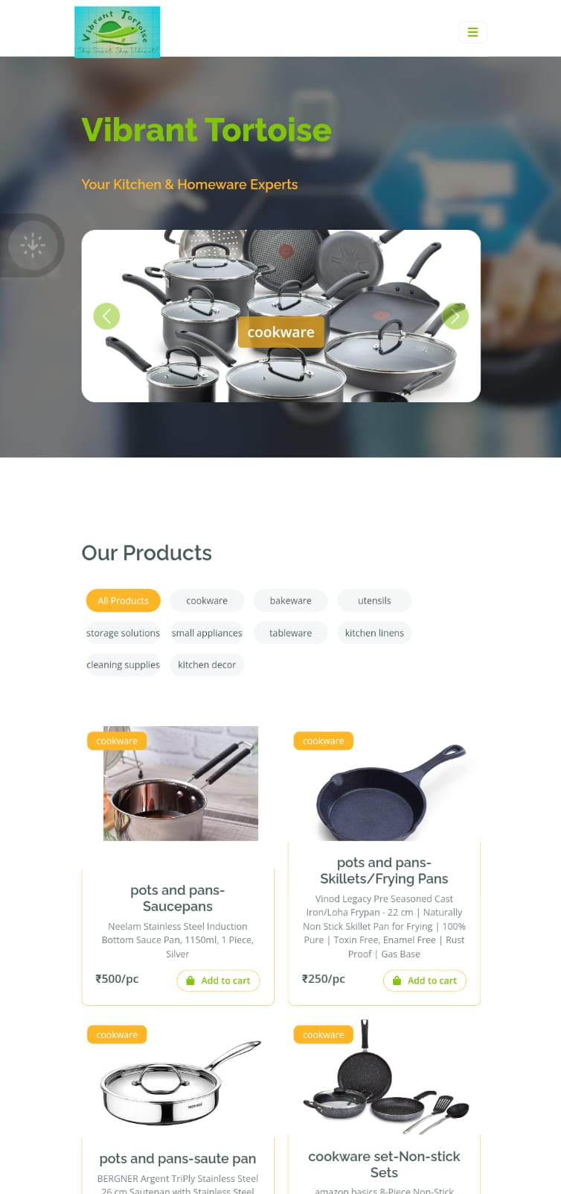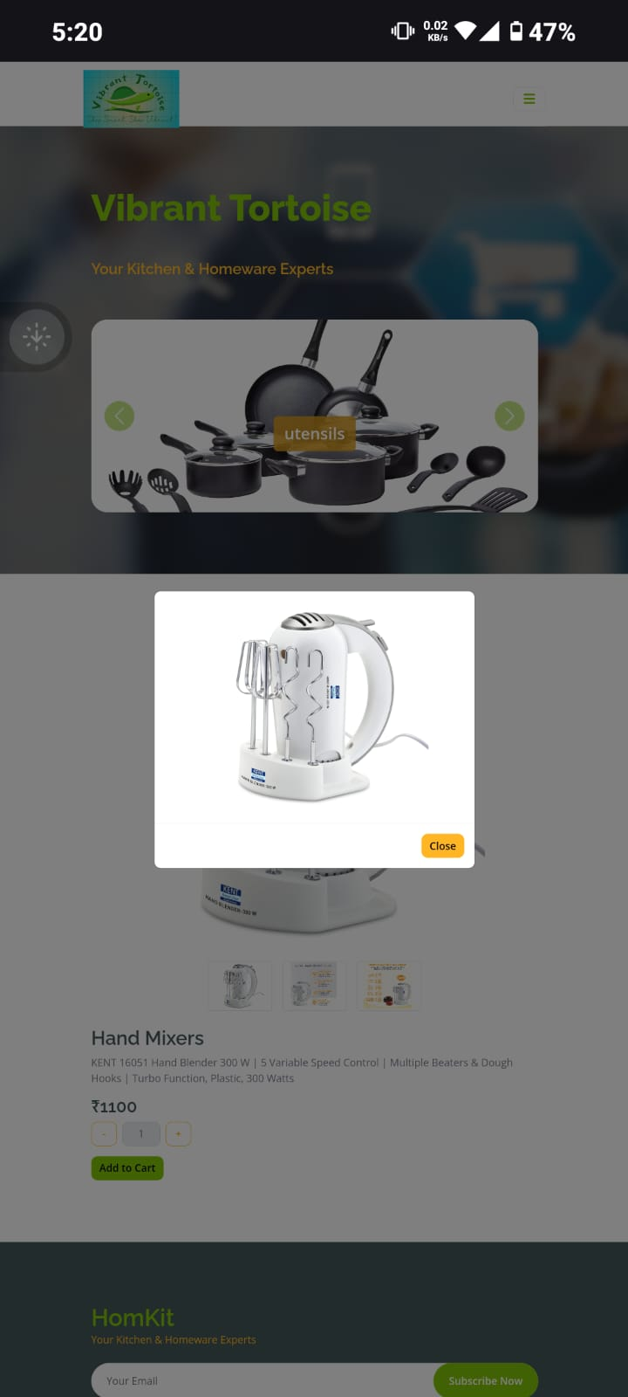

Profile.python order.python
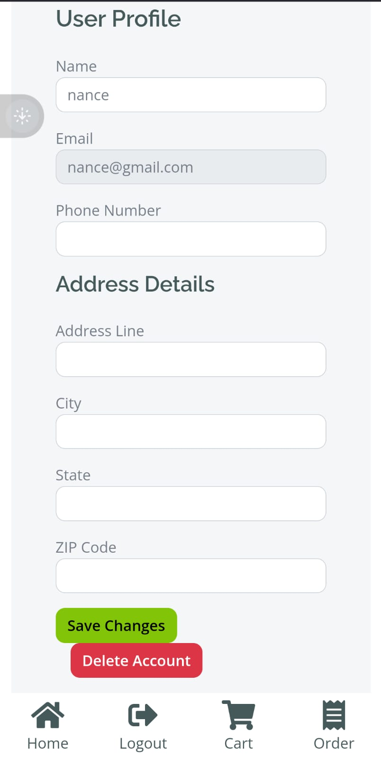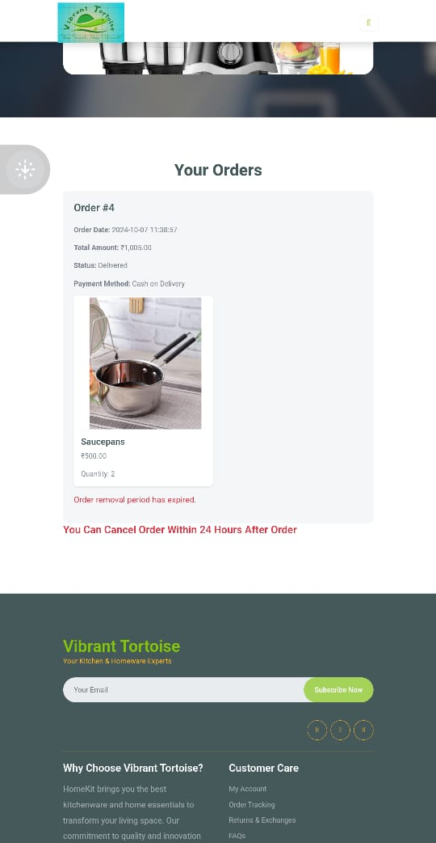

Login.python

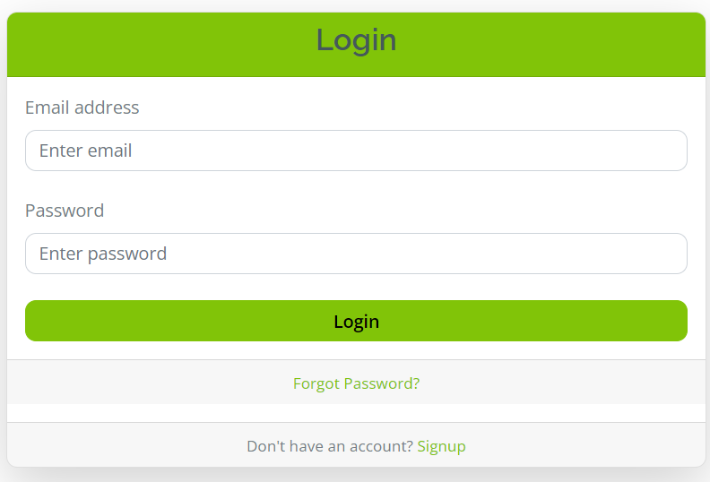

Reset_password.python

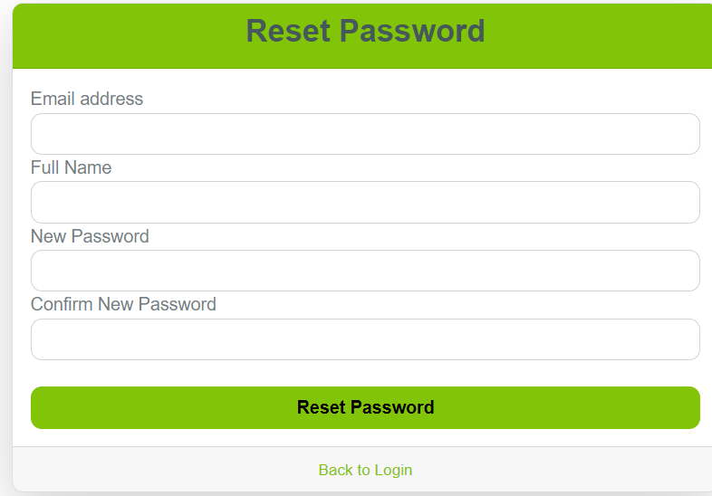

Conclusion

In conclusion, the “Vibrant Tortoise” project successfully delivers a comprehensive School Management System designed to streamline and simplify the overall management process for educational institutions. Developed using modern web technologies such as HTML, CSS, JavaScript for the front-end and Python, MySQL for the back-end, the system ensures both efficiency and user-friendliness.
The platform enables students and staff to interact seamlessly — from managing student records, attendance, and grades to handling administrative operations like user management and data maintenance. Administrators can easily monitor all activities, maintain records, and ensure smooth system operation, while users benefit from a clean and intuitive interface.
Overall, this project demonstrates the practical implementation of full-stack web development and provides a reliable, scalable, and secure solution for managing academic operations effectively. It stands as a testament to how technology can enhance institutional productivity and improve accessibility for all users.

Limitations
• Limited Payment Options:
Currently supports only basic payment methods, lacking integration with modern gateways like UPI or digital wallets.
• Scalability:
The system may struggle to handle a large number of simultaneous users or transactions without further optimization.
• Customization:
Users have limited customization options for the interface and product display.
• Security Measures:
Basic security features are in place, but advanced encryption and user data protection might require improvements.
• Mobile Optimization:
While responsive, the platform may need further refinement for seamless mobile experience.

5. Bibliography

    - Book Reference:

• PYTHON 5.0
• Designing using PYTHON
• Web Developing using PYTHON

    - WEB Reference:
https://www.w3schools.com/python

