
A
Project Report On
“DigitaL VIBE”

Towards partial fulfillment of the requirement in
Master of Science In
Information Technology & Computer Application
Submitted by
ACADEMIC YEAR: 2025-2026
Name:
- Khatra Nensi Tejasbhai
2) Chavda Suraj Mukeshbhai

M.Sc. (IT & CA): SEM (2)

Enrollment No:
25CS302PG00483 (Nensi)
25CS302PG00469 (Suraj)

Project Guide
Prof. Mitalben Vaishnav



Submitted To:
Shree Matrumandir Institute of Information Technology & Management
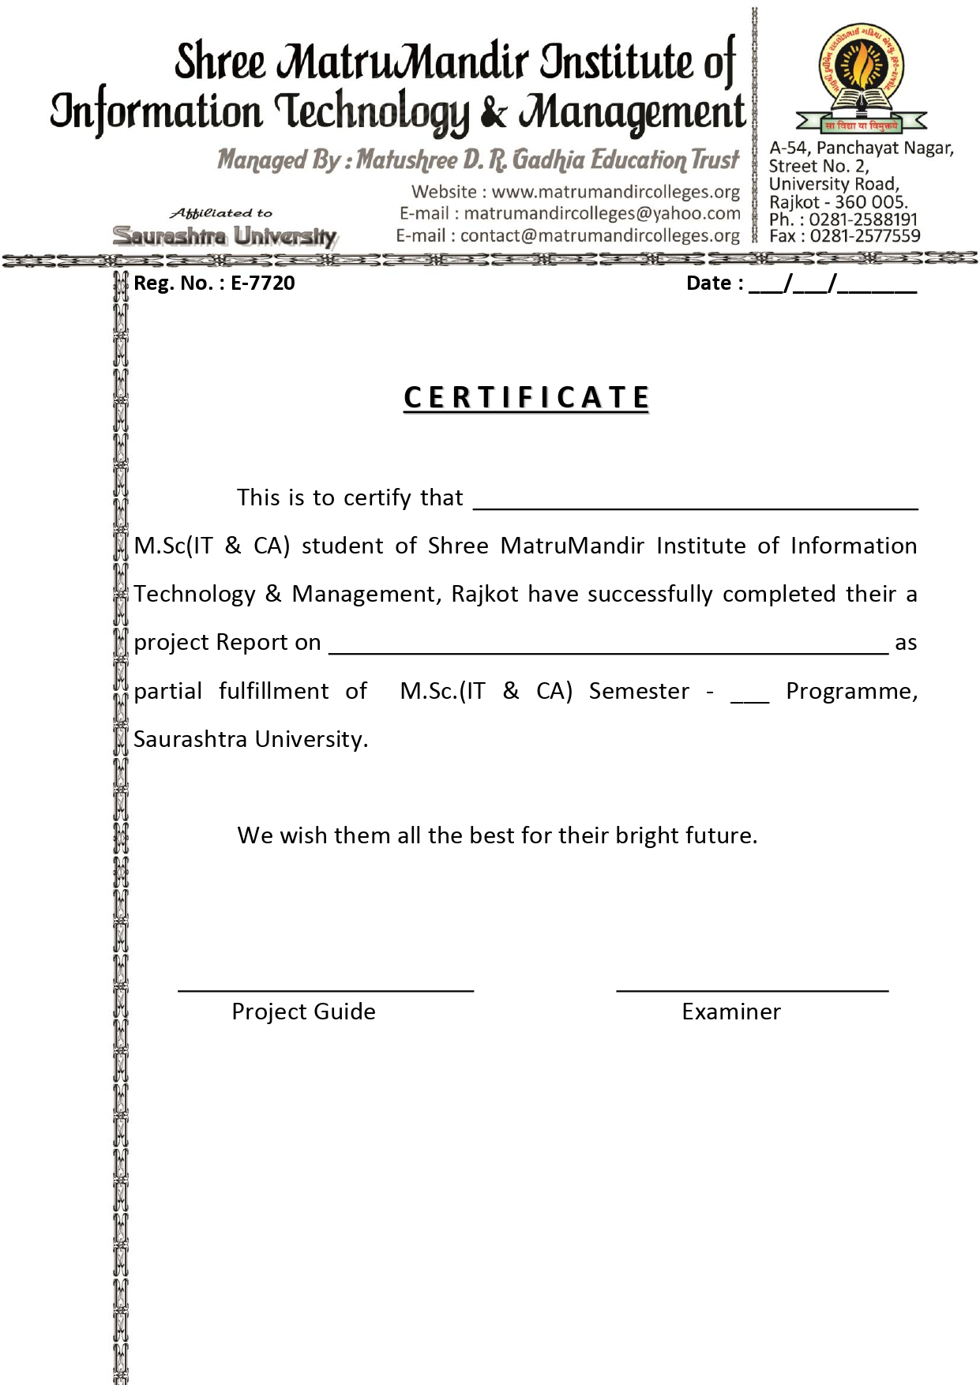
Digital Vibe
2
Chavda Suraj Mukeshbhai
2
Khatra Nensi Tejasbhai
Digital Vibe

ACKNOWLEDGEMENT
First and foremost, we would like to express our sincere gratitude to our respected guide, Prof. Mitalben Vaishnav, for her valuable guidance, continuous support, and motivation throughout the completion of this project. We are truly thankful to her for providing us with this wonderful opportunity to work on the project “Digital Vibe”.

This project has given us hands-on exposure to various concepts related to E-commerce systems, website development, and database management. Working on this project has enhanced our technical knowledge and improved our practical understanding of web technologies.

We are also thankful to all our faculty members of Shree Matrumandir Institute of Information Technology & Management for their constant encouragement and for sharing their knowledge, which helped us at every stage of this project.

Finally, we would like to thank our classmates, friends, and everyone who directly or indirectly supported us during the development and testing phase of this project.

PREFACE
The project “Digital Vibe” is developed to provide users with a seamless and modern online shopping experience for a wide range of electronic products. The platform focuses on delivering the latest gadgets, home appliances, and tech accessories that cater to different user needs, preferences, and budgets.
At Digital Vibe, we believe that online shopping should be fast, secure, and user-friendly. Therefore, the website is designed using modern web technologies such as React.js for a dynamic and responsive user interface, ensuring smooth navigation and an interactive browsing experience. Customers can easily explore products, compare specifications, and make purchases from anywhere at their convenience.
All products available on the platform are well-organized into categories, making it easier for users to find what they are looking for. The system also ensures product authenticity, detailed descriptions, and updated pricing to build user trust and satisfaction. Our aim is to combine innovation with reliability, giving customers both quality products and a secure transaction environment.
The platform includes essential e-commerce features such as a shopping cart, secure checkout process, and multiple payment options, supported by a robust backend developed using Node.js and a MongoDB database for efficient data management.
We also emphasize continuous improvement by considering user feedback and integrating new features based on customer needs and market trends. This project represents our practical understanding of full-stack web development and modern e-commerce architecture.
Thank you for exploring our project. We hope that Digital Vibe successfully demonstrates an efficient, scalable, and user-friendly online electronics shopping platform.

INDEX

No |  | Description | Page No.
1 |  | Project Summary
 | 1.1 | Project Profile | 7
 | 1.2 | Project Purpose | 8
 | 1.3 | Project Development Model | 9
 | 1.4 | Project Development Scheduling | 10
 | 1.5 | Project scope | 11
 | 1.6 | Technology used | 12
 | 1.7 | Feasibility study | 13
2 |  | System requirement & specification
 | 2.1 | User Characteristics | 14
 | 2.2 | User access flow | 15
 | 2.3 | Proposed system & advantage | 16
 | 2.4 | Hardware & Software requirement | 17
3 |  | Design System
 | 3.1 | Context Diagram | 18
 | 3.2 | Dataflow Diagram | 19
 | 3.3 | ER diagram | 20
 | 3.4 | Use Cases | 21
 | 3.5 | Flow Chart | 22
4 |  | System Design
 | 4.1 | Data dictionary | 24
 | 4.2 | Screenshot of application | 27
 | 4.3 | Conclusion | 33
 | 4.4 | Limitations. | 34
5 |  | Bibliography | 35
1. Project Summary

1.1 Project Profile.
1.2 Project Purpose.
1.3 Project Development Model.
1.4 Project Development Scheduling.
1.5 Project scope.
1.6 Technology Used.
1.7 Feasibility Study.

1.1 Project Profile:

Project Title : Digital Vibe
Institution : Rajkot
Front End : HTML, CSS, JavaScript, Bootstrap, React js
Back End : Node js, Mongo DB
Team Size : 2 Members
Project Guide : Prof. MITALBEN VAISHNAV
Submitted By : Chavda Suraj Mukeshbhai
And Khatra Nensi Tejasbhai
Submitted To : Shree Matrumandir Institute of Information Technology & Management
1.2 Project definition - purpose

The purpose of the Digital Vibe project is to provide users with a reliable and user-friendly online platform for purchasing electronic products. It allows customers to easily browse, select, and buy gadgets and accessories from anywhere.
The main goal is to develop a secure and efficient e-commerce system using modern technologies like React.js, ensuring smooth navigation, clear product information, and a hassle-free shopping experience.
Additionally, the platform is designed to build customer trust by offering accurate product information, multiple payment options, and reliable transaction handling through a robust backend using Node.js and MongoDB.
Overall, Digital Vibe aims to create a simple, convenient, and trustworthy platform that enhances customer satisfaction in online electronics shopping.

1.3 Project Development Model
A software development model is a simplified description of the software process that shows how a project is planned and executed. The choice of a suitable model depends on the type of project, its requirements, tools, and the expected outcomes.
For Digital Vibe, a systematic development model was followed to ensure smooth and organized progress at every stage. The project is treated as a problem-solving process that passes through four main stages:
• Status Quo: Represents the current situation, identifying the need for an online platform for purchasing electronic products easily.
• Problem Definition: Defines the problem of limited accessibility to electronic products in offline stores and the need for a convenient and reliable online shopping system.
• Technical Development: Develops the solution using technologies like HTML, CSS, JavaScript, Bootstrap, React.js, Node.js, and MongoDB.
• Solution Integration: Delivers the final working e-commerce website with all features such as product browsing, shopping cart, secure checkout, and complete system functionality to meet user requirements.

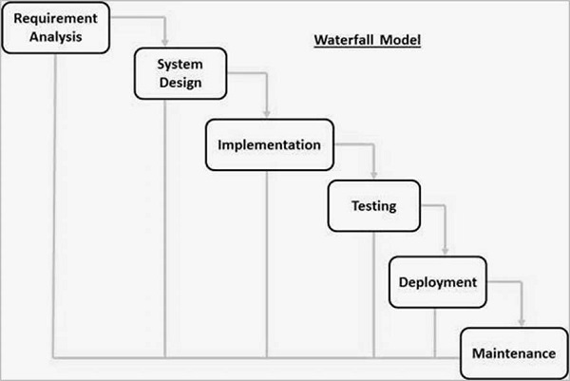

1.4 Project Development Scheduling:

Week  Month | Week 1 | Week 2 | Week3 | Week 4
1st Month | Requirement Gathering | Initial Design | Database Setup | Frontend Development
2nd Month | Backend Development | Integration of Modules | Testing (Phase 1) | Bug Fixes & Improvements
3rd Month | User Testing | Final Debugging | Project Deployment | Post-Deployment Support

1.5 Project scope.
The Digital Vibe project aims to develop a reliable and modern online platform for purchasing electronic products, offering a smooth and efficient shopping experience for users. The website provides a user-friendly interface where customers can easily browse and search for various gadgets, home appliances, and accessories, with options to filter by price, brand, or category. Registered users can create and manage their accounts to save favorite products, view order history, and receive personalized recommendations based on their preferences.
The platform includes secure and multiple payment options to ensure safe online transactions. Customers can track their orders, receive updates on order status, and contact support for assistance or queries. The scope also includes an effective inventory management system that allows the admin to manage product listings, stock availability, and sales records efficiently.
In addition, the project integrates features like customer reviews, ratings, and discount offers to increase user engagement and trust. Promotional deals and special offers are included to enhance customer satisfaction and encourage repeat purchases. The system also focuses on a smooth delivery process to ensure timely and accurate shipment of products.
Overall, the scope of Digital Vibe is to create a complete, secure, and scalable e-commerce solution that provides a convenient and trustworthy online shopping experience for electronic products.

1.6 Technology Used.

What is React.js?
React.js is a popular open-source JavaScript library used for building modern and dynamic user interfaces, especially for single-page applications. It allows developers to create reusable UI components, making the development process faster and more efficient. React uses a virtual DOM to improve performance by updating only the necessary parts of a web page instead of reloading the entire page. It works seamlessly with HTML, CSS, and JavaScript to create interactive and responsive front-end applications. React.js is widely used for building scalable and high-performance user interfaces.

What is Node.js?
Node.js is a powerful server-side JavaScript runtime environment that allows developers to build fast and scalable web applications. It uses an event-driven, non-blocking architecture, making it efficient for handling multiple requests at the same time. Node.js enables developers to use JavaScript for both front-end and back-end development, simplifying the development process. It is widely used for building APIs, handling server logic, and managing data flow between the client and the database.

What is HTML?
HTML (Hypertext Markup Language) is the basic structure of any website. It defines the layout of content such as text, images, links, and forms on a web page. Web browsers read HTML documents and display them to users as visual web pages. HTML is easy to learn and forms the foundation upon which other technologies like CSS, JavaScript, and Bootstrap work together to make websites dynamic and attractive.

What is CSS?
CSS (Cascading Style Sheets) is used to design and format web pages created with HTML. It defines how the elements should look — including colors, fonts, layout, and spacing. By separating content from design, CSS makes it easier to manage and update website styling. A single CSS file can be used across multiple pages to ensure consistent design and improve website speed. CSS also helps make web pages responsive so they look good on all devices.

What is JAVASCRIPT?
JavaScript is a lightweight programming language that adds interactivity and dynamic features to web pages. It runs directly in the web browser, allowing actions like form validation, animations, and live content updates without reloading the page. JavaScript makes websites more engaging and user-friendly. It is supported by all modern browsers and works closely with HTML and CSS to create powerful front-end experiences.

What is MongoDB ?
MongoDB is a NoSQL, open-source database used to store and manage large amounts of unstructured data. Unlike traditional databases, it stores data in flexible, JSON-like documents, making it easy to scale and modify. MongoDB provides high performance, scalability, and flexibility, making it suitable for modern web applications. It works efficiently with Node.js to handle backend operations such as data storage, user management, and application logic.

1.7 Feasibility Study.
A feasibility study is an essential step carried out before starting the Digital Vibe project to determine whether it is practical, achievable, and worth developing. It helps in evaluating if the project can be successfully implemented using the available time, budget, and resources. This study includes analyzing key aspects such as technical feasibility (availability of technologies like React.js, Node.js, and MongoDB), economic feasibility (cost-effectiveness of development and maintenance), legal feasibility (compliance with online transaction and data security regulations), operational feasibility (ease of use for customers and administrators), and schedule feasibility (completion within the planned timeline).
By carefully evaluating these factors, the feasibility study helps identify possible challenges at an early stage, reduce risks, and support effective decision-making. It also provides a clear understanding of the project’s strengths, limitations, and growth opportunities. Overall, the main objective of conducting this feasibility study is to ensure that the Digital Vibe project is technically reliable, economically viable, and capable of delivering a successful and efficient e-commerce solution.

2. System requirement & specification.

  - User Characteristics.
  - User access flow.
  - Current system.
  - Proposed system & advantage.
    - Proposed system.
    - Advantage of proposed system.
  - Hardware & Software requirement.
2.5.1 Hardware requirement.
2.5.2 Software requirement.

2.1 User characteristics
In the Digital Vibe project, users can perform a variety of essential functions that make their shopping experience smooth and convenient:
- Browse and Search for Products: Users can explore different categories such as smartphones, laptops, accessories, and home appliances. They can also use the search bar and filters to quickly find specific products.
- View Product Details: Each product has a detailed page displaying information like price, specifications, features, images, and customer reviews to help users make informed decisions.
- Add to Cart and Wishlist: Users can add selected products to their shopping cart for purchase or save them to their wishlist for future reference.
- Place Orders: Customers can proceed to checkout, review selected items, choose payment methods, enter delivery details, and confirm their orders easily.
- Manage Orders: Users can view their order history, track current orders, and manage their purchases efficiently.
- Feedback and Support: Users can rate products, provide feedback, and contact customer support for any queries or issues.
This system ensures a simple, user-friendly, and efficient online shopping experience, guiding users from product browsing to purchase and post-sale support.

2.2 User access Flow

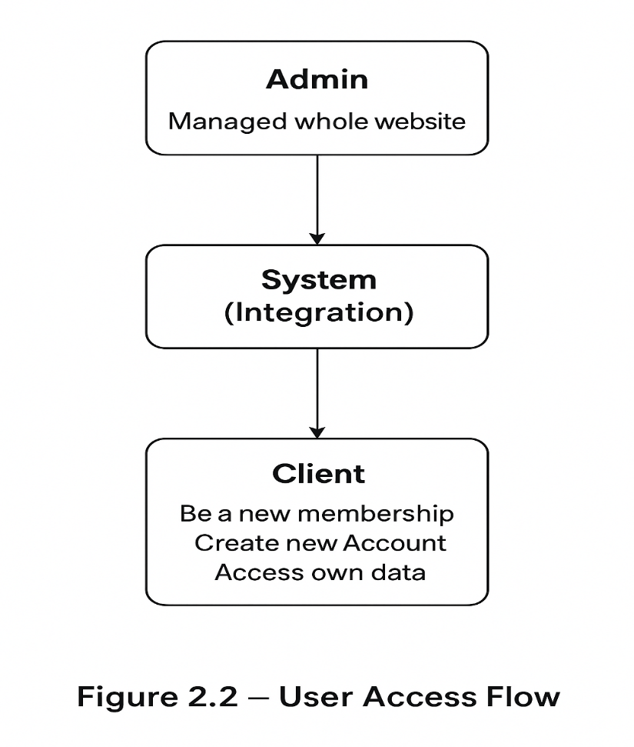

2.3 Proposed system & advantages
Proposed System
The proposed system is a modern, role-based e-commerce platform developed using React.js for the front-end and Node.js with MongoDB for the back-end. It includes both an admin panel and a user-facing website, designed to ensure efficiency, security, and scalability.
The admin panel allows authorized users to manage key modules such as products, categories, users, and orders through a well-structured interface.
On the other hand, customers can browse electronic products, add items to their cart or wishlist, and complete purchases easily. The system focuses on providing a secure, responsive, and user-friendly experience across different devices.

Advantages of the Proposed System
1. Scalability:
The system is designed to handle a growing number of users, products, and transactions. With the use of modern technologies, it can easily scale as the platform expands.
2. Security & Role Management:
Role-based access control ensures that only authorized admins can manage system data. Secure authentication and data handling help protect user information and transactions.
3. User-Friendly Experience:
The platform provides a clean and interactive interface. Users can easily browse products, manage their cart, and complete purchases with features like wishlist, order tracking, and secure checkout.
4. Efficient Management:
All operations such as product management, user handling, and order processing are centralized, reducing manual effort and improving system efficiency.

2.4 Software& hardware requirement

2.4.1 Hardware Requirement:
To run and test the Digital Vibe project smoothly, the following minimum hardware configuration is required:
• Processor: Intel Core i3 or higher
• RAM: Minimum 4 GB (8 GB recommended)
• Hard Disk: 500 GB or more
• Monitor: Standard Display (15” or higher)
• Keyboard & Mouse: Standard Input Devices

2.4.2 Software Requirement:
The project is developed using modern web technologies with a full-stack JavaScript approach.
Below are the required software tools and versions for proper setup and execution:
• Operating System: Windows 10 / 11 or Ubuntu Linux
• Front-End Technologies: HTML, CSS, JavaScript, Bootstrap, React.js
• Back-End Technologies: Node.js (latest LTS version)
• Database: MongoDB
• Server & API Tools: Express.js (for backend development)
• Package Manager: npm (Node Package Manager)
• Code Editor: Visual Studio Code / Sublime Text
• Browser: Google Chrome / Mozilla Firefox (latest version)

3. Design System
3.1 Context Diagram.
3.2 Dataflow Diagram.
3.3 ER diagram.
3.4 Use Cases
3.5 Flow Chart

3.1 Context Diagram:
Data flow diagrams can be used to provide a clear representation of any business function. The technique starts with an overall picture of the business and continues by analyzing each of the functional areas of interest. This analysis can be carried out to precisely the level of detail required. The technique exploits a method called top-down expansion to conduct the analysis in a targeted way.
- Customer (browsing jewellery, adding to cart, making payment)
- Admin (managing products, orders, categories, users)
- System (central website handling all operations)
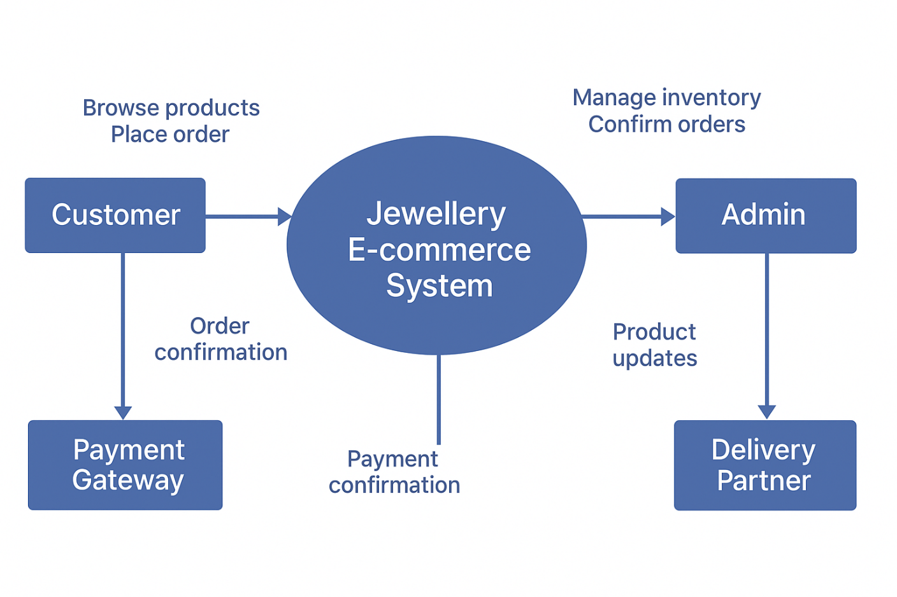
- Possibly Payment Gateway (for online payments)

1ST LEVEL DFD

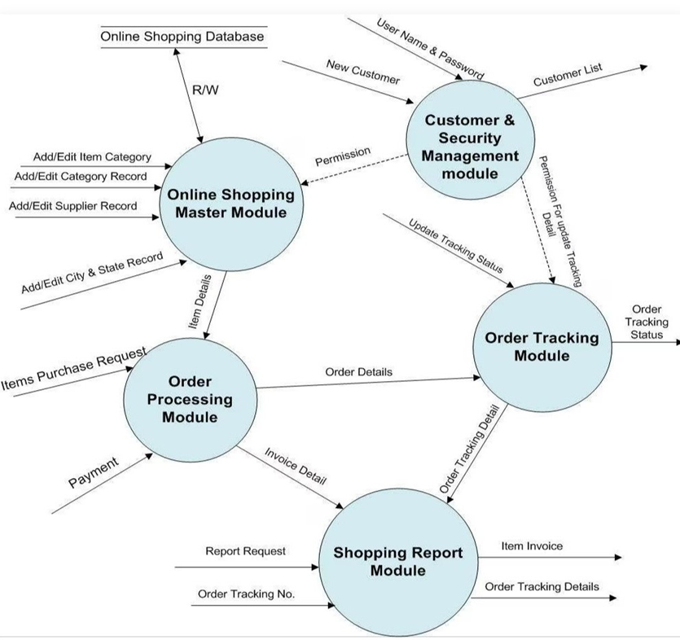

2ND LEVEL DFD
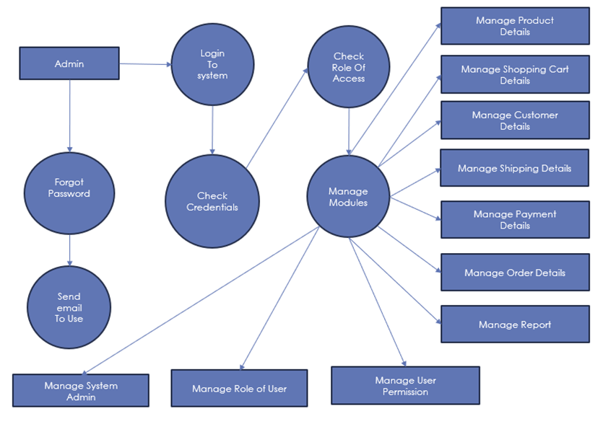

ER-Diagram:

The ER diagram model also called “An Entity Relationship Diagram” is a graphical representation of entities and their relationship to each other, typically used in computing in regard to organization of data within databases or information system.

An entity relationship diagram is a data modeling technique that can help define business process and can be used as foundation for relational database. The shapes we have used in E-R Diagrams are as follows.

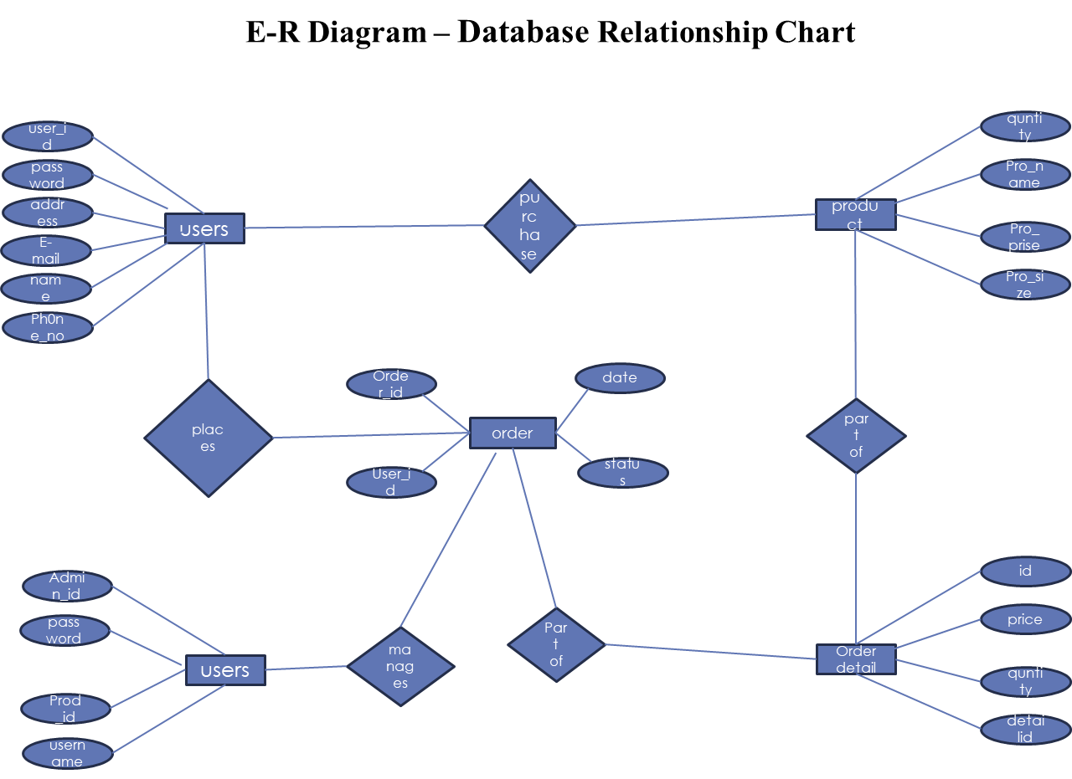

3.4 Use-Cases:

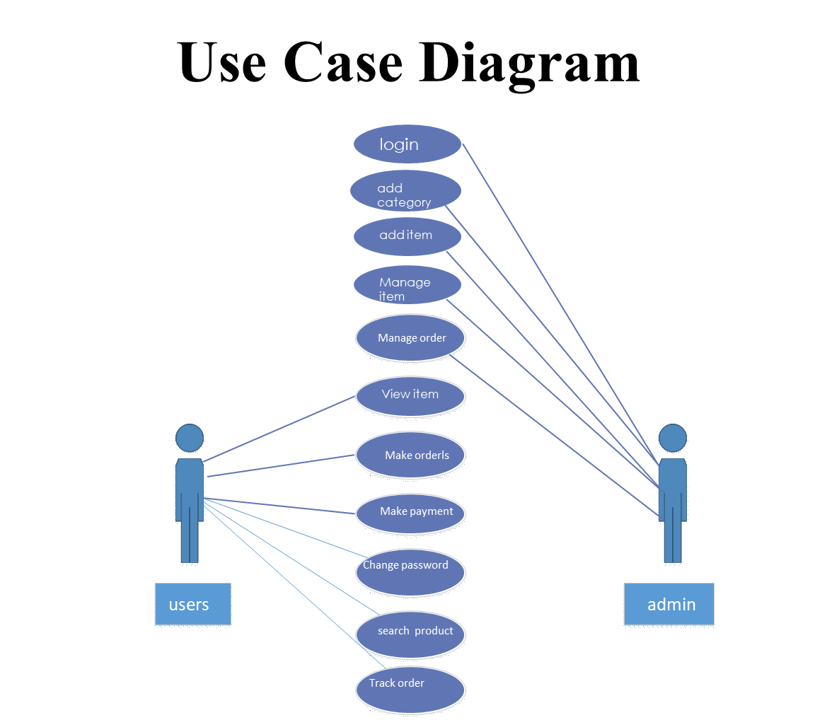

Flow Chart:

PROCESS FLOW DIAGRAM

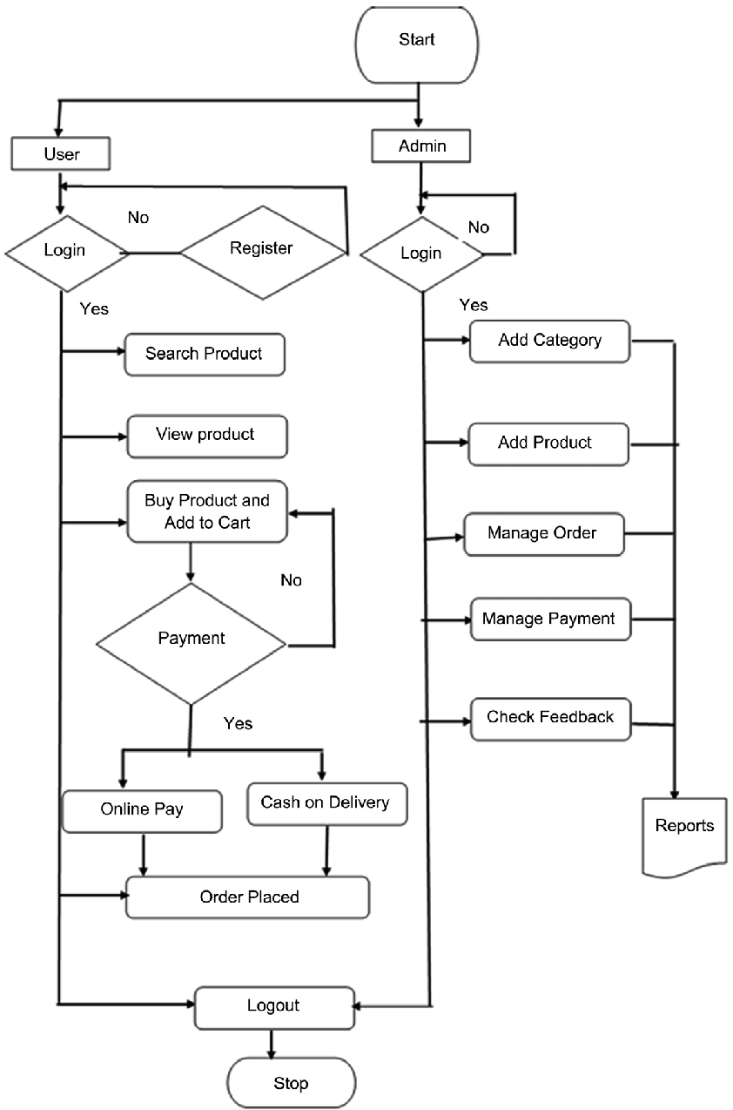

order detail

4. System Design
4.1 Data dictionary

import { useEffect, useState } from "react";

function Products() {
const [data, setData] = useState([]);

useEffect(() => {
fetch("http://localhost:5000/api/products")
.then(res => res.json())
.then(result => setData(result))
.catch(err => console.log(err));
}, []);

return (
<div>
{data.map((item) => (
<h3 key={item._id}>{item.name}</h3>
))}
</div>
);
}

export default Products;

4.2 Screenshot of application:
At admins

- Login
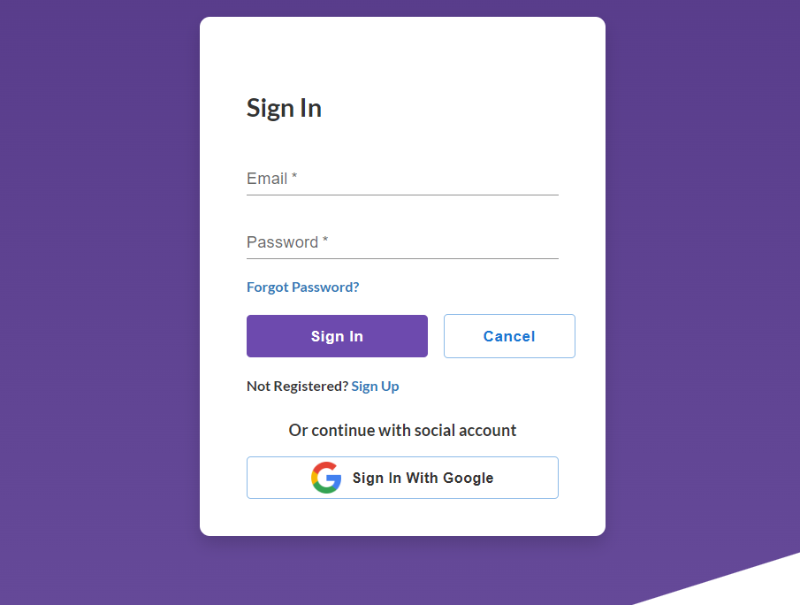

- Register
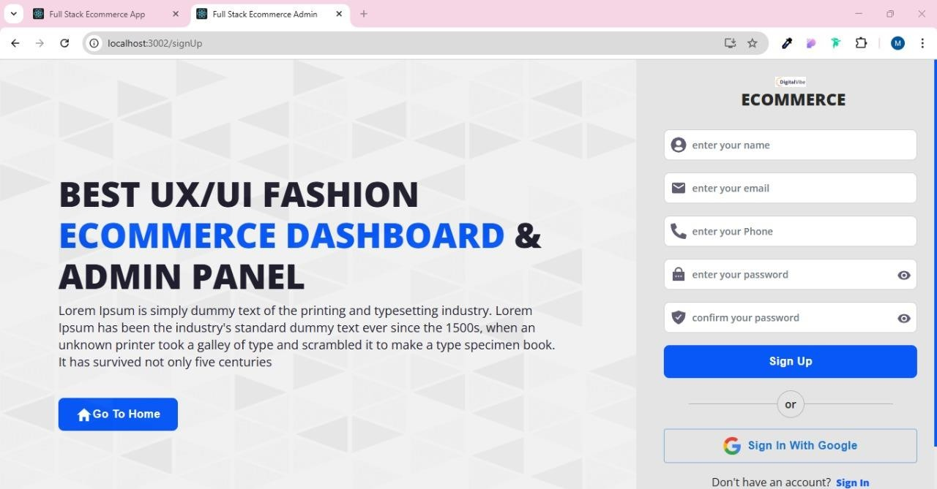

- About

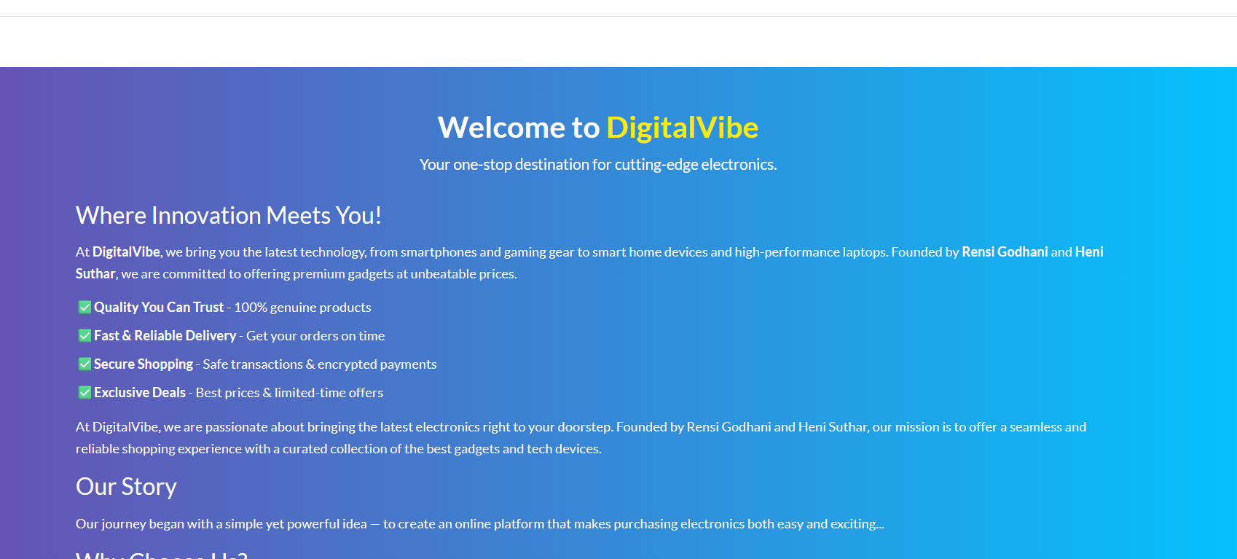

- Product list
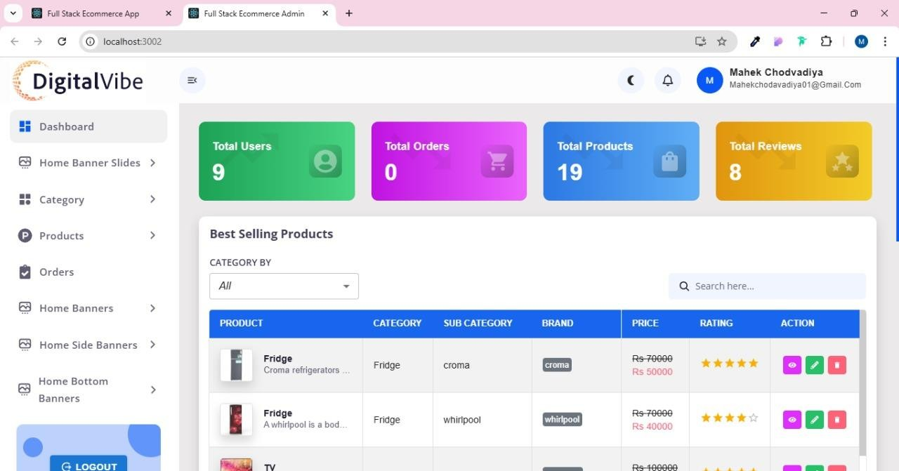

- Order list
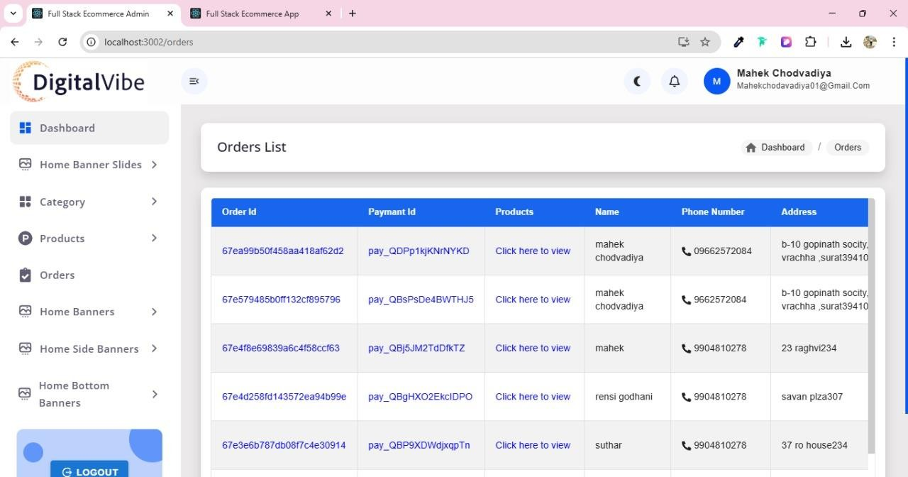

Client
- Home page
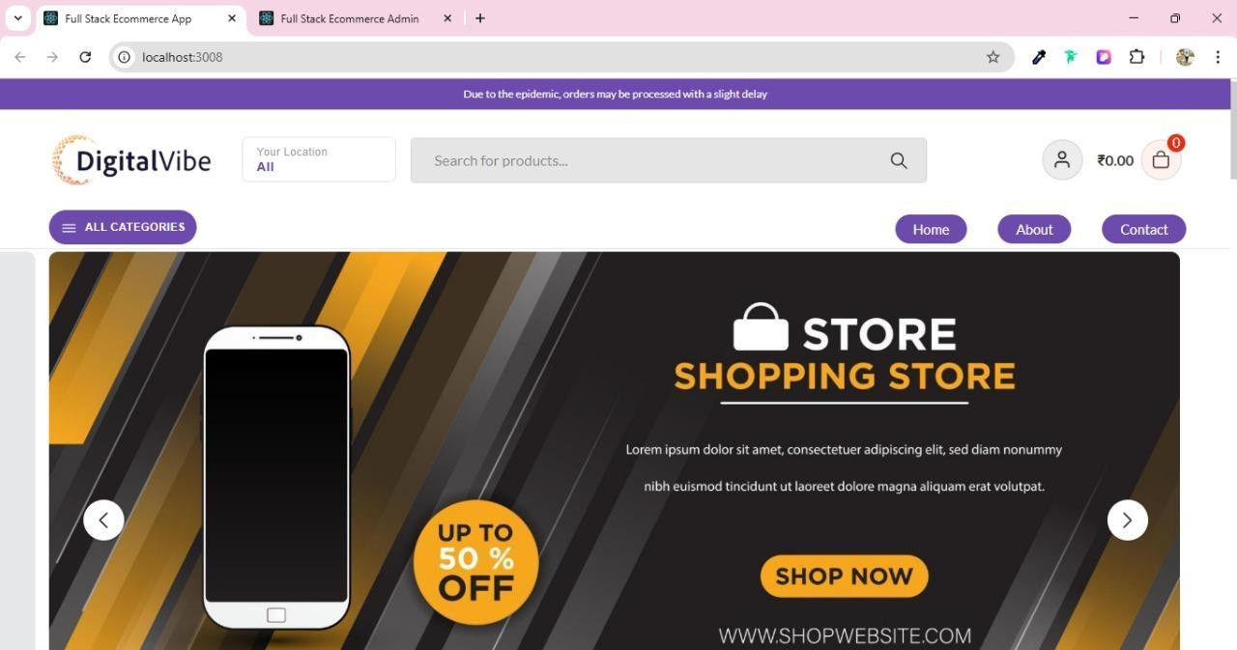

- Featured product

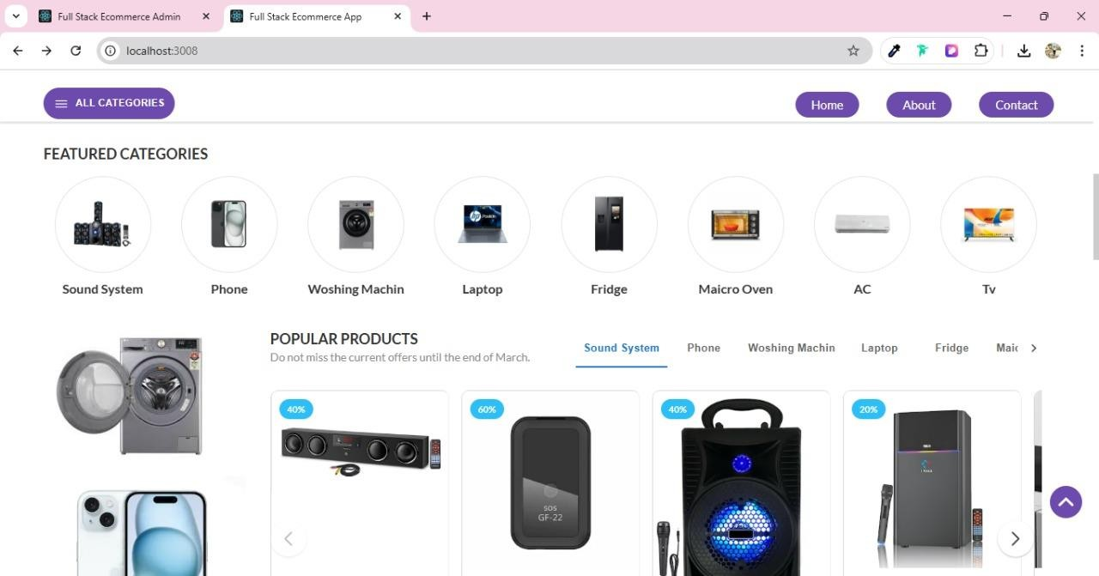
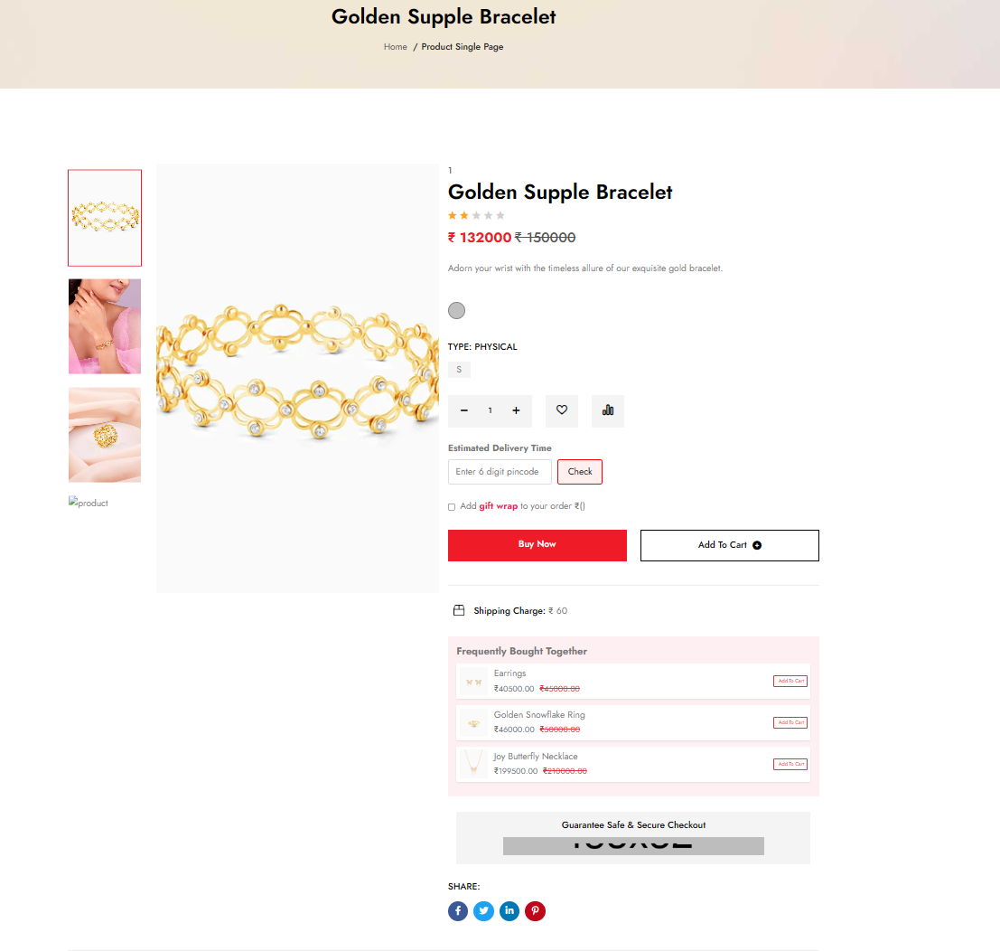
- Cart
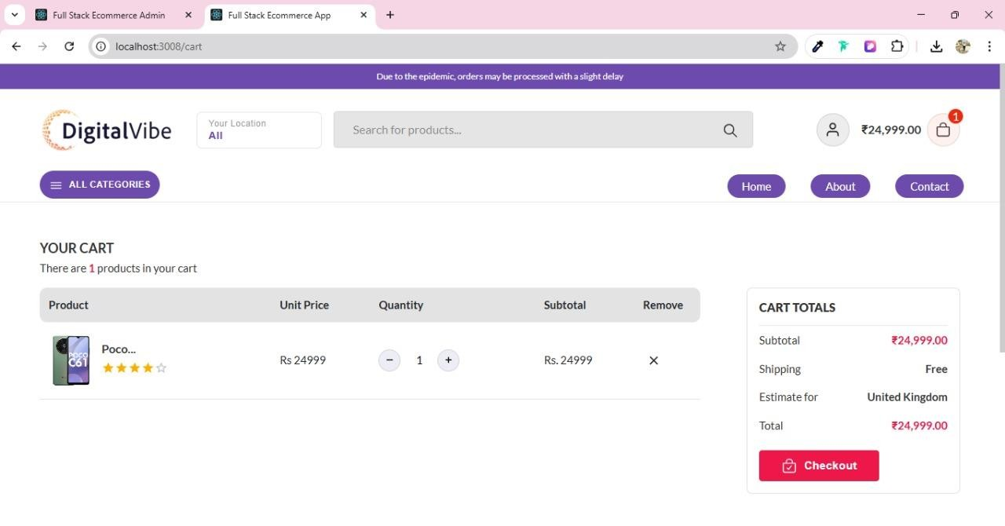

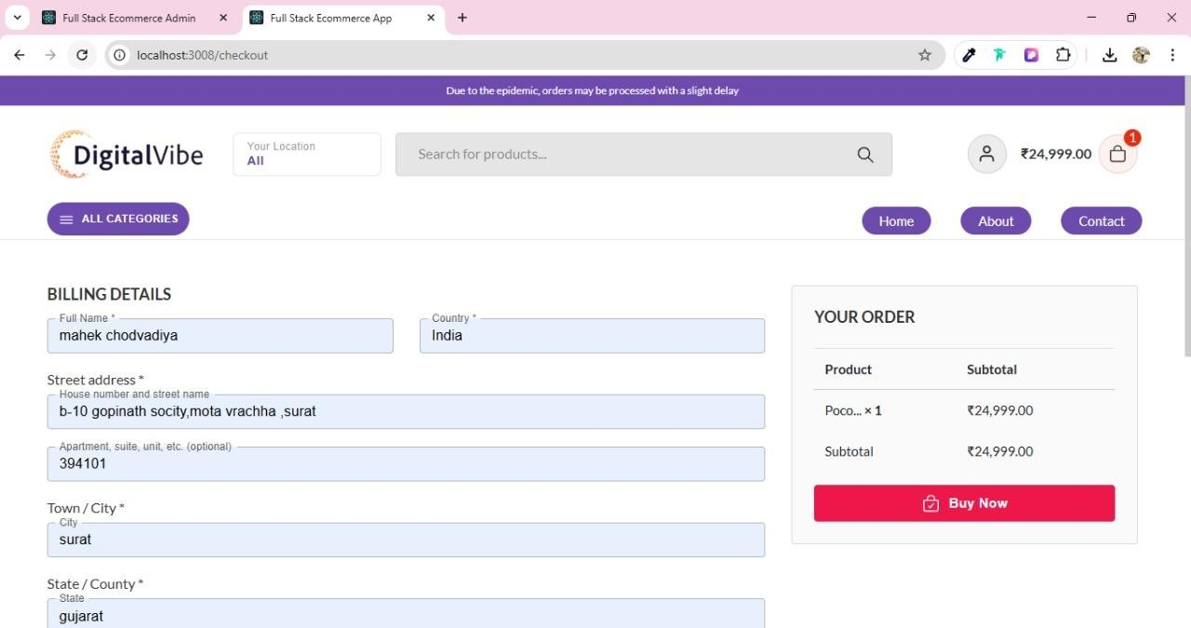

- Checkout

- Product Detail

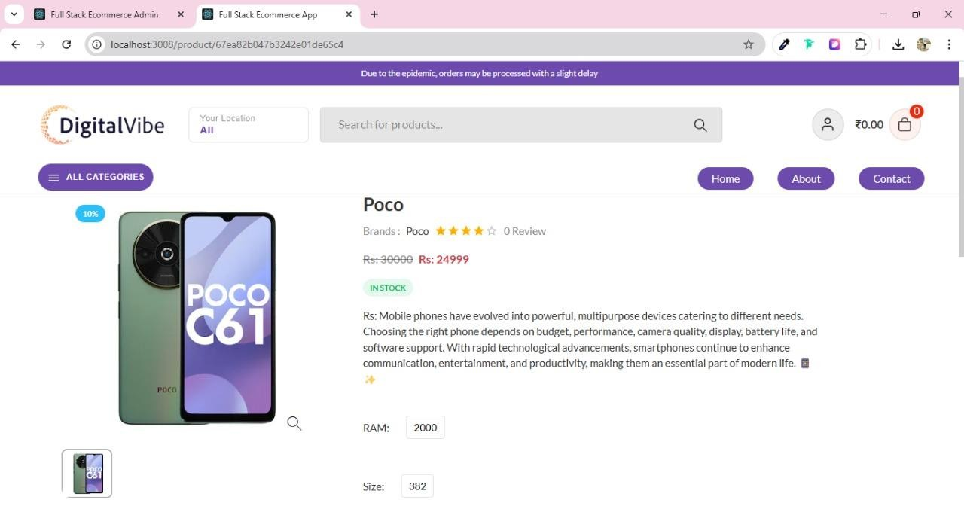

Conclusion

In conclusion, the “Digital Vibe” project successfully delivers a modern and efficient e-commerce platform for electronic products, simplifying online shopping for customers and management tasks for administrators. The system is developed using HTML, CSS, JavaScript, Bootstrap, and React.js for the front end, while Node.js and MongoDB are used for the back end, ensuring a secure, scalable, and well-structured application.
The platform allows customers to register, browse electronic products, view detailed specifications, add items to the cart or wishlist, and place orders easily through a smooth checkout process. At the same time, the admin panel provides complete control over product management, orders, users, and transactions through proper access control.
Overall, the project demonstrates the practical implementation of full-stack web development in building a real-world e-commerce system. It provides a reliable, user-friendly, and secure solution that meets modern online shopping requirements and can be further enhanced with additional features in the future.

Limitations
• Limited Payment Options:
Currently supports basic payment methods; integration with advanced gateways like UPI, wallets, or real-time payment APIs can be enhanced.
• Scalability:
The system may require further optimization and cloud integration to efficiently handle a very large number of users and transactions.
• Customization:
Users have limited options for personalizing the interface and product display according to their preferences.
• Security Measures:
Standard security practices are implemented, but advanced features like data encryption, token-based authentication, and secure APIs can be improved.
• Mobile Optimization:
Although the platform is responsive, additional improvements can enhance performance and user experience on mobile devices.
5. Bibliography

    - Book Reference:
• React.js Documentation – Official React Guide
• Node.js Design Patterns and Development
• Full Stack Web Development with React and Node.js
    - WEB Reference:
• Official React Website: https://react.dev/
• Official Node.js Website: https://nodejs.org/
• Official MongoDB Website: https://www.mongodb.com/

