**INTRODUCTION**

In the digital age, interactive entertainment has become a crucial part of our daily lives, particularly for stress relief and cognitive stimulation. This project, titled GameHub, is a Java-based desktop application that serves as a centralized portal for accessing multiple classic games. The goal is to deliver a lightweight, responsive, and enjoyable user experience with games like Rock Paper Scissors, Memory Game, and Snake Game. By utilizing Java Swing for the user interface and maintaining simple yet engaging gameplay logic, this application offers users both recreation and mental engagement environment.

**PROBLEM STATEMENT**

Many users lack access to a lightweight, offline platform that combines multiple classic games in one place. Existing solutions are often fragmented or complex, reducing accessibility and user engagement.

**FEATURES OF THE PROJECT**

* User Authentication
* Main Game Menu Dashboard
* Three Classic Games- Rock Paper Scissors, Memory Game, Snack Game
* GUI
* Database

**TECHNOLOGIES USED**

* Java
* Java Swing
* Java Database Connectivity (JDBC)
* MySQL

**CODE**

1. GameHub.java

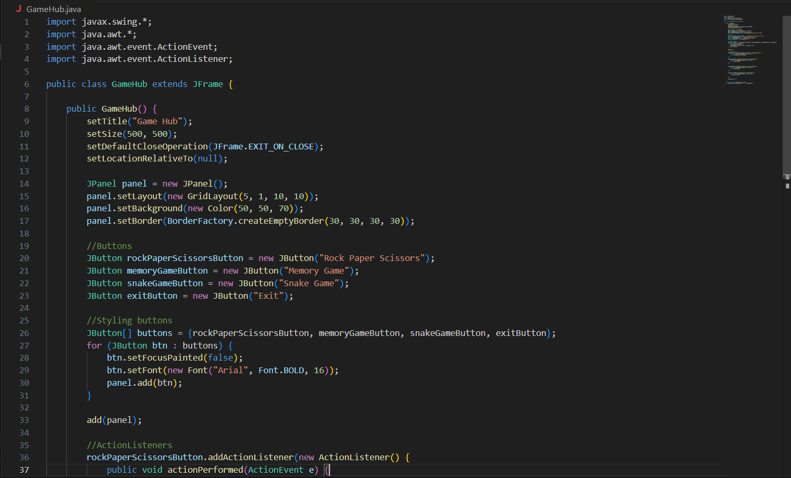

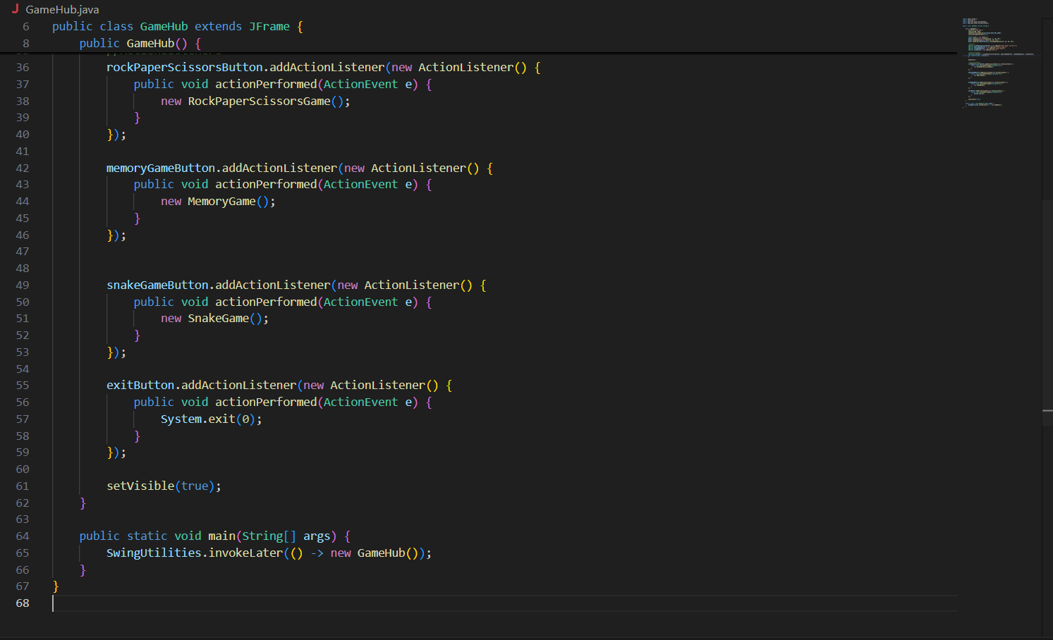

1. GameMenu.java

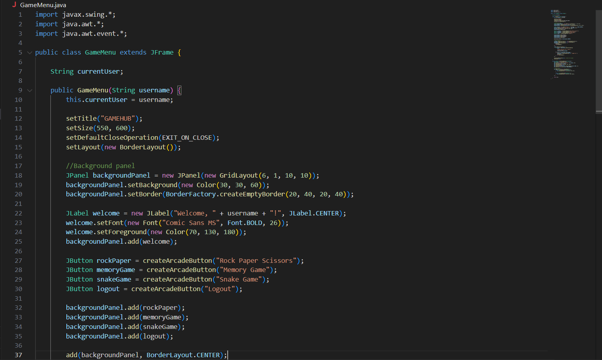

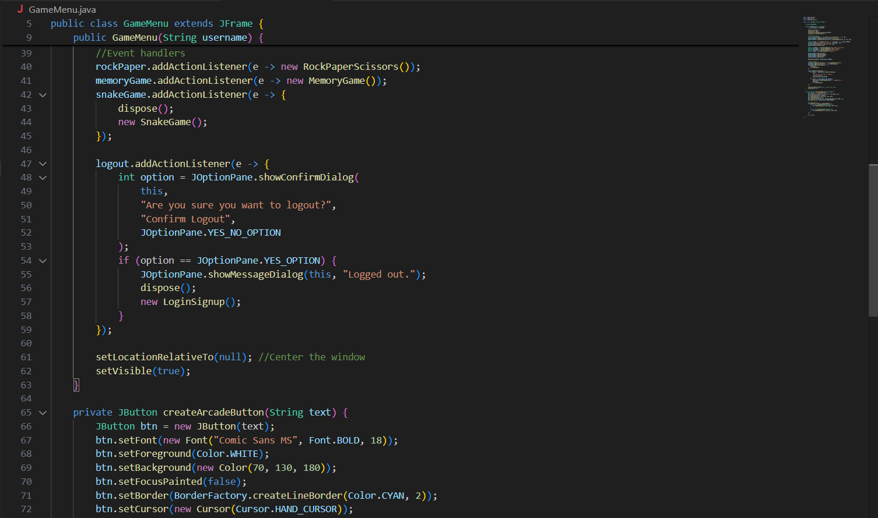

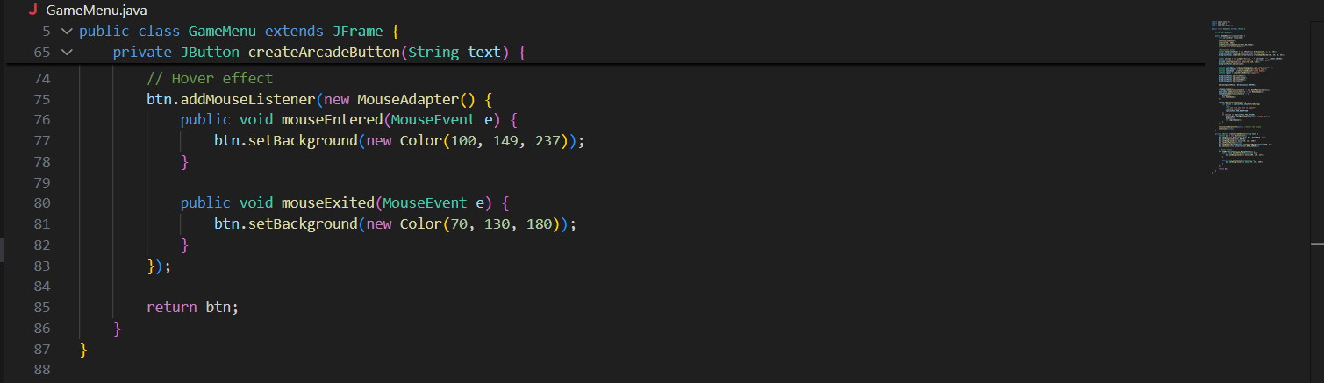

1. GamePanel.java

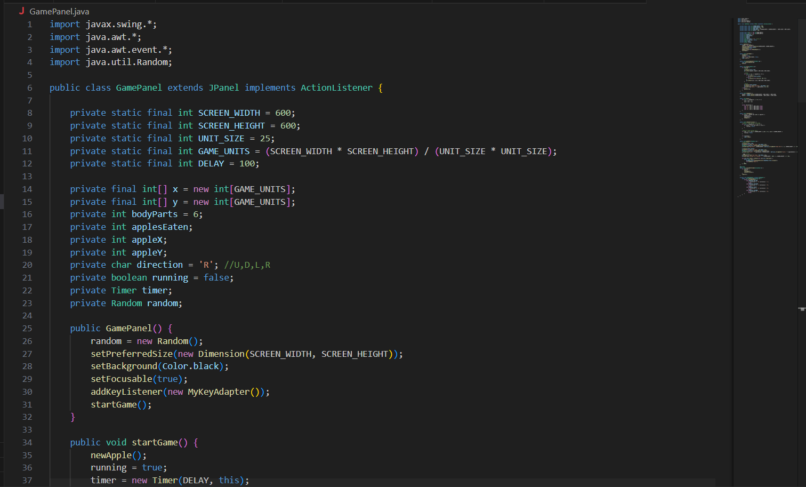

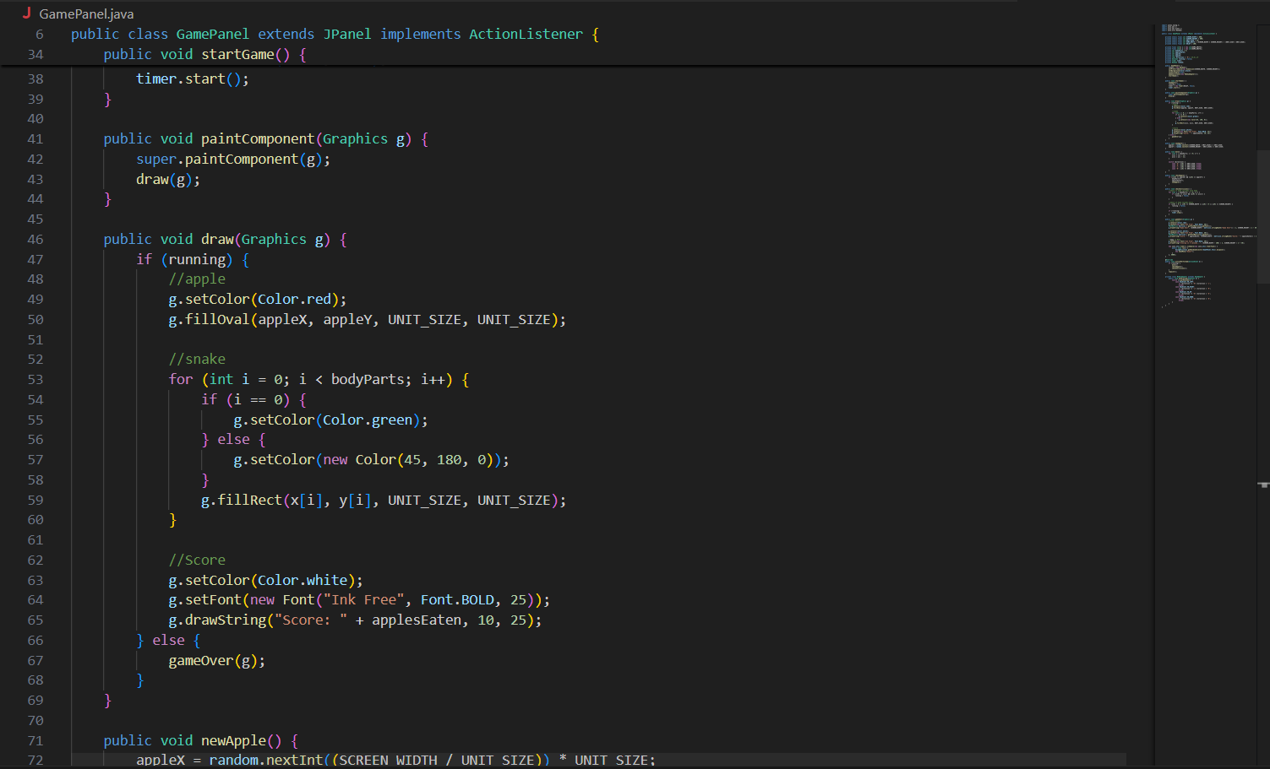

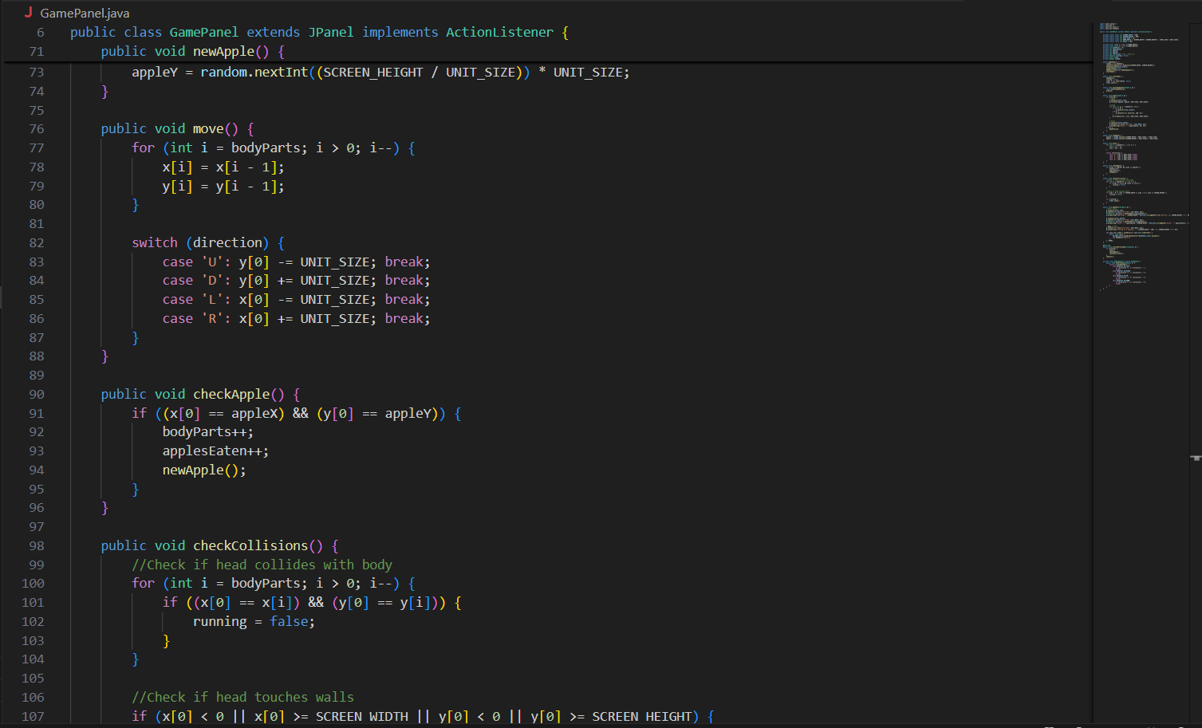

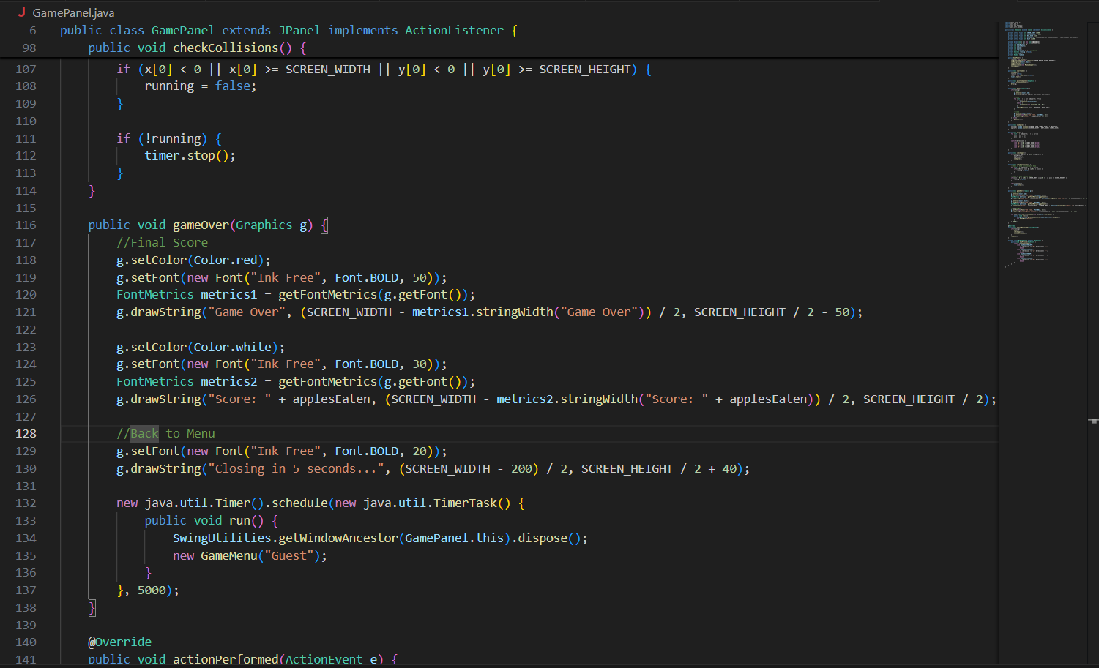

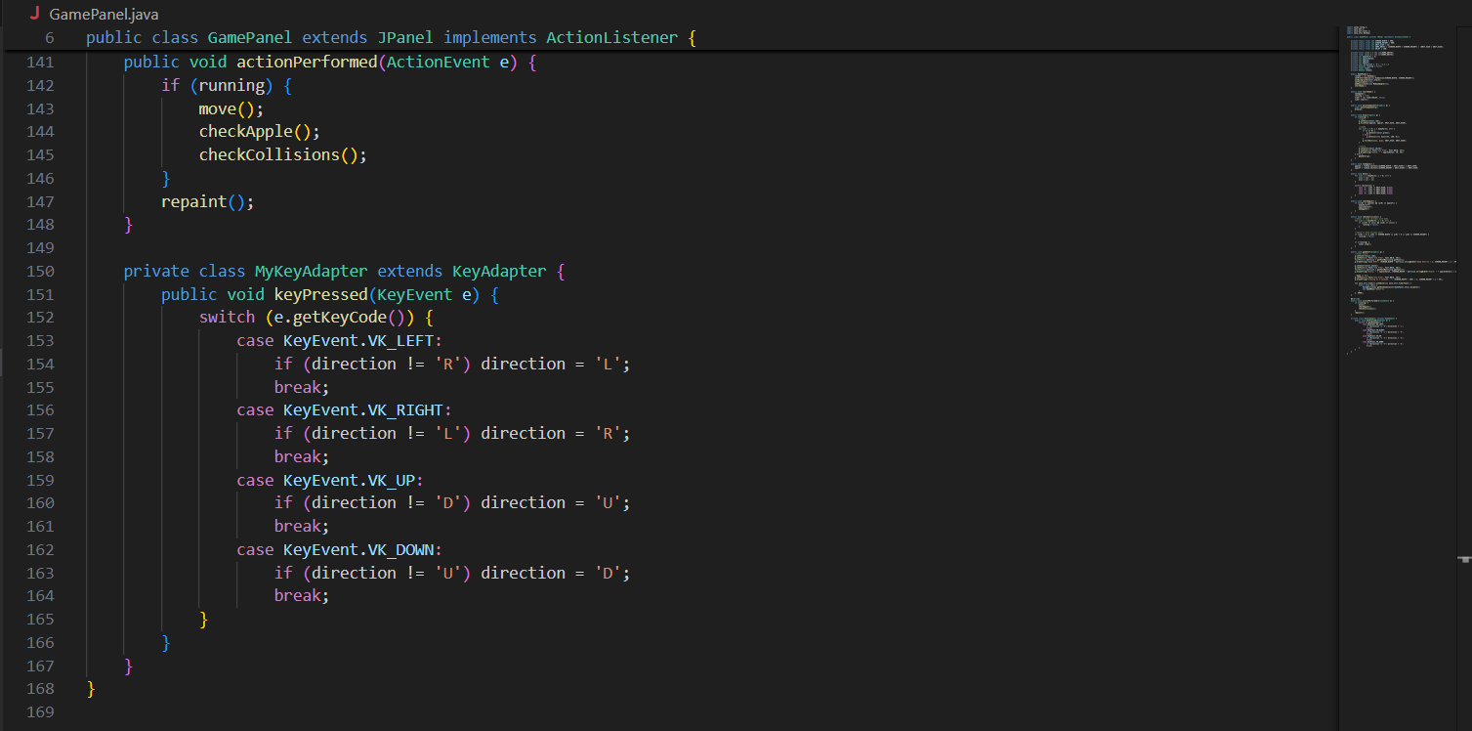

1. LoginSignup.java

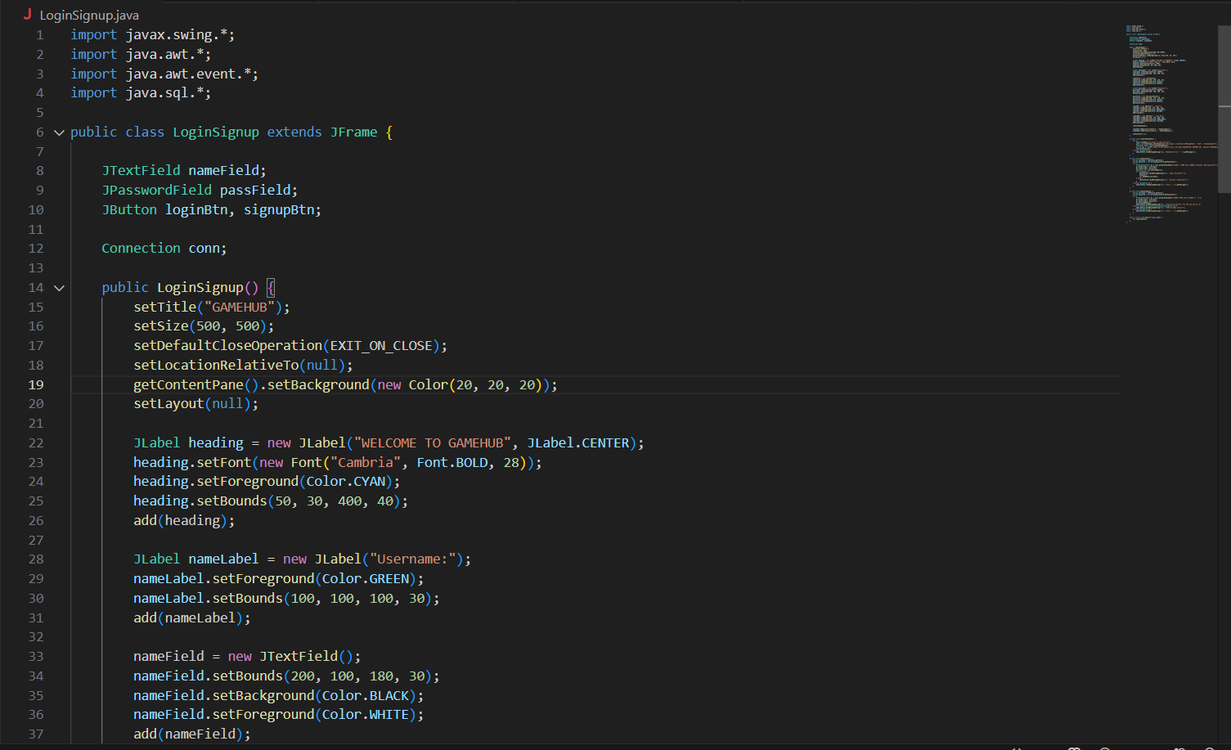

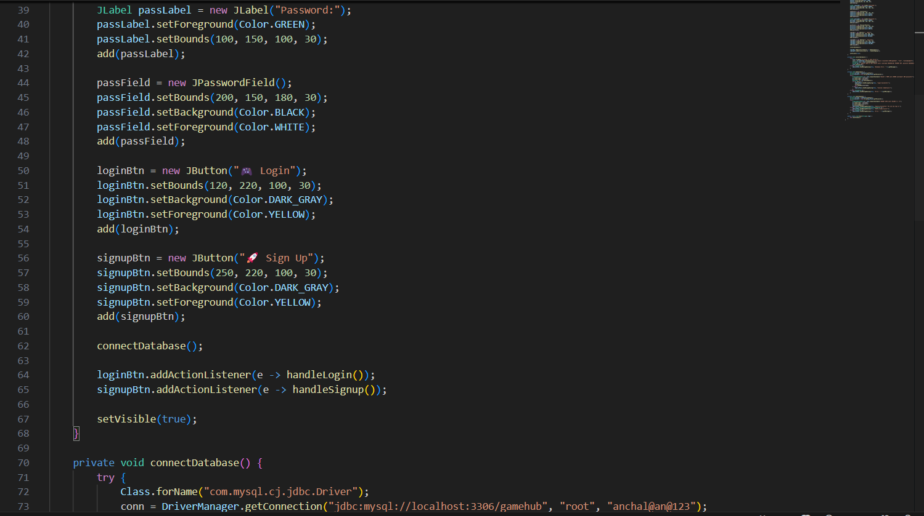

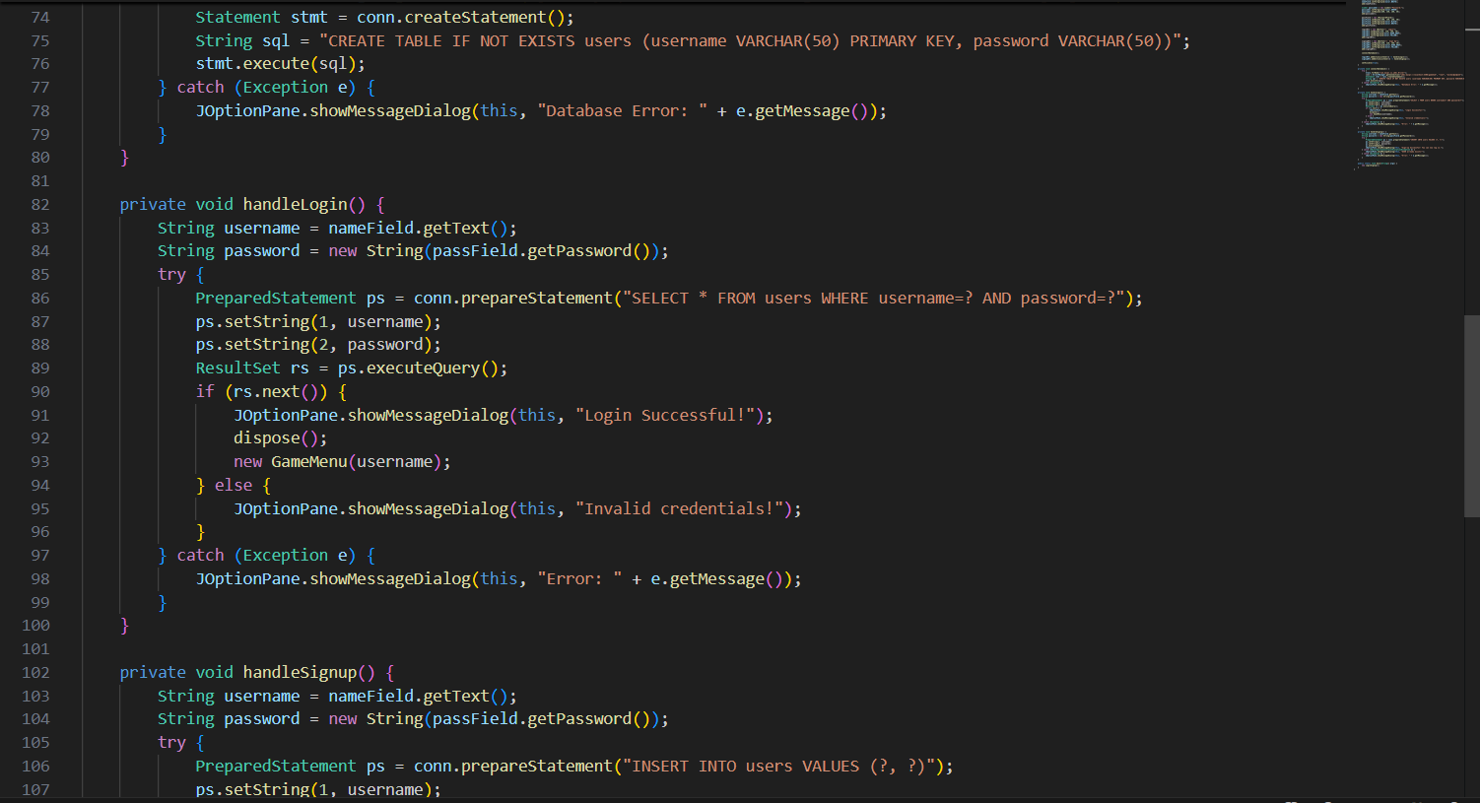

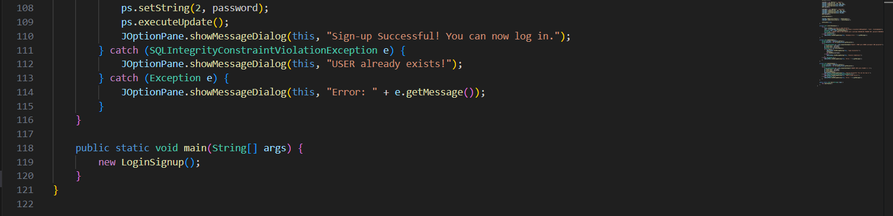

1. MemoryGame.java

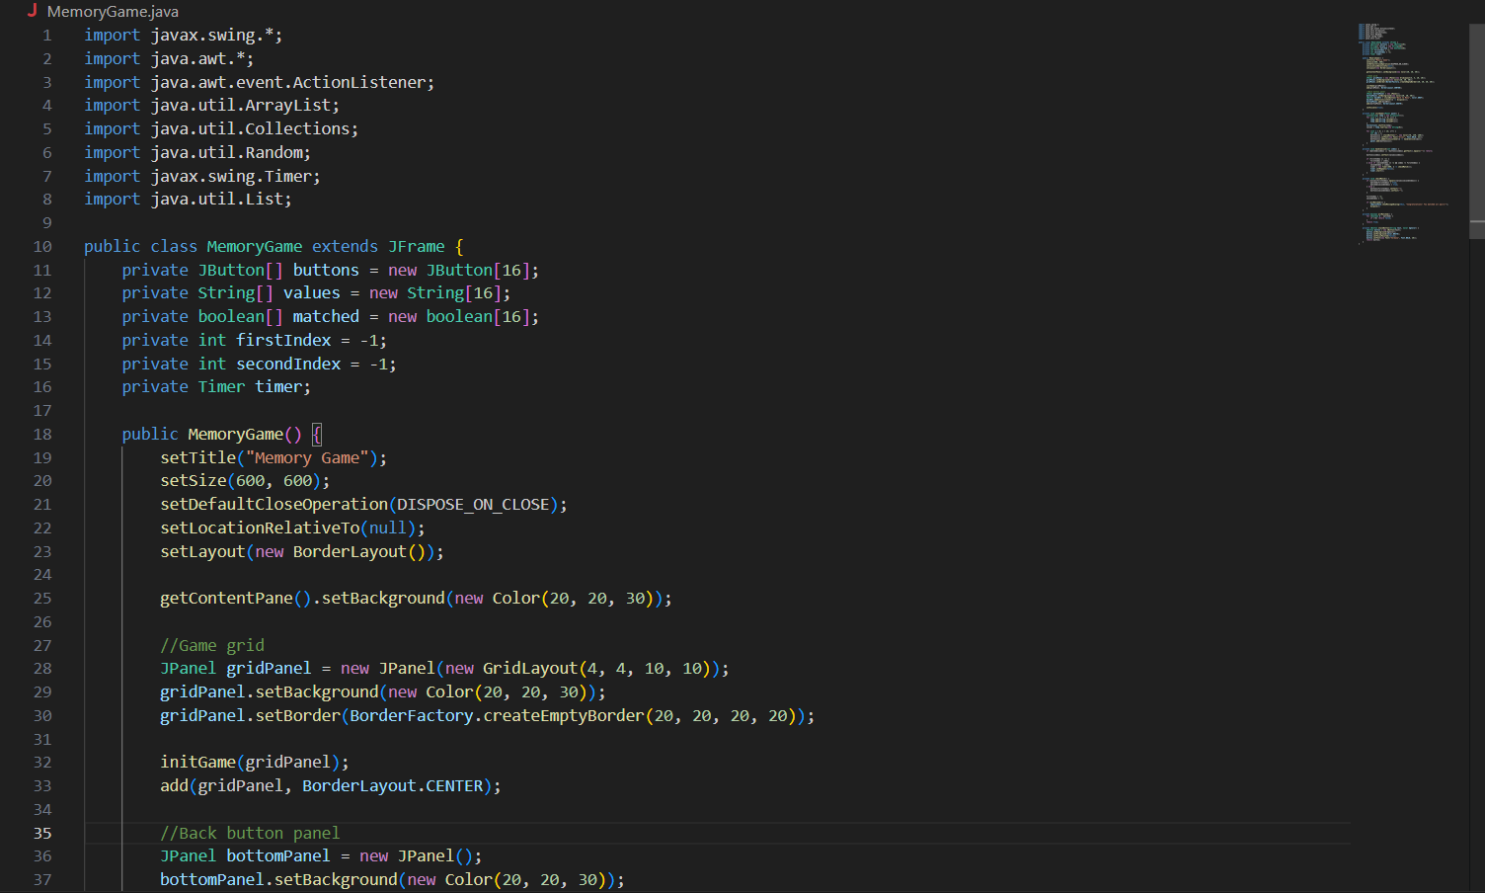

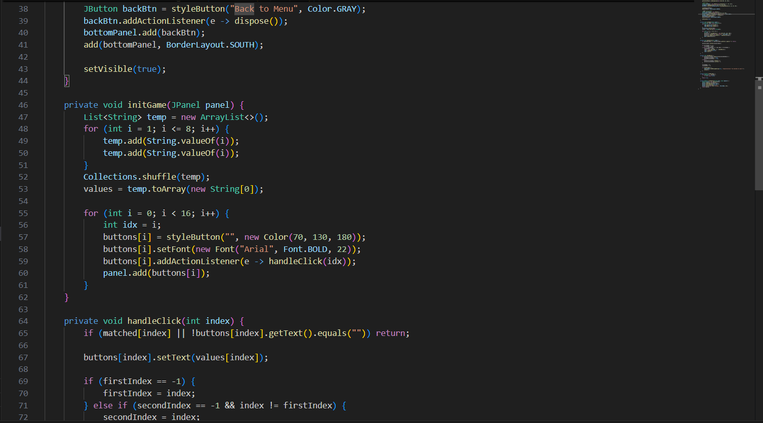

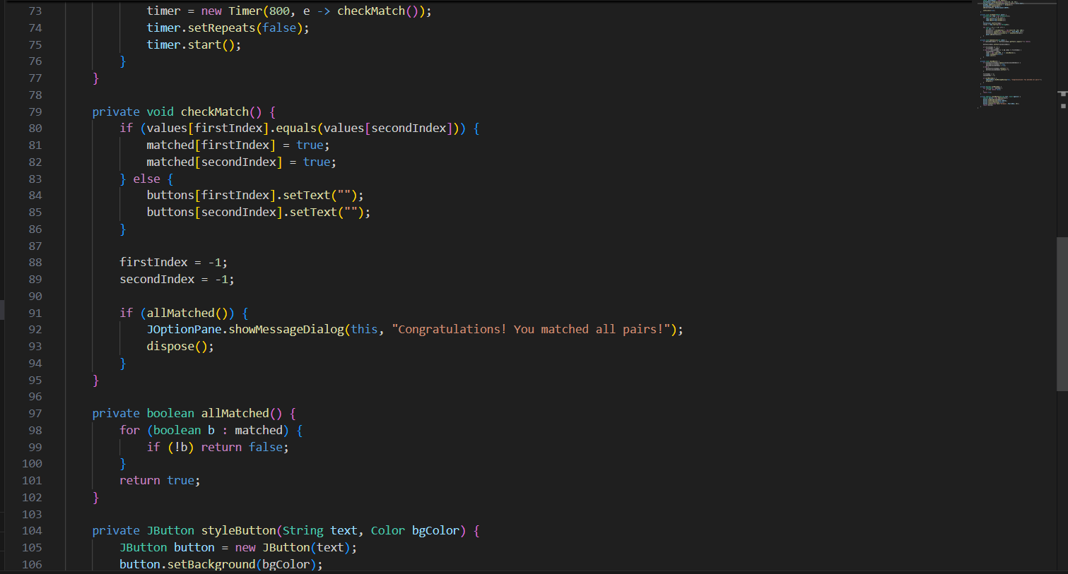

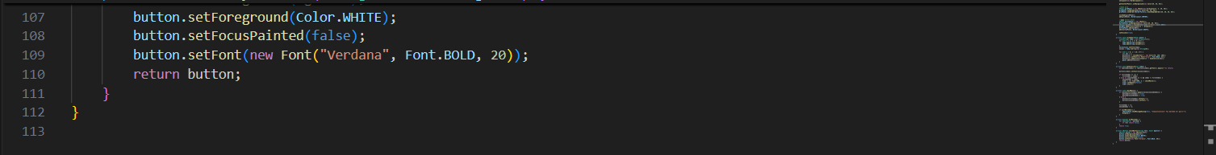

1. RockPaperScissors.java

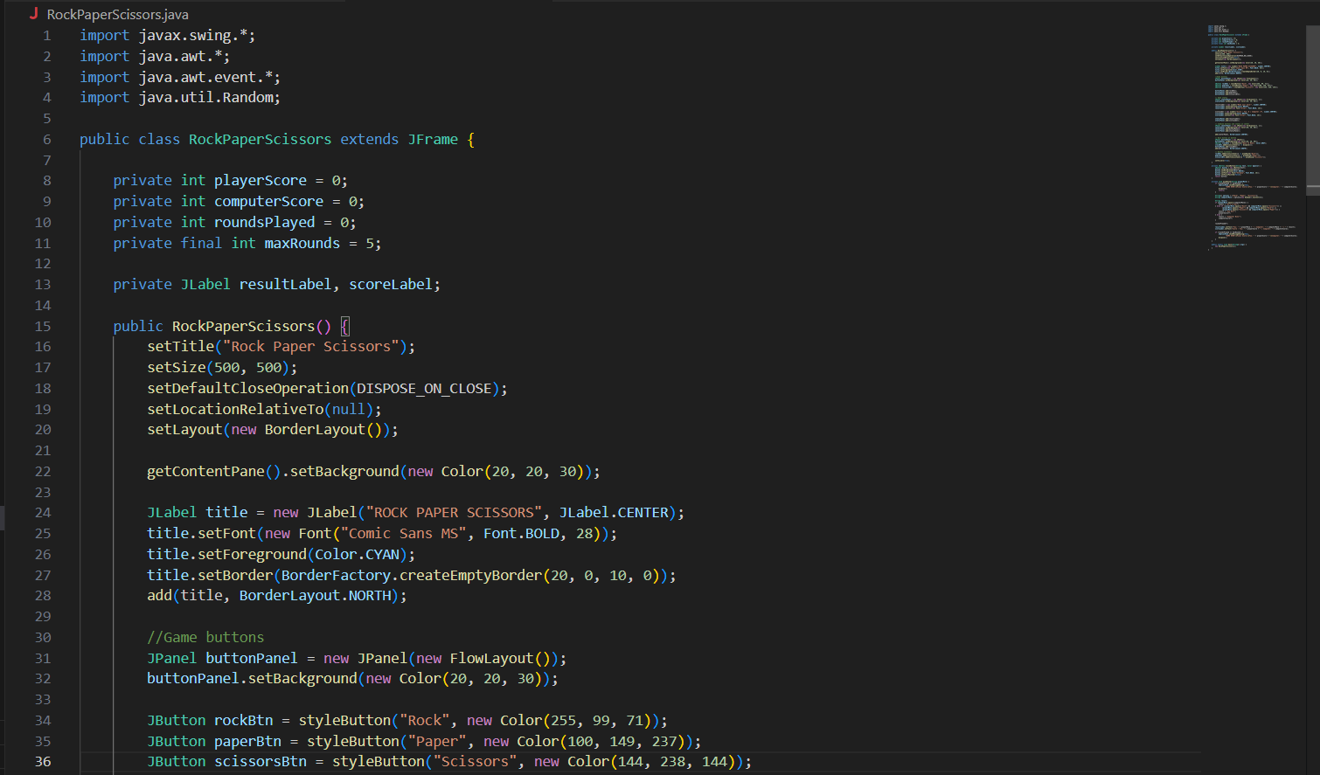

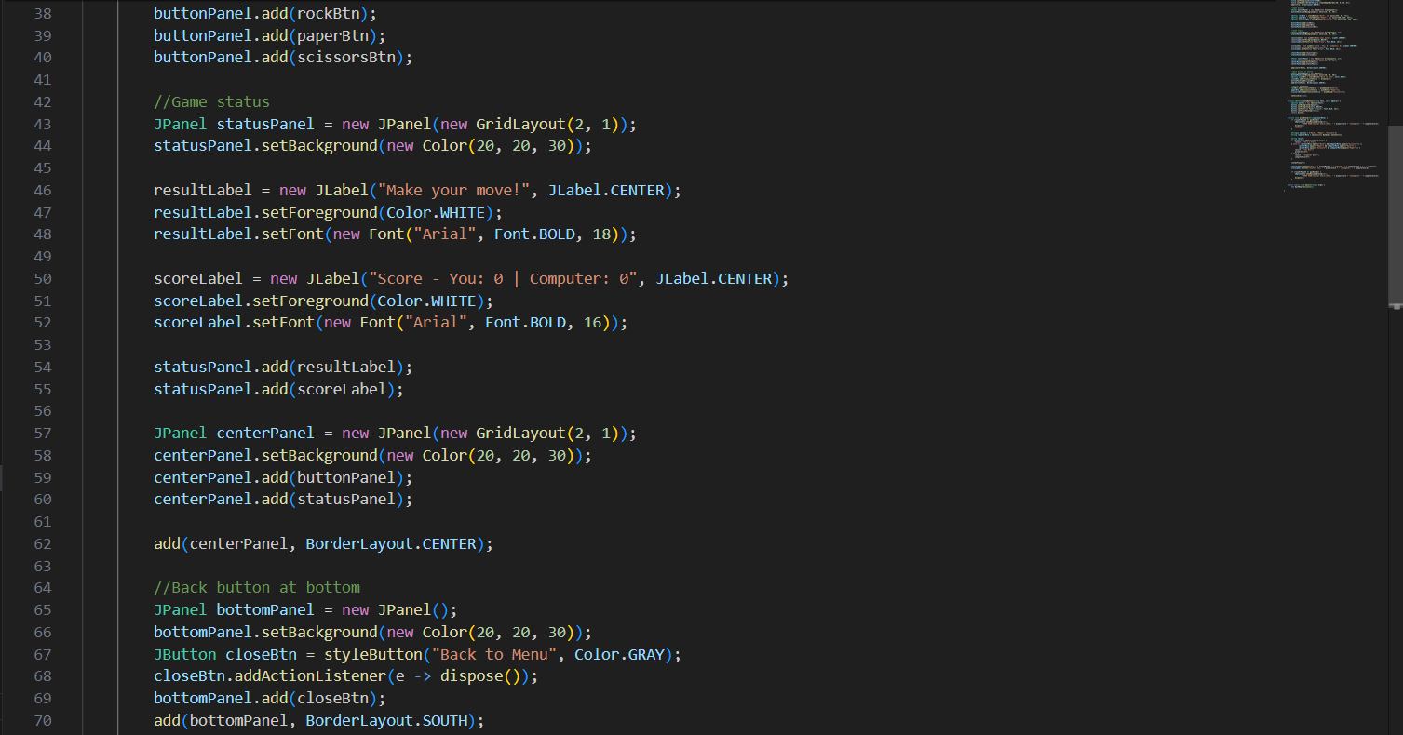

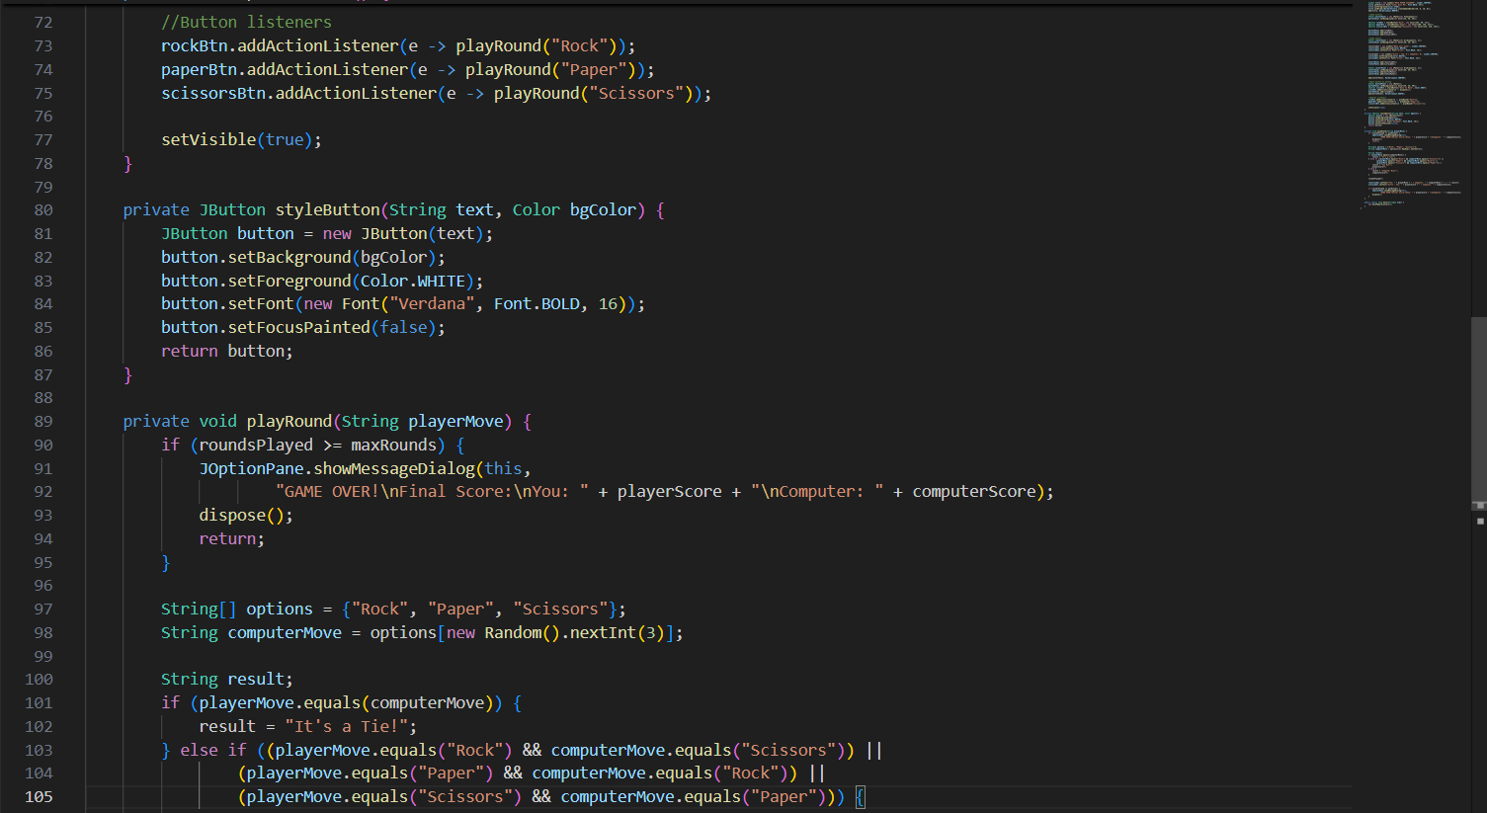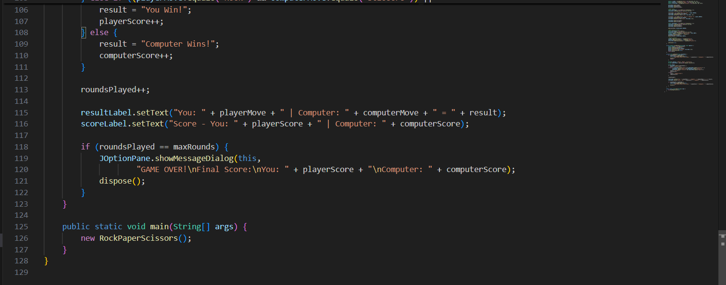

1. RockPaperScissorsGame.java

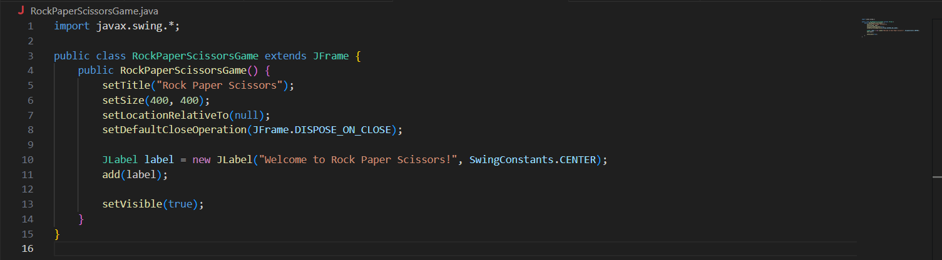

1. SnakeGame.java

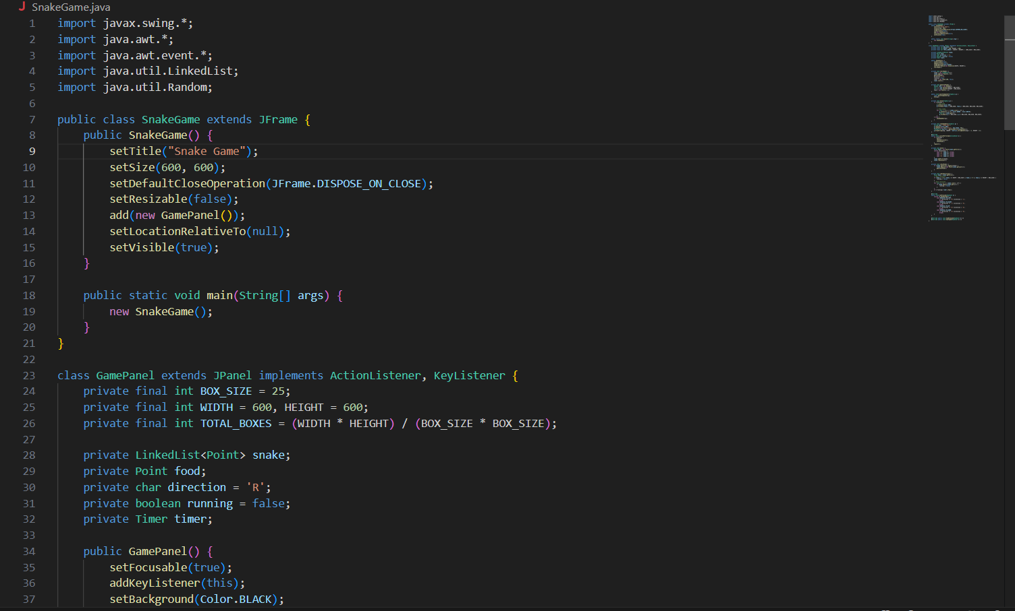

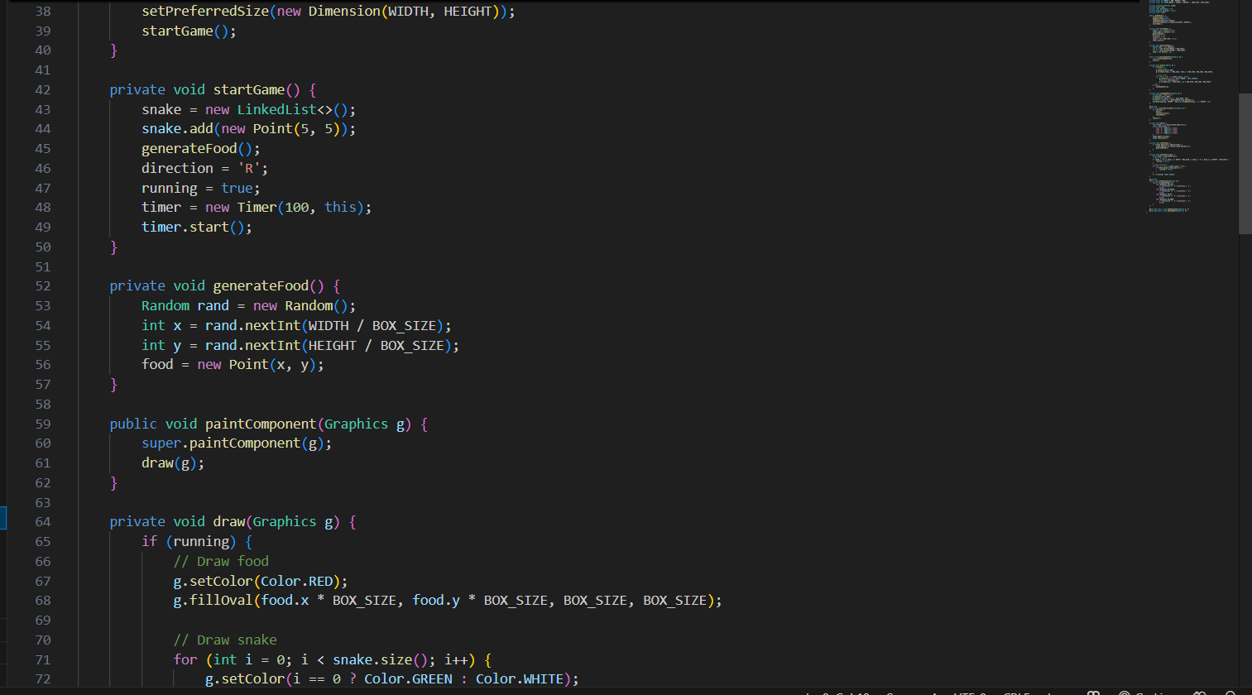

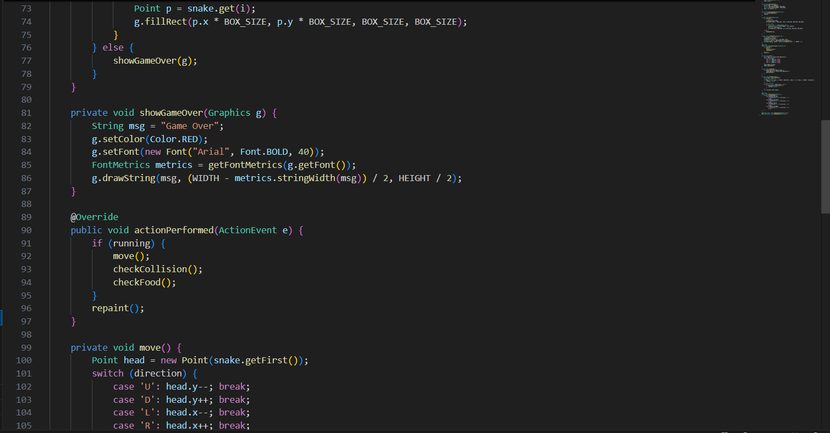

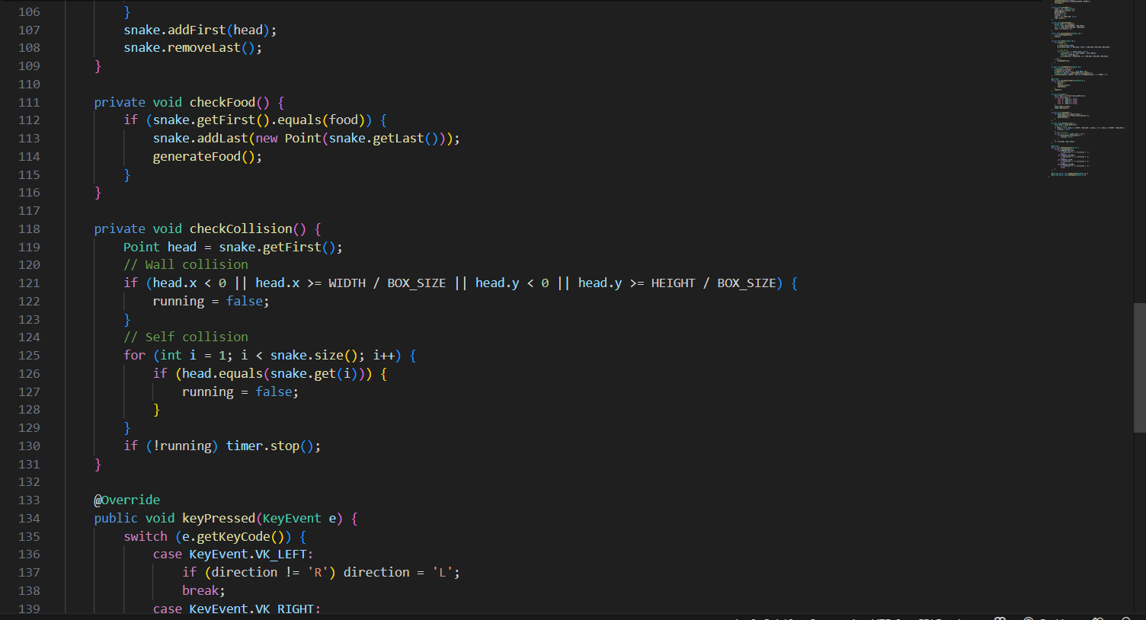

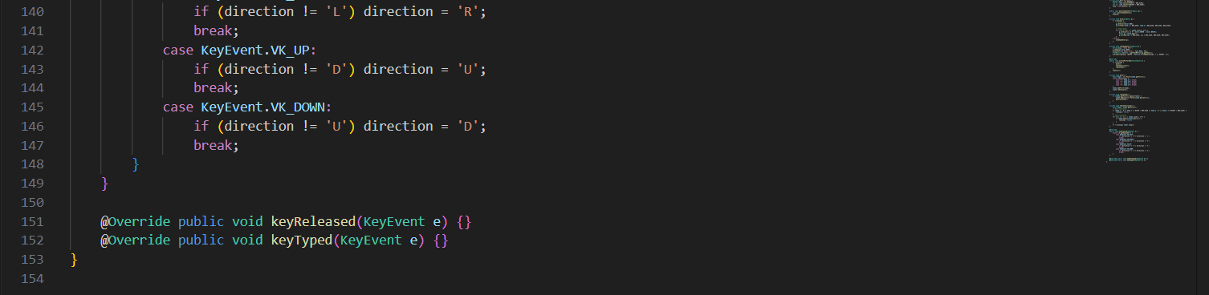

**OUTPUT**

**Login/ Signup Page:**

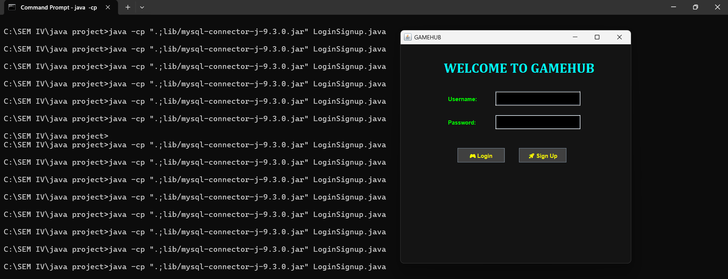

* If user already exists, and trying to sign up

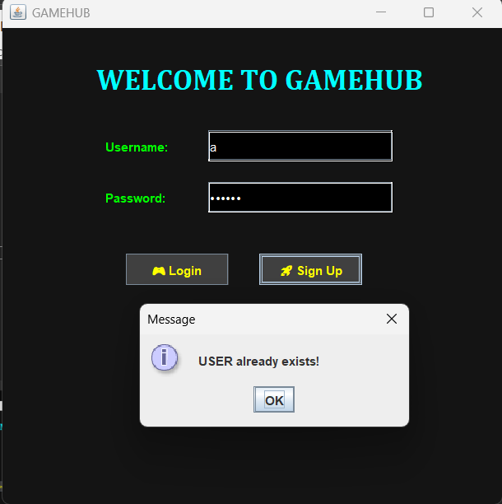

* If password entered is incorrect

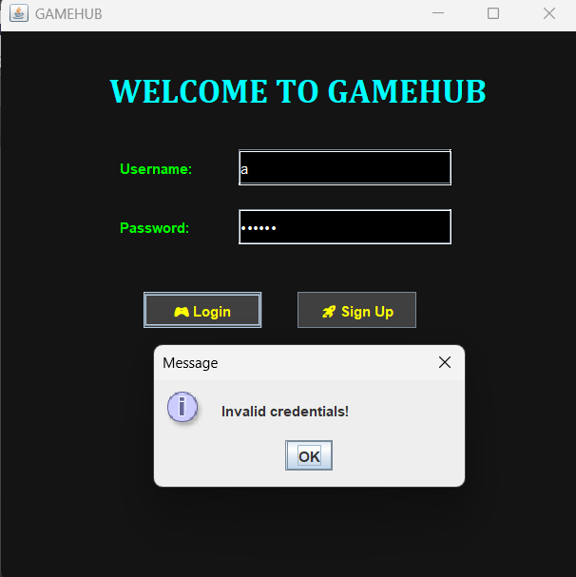

* Information entered is correct

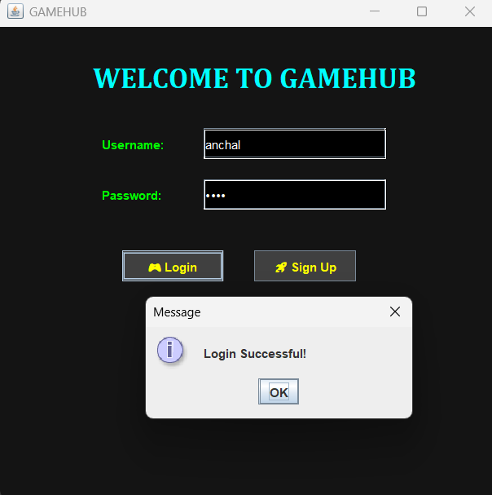

**Menu Page:**

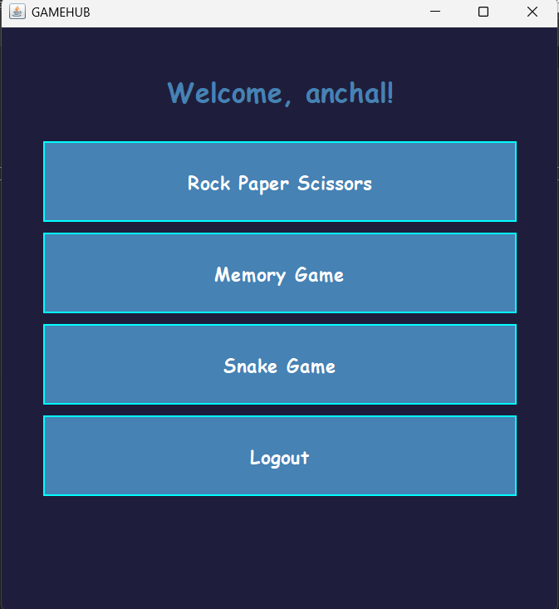

**Rock Paper Scissors:**

* Main window

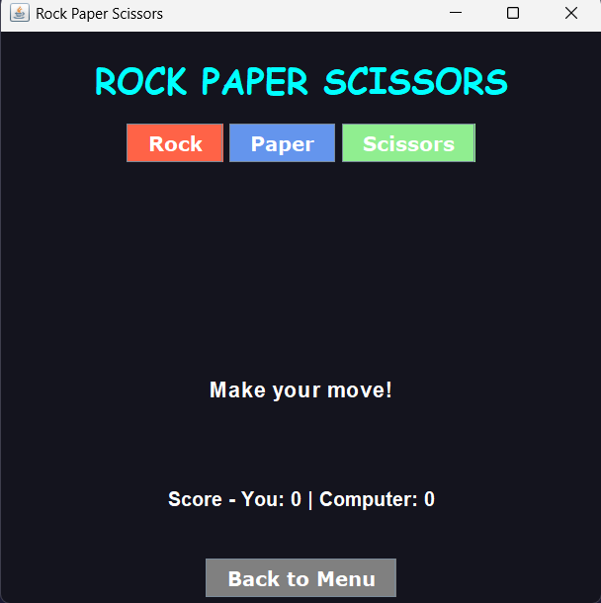

* After one round

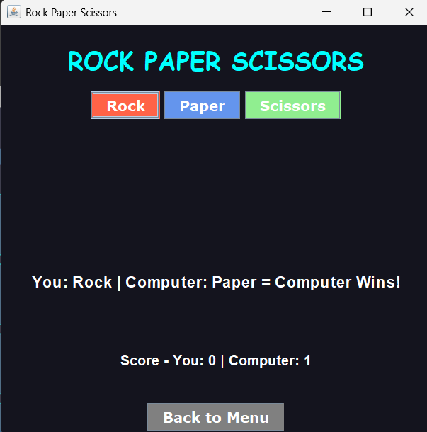

* After 5 rounds

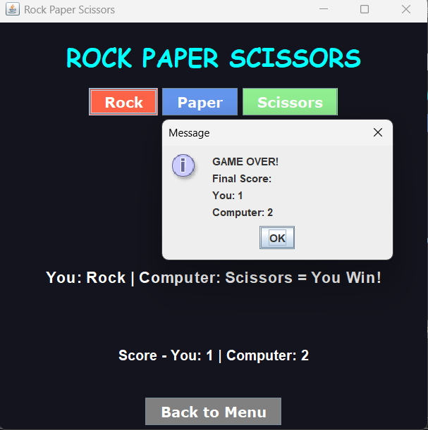

**Memory Game**

* Main Window

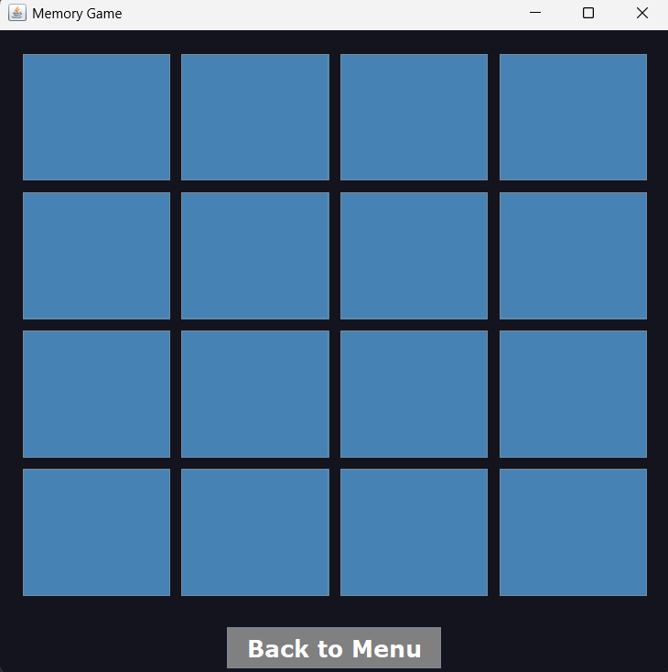

* After getting 2 similar cards

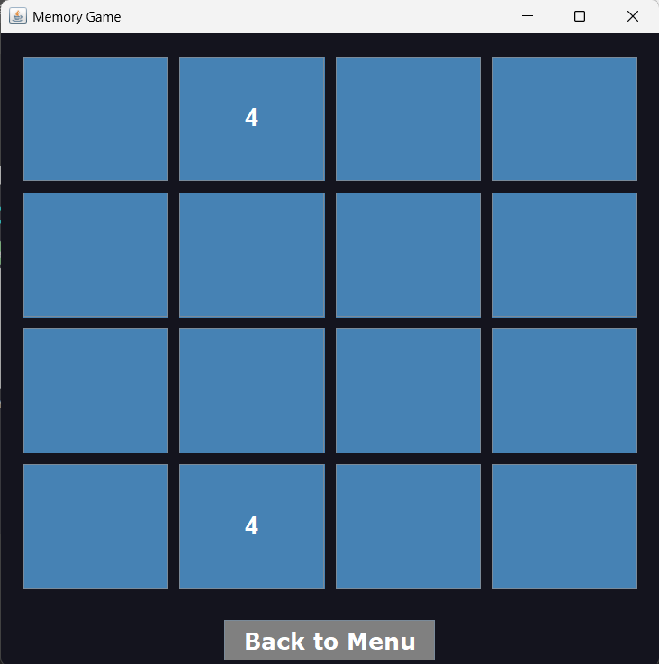

* After getting all cards

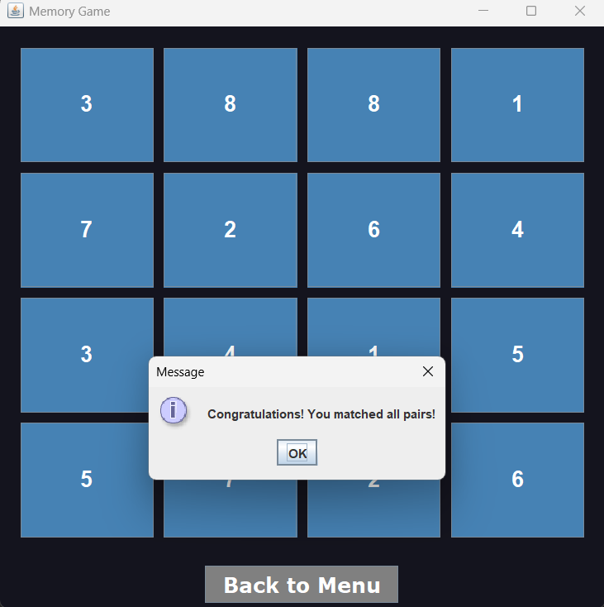

**Snake Game**

* Main Window

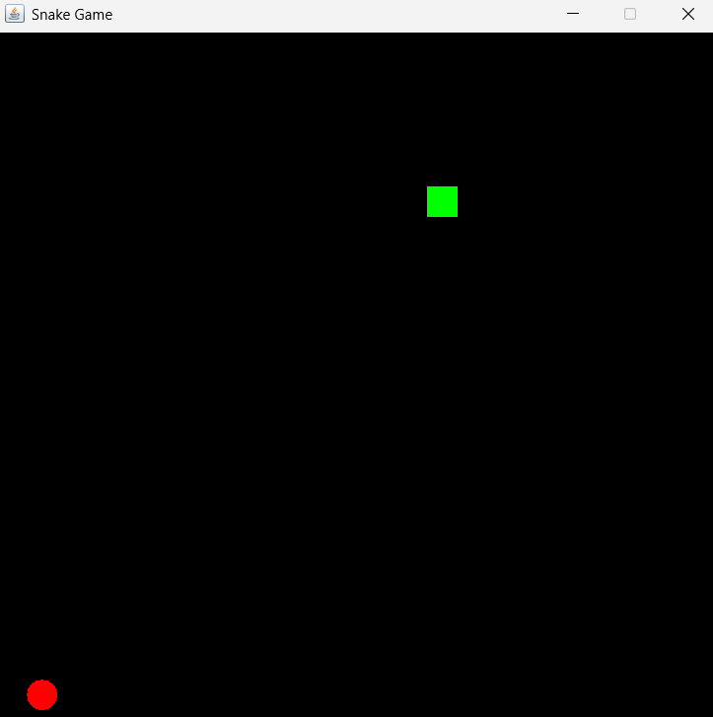

* In the middle

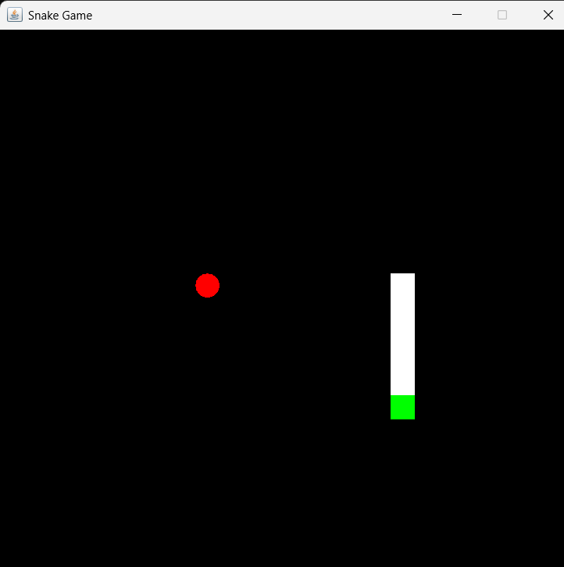

* After loosing

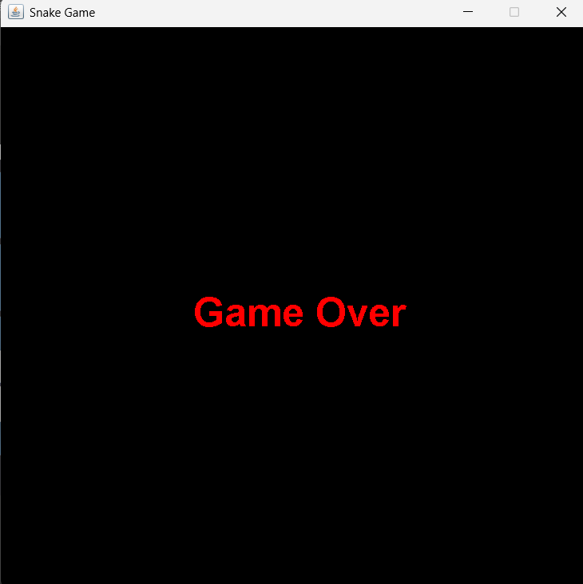

**Logout**

* Confirmation

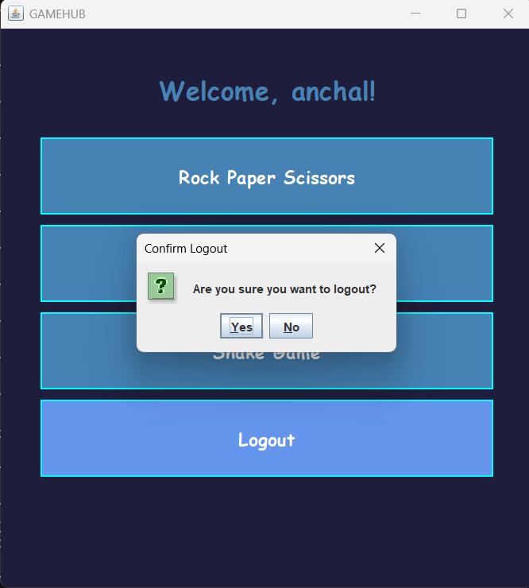

* Logout

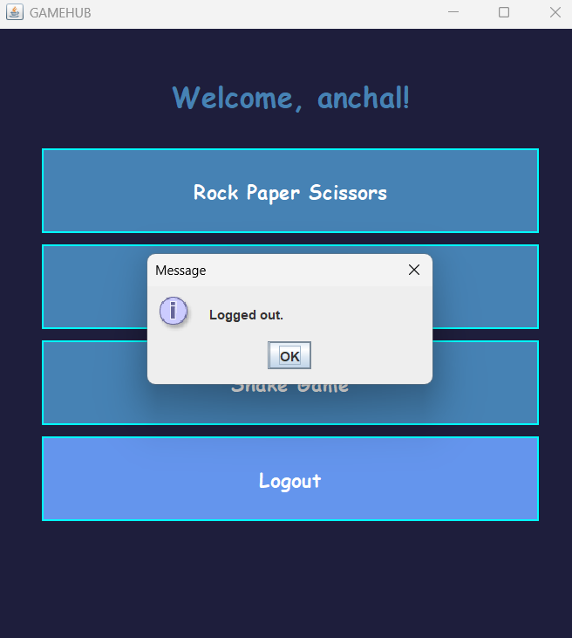

**Database**

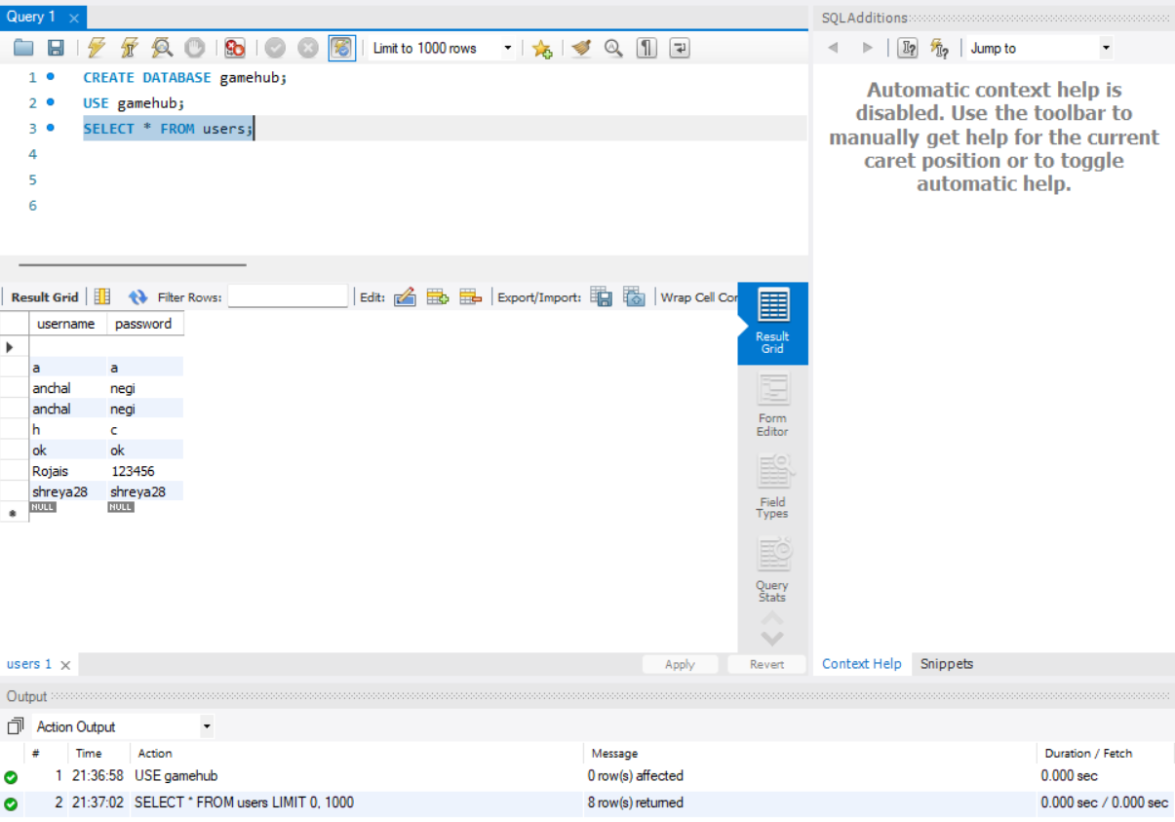

**CONCLUSION**

The GameHub project successfully demonstrates the development of an interactive desktop application using Java Swing. Through classic games like Rock Paper Scissors and Memory Match, it offers a fun and user-friendly experience while showcasing key programming concepts such as GUI design, event handling, and logic implementation. This project not only enhanced understanding of Java-based application development but also encouraged modular design and user engagement through creative interfaces.

**REFERENCES**

* W3Schools
* GeeksforGeeks
* Oracle