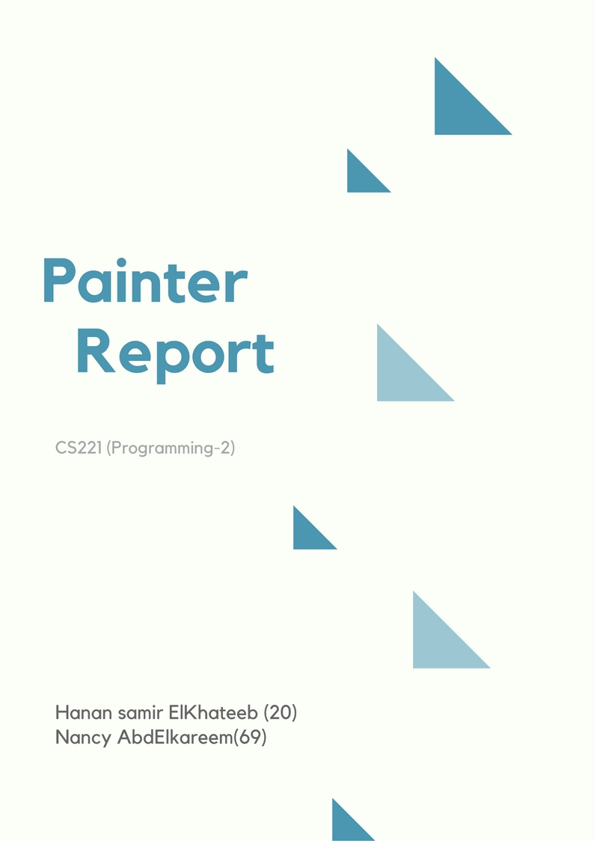

Table Of Contents.

**DESCRIBTION……………………………………………………………………………….3**

**DESIGN…………………………………………………………………………………………3**

**-** UML……………………………………………………………………………………………………...3

- MVC………………………………………………………………………………………………………4

- SWING For GUI………………………………………………………………………………………4

**FEATURES……………………………………………………………………………………...5**

- Save as image…………………………………………………………………………………………5

- Group Selection……………………………………………………………………………………..6

-Shortcuts………………………………………………………………………………………………..6

- Editing colors while drawing…………………………………………………………………..6

**USER GUIDE……………………………………………………………………………………7**

**SCREENSHOTS………………………………………………………………………………..8**

**Description:**

Drawing and painting application is very popular and has a huge user base. Our application offers several features that: Drawing, Coloring, moving and Resizing. It also includes built in, and possibly extensible set of geometric shapes, and classically, it allows the user to undo, redo, save and load any instructions to make the application more usable.

**Design:**

**UML:**

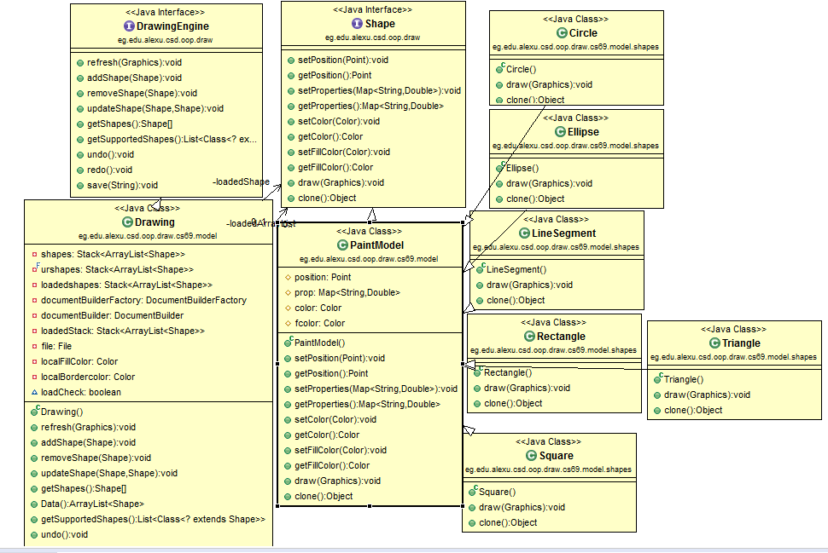

**MVC:**

**Model–view–controller** (**MVC**) is a software architectural pattern for implementing user interfaces on computers. It divides a given application into three interconnected parts. This is done to separate internal representations of information from the ways information is presented to, and accepted from, the user. The MVC design pattern decouples these major components allowing for efficient code reuse and parallel development.

So, The code is organized into three packages:

**Model Package:** contains a class implements the interface “Shape”, package contains six classes that extends that class, a class implements the interface “Drawing Engine”.

**View Package:** represents the visualization of the data that model contains.

**Control Package**:acts on both model and view. It controls the data flow into model package. It contains classes that implements the mouse actions and updates the view

Whenever data changes.

**SWING For GUI:**

We implement the GUI view by using SWING for implementing buttons , menus and panels.

**Features:**

**Save as image:**

Allow the user to save the drawing shapes as an image ( .png).

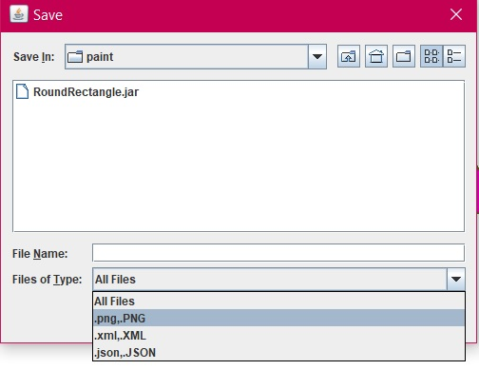

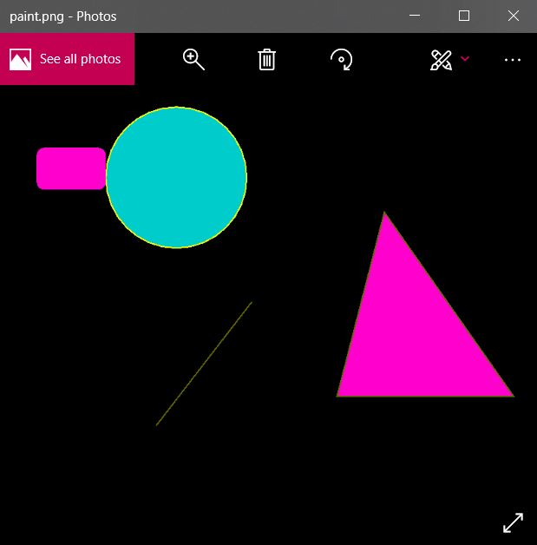

**Group Selection:**

Allow the user to group select objects, then apply delete operation on them.

Using this button.



**Shortcut:**

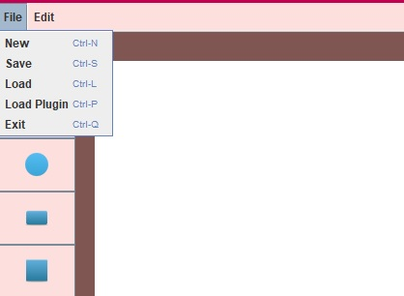

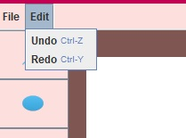

**Editing colors:**

Allow the user to edit the colors of the shape after drawing it.

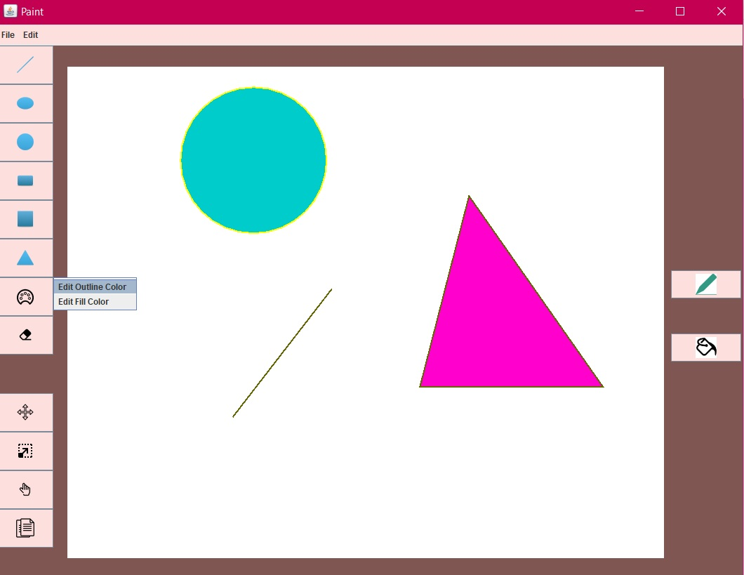

**User Guide:**

**To move shapes: select move button, select any shape then drag it to any position in the area of the grid.**

**To resize shapes: select resize button, select any shape then resize it by dragging.**

**To delete shapes: firstly select the shape then select delete button.**

**To undo or redo: select edit from the toolbar then choose undo or redo.**

**To get new canvas or exit the paint application, you can select file from the toolbar then choose**

**New or Exit.**

**To save the drawing: select file from the toolbar, choose save, from the showing screen select the place where to save the drawing, type the name of the file then choose the way to save it as .xml file or .json file or as .png .**

**To load an existing drawing file: select file from the toolbar, choose load, from the showing screen select the place where the drawing file is existing then select open.**

**To Copy shape: first select the shape,select the position you want to copy the shape in it then select the copy buttons.**

**ScreenShots:**



