Distributed Systems
Midterm Examination Report
Antonine University
Faculty of Engineering
Department of Computer and Communications Engineering
Student Name: Nancy Ajouz
Student ID: 202112046
Github repo: https://github.com/nancyajouz23/midterm_DS
Course: Distributed Systems
Academic Year: 2026–2027
Development Environment
The development environment was prepared with the following tools and technologies:
- Python 3.11.9: Main programming language.
- PyCharm: Integrated development environment.
- Python Virtual Environment: Isolates project dependencies.
- Git and GitHub: Version control and source code management.
- Docker Desktop: Containerization and service deployment.
- Kubernetes: Container orchestration and management.
- Apache Kafka: Distributed event streaming and messaging.
- RabbitMQ: Asynchronous message queuing.
- Prometheus: Metrics collection and monitoring.
- Grafana: Visualization of system metrics and performance.
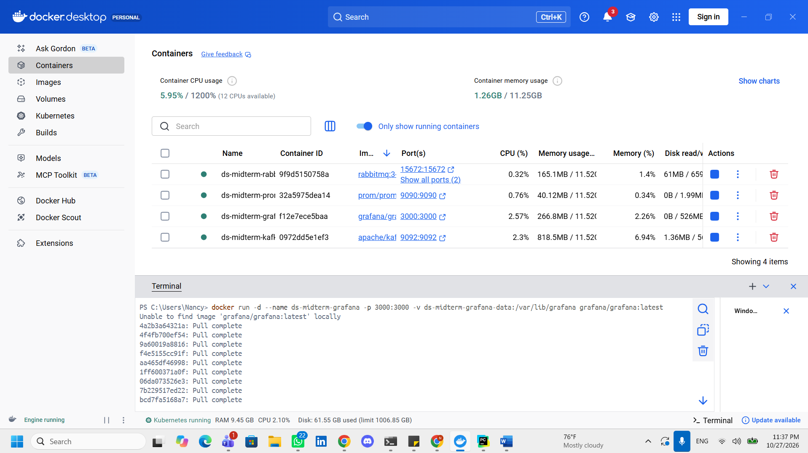

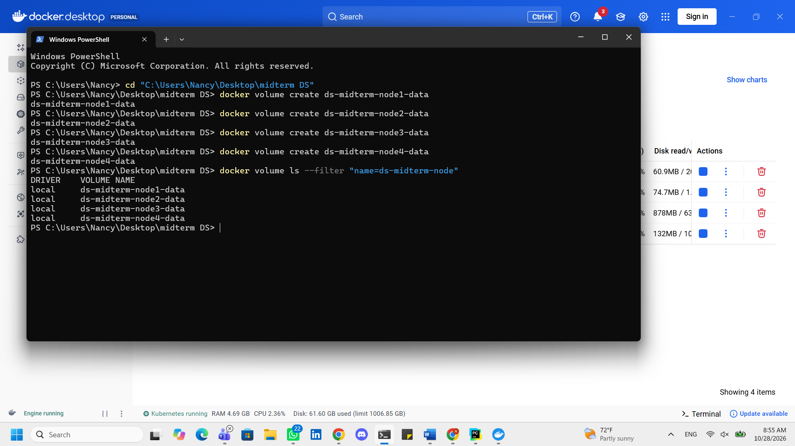
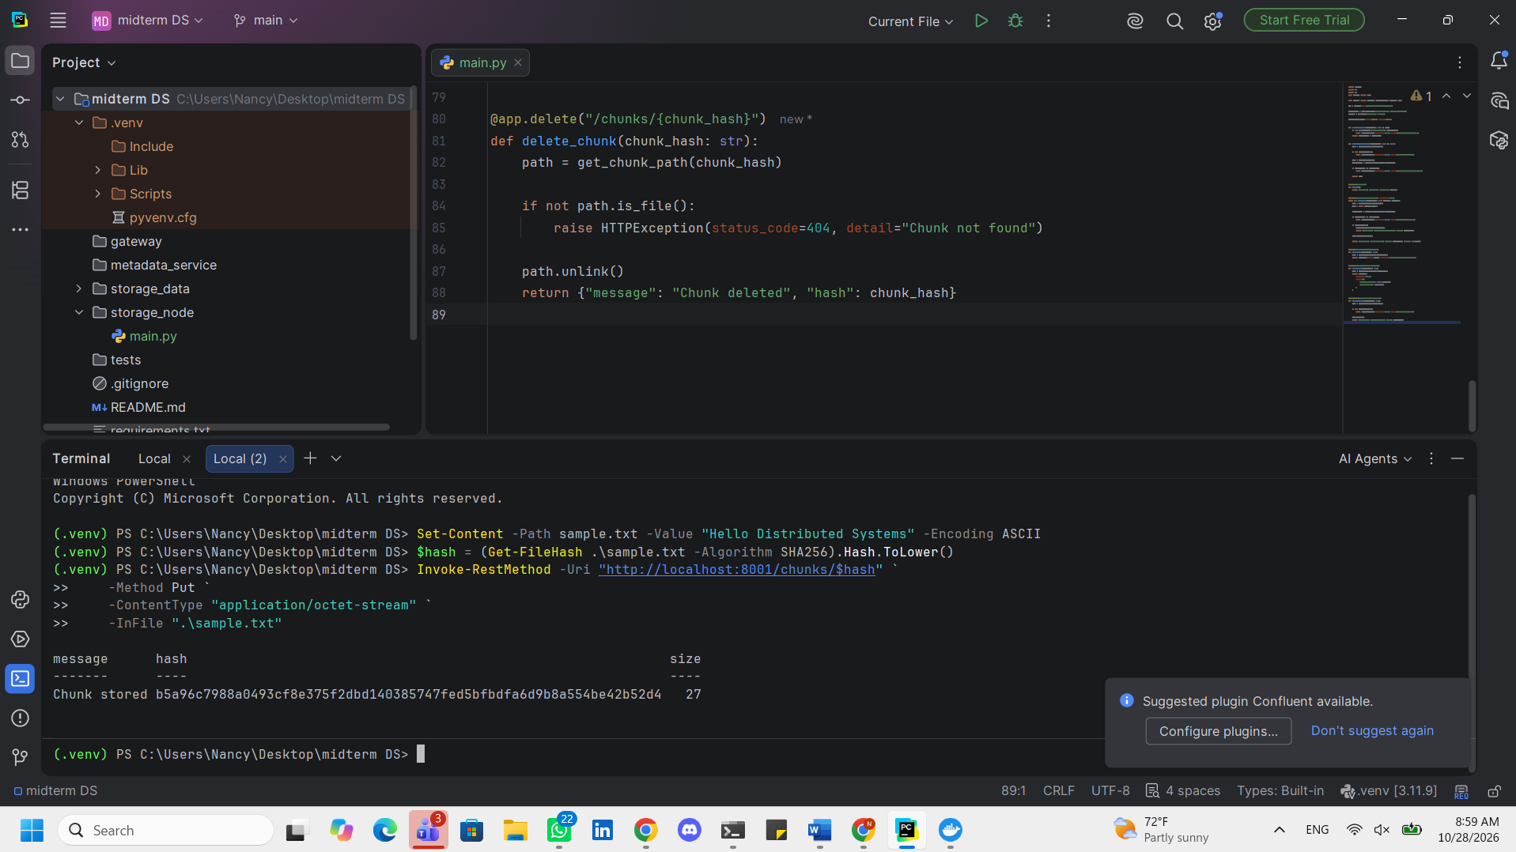
Storage Node Implementation
A storage node service was implemented using Python and FastAPI to manage individual file chunks.
The service exposes REST endpoints supporting PUT, GET, HEAD, and DELETE operations. Each chunk is identified by a SHA-256 hash calculated from its contents, enabling content-addressed storage.
During upload, the service calculates the hash of the received data and compares it with the requested chunk identifier before storing it on the local filesystem. When retrieving a chunk, the hash is recalculated to verify data integrity. Corrupted chunks are rejected with an HTTP 409 response.
The implementation also prevents duplicate chunks with identical content from being stored repeatedly on the same node.
Testing
The storage node was tested by uploading a sample file and retrieving it through the REST API. The original and downloaded files were compared using SHA-256 to verify their integrity.
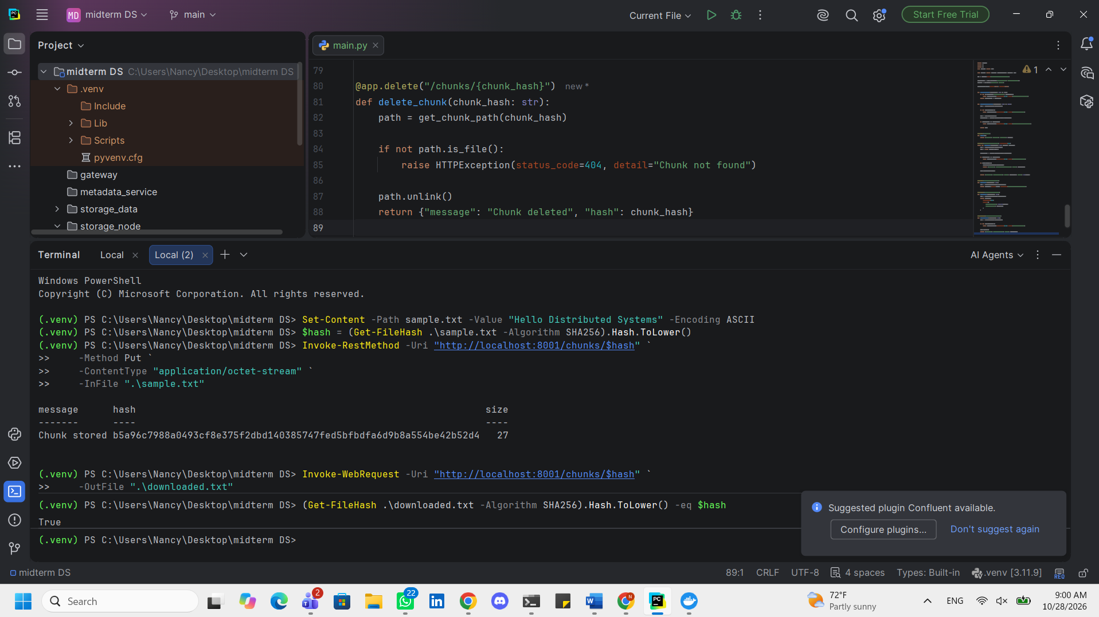
Deployment of Multiple Storage Nodes
The storage node service was containerized using Docker to enable independent deployment and execution of multiple instances.
A Dockerfile was created to package the Python application and its dependencies. Docker Compose was then configured to deploy four storage node containers, each running the same FastAPI application with a unique node identifier.
Each node was assigned a separate Docker volume to ensure independent and persistent chunk storage. The services were exposed through ports 8001, 8002, 8003, and 8004.
The deployment was verified by inspecting the running containers and sending HTTP health-check requests to each node.
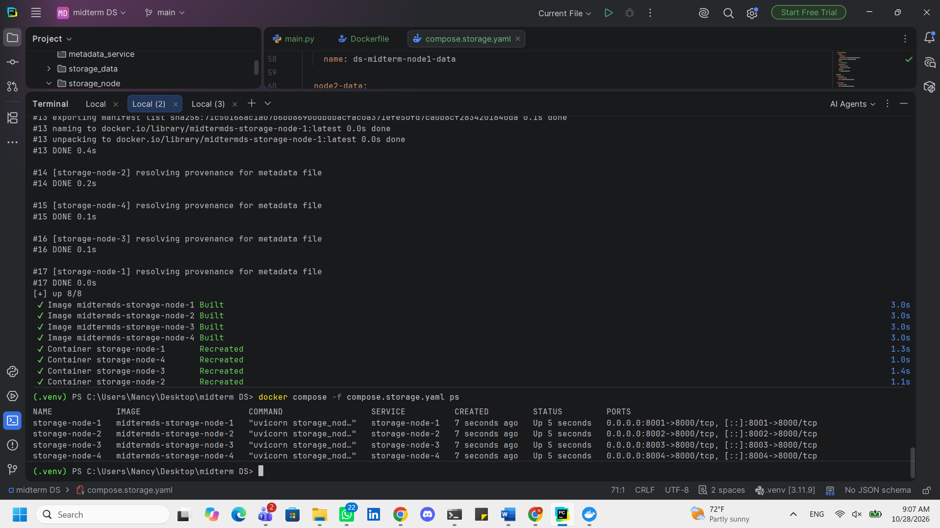
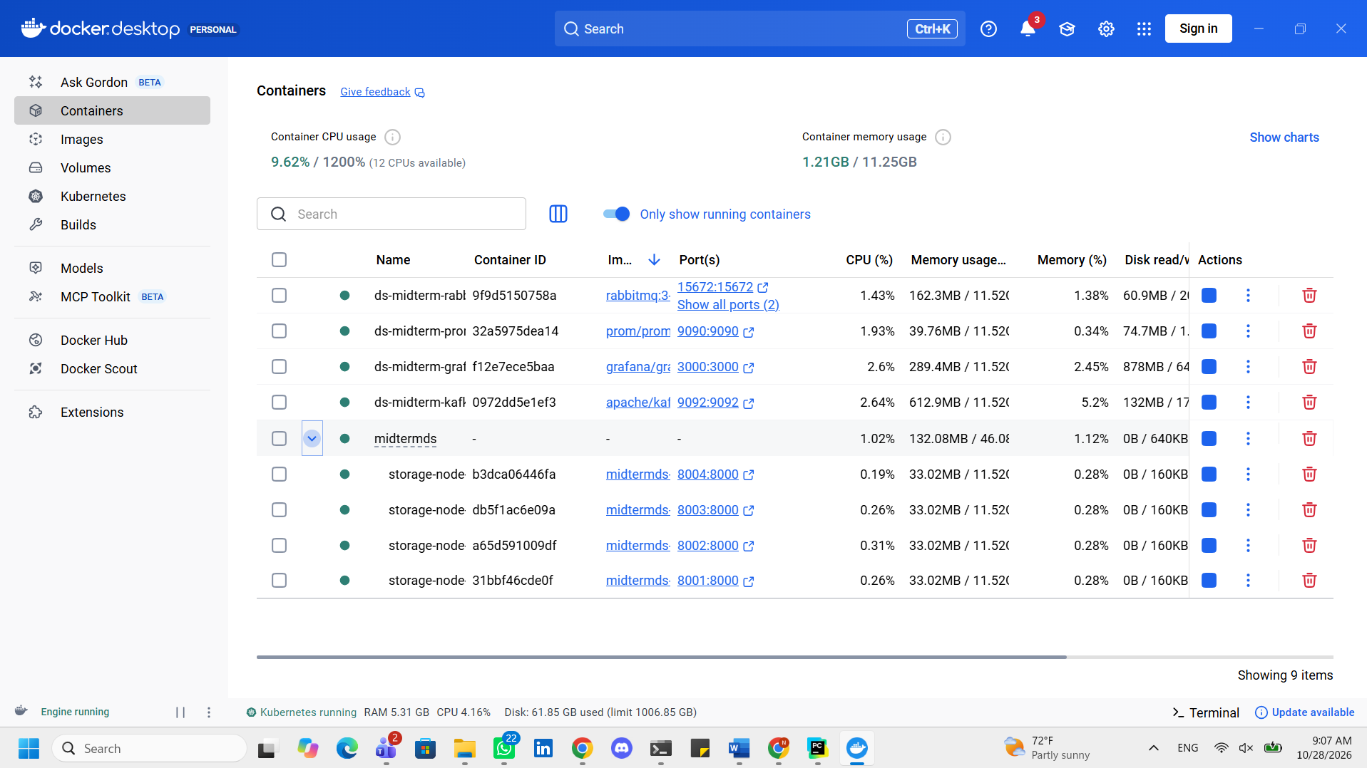
Metadata Service Implementation
A centralized metadata service was developed using FastAPI and PostgreSQL to manage information about the distributed storage nodes.
The service maintains a registry containing each node's identifier, available disk space, stored chunk count, and latest heartbeat timestamp.
A heartbeat endpoint was implemented to receive status updates from storage nodes. The information is stored persistently in PostgreSQL using an insert-or-update operation.
Node availability is determined using the latest heartbeat timestamp. Nodes that have not reported within the configured timeout are marked as offline, enabling the system to identify potentially unavailable storage nodes.
Testing
The metadata service was deployed in Docker and connected to PostgreSQL. Its API endpoints were tested using HTTP requests to verify heartbeat registration and retrieval of stored node information.
Metadata Service and PostgreSQL Containers
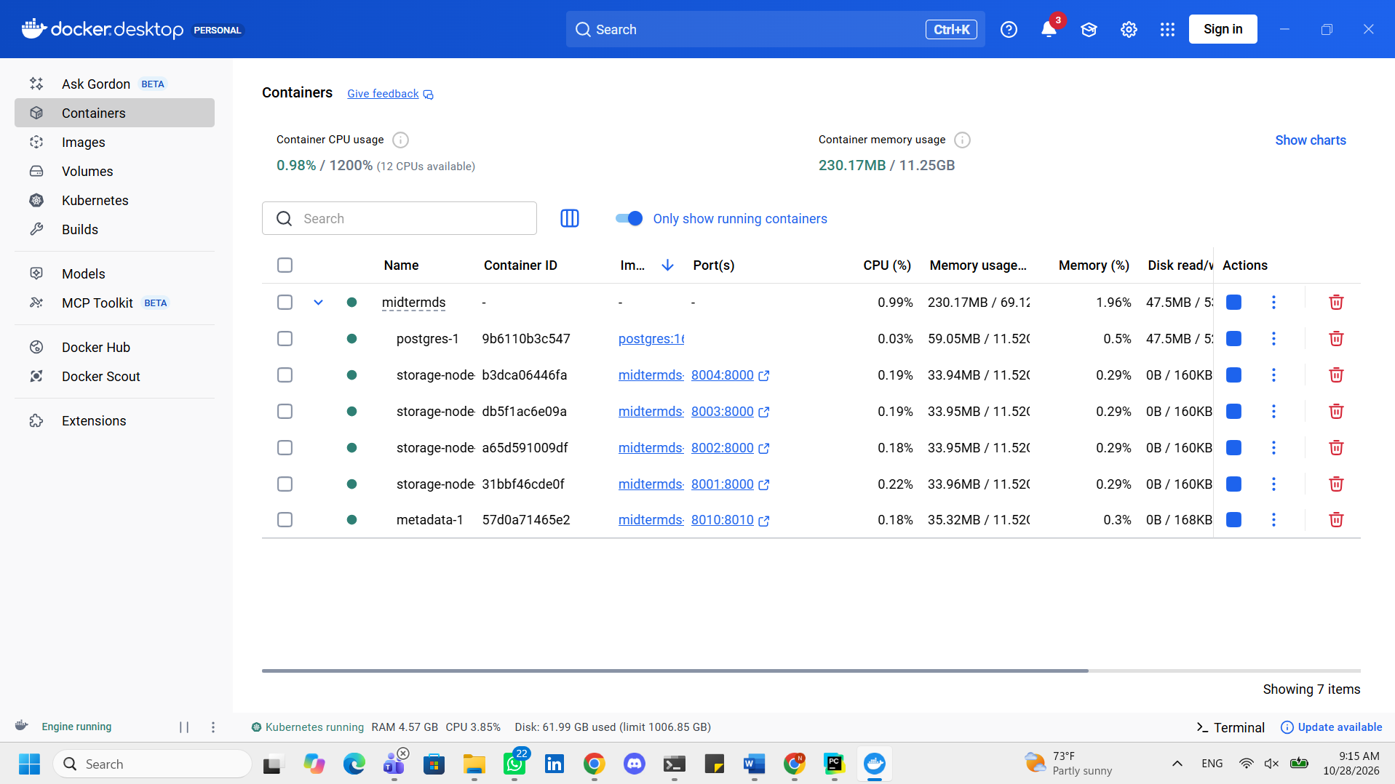
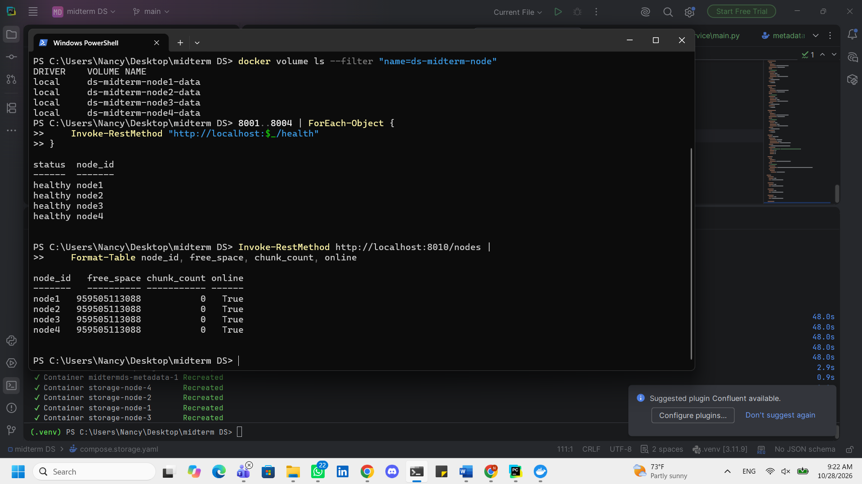
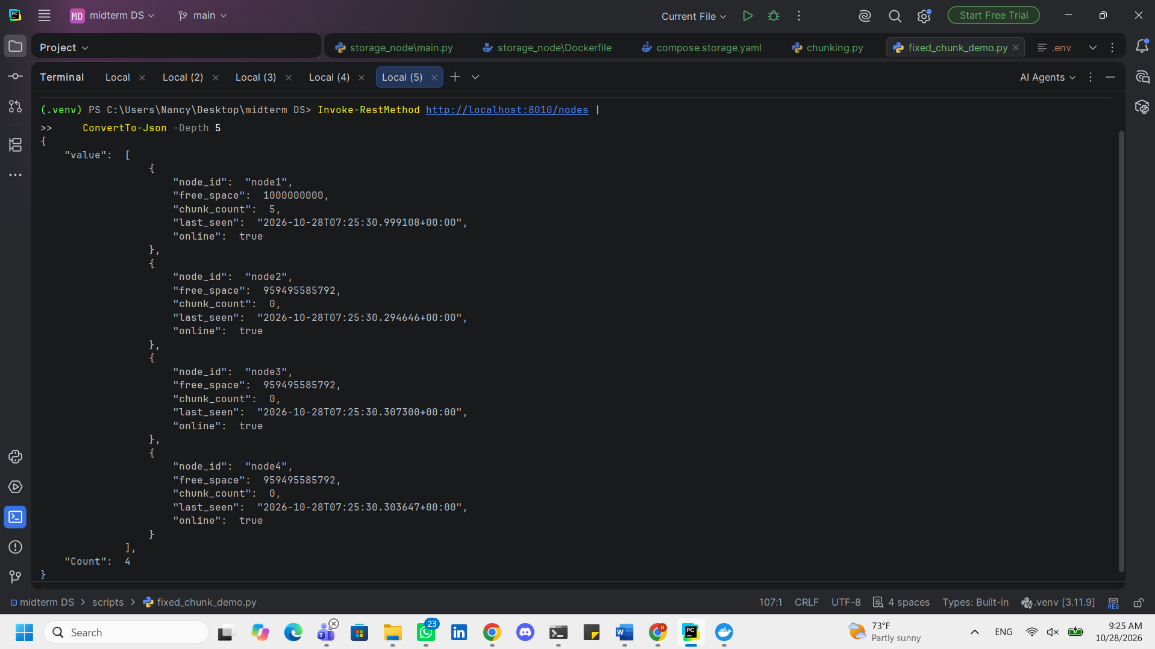
Fixed-Size File Chunking
Fixed-size chunking was implemented in Python to divide large files into 4 MiB chunks. Each chunk is assigned a unique SHA-256 hash based on its content.
The implementation uses sequential file reading to process one chunk at a time, reducing memory usage when handling large files.
To verify the implementation, a sample file larger than 10 MiB was divided into three chunks. The chunks were uploaded to a storage node through its REST API, retrieved in their original order, and combined to reconstruct the complete file.
The integrity of the reconstructed file was verified by comparing its SHA-256 hash with that of the original file.
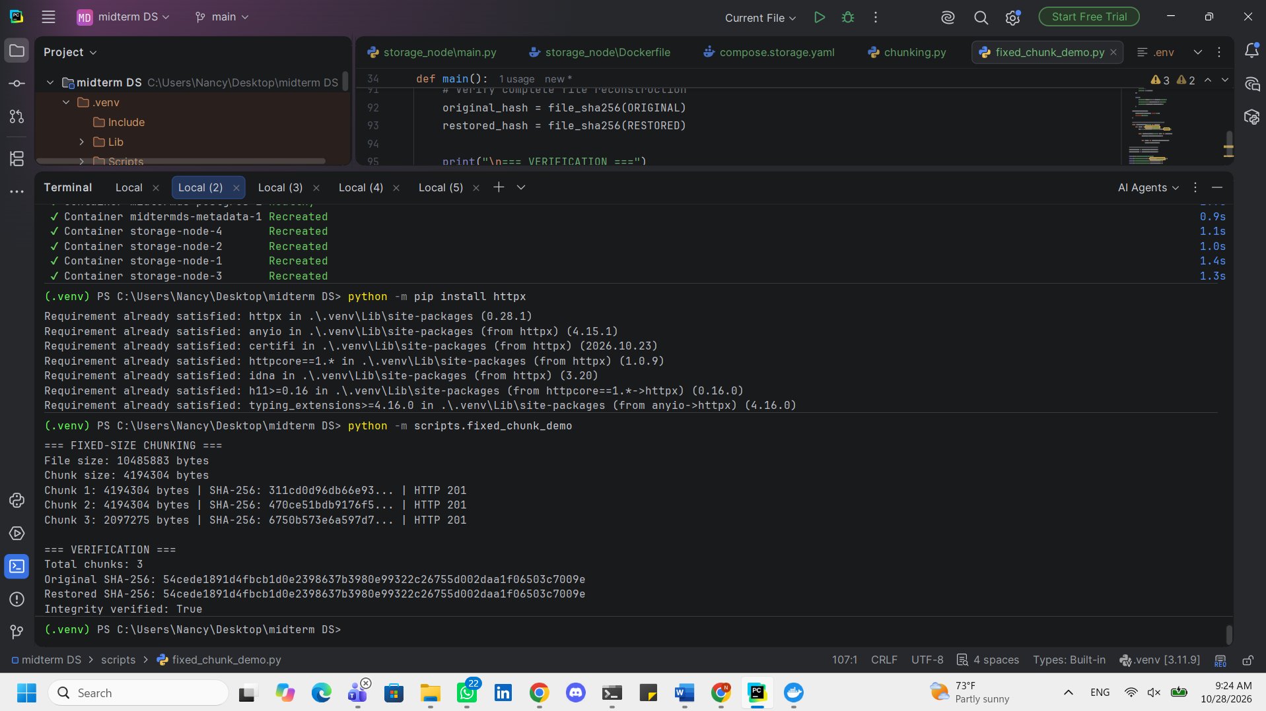
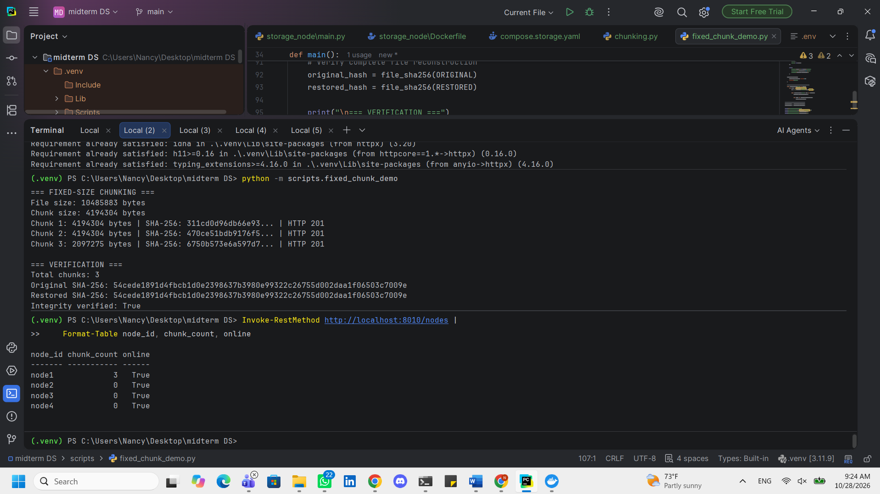
Content-Defined Chunking and Comparison
A content-defined chunking algorithm was implemented using a Gear rolling hash to identify chunk boundaries according to file contents. The algorithm was configured with a minimum chunk size of 2 MiB, a target average of approximately 4 MiB, and a maximum of 8 MiB.
Unlike fixed-size chunking, content-defined chunking can preserve chunk boundaries when bytes are inserted or removed from a file. This allows unchanged chunks to be reused and can improve deduplication efficiency.
To compare both methods, a 32 MiB sample file was generated and a modified version was created by inserting bytes at its beginning. Both versions were processed using fixed-size and content-defined chunking.
The experiment measures chunk counts, reusable chunks, reusable bytes, data-reuse percentages, and processing times for each algorithm.
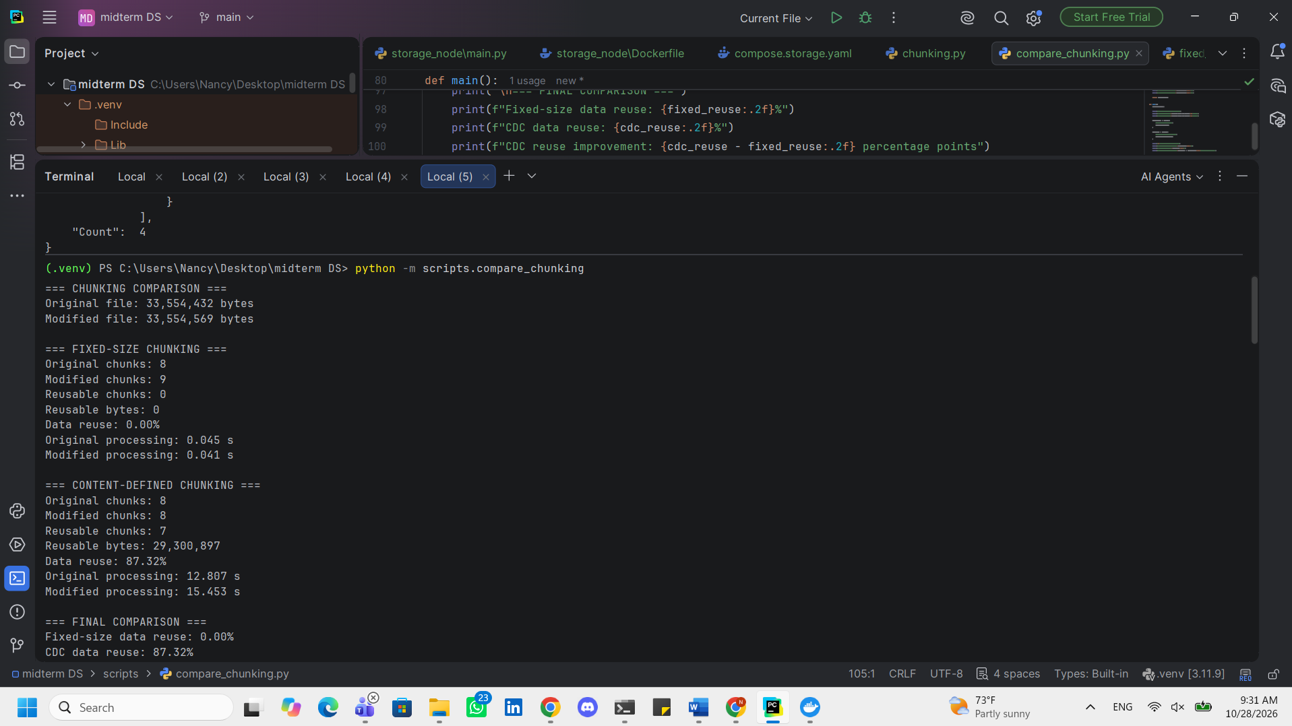
Chunking Performance Comparison
The chunking algorithms were evaluated using a 32 MiB file and a modified version containing 137 additional bytes at the beginning.
Fixed-size chunking generated eight chunks for the original file and nine for the modified file. No original chunks could be reused, resulting in a data reuse rate of 0%.
Content-defined chunking generated eight chunks for each version and successfully reused seven chunks, representing 87.32% of the original file's data.
The total processing times were 0.102 seconds for fixed-size chunking and 21.742 seconds for content-defined chunking.
These results demonstrate that content-defined chunking can significantly improve deduplication when data is inserted into a file, although the current Python implementation introduces substantial processing overhead.
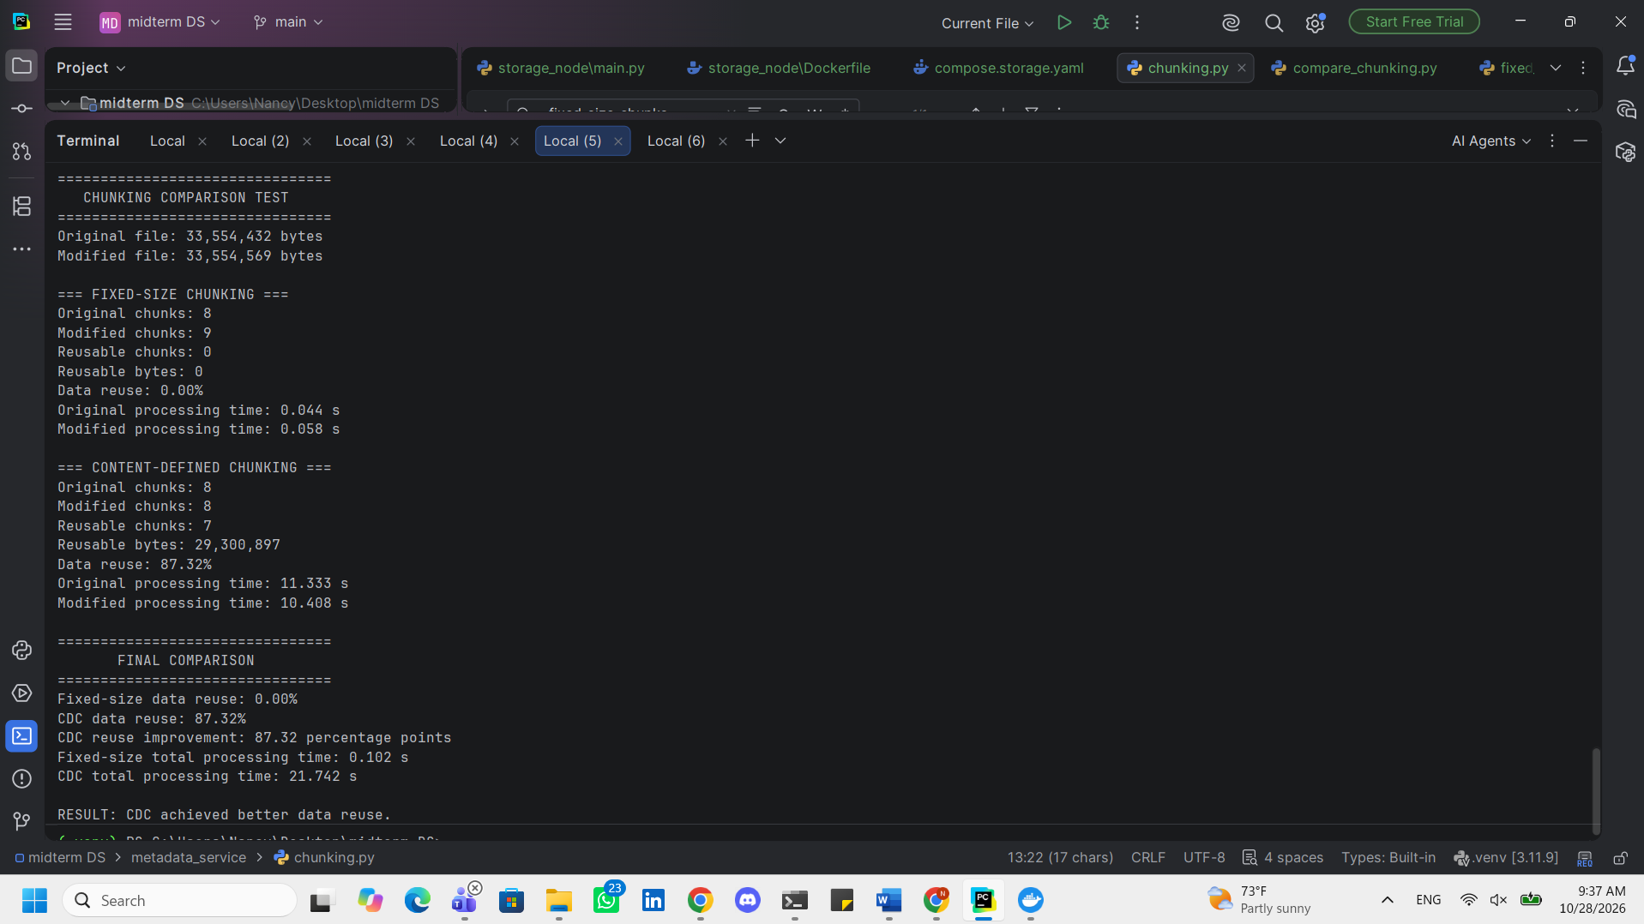
Consistent Hashing and Virtual Nodes
A consistent hashing ring was implemented to distribute file chunks among the storage nodes based on their SHA-256 identifiers.
Each physical storage node is represented by 128 virtual nodes positioned around the hash ring. This improves the distribution of chunks and reduces the impact of individual node additions or removals.
For each chunk, the placement algorithm locates the first node clockwise from the chunk's hash position. The algorithm can also select multiple distinct storage nodes to support replication.
To evaluate placement stability, 10,000 sample chunk identifiers were generated and assigned to an initial cluster of four storage nodes.
Two scenarios were evaluated: adding a fifth node and removing an existing node. The percentage of primary chunk placements that changed was measured in each scenario.

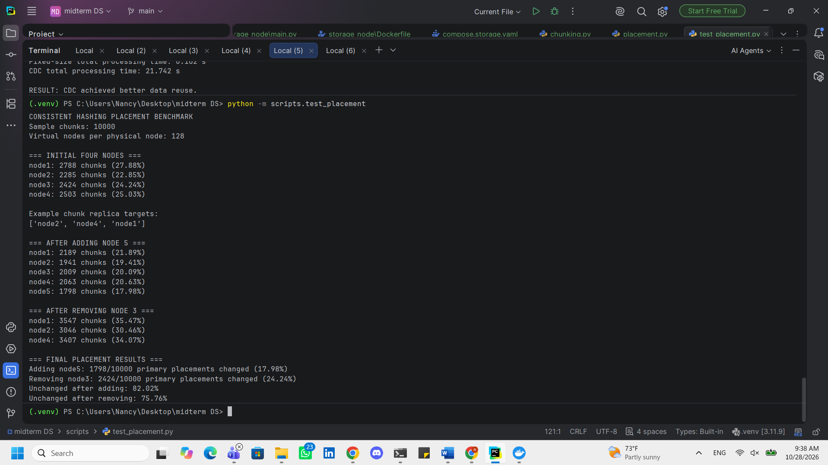
PostgreSQL Object Metadata and Deduplication
PostgreSQL was used to implement persistent object metadata management. The database schema includes tables for buckets, objects, chunk references, and unique chunks.
Each object record stores its bucket, key, size, version, creation date, and user-defined tags. An ordered chunk mapping maintains the sequence of SHA-256 chunk identifiers needed for file reconstruction.
Chunk-level deduplication is supported through reference counting. Identical chunk hashes share a single metadata record, and the reference count increases whenever another object references the same chunk.
When an object version is deleted, its chunk reference counts are decremented. Chunks with zero references are identified as candidates for physical cleanup, preventing the deletion of chunks still required by other objects.
The metadata layer was designed to support object versioning and subsequent integration with the distributed placement and replication modules.

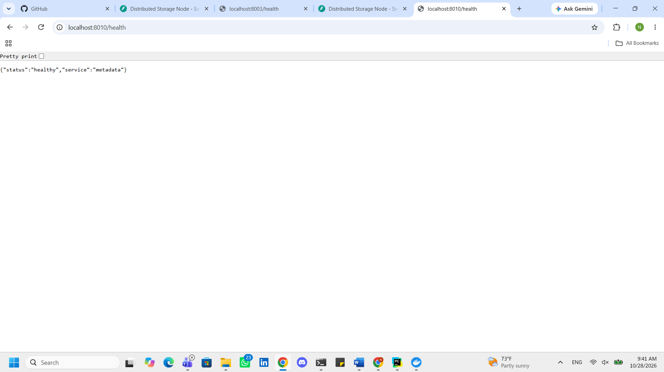
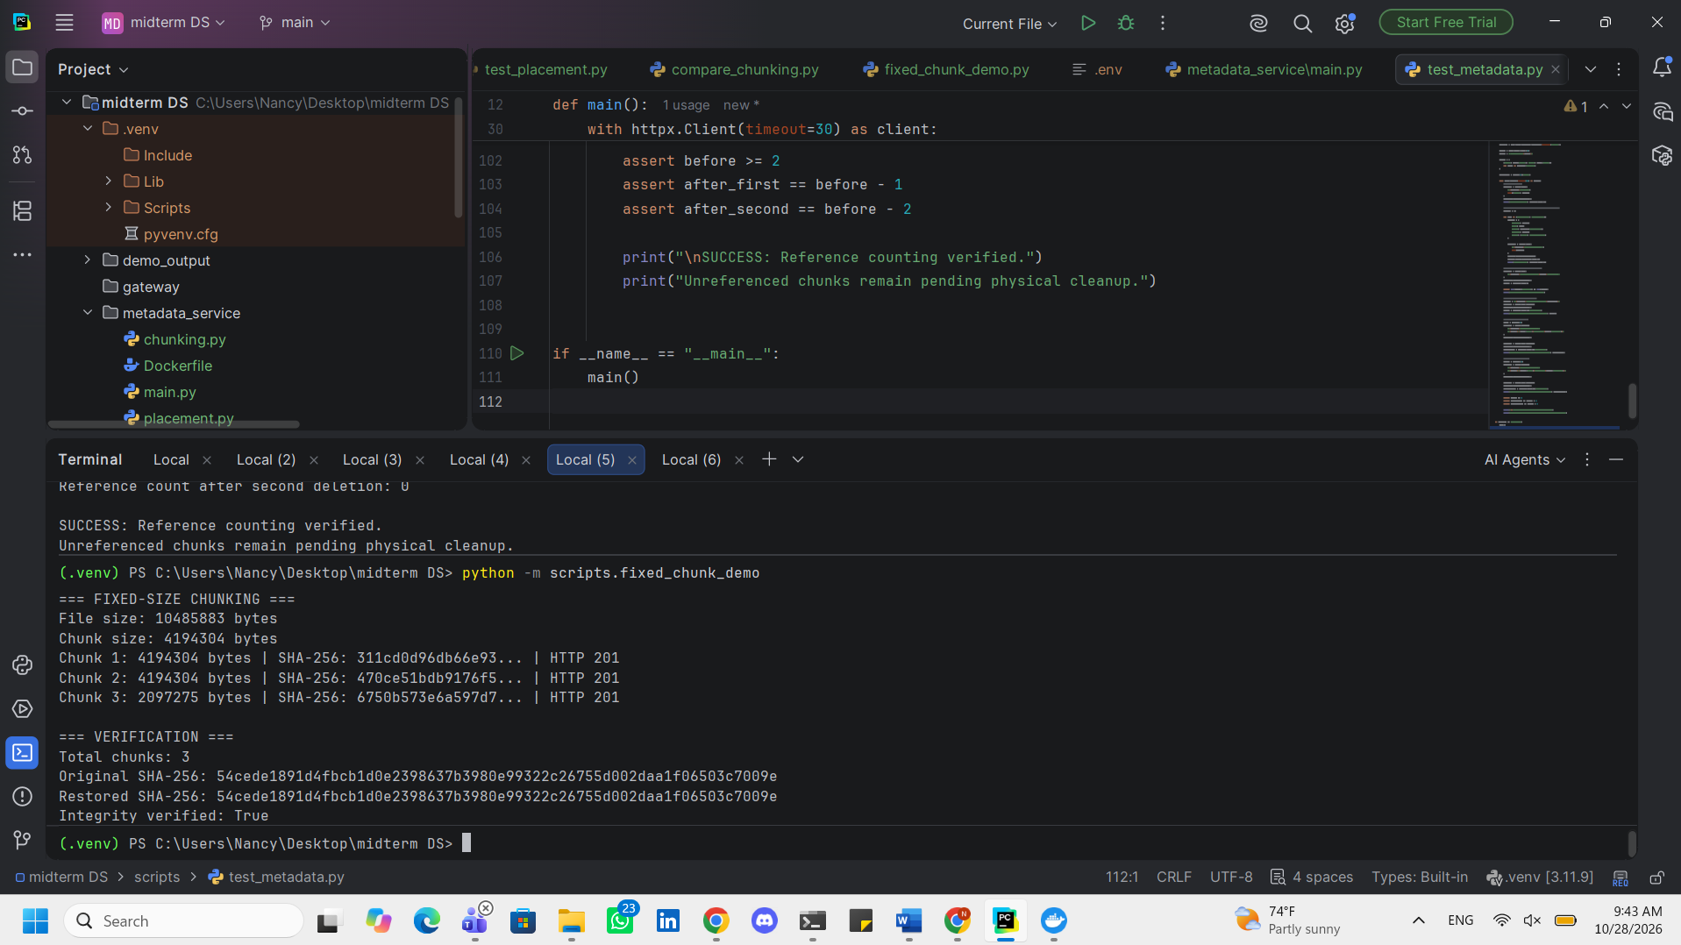
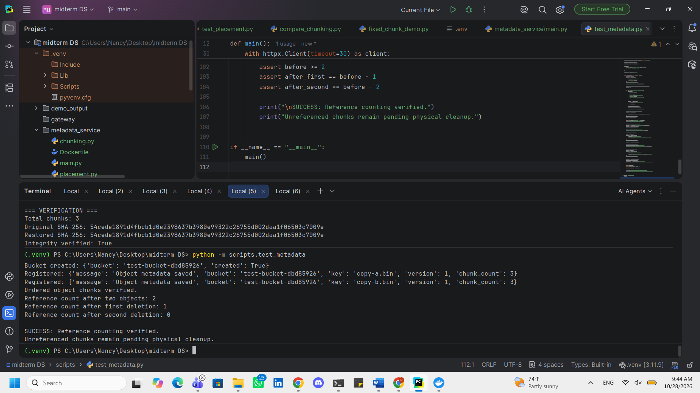
Physical Chunk Distribution Using Consistent Hashing
The consistent hashing placement algorithm was integrated with the storage node REST APIs to support distributed chunk storage.
A sample file was divided into fixed-size chunks, and the SHA-256 identifier of each chunk was used to determine its target node through the consistent hashing ring.
The chunks were uploaded to their assigned storage nodes, while their ordered metadata and physical storage locations were recorded in PostgreSQL.
During retrieval, the system obtained the object's chunk manifest and storage locations from the metadata service. Each chunk was downloaded from its assigned node and checked against its SHA-256 hash before reconstructing the original file.
This implementation establishes the connection between content-addressed chunk storage, consistent hashing placement, and persistent object metadata.
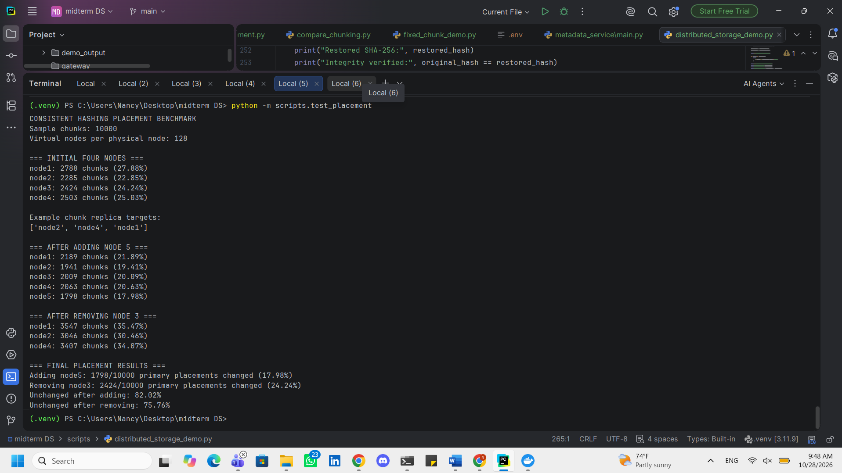
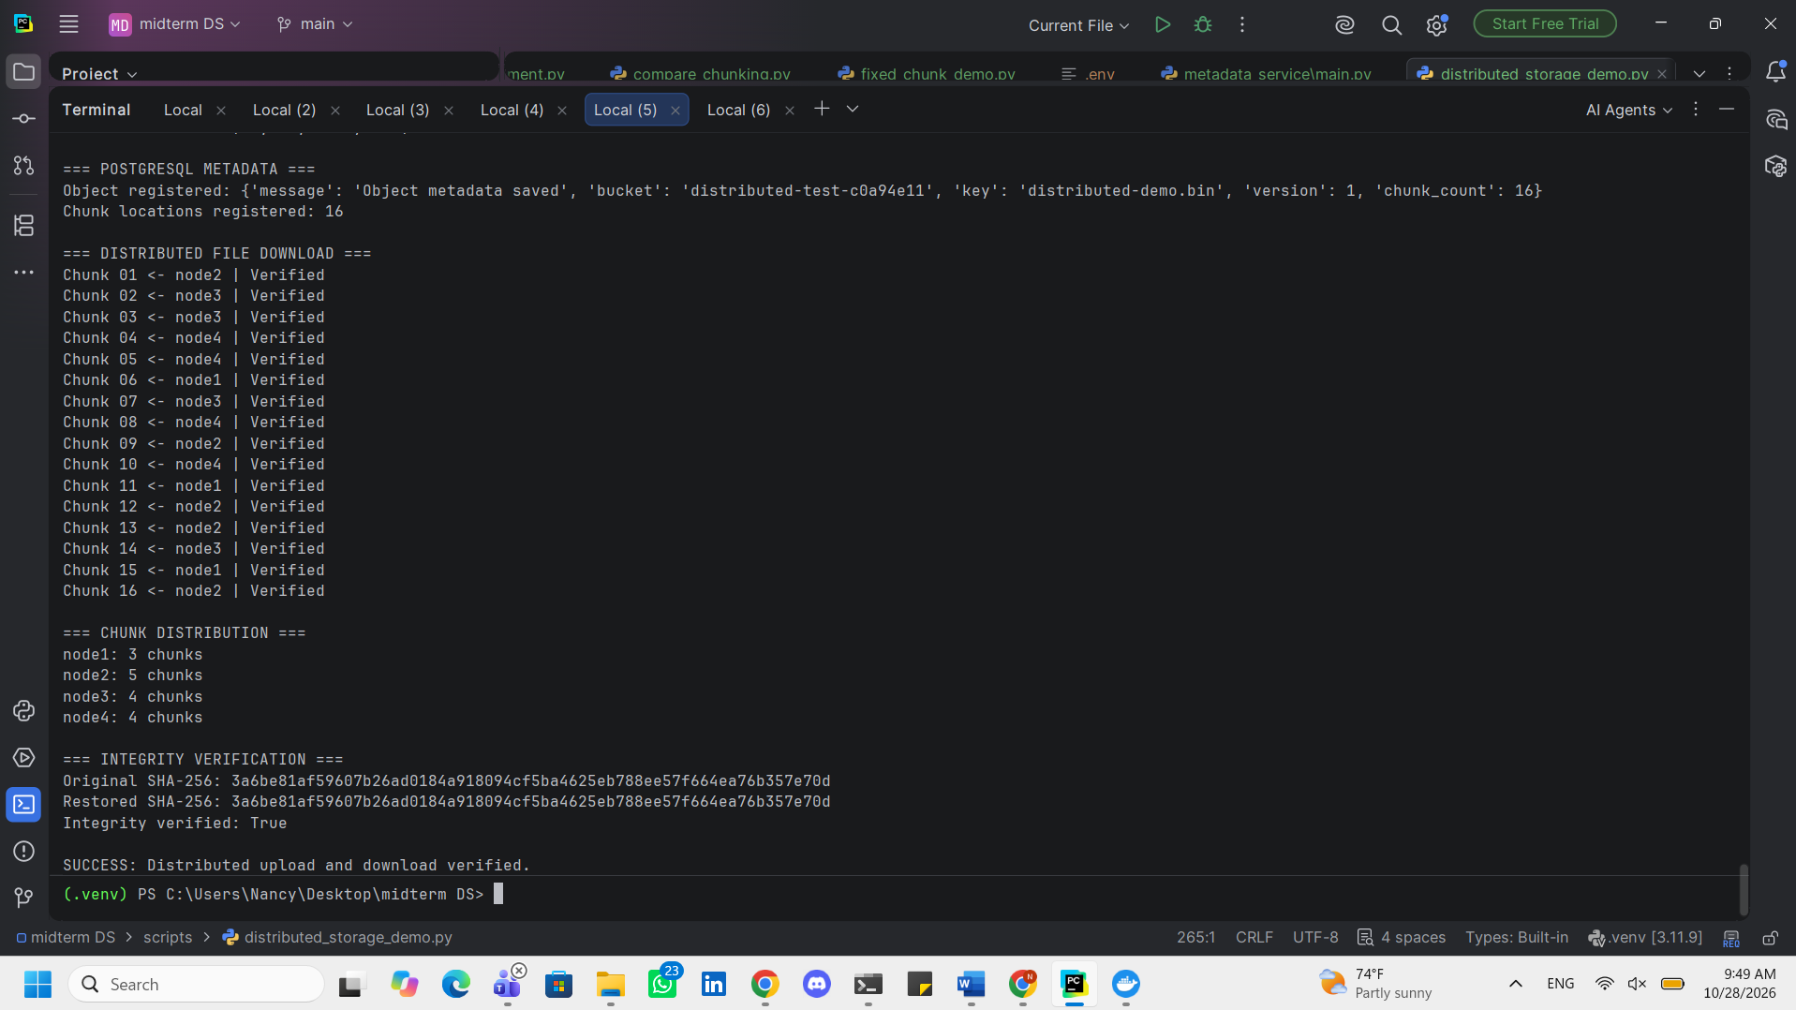
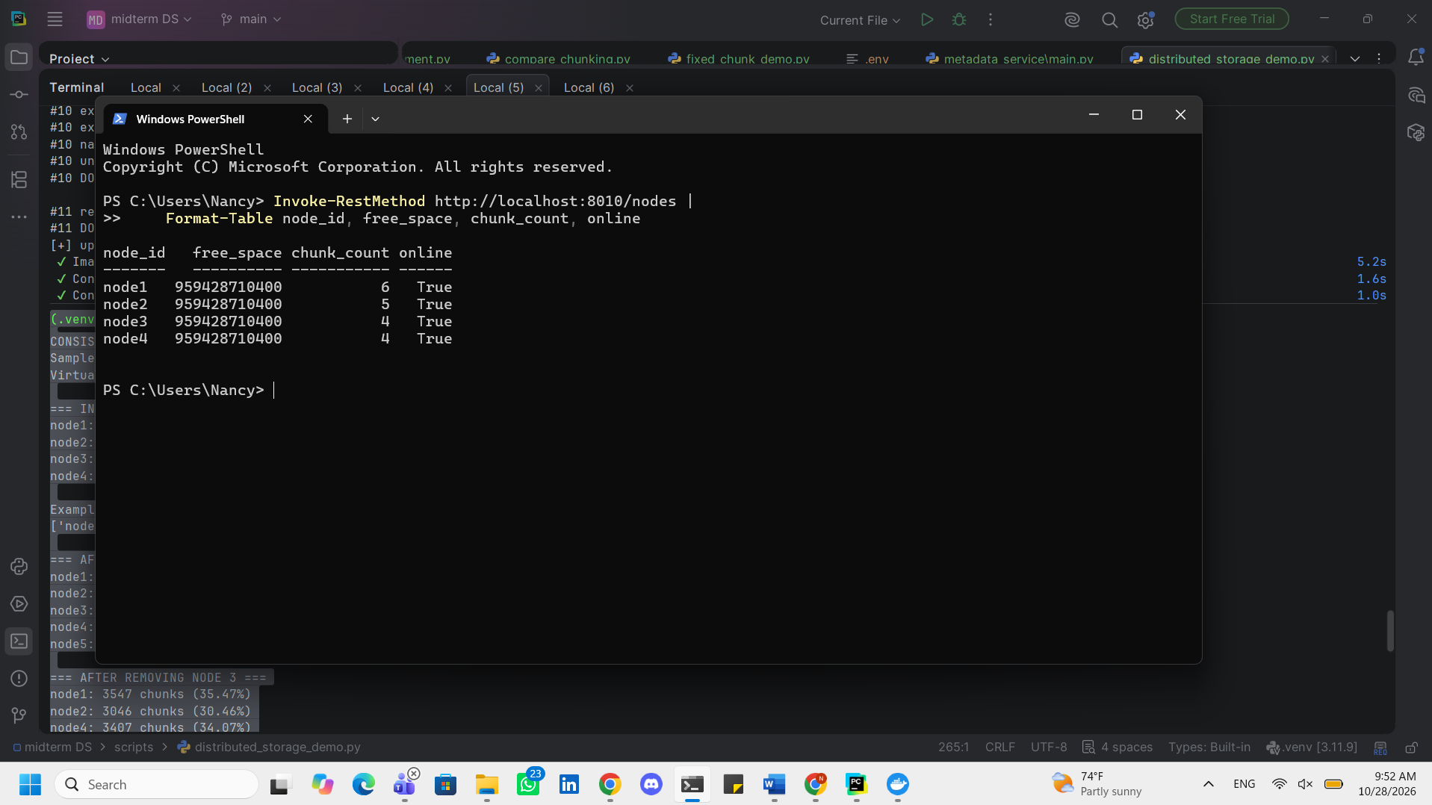
Task 4
Redundancy and Fault Tolerance
Replication and Quorum Operations
Chunk replication was implemented using the consistent hashing placement module. Each chunk is assigned to three distinct storage nodes, corresponding to a replication factor of N = 3.
The system was configured with a write quorum of W = 2 and a read quorum of R = 2, satisfying the condition W + R > N.
During upload, the application sends each chunk to its designated replica nodes and verifies that at least two write operations succeed before accepting the chunk. The successfully stored replica locations are registered in PostgreSQL.
During retrieval, the application requests the recorded replicas and validates their SHA-256 hashes. A read succeeds only when at least two replicas return valid data.
Node Failure Simulation
A storage-node failure test was designed by stopping one of the Docker containers and attempting to retrieve an object previously stored with three replicas.
The test evaluates whether the system can satisfy the read quorum using the surviving storage nodes and reconstruct the original file without compromising its integrity.
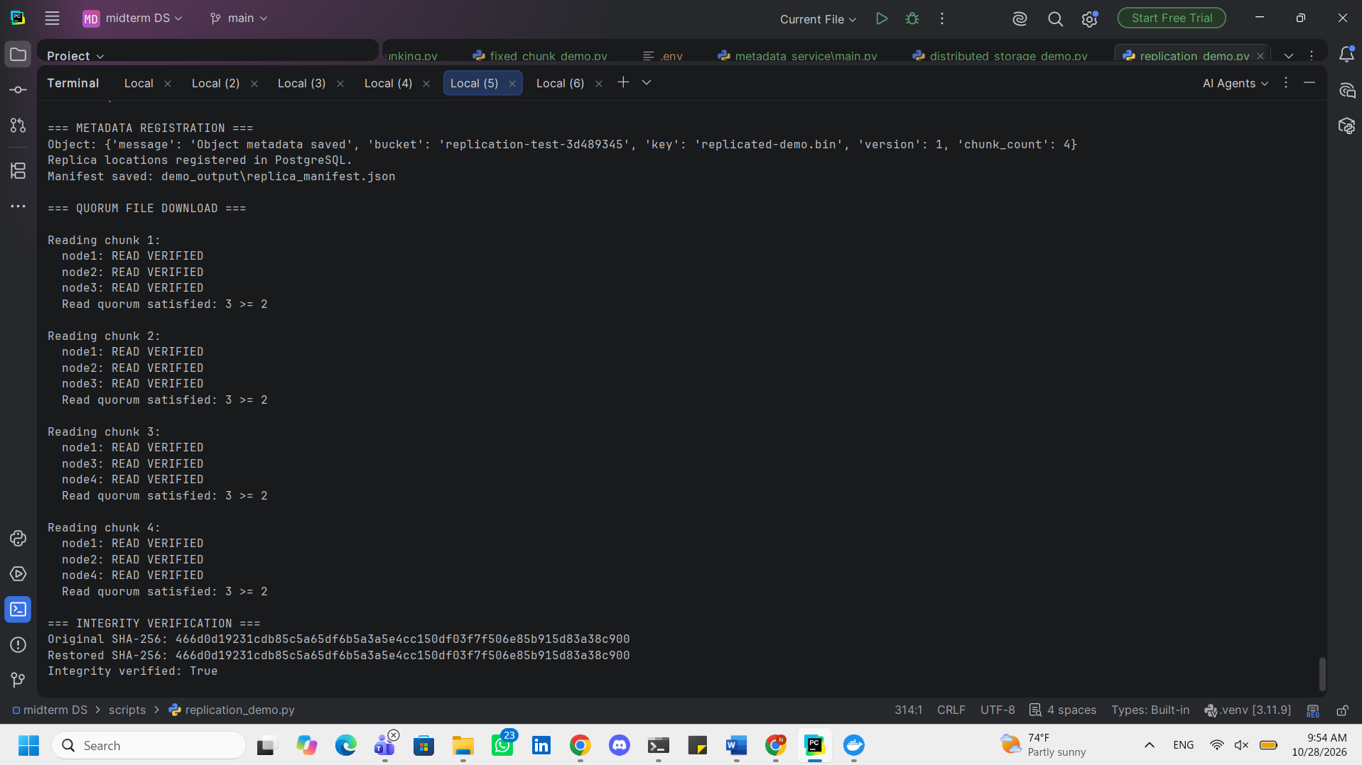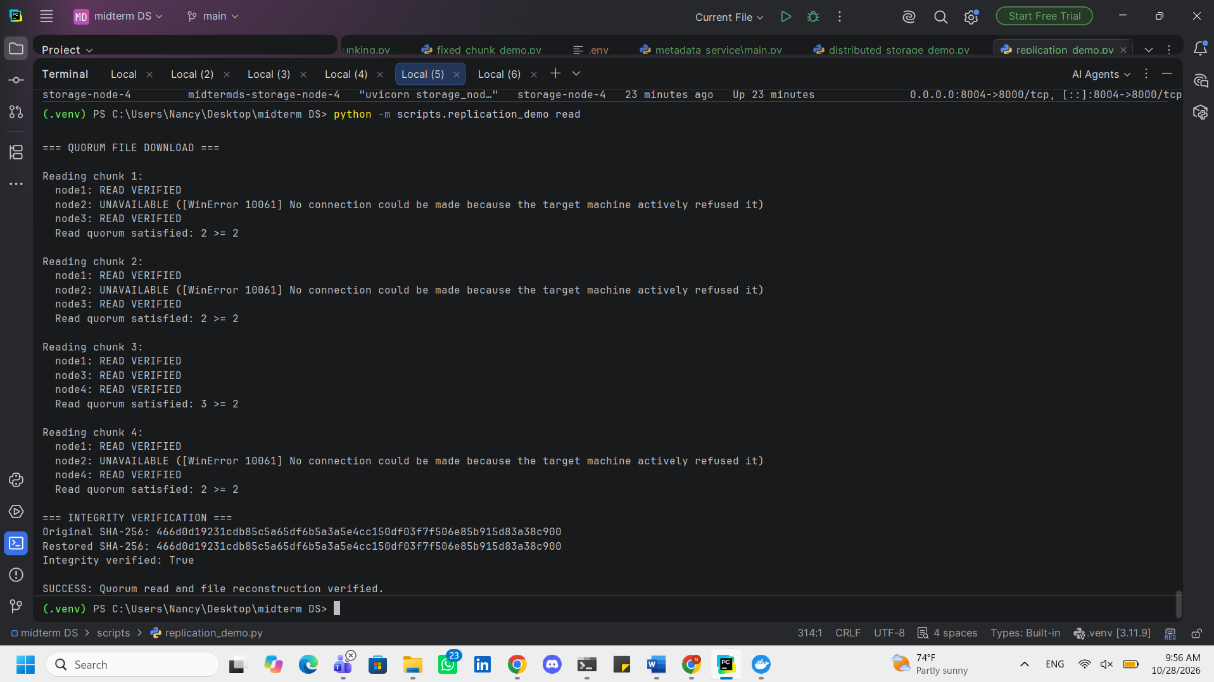
docker start storage-node-2
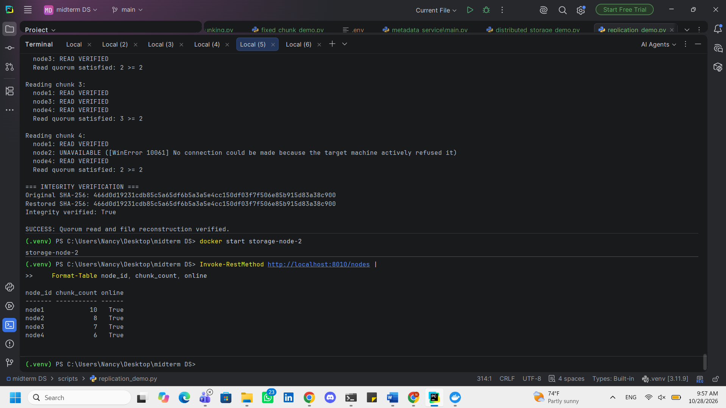
Automatic Replica Repair and Integrity Scrubbing
An automatic repair worker was implemented to monitor the integrity and availability of replicated chunks.
The worker periodically checks registered replicas using the storage nodes' HEAD endpoints, which validate the stored chunks against their SHA-256 identifiers.
When a missing or corrupted replica is detected, the worker attempts to retrieve a verified copy from a healthy storage node and restore the required replication factor by copying the chunk to another available node.
Following a successful replacement, the new replica location is registered in PostgreSQL and the obsolete location record is removed.
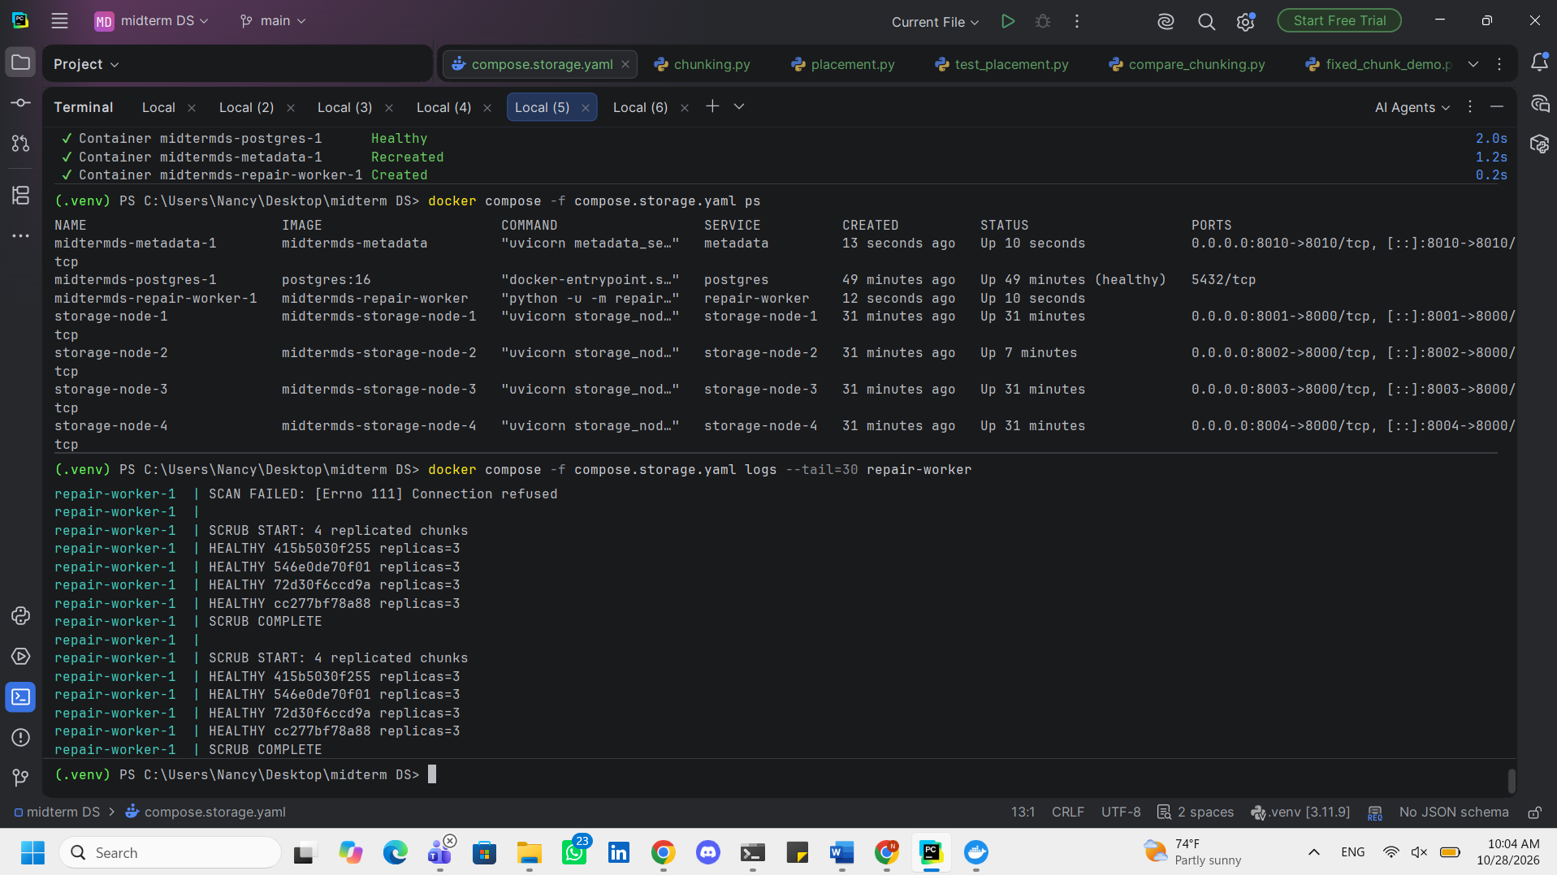
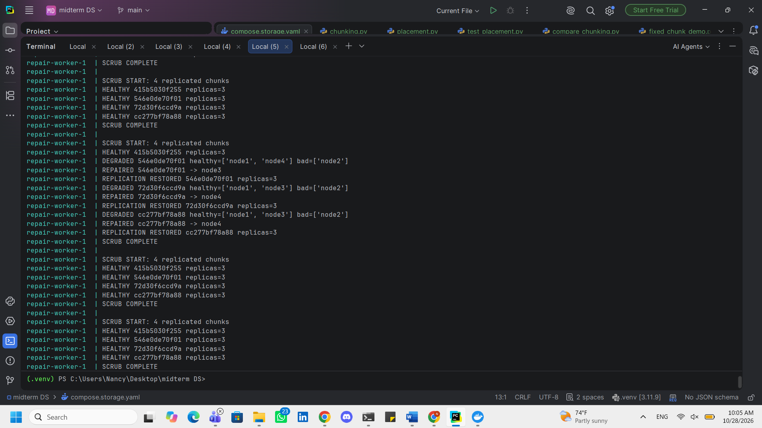
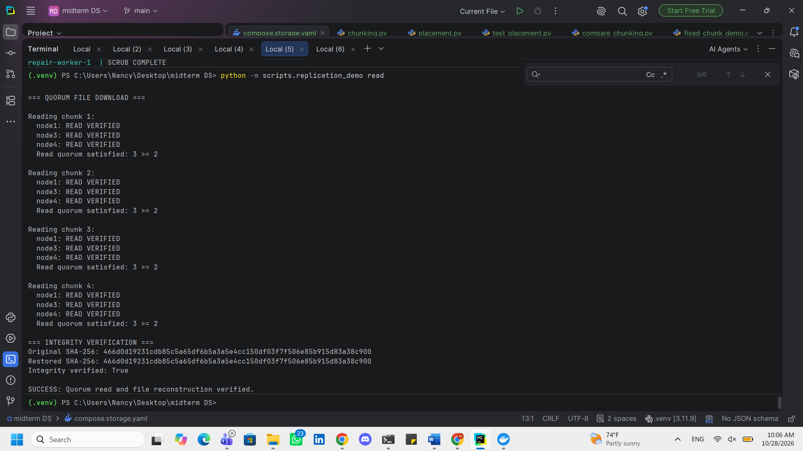
Restart node 2: docker start storage-node-2
Add Storage Nodes 5 and 6
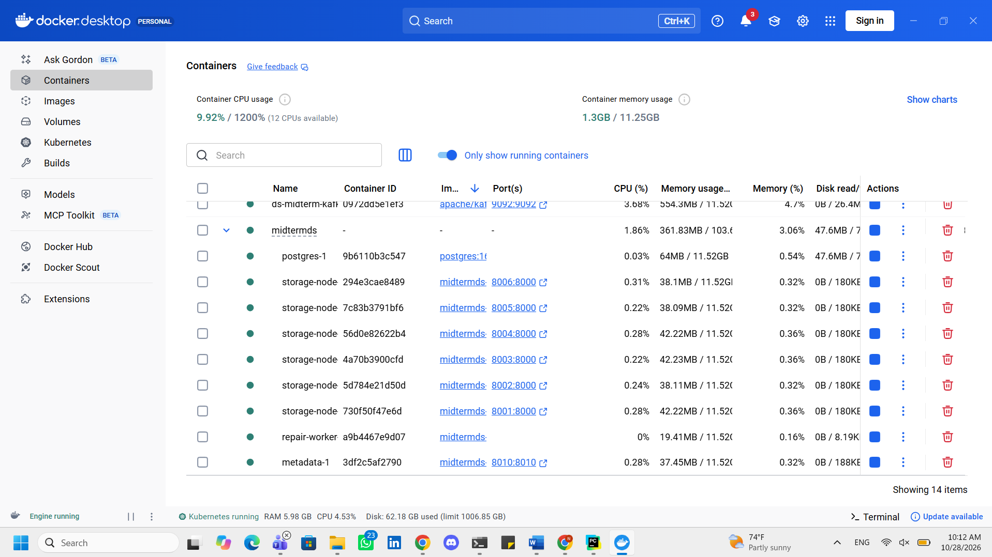
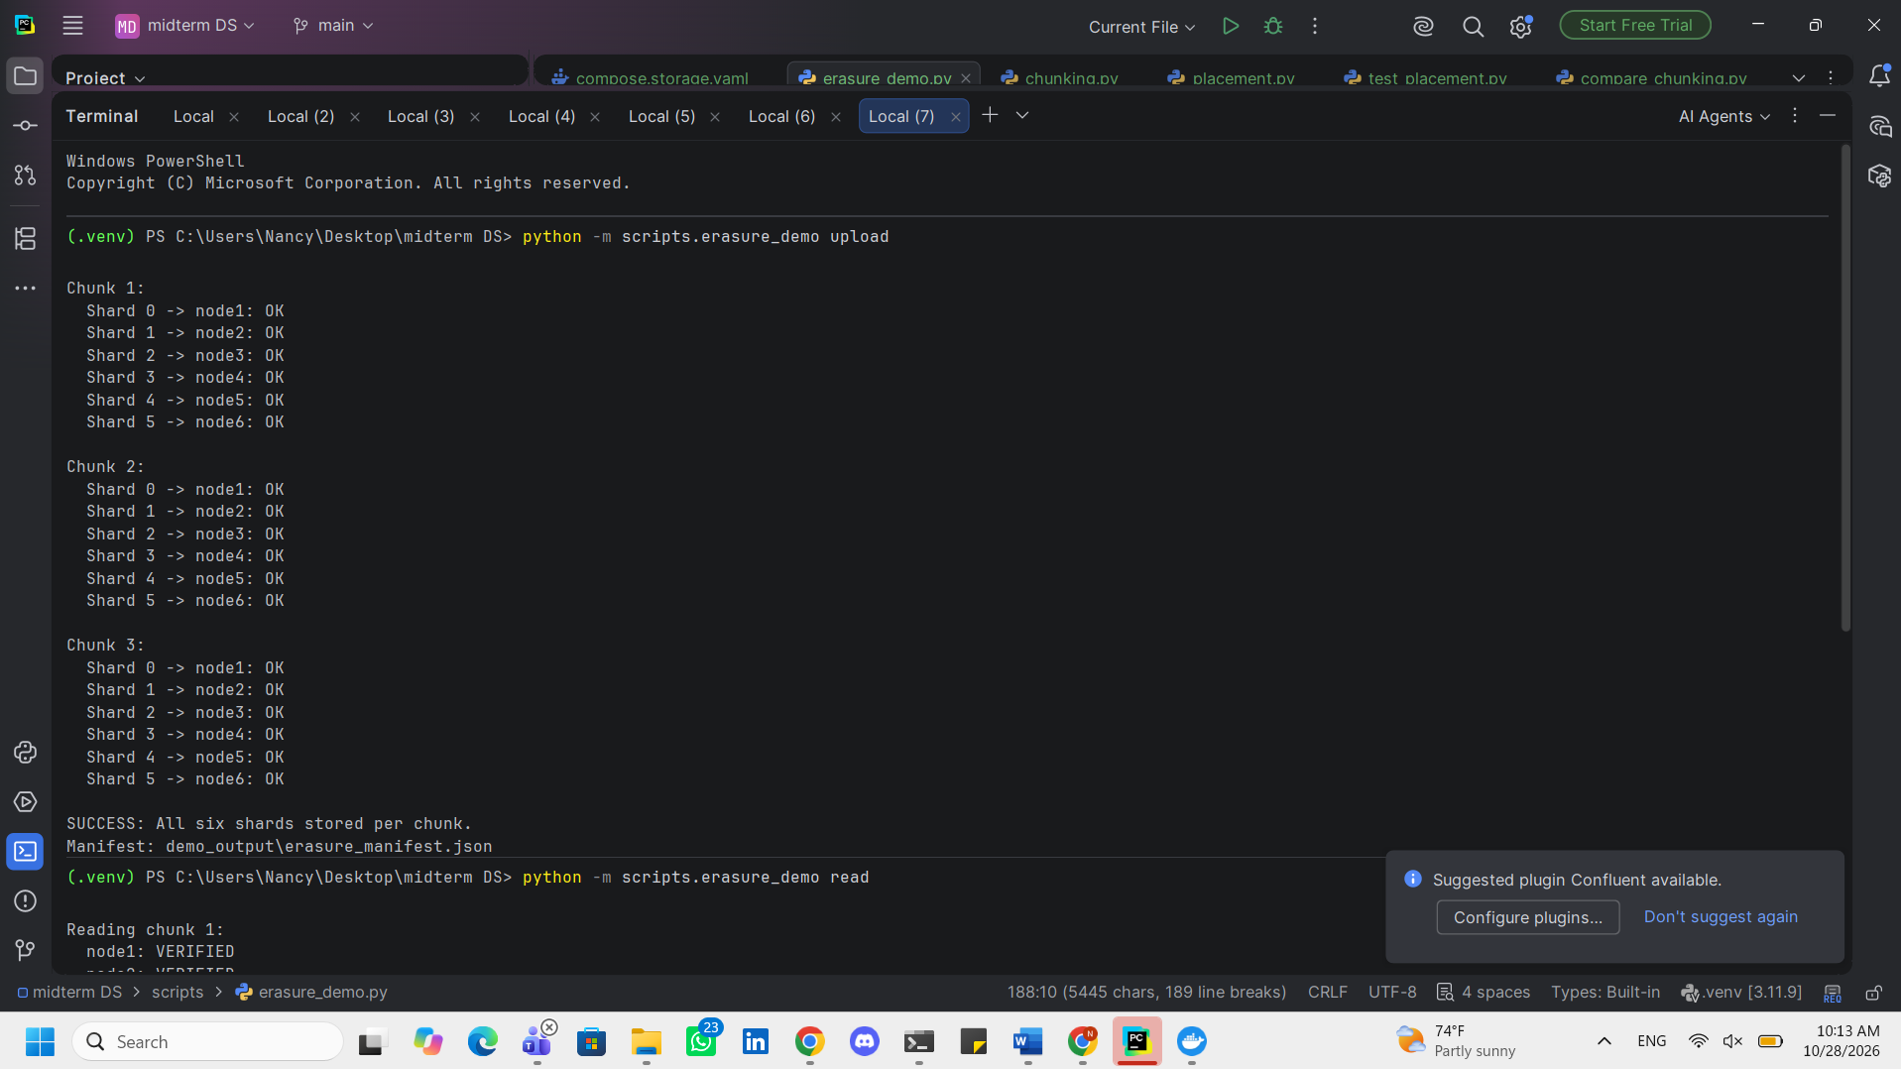
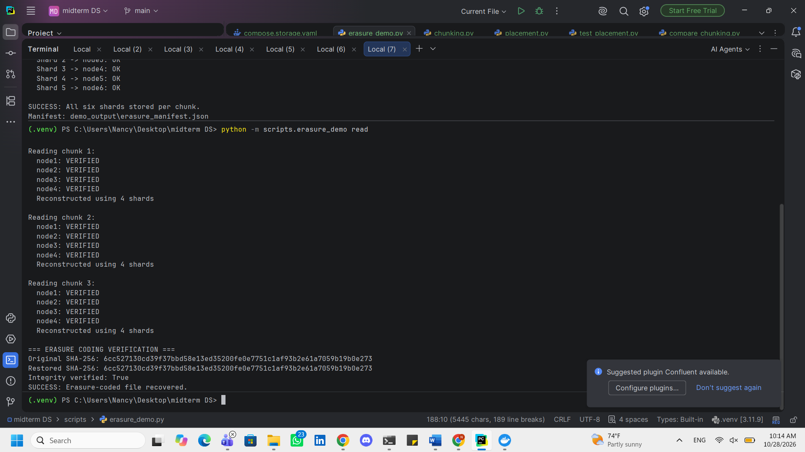
Test recovery after two-node failure
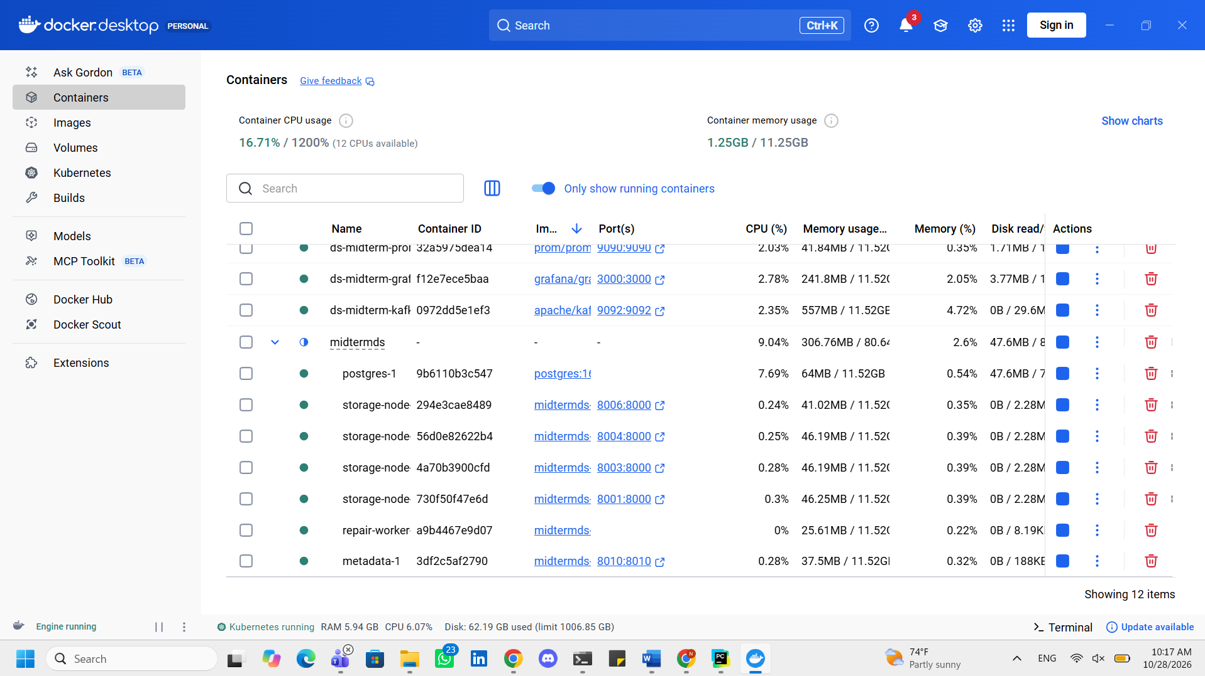
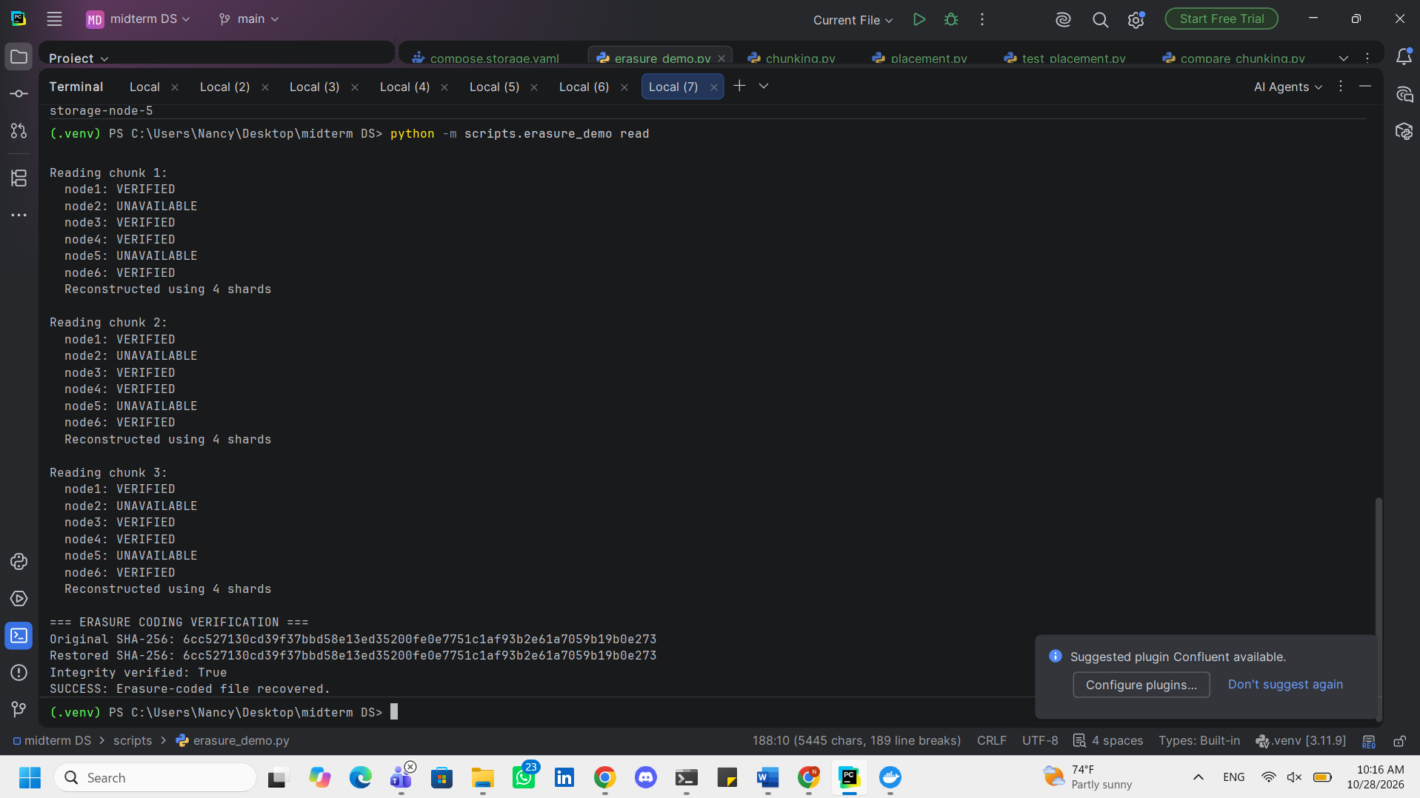
Task 5
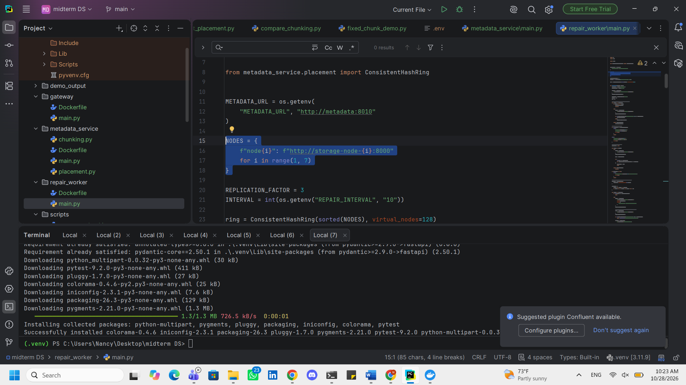
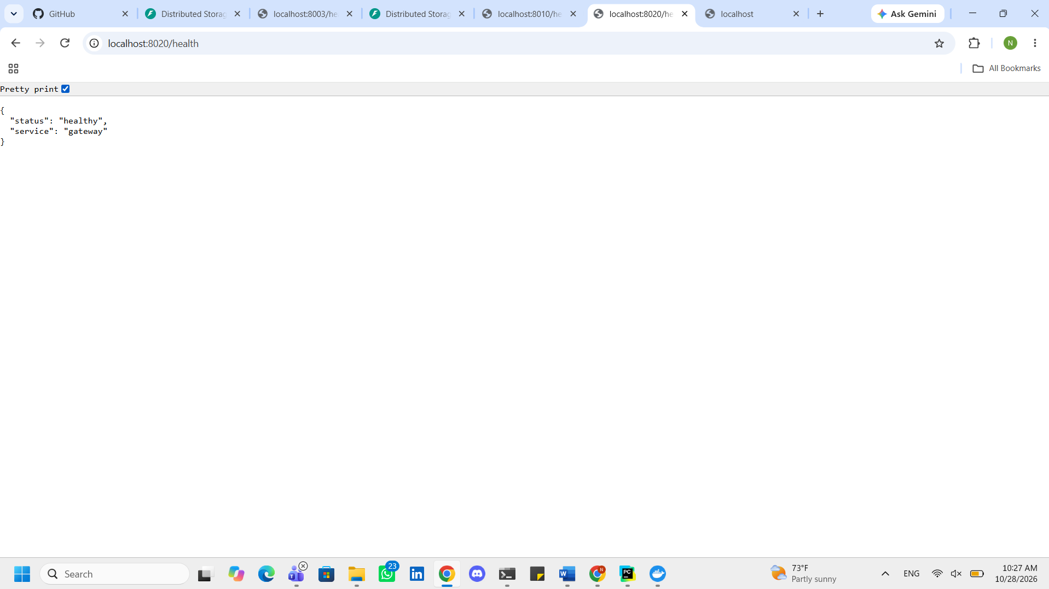
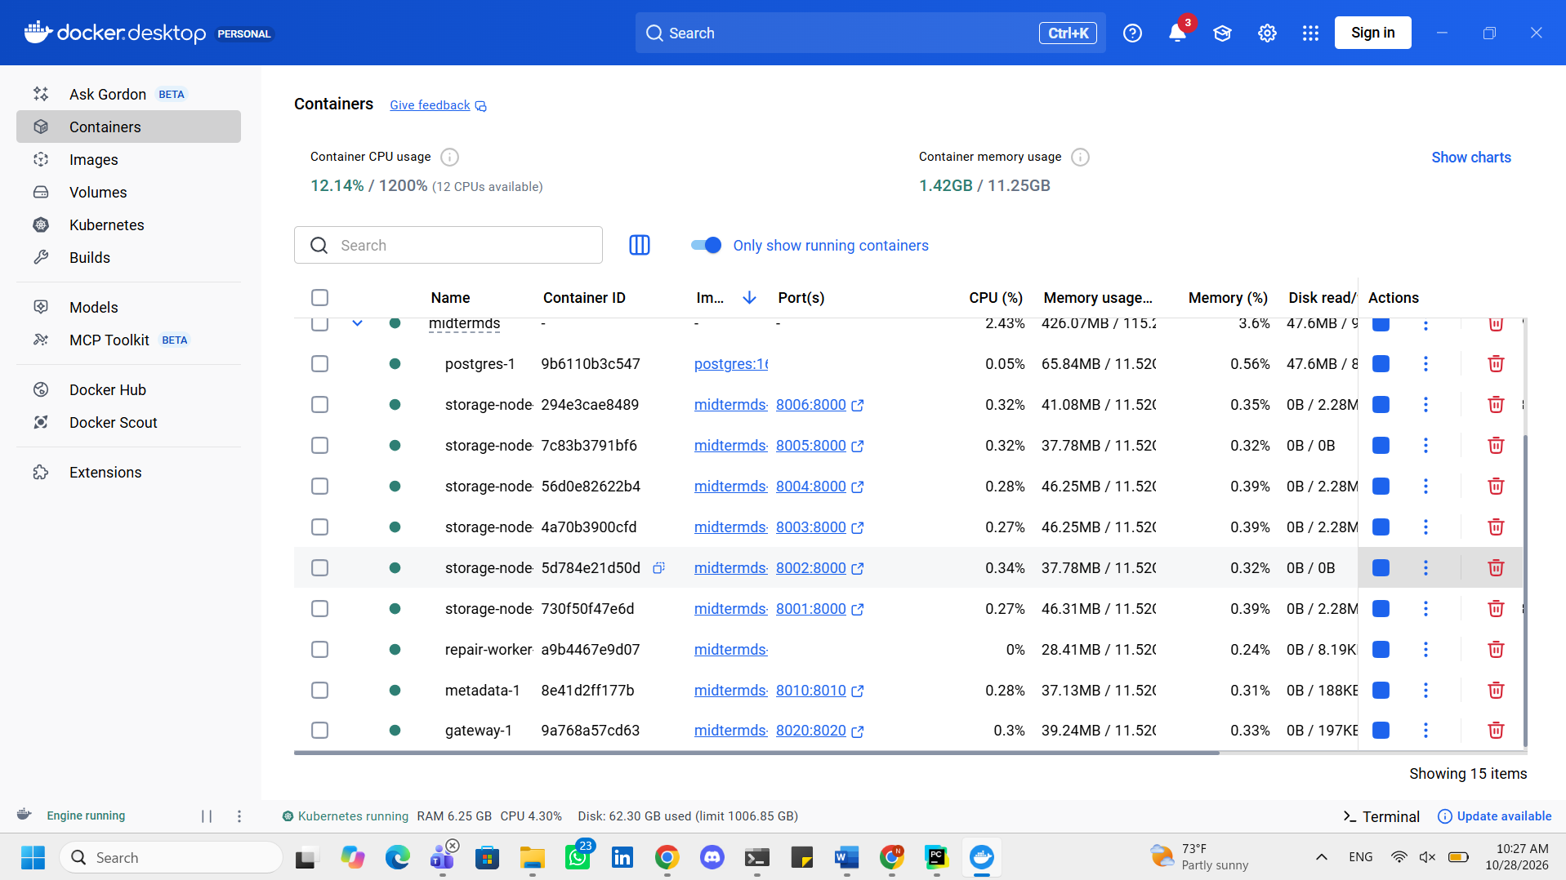
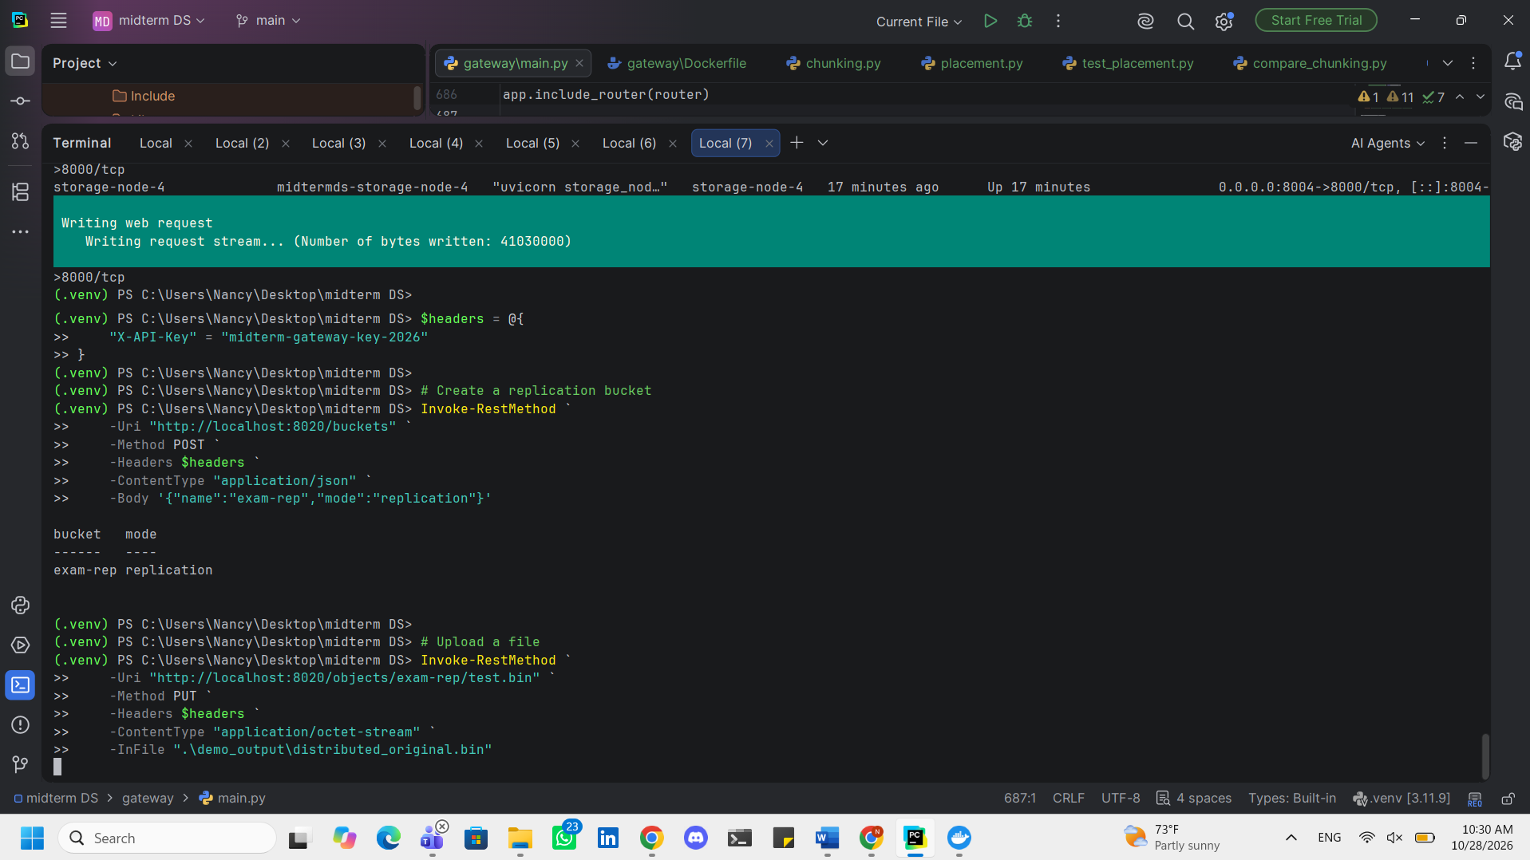
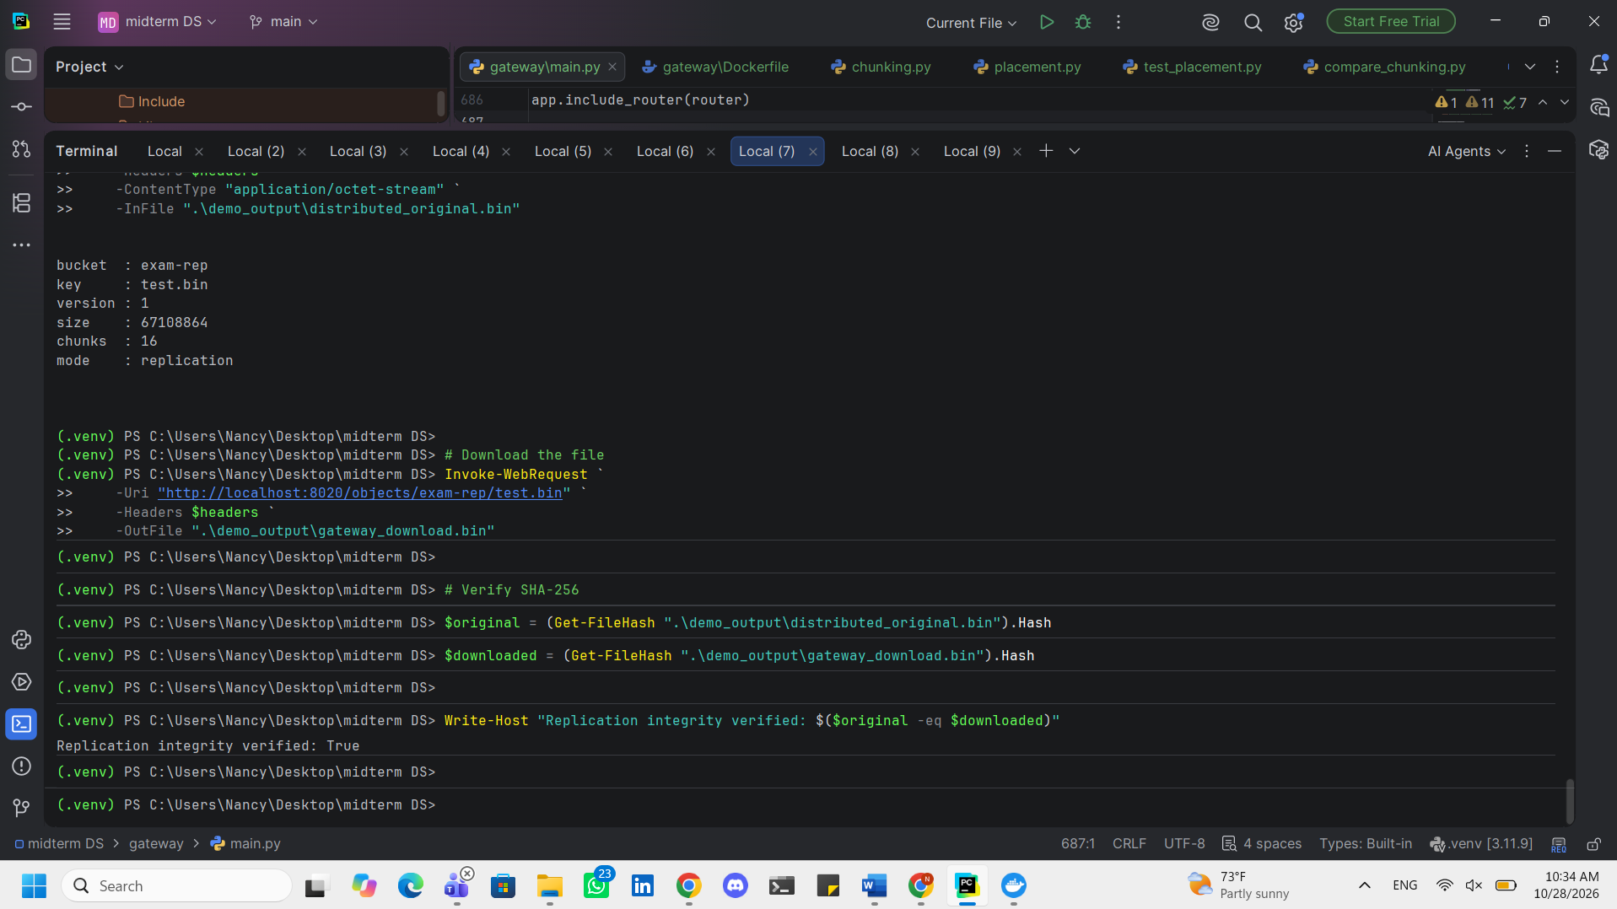

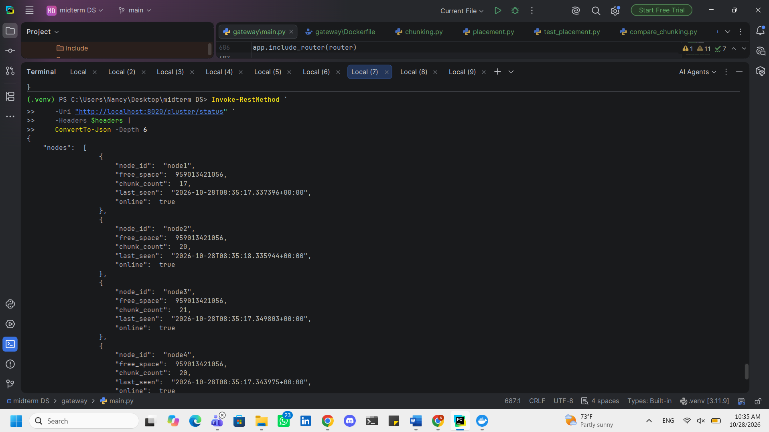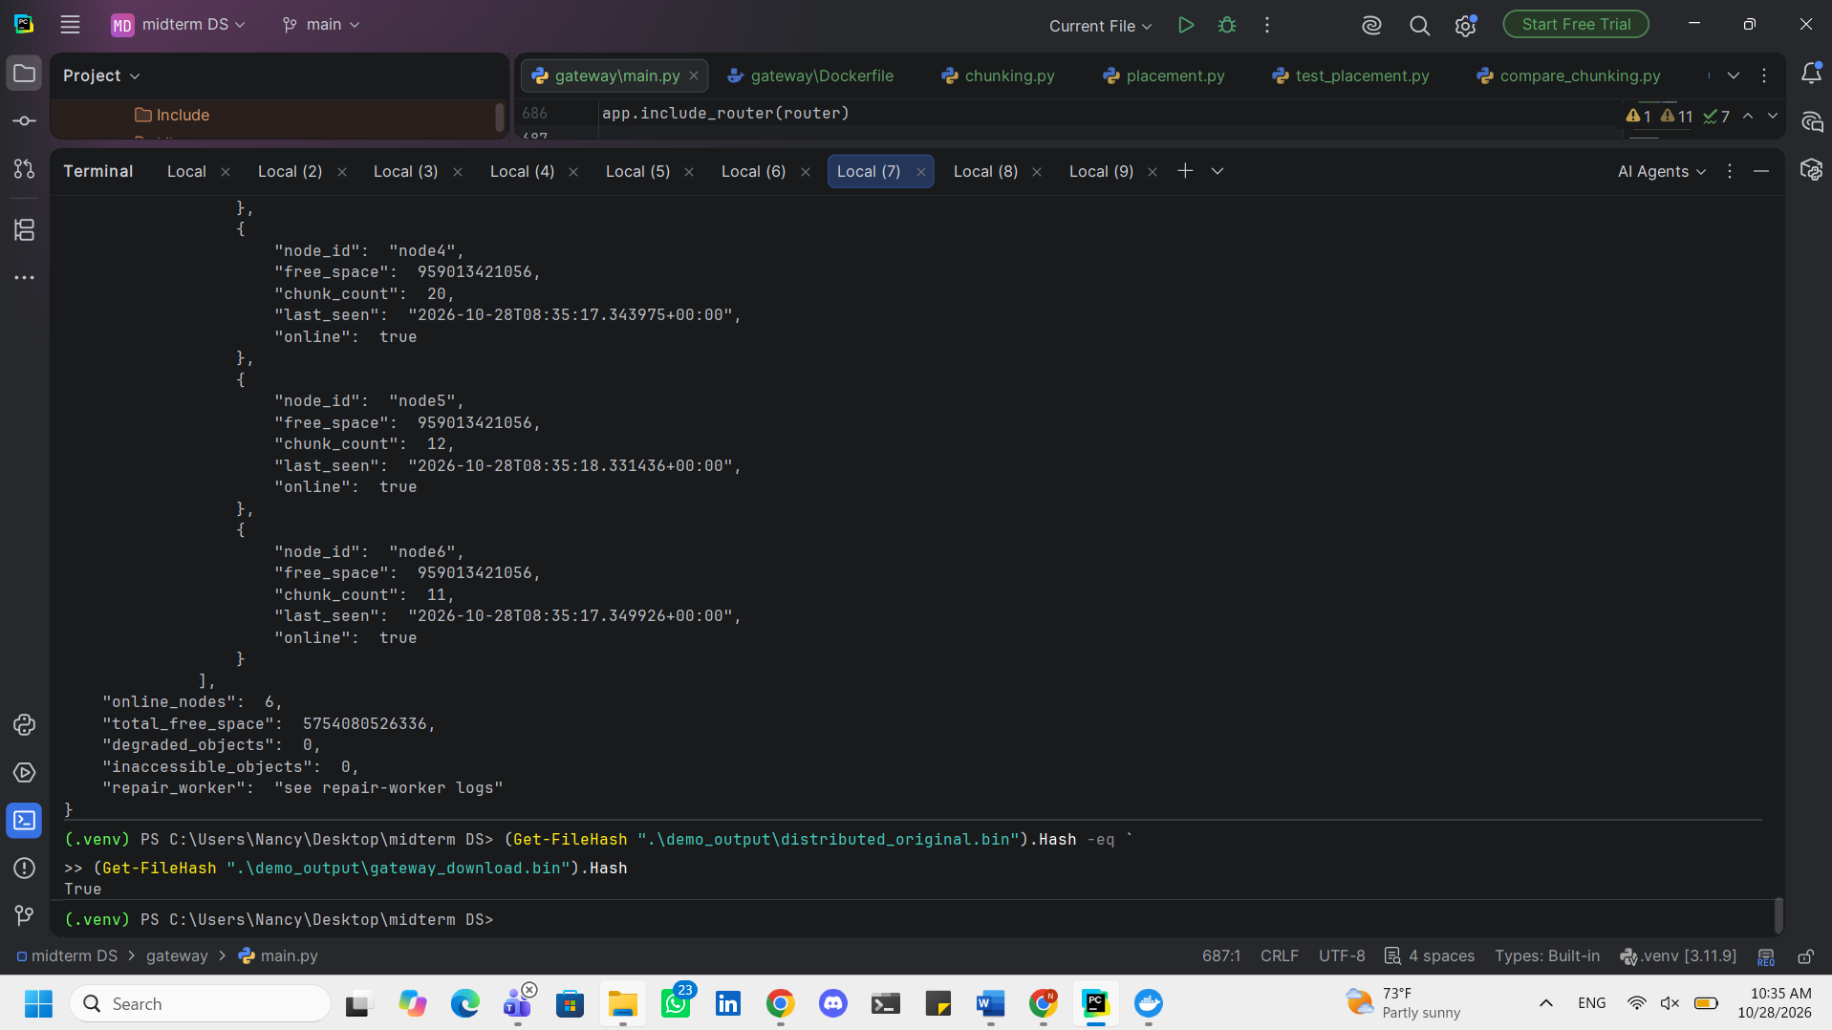
Automated Gateway API Testing
Automated integration tests were developed using pytest and HTTPX to validate the FastAPI gateway.
The test suite covers gateway availability, API-key authentication, bucket creation, object upload and download, byte-range requests, object metadata retrieval, prefix-based search, object deletion, and cluster-status reporting.
Both replication and Reed–Solomon erasure-coded storage modes were tested. Downloaded objects were compared with their original data to verify successful reconstruction and data integrity.
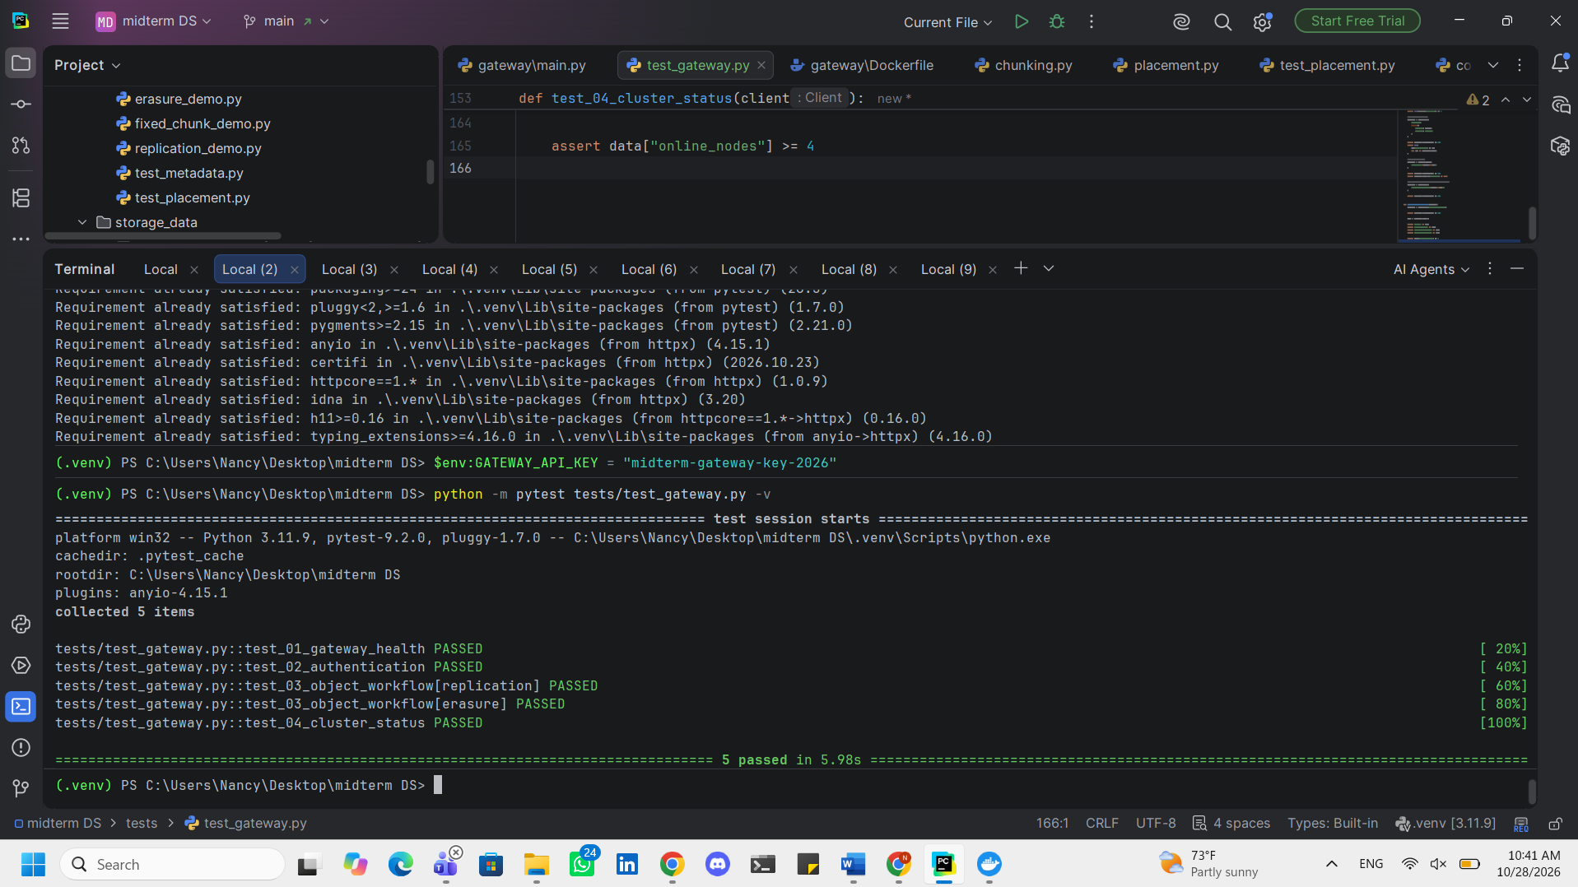
Task 6
Web Interface and Elasticsearch Integration
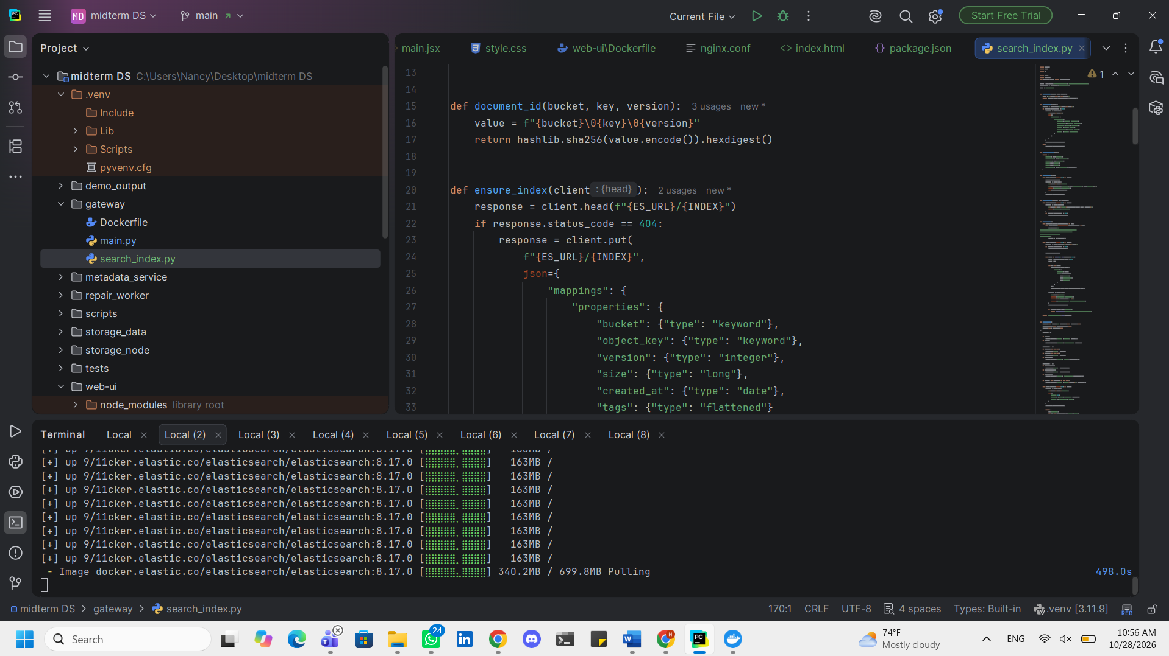
A React-based web interface was developed to provide a centralized management console for the distributed object storage system.
Web UI file structure:
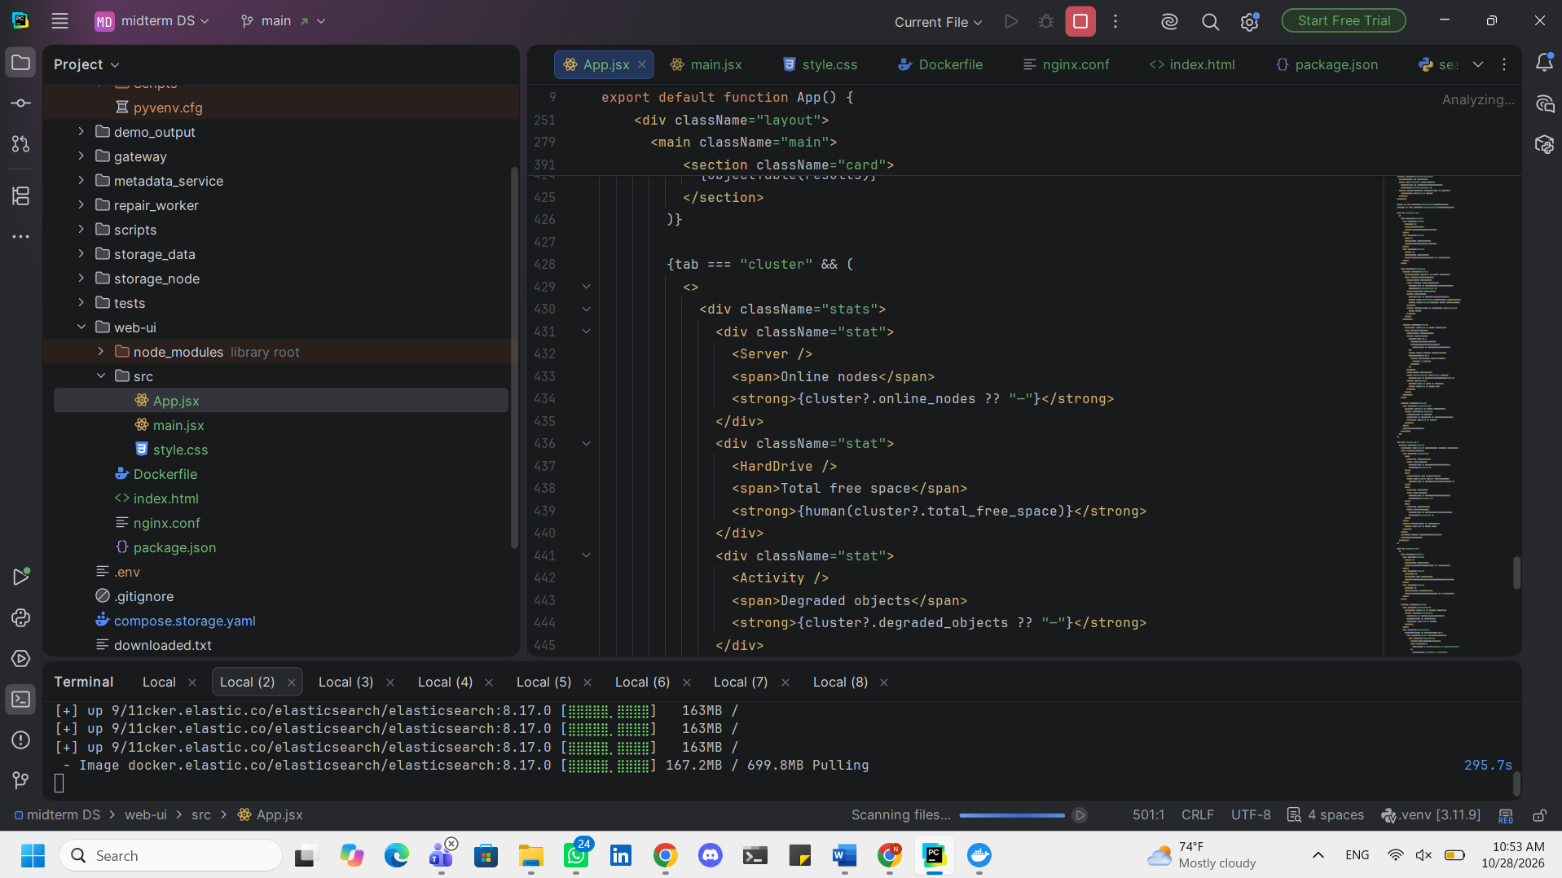
The interface communicates with the FastAPI gateway and supports bucket creation, file upload, object browsing, downloading, deletion, and metadata search.
The interface also displays storage-node availability, chunk distribution, available storage capacity, degraded-object counts, and repair-scan progress.
Elasticsearch was integrated to index object metadata and support searches using object key prefixes, file sizes, creation dates, and user-defined tags.
The React application is containerized using Docker and served through Nginx, which forwards API requests to the FastAPI gateway.



