Accounting Information Systems, 12e (Romney/Steinbart)
Chapter 17 The REA Data Model

1) Which of the following statements about REA modeling and REA diagrams is false?
A) REA is an acronym for Resources, Entities, and Agents.
B) REA data modeling does not include traditional accounting elements such as ledgers, chart of accounts, debits and credits.
C) REA data modeling could be referred to as an events-based model.
D) REA diagrams must include at least two activities, which together represent a give-get economic exchange.
Answer: A
Page Ref: 496
Objective: Learning Objective 1
Difficulty : Moderate
AACSB: Analytic

2) What is the standard cardinality pattern for a relationship between an event and an agent?
A) 1:1
B) 0:1
C) 0:N
D) 1:N
Answer: D
Page Ref: 506
Objective: Learning Objective 3
Difficulty : Difficult
AACSB: Reflective Thinking

3) The REA data model approach facilitates efficient operations by all the following except
A) standardizing source document format.
B) identifying non-value added activities.
C) storing financial and nonfinancial data in the same database.
D) organizing data to simplify data retrieval and analysis.
Answer: A
Page Ref: 496
Objective: Learning Objective 1
Difficulty : Moderate
AACSB: Analytic
4) The process of defining a database so that it faithfully represents all aspects of the organization including its interactions with the external environment is called
A) data modeling.
B) data designing.
C) data development.
D) data definition.
Answer: A
Page Ref: 494
Objective: Learning Objective 1
Difficulty : Easy
AACSB: Analytic

5) In which stage(s) of the database design process does data modeling occur?
A) only in the systems analysis stage
B) only in the design stage
C) in both the systems analysis and design stages
D) neither the systems analysis nor the design stages
Answer: C
Page Ref: 494
Objective: Learning Objective 1
Difficulty : Easy
AACSB: Analytic

6) A(n) ________ diagram graphically depicts a database's contents by showing entities and relationships.
A) data flow
B) flowchart
C) entity-relationship
D) REA
Answer: C
Page Ref: 494
Objective: Learning Objective 1
Difficulty : Moderate
AACSB: Analytic

7) On an entity-relationship (E-R) diagram, anything about which an organization wants to collect and store information is called
A) a data model.
B) an entity.
C) a schema.
D) a tuple.
Answer: B
Page Ref: 494
Objective: Learning Objective 1
Difficulty : Easy
AACSB: Analytic
8) An entity-relationship (E-R) diagram represents entities as ________ and the relationships between them as lines and ________.
A) circles; squares
B) squares; diamonds
C) rectangles; diamonds
D) rectangles; circles
Answer: C
Page Ref: 495
Objective: Learning Objective 1
Difficulty : Easy
AACSB: Analytic

9) An entity-relationship (E-R) diagram
A) can represent the contents of any database.
B) are only used in conjunction with REA models.
C) can show a limited number of entities and relationships.
D) are used only to design new databases.
Answer: A
Page Ref: 495
Objective: Learning Objective 1
Difficulty : Easy
AACSB: Analytic

10) The REA data model
A) is used in many areas of business and science.
B) was developed solely for use in designing accounting information systems.
C) classifies data into relationships, entities and accounts.
D) all of the above
Answer: B
Page Ref: 496
Objective: Learning Objective 2
Difficulty : Moderate
AACSB: Analytic

11) Which of the following is not one of the rules in creating an REA data model?
A) Each event is linked to at least one resource that it affects.
B) Each event is linked to at least one other event.
C) Each event is linked to at least two participating agents.
D) All of the above are important rules.
Answer: D
Page Ref: 497
Objective: Learning Objective 2
Difficulty : Easy
AACSB: Analytic
12) Which is a true statement about the REA data model?
A) The REA data model classifies entities into three distinct categories.
B) The term REA is an acronym that stands for resources, entities, and agents.
C) Using an REA data model is not helpful when creating an R-E diagram.
D) The "E" in the REA data model stands for things that have an economic value to the organization.
Answer: A
Page Ref: 496
Objective: Learning Objective 2
Difficulty : Easy
AACSB: Analytic

13) An REA diagram must link every event to at least one ________ and two ________.
A) resource; agents
B) agent; resources
C) transaction; entities
D) resource; relationships
Answer: A
Page Ref: 497
Objective: Learning Objective 3
Difficulty : Easy
AACSB: Analytic

14) Each event in an REA model will in most cases have at least one ________ agent and one ________ agent involved with the event.
A) internal; resource
B) external; entity
C) internal; employee
D) internal; external
Answer: D
Page Ref: 501
Objective: Learning Objective 3
Difficulty : Easy
AACSB: Analytic

15) Relationships that affect the quantity of a resource are sometimes referred to as ________ relationships.
A) commitment
B) exchange
C) stockflow
D) duality
Answer: C
Page Ref: 497
Objective: Learning Objective 2
Difficulty : Moderate
AACSB: Analytic
16) The "give" event represents an activity which
A) includes a promise to engage in future economic exchanges.
B) increases the organization's stock of an economic resource.
C) reduces the organization's stock of a resource that has economic value.
D) none of the above
Answer: C
Page Ref: 497
Objective: Learning Objective 2
Difficulty : Easy
AACSB: Analytic

17) The "get" event represents an activity which
A) includes a promise to engage in future economic exchanges.
B) increases the organization's stock of an economic resource.
C) reduces the organization's stock of a resource that has economic value.
D) none of the above
Answer: B
Page Ref: 497
Objective: Learning Objective 2
Difficulty : Easy
AACSB: Analytic

18) Which of the following statements is true about the development of an REA model?
A) Events that pertain to the entry of data are included in the REA model.
B) The objective is to model basic value-chain activities.
C) REA diagrams model individual transactions and data collections.
D) Information retrieval events are modeled as events in the REA model.
Answer: B
Page Ref: 501
Objective: Learning Objective 3
Difficulty : Moderate
AACSB: Analytic

19) Developing an REA diagram for a specific transaction cycle begins by identifying
A) relevant events.
B) agents involved.
C) resources affected.
D) relationship cardinalities.
Answer: A
Page Ref: 499
Objective: Learning Objective 3
Difficulty : Easy
AACSB: Analytic
20) Which of the following is false about cardinalities?
A) Cardinalities describe the nature of the relationship between two entities.
B) No universal standard exists for representing information about cardinalities in REA diagrams.
C) The minimum cardinality can be zero or one.
D) The maximum cardinality can be zero, one, or many.
Answer: D
Page Ref: 502-503
Objective: Learning Objective 3
Difficulty : Moderate
AACSB: Analytic

21) The minimum cardinality of a relationship in an REA diagram can be either
A) 0 or 1.
B) 0 or N.
C) 1 or N.
D) none of the above
Answer: A
Page Ref: 503
Objective: Learning Objective 3
Difficulty : Easy
AACSB: Analytic

22) The maximum cardinality of a relationship in an REA diagram can be either
A) zero or one.
B) one or many.
C) zero or many.
D) none of the above
Answer: B
Page Ref: 503
Objective: Learning Objective 3
Difficulty : Easy
AACSB: Analytic

23) How many types of relationships are possible between entities?
A) one
B) two
C) three
D) an infinite number
Answer: C
Page Ref: 504
Objective: Learning Objective 3
Difficulty : Easy
AACSB: Analytic
24) A relationship in which cardinalities have zero minimums and N maximums would most likely be an
A) agent-event relationship.
B) resource-event relationship.
C) event-event relationship.
D) All of the above are equally likely.
Answer: B
Page Ref: 504
Objective: Learning Objective 3
Difficulty : Moderate
AACSB: Reflective Thinking

25) Concerning REA diagrams, which of the following is false?
A) Each organization will have its own unique REA diagram.
B) An REA diagram for a given organization will change over time.
C) Data modeling and REA diagram development involve complex and repetitive processes.
D) Redrawing an REA diagram several times during development is uncommon.
Answer: D
Page Ref: 508
Objective: Learning Objective 3
Difficulty : Easy
AACSB: Analytic

26) Data modeling is an element of
A) systems analysis.
B) conceptual design.
C) both A and B
D) none of the above
Answer: C
Page Ref: 494
Objective: Learning Objective 1
Difficulty : Easy
AACSB: Analytic
27) Which of the following graphical symbols represents a minimum cardinality of zero and a maximum cardinality of one?
A)
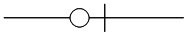
B)
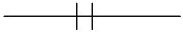
C)
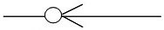
D)
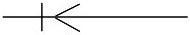
Answer: A
Page Ref: 502
Objective: Learning Objective 3
Difficulty : Moderate
AACSB: Analytic

28) Which of the following graphical symbols represents a minimum cardinality of zero and a maximum cardinality of many?
A)
B)
C)
D)
Answer: C
Page Ref: 502
Objective: Learning Objective 3
Difficulty : Moderate
AACSB: Analytic
29) Which of the following graphical symbols represents a minimum cardinality of one and a maximum cardinality of one?
A)
B)
C)
D)
Answer: B
Page Ref: 502
Objective: Learning Objective 3
Difficulty : Moderate
AACSB: Analytic

30) Which of the following graphical symbols represents a minimum cardinality of one and a maximum cardinality of many?
A)
B)
C)
D)
Answer: D
Page Ref: 502
Objective: Learning Objective 3
Difficulty : Moderate
AACSB: Analytic

31) Which of the following transactions is represented by the diagram below?
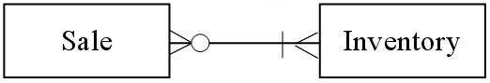
A) An automobile salvage business holds weekly auctions at which it sells its entire inventory.
B) A grocery store sells products to consumers.
C) A hobbyist restores antique cars. When a car is finished, she sells it on eBay.
D) A firm sells movies to consumers through an online downloading service.
Answer: B
Page Ref: 506-507
Objective: Learning Objective 4
Difficulty : Difficult
AACSB: Reflective Thinking
32) Which of the following transactions is represented by the diagram below?
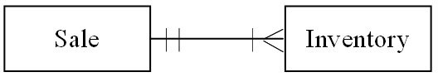
A) An automobile salvage business holds weekly auctions at which it sells its entire inventory.
B) A grocery store sells products to consumers.
C) A hobbyist restores antique cars. When a car is finished, she sells it on eBay.
D) A firm sells movies to consumers through an online downloading service.
Answer: A
Page Ref: 506-507
Objective: Learning Objective 4
Difficulty : Difficult
AACSB: Reflective Thinking

33) Which of the following transactions is represented by the diagram below?
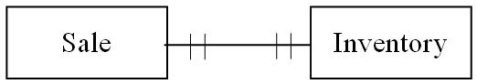
A) An automobile salvage business holds weekly auctions at which it sells its entire inventory.
B) A grocery store sells products to consumers.
C) A hobbyist restores antique cars. When a car is finished, she sells it on eBay.
D) A firm sells movies to consumers through an online downloading service.
Answer: C
Page Ref: 506-507
Objective: Learning Objective 4
Difficulty : Difficult
AACSB: Analytic

34) Which of the following transactions is represented by the diagram below?
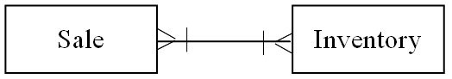
A) An automobile salvage business holds weekly auctions at which it sells its entire inventory.
B) A grocery store sells products to consumers.
C) A hobbyist restores antique cars. When a car is finished, she sells it on eBay.
D) A firm sells movies to consumers through an online downloading service.
Answer: D
Page Ref: 506-507
Objective: Learning Objective 4
Difficulty : Easy
AACSB: Reflective Thinking
35) Which of the following transactions is represented by the diagram below?
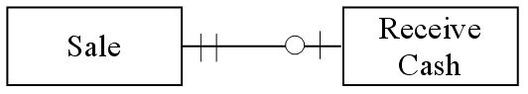
A) Cash and carry consumer retail sales
B) Consumer retail sales paid in installments to the seller
C) Business to business sales of nondurable goods
D) Business that allows customers to carry a balance and make installment payments
Answer: A
Page Ref: 505
Objective: Learning Objective 4
Difficulty : Difficult
AACSB: Reflective Thinking

36) Which of the following transactions is represented by the diagram below?
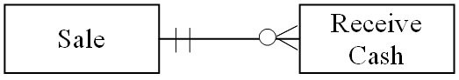
A) Cash and carry consumer retail sales
B) Consumer retail sales paid in installments to the seller
C) Business to business sales of nondurable goods
D) Business that allows customers to carry a balance and make installment payments
Answer: B
Page Ref: 505
Objective: Learning Objective 4
Difficulty : Difficult
AACSB: Reflective Thinking

37) Which of the following transactions is represented by the diagram below?
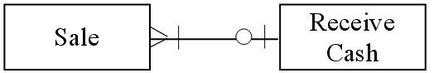
A) Cash and carry consumer retail sales
B) Consumer retail sales paid in installments to the seller
C) Business to business sales of nondurable goods
D) Business that allows customers to carry a balance and make installment payments
Answer: C
Page Ref: 505
Objective: Learning Objective 4
Difficulty : Difficult
AACSB: Reflective Thinking
38) Which of the following transactions is represented by the diagram below?
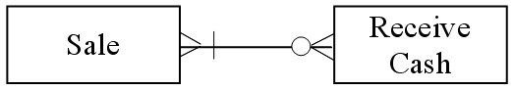
A) Cash and carry consumer retail sales
B) Consumer retail sales paid in installments to the seller
C) Business to business sales of nondurable goods
D) Business that allows customers to carry a balance and make installment payments
Answer: D
Page Ref: 505-506
Objective: Learning Objective 4
Difficulty : Difficult
AACSB: Reflective Thinking

39) Which of the following transactions is represented by the diagram below?
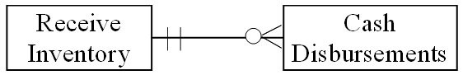
A) Vendors send a bill for each inventory item purchased which is payable on receipt.
B) A single purchase of inventory is paid for with multiple payments.
C) Inventory vendors send a monthly bill for merchandise delivered. The seller does not accept or allow installment payments.
D) Some inventory purchases are paid for with multiple payments and some payments may apply to multiple purchases.
Answer: B
Page Ref: 505
Objective: Learning Objective 4
Difficulty : Difficult
AACSB: Reflective Thinking

40) Which of the following transactions is represented by the diagram below?
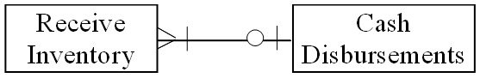
A) Vendors send a bill for each inventory item purchased which is payable on receipt.
B) A single purchase of inventory is paid for with multiple payments.
C) Inventory vendors send a monthly bill for merchandise delivered. The seller does not accept or allow installment payments.
D) Some inventory purchases are paid for with multiple payments and some payments may apply to multiple purchases.
Answer: C
Page Ref: 505
Objective: Learning Objective 4
Difficulty : Difficult
AACSB: Reflective Thinking
41) Which of the following transactions is represented by the diagram below?
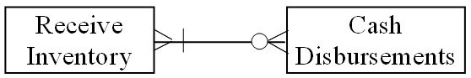
A) Vendors send a bill for each inventory item purchased which is payable on receipt.
B) A single purchase of inventory is paid for with multiple payments.
C) Inventory vendors send a monthly bill for merchandise delivered. The seller does not accept or allow installment payments.
D) Some inventory purchases are paid for with multiple payments and some payments may apply to multiple purchases.
Answer: D
Page Ref: 505
Objective: Learning Objective 4
Difficulty : Difficult
AACSB: Reflective Thinking

42) Which of the following transactions is represented by the diagram below?
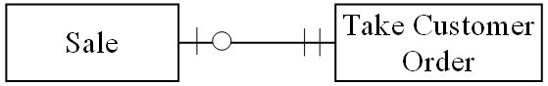
A) Each sale is associated with a single order and there is a time lag between the time an order is taken and delivery of the product.
B) Each sale can be comprised of multiple orders and each order can be associated with multiple sales or no sales.
C) Each sale can be comprised of multiple orders and each order can be associated with one or more multiple sales.
D) Each sale is associated with a single order and there is no time lag between the time an order is taken and delivery of the product.
Answer: A
Page Ref: 505
Objective: Learning Objective 4
Difficulty : Difficult
AACSB: Reflective Thinking
43) Which of the following transactions is represented by the diagram below?
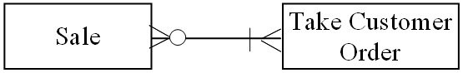
A) Each sale is associated with a single order and there is a time lag between the time an order is taken and delivery of the product.
B) Each sale can be comprised of multiple orders and each order can be associated with multiple sales or no sales.
C) Each sale can be comprised of multiple orders and each order can be associated with one or more sales.
D) Each sale is associated with a single order and there is no time lag between the time an order is taken and delivery of the product.
Answer: B
Page Ref: 505
Objective: Learning Objective 4
Difficulty : Difficult
AACSB: Reflective Thinking

44) Which of the following transactions is represented by the diagram below?
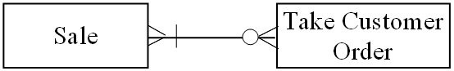
A) Each sale is associated with a single order and there is a time lag between the time an order is taken and delivery of the product.
B) Each sale can be comprised of multiple orders and each order can be associated with multiple sales or no sales.
C) Each sale can be comprised of multiple orders and each order can be associated with one or more sales.
D) Each sale is associated with a single order and there is no time lag between the time an order is taken and delivery of the product.
Answer: C
Page Ref: 505
Objective: Learning Objective 4
Difficulty : Difficult
AACSB: Reflective Thinking
45) Which of the following transactions is represented by the diagram below?
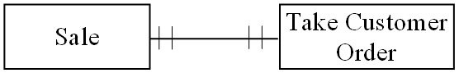
A) Each sale is associated with a single order and there is a time lag between the time an order is taken and delivery of the product.
B) Each sale can be comprised of multiple orders and each order can be associated with multiple sales or no sales.
C) Each sale can be comprised of multiple orders and each order can be associated with one or more sales.
D) Each sale is associated with a single order and there is no time lag between the time an order is taken and delivery of the product.
Answer: D
Page Ref: 505
Objective: Learning Objective 4
Difficulty : Difficult
AACSB: Reflective Thinking

46) A relationship is diagrammed below using the [Min, Max] notation. Which of the diagrams below represents the same relationship using the "crow's fee" notation?
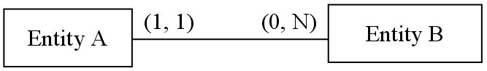
A)
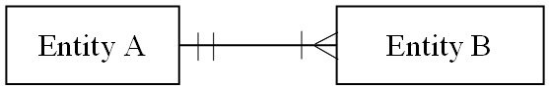
B)
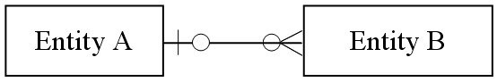
C)
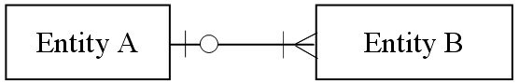
D)
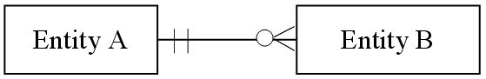
Answer: D
Page Ref: 502-503
Objective: Learning Objective 3
Difficulty : Difficult
AACSB: Analytic
47) Cosgrove Art & Antiques sells unique art and antiques exclusively at antique shows. Cosgrove purchases inventory from individuals and other dealers at garage sales, flea markets, antique malls, and estate sales. Each time Cosgrove makes a purchase, she records the person's name, address, date, specific items purchased and price paid, and total amount spent. Later at home, Cosgrove cleans, researches and prices the inventory items. She assigns an inventory number to each item and records the "asking" price. Cosgrove buys price tags and display supplies from a company that sells at flea market and antique shows. All inventory and supplies purchases are paid immediately with cash, or with checks from a bank account in the business' name, to which sales are also deposited. Several times a year Cosgrove rents a booth at an antique show. A deposit is always required, with the balance due at the start of the show. Cosgrove records the deposit and final payment, along with the show organizer's name and address, in the same worksheet on which purchases of inventory and supplies are recorded.

A well-planned and correctly drawn REA diagram for Cosgrove Art & Antiques, related to purchasing inventory and supplies, renting booths, and paying for all items, would
A) include eight unique entities.
B) include nine unique entities.
C) include seven unique entities.
D) include ten unique entities.
Answer: A
Page Ref: 499
Objective: Learning Objective 3
Difficulty : Difficult
AACSB: Reflective Thinking
48) Cosgrove Art & Antiques sells unique art and antiques exclusively at antique shows. Cosgrove purchases inventory from individuals and other dealers at garage sales, flea markets, antique malls, and estate sales. Each time Cosgrove makes a purchase, she records the person's name, address, date, specific items purchased and price paid, and total amount spent. Later at home, Cosgrove cleans, researches and prices the inventory items. She assigns an inventory number to each item and records the "asking" price. Cosgrove buys price tags and display supplies from a company that sells at flea market and antique shows. All inventory and supplies purchases are paid immediately with cash, or with checks from a bank account in the business' name, to which sales are also deposited. Several times a year Cosgrove rents a booth at an antique show. A deposit is always required, with the balance due at the start of the show. Cosgrove records the deposit and final payment, along with the show organizer's name and address, in the same worksheet on which purchases of inventory and supplies are recorded.

A well-planned and correctly drawn REA diagram for Cosgrove Art & Antiques, related to purchasing inventory and supplies, renting booths, and paying for all items, would
A) reflect nine 1:N relationships.
B) reflect two M:N relationships.
C) reflect ten 1:N relationships.
D) include two 1:1 relationships.
Answer: A
Page Ref: 502
Objective: Learning Objective 3
Difficulty : Difficult
AACSB: Reflective Thinking
49) Cosgrove Art & Antiques sells unique art and antiques exclusively at antique shows. Cosgrove purchases inventory from individuals and other dealers at garage sales, flea markets, antique malls, and estate sales. Each time Cosgrove makes a purchase, she records the person's name, address, date, specific items purchased and price paid, and total amount spent. Later at home, Cosgrove cleans, researches and prices the inventory items. She assigns an inventory number to each item and records the "asking" price. Cosgrove buys price tags and display supplies from a company that sells at flea market and antique shows. All inventory and supplies purchases are paid immediately with cash, or with checks from a bank account in the business' name, to which sales are also deposited. Several times a year Cosgrove rents a booth at an antique show. A deposit is always required, with the balance due at the start of the show. Cosgrove records the deposit and final payment, along with the show organizer's name and address, in the same worksheet on which purchases of inventory and supplies are recorded.

A well-planned and correctly drawn REA diagram for Cosgrove Art & Antiques, related to purchasing inventory and supplies, renting booths, and paying for all items, would
A) reflect minimum cardinalities of 1 for the relationship between Vendor and Cash Disbursement entities.
B) reflect the same number of 0 and 1 minimum cardinalities.
C) reflect more maximum cardinalities of M than of 1.
D) reflect maximum cardinalities of M for the relationship between Inventory and Purchase entities.
Answer: A
Page Ref: 502
Objective: Learning Objective 3
Difficulty : Difficult
AACSB: Reflective Thinking
50) Cosgrove Art & Antiques sells unique art and antiques exclusively at antique shows. Cosgrove purchases inventory from individuals and other dealers at garage sales, flea markets, antique malls, and estate sales. Each time Cosgrove makes a purchase, she records the person's name, address, date, specific items purchased and price paid, and total amount spent. Later at home, Cosgrove cleans, researches and prices the inventory items. She assigns an inventory number to each item and records the "asking" price. Cosgrove buys price tags and display supplies from a company that sells at flea market and antique shows. All inventory and supplies purchases are paid immediately with cash, or with checks from a bank account in the business' name, to which sales are also deposited. Several times a year Cosgrove rents a booth at an antique show. A deposit is always required, with the balance due at the start of the show. Cosgrove records the deposit and final payment, along with the show organizer's name and address, in the same worksheet on which purchases of inventory and supplies are recorded.

A well-planned and correctly drawn REA diagram for Cosgrove Art & Antiques, related to purchasing inventory and supplies, renting booths, and paying for all items, what entities would reflect economic duality?
A) Purchases and Cash Disbursements
B) Booth Rental and Cash Disbursements
C) Inventory and Purchases
D) Cash and Cash Disbursements
Answer: A
Page Ref: 498
Objective: Learning Objective 3
Difficulty : Difficult
AACSB: Reflective Thinking

51) Cosgrove Art & Antiques sells unique art and antiques exclusively at antique shows. Cosgrove purchases inventory from individuals and other dealers at garage sales, flea markets, antique malls, and estate sales. Each time Cosgrove makes a purchase, she records the person's name, address, date, specific items purchased and price paid, and total amount spent. Later at home, Cosgrove cleans, researches and prices the inventory items. She assigns an inventory number to each item and records the "asking" price. Cosgrove buys price tags and display supplies from a company that sells at flea market and antique shows. All inventory and supplies purchases are paid immediately with cash, or with checks from a bank account in the business' name, to which sales are also deposited. Several times a year Cosgrove rents a booth at an antique show. A deposit is always required, with the balance due at the start of the show. Cosgrove records the deposit and final payment, along with the show organizer's name and address, in the same worksheet on which purchases of inventory and supplies are recorded.

Draw an REA diagram for Cosgrove Art & Antiques, related to purchasing inventory and supplies, renting booths, and paying for all items.
Answer: 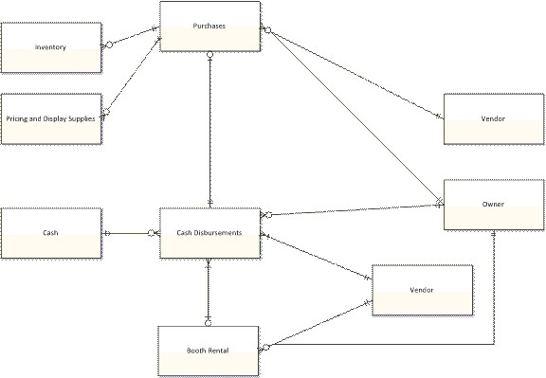
Page Ref: 499
Objective: Learning Objective 3
Difficulty : Difficult
AACSB: Reflective Thinking

52) Describe data modeling.
Answer: Data modeling is the process of defining a database so that it faithfully represents all aspects of the organization, including its interaction with the external environment.
Page Ref: 494
Objective: Learning Objective 1
Difficulty : Easy
AACSB: Analytic
53) Describe an REA data model.
Answer: The REA data model is a conceptual modeling tool specifically designed to provide structure for designing an AIS database. The REA data model identifies what entities should be included in the AIS database and prescribes how to structure relationships among the entities in the AIS database. REA stands for resources, events, and agents. Resources are defined as those things that have economic value to the organization. Events are the various business activities about which management wants to collect information for planning and control purposes. Agents are the people and organizations that participate in events and about which information is desired for planning, control, and evaluation purposes.
Page Ref: 496
Objective: Learning Objective 2
Difficulty : Moderate
AACSB: Analytic

54) Define cardinality.
Answer: The cardinality of the relationship indicates how many occurrences of the entity on the other side of the relationship can be linked to a single occurrence of the entity on this side of the relationship. In relational database terms, cardinality provides information about how many rows in the other table can be linked to each row in this table.
Page Ref: 502
Objective: Learning Objective 3
Difficulty : Moderate
AACSB: Analytic

55) Describe the three basic rules that apply to the REA model pattern.
Answer: Each event is linked to at least one resource that it affects. Each event is linked to at least one other event. Each event is linked to at least two participating agents.
Page Ref: 497
Objective: Learning Objective 3
Difficulty : Easy
AACSB: Analytic

56) Describe the steps in developing an REA diagram.
Answer: Developing an REA diagram involves three steps. First, identify the basic events of interest (any activity about which management wants to collect information in order to plan, control, and evaluate performance). Second, identify the resources affected by and the agents who participate in those events. Third, use knowledge about the organization's business practices to add relationship cardinality information to the diagram.
Page Ref: 499
Objective: Learning Objective 3
Difficulty : Moderate
AACSB: Analytic
57) Explain how an AIS system can be viewed as a set of "give-to-get" exchanges.
Answer: An AIS system can be viewed as a set of "give-to-get" exchanges because such exchanges reflect the nature of the five transaction cycles: revenue, expenditure, human resources, production, and financing. In each cycle the organization "gives" some resource in exchange for another resource (the "get" part of the transaction). The goal is that the "give" part of the exchange is of lesser value than the "get" portion, thus generating a profit for the organization. The AIS should capture, record, and organize information relating to any transaction that occurs within a cycle.
Page Ref: 497
Objective: Learning Objective 3
Difficulty : Moderate
AACSB: Analytic

58) Define minimum and maximum cardinalities.
Answer: A minimum cardinality indicates the number of instances of that entity that must be associated with at least one instance of the other entity. Minimum cardinalities can be 0 or 1. A maximum cardinality indicates the number of instances of that entity that can be linked to at most one instance of the other entity. Maximum cardinalities can be 1 or N (many).
Page Ref: 503
Objective: Learning Objective 3
Difficulty : Moderate
AACSB: Analytic

59) Describe the possible relationships between entities, in terms of cardinalities.
Answer: There are three types or relationships possible between entities depending upon maximum cardinality. These are: A one-to-one relationship exists when the maximum cardinality of each entity is 1. A one-to-many relationship exists when the maximum cardinality on one entity is 1 and maximum cardinality of the other entity is N. A many-to-many relationship exists when the maximum cardinality of both entities is N.
Page Ref: 504-505
Objective: Learning Objective 3
Difficulty : Moderate
AACSB: Analytic
60) Explain specifically what is meant by the following statement, "Accountants can and should participate in all stages of the database design process."
Answer: Accountants are in a unique position within a business organization. They are intimately acquainted with the many business transactions that occur in an organization and they are knowledgeable about the policies and practices of the business itself as well as the environment within which it operates. The knowledge base and skill sets of the accountant should be put to good use in the development of database design to the fullest extent possible (although some accountants may not possess AIS coding and development skill sets). Consider that during the planning stage accountants provide some of the information used to evaluate the feasibility of the proposed project and they participate in making the decision itself. Accountants can identify user information needs and develop logical schema during the requirement analysis and design stages. Accountants can also help test the accuracy of the new database and application programs during the implementation stage of development. Accountants can also act as "subject matter experts" since they are knowledgeable users of the new system. They can also serve as managers of the system once it is up and running.
Page Ref: 494
Objective: Learning Objective 1
Difficulty : Moderate
AACSB: Analytic
61) A dental office employs three dentists and five dental hygienists. One of the dentists is a very recent dental school graduate and can't yet see patients on her own until she passes boards and obtains a license. Dentists perform all procedures personally, except for regular cleaning and x-rays, which are performed exclusively by dental hygienists. Three of the five dental hygienists perform only regular cleaning and x-rays. The other two hygienists each assist a specific dentist during procedures, as well as performing regular cleaning and x-rays. One of the hygienists will be assigned to the new dentist when she begins seeing patients. Hygienists usually 'shadow' other hygienists and dentists for two weeks prior to seeing patients.

Patients schedule appointments directly with dentists and hygienists, depending on the type of dental service needed. Patients do not have to choose a dentist until they need service other than routine cleaning or x-rays. Patients are assigned to a specific dental hygienist when they schedule their first appointment. The customer master file has 549 records. Diagram the agents described, relationships between agents, and the cardinality pairs for each relationship.
Answer: 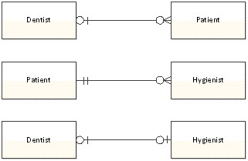
Page Ref: 504
Objective: Learning Objective 3
Difficulty : Moderate
AACSB: Reflective Thinking

